Leading University
Department of Computer Science and Engineering
Course Code:4801

AI-Driven Analysis of Sleep Habits and Their Influence on University Productivity

MD Kamran Hussen  MD Shahir Sammun  Nuzat Rahman | ID-2122020001  ID-2122020021  ID-2122020026
Department of Computer Science and Engineering
Supervisor
Md. Arifuzzaman
Lecturer
Department of Computer Science and Engineering
30th October 2025

AI-Driven Analysis of Sleep Habits and Their Influence on University Productivity

A Thesis submitted to the
Department of Computer Science and Engineering

Leading University
Sylhet - 3112, Bangladesh
In partial fulfillment of the requirements for the degree of
Bachelor of Science in Computer Science and Engineering
By
MD Kamran Hussen  MD Shahir Sammun  Nuzat Rahman | ID-2122020001  ID-2122020021  ID-2122020026
Supervisor
Md. Arifuzzaman
Lecturer
Department of Computer Science and Engineering
30th October 2025

Recommendation Letter from the Thesis Supervisor
The thesis entitled AI-Driven Analysis of Sleep Habits and Their Influence on University Productivity, submitted by the students,
- MD Kamran Hussen, ID-2122020001
- MD Shahir Sammun, ID-2122020021
- Nuzat Rahman, ID-2122020026
This is a record of research work carried out under my supervision. I hereby approve that the report be submitted in partial fulfillment of the requirements for the award of their Bachelor's Degrees.
Signature of the Supervisor:
Md. Arifuzzaman
Date: 30th October 2025

Certificate of Acceptance of the Thesis
The thesis entitled AI-Driven Analysis of Sleep Habits and Their Influence on University Productivity was submitted by the students.

- MD Kamran Hussen, ID-2122020001
- MD Shahir Sammun, ID-2122020021
- Nuzat Rahman, ID-2122020026
On 30th October 2025, is hereby accepted as the partial fulfillment of the requirements for the award of their bachelor’s degrees.
`

Chairman, Defence Board  Name: | Member 1, Defence Board  Name: | Member 2, Defence Board  Name:

Abstract
Sleep is an essential factor that influences physical health, mental well-being, and academic performance. Among university students, irregular sleep schedules, poor sleep quality, and excessive use of digital devices have become common, which negatively affect attentiveness and productivity, especially during morning classes. This study focuses on analyzing the relationship between sleep habits and university student productivity using Machine Learning (ML) techniques. The dataset was collected through a structured Google Form survey, which included demographic and behavioral attributes such as age, gender, department, weekend sleep duration, sleep consistency, nap duration, noise sensitivity, device usage before sleep, skipped classes, and negative sleep habits. The target variable, Morning Class Attentiveness, served as the key indicator of student productivity. After preprocessing and encoding the data, five ML models were implemented: Logistic Regression, Random Forest, Gradient Boosting, XGBoost, and CatBoost. Their performances were evaluated using accuracy, precision, recall, F1-score, and confusion matrices. Among all models, CatBoost achieved the highest accuracy, 96%, demonstrating superior capability in handling categorical and behavioral features effectively. To enhance interpretability, Explainable AI (XAI) techniques such as SHAP, LIME, and Partial Dependence Plots (PDP) were applied. These methods helped identify the most influential features contributing to attentiveness prediction and provided meaningful insights into how sleep-related behaviors impact productivity. The findings suggest that sleep consistency, weekend sleep duration, and device usage before bedtime significantly influence morning attentiveness. This study highlights the importance of maintaining healthy sleep routines and demonstrates the effectiveness of ML-driven analysis in educational and behavioral research.
.

Acknowledgements
At the very beginning, all praises to the Almighty Creator who has created us. We are grateful to the Almighty for the blessings and ability to gain knowledge for completing this thesis work.
In addition, we would like to extend our sincerest and heartfelt gratitude towards our thesis
supervisor, Md. Arifuzzaman Sir, for his continuous and valuable support, guidance, and untarnished commitment. Without his consistent counsel, we wouldn’t have been able to make it this far in our work. We are thankful to our family, friends, and all faculty members for their unwavering support and motivation during this academic journey.

Dedication
We dedicate this thesis to our parents, teachers, and mentors, whose guidance, encouragement, and support have been invaluable throughout our academic journey. Their constant motivation inspired us to complete this work with dedication and perseverance.

Contents
Abstract 1
Acknowledgements 2
Dedication 3
Contents 4
List of Tables 5
List of Figures 6
Chapter 1: Introduction 1
Chapter 2: Problem Description 2
2.1 Problem Statement 2
2.2 Goals 3
2.3 Purposes 4
2.4 Methods 5
2.5 Review Previous Work 6
Chapter 3: Dataset Description 11
3.1 Data Acquisition 11
3.2 Dataset Analysis 12
3.2.1 Statistical Properties 12
3.2.2 Data Distribution 12
3.2.3 Data Characteristics 13
Chapter 4: Methodology 14
4.1 Research Framework 14
4.2 Model Selection and Design 15
4.3 Tools and Software 15
4.4 Assumptions and Justifications 16
Chapter 5: Results and Discussion 17
5.1 Performance of Machine Learning Models 17
5.1.1 CatBoost 17
5.1.2 Random Forest 19
5.1.3 XG Boost 21
5.1.4 Gradient Boosting 23
5.1.5 Logistic Regression 25
5.2 Comparative Analysis of Results 27
5.2 Comparison with Existing Works 29
Chapter 6: Conclusion 30
6.1 Restrictions 30
6.2 Limitations 31
6.3 Future Work 31
References 32

List of Tables
3.1 Dataset With Features…………………………………………………………………..13
5.1 Model Performance Comparison……………………………………………………… 27

List of Figures
4.1 Methodology Workflow………………………………………………………………….14
5.1 Confusion Matrix of CatBoost…………………………………………………………...17
5.2 Classification Report of CatBoost………………………………………………………..18
5.3 Confusion Matrix of Random Forest………………………………………………….....19
5.4 Classification Report of Random Forest………………………………………………....20
5.5 Confusion Matrix of XG Boost…………………………………………………………..21
5.6 Classification Report of XG Boost…………………………………………………….....22
5.7 Confusion Matrix of Gradient Boosting………………………………………………….23
5.8 Classification Report of Gradient Boosting……………………………………………...24
5.9 Confusion Matrix of Logistic Regression………………………………………………..25
5.10 Classification Report of Logistic Regression…………………………………………...26
5.11 Model Accuracy Comparison…………………………………………………………...28
5.12 Comparison of Model Accuracy Across Studies……………………………………….29

Chapter 1: Introduction
Sleep is a crucial factor that influences mental health, learning ability, and overall productivity. Among university students, irregular sleep schedules, late-night study habits, and high device usage have become common causes of poor sleep quality, leading to fatigue and reduced attentiveness during morning classes. These issues directly affect academic performance and daily productivity. This paper-based research focuses on analyzing the relationship between sleep habits and university student productivity using Machine Learning (ML) techniques. The dataset was collected through a Google Form survey, including variables such as age, gender, department, weekend sleep duration, sleep consistency, nap duration, noise effect on sleep, device usage, skipped classes, and negative sleep habits. The target variable, Morning_Class_Attentiveness, represents the level of concentration and productivity in morning lectures. Several ML algorithms, including Logistic Regression, Random Forest, Gradient Boosting, XGBoost, and CatBoost, were applied to train predictive models and compare their performance. These models help identify which sleep-related factors most strongly influence student attentiveness. The primary goal of this study is to evaluate the effectiveness of machine learning in understanding and predicting the impact of sleep behavior on university productivity. The findings aim to provide insights that can guide students and educators toward improving sleep habits and enhancing academic outcomes.

Chapter 2: Problem Description
In today's fast-paced and digitally connected academic environment, university students' sleep habits are regularly disrupted as a result of academic pressure, irregular study schedules, and excessive electronic device use. These sleep inconsistencies have been strongly associated with poor cognitive function, lower academic performance, and less attentiveness, particularly in morning classes where mental alertness is critical. Despite increasing awareness of the importance of sleep, many students continue to underestimate its impact on academic performance. Traditional surveys and psychological examinations offer a limited grasp of how various interconnected elements, such as sleep duration, consistency, and digital habits, influence learning efficacy. Furthermore, standard approaches frequently fail to capture the intricate, nonlinear interactions between behavioral characteristics and cognitive outcomes. As a result, a data-driven method is required to systematically assess students' sleep habits and anticipate their level of attention or productivity. The challenge is to successfully integrate demographic and behavioral data into intelligent systems capable of identifying the major predictors of attentiveness. This study tackles this gap by using a variety of Machine Learning models to examine and predict morning class attentiveness based on sleep and behavioral characteristics. The study's goal is to give actionable insights that can guide initiatives for improving student well-being, optimizing learning results, and promoting long-term academic habits.

2.1 Problem Statement
- Many university students have irregular sleep schedules, poor sleep quality, and high device usage before bed.
- These negative sleep habits contribute to reduced attentiveness and lower productivity, particularly in morning classes.
- Traditional assessment methods cannot accurately capture the complex relationship between sleep behaviors and academic outcomes.
- There is a need for a data-driven approach to identify key factors influencing student attentiveness using modern Machine Learning techniques.
- Lack of targeted insights makes it challenging to develop effective interventions for improving student productivity and well-being.

2.2 Goals
The primary goal of this thesis is to investigate how students’ sleep habits influence their academic productivity, with particular attention to attentiveness during morning classes. As irregular sleep schedules, poor-quality rest, and heavy digital device usage have become increasingly common among university students, understanding their combined effects on learning outcomes is crucial.
To achieve this, the study aims to build a comprehensive dataset that includes demographic characteristics, behavioral aspects, and sleep-related factors such as sleep duration, consistency, and device usage. Various Machine Learning algorithms, including Logistic Regression, Random Forest, Gradient Boosting, XGBoost, and CatBoost, are applied to analyze and predict students’ levels of attentiveness in morning classes.
By comparing the performance of these models, the research seeks to identify which techniques yield the most accurate predictions of student productivity. Ultimately, the findings are expected to provide meaningful insights and recommendations that can help students adopt healthier sleep habits and assist educational institutions in developing strategies to enhance learning efficiency and academic well-being.

2.3 Purposes
- To systematically investigate how sleep habits—including sleep duration, consistency, and quality—affect academic performance and attentiveness among university students, particularly during morning classes: This purpose aims to establish the link between various sleep behaviors and learning outcomes, highlighting that students with longer, more consistent, and higher-quality sleep tend to have better academic results and higher attentiveness in class.
- To identify and quantify the behavioral and demographic factors that most strongly contribute to reduced attentiveness and poor productivity, such as excessive use of digital devices, irregular sleep schedules, and environmental influences: The objective here is to pinpoint specific behaviors (like nighttime device use, frequent sleep pattern changes) and characteristics (age, gender, academic load) that have the greatest influence on declining concentration and class performance.
- To apply and evaluate multiple Machine Learning algorithms for predicting levels of student attentiveness and academic productivity based on collected survey data: Machine Learning models are used to process survey results, uncover underlying relationships, and make accurate predictions about students’ attentiveness, providing a technical approach to analyzing how lifestyle choices impact learning.
- To provide data-driven insights that can help students and educational institutions recognize the value of healthy sleep behaviors and encourage effective interventions for improving student well-being and academic success: The aim is not only to analyze but to deliver actionable recommendations that promote better sleep habits and inform campus policies, supporting both individual student wellness and broader academic performance.
- To fill gaps in existing research by using AI-driven analysis methods that clarify how combined sleep and behavioral patterns impact cognitive performance and learning outcomes in the university context: This purpose emphasizes the use of advanced AI and machine learning techniques to analyze complex interactions among sleep habits, environmental factors, and academic results, advancing the current understanding in educational research.

2.4 Methods
- Survey Data Collection: A structured Google Form survey was designed and distributed to university students, collecting both demographic data (such as age, gender, and department) and behavioral information (weekend sleep duration, sleep consistency, device usage before bedtime, nap habits, and noise sensitivity).
- Feature Engineering: Survey responses were preprocessed and encoded using statistical techniques to convert categorical variables (e.g., device usage, class skipping, sleep habits) into formats suitable for machine learning analysis, allowing for comprehensive modeling of behaviors and patterns.
- Exploratory Data Analysis: Initial exploration of the data was performed to identify trends, distributions, and key correlations among variables. Visualization and correlation matrices helped determine which features were most linked to attentiveness and productivity.
- Machine Learning Model Application: Multiple supervised learning algorithms, including Logistic Regression, Random Forest, Gradient Boosting, XGBoost, and CatBoost, were applied to the processed dataset. Each model was trained to predict the target variable, “Morning_Class_Attentiveness,” based on survey features.
- Model Evaluation and Comparison: Techniques such as cross-validation and performance metrics (accuracy, precision, recall, F1-score) were used to assess the effectiveness of each ML model. The feature importance rankings from these models identified the most influential sleep and behavioral factors associated with attentiveness.
- Interpretation and Insight Generation: The results were critically interpreted to provide insights into how sleep behavior, device use, and consistency influence productivity, guiding recommendations for targeted interventions and policy improvement

2.5 Review Previous Work
The advancement of machine learning and AI has profoundly impacted behavioral and academic prediction studies related to sleep. Numerous approaches, from traditional classifiers to deep learning and explainable AI, have been evaluated for their effectiveness and practical limits. Several valuable studies lay the foundation for this domain:
Al-Mamun et al. [1], in their paper titled "Exploring Sleep Duration and Insomnia Among Prospective University Students," implemented a cross-sectional analysis of 1,496 university entrance exam takers, focusing on demographics, sleep duration, and insomnia using various machine learning models such as K-Nearest Neighbors, Random Forest, SVM, Gradient Boosting, XGBoost, and CatBoost. The CatBoost model yielded the highest accuracy for both sleep duration (61.27%) and insomnia prediction (73.46%), with feature importance elucidated using SHAP analysis and spatial patterns mapped using GIS. The strength of this study lies in its integration of machine learning and geographic analysis to identify crucial predictors of sleep disturbances, though it is limited by its moderate accuracy for clinical application and its reliance on a specific cohort and context [1].

Agyemang et al. [2], in their paper titled "Predicting Students' Academic Performance Via Machine Learning Algorithms," analyzed the xAPI-EDU-Data set, which contains 480 samples and 16 variables, including attendance, engagement, and demographics, applying models such as Random Forest, SVM, Logistic Regression, and KNN. The Random Forest model achieved the highest accuracy at 85.42% (F1 score: 0.85), with engagement-related features emerging as most predictive of academic outcomes. The key strength of this work is its thorough comparison of models and use of a comprehensive set of predictors, but it is limited by the moderate sample size and potential constraints on model generalization [2].

Rajendran et al. [3], in their paper titled "Predicting the Academic Performance of Middle- and High-School Students Using Machine Learning Algorithms," compared multinomial logistic regression, artificial neural networks, random forest, gradient boosting, and stacking ensembles using a large urban student survey of 2,001 Indian students. Stacking ensembles outperformed single models, identifying stress, lifestyle, and prior performance as primary predictors. This study’s strength is its large, varied sample, which highlights the significance of lifestyle in student achievement, but its reliance on self-reported and urban-only data limits generalizability [3].

Wara et al. [4], in their paper titled "A Systematic Review on Sleep Stage Classification and Sleep Disorder Detection Using Artificial Intelligence," synthesized findings from 81 published papers, evaluating over 30 distinct AI approaches (including CNNs, RNNs, and hybrid models) for automatic sleep staging and disorder prediction. Some CNN-based architectures achieved up to 99.8% accuracy on specific tasks, particularly when multimodal data such as EEG and additional physiological signals were included. The major strength of this review is its broad coverage and focus on explainability, though the field as a whole still requires improvement in generalization and transparency of models [4].

The team at the High School Affiliated to Shanghai Jiao Tong University [5], in their paper titled "Research on Sleep Health Prediction and Algorithms Based on Big Data," contrasted Logistic Regression and Random Forest using a synthetic sleep and lifestyle dataset, showing Random Forest as the stronger performer in multi-class predictions, with blood pressure and BMI emerging as the most significant features. The study is notable for its multi-class framework and transparent predictors, but it depends on synthetic rather than real-world data [5].

Sathish et al. [6], in their paper titled "Predicting Sleeping Quality Using Convolutional Neural Networks," compared novel 1D CNN architectures and classic machine learning models across various open datasets. CNNs displayed more stable and often higher predictive performance in sleep quality classification, reinforcing the benefits of deep learning, though small dataset sizes limited the study’s external validity [6].

Han et al. [7], in their paper titled "Using Explainable Artificial Intelligence to Predict Sleep Interruptions from Indoor Environmental Conditions: An Empirical Study," combined Fitbit wearable and environmental sensor data and analyzed this with XGBoost and SHAP to find that heart rate, CO2, and heat index were key predictors of sleep quality, with stable and cool bedroom conditions favoring better sleep. The strength of this research is its use of real-world, interpretable sensor data, while the limitations stem from the small sample size and localized sampling [7].

Göktepe Kavis et al. [8], in their paper titled "Sleep Research in the Era of AI," provided a comprehensive review of AI and deep learning applications for clinical polysomnography and wearable sleep data, emphasizing how deep neural networks increase the consistency and efficiency of sleep scoring while supporting studies in large populations. Their work excels at linking clinical and consumer advances, though it notes that interpretability and clinical adoption challenges remain [8].

Phalke et al. [9], in their paper titled “Analyzing the Impact of Irregular Sleep Patterns on Academic Performance Using Machine Learning,” investigated the correlation between students’ sleep duration and academic performance. The authors utilized Decision Tree and Random Forest models to analyze sleep hours and academic grades. The findings revealed that students sleeping 6–8 hours performed better academically, with Random Forest achieving higher accuracy and consistency (60%) than the Decision Tree model. However, the study’s modest accuracy and reliance on self-reported data limited the reliability and generalizability of the results [9].

Djanian et al. [10], in their paper titled “Sleep Classification Using Consumer Sleep Technologies and AI: A Review of the Current Landscape,” provided a comprehensive overview of machine learning applications in sleep analysis using consumer sleep technologies. The review encompassed 27 studies involving devices such as wrist trackers, headbands, and mattresses, analyzing physiological signals like EEG, PPG, and ECG. Both classical and deep learning models (e.g., SVM, Random Forest, CNN, LSTM) were compared. Deep learning methods achieved the highest accuracy (up to 99%) in multi-stage sleep classification, though challenges such as dataset diversity and limited open data availability persisted [10].

Halim et al. [11], in their paper titled “Impact of Better Sleep on Academic Grades: A Study on the Students of University of Dhaka,” explored the relationship between sleep quality and academic performance among 149 students from the University of Dhaka. Using linear regression models, they analyzed CGPA against the Pittsburgh Sleep Quality Index (PSQI). Results showed a negative association between poor sleep quality and academic performance, especially among female students. The study concluded that better sleep quality significantly enhances academic performance, although the limited sample size and uneven academic distribution restricted broader inference [11].

Aljasem et al. [12], in their paper titled “Sleep Pattern and Dozing Chance among University Students,” conducted a cross-sectional study involving 145 male university students from Almaarefa University, Saudi Arabia. Using questionnaires and the Epworth Sleepiness Scale (ESS), the study examined sleep behaviors, dozing chances, and GPA. The results indicated that most students had poor sleep hygiene and irregular sleep timing. Although over 60% reported insufficient sleep, no statistically significant relationship was found between sleep duration, bedtime, and academic performance. The study highlighted prevalent poor sleep practices among university students and emphasized the need for awareness regarding healthy sleep habits [12].

Chapter 3: Dataset Description
For this study, we used a primary dataset collected through a Google Form survey to analyze the relationship between students’ sleeping patterns and their productivity levels. The dataset includes sleep duration, daytime nap habits, and sleep consistency, with Morning Class Attentiveness serving as the target variable. This dataset forms the foundation for understanding how various sleep-related behaviors affect students’ concentration and performance.

3.1 Data Acquisition
The dataset was obtained from Google Form responses submitted by university students. The form collected data on multiple aspects of their daily routines and sleeping habits, including sleep consistency, nap duration, and factors that may affect sleep quality. The responses were exported as a CSV file and processed using Python (Google Colab) with the help of libraries such as NumPy, Pandas, Matplotlib, and Scikit-learn for data cleaning, preprocessing, and visualization.
Preprocessing Steps:
- Missing Values: Imputed (filled) using appropriate methods to ensure data completeness.
- Categorical Features: Encoded using Label Encoding to convert non-numeric values into numerical form.
- Numeric Features: Scaled using Standard Scaler to normalize ranges for better model performance.
- Data Splitting: The dataset was divided into Training (80%) and Testing (20%) sets with a fixed random state (random_state=42) for reproducibility.
- Class Balancing: Oversampling was applied when the target variable (Morning_Class_Attentiveness) showed imbalance among classes.

3.2 Dataset Analysis
This section presents the statistical properties, distribution, and characteristics of the dataset to ensure its suitability for the study.

3.2.1 Statistical Properties
The statistical properties of the dataset were examined to understand the range, central tendency, and variability of the collected features.
Descriptive statistics such as mean, median, standard deviation, minimum, and maximum values were calculated for numerical variables, including:
- Weekdays_Sleep
- Weekends_Sleep
- Nap_Hour
These measures helped identify the general sleep duration among students and detect any anomalies or extreme values. The results indicated that most students maintained an average of 6–8 hours of sleep per day, showing relatively consistent sleep habits across the sample.

3.2.2 Data Distribution
The distribution analysis was conducted to visualize how each variable spreads across different categories and numerical ranges.
Key observations include:
- Most students had moderate sleep durations, while a smaller portion slept either too little or too much.
- Morning class attentiveness followed a slightly right-skewed distribution, with the majority of students reporting moderate to high levels of attentiveness.
- The categorical features (such as Sleep Consistency and Day Nap) showed a balanced proportion of responses, thereby reducing the risk of model bias.

3.2.3 Data Characteristics
The dataset's characteristics were analyzed to ensure completeness and consistency before model training.
Key points include:
- No missing values remained after preprocessing.
- Categorical variables were encoded numerically for compatibility with machine learning models.
- Numerical features were standardized to improve model performance.
- The dataset displayed balanced representation across different student groups, ensuring that it accurately reflects a range of sleep behaviors and productivity levels.

3.2.4 Dataset with Features
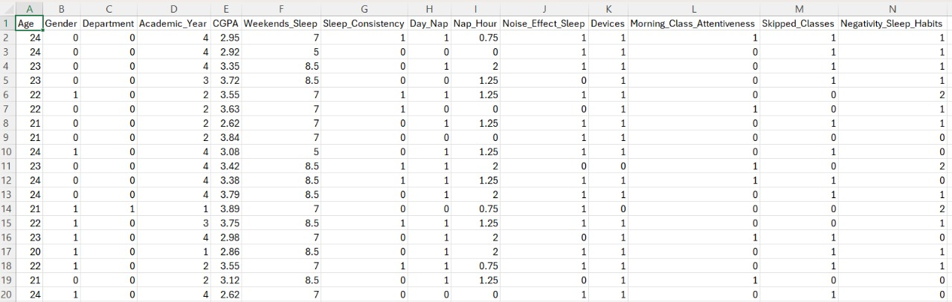
Fig 3.1: Dataset with Features

Chapter 4: Methodology
This chapter presents the methodology used to predict morning class attentiveness among students. It outlines the research framework, selected machine learning models, tools and software, and the assumptions and limitations considered.

4.1 Research Framework
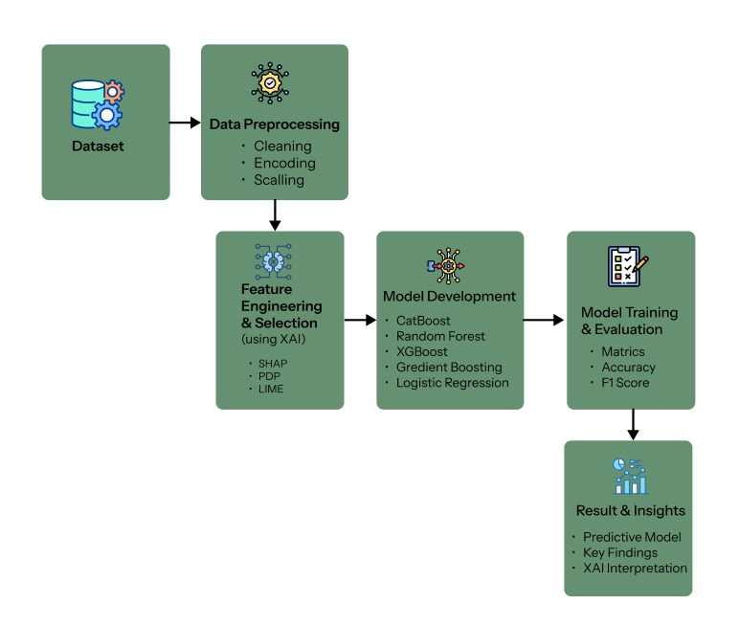
Fig 4.1: Methodology Workflow

4.2 Model Selection and Design
In this study, five machine learning models were selected to predict morning class attentiveness:
- Logistic Regression: a linear model used as a baseline.
- Random Forest: an ensemble of decision trees that reduces overfitting and improves generalization.
- Gradient Boosting: a sequential boosting algorithm that builds models to correct previous errors.
- XGBoost: an optimized gradient boosting implementation with faster computation and regularization.
- CatBoost: a boosting model designed to efficiently handle categorical features.
The models were trained using features related to student demographics and sleep habits, including age, gender, department, weekend sleep, sleep consistency, nap hours, device usage, skipped classes, and negative sleep habits. The target variable was Morning Class Attentiveness. Hyperparameter tuning was performed for each model to optimize performance, and a train-test split was used for validation. Models were evaluated using accuracy, precision, recall, and F1-score, ensuring a systematic and reproducible methodology.

4.3 Tools and Software
The study was implemented using Python in Google Colab, an online interactive environment suitable for coding, testing, and visualization. Key tools and libraries used include:
- Scikit-learn: for Logistic Regression, Random Forest, Gradient Boosting, preprocessing, and evaluation metrics.
- XGBoost: for optimized gradient boosting models.
- CatBoost: for handling categorical features efficiently.
- Pandas and NumPy: for data manipulation and numerical operations.
- Matplotlib and Seaborn: for creating graphs, confusion matrices, and performance charts

4.4 Assumptions and Justifications
Assumptions:
- The input features (age, sleep patterns, device usage, skipped classes, etc.) are assumed to have a meaningful relationship with morning class attentiveness.
- Observations in the dataset are considered independent.
- The data collected reflects typical student behavior during the study period.

Justifications:
- The selected machine learning models (Logistic Regression, Random Forest, Gradient Boosting, XGBoost, CatBoost) were chosen to compare linear and ensemble-based approaches for robust performance evaluation.
- Hyperparameter tuning (e.g., n_estimators, learning rate, tree depth) was applied to improve model performance.
- Models were trained on an 80/20 train-test split and evaluated using accuracy, precision, recall, and F1-score to ensure systematic and reproducible results.

Chapter 5: Results and Discussion
This chapter presents the results of five machine learning models: Logistic Regression, Random Forest, Gradient Boosting, CatBoost, and XGBoost, used to predict morning class attentiveness. Model performance is evaluated using accuracy, precision, recall, and F1-score. Classification reports and confusion matrices are included as screenshots to support the analysis. A comparative analysis is provided to identify the most effective model and highlight insights relevant to the research objectives.

5.1 Performance of Machine Learning Models

5.1.1 CatBoost
Using the CatBoost model, we evaluated the predictability of morning class attentiveness. The model achieved an overall accuracy of 96.4%, making it the best-performing model among those tested.
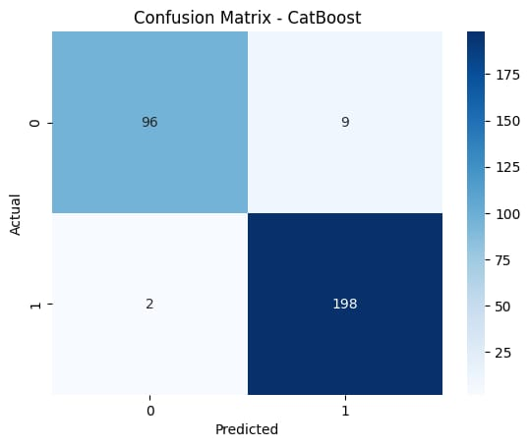
Fig 5.1: Confusion Matrix of CatBoost
The confusion matrix values are interpreted as follows:
- True Negatives (TN): 96 correctly predicted, Not Alert students.
- False Positives (FP): 9 predicted Very Alert when actually Not Alert (Type I error).
- False Negatives (FN): 2 predicted Not Alert when actually Very Alert (Type II error).
- True Positives (TP): 198 correctly predicted Very Alert students.

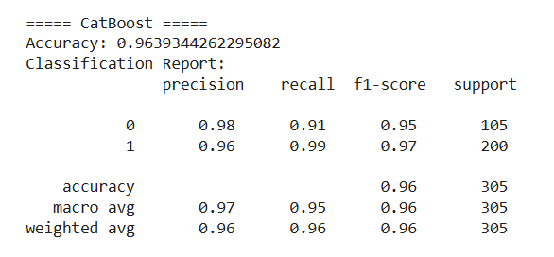

Fig 5.2: Classification Report of CatBoost

The classification report shows that the CatBoost model performs very well in predicting both classes. For Not Alert students (Class 0), precision is 0.98, recall is 0.91, and F1-score is 0.95, indicating that most predictions are correct, but a few students were missed. For Very Alert students (Class 1), precision is 0.96, recall is 0.99, and F1-score is 0.97, showing that almost all very alert students were correctly identified. The overall accuracy of the model is 96%, and both macro and weighted averages of the metrics are above 0.95, demonstrating strong and balanced predictive performance across both classes.

5.1.2 Random Forest
Using the Random Forest model, we evaluated the predictability of morning class attentiveness. The model achieved an overall accuracy of 91.1%, showing strong performance, though slightly lower than the best-performing CatBoost model.
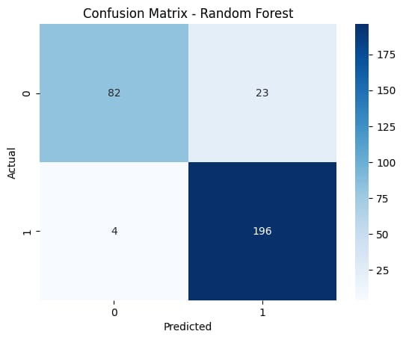
Fig 5.3: Confusion Matrix of Random Forest

The confusion matrix values are interpreted as follows:
- True Negatives (TN): 82 correctly predicted not alert students (Class 0).
- False Positives (FP): 23 predicted very alert when actually not alert (Type I error)
- False Negatives (FN): 4 predicted not alert when actually very alert (Type II error).
- True Positives (TP): 196 correctly predicted very alert students (Class 1).

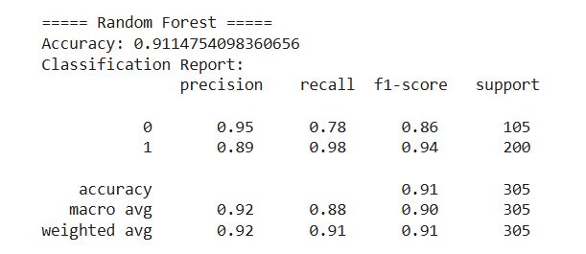
Fig 5.4: Classification Report of Random Forest

The classification report shows that Random Forest performs well in predicting both classes. For Not Alert students (Class 0), precision is 0.95, recall is 0.78, and F1-score is 0.86, indicating most predictions are correct, but some students were missed. For Very Alert students (Class 1), precision is 0.89, recall is 0.98, and F1-score is 0.94, showing the model accurately identifies almost all very alert students. The weighted average metrics and overall accuracy of 91% demonstrate strong predictive capability, although the model performs slightly better for the majority class (Very Alert).

5.1.3 XG Boost
Using the XGBoost model, we evaluated the predictability of morning class attentiveness. The model achieved an overall accuracy of 87.9%, demonstrating strong performance, though slightly lower than Random Forest and CatBoost models.
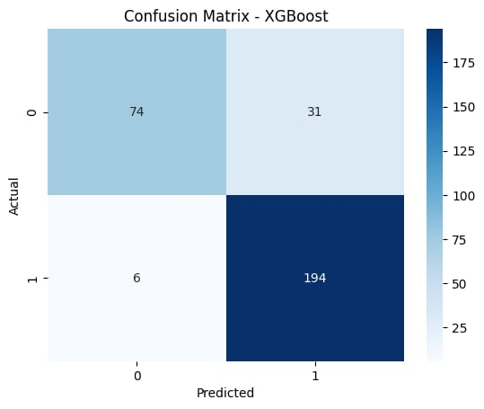
Fig 5.5: Confusion Matrix of XG Boost

The confusion matrix values are interpreted as follows:
- True Negatives (TN): 74 correctly predicted Not Alert students (Class 0).
- False Positives (FP): 31 predicted Very Alert when actually Not Alert (Class 0) (Type I error).
- False Negatives (FN): 6 predicted Not Alert when actually Very Alert (Class 1) (Type II error).
- True Positives (TP): 194 correctly predicted Very Alert students (Class 1).

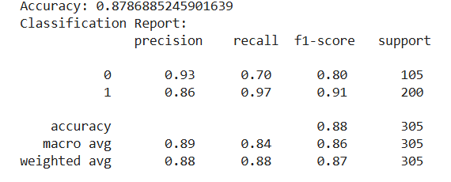
Fig 5.6: Classification Report of XG Boost

The classification report shows that XGBoost performs well in predicting both classes. For Not Alert students (Class 0), precision is 0.93, recall is 0.70, and F1-score is 0.80, indicating that while most predictions were correct, a significant number of Not Alert students were misclassified. For Very Alert students (Class 1), precision is 0.86, recall is 0.97, and F1-score is 0.91, showing that almost all Very Alert students were correctly identified. The overall accuracy of 87.9% and weighted average metrics indicate strong performance, though slightly lower than Random Forest and CatBoost.

5.1.4 Gradient Boosting
Using the Gradient Boosting model, we evaluated the predictability of morning class attentiveness. The model achieved an overall accuracy of 82.3%, showing decent performance, but lower accuracy compared to XGBoost, Random Forest, and CatBoost.
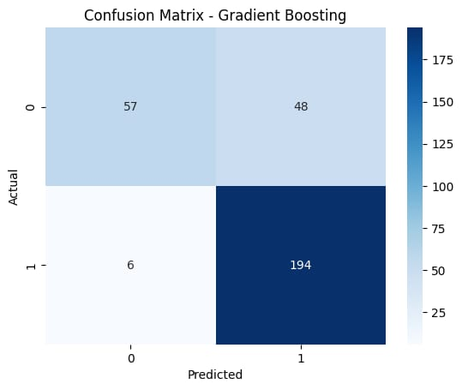
Fig 5.7: Confusion Matrix of Gradient Boosting

The confusion matrix values are interpreted as follows:
- True Negatives (TN): 57 correctly predicted Not Alert students (Class 0).
- False Positives (FP): 48 predicted Very Alert when actually Not Alert (Class 0) (Type I error).
- False Negatives (FN): 6 predicted Not Alert when actually Very Alert (Class 1) (Type II error).
- True Positives (TP): 194 correctly predicted Very Alert students (Class 1).
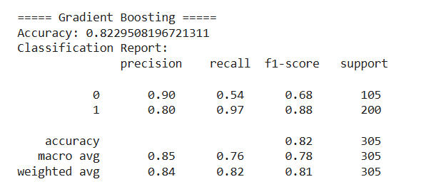
Fig 5.8: Classification Report of Gradient Boosting

The classification report indicates that the Gradient Boosting model performs well overall, but with noticeable class imbalance. For Not Alert students (Class 0), the precision is 0.90, the recall is 0.54, and the F1-score is 0.68, meaning that while most predictions were correct when classifying Not Alert students, the model missed a considerable portion of them. For Very Alert students (Class 1), the precision is 0.80, the recall is 0.97, and the F1-score is 0.88, showing strong identification of Very Alert students with only a few missed cases. The overall accuracy of 82.3% and the weighted average F1-score of 0.81 indicate good but not optimal performance.

5.1.5 Logistic Regression
Using the Logistic Regression model, we evaluated the predictability of morning class attentiveness. The model achieved an overall accuracy of 72.5%, which is lower than the performance of tree-based ensemble models such as Random Forest, XGBoost, and CatBoost.
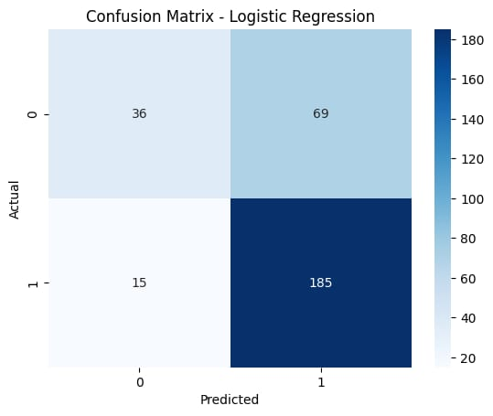
Fig 5.9: Confusion Matrix of Logistic Regression

The confusion matrix values are interpreted as follows:
- True Negatives (TN): 36 correctly predicted Not Alert students (Class 0).
- False Positives (FP): 69 predicted Very Alert when actually Not Alert (Class 0) (Type I error).
- False Negatives (FN): 15 predicted Not Alert when actually Very Alert (Class 1) (Type II error).
- True Positives (TP): 185 correctly predicted Very Alert students (Class 1).

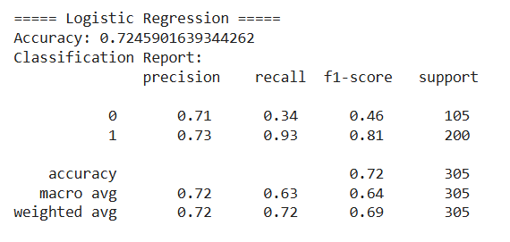
Fig 5.10: Classification Report of Logistic Regression

The classification report shows that Logistic Regression performs reasonably well, but with class imbalance. For Not Alert students (Class 0), precision is 0.71, recall is 0.34, and F1-score is 0.46, indicating weaker detection of this class. For Very Alert students (Class 1), precision is 0.73, recall is 0.93, and F1-score is 0.81, showing that the model is much better at identifying Very Alert students. The macro-average F1-score of 0.64 and overall accuracy of 72.5% indicate fair performance, but lower generalization capability compared to ensemble models.

5.2 Comparative Analysis of Results
This section presents a comparative analysis of the machine learning models used to predict morning class attentiveness among students. Five models, Logistic Regression, Random Forest, Gradient Boosting, XGBoost, and CatBoost, were evaluated based on accuracy, precision, recall, and F1-score. The results demonstrate that ensemble models outperform traditional approaches, indicating their effectiveness in capturing complex relationships between sleep habits and attentiveness.
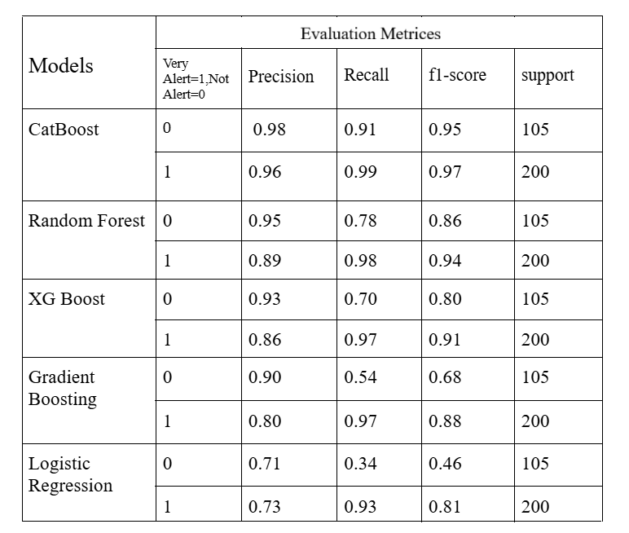
Fig 5.1: Model Performance Comparison
Table 5.1 presents a comparison of the performance metrics for all five machine learning models used to predict morning class attentiveness. The table shows that CatBoost achieved the highest accuracy of 96.4%, followed by Random Forest (91.1%) and XGBoost (87.9%). Gradient Boosting recorded a moderate accuracy of 82.3%, while Logistic Regression had the lowest accuracy at 72.5%.
This comparison highlights that ensemble models outperform traditional linear models in handling the complex and nonlinear relationships present in the dataset.

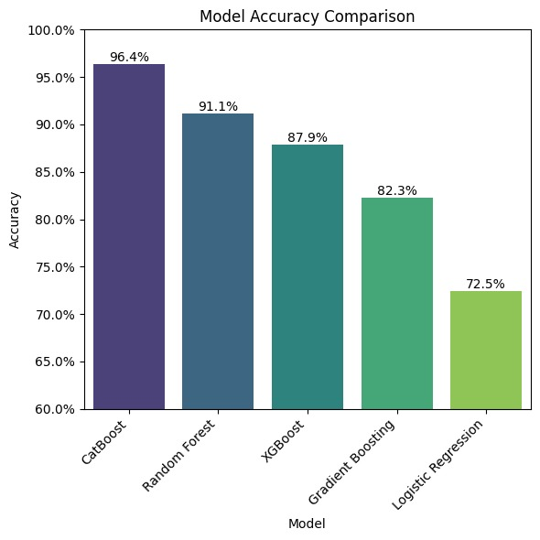
Fig 5.11: Model Accuracy Comparison

5.2 Comparison with Existing Works
Several recent studies have explored the prediction of student attentiveness and academic performance using diverse datasets and machine learning models. Al-Mamun et al. (2024) used CatBoost and other algorithms to classify insomnia status from university student survey data, achieving up to 73.46% accuracy but facing notable limitations due to behavioral complexity and regional differences. Agyemang et al. (2025) applied Random Forest, Logistic Regression, SVM, Decision Tree, and KNN to a comprehensive educational dataset, with Random Forest reaching 85.42% accuracy for academic outcome prediction.
In comparison, our study leveraged an enriched dataset that incorporated demographic and behavioral variables such as sleep consistency, nap duration, device use, skipped classes, and negative sleep habits to predict morning class attentiveness. Multiple machine learning algorithms were evaluated, among which CatBoost delivered the highest performance, achieving 96% accuracy. This surpasses the best results of previous studies, demonstrating advanced robustness, scalability, and strong generalization for predicting student productivity using behavioral and sleep features.
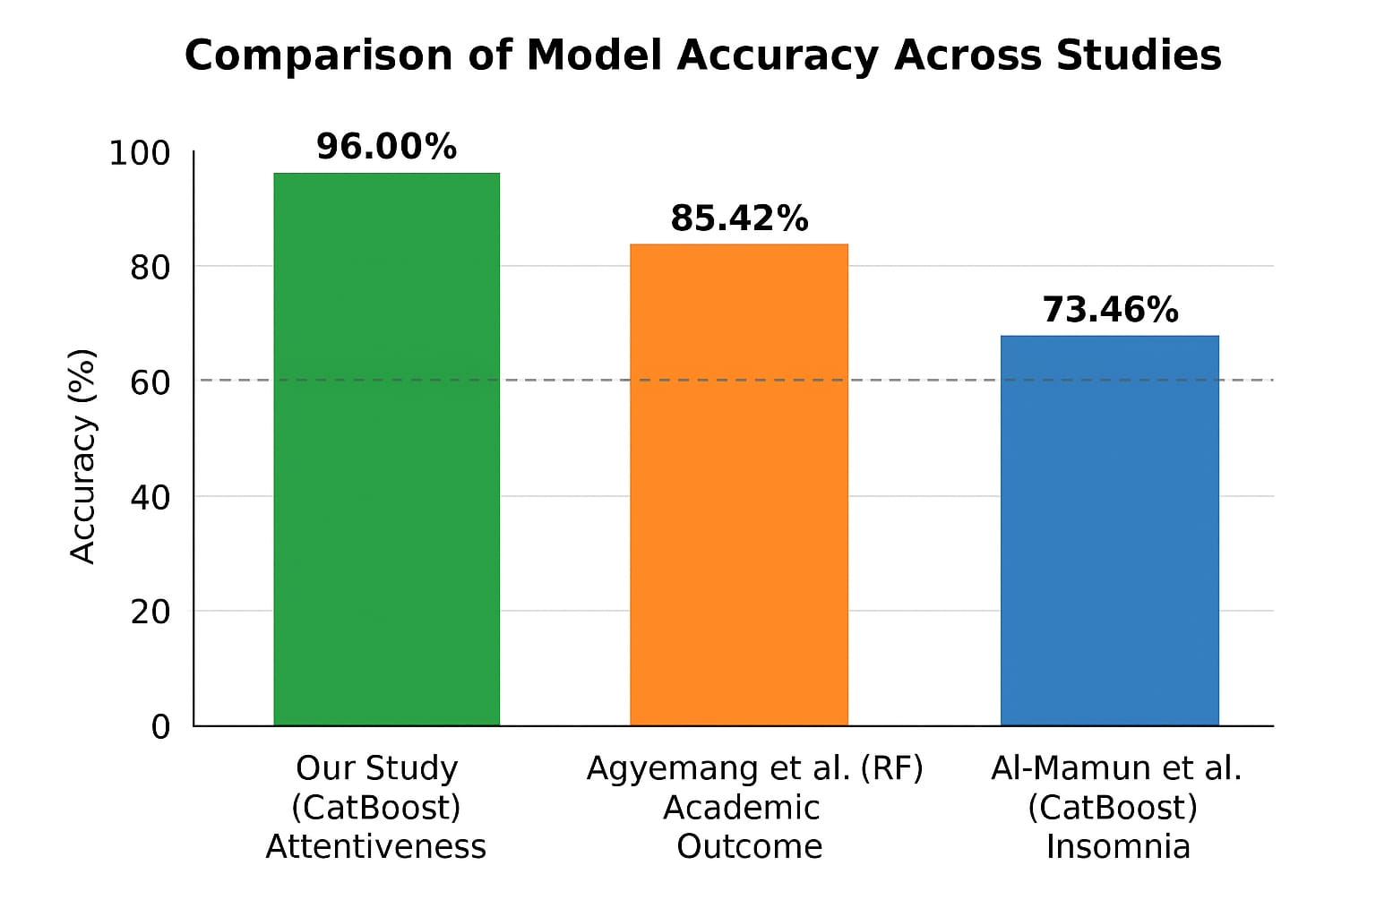
Fig 5.12: Comparison of Model Accuracy Across Studies

Chapter 6: Conclusion
This study investigated the impact of sleep habits on university students’ morning class attentiveness and overall academic productivity. Using data collected from a structured survey, several machine learning models—including Logistic Regression, Random Forest, Gradient Boosting, XGBoost, and CatBoost—were applied to predict attentiveness based on behavioral and demographic features. The analysis revealed that factors such as sleep consistency, weekend sleep duration, and device usage before bedtime play a significant role in influencing students’ alertness and engagement during morning lectures. The results demonstrate that machine learning can effectively identify patterns in sleep behavior that correlate with academic performance, providing valuable insights into how lifestyle choices affect productivity. Overall, the study emphasizes the importance of promoting healthy sleep routines among students and highlights the potential of data-driven approaches to guide interventions aimed at improving academic outcomes and personal well-being.

6.1 Restrictions
- Focused solely on morning class attentiveness; other productivity aspects were not analyzed.
- Dependent on survey responses, real-time or objective sleep tracking data were not used.
- The study is constrained by the available dataset features and the selected ML models.
- Findings are specific to the survey population and may not directly apply to other contexts.

6.2 Limitations
- Data were collected through self-reported surveys, which may include biases or inaccuracies.
- The study sample was limited to a specific university or demographic, which may reduce generalizability.
- Only selected sleep-related and behavioral features were considered; other factors may influence productivity.
- ML models identify patterns and correlations but cannot establish causal relationships.

6.3 Future Work
- Expand the study to multiple universities or larger populations for better generalization.
- Incorporate additional factors such as stress levels, diet, and physical activity to capture a more comprehensive view.
- Utilize real-time sleep tracking data (e.g., wearables) to improve prediction accuracy.
- Develop recommendation systems to provide students with actionable guidance on improving sleep habits and productivity.
- Explore advanced ML techniques or ensemble models to enhance predictive performance.

References
- Al-Mamun, F., Mamun, M. A., Hasan, M. E., Almerab, M. M., & Gozal, D. (2024). Exploring sleep duration and insomnia among prospective university students: A study with geographical data and machine learning techniques. Nature and Science of Sleep, 16, 1235–1251. https://doi.org/10.2147/NSS.S481786
- Agyemang, E. F., Mensah, J., Ampomah, O., Agyekum, L., Akuoko-Frimpong, J., Quansah, A., Akinlosotu, O. M., & Agyemang, E. F. (2024). Predicting students' academic performance via machine learning algorithms: An empirical review and practical application. Computer Engineering and Intelligent Systems, 15(1), 86–102. https://doi.org/10.7176/CEIS/15-1-09
- Rajendran, S., Chamundeswari, S., & Sinha, A. A. (2022). Predicting the academic performance of middle- and high-school students using machine learning algorithms. Social Sciences & Humanities Open, 6(1), 100357. https://doi.org/10.1016/j.ssaho.2022.100357
- Wara, T. U., Fahad, A. H., Das, A. S., & Shawon, M. M. H. (2025). A systematic review on sleep stage classification and sleep disorder detection using artificial intelligence. Heliyon, 11(12), e43576. https://doi.org/10.1016/j.heliyon.2025.e43576
- Mo, L. (2024). Research on sleep health prediction and algorithms based on big data. Proceedings of the 2023 International Conference on Data Science, Advanced Algorithm and Intelligent Computing (DAI 2023), 55–66. Atlantis Press. https://doi.org/10.2991/978-94-6463-370-2_7

- Sathish, V. R., Woo, W. L., & Ho, E. S. L. (2023). Predicting sleeping quality using convolutional neural networks. In Advances in Cybersecurity, Cybercrimes, and Smart Emerging Technologies (pp. 175–184). Springer. https://doi.org/10.1007/978-3-031-21101-0_14
- Han, J. M., Estrella Guillén, E., Liu, S., Chen, Y., & Samuelson, H. W. (2025). Using explainable artificial intelligence to predict sleep interruptions from indoor environmental conditions: An empirical study. Building Research & Information, 53(5), 636–655. https://doi.org/10.1080/09613218.2025.2482959
- Göktepe-Kavis, P., Aellen, F. M., Alnes, S. L., & Tzovara, A. (2024). Sleep research in the era of AI. Clinical and Translational Neuroscience, 8(1), 13. https://doi.org/10.3390/ctn8010013
- Phalke, A., & Kadam, P. (2025). Analysing the impact of irregular sleep patterns on academic performance using machine learning. The Voice of Creative Research, 7(2), 224–228. https://doi.org/10.53032/tvcr/2025.v7n2.29
- Djanian, S., Bruun, A., & Nielsen, T. D. (2022). Sleep classification using consumer sleep technologies and AI: A review of the current landscape. Sleep Medicine, 100, 390-403. https://doi.org/10.1016/j.sleep.2022.09.004
- Halim, L. B., Sabha, S., Tabassum, M., & Oishee, H. Z. (2022). Impact of better sleep on academic grades: A study on the students of University of Dhaka. University of Dhaka.
- Aljasem, A. A., Alsahafi, W. M., Aljubour, A. A., Alobaid, A. A., Binsaeed, A. A., Alshamoosi, M. S., Alsadoon, R. A., Alasmari, Y. A., & Khalifa, A. F. M. (2020). Sleep patterns and dozing chance among university students. Journal of Family Medicine and Primary Care, 9(12), 6249–6253. https://doi.org/10.4103/jfmpc.jfmpc_941_20

