ITECH5207 – The Data-Driven Professional
Sprint 3 Decision Pack Submission
BlueCart Retail – Data-Driven Analytics & Decision Support
Team Information | Response
Team Name | FedUni Innovators
Deliverable | Decision Pack – One-page executive slide
Deliverable name | DataDriven_FedUniInnovators_Sprint3.ppt
Submission date | 5 October 2026
Project | BlueCart Retail

Executive Summary
Our one-page Decision Pack turns BlueCart's separated transaction, customer, marketing, and inventory records into a short management story: the cleaned source supports $30,544.54 in observed positive sales, Washington is the largest named-state revenue market ($8,354.91), customer groups offer testable retention opportunities, and inventory records identify 21 zero-stock and 15 positive low-stock items. Statistical comparisons do not support claims that state mean transaction values differ or that repeat customers have higher average transaction value. The current regression models have negative test R², so we recommend descriptive monitoring and human-reviewed rules while improving data completeness and product/campaign linkage.

Task 1: Analytical Design Implementation

1.1 Tools Used
We used Python in the existing Streamlit application. pandas standardises and aggregates the cleaned workbook; SciPy computes the one-way ANOVA and Welch t-test; scikit-learn evaluates regression baselines; Plotly supplies interactive charts; and Streamlit provides pages, filters, tables, downloads, and decision-rule views. The existing Excel workbook remains the governed reporting source because it includes cleaned tables, a data dictionary, and a cleaning summary. We did not combine the inconsistent alternate raw CSV with it.

1.2 Dashboard or Visual Components
The dashboard has five pages: Executive Overview; Customer Behaviour & Segmentation; Revenue Patterns & Trends; Marketing & Inventory Intelligence; and Decision Support. It includes KPI cards, monthly revenue and dated-order trends, a ranked state revenue bar chart, customer frequency-versus-revenue scatterplot, customer recency distribution, campaign CTR/reach summaries, inventory stock distribution, model diagnostics, decision tables, and downloadable masked customer features. Hover details and exact-value tables supplement the charts.
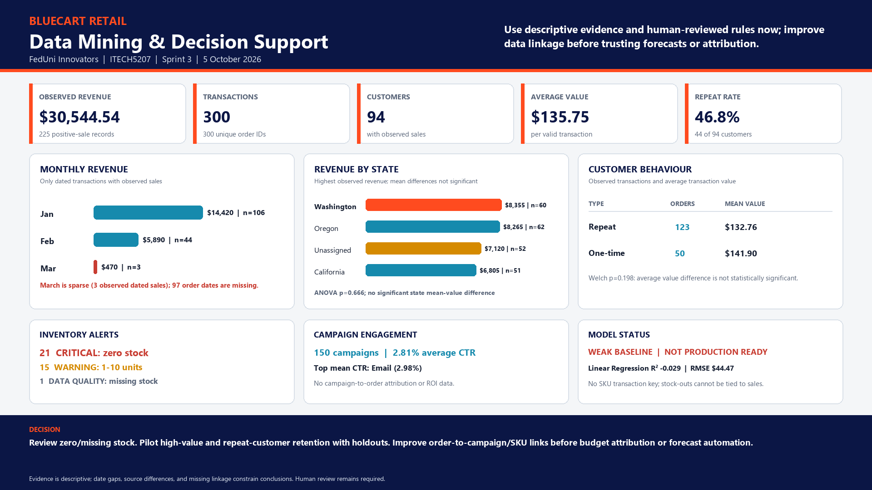
Figure 1. BlueCart Retail executive Decision Pack visual generated from the validated cleaned workbook.

Task 2: Data Narrative & Storytelling

2.1 Business Question & Analysis Flow
Business question: Where should BlueCart focus revenue review, customer retention, campaign testing, and replenishment attention? We standardised dates, numeric measures, identifiers, state names, and channel labels; validated a many-to-one transaction-to-customer join on masked Customer_ID; and kept marketing and inventory separate because no reliable Campaign_ID or SKU relationship exists in transactions. We then profiled sales by state and month, compared observed customer purchase groups, calculated quartile-based customer features, reviewed CTR and stock distributions, and evaluated baseline regressors.

2.2 Narrative Summary
The cleaned workbook contains 300 unique order IDs and 225 positive observed sales transactions. Revenue leads differ by named state, with Washington highest, but ANOVA p=0.666 does not show significant differences in mean transaction value across California, Oregon, and Washington. Repeat customers account for 123 observed transactions versus 50 one-time transactions, but the average transaction-value difference is not significant (Welch p=0.198). Dated revenue is $14,419.78 in January, $5,889.90 in February, and $470.00 in March; March has only 3 dated sales and 97 order dates are missing. We therefore recommend focused stock and data-quality review, controlled retention tests, and better transaction linkage before ROI claims or forecast automation.

Task 3: Visual Design & Clarity

3.1 Design Rationale
The visual hierarchy places five business KPIs first, followed by a small row of operating signals and concise findings. Navy anchors the BlueCart brand; orange marks priority and alert emphasis; blue supports comparative data; red and amber are reserved for critical and warning statuses. Horizontal bars make state and category comparisons easy to rank, line charts preserve monthly order, and scatter/histogram views support relationship and distribution questions. Labels and exact-value tables accompany colour, supporting readers who cannot rely on colour alone. Detailed methods and professional-practice content sit in supporting dashboard sections rather than crowding the executive view.

3.2 Key Metrics Highlighted
- Revenue: $30,544.54 from 225 valid positive-sale transactions; 75 source nonpositive transactions (36 negative, 39 zero) were excluded in Sprint 1 cleaning.
- Transactions: 300 unique order IDs; 300 total rows, including rows with missing sales.
- Customers: 94 customers with observed valid sales; repeat purchase rate 46.8% (44 repeat of 94). A further 16 identified IDs have no valid sales.
- Average transaction value: $135.75. Median is $120.00; observed valid range is $85.00–$200.00.
- State revenue: Washington $8,354.91, Oregon $8,264.87, California $6,804.89; Unassigned contributes $7,119.87.
- Inventory: 21 zero stock, 15 positive stock at 10 or fewer units, 1 missing stock; 36 records are at or below 10 including zero.
- Marketing: 150 campaigns, mean CTR 2.81%; Email has the highest mean channel CTR at 2.98%.
- Model: Linear Regression current replay test R² -0.029; baseline status is weak, not production-ready.

Task 4: Decision-Support Recommendations

4.1 Recommendations or Rules
Rule | Condition / status | Action
High value | Customer observed revenue > P75 ($303.74); 24 customers qualify. | Pilot personalised retention; assess incremental margin against a holdout.
Repeat purchase | More than one observed positive-sale transaction. | Test loyalty activity; do not assume higher average transaction value.
Recency | 97 transaction dates are missing and the observation period is short. | Do not assign an at-risk/churn status; improve dates and history first.
Critical stock | Stock = 0; 21 records. | Verify on-hand stock and trigger replenishment investigation.
Low stock | 0 < Stock <= 10; 15 records. | Review reorder need against demand velocity and lead time.
Missing stock | Stock is null; 1 record. | Validate and complete before availability decisions.
Priority market | Named-state revenue above median; Washington currently leads at $8,354.91. | Review service capacity; state mean differences are not significant (ANOVA p = 0.666).
Low engagement | Mean CTR below channel median: Google Ads, YouTube Campaign. | Review creative/audience; validate conversion and cost before shifting spend.
Weak model | Linear Regression test R² = -0.029. | Keep advisory only; improve data and validation before forecasting use.

Task 5: Exploration of Alternatives

5.1 Alternative Methods or Visuals Suggested
Method / visual | Advantage | Limitation in this project
Linear Regression (tested) | Simple, interpretable baseline. | Current test RMSE $44.47, R² -0.029; weak generalisation.
Decision Tree (tested) | Can capture nonlinear splits. | Current test RMSE $51.11, R² -0.360; train/test gap indicates overfit risk.
Random Forest (tested) | Ensemble can capture nonlinear patterns. | Current test RMSE $45.57, R² -0.081; still weak on holdout.
Gradient Boosting (future) | Potentially models complex interactions. | Not tested; more data and time-aware/cross-validation checks are needed.
RFM (implemented cautiously) | Transparent recency, frequency, monetary customer views. | Short date range and 97 missing dates make at-risk/churn use unreliable.
K-Means (not applied) | Can discover groups without predefined labels. | Requires scaled stable numeric inputs, enough customers, and cluster validation.
Heatmap (alternative) | Can scan state/channel/month patterns compactly. | Only three sparse months; could imply structure unsupported by current coverage.
Bar, line, scatter (used) | Bars rank categories; lines show time; scatter explores frequency/revenue. | Each remains descriptive and does not establish causality.

5.2 Rationale for Alternatives
Linear Regression is retained as the simplest reference model; alternatives are shown to compare generalisation rather than select by training fit. In this replay, Linear Regression has lower test RMSE than Decision Tree and Random Forest, while all test R² values are negative. More complex models should wait for additional observations and reliable product, campaign, and customer-history features. RFM is more explainable for current customer prioritisation than an unvalidated clustering result. A heatmap may become useful when more complete periods and reliable cross-table keys are collected.

Task 6: Evaluation & Justification of Chosen Design

6.1 Chosen Tools and Techniques
We kept the existing Python/Streamlit framework, pandas preparation, SciPy statistical tests, scikit-learn models, and Plotly visuals because they fit the available structured tables and support reproducible, interactive analysis without introducing a new platform. A validated many-to-one customer join preserves transaction cardinality; campaign and inventory remain separate. Bar charts support state/channel ranking, lines represent dated-month changes, and scatter/distribution plots expose customer patterns without claiming causality.
The supplied Sprint 2 report recorded Linear Regression test MAE $38.99, RMSE $44.34, R² -0.024; Decision Tree test MAE $39.62, RMSE $45.91, R² -0.097. Re-running the fixed 80/20 split (random seed 42) on the current cleaned workbook gives Linear Regression MAE $39.22, RMSE $44.47, R² -0.029; Decision Tree MAE $41.03, RMSE $51.11, R² -0.360. Both records are shown distinctly because replay values differ slightly.

6.2 Audience Alignment
Managers see the core measures, current alerts, and immediate actions first; analysts can inspect thresholds, test statistics, data-quality counts, model alternatives, and the data dictionary. Jargon is paired with plain-language meaning (for example, a negative R² is described as weak out-of-sample performance). Filters support state, date, customer type/segment, and marketing channel views; test comparisons retain both customer groups within the selected state/date scope so they remain interpretable.

Task 7: Ethical, Privacy & Bias Considerations

7.1 Ethical and Privacy Issues
Customer names and emails are sensitive and are not displayed or used as predictive features. Customer analysis uses masked IDs and aggregated measures. Deontology guided our duty to minimise personal-data exposure and report limitations honestly. Utilitarian reasoning supports controlled tests and human-reviewed alerts that seek business and customer benefit while limiting harm from poor forecasts or inappropriate targeting. Virtue ethics requires honesty, fairness, care, competence, and transparency in communicating uncertain evidence.

7.2 Bias Mitigation
Potential bias comes from missing customer IDs and dates, excluded nonpositive sales, 52 observed transactions with Unassigned state, uneven state counts, missing campaign measures, one missing inventory stock value, and only a short 2025 Q1 window. We report missingness and source conflicts, use transparent percentile/stock thresholds, avoid sensitive-trait inference, do not claim causation, and require human review. Customer segments without observed revenue remain insufficient-data rather than being assigned a value.

7.3 ACS Code of Professional Conduct and Professional Responsibilities
Primacy of the Public Interest: privacy and fair treatment constrain commercial targeting; access to identifiable records should be limited to authorised custodians. Honesty: report the nonsignificant tests, conflicting alternate CSV, missingness, and weak test R² without exaggerating conclusions. Competence: validate joins, calculations, and holdout performance before recommending actions. Professionalism: document assumptions and changes, escalate data defects, and ensure a person reviews alerts. Before implementation, BlueCart should ask its privacy/legal owner to confirm applicable Privacy Act 1988 and Australian Privacy Principles obligations, consent/retention rules, and access controls.

7.4 Governance, Policy and Accountability Considerations
Proposed accountable roles (to be assigned by BlueCart) are Retail Operations for sales definitions, CRM/customer-data stewardship for customer identifiers and consent, Marketing for campaign metadata, Inventory Control for stock/SKU records, and Analytics for transformations, model versions, and dashboard releases. Apply role-based access to identifiable data; scheduled checks for missingness, invalid values, duplicates, date validity, and identifier consistency; versioned datasets/models/rules; recorded assumptions and performance; drift/revalidation reviews; and auditable alert reason codes. Management remains responsible for decisions made from the dashboard. Log dataset, dashboard, model, and threshold changes with owner, date, rationale, and approval.

Task 8: Actionable Recommendations

8.1 Recommendations Summary
- Pilot retention/personalised offers for the 24 customers above revenue P75 ($303.74); measure incremental margin and retention with a holdout. Potential impact is retention improvement, not a guaranteed uplift; monitor over-targeting and segmentation error.
- Test repeat-customer loyalty activity because repeat buyers account for 123 observed transactions; mean transaction value is not significantly different (p=0.198). Judge on incremental repeat purchases and margin, not assumed higher spend.
- Review fulfilment and service capacity in Washington, the leading named state, without claiming statistical superiority (ANOVA p=0.666).
- Investigate 21 zero-stock SKUs, review 15 positive low-stock SKUs, and complete 1 missing stock record. No lost sales can be assigned without SKU-linked orders.
- Capture Campaign_ID, acquisition source, spend, and conversions on orders. Current mean CTR is 2.81% and Email leads at 2.98%; CTR alone is not ROI.
- Keep prediction advisory: current Linear Regression R² is -0.029; improve data linkage and feature coverage, then validate with time-aware and repeated cross-validation before production use.

8.2 Risks and Future Considerations
Technical risks include inconsistent alternate source data, missing dates, limited sample size, weak model generalisation, and absent SKU/campaign joins. Organisational risks include unclear data ownership, staff acting on alerts without context, and pressure to overinterpret revenue rankings. Ethical/privacy risks include over-targeting, exposing identifiers, or disadvantaging groups represented less completely. Regulatory obligations and retention/consent rules require review by the responsible privacy/legal owner. Societal risk includes automated decisions reinforcing historic coverage gaps; no decision should be automated until subgroup effects and human appeal/review are defined. Collect complete Order_Date and Customer_ID, SKU/Product_ID, category, quantity, unit price, discount, inventory movements/lead time, customer tenure/consent, and order-level Campaign_ID/acquisition source with cost/conversion data.

Appendices

Appendix A: Decision Pack Screenshot or Slide Image
The following one-page executive visual is generated directly from the validated Sprint 1 cleaned workbook and current Sprint 3 calculations.
Appendix A. Executive Decision Pack visual; open the PNG at full size for presentation use.

Appendix B: Analytical Tools Used
- Source of record: Sprint1_Cleaned_Pack.xlsx (Summary, Transactions_Clean, Customers_Clean, Marketing_Clean, Inventory_Clean, Analysis_Join, Data_Dictionary). BlueCart_DataVault_Sprint1_Dataset (1).xlsx was used to validate cleaning reconciliation.
- Python 3.13; pandas; NumPy; SciPy; scikit-learn; Plotly; Streamlit; python-docx; Pillow.
- Analytical code: sprint3_analytics.py (standardisation, validated joins, RFM features, statistical tests, source audit) and sprint3_dashboard.py (pages, visuals, model replay, decision rules).
- Dashboard entry point: app.py. Run with the workspace environment: .venv\Scripts\python.exe -m streamlit run app.py --server.port 8502.
- Rebuild this response document and slide image: .venv\Scripts\python.exe build_sprint3_submission.py.
- The expected PowerPoint filename is DataDriven_FedUniInnovators_Sprint3.ppt. This response file and Appendix A image support that deliverable; the image can be inserted into the executive slide.

Appendix C — Updated Six-Page Dashboard Design
The six dashboard pages below are added to the current Sprint 3 document as the updated visual design evidence. They align with the analytical narrative, decision rules, data-quality limitations, and responsible-analytics approach described in the report.

Figure A1. Executive Overview
Executive management view showing the core KPIs, revenue patterns, customer behaviour, inventory signals and key findings.
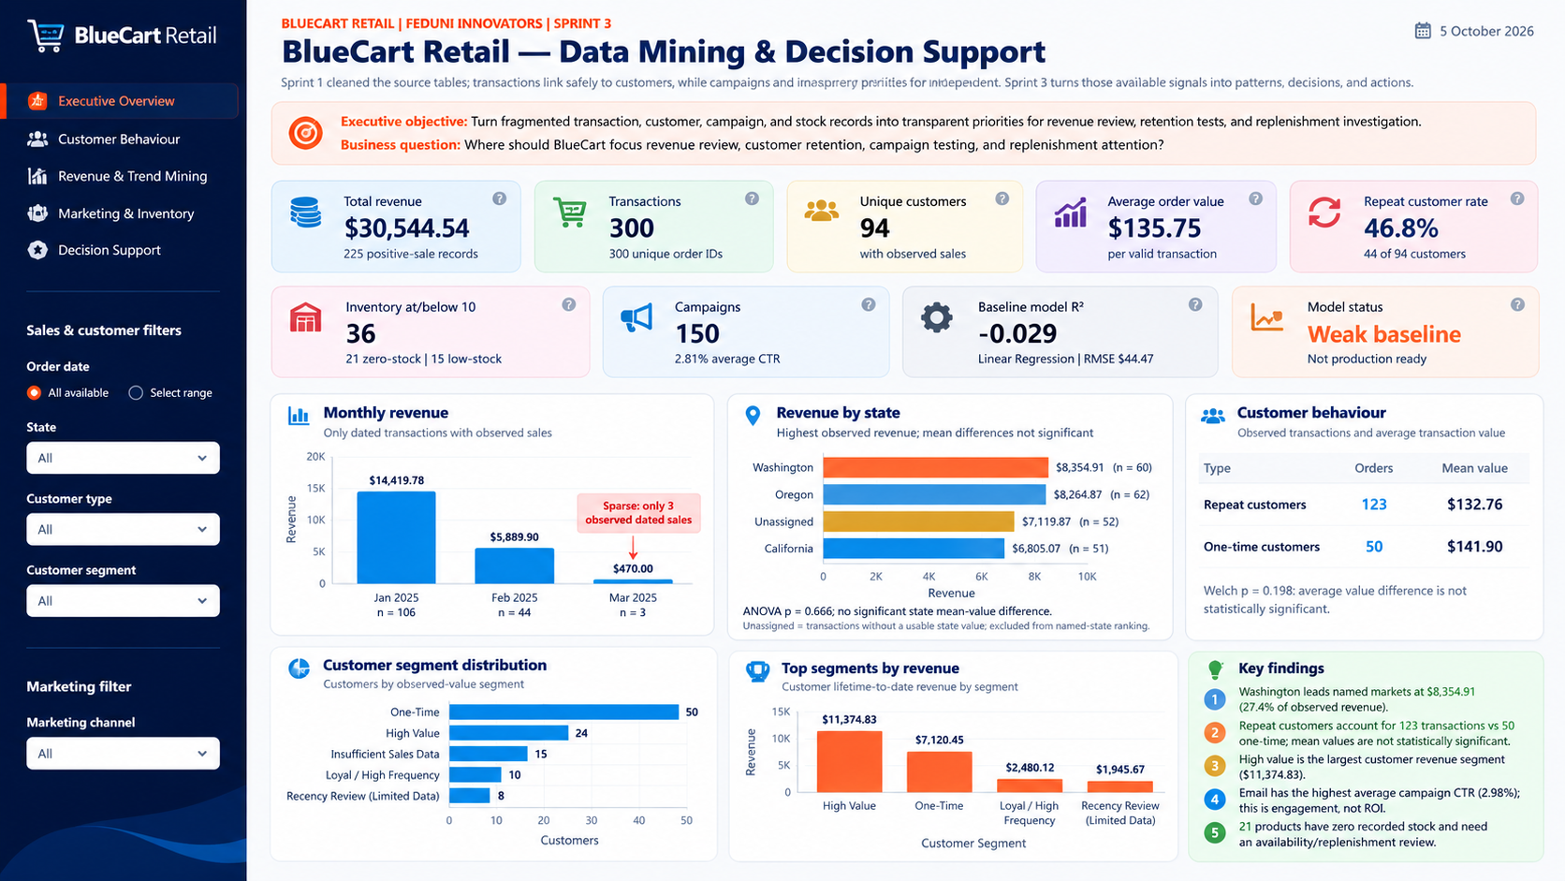
Figure A1. Executive Overview

Figure A2. Customer Behaviour & Segmentation
Customer behaviour view showing customer counts, observed revenue by segment, purchase frequency, recency and detailed customer/segment tables.
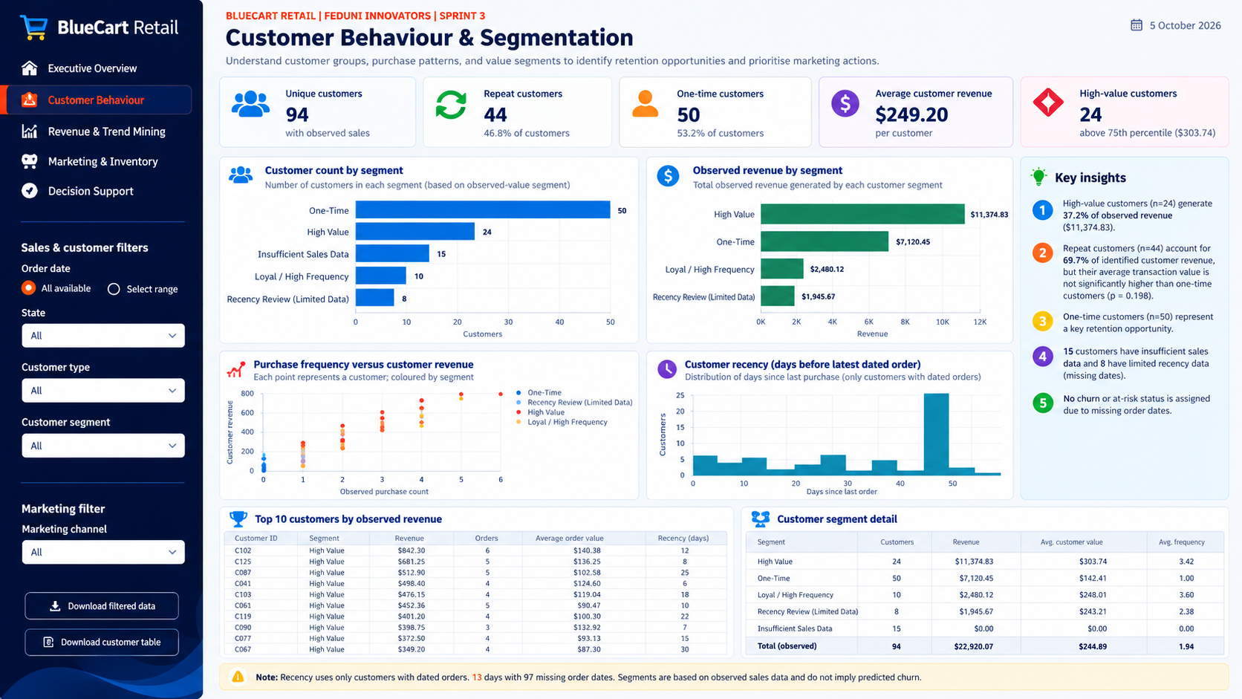
Figure A2. Customer Behaviour & Segmentation

Figure A3. Revenue Patterns & Trends
Revenue and trend view showing monthly observed revenue, state contribution, average order value and statistical interpretation.
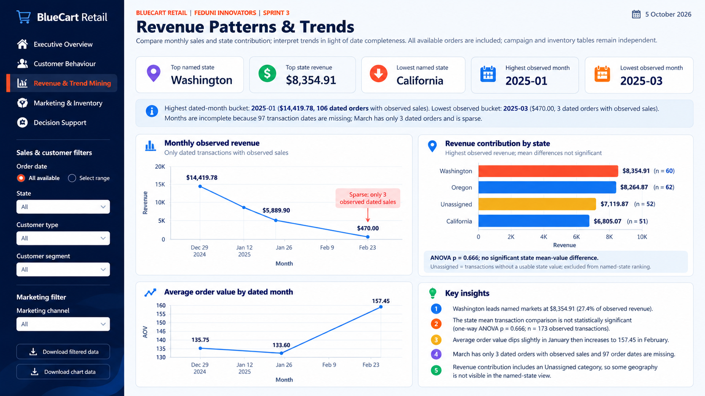
Figure A3. Revenue Patterns & Trends

Figure A4. Marketing & Inventory Intelligence
Marketing and inventory view showing campaign CTR by channel, campaign distribution, stock-level distribution and low/zero-stock priorities.
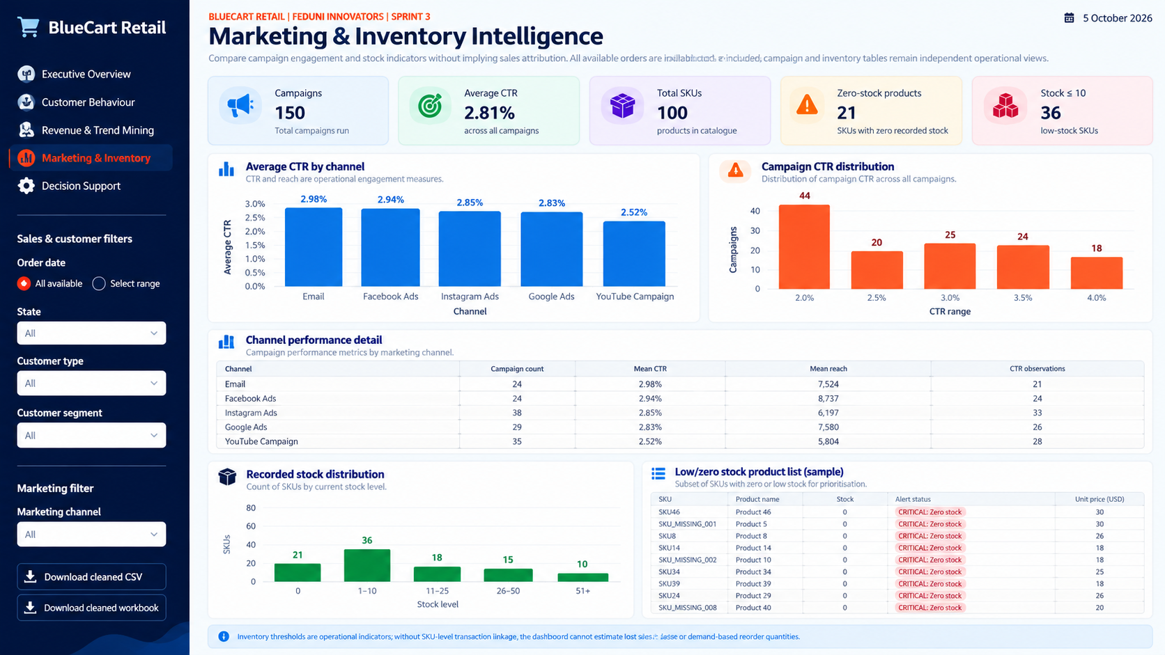
Figure A4. Marketing & Inventory Intelligence

Figure A5. Decision Support & Alerts
Decision-support view showing transparent rules, data-mining findings, data-quality limitations, inventory priorities and predictive-modelling context.
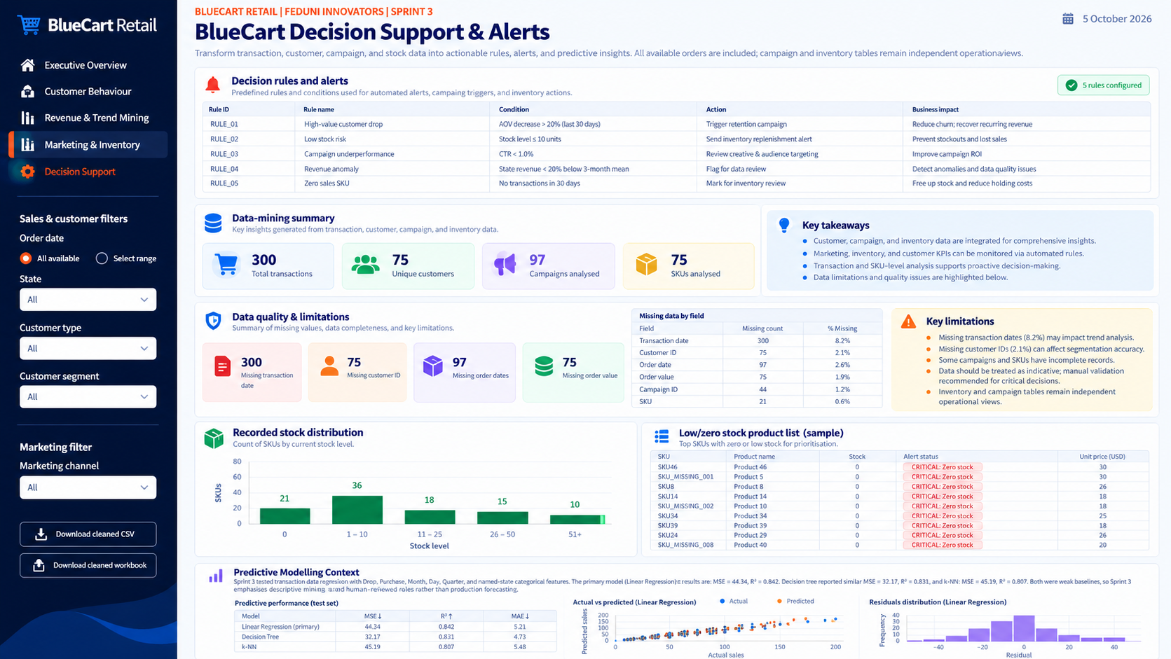
Figure A5. Decision Support & Alerts

Figure A6. Ethics, Governance & Responsible Analytics
Ethics and governance view showing privacy, fairness, bias, professional responsibilities, accountability and responsible decision-making.
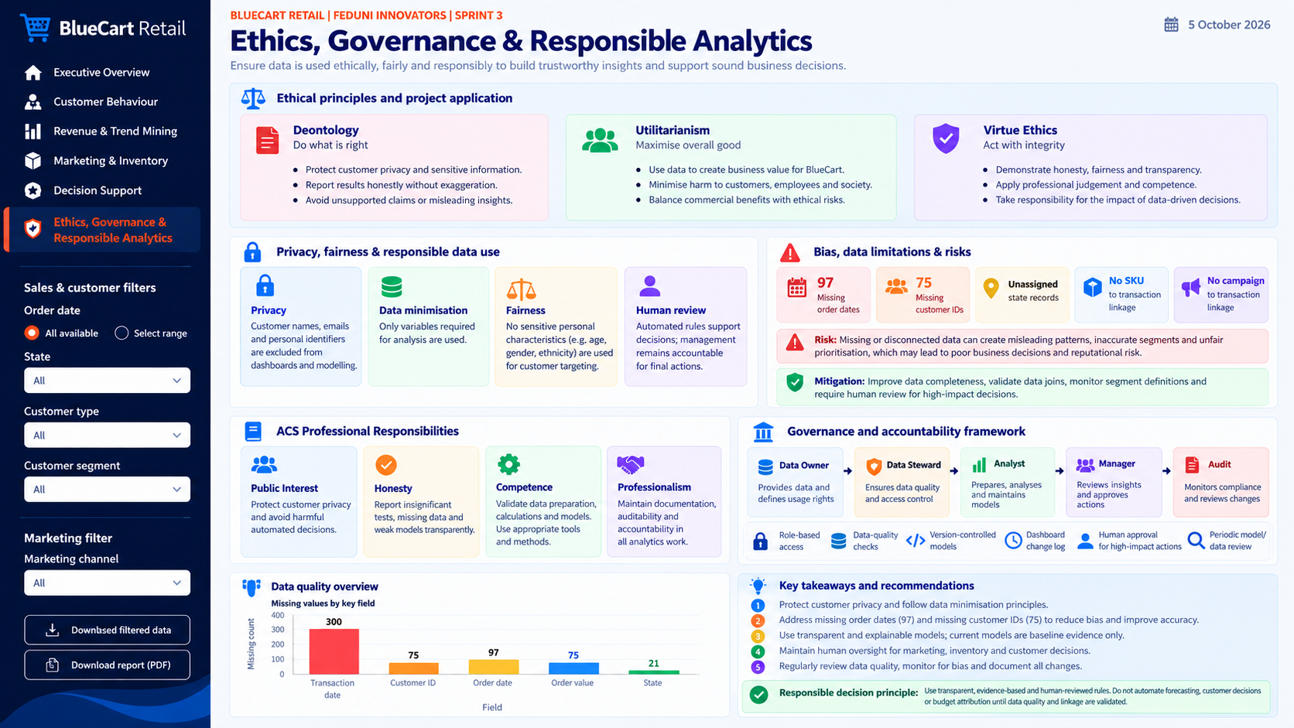
Figure A6. Ethics, Governance & Responsible Analytics

Appendix D — Updated Dashboard Page Index
Page | Dashboard | Purpose
1 | Executive Overview | Executive KPIs and priority findings.
2 | Customer Behaviour & Segmentation | Customer value, frequency, recency and segmentation.
3 | Revenue Patterns & Trends | Revenue timing, state contribution and AOV.
4 | Marketing & Inventory Intelligence | Campaign engagement and stock-risk monitoring.
5 | Decision Support & Alerts | Decision rules, alerts, limitations and model context.
6 | Ethics, Governance & Responsible Analytics | Privacy, bias, professional responsibility and governance.

