Report
Of
STUDENT FEEDBACK SENTIMENT ANALYSIS SYSTEM
Submitted
To
School of Computer Science and Engineering
IILM University, Greater Noida, U.P.
In partial fulfilment of the requirement of degree of
B.Tech CSE

By
Roll Number of Student: 2410030957
Name of Student: MD KAMRAN RAIS
Class / Section: 3CSE23
Batch: 2024-28

CANDIDATE'S DECLARATION
I, Md Kamran Rais, do hereby declare that the internship report titled “Student Feedback Sentiment Analysis System” has been completed by me to fulfil the requirement for the award of the degree of Bachelor of Technology in CSE. All the references have been quoted and I have not taken as such any material from any other source. I affirm to you that this report is my own and has not been submitted to any other institute for any degree/diploma requirement and further I shall be solely responsible for any kind of copyright violation in this regard.
Signature
Student Name: Md Kamran Rais
Roll No.: 2410030957

ACKNOWLEDGEMENT
I am using this opportunity to express my gratitude to everyone who supported me throughout the Internship Program. I am thankful for their aspiring guidance, invaluably constructive criticism and friendly advice during this work. I am sincerely grateful to them for sharing their truthful and illuminating views on a number of issues related to this work.
I express my gratitude to my parents for their blessings.
Signature
Student Name: Md Kamran Rais
Roll No.: 2410030957

TABLE OF CONTENTS
Chapter No. | Chapter Name | Page Nos.
 | Cover Page | ---
1. | Candidate's Declaration | i
2. | Acknowledgement | ii
3. | Internship Completion Certificate | iv
4. | Project Description  4.1 Introduction  4.2 Organization Profile  4.3 Problem Statement  4.4 Project Objectives  4.5 Scope of the Project  4.6 Technologies and Tools Used  4.7 System Architecture  4.8 Methodology  4.9 Expected Outcomes  4.10 Certificates of completion and other communication mail proof | 1  1  1  1  1  2  2  2  3  4  4
5. | Bibliography / References | 7

3. INTERNSHIP COMPLETION CERTIFICATE
The Codec Technologies Certificate of Internship awarded on successful completion of the 6-month Full Stack Developer Internship (02/10/2026 to 08/10/2026) is reproduced below.
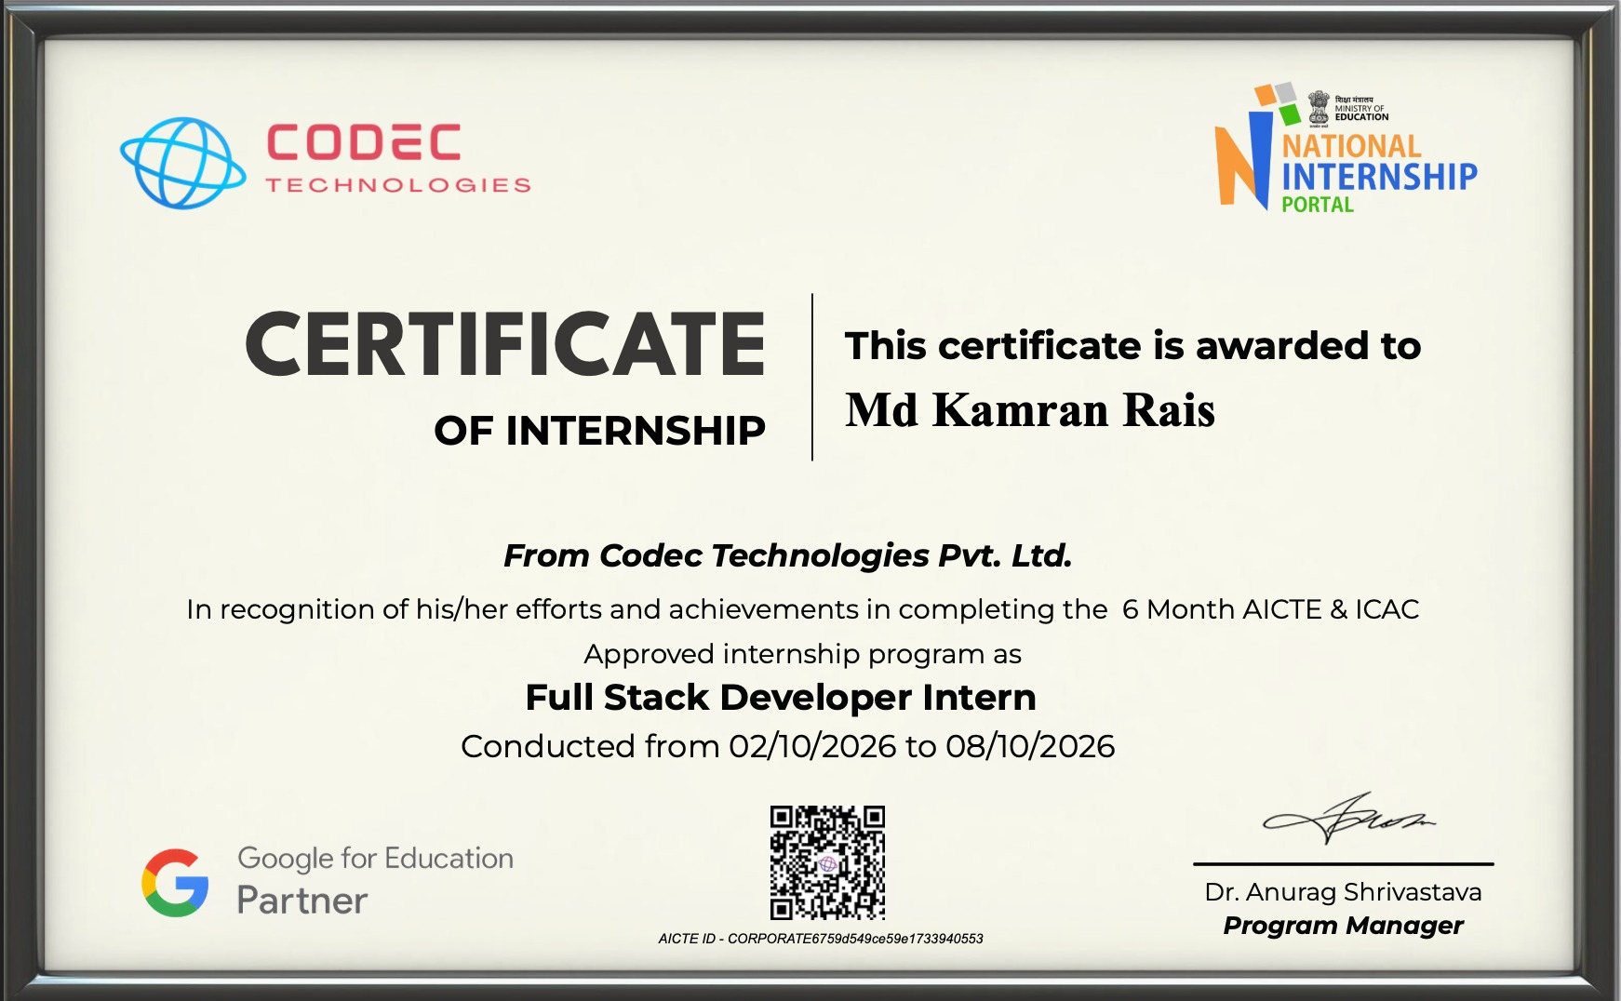
Fig. 3.1: Certificate of Internship issued by Codec Technologies

4. PROJECT DESCRIPTION

4.1 Introduction
Educational institutions regularly collect feedback from students to evaluate teaching quality, course content, and overall learning experience. Manually reading and interpreting large volumes of open-ended feedback is time-consuming and prone to inconsistent judgement. The Student Feedback Sentiment Analysis System was developed to address this problem — it allows a student to log in, submit feedback, and have the feedback automatically analyzed using Natural Language Processing (NLP) so that the results can be viewed on an analytics dashboard.
This project was undertaken as part of the Codec Technologies Full Stack Developer Internship (02/10/2026 to 08/10/2026), applying the full-stack development, database, and NLP concepts learned during the internship.

4.2 Organization Profile
This internship was conducted at Codec Technologies, a global platform dedicated to empowering learners and connecting diverse talent to create meaningful career opportunities worldwide. Codec Technologies delivers dedicated IT and business consultancy services across 27+ countries, empowering global innovation and strategic growth. It is an ISO 9001:2015 certified organization and a Google for Education Partner, and the internship was listed on the National Internship Portal, Ministry of Education, Government of India.

4.3 Problem Statement
Manual analysis of student feedback is slow, subjective, and does not scale well as the number of responses grows. Faculty and administrators often struggle to quickly identify overall sentiment trends or specific complaints buried within large volumes of free-text comments. There is a need for a system that can securely collect student feedback and automatically classify it as Positive, Negative, or Neutral, presenting the results in an easily interpretable form.

4.4 Project Objectives
- To design a secure login page through which only registered students can access the feedback form.
- To build a feedback submission module that captures both structured ratings and free-text comments.
- To apply sentiment analysis (NLP) techniques to automatically classify the textual feedback.
- To present the analyzed results on a dashboard using charts and summary statistics for quick interpretation by faculty/administrators.

4.5 Scope of the Project
The current scope of the project covers student login/authentication, collection of course-wise feedback (ratings and comments), automated sentiment classification of the textual comments, and visualization of the aggregated results on a dashboard. It is intended for use within a single institution and can be extended in the future to support multiple departments, multilingual feedback, and real-time analytics.

4.6 Technologies and Tools Used
Component | Technology Used
Frontend | HTML5, CSS3, JavaScript (login page and feedback form UI)
Backend | Python (Flask), REST APIs
Database | MySQL / SQLite (student credentials and feedback records)
NLP / Sentiment Engine | Python – NLTK / TextBlob / VADER or a fine-tuned classifier
Visualization / Dashboard | Chart.js / Plotly for graphical representation of sentiment results
Authentication | Session-based login with hashed password storage
Table 4.1: Technology Stack used in the Student Feedback Sentiment Analysis System

4.7 System Architecture
The system follows a four-stage pipeline: the student first authenticates through the Login Page, then submits feedback through the Feedback Submission Form, the responses are stored in a Database, processed by the Sentiment Analysis Engine, and the results are finally rendered on the Analytics Dashboard, as shown in Fig. 4.1.
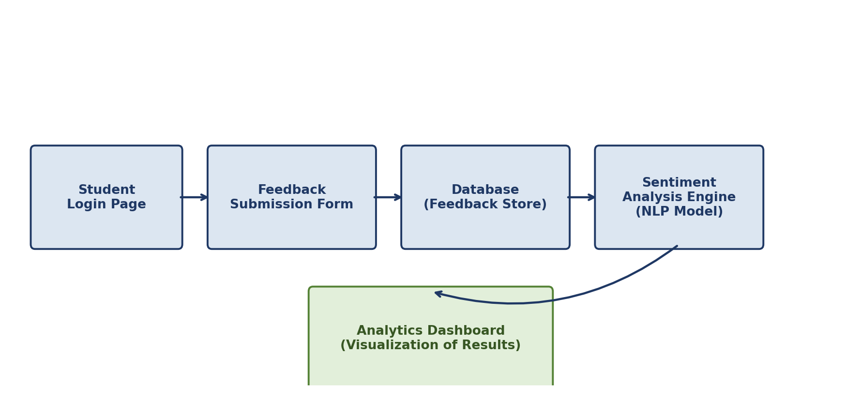
Fig. 4.1: System Architecture of the Student Feedback Sentiment Analysis System
Login / Authentication Module: Validates student credentials (roll number and password) before granting access to the feedback form, ensuring only authorized students can submit feedback.
Feedback Collection Module: Presents rating-based questions (teaching quality, course content, lab sessions) along with an open-ended comment box for free-text feedback.
Sentiment Analysis Engine: Cleans and tokenizes the free-text feedback, then classifies it as Positive, Negative, or Neutral with a confidence score, as illustrated in Table 4.2.
Sample Feedback Text | Predicted Sentiment | Confidence Score
“The faculty explained the concepts very clearly.” | Positive | 0.86
“The lab sessions were okay, nothing special.” | Neutral | 0.52
“The course pace was too fast and confusing.” | Negative | 0.79
Table 4.2: Sample Sentiment Classification Output
Analytics Dashboard Module: Aggregates all classified feedback and displays the overall proportion of positive, negative and neutral responses, sentiment trends, and flagged negative comments for quick review.

4.8 Methodology
- Step 1: Student logs in through the authentication module.
- Step 2: Student fills and submits the feedback form (ratings + comments).
- Step 3: Feedback data is stored in the backend database.
- Step 4: The NLP-based sentiment engine processes the textual comments and assigns sentiment labels.
- Step 5: Processed results are aggregated and rendered on the dashboard as charts and summary statistics.

4.9 Expected Outcomes
- A working prototype that allows students to securely log in and submit feedback.
- Automatic classification of free-text feedback into Positive, Negative, or Neutral sentiment.
- A dashboard that gives faculty/administrators a quick, visual summary of overall student sentiment, reducing the manual effort of reading every response.
- A reusable pipeline that can be extended with better models, multilingual support, and real-time updates in the future.

4.10 Certificates of Completion and Other Communication/Mail Proof
The Internship Offer Letter (NCS ID: E19E86-0116588288923) issued by Codec Technologies, confirming enrolment in the 6-month Full Stack Developer Internship, is attached below as proof of communication, in addition to the Internship Completion Certificate presented in Chapter 3.
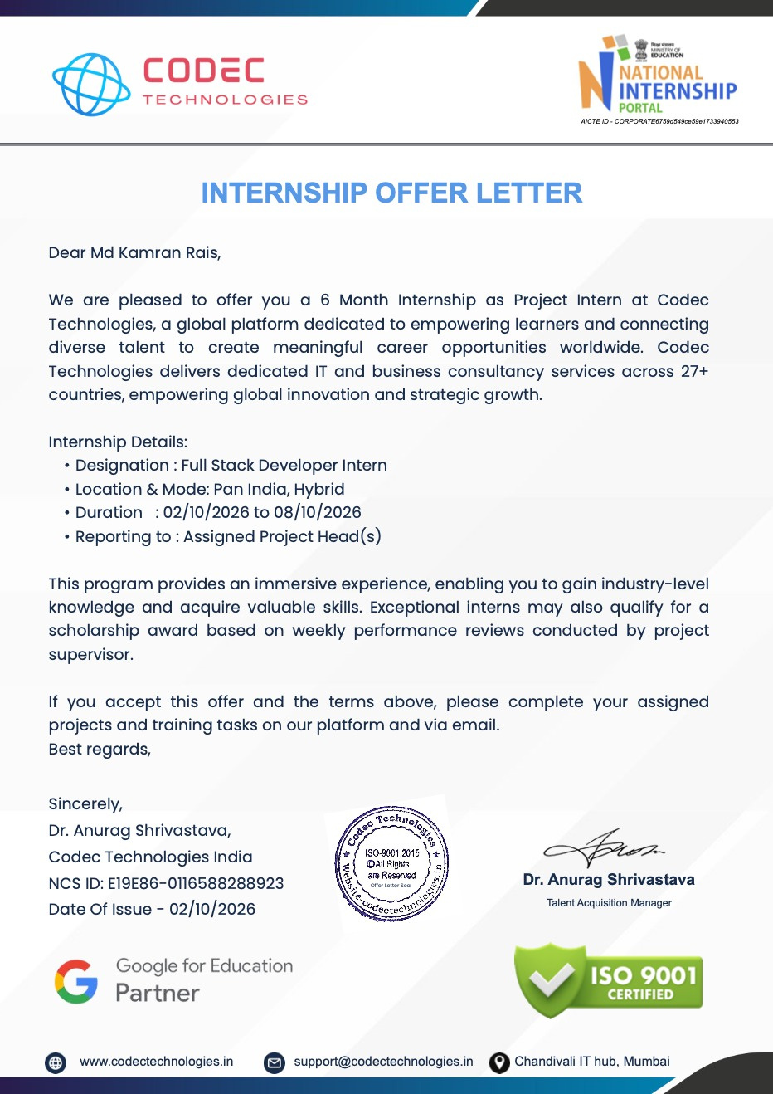
Fig. 4.2: Internship Offer Letter

5. BIBLIOGRAPHY / REFERENCES
1. National Internship Portal, Ministry of Education, Government of India.
2. Codec Technologies Pvt. Ltd. – Full Stack Developer Internship Program, NCS ID: E19E86-0116588288923.
3. Python, Flask, and NLP libraries (NLTK, TextBlob, VADER) documentation and tutorials.
4. Chart.js / Plotly Documentation – for dashboard visualization, https://www.chartjs.org
5. Flask Documentation – https://flask.palletsprojects.com

