|  |  |  |  |  |  |  |  |  |  |  |
| --- | --- | --- | --- | --- | --- | --- | --- | --- | --- | --- |
|  |  | | Daffodil International University | | | | |  |  | |
|  |  | | |  | | |  | |  | |
|  | | | | | | | | | | |
| http://4.bp.blogspot.com/-SotLIkzmscA/UqQLE9BjdPI/AAAAAAAAARc/-SF46qFfVE0/s1600/daffodil-international-university-logo.png | | | | | | | | | | |
| Project Report | | | | | | | | | | |
| PROJECT TITLE: OLD CAR SELL SYSTEM(OCSS)  Course Code: SWE-426  Course Title: Software Engineering Web Project 2 | | | | | | | | | | |
|  | | **NAME** | | | **:** | **Md. Kamrul Hasan** | | | |  |
| **ID** | | | **:** | **143-35-769** | | | |
| **DEPARTMENT** | | | **:** | **Software Engineering** | | | |
| **Faculty of Science and Information Technology** | | | | | | | |
|  | | |  |  | | | |
|  | | | | | | | | | | |

Table of Contents

Chapter 1 1

1. Introduction 2

1.1 About the System 2

1.2 Purpose 2

1.3 Scope 2

1.4 Vision 2

1.5 Why this system is necessary? 2

Chapter 2 3

2. System Analysis 4

2.1 Use Case Model 5

2.2 Actor Goal List 5

2.3 Use Case Description (Brief) 5

2.3.1 User Registration 5

**2.3.2 Post car-----------------------------------------------------------------------------------------------5**

**2.3.3 Post comment-----------------------------------------------------------------------------------------6**

2.4 Use Case Description (Detailed) 6

2.4.1 User Registration 6

2.4.2 Post car 6

2.4.3 Post comment -----------------------------------------------------------------------------------------7

2.5 System Sequence Diagrams 6

2.5.1 User Registration(Success Scenario) 6

2.5.2 User Registration (Failure Scenario) 6

2.5.3 Post car (Success Scenario) 6

2.5.4 Post car (Failure Scenario)---------------------------------------------------------------- 6

2.5.5 Post Comment(success scenaior )-------------------------------------------------------------8

2.5.6 Post comment (Failur scenarior )---------------------------------------------------------------8

2.6 Activity diagram 7

Chapter 3 9

3. System Design 10

3.1 Sequence Diagrams 10

3.2 Class Diagram 11

3.3 Entity Relationship Diagram 13

Chapter 4 15

4. Implementation 15

4.1 Tools &Technologies 16

4.2 Project Link 16

5. References 24

**Chapter 1:**

**Introduction:** Here I try to create a web based software system where people can sell their old car.

By getting registration they can post their car details and price in this website then easily find out their customer

* 1. **Old car selling System.**
  2. **Purpose:** Old car selling system help people to sell their old car in their own demand price and on the other site who needs an old car for less price they also find out one of them, so it takes a great change in e-commerce business.
  3. **Scope:** The scope of the project is the system on which the software is installed the project is developed as a web application. This software can use any people who has internet and can easily assess. Later this application will be modified and bring some new features which is useful for the people and country.
  4. **Vision**: Get response of our country people who are needed an old car and also the people who want to sell his/ her old car
  5. **Why this system is necessary:** It helps to people to sell his old car easily and a customer also find a car in his budget. The heragement of local market will decreased by using this system

**Chapter 2**: **System Analysis.**

**2.1)** **Use Case Model:**

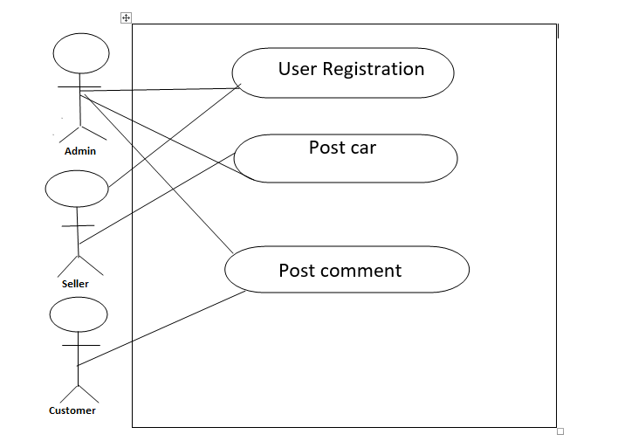

**2.2)**  **Actor Goal List:**

* Admin can add, delete, update seller all information.
* Admin can also view all car post information.
* Customer can post a comment on each car
* Seller can delete any previous post

**2.3)** **Use case description**

**2.3.1) User Registration:**

* After registration admin will verified the seller id and will give a confirmation message
* Getting confirmation message seller can use the system

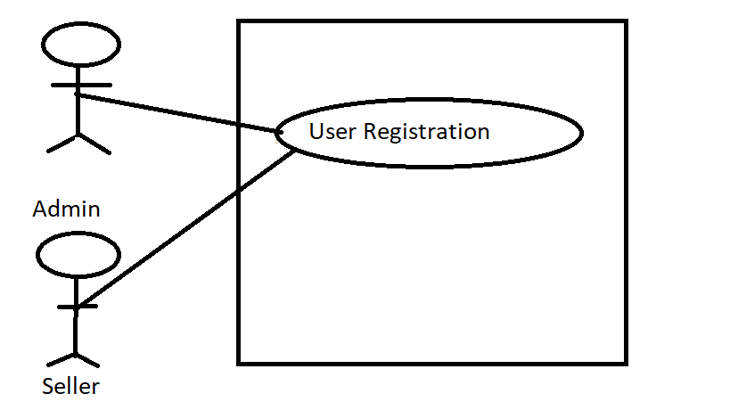

**2.3.2) Post car:**

* Seller upload his new post in the system
* Admin will confirm the post and give permit with confirmation message

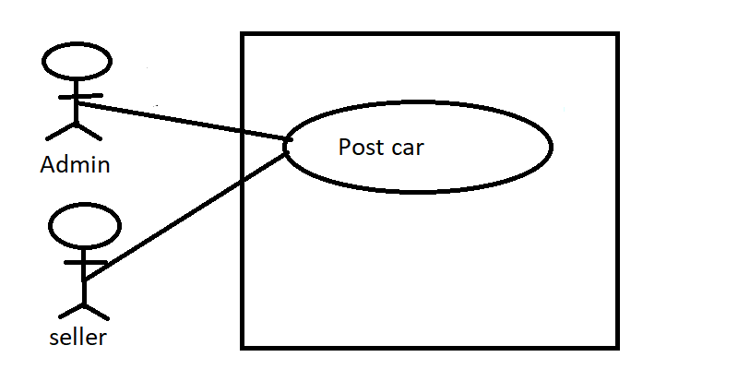

**2.3.3) Post comment:**

* Customer can post comment on any post that was uploaded by seller
* Customer can delete their comment also

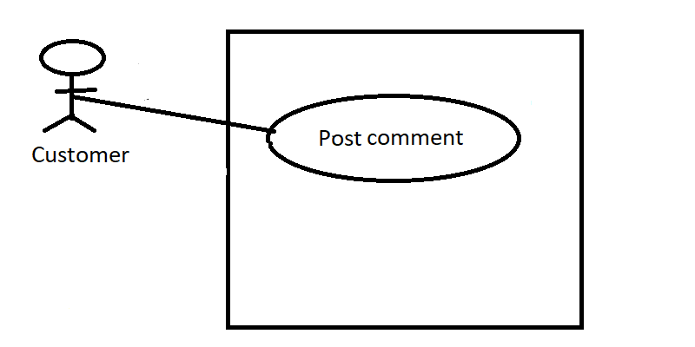

**2.4) Use Case Description Detailed**

**2.4.1) User registration:**

|  |  |  |
| --- | --- | --- |
| Use Case Id | 1 | |
| Use Case Name | User registration | |
| Primary Actor | Admin | |
| Goal | Make ensure the seller detail and give permit. | |
| Pre-Condition | User detail should be authorize. | |
| Post Condition | By any fault admin can cancel the seller id. | |
| Main Success Scenario | **Actor** | **System** |
| 1) Submit all information detail to server.  2) Admin can able to see all seller lists. | 1.1) System gives confirmation message.  2.1) Server generate confirm message. |
| Failure Scenario | 1) Don’t able to registration  3) System disables. | |

**2.4.2) post car:**

|  |  |  |
| --- | --- | --- |
| Use Case Id | 2 | |
| Use Case Name | Post car | |
| Primary Actor | Seller | |
| Goal | Make a new post for sell a car | |
| Pre-Condition | Should be authorized member of this system | |
| Post Condition | Post can delete any time. | |
| Main Success Scenario | **Actor** | **System** |
| 1) Seller upload their new post with their car details. | 2.1) System gives confirmation message.  3.1) System generate confirm message as successfully taken post. |
| Failure Scenario | 1) Don’t able to upload a new post. 2) System disables. | |

**2.4.2) post comment:**

|  |  |  |
| --- | --- | --- |
| Use Case Id | 3 | |
| Use Case Name | Post car | |
| Primary Actor | customer | |
| Goal | Make a comment for a car | |
| Pre-Condition | No need to be an authorized member of this system | |
| Post Condition | Post can delete any time. | |
| Main Success Scenario | **Actor** | **System** |
| 1) Seller upload their new post with their car details. | 2.1) System gives confirmation message.  3.1) System generate confirm message as successfully taken post. |
| Failure Scenario | 1) Don’t able to upload a new post. 2) System disables. | |

**2.5) System Sequence Diagram:**

**2.5.1) User Registration (success scenario):**

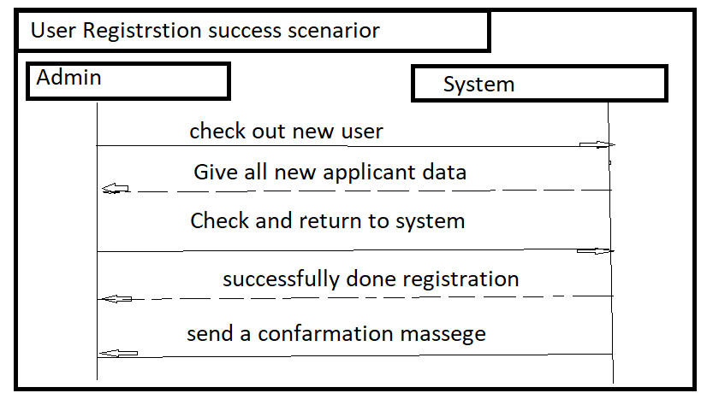

**2.5.2) User Registration (Failure scenario):**

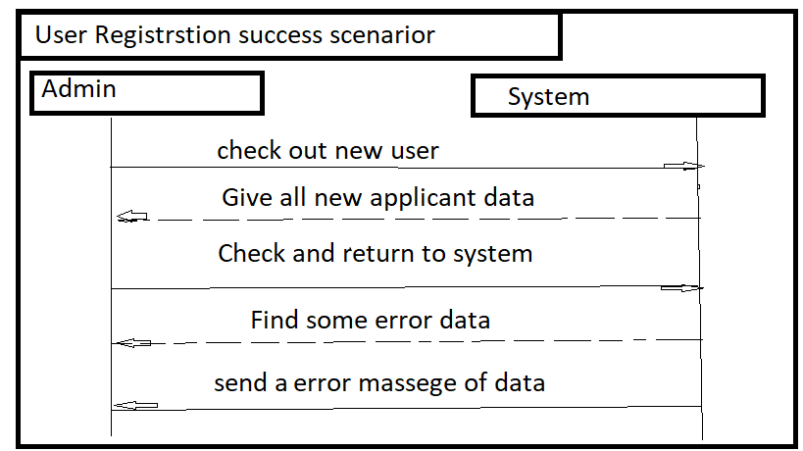

**2.5.3) Post car (success scenario):**

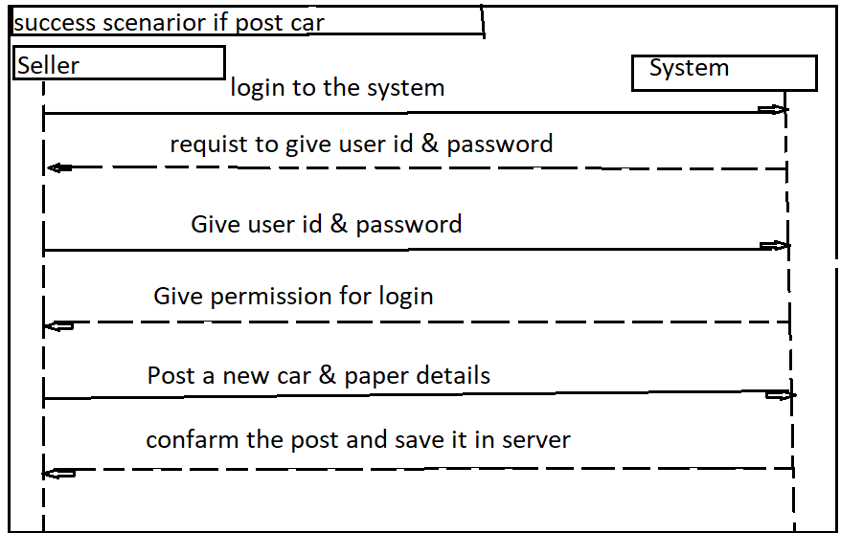

**2.5.4) Post car (Failure scenario):**

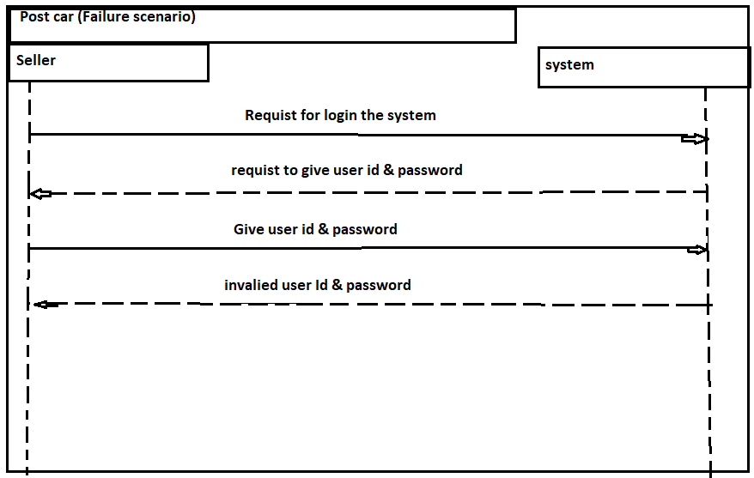

**2.5.5) Post comment (success scenario):**

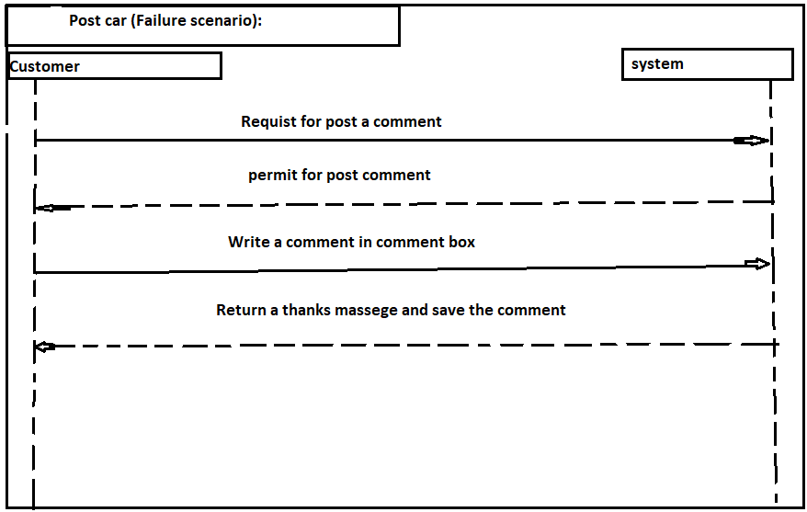

**2.5.6) Post comment (Failure scenario):**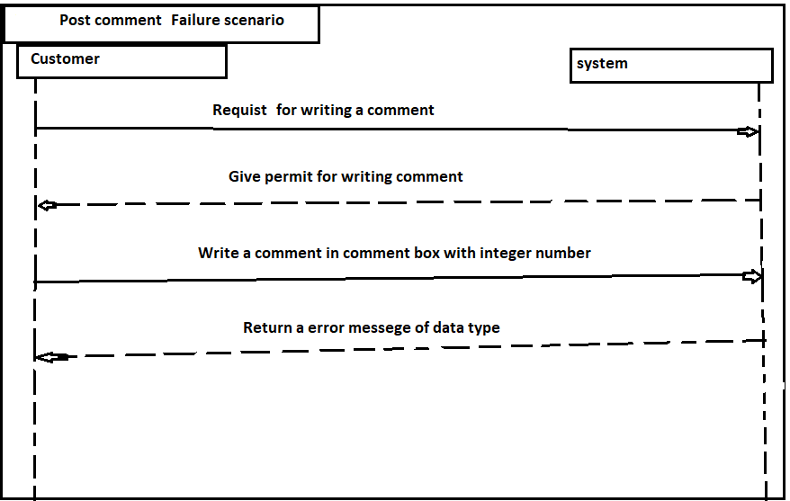

## **2.6** **Domain/Conceptual Model**

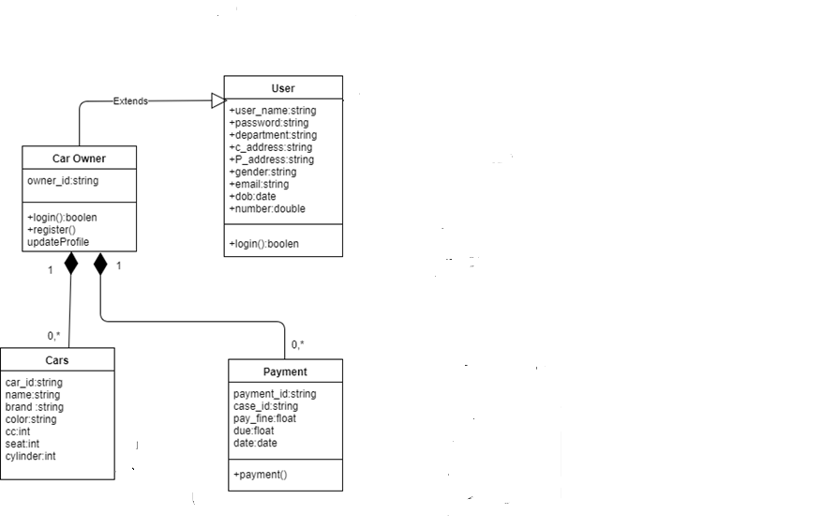

**2.7) Activity Diagram:**

Activity diagrams are graphical representations of workflows of stepwise activities and actions with support for choice, iteration and concurrency.

In the system workflows starts from the stage when an applications enters the area of Federal Shari at Court i.e. uploaded in the system to last activity that is a judgment comes or the case is dismissed .This whole process is shown in the below diagram.

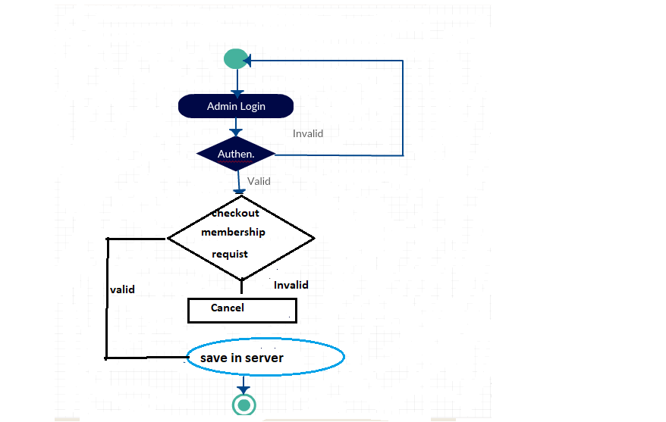

**3) System Design:**

## **Sequence Diagrams**

The UML includes interaction diagrams to illustrate how objects interact via messages. They are used for dynamic object modeling. The term interaction diagram is a generalization of two more specialized UML diagram types:

### **Register Account:**

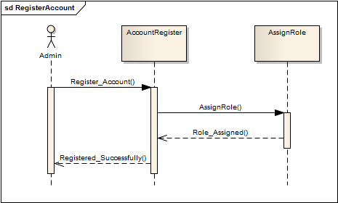

**3.1) Class Diagram:**

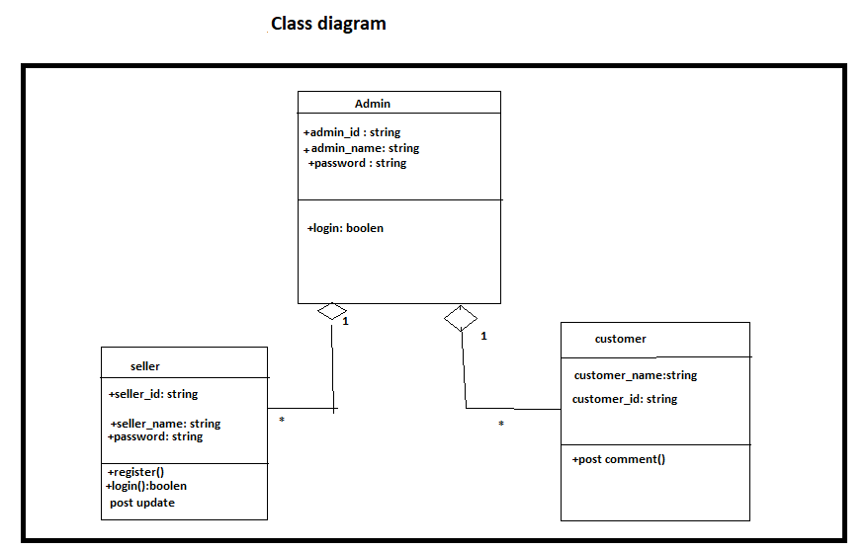

**3.2) ER Diagram:**

An entity-relationship model is an abstract and conceptual representation of data. Entity-relationship modeling is a database modeling method, used to produce a type of conceptual schema or semantic data model of a system, often a relational database, and its requirements in a top-down fashion. Diagrams created by this process are called Entity-Relationship Diagrams.

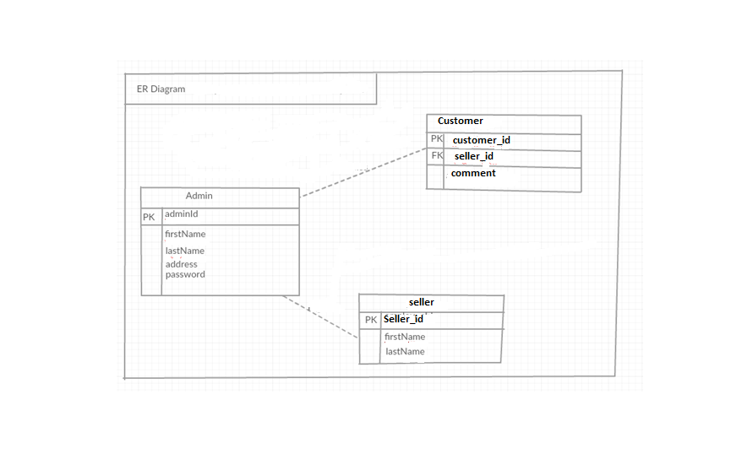

Chapter 4

**Implementation**

# Implementation

Implementation (software) perspective describes software implementations in a particular technology (such as C#). In the UP, Implementation means programming and building the system, not deploying it.

In the implementation phase, the developer builds the components either from scratch or by composition given the architecture document from the design phase and the requirement document from the analysis phase. The architecture document should give guidance. Sometimes, this guidance is found in the requirement document. The implementation phase deals with issues of quality, performance and debugging. The end deliverable of implementation phase is the product itself.

## Tools &Technologies

Following are the tools and technologies used in development of this project:

Microsoft Visual Studio 2012

ASP.NET Framework

Microsoft SQL Server 2008

Telerik reports

Microsoft Visio

Microsoft Architect

HTML5, CSS, JavaScript, J-query, Twitter bootstrap

## Project Link

They provide github repository link after uploading the