Ring Oscillator with Control logic

15/07/2022

Width of the logic transistor(pmos) W = 0.42 um

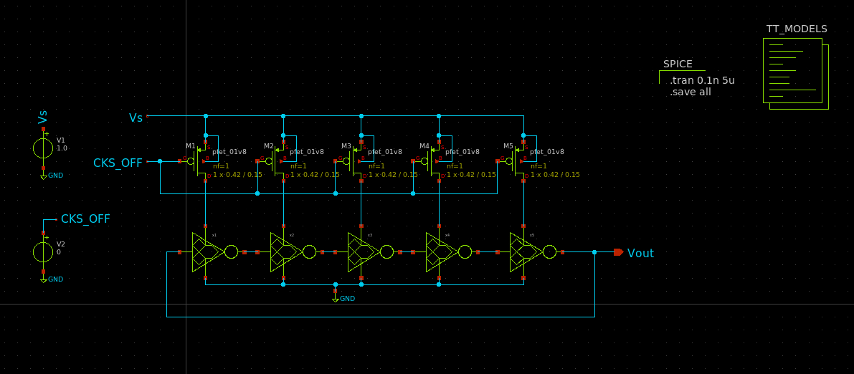

Supply 1V

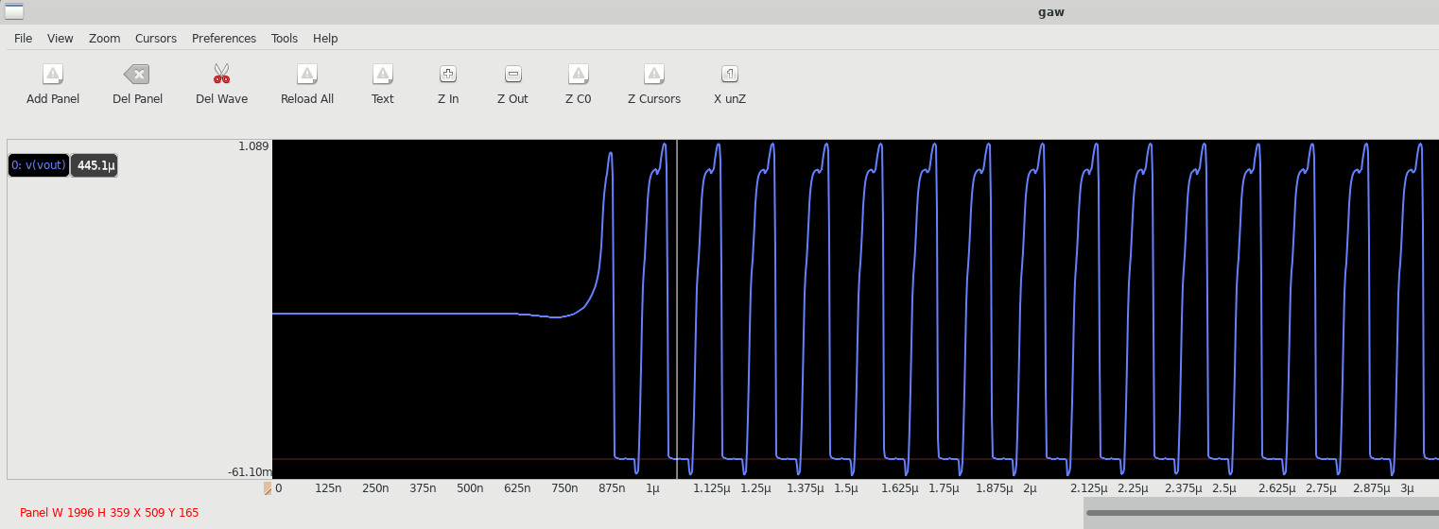

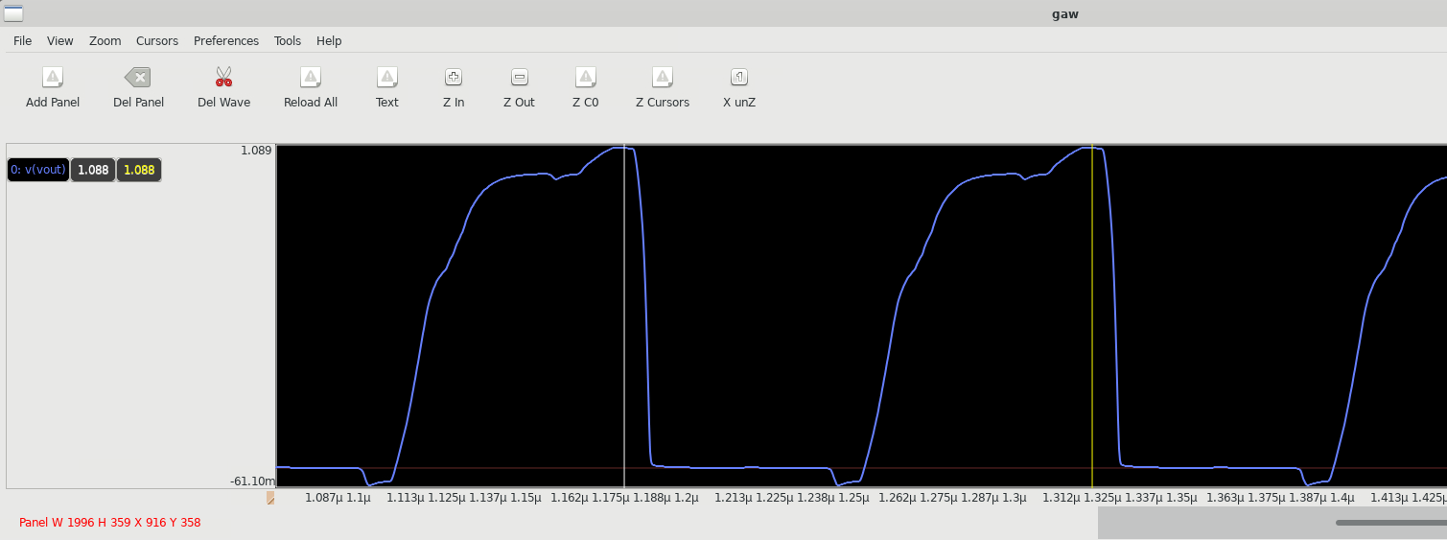

f=6.8 MHz

supply=0.7V

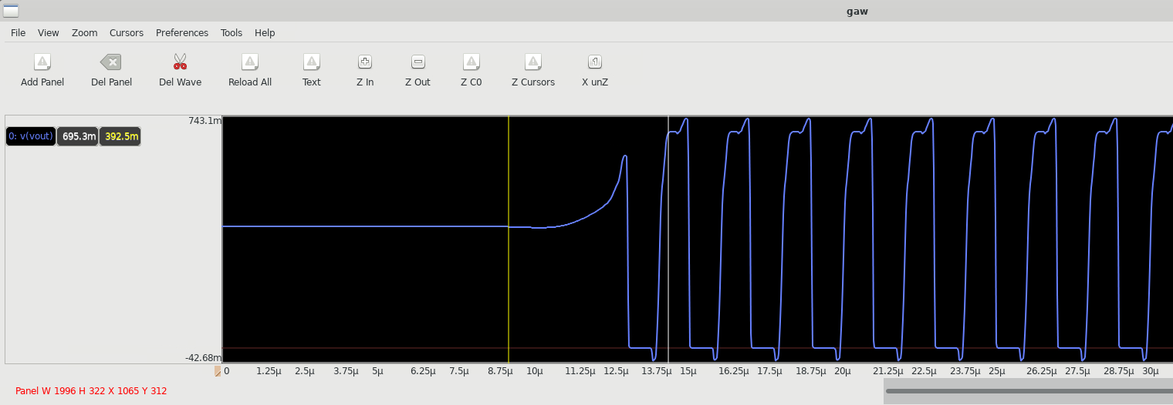

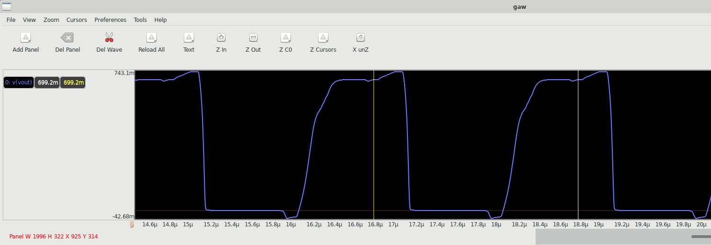

f=500KHz

Supply = 0.4V

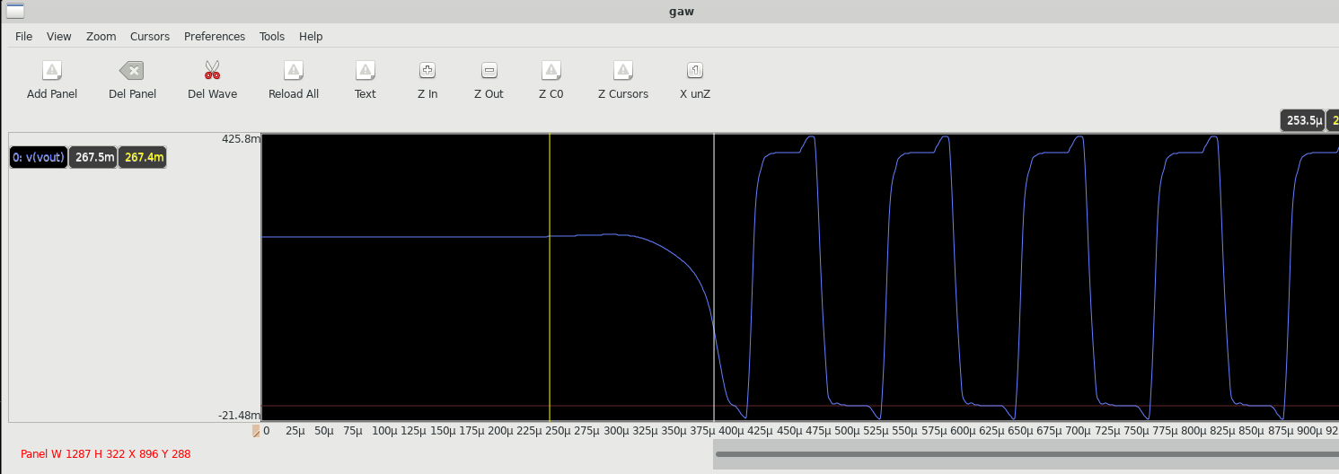

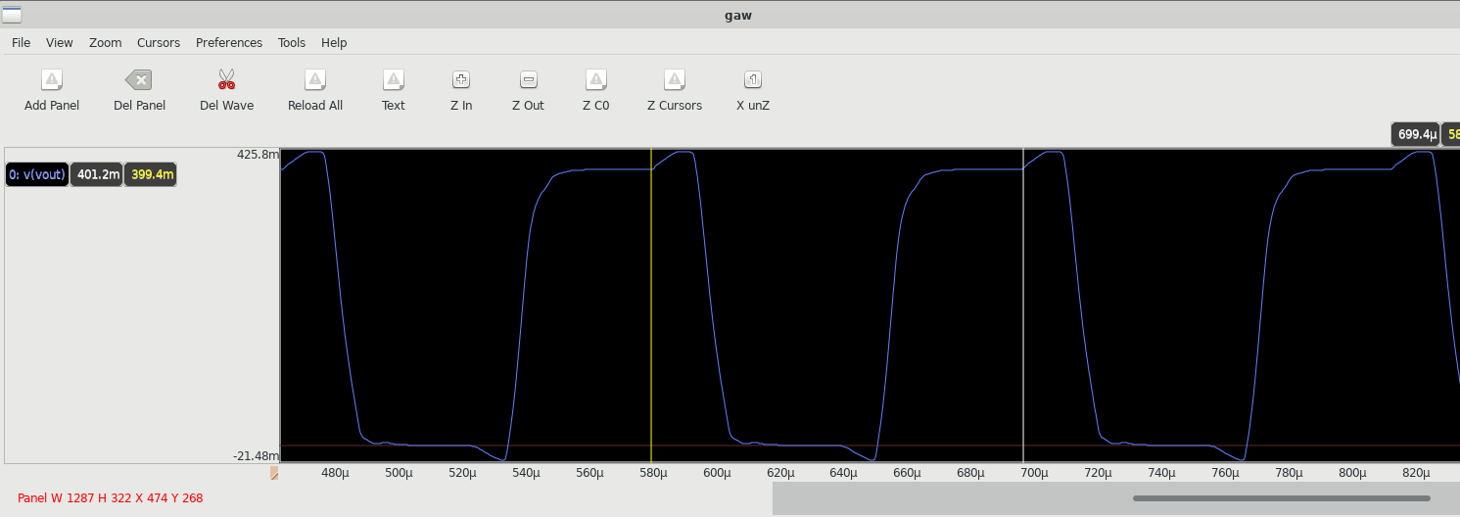

f=50 KHz

Supply = 250mV

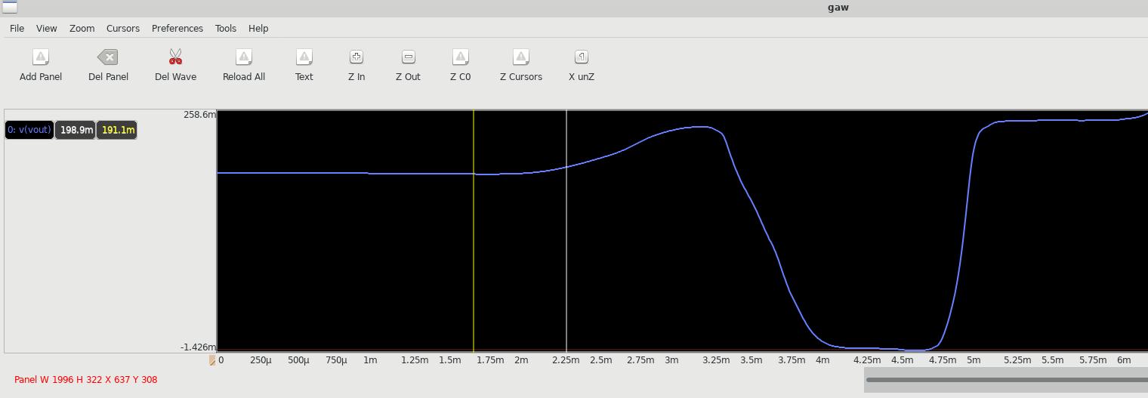

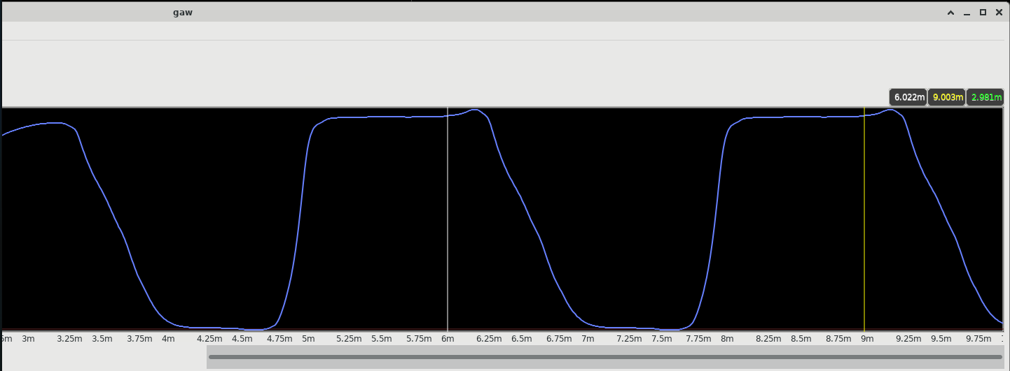

f=333.3 Hz

supply=200mV

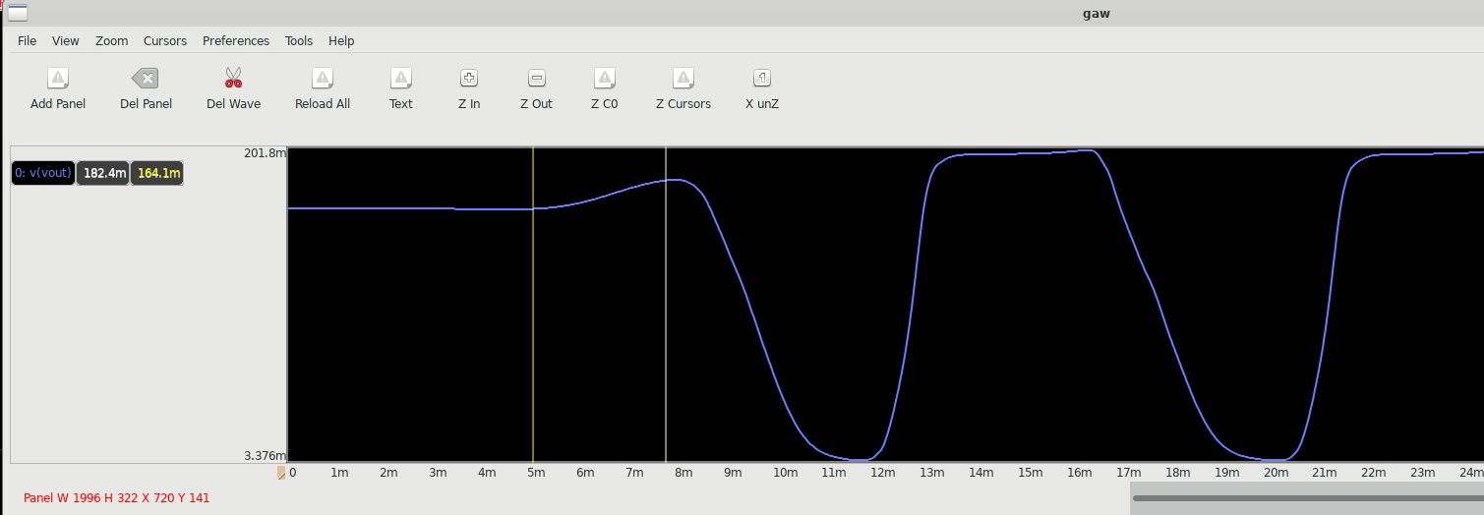

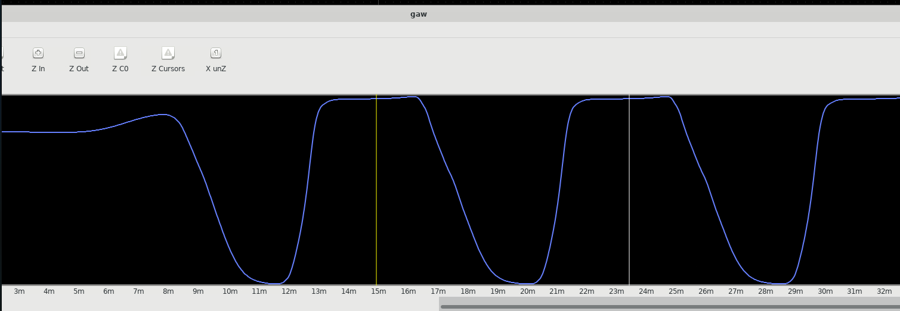

f=117.6 Hz

Supply =170mV

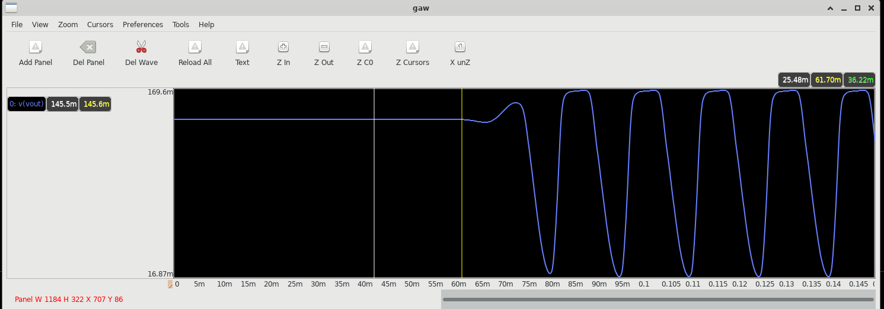

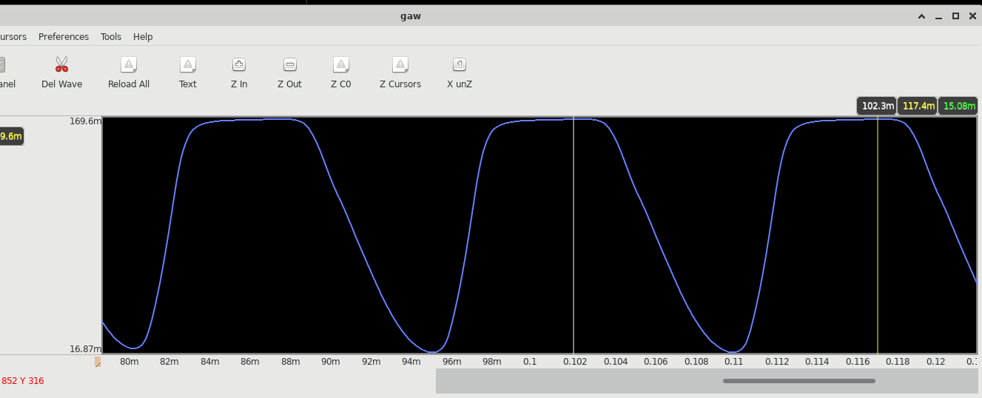

f=66.6 Hz

Supply 160 mV

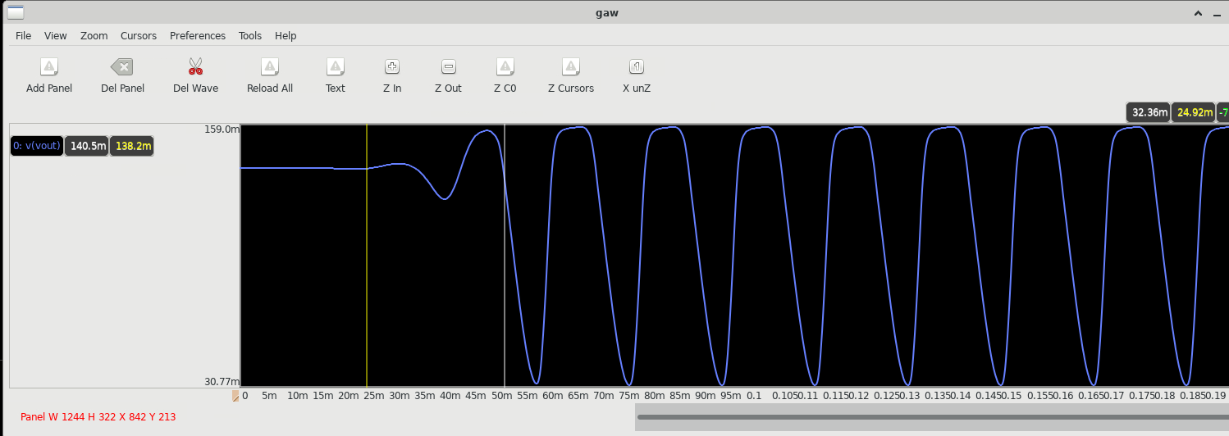

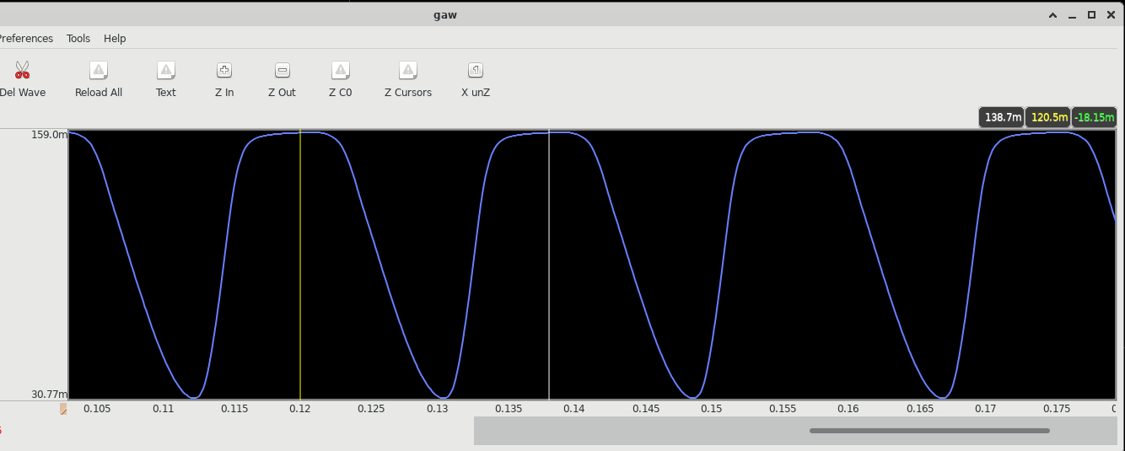

f=57 Hz

Supply 155mV

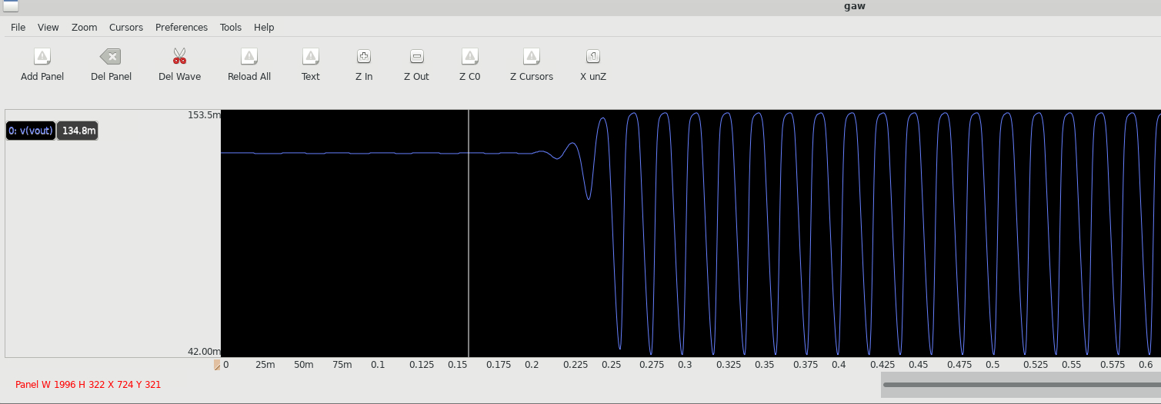

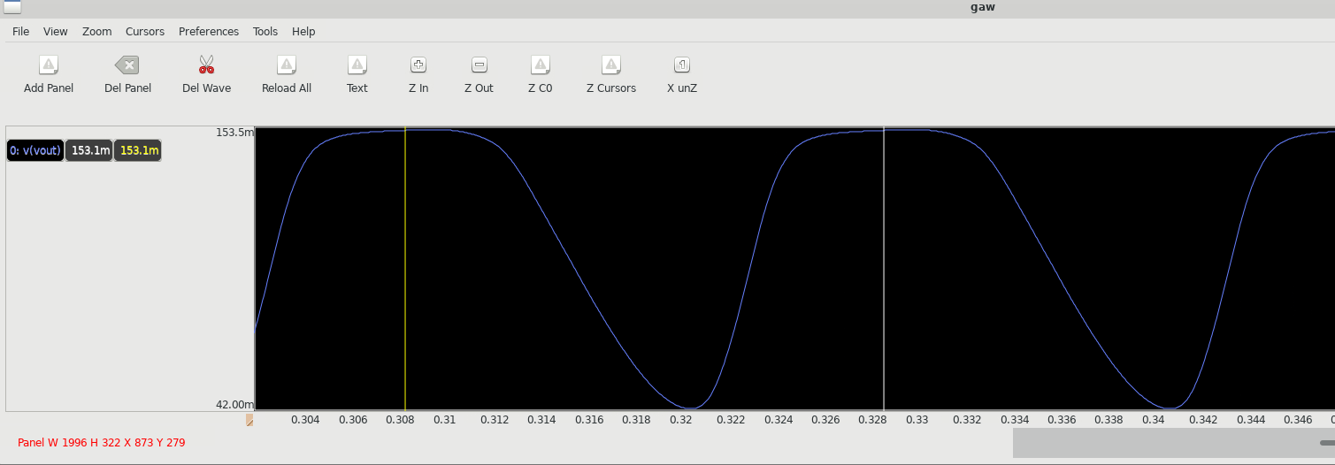

f=47.6 Hz

Supply 150mV

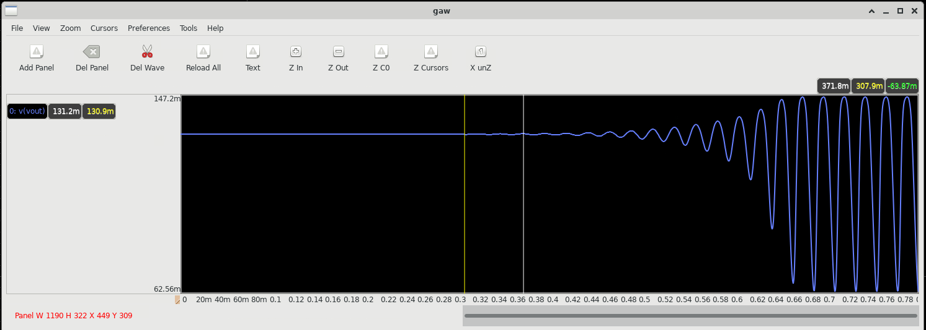

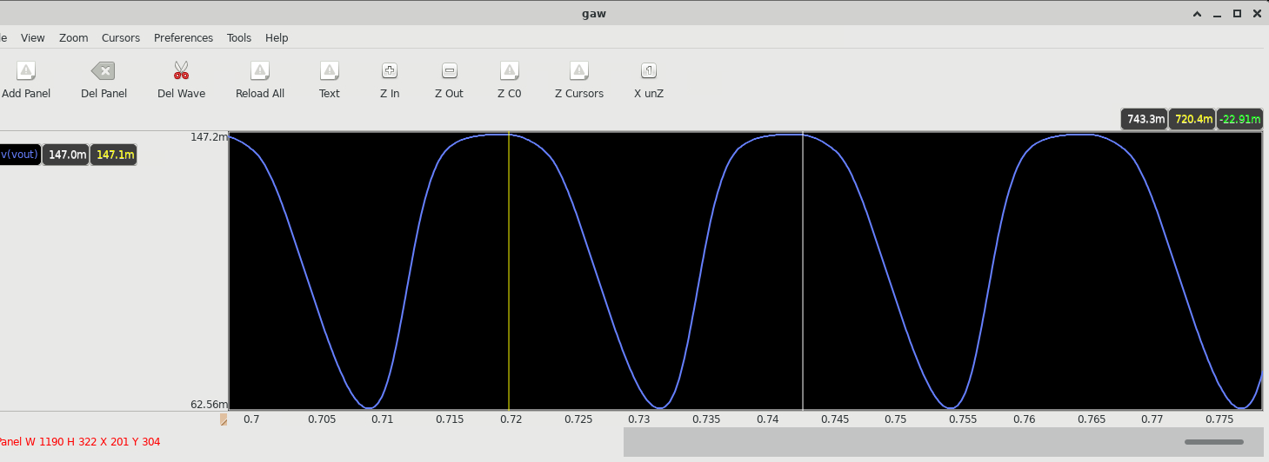

f=44.4 Hz

Supply = 145 mV

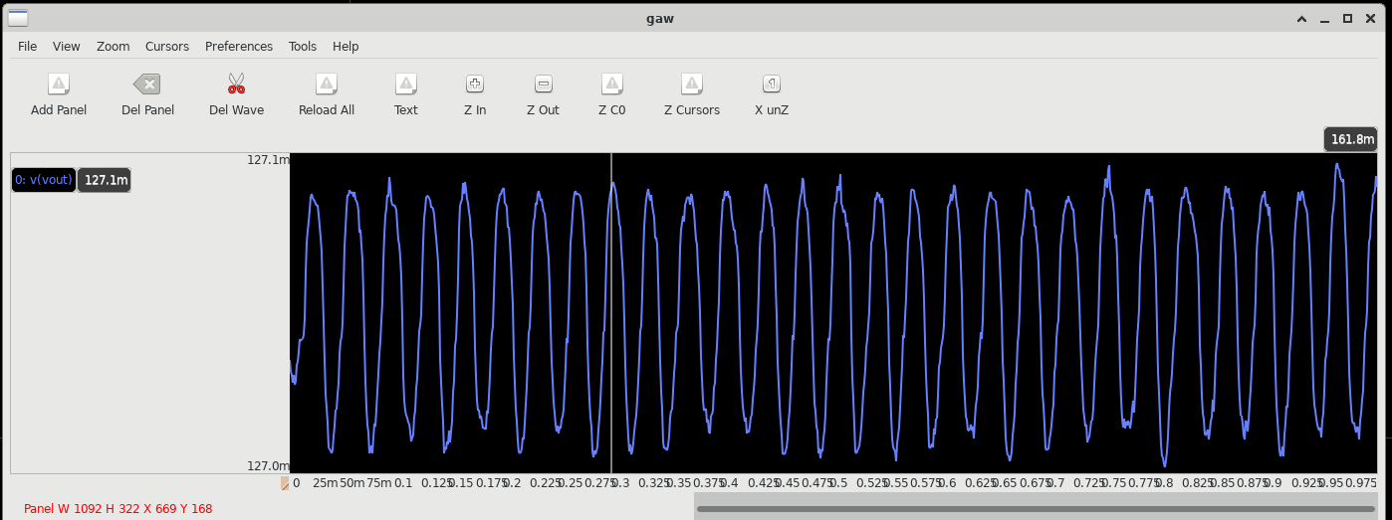

Output swing is 0.1mV (can not be used)

**W=0.63u**

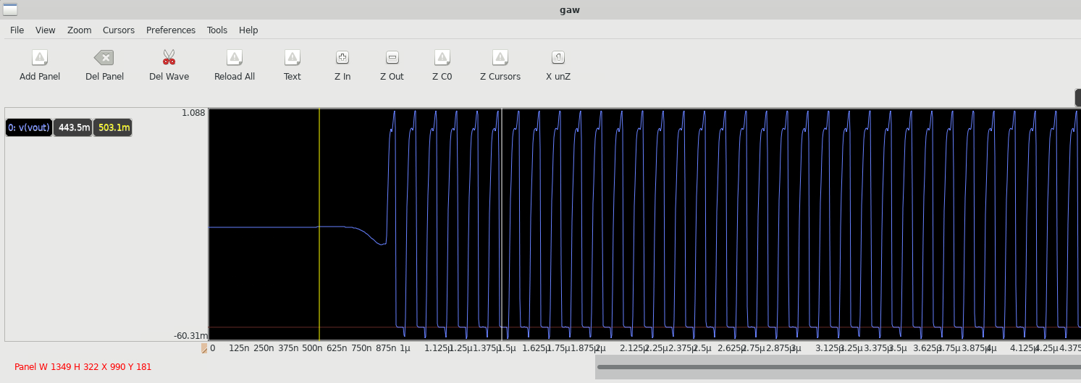

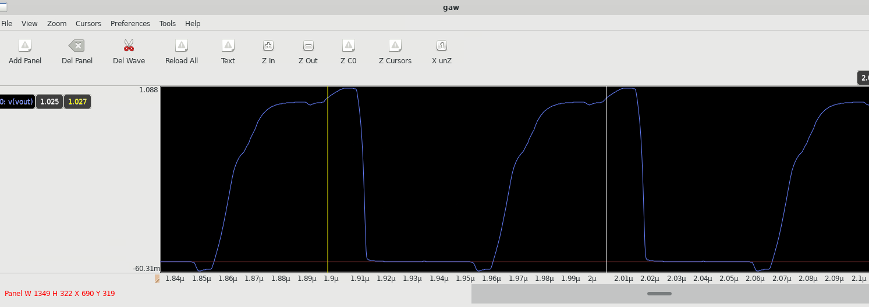

f=9.5 MHz

Supply 0.7V

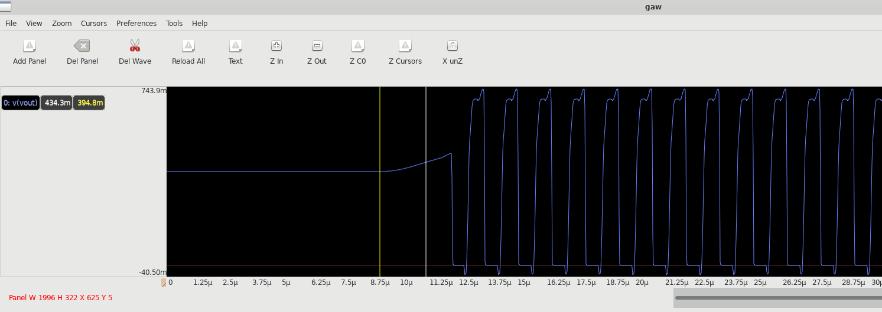

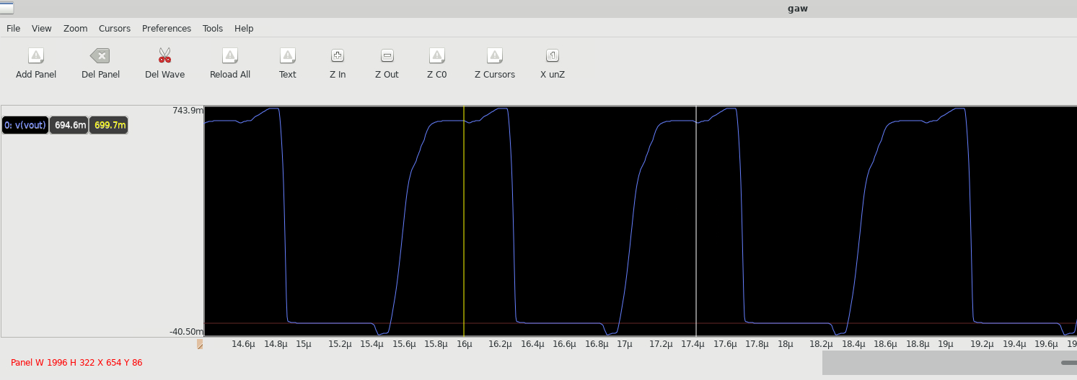

f=714 KHz

Supply 0.4 V

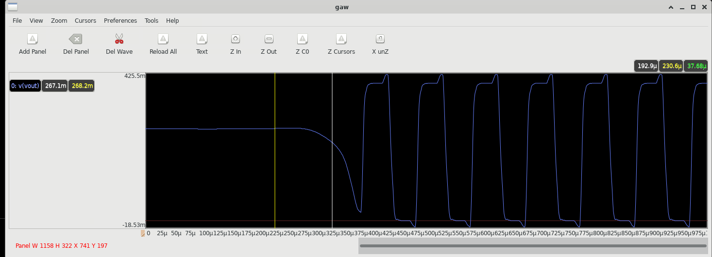

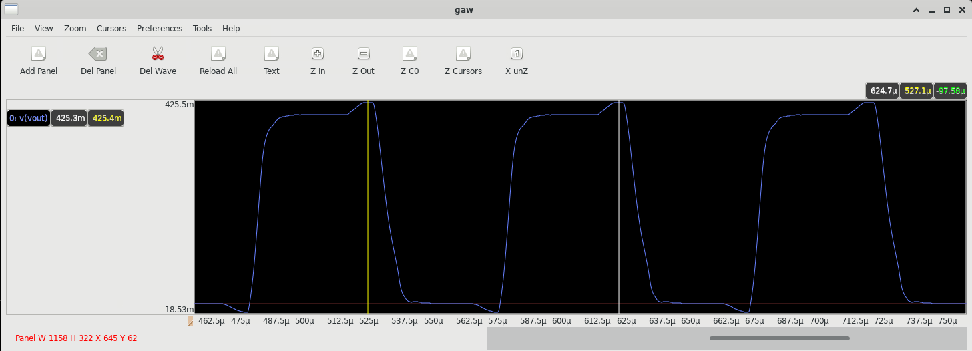

f=10KHz

Supply 250 mV

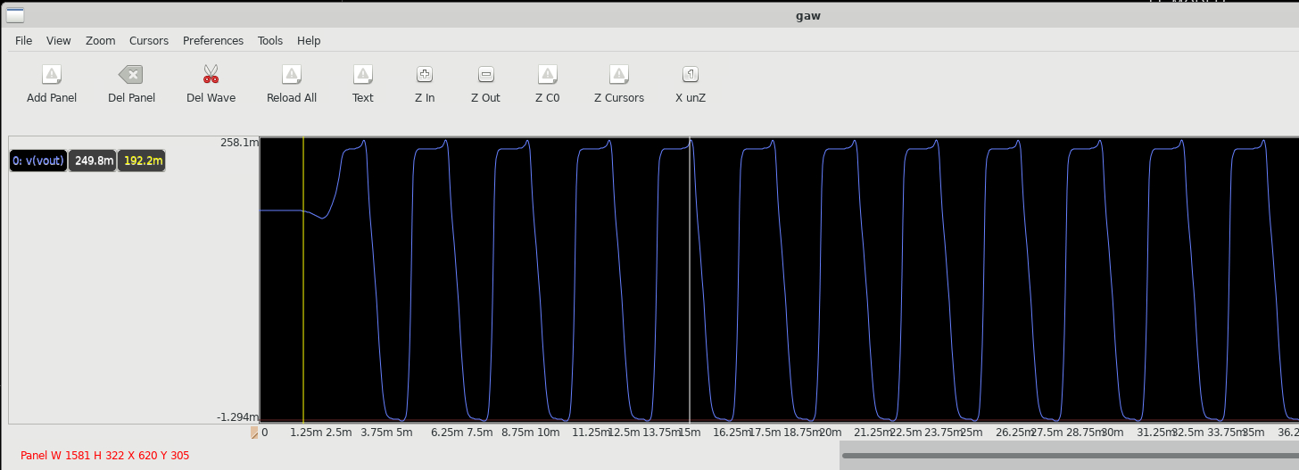

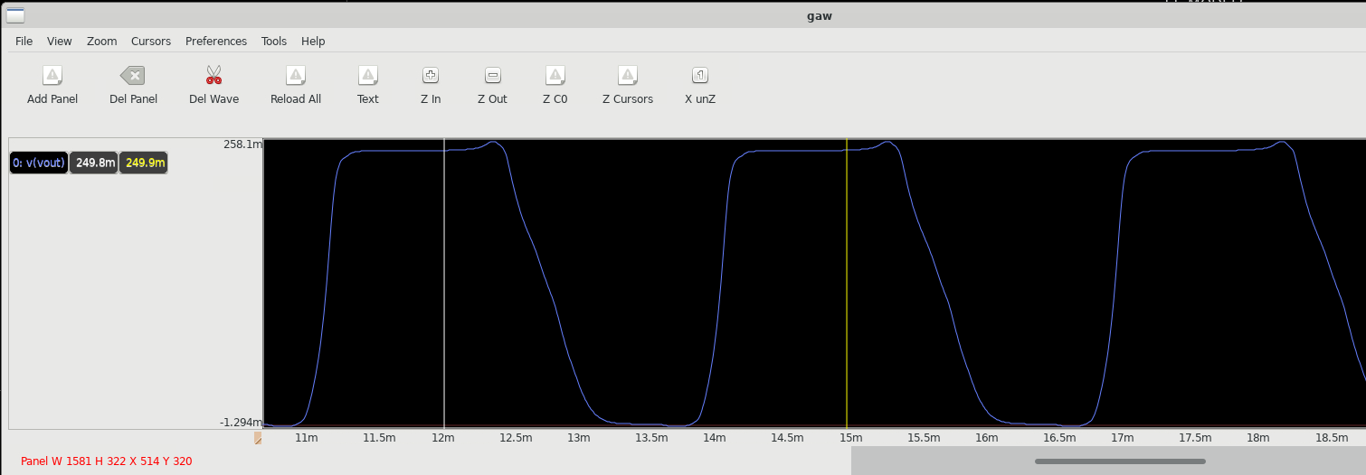

f=333.3 Hz

Supply 200mV

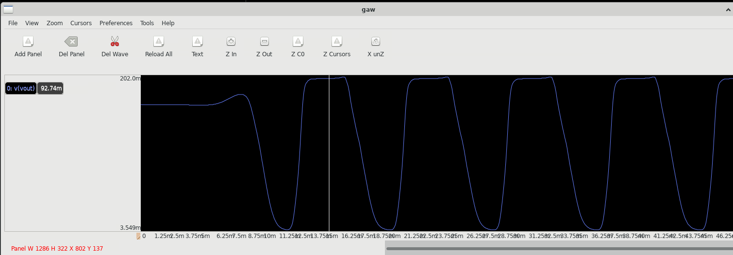

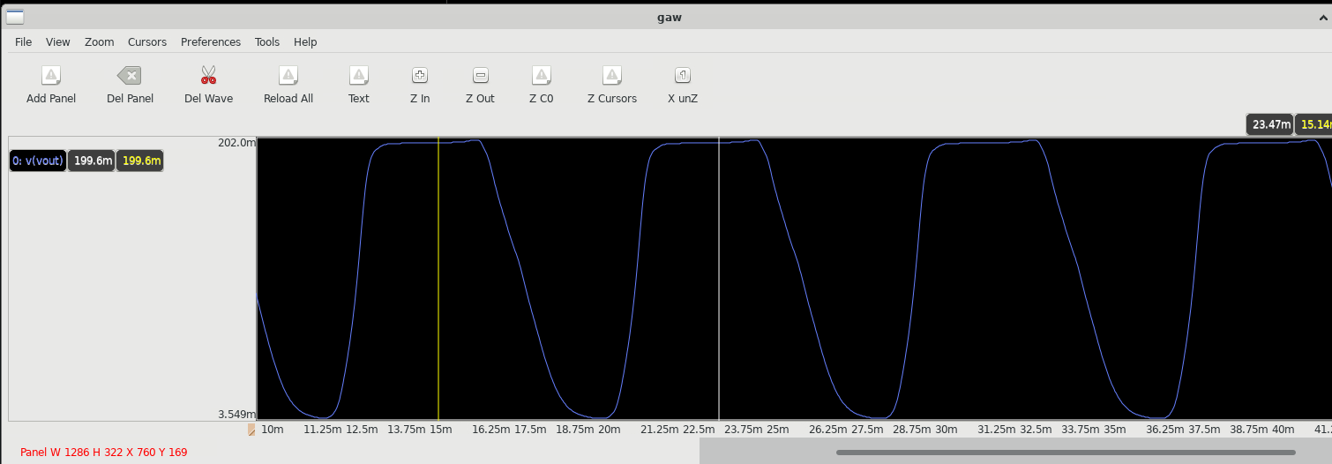

f=131 Hz

Supply 170mV

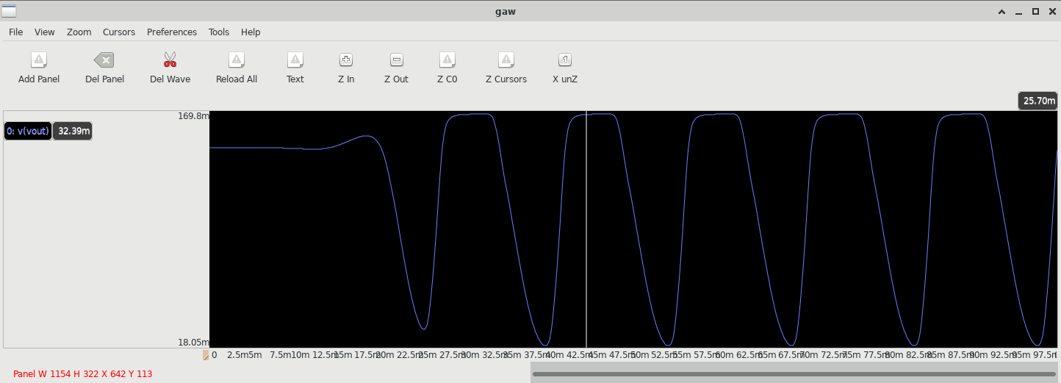

f=71.4 Hz

Supply = 160mV

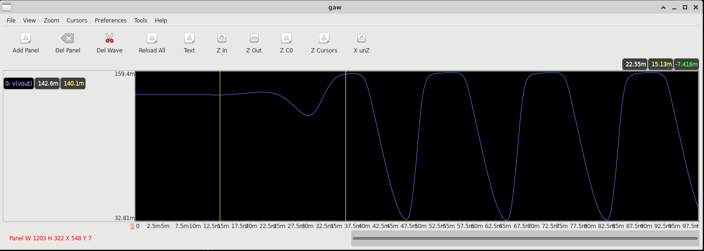

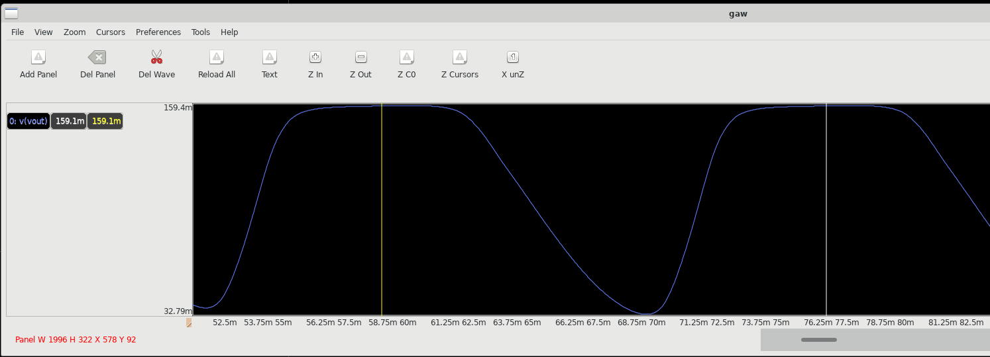

f=57.3 Hz

Supply 155mV

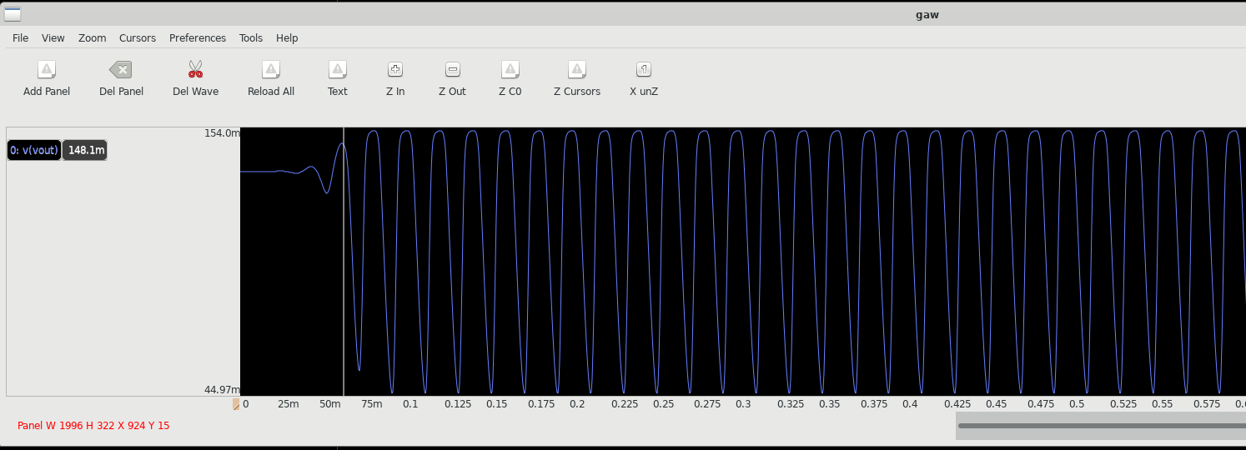

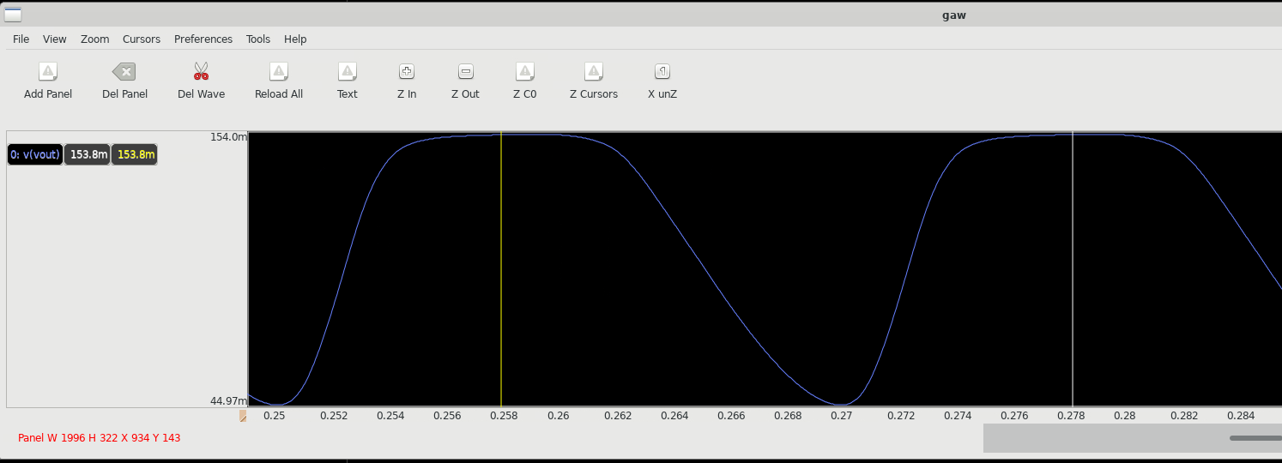

f=50 Hz

Supply 150mV

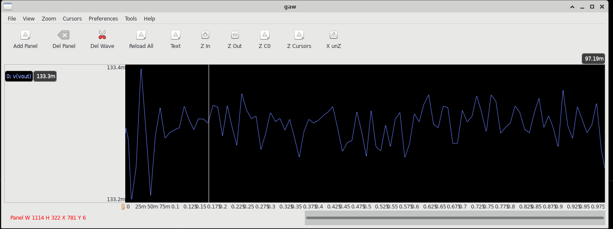

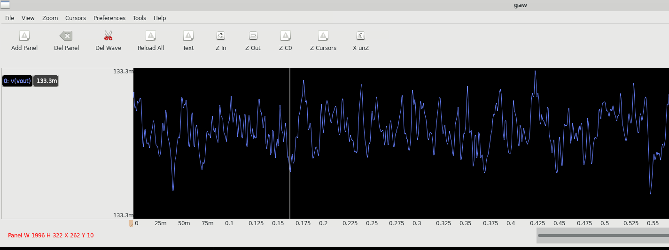

**W=0.84u**

Supply 1V

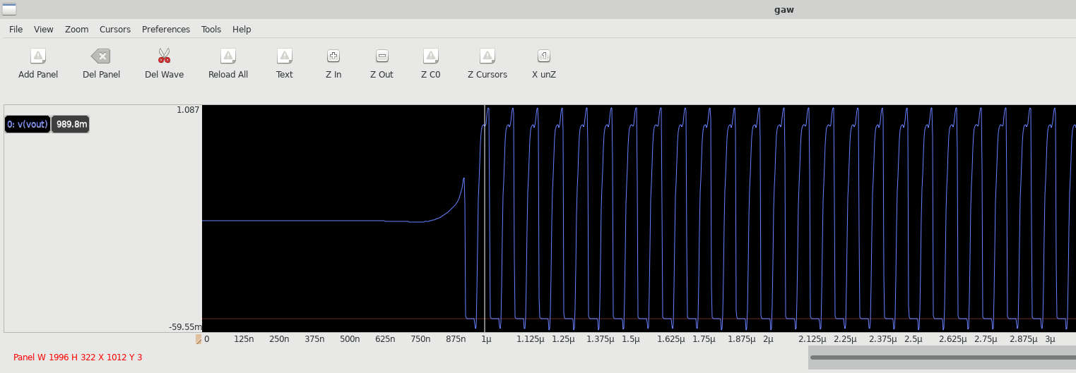

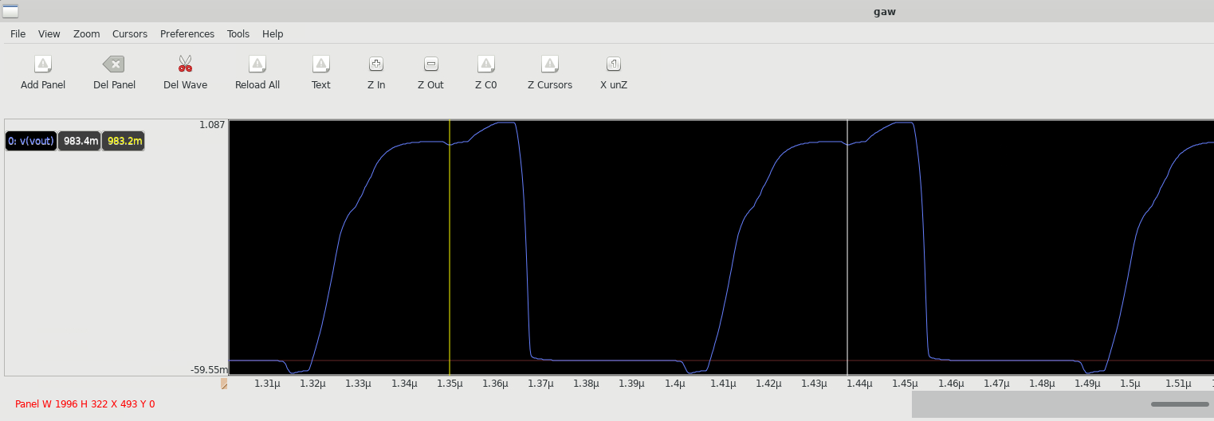

f=11.11 MHz

Supply 0.7V

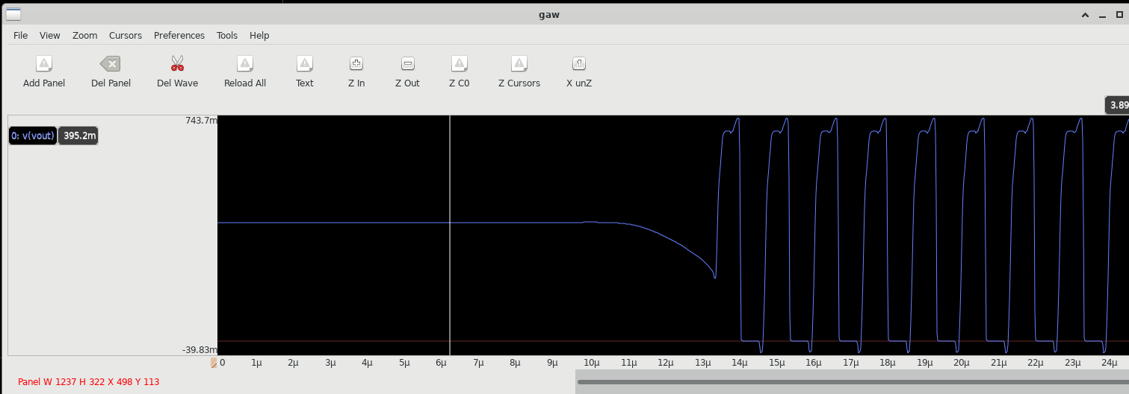

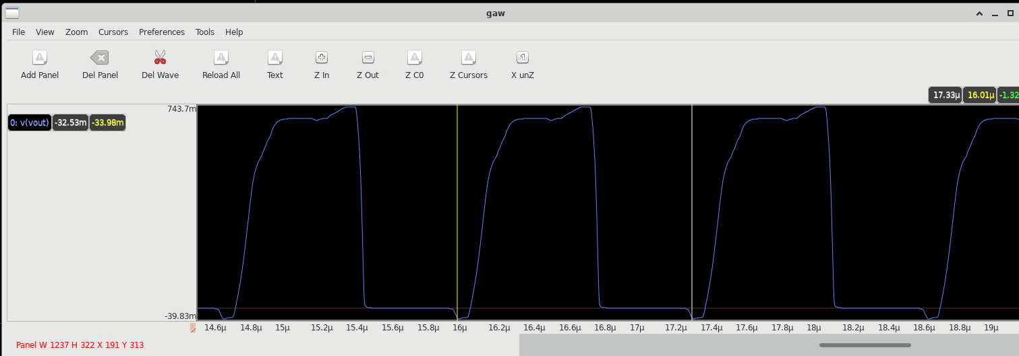

f=769KHz

Supply 0.4V

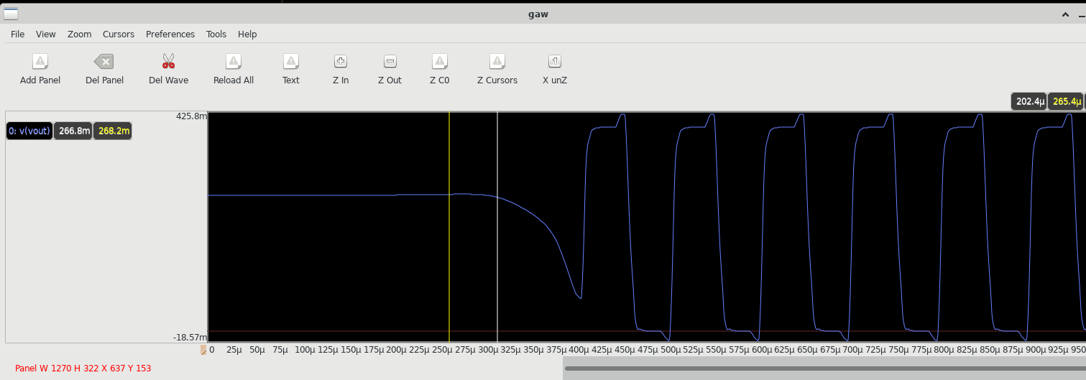

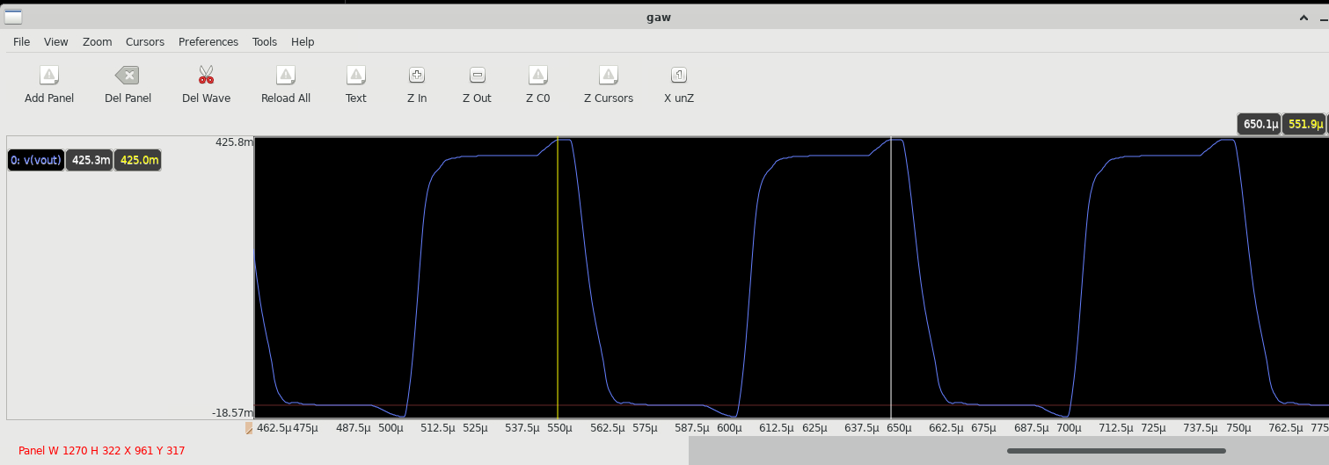

f=10KHz

Supply 250mV

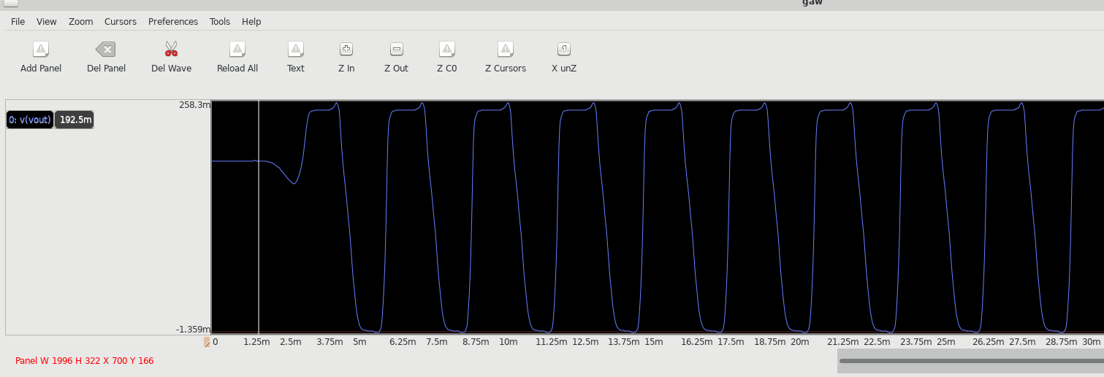

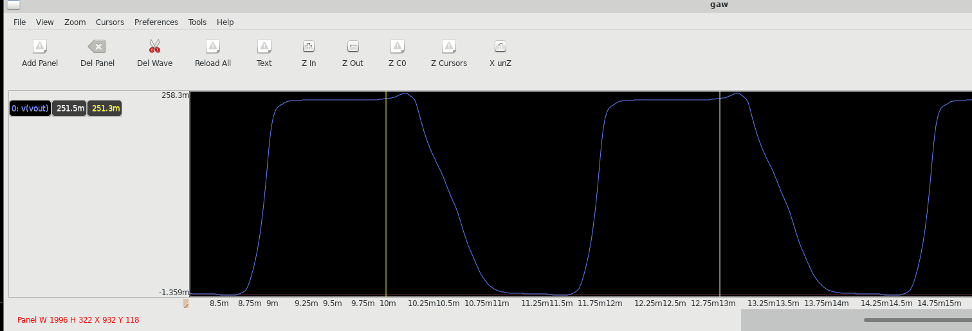

f=333.3 Hz

Supply 200mV

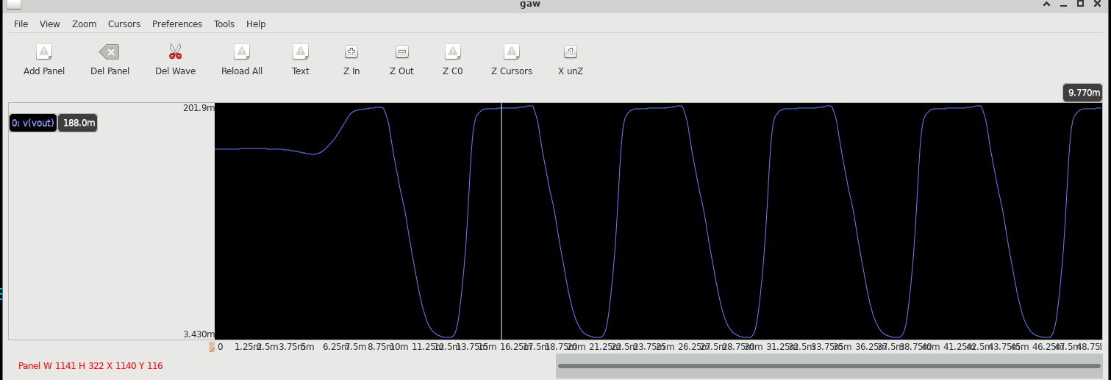

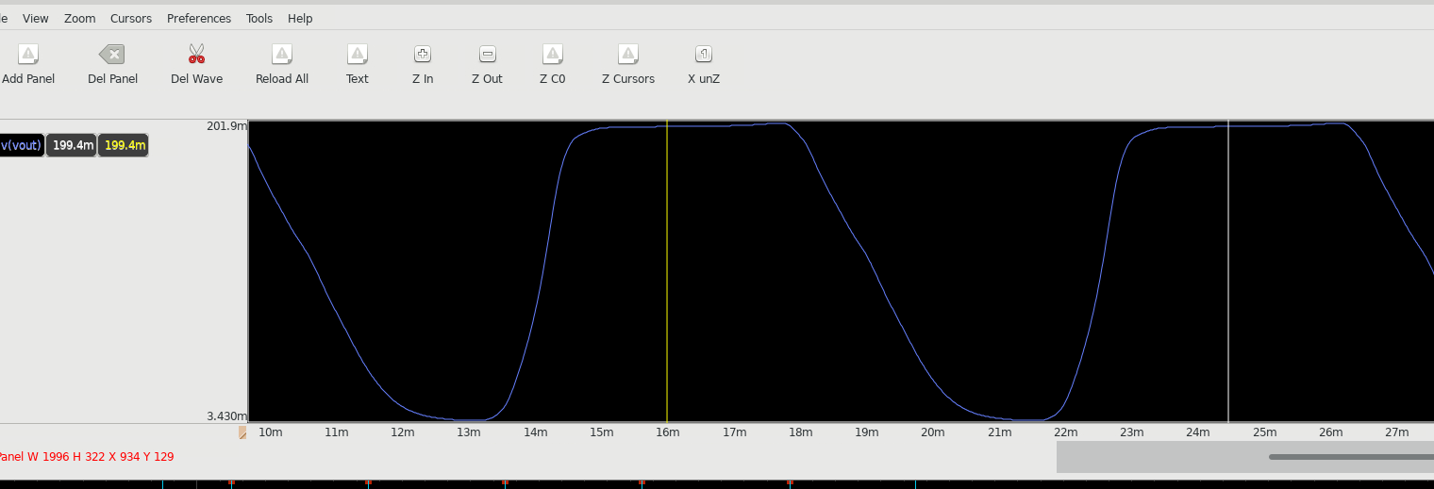

f=117.64 Hz

Supply 170mV

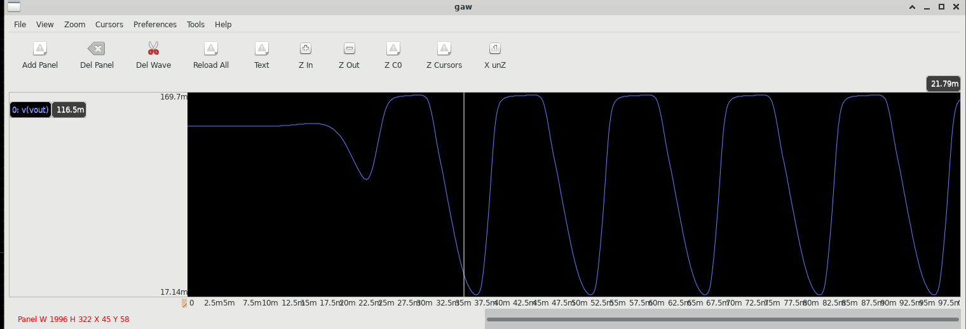

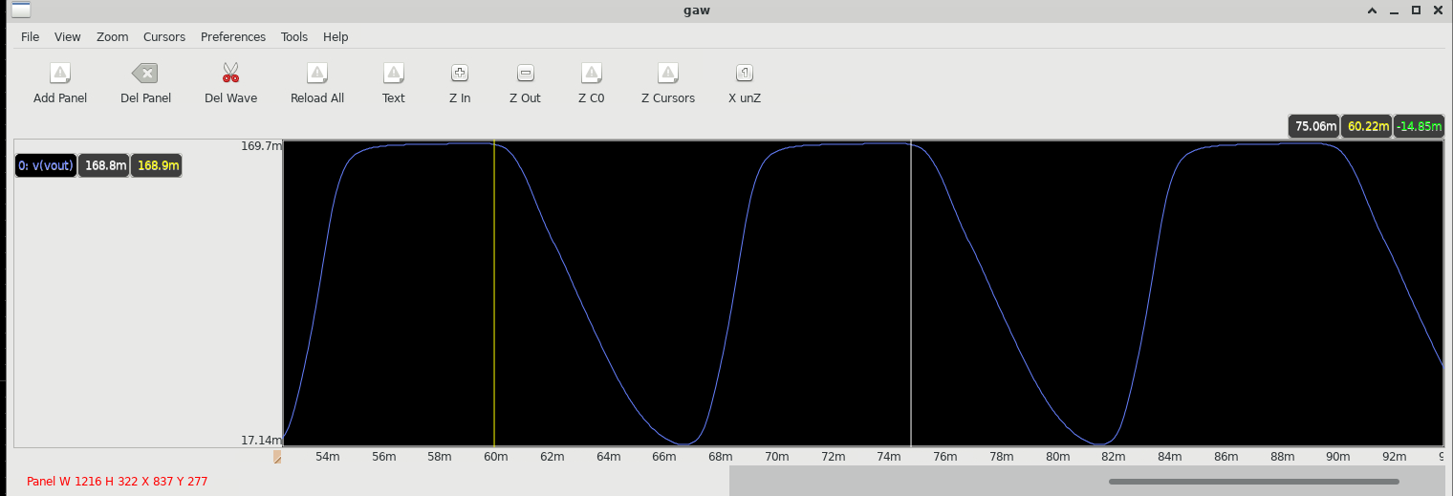

f=66.6 Hz

Supply 160mV

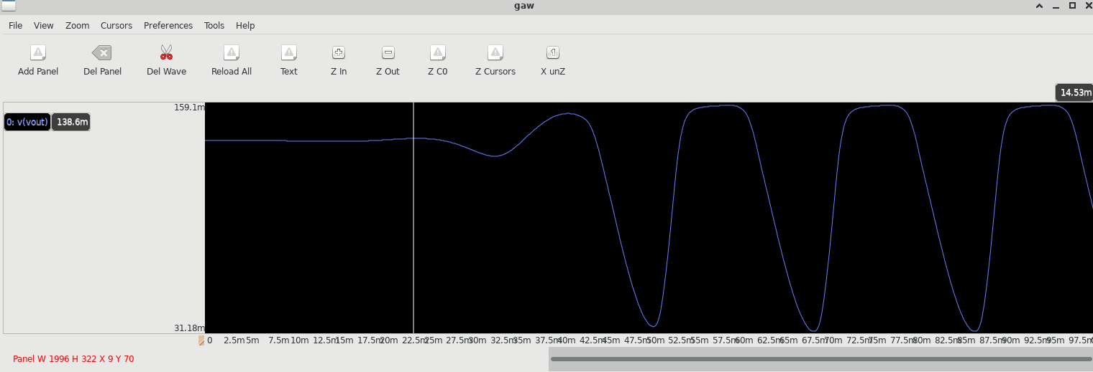

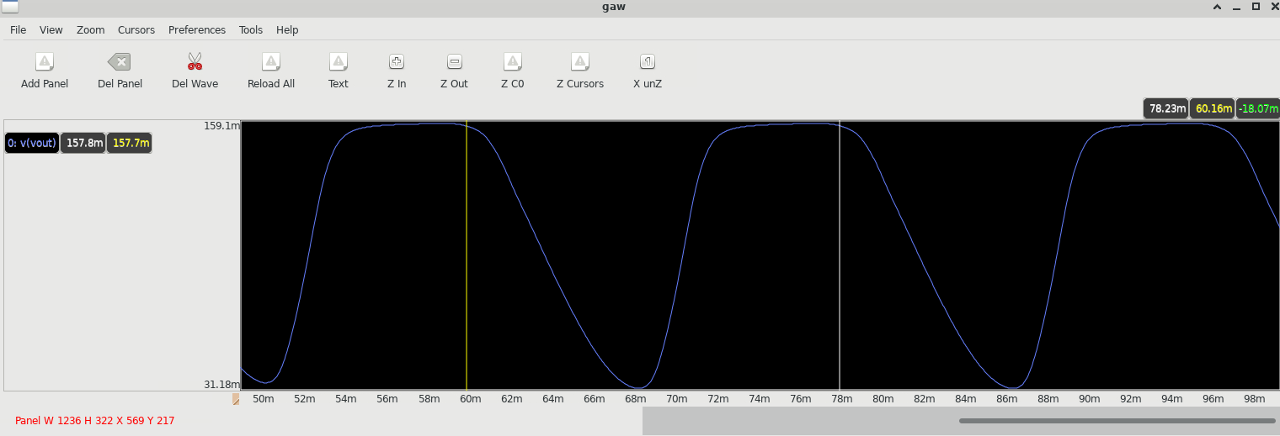

f=55.5 Hz

Supply 155mV

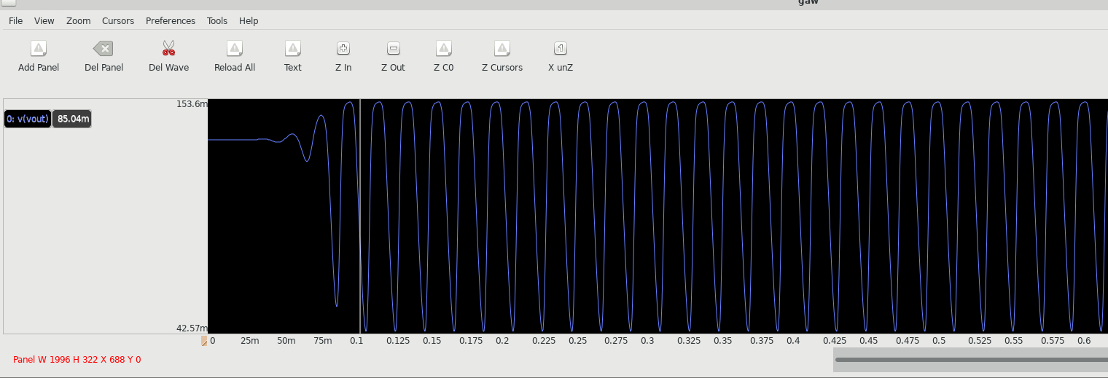

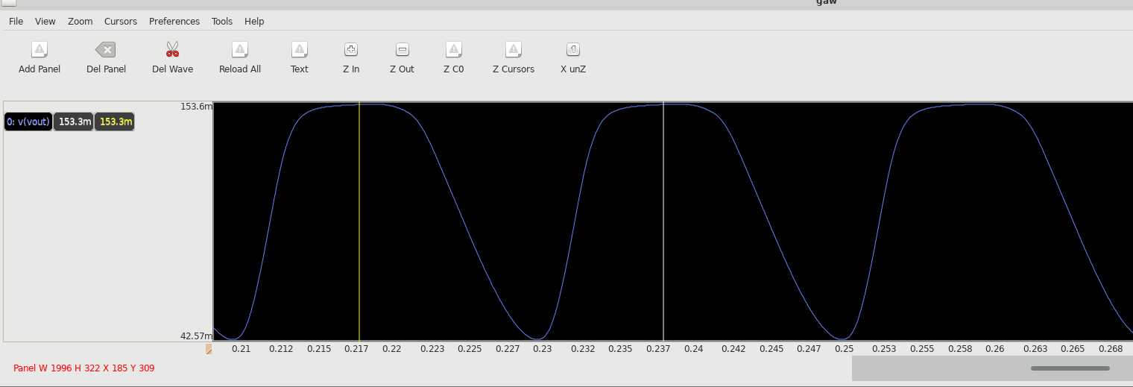

f=50 Hz

Supply 150mV

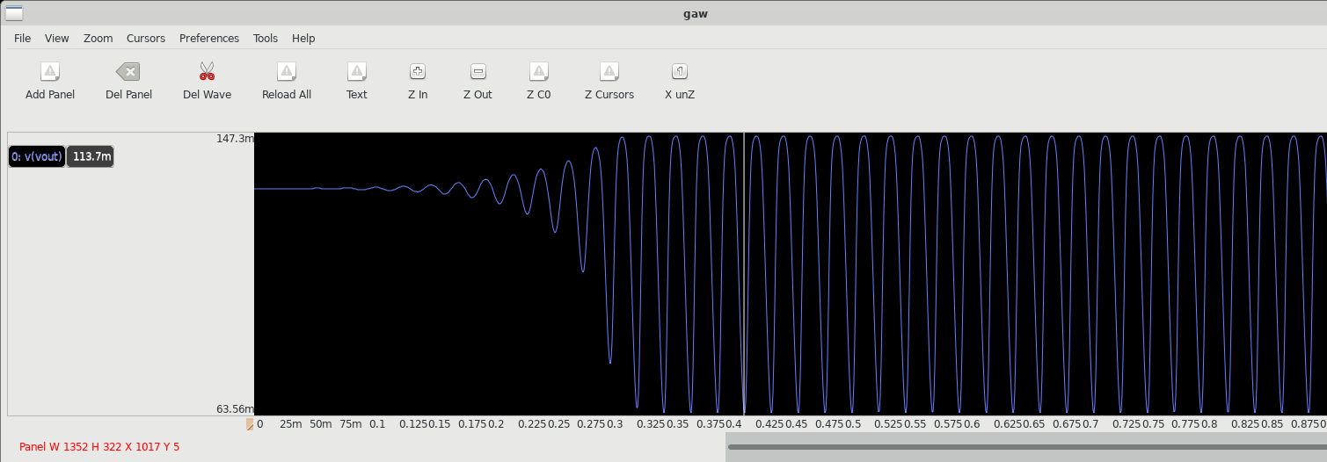

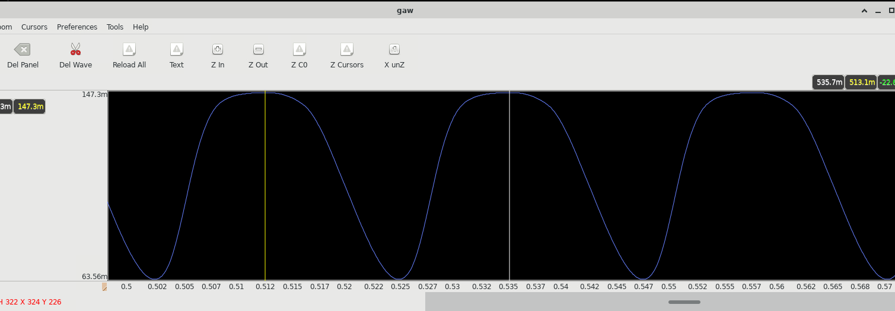

f=43.4 Hz

Supply 145mV

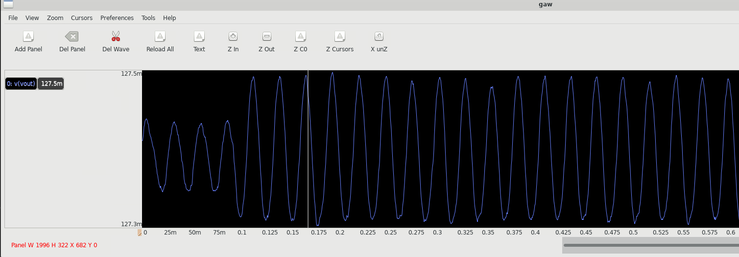

Swing is very small.

There may be 2% - 3% deviation from the given data.

| Power supply | Frequency of Osci at W=0.42u | Frequency of Osci at W=0.63u (1.5 times) | Frequency of Osci at W=0.84 (2 times) |
| --- | --- | --- | --- |
| 1 V | 6.8 MHz | 9.52 MHz | 11.1 MHz |
| 0.7 V | 500 KHz | 714 KHz | 769 KHz |
| 0.4 V | 50 KHz | 10 KHz | 10 KHz |
| 250 mV | 333.3 Hz | 333.3 Hz | 333.3 Hz |
| 200 mV | 117.6 Hz | 131 Hz | 117.64 Hz |
| 170 mV | 66.6 Hz | 71.4 Hz | 66.6 Hz |
| 160 mV | 57 Hz | 57.3 Hz | 55.5 Hz |
| 155 mV | 47.6 Hz | 50 Hz | 50 Hz |
| 150 mV | 44.4 Hz | - | 43.4 Hz |
| 145 mV | - | - | - |

**Observation**: Sizing of Logic transistors used in controlling ring oscillator has no significant role according to above data. So keeping the low size of overall system in mind we should go with minimum size of the transistor ie w=0.42u

* Kamta Kesharwani