CS 4620 Midterm
All answers to discussion questions must be in complete sentences and grammatically correct!
- Describe what our author means by an agile process. How does this differ from what was presented in 3600/3610?
The Agile process is an iterative design process focused on creating quality product through accomplishing work and progress over unnecessary documentation process. In part this is because Agile process focuses on the clientele, and their goals for the product, which they may or may not have know what those goals are at the beginning of the initial designs.
As customers often don’t understand what they are asking for or how to phrase what they do know they want, developers are often called upon to be agile, and change progress paths whether planned or not. Agile process simply plans on the development team being able to change direction at predefined junctures by following an iterative process.
- What are the goals of a system sequence diagram and how does it accomplish those goals?
The goal of a system sequence diagram is to convey the different available ways in which a User (Actor) may communicate with the computer system in order to accomplish the purposes for which the system is designed.
This is accomplished by mapping the interaction in as “high-level” and simple way as possible, generally listing the actions down parallel lifelines which label.
(e.g. “Customer scans item.”)

- What do high cohesion and low coupling mean?
Coupling: A dependency or inter-dependency between two classes that require one to continuously call the other in order to perform its responsibilities.
Cohesion: A relationship in which classes with specific responsibilities communicate with one another to accomplish goals.
A modular system, typically, is a system where there are many classes with specific responsibilities that communicate with one another to accomplish tasks as necessary (high cohesion), and limits the amount of dependency that is required (low coupling) as the modular classes should complete their work and pass only a result for the requesting class.
- Our author recommends writing “black box” uses cases where the focus on an actor- goal perspective. Explain what the author means.

Black box: Academic theory centered on knowing what going into a process, and what the results should be or are, but not necessarily how the process itself works or manipulates data to get a result.
Applying Black box principle to Use Cases helps alleviate some of the complexity in its development. A Use Case is designed to present “what” may be done by an Actor, not how the task needs to be completed. By concentrating on which Actor can get what result (ignoring how that result may be computed), efficient Use Cases may be created.
- What is the Information Expert pattern and how is it used?
This pattern focuses on certain classes holding primary, if not sole, responsibility for particular information and features related to that information. When creating classes and attributes, the class that has the logical necessity for that information holds it.
(e.g. In the POS example the Sale class contained the SalesLineItem objects and each of those contained the Quantity and Price of themselves, and the ability to calculate their own subtotals.)

- In the POS example in the text, the author provides 2 possible designs (see below) for the creation of a payment object that will be associated with a sale object. Give the strengths and weaknesses of each.

Either scenario begins with something requesting the Register class makePayment()
- The first scenario creates a Payment, p, of its own, then uses addPayment(p) have Sale alter its attributes to accommodate the new input. Foremost this causes there to be two Payment attributes in the System after any sale that have the same value. Unless this is requires for a particular feature, this is a waste of computation and memory. However, this is a more versatile format and allows more options, though at the cost of memory and processing time.
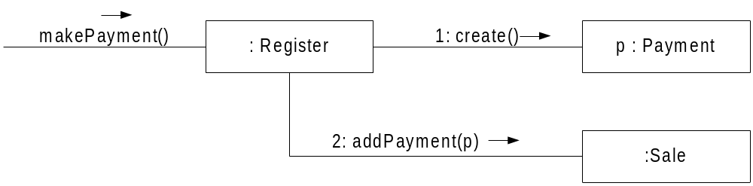
- The second scenario has the Register class request the Sale class create its own payment. Assuming there is a value being passed, the only alteration to the System is the new value in the Sale’s Payment attribute, limiting initial work and memory usage. However, this creates an inherit coupling. Whenever something (such as the Register class) needs to access the last payment, extra work must be done in order to reach the desired data. (This assumes that the Sale class is an attribute of the Register class)
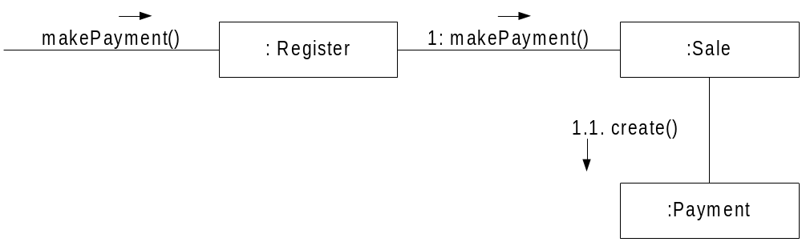

- Describe the relationships described in the attached class diagram.
The attached class diagram appears to be representative of a person’s work attire to his or her personal image.
A person’s overall DressCode is dependent upon their PersonalImage, and each variation of subsequent DressCodes are dependent upon the relative PersonalImage.
There are three DressCodes dependent upon separate PersonalImages:
- SalesmanDressCode (dependent upon seriousBusinessman) composed of DressShirt, DressPants, NeckTie, and SuitJacket (~approximately $600 in value). The overall attire seems to be expensive, uncomfortable and extremely short lived.
- OOGuruDressCode (dependent upon selfImportantExpert) composed of T-Shirt of the Rock&Roll variety (such as GreatfulDead, LedZeplin or PinkFloyd) or HiTech variety (such as MaxwellsEquations, E=MC2, PI, or Euler’s Formula), and frayed Bluejeans containing at least three holes.
- SoftwareEngineerDressCode (dependent upon careFree Techie) composed of clean, sometimes visible Underwear, stained shirt (to include PocketProtector which subsequently contains from 3 to 9 FeltTipMarkers, of which must be different colors), and poorly fitting, ancient, patched pants (of which, either the shirt or pants must be striped, whilst the other be plaid, but never will both be either striped nor plaid).
