A Day in the Life

Student Name: ILLIA VOIITULEVYCH
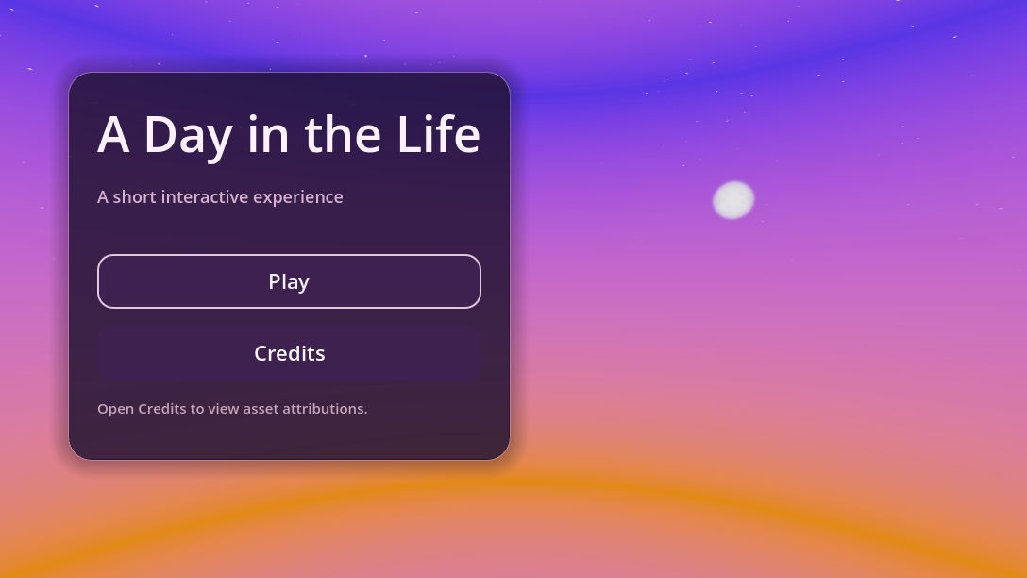

Project Overview

A Day in the Life is a short interactive Godot experience about a first-year game design student moving through a busy day. The project begins in a home environment where the player completes a morning routine, then transitions into a stylised parkour level that represents trying to get to university on time.
The experience combines narrative, exploration, interaction, platforming, tutorial prompts, checkpoints, and a final completion sequence. The goal was to create a small but complete playable experience that reflects a personal daily routine in a playful and exaggerated way.

Response to the Brief

The assignment brief asked for an interactive experience titled around "A Day in the Life of a First Year Game Design Student". I interpreted this as a playable version of a normal student morning, with the routine and stress of getting to university turned into game mechanics.
The Home scene represents the beginning of the day. The player has to complete familiar morning activities such as taking a shower, making the bed, getting dressed, eating breakfast, drinking coffee, and taking a laptop before leaving the house.

The Level 2 scene represents the journey to university. Instead of showing a realistic commute, I exaggerated the feeling of running late by turning it into a floating parkour route. The player has to use movement mechanics, checkpoints, ledge grabs, wall slides, and platforming skills to reach the end.
This structure keeps the project connected to daily life while still allowing the experience to be playful and game-like.

Controls

- `WASD` - Move the character
- `Mouse` - Rotate the camera
- `Space` - Jump
- `E` - Interact with objectives in the Home scene
- `Q` - Continue / close intro dialogue
- `Space near an edge` - Climb up after grabbing a ledge
- `Jump into a marked wall` - Start wall slide
- `Space while wall sliding` - Jump off the wall

Gameplay Structure
The project is structured as a short complete flow:

1. Main Menu
The player starts on a minimal menu screen with a soft sky background, a Play button, and a Credits section.
2. Home Scene
The player begins with an intro dialogue explaining that they need to get ready for university. A quest UI shows the morning routine objectives.
3. Morning Routine Objectives
The player completes interactive objectives around the house. The UI updates as tasks are completed, and prompts appear when the player is close enough to interact.

4. Waypoint Guidance
A small 3D waypoint appears above the nearest unfinished objective so the player understands where to go next without needing a minimap.
5. Transition to Level 2
After completing the routine and leaving the house, the project loads the second scene.
6. Level 2 Intro
A narrative intro explains that the player is now running late for university and needs to reach the end of the route.
7. Parkour Level
The player crosses a floating platforming route using jumping, ledge grabbing, wall sliding, checkpoints, and tutorial hints.
8. Finish Sequence
When the player reaches the final platform, the game displays a completion message, plays a small celebration effect, and returns to the main menu.

Implemented Features

- Main menu with Play and Credits buttons
- Credits panel with scrolling text support
- Background music slots for the menu, Home scene, and Level 2
- Home intro dialogue with player control lock
- Home quest and objective system
- Interactive object prompts using `E`
- Objective checklist UI
- 3D waypoint marker for objective guidance
- Tutorial trigger system using reusable `Area3D` scenes
- Tutorial queue system so multiple hints can appear in order
- Character movement with third-person camera control
- Ledge grab and ledge climb system
- Wall slide and wall jump system
- Static platforms with optional ledge grab support
- Parkour wall objects with optional wall slide support
- Checkpoint system with respawn points
- Kill-plane respawn support
- Finish platform that completes the level automatically
- Confetti-style celebration particles on completion
- Scene transitions between Main Menu, Home, Level 2, and back to Main Menu
- UI panels for objectives, prompts, tutorial hints, status messages, and narrative intros

Visual and Aesthetic Direction
The project uses a soft, dream-like visual style built around pink, purple, and orange lighting. The skybox and colour palette create a surreal version of an ordinary day, which helps connect the normal daily routine to the more exaggerated parkour section.
The Home scene uses pastel lighting and domestic objects to communicate the student's morning routine. The Level 2 scene keeps the same sky and colour atmosphere but shifts into a more abstract platforming space. This makes the transition feel like a stylised version of travelling to university while under pressure.
The UI uses dark translucent panels with light text so it remains readable against the bright environment. Tutorial cards, quest panels, prompts, and intro dialogues all use a consistent visual language.

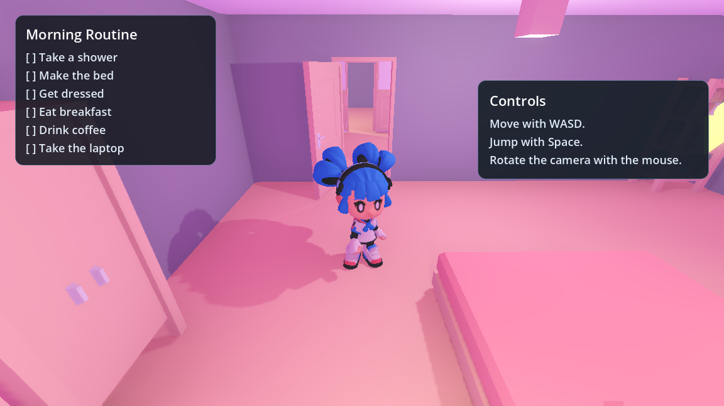
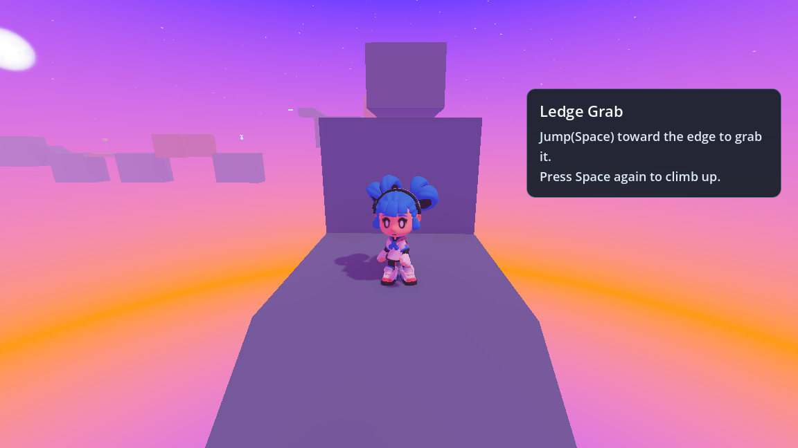

Assets and Credits

Character
- GDQuest. Available at: https://www.gdquest.com

Home Environment Assets
- Furniture Kit by Kenney.
- Used for 3D environment/furniture assets in the project.
- License: Creative Commons CC0 / Public Domain.
- Source: https://www.kenney.nl/assets/furniture-kit

Music and Sound

- Home / Morning Routine Level:
"Lo Fi Hip Hop (Cozy Morning)"
by Alex_Kizenkov
Source: Pixabay

- Main Menu / Calm Background Music:
"Morning Lofi Chill Music"
by SoundGalleryByDmitryTaras
Source: Pixabay

- Parkour / Travelling to University Level:
"Game Background Loop – Uplifting Adventure Music Loop"
by Cyberwave-Orchestra
Source: Pixabay

What I Created Myself

Although the project uses external assets, the interactive structure and gameplay implementation were created for this assignment. The main parts I created and assembled myself include:

- Overall game structure and scene flow
- Main menu layout and credits flow
- Skybox / world environment
- Home level objective design
- Morning routine quest structure
- Interaction prompts and objective checklist UI
- 3D waypoint guidance system
- Tutorial trigger system and tutorial UI
- Level 2 layout and platforming route
- Checkpoint and respawn flow
- Ledge grab and ledge climb integration
- Wall slide and wall jump integration
- Parkour object setup and tuning
- Finish sequence with completion message and celebration effect
- Scene transitions between the menu, Home, Level 2, and ending
- Visual composition of the Home and Level 2 scenes

Development Reflection

The most challenging and rewarding part of the project was building the parkour movement system, especially the ledge grab system. It was difficult to make the character detect edges properly, attach to the platform, play the correct animation, and then climb up in a way that felt responsive. After testing and adjusting the values, the mechanic became one of my favourite parts of the project because it made the platforming feel much more satisfying.
Working on the parkour system also helped me understand how gameplay code, physics checks, animation states, and level design work together. I learned more about how Godot scenes communicate through signals, how reusable scenes can be built, and how player mechanics need to be tuned through testing rather than just written once.
Another important part of the development was improving the player experience. I added tutorials, checkpoints, UI prompts, and waypoints because I wanted the player to understand what to do without being confused. This helped the project feel more like a complete interactive experience instead of just separate mechanics.
Overall, this project helped me understand the process of making a small game from beginning to end: planning the structure, building scenes, connecting scripts, testing mechanics, adjusting UI, and shaping the final experience around a clear theme.

Future Improvements

If I continued developing the project, I would improve it in several ways:

- Add more levels or a longer route to university
- Improve the camera behaviour, especially when the camera gets too close to the character
- Make the character fade or hide when the camera clips into them
- Add more sound effects for interactions, checkpoints, parkour moves, and the finish sequence
- Add more original animations and environmental details
- Expand the narrative with more personal moments from a student's day
- Add more platforming mechanics and difficulty variation
- Polish the environment with more custom-made assets

Links

- Itch.io page: [Add link]
- GitHub / source repository: https://github.com/KamuroKen/Assignment

Computational Elements

The project demonstrates Godot's node and scene workflow through a main menu, a Home scene, a parkour level, reusable platform scenes, tutorial trigger scenes, checkpoint scenes, and multiple scripts. It uses signals, groups, scene instancing, UI overlays, player movement, interaction prompts, objectives, tutorials, respawn logic, and scene transitions.

Aesthetic Elements

The project has a consistent pink and purple visual style, a clear daily-life theme, a personal interpretation of the brief, readable UI, and a playful contrast between the ordinary Home scene and the exaggerated parkour commute. External assets are credited, while the layout, structure, interaction design, UI, and gameplay flow were created for this assignment.

Documentation

This document describes the project concept, relation to the brief, controls, gameplay structure, implemented features, aesthetic direction, asset credits, personal contribution, development reflection, future improvements, and project links. The Itch.io page and video demo should be linked above before submission.

Some screenshots from the game:
