Shannos Food Truck – Task 3 Final Project Report
Nov 9, 2026 · @Kamv'elihle Dyantyi

Cover
Shannos Food Truck: online ordering app and website Module: XISD6329 · Task 3, final WIL submission (Week 12) · Team: Zentra
Team member | Student number | Main role
Kamv’elihle Dyantyi | ST10434588 | Team Lead, DevOps, GitHub, final code and publishing
Katleho Khutsoane | ST10442069 | UI/UX design, UI and input controls, presentation
Neziswa Bikitsha | ST10456794 | Requirements, documentation, README, AI write-up
Amandla Sekeleni | ST10456349 | Database and development (menu, Firestore data)
Submitted by: ______________________ (name) · ______________ (student number)
- GitHub repository: github.com/KamvelihleAthabileDyantyi17/Zentra
- README (setup, user guide, release notes): README.md
- Website (Firebase Hosting): https://shannos-food-truck.web.app
- Video presentation (unlisted YouTube): add link here

Annexure A: Group declaration of authenticity
This declaration is signed once by the whole group. Annexures B and C (peer and self-evaluation) are separate forms that each member completes on their own, at the end of this report.
We, the members of group Zentra listed below, hereby declare that this portfolio, and any evidence included therein, contains our own independent group work and that we have not received help from other groups.
We confirm that we have not committed plagiarism in the accomplishment of this work, nor have we falsified and/or invented experimental data.
We accept the academic penalties that may be imposed for violations of the above.
Reiteration of the declaration we have signed:
- We have been informed about the seriousness of acts of plagiarism.
- We understand what plagiarism is.
- We are aware that The Independent Institute of Education (IIE) has a policy regarding plagiarism and that it does not accept acts of plagiarism.
- We are aware that the Intellectual Integrity Policy and the Student Code of Conduct prescribe the consequences of plagiarism.
- We are aware that referencing guides are available in our student handbook or equivalent and in the library and that following them is a requirement for successful completion of our programme.
- We are aware that should we require support or assistance in using referencing guides to avoid plagiarism we may speak to the lecturers, the librarian or the campus ADC/Campus Co-ordinator.
- We are aware of the consequences of plagiarism.
The use of AI tools in this project is declared and described in the section Use of AI tools.
Student name | Student number | Signature | Date
Kamv’elihle Dyantyi (Team Lead) | ST10434588
Amandla Sekeleni | ST10456349
Neziswa Bikitsha | ST10456794
Katleho Khutsoane | ST10442069

Introduction
Task 3 delivers a working Android app (Kotlin, Jetpack Compose) and a website that share one Firebase back end, so Shannon’s customers can order ahead and her team can run the trucks from one live system.
In Task 1 we planned the system and in Task 2 we built a first app in XML. That app had two login systems, a settings screen that crashed, a menu that was not linked to the cart and no real tests. For Task 3 we rebuilt it on a clean structure, added the website, Google single sign-on and the Daily Purchase Recommendation from our Task 1 plan, and answered every point of lecturer feedback.
This report covers the feedback and what we changed, the purpose of the app and website, how we built them, the SSO feature, screenshots and designs, testing, publishing, release notes and our use of AI tools.

Feedback from Task 1 and Task 2
We acted on all eleven points of lecturer feedback: nine are done in the code and documents, and two (physical-phone evidence and the Firebase check) wait on the Firebase setup, with a checklist ready.

Task 1 (planning)
Strengths the lecturer named: a strong client-needs analysis with clear links between Shannon’s problems, stakeholders and system features; good DevOps planning (Azure DevOps Boards, GitHub, feature branches, pull requests, CI/CD); real development activity in the repository.
What we kept: the client-needs analysis became our checklist. Every Task 3 feature is traced to a Task 1 requirement (see Purpose of the app and website). We kept the branch-and-pull-request workflow for every change in Task 3 (pull requests #33 to #35 and the v2.4 pull request).
Weakness raised | What we changed in Task 3 | Evidence
Not enough clearly separated website and mobile-app screens in the wireframes | Five mobile-app wireframes and seven website wireframes, drawn separately, with numbered notes explaining each element | Screenshots and designs; design canvas
Sitemap shown as an architecture diagram, not a navigation structure | Two navigation sitemaps (app and website) showing every screen and how users move between them | Screenshots and designs
Automated testing not demonstrated | 33 app unit tests and a 20-check website end-to-end test, both run by GitHub Actions on every push | Testing evidence; GitHub Actions

Task 2 (mobile app)
Strengths the lecturer named: native Kotlin screens, menu search and filtering, cart logic, Firebase authentication, a Firestore order attempt, a README and a GitHub Actions workflow.
What we learnt: most of our Task 2 problems came from building screens separately with no shared structure. We had two login systems (Firebase and a local SQLite table), two settings screens, a crash when opening Settings, and a menu that never reached the cart. We also found CI could never pass: gradlew was not executable and the Gradle, Kotlin and Java versions did not match. For Task 3 the team agreed to rebuild on one structure instead of patching.
Weakness raised | What we changed in Task 3 | Evidence
Physical-phone testing not completed | A 20-step phone test plan; the app runs on demo data with no setup, so anyone can test it | docs/testing.md
Menu-to-cart connection not finished | One shared cart used by every screen; menu, cart, checkout and tracking are connected | Unit test fullOrderJourney
Settings menu limited | A Settings section: my truck, remember my details, privacy policy, staff login | Account screen screenshots
Meaningful automated tests only planned | 33 unit tests on the core logic, plus the website end-to-end test | app/src/test, tests/web
Confirmation shown before the online order write succeeded | The app and website now wait for Firebase to confirm the save before showing tracking or clearing the cart; offline, the button keeps waiting | CustomerViewModel.placeOrder, customer.js
Report needed a practical end-user guide | Step-by-step guide for customers and staff | README, How to use it
README placeholders and status out of line with the code | README rewritten for the new code; truck locations and delivery fees now real (no placeholders); release notes per version | README
Verify the Firebase/Firestore configuration and give evidence of testing | Security rules in the repository, a Firebase setup guide and a configuration checklist | firestore.rules, README, docs/testing.md

Overall reflection
Our planning was strong, but our build in Task 2 did not follow it closely enough. In Task 3 we tied every feature back to a requirement, tested the logic automatically, and fixed the build pipeline first so that every later change was checked. Our main remaining weakness is evidence from real devices, which depends on finishing the Firebase setup.

Purpose of the app and website
The app and website replace Shannon’s WhatsApp ordering and guesswork stock buying with one live ordering and stock-planning system for her food trucks.

The problem
Shannon runs a food truck in Parklands selling kotas, amagwinya, slap chips, rolls and cold drinks. Her Task 1 analysis showed three problems:
- “WhatsApp chaos”: orders arrive by walk-up and WhatsApp, so orders are missed or duplicated and demand can’t be predicted.
- Buying by guesswork: stock is bought without data, causing food waste or running out.
- No brand presence: customers can only find her by word of mouth.

Who it is for
User | Needs | How they use it
Customers: construction workers and busy people near the trucks | Order quickly, know when food is ready, no queue | App or website: order, pay at collection or delivery, track live
Shannon (owner) | One view of all orders, less waste, more sales | Staff dashboard: live orders, Sales & buying, menu, stock
Truck staff | Clear list of what to cook, simple to use | Staff dashboard: one tap per order stage

Why both an app and a website
The app is for regular customers who order often; it remembers their details and truck. The website needs no install, so first-time customers can order from a link, and Shannon can run the staff dashboard on a laptop or tablet in the truck. Both share one Firebase database and the same Google login, so an order placed on either appears instantly on both.

Key features, traced to the Task 1 requirements
Feature | Task 1 requirement | App | Website
Menu with prices, filtered by category | FR-01, FR-02 | Yes | Yes
Cart with quantities and a kitchen note | FR-03 | Yes | Yes
Order with name, cellphone and pickup time (ASAP or 15-minute slots) | FR-04 | Yes | Yes
Order number and live tracking: Received, On the pan, Ready, Collected | FR-05 | Yes | Yes
Order history (My orders) | FR-06 | Yes | Yes
Google sign-in (optional; guests can order) | FR-07 | Yes | Yes
Live order board; staff move orders through stages | FR-08, FR-09 | Yes | Yes
Daily Purchase Recommendation from real orders, in Checkers packs with estimated cost | FR-10, FR-14 | Yes | Yes
Menu management: mark items sold out | FR-11 | Yes | Yes
Sales report: orders, sales, average order, top sellers | FR-12 | Yes | Yes
Data stored in a database | FR-13 | Firestore | Firestore
Delivery: free in Parklands, R50 outside | Client request | Yes | Yes
Several trucks: Truck 1 at Sandown Rd & Discovery Dr, Rivergate; Trucks 2 and 3 coming soon | Client request | Yes | Yes
Not yet built: push notifications (FR-15) and online card payment (FR-16, Phase 2 in our plan). Card and cash are paid at collection or on delivery.

Expected impact
- No missed orders: every order lands on one live board, with a number and a status.
- Less waste: the Daily Purchase Recommendation turns the day’s orders into a shopping list, minus what is already on the truck.
- Shorter queues: customers order ahead and collect at a chosen time.
- A brand online: a website and an app in a consistent kasi street-signage style.

Development: how we built it
We rebuilt the app in Kotlin with Jetpack Compose and wrote the website in plain HTML, CSS and JavaScript; both talk to one Firebase project (Authentication and Cloud Firestore), and GitHub Actions builds and tests every change.

Architecture
The app and website follow the same three layers, so the code reads the same on both:
- Screens (Compose screens / website views) only show state and pass taps on.
- View models (CustomerViewModel, StaffViewModel) hold the screen state and the rules: cart maths, checkout checks, pickup times, delivery fees.
- One data interface (FoodRepository and AuthService in the app, backend.js on the website) with two implementations: Firebase for live data and an in-memory demo version for tests and for running without internet.
Orders, the menu and stock use Firestore live listeners: when staff tap Start cooking, the customer’s tracking screen updates within a second, with no refresh. Firestore security rules (firestore.rules) let customers read only their own orders and let only staff change the menu or an order’s stage.

Technology
Part | Choice | Why
App language and UI | Kotlin, Jetpack Compose, Material 3 | Google’s recommended UI toolkit; less code than XML; screens update automatically when data changes
Navigation and state | Navigation Compose, ViewModel, StateFlow | One shared cart and order state across screens
Back end | Firebase Authentication, Cloud Firestore | Real-time updates, Google sign-in, free tier, no server to run
Google sign-in | Android Credential Manager (app), Firebase popup sign-in (web) | Current Google-recommended sign-in on each platform
Website | HTML, CSS, JavaScript modules, Firebase Hosting | No build step; every line is readable; free hosting
Build | Gradle 8.11, Android Gradle Plugin 8.10, Kotlin 2.0, JDK 17, min SDK 24, target SDK 36 | A tested version set; Task 2’s mismatched versions broke CI
Tests | JUnit, kotlinx-coroutines-test, Playwright | Unit tests for logic; a real browser for the website

Design
We redesigned the look before coding, in a clickable prototype: a kasi street-signage style with sign yellow (#FFC531), chilli red (#C73A1D) and ink black (#1A1612), bold condensed headings (Anton) and food “tiles” (KOTA, AMA, WORS) instead of stock photos. The same colours and components are used in the app (ui/theme/Theme.kt) and on the website (web/css/styles.css). Touch targets are at least 44 dp and text colours meet WCAG AA contrast.

Decisions we made
- Rebuild, not patch. Task 2 had two login systems and two settings screens. One structure was quicker to make correct than fixing every screen.
- Compose instead of XML. Compose updates the screen by itself when Firestore data changes, which live tracking needs.
- Guest checkout. Customers at a food truck window won’t make an account first. A hidden anonymous Firebase account protects their order, and signing in with Google later keeps it.
- Demo mode. Setting USE_FIREBASE to false runs the app and website on built-in data, so testers and markers can try them without our Firebase project.
- Logging. Every important step is logged with one tag, Shannos (AppLog.kt; [Shannos] in the browser console), never passwords, tokens or phone numbers.

GitHub and DevOps
- Planning: Azure DevOps Boards, with Task 3 work items per member.
- Branching: no direct commits to main. Each change is a feature/... branch and a pull request, reviewed by the Team Lead before merging (#33 rebuild, #34 Google sign-in, #35 website and Play Store preparation, then the v2.4 feedback fixes).
- GitHub Actions (.github/workflows/android.yml) runs on every push and pull request:
  - build job: unit tests, then builds the debug APK and uploads it as a download. When the signing secrets are set, it also builds a signed release APK and App Bundle.
  - website job: checks every script for errors, then runs the end-to-end browser test and saves its screenshots.
- README: setup, Firebase steps, end-user guide, testing, logging and release notes for each version.

Single sign-on (SSO) on the app and website
Customers and staff sign in with their Google account on both the app and the website. One Firebase Authentication project serves both, so the same Google account is the same user everywhere: an order placed on the website shows up under My orders in the app.

How it works
Step | Android app | Website
1. Customer taps Continue with Google | Android Credential Manager shows the Google account picker (GetSignInWithGoogleOption) | Firebase signInWithPopup with GoogleAuthProvider
2. Google returns an ID token | Token passed to Firebase with GoogleAuthProvider.getCredential | Handled by the Firebase SDK
3. Firebase signs the user in | FirebaseAuthService (auth/GoogleSignIn.kt) | firebase-backend.js
4. Guest orders kept | linkWithCredential joins the anonymous guest account to the Google account, so earlier orders stay | Same, with linkWithPopup
5. Session | Firebase keeps the user signed in after the app is closed | Firebase keeps the session in the browser
The Web client ID comes from google-services.json (R.string.default_web_client_id); we never hard-code keys or passwords.

Staff access
Staff sign in with the same Google button (or a staff email and password set up by the owner). The app and website then check for a document at staff/{uid} in Firestore. Only accounts listed there see the Staff tab and staff.html, and the Firestore rules enforce the same check on the server, so hiding a button is not the only protection.

Sign out and delete account
The Account screen (app) and account panel (website) show the signed-in name and email, with Sign out and Delete my account. Deleting permanently removes the user’s login, which Google Play requires for apps with sign-in. Firebase only allows this soon after signing in, so if the sign-in is old the app asks the user to sign in again first. Orders already placed stay in the truck’s sales records.

What still needs setting up
Google sign-in on Android only works once each developer’s SHA-1 fingerprint and the release-key SHA-1 are added in Firebase, and Google is turned on as a sign-in provider. The website also needs its domain added to Firebase’s authorised domains. These steps are in the README; until they are done, demo mode shows a pretend Google sign-in so the flow can still be tested.

Screenshots and designs
Task 1 feedback asked for separate web and app wireframes and a sitemap that shows navigation. This section shows the full set, followed by screenshots of the finished website. Full-size versions are in the project’s design canvas and in docs/screenshots/web in the repository.

Sitemaps (navigation structure)
The app sitemap shows the five bottom tabs (Home, Menu, Order, Track, Account), the screens behind each tab, and the staff area that only appears for staff accounts. The website sitemap shows the customer site (index.html), the separate staff site (staff.html) and the privacy policy, with arrows for each link a user can follow.
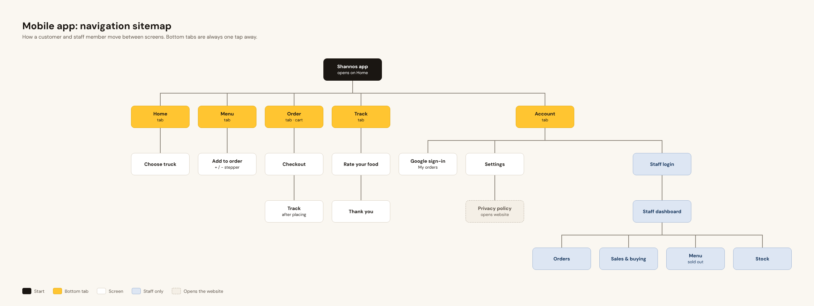
Figure 1. App sitemap (navigation structure).
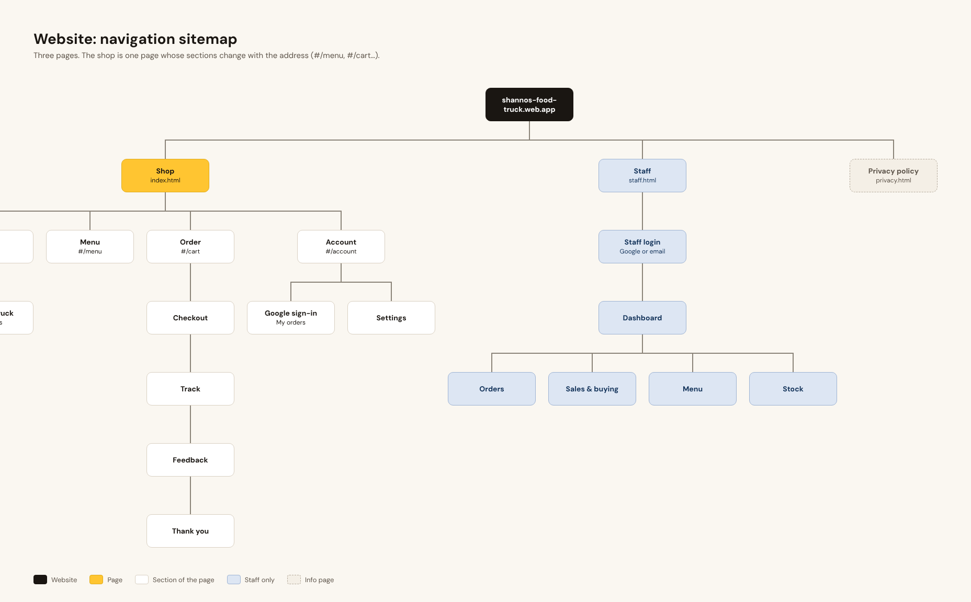
Figure 2. Website sitemap (navigation structure).

App wireframes (phone, 390 × 844)
Five low-fidelity wireframes cover the main customer journey: Home (truck and open status), Menu (categories and add buttons), Checkout (pickup or delivery, pickup time, payment), Track order (four stages) and Account (Google sign-in and settings).
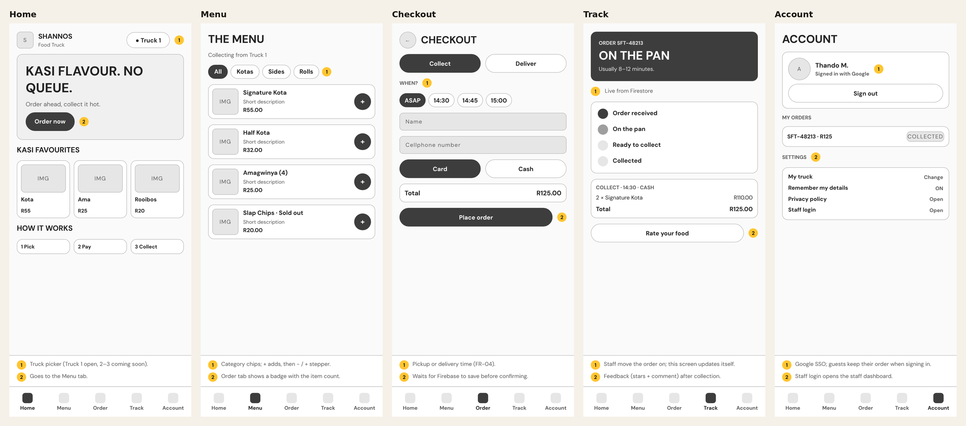
Figure 3. App wireframes. Numbered notes explain each element.

Website wireframes (desktop, 1280 × 820)
Seven wireframes cover the customer website (Home, Menu, Checkout, Track, Account) and the staff website (Orders board and Sales & buying report). The website uses a wider layout: menu and cart sit side by side, and staff see orders as columns by stage.
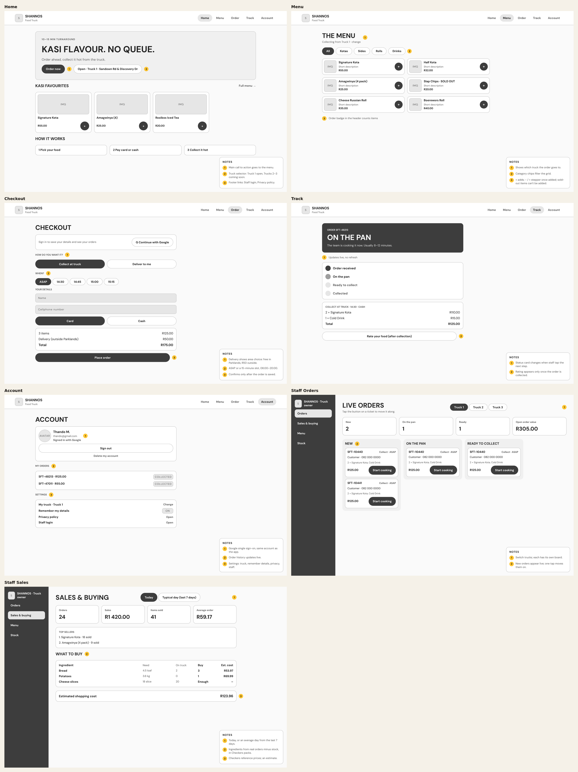
Figure 4. Website wireframes: customer pages and the staff Orders and Sales & buying pages.

Finished website
The screenshots below were taken automatically by our end-to-end test in a real Chromium browser, so they show the website exactly as it runs.
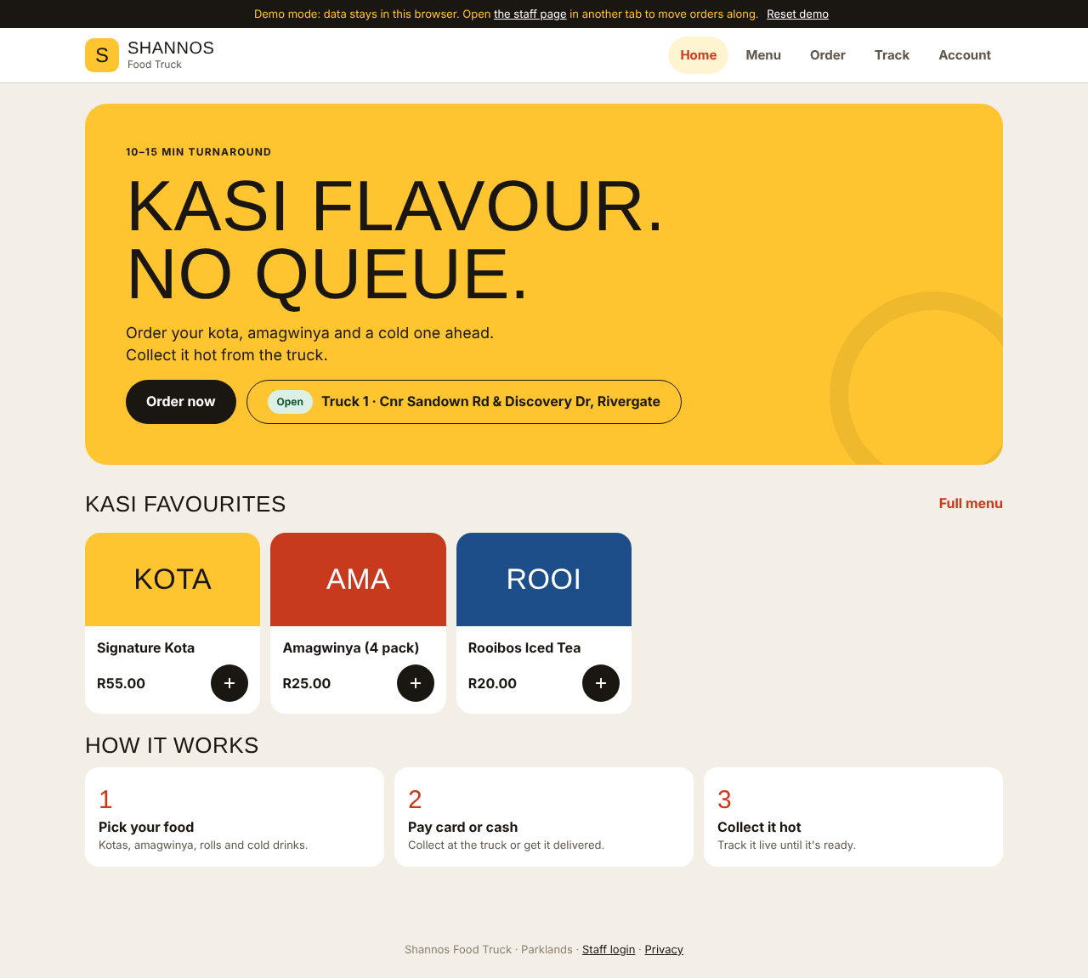
Figure 5. Home page with Truck 1 and its address.
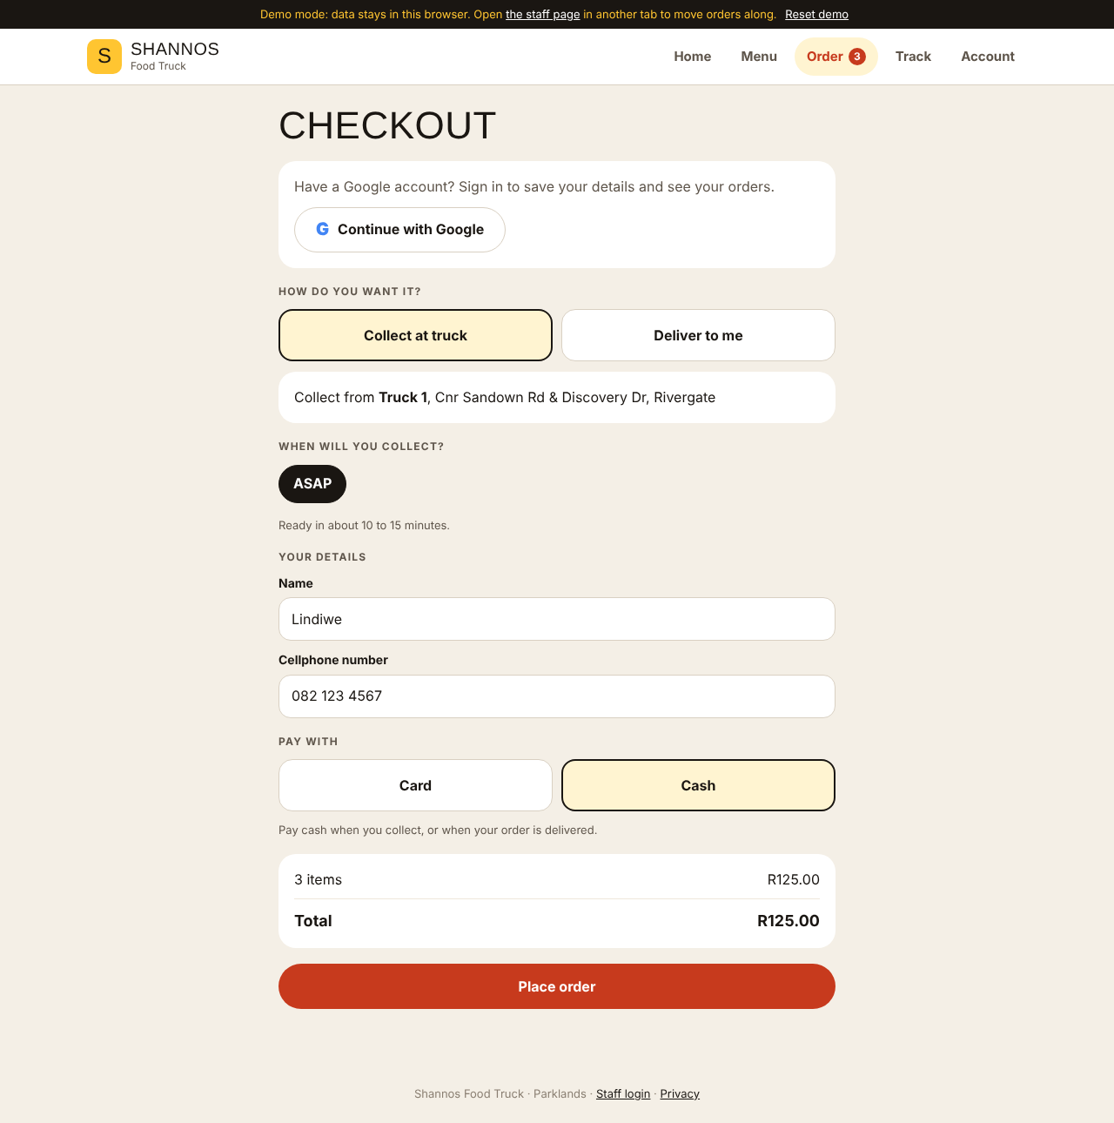
Figure 6. Checkout: collect or delivery, pickup time, payment.
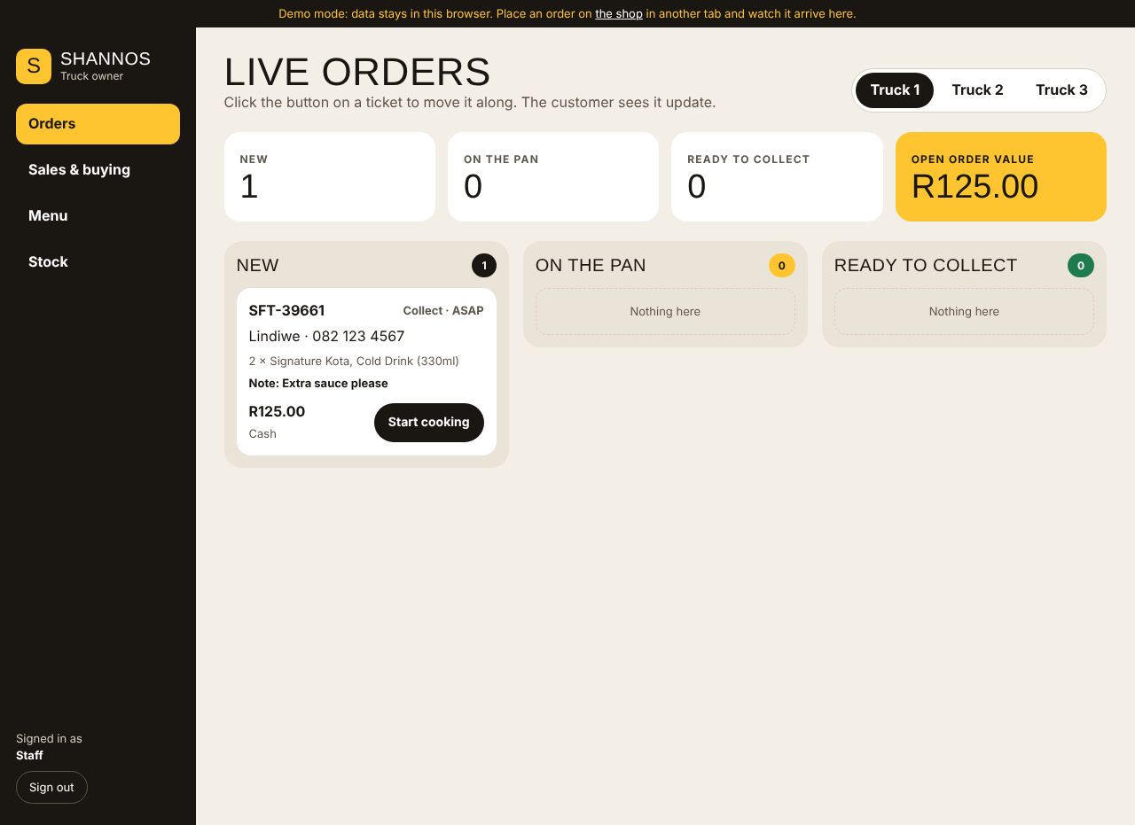
Figure 7. Staff order board: the new order arrives live.
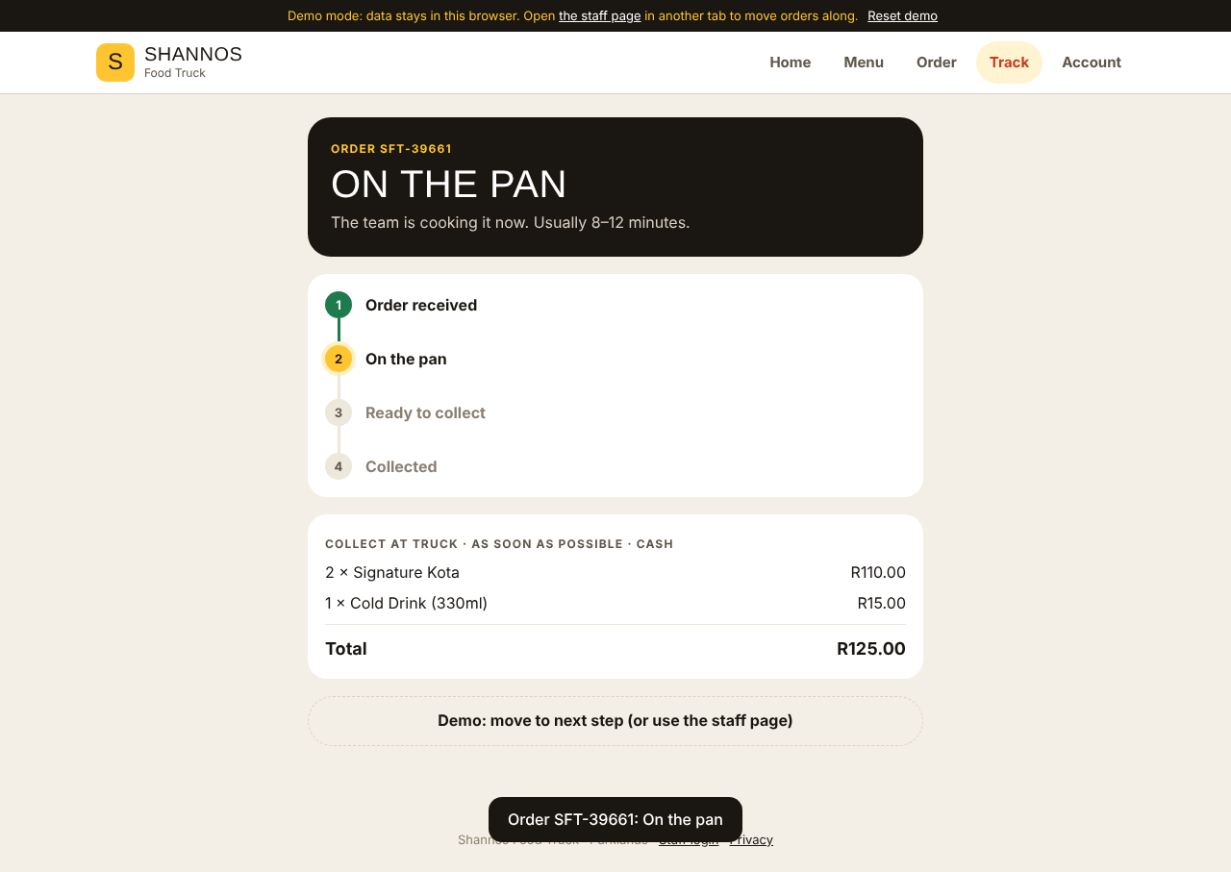
Figure 8. Customer tracking updates to On the pan when staff start cooking.
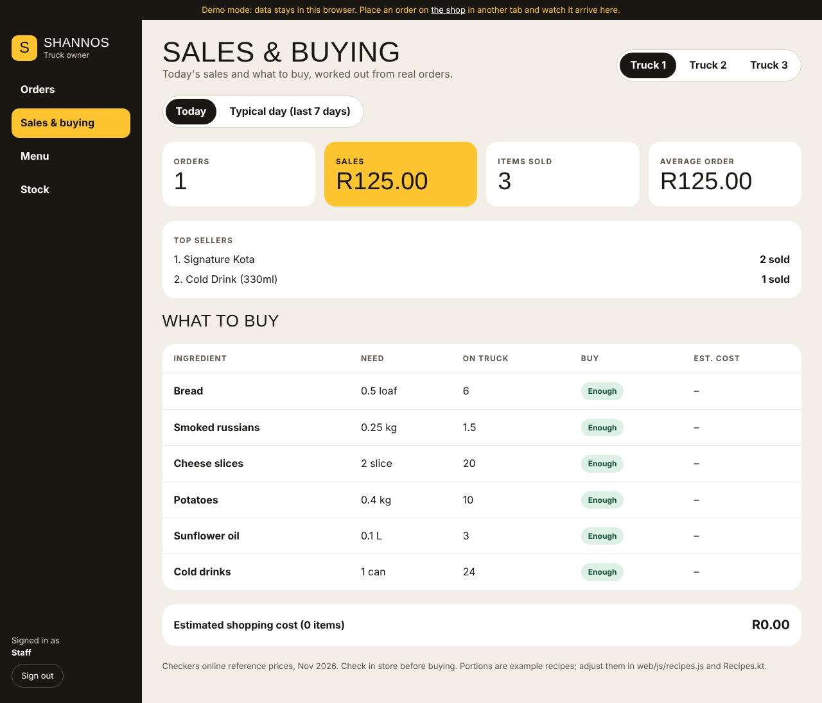
Figure 9. Sales & buying: sales summary and the Checkers shopping list.
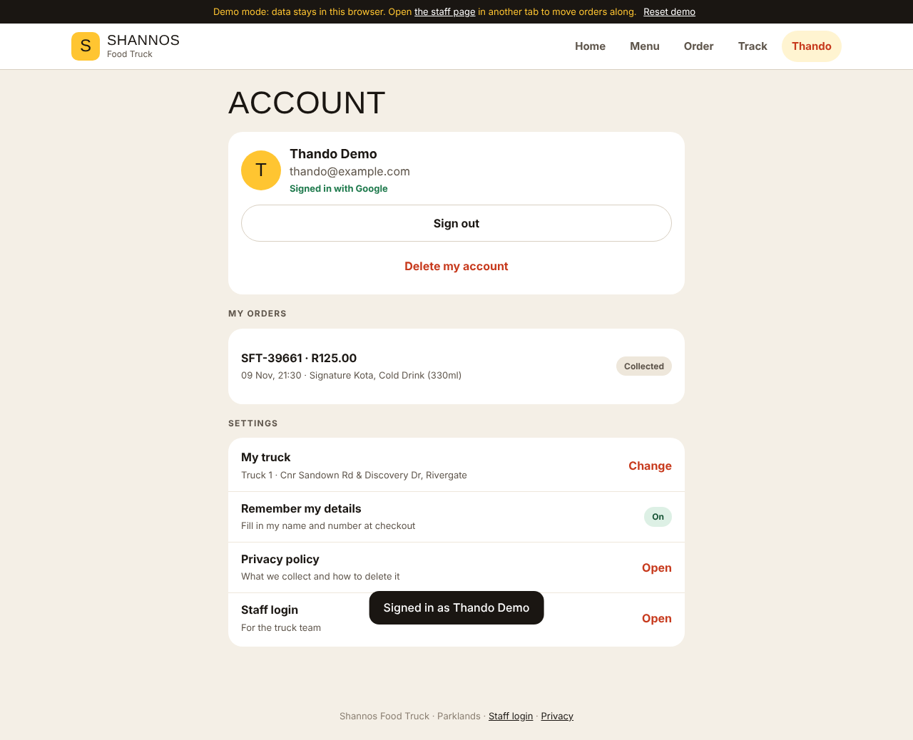
Figure 10. Account signed in with Google: order history, settings, sign out and delete.

Android app
App screenshots from a phone are added once Firebase is connected (see Testing evidence). The app uses the same layout and colours as the wireframes and the website.

Testing evidence
Task 2 feedback said our tests were only planned. In Task 3 they are written, run automatically by GitHub Actions on every push, and a failing test stops the build.

Automated unit tests (Android app): 33 tests
Test file | Tests | What it proves
OrderFlowTest | 13 | Menu and trucks load; category filter; checkout with missing details places no order; the full journey from cart to Collected; sold-out items can’t be ordered; Google sign-in keeps guest orders and shows history; sign-out stops tracking; staff Google sign-in; delete account clears saved details; coming-soon trucks can’t be chosen; R50 delivery outside Parklands; remembered details pre-fill and can be turned off; the staff report counts today’s orders
CartTest | 11 | Empty start; same item increases quantity; removing the last one drops the line; quantity cap; sold-out items dropped; current menu prices; rand formatting; order stages move forward and stop; stock status; South African phone numbers; delivery needs an address
PurchasePlannerTest | 9 | Every menu item has a recipe; sales summary and top sellers; ingredient usage per quantity; buying rounds up to whole Checkers packs and subtracts stock; enough stock means buy nothing; weekly basis averages per day; unpriced items have no cost; free delivery in Parklands, R50 outside; pickup slots start 15 minutes ahead and stop at closing
These run on the in-memory demo data, so they test our rules without needing the internet or Firebase.

Automated end-to-end test (website): 20 checks
tests/web/e2e.mjs opens the website in a real Chromium browser (Playwright) and acts like a customer and a staff member at the same time, in two tabs:
# | Check | # | Check
1 | Home loads | 11 | Sold-out toggle and stock with units
2 | Trucks 2 and 3 show “coming soon” | 12 | Feedback sent
3 | Menu filter and add to order | 13 | Sold-out item shows on the shop
4 | Checkout blocks missing details | 14 | Google sign-in shows order history
5 | Delivery free in Parklands, R50 outside | 15 | Session survives reload
6 | Order placed, tracking shows Received | 16 | Saved details pre-fill checkout
7 | Staff see the order live | 17 | “Remember details” can be switched off
8 | Customer sees On the pan live | 18 | Delete account
9 | Collected order leaves the board | 19 | Privacy policy page
10 | Sales report and purchase list | 20 | Phone-sized layout
All 20 pass. The test also saves the 16 screenshots shown in this report, so the screenshots are evidence of a passing run, not staged pictures.

CI results
The GitHub Actions page shows a green build job (unit tests, debug APK) and a green website job (script check, end-to-end test) for the merged pull requests. [Add a screenshot of the Actions page for the latest run on main.]

Manual testing on a phone
docs/testing.md is a 20-step checklist for a real Android phone: install, guest order, Google sign-in, live tracking while staff change the stage, delivery fee, settings, sign out, delete account, offline behaviour and dark mode. Each member runs it on their own phone once Firebase is connected.
Device | Android version | Tester | Result
[phone model] | [version] | Kamv’elihle Dyantyi | [pass / issues]
[phone model] | [version] | Amandla Sekeleni | [pass / issues]
[phone model] | [version] | Neziswa Bikitsha | [pass / issues]
[phone model] | [version] | Katleho Khutsoane | [pass / issues]

Testing with the client
Shannon’s details (the truck’s address, free delivery in Parklands and R50 outside, and buying from Checkers) are built into v2.4 and covered by the tests above. [Add the date Shannon tried the website or app, and her comments.]

Publishing on Google Play
The app is prepared for Google Play. The repository has everything Play needs; the steps that need our own accounts and keys are listed below with who does them. The full guide is docs/play-store/README.md.

Ready in the repository
Play requirement | Where it is
App icon (adaptive) and 512 × 512 store icon | res/mipmap-*, docs/play-store/play-icon-512.png
Feature graphic 1024 × 500 | docs/play-store/feature-graphic-1024x500.png
Store listing text (name, short and full description) | docs/play-store/README.md
Privacy policy page | web/privacy.html, hosted with the website
Account deletion inside the app and on the web | Account screen → Delete my account
Release signing | app/build.gradle.kts reads keystore.properties; the keystore is never committed (.gitignore)
Signed build on every push | GitHub Actions builds a signed APK and App Bundle (.aab) once the four keystore secrets are added
Target SDK | Android 16 (API 36). Since 31 August 2026 Play only accepts new apps that target API 36, so v2.4 moved from API 35 to 36

Steps to publish
- Change the application ID from com.example.shannosfoodtruck to za.co.shannos.foodtruck (Play rejects com.example), and register it in Firebase with a new google-services.json.
- Create the upload keystore in Android Studio (Build → Generate Signed Bundle / APK) and add its SHA-1 to Firebase so Google sign-in works in the release build.
- Build the signed APK and App Bundle: ./gradlew assembleRelease bundleRelease.
- Create the Play Console account (once-off US$25 fee) and the app, then fill in the store listing, content rating, data safety form (we collect name, phone and email for orders) and the privacy policy link.
- Upload the App Bundle to the internal testing track first, then a closed test.
- Closed test. Google requires new personal developer accounts to run a closed test with at least 12 testers who stay opted in for 14 days in a row before the app can go to production.
- Apply for production access and publish.

Evidence
[Add: a screenshot of the signed APK (or the signed artifact in GitHub Actions), a screenshot of the app in Play Console with the uploaded App Bundle, and the store listing preview.]

Release notes, README and links
The README is the front page of the repository. Task 2 feedback said it had placeholders; it now has setup steps, Firebase setup, an end-user guide, testing evidence, logging, the team workflow and release notes for every version.

Release notes
Version | Theme | Main changes
v2.0 | Full rebuild | Jetpack Compose app matching the new design; one login and one data source instead of two; live order tracking; staff dashboard in the app; multi-truck ordering; guest checkout with SA cellphone checks; feedback saved; Firestore security rules; demo mode and unit tests; CI fixed
v2.1 | Google sign-in and logging | Continue with Google (SSO); guest orders kept after sign-in; My orders history; staff Google sign-in limited to the staff list; session kept between launches; logging with tag Shannos
v2.2 | Website | Customer website with ordering, live tracking, feedback and Google sign-in; staff web dashboard; live sync between app and website; demo mode; Firebase Hosting setup
v2.3 | Ready for Google Play | App icon; Delete my account on app and web; privacy policy page (POPIA); release signing and signed builds in CI; store listing, icon and feature graphic
v2.4 | Lecturer and client feedback | Daily purchase recommendation from real orders, priced at Checkers; sales report (today or 7 days); preferred pickup time; delivery free in Parklands, R50 outside; real Truck 1 address, Trucks 2 and 3 coming soon; Settings; website end-to-end test in CI; stock with units; end-user guide and phone checklist; targets Android 16 (API 36)

What still needs doing
- Connect Firebase: SHA-1 fingerprints, Google provider, rules, the staff list and the website’s Firebase settings.
- Deploy the website to Firebase Hosting.
- Change the application ID and upload to Play internal testing, then the closed test.
- Add the owner’s details to the privacy policy (date, how long orders are kept, contact email).
- Add Trucks 2 and 3 once their locations are decided, and check the recipes against Shannon’s real portions.

Links
What | Link
GitHub repository | https://github.com/KamvelihleAthabileDyantyi17/Zentra
README and release notes | https://github.com/KamvelihleAthabileDyantyi17/Zentra#readme
GitHub Actions (build and test runs) | https://github.com/KamvelihleAthabileDyantyi17/Zentra/actions
Pull requests | https://github.com/KamvelihleAthabileDyantyi17/Zentra/pulls?q=is%3Apr
Phone test checklist | https://github.com/KamvelihleAthabileDyantyi17/Zentra/blob/main/docs/testing.md
Play Store guide | https://github.com/KamvelihleAthabileDyantyi17/Zentra/blob/main/docs/play-store/README.md
Designs, wireframes and sitemaps | https://claude.ai/artifact/TDJvDfTHGK885u7UaYBEAg
Live website | [Firebase Hosting link, e.g. https://shannos-food-truck.web.app, once deployed]
Google Play listing | [Add once published]
Azure DevOps board | [Add link]

Use of AI tools
We used Claude (Anthropic’s AI assistant) in Task 3. We are stating this openly, as the IIE’s rules on AI require, so the marker can see what we did ourselves and what we got help with.

What we used it for
- Reviewing our Task 2 repository against the lecturer’s feedback and the Task 3 rubric, to list what was missing (automated tests, menu–cart link, settings, README placeholders).
- Writing code for the Jetpack Compose rebuild (pull request #33), Google sign-in (#34), the website and Play Store preparation (#35), and the v2.4 feedback fixes.
- Fixing the broken CI build: the Gradle, Kotlin and Java version mismatch and the non-executable gradlew.
- Writing tests: the 33 unit tests and the 20-check website end-to-end test.
- Design: the clickable prototype, the sitemaps and wireframes, the app icon and the Play feature graphic.
- Documents: the README, the phone test checklist, the Play Store guide, and drafting this report and the slides.

What we did ourselves
- Decisions. We chose the kasi street-food direction, Jetpack Compose over XML, guest checkout and what went into each version. We rejected suggestions that didn’t fit Shannon’s business.
- Client requirements. The truck’s address, the Parklands delivery rule and buying from Checkers came from our client, not the AI.
- Review and merging. Every AI-written change came to us as a branch. The Team Lead read each pull request and merged it only after GitHub Actions passed.
- Firebase and accounts. Setting up Firebase, the SHA-1 fingerprints, the keystore and the Play Console account are done by the team.
- Testing. We run the phone checklist on our own devices and fill in the results.

What we learned
AI was fastest at repetitive work: matching the same feature on the app and the website, or writing many similar tests. It was less reliable on facts that change. For example, it first left the app on Android 15 (API 35), and we had to check Google’s current rule, which since August 2026 asks for API 36. It also once miscounted our test checks. We learned to check its claims against the code and against official documentation before we accepted them.

Contribution history
At the start of Task 3, the AI-assisted commits carried an automatic “co-authored by Claude” line, which made Claude appear as a contributor on GitHub. We removed those lines from the commit messages, because GitHub’s contributor list is meant to show team members. The code itself did not change. This section is the record of where AI was used.

References
Anthropic. 2026. Claude [AI assistant]. Available at: https://claude.ai [Accessed 9 November 2026].
Android Developers. 2026. Android Gradle plugin release notes. Available at: https://developer.android.com/build/releases/about-agp [Accessed 9 November 2026].
Android Developers. 2026. Authenticate users with Sign in with Google (Credential Manager). Available at: https://developer.android.com/identity/sign-in/credential-manager-siwg [Accessed 9 November 2026].
Android Developers. 2026. Jetpack Compose. Available at: https://developer.android.com/compose [Accessed 9 November 2026].
Firebase. 2026. Authenticate with Google on Android. Available at: https://firebase.google.com/docs/auth/android/google-signin [Accessed 9 November 2026].
Firebase. 2026. Get realtime updates with Cloud Firestore. Available at: https://firebase.google.com/docs/firestore/query-data/listen [Accessed 9 November 2026].
Firebase. 2026. Firebase Hosting. Available at: https://firebase.google.com/docs/hosting [Accessed 9 November 2026].
GitHub. 2026. GitHub Actions documentation. Available at: https://docs.github.com/en/actions [Accessed 9 November 2026].
Google Play Console Help. 2026. App testing requirements for new personal developer accounts. Available at: https://support.google.com/googleplay/android-developer/answer/14151465 [Accessed 9 November 2026].
Google Play Console Help. 2026. Target API level requirements for Google Play apps. Available at: https://support.google.com/googleplay/android-developer/answer/11926878 [Accessed 9 November 2026].
Google Play Console Help. 2026. Understanding Google Play’s app account deletion requirements. Available at: https://support.google.com/googleplay/android-developer/answer/13327111 [Accessed 9 November 2026].
Information Regulator (South Africa). 2026. Protection of Personal Information Act (POPIA). Available at: https://inforegulator.org.za [Accessed 9 November 2026].
Microsoft. 2026. Azure Boards documentation. Available at: https://learn.microsoft.com/en-us/azure/devops/boards [Accessed 9 November 2026].
Microsoft. 2026. Playwright documentation. Available at: https://playwright.dev/docs/intro [Accessed 9 November 2026].
Shoprite Checkers. 2026. Checkers Sixty60 / online grocery prices. Available at: https://www.checkers.co.za [Accessed November 2026].
W3C. 2018. Web Content Accessibility Guidelines (WCAG) 2.1. Available at: https://www.w3.org/TR/WCAG21/ [Accessed 9 November 2026].

Annexure B: Peer evaluation
Each member scores every other member on their own copy. Scores: 0 = did not contribute, 1 = some contribution, 2 = good contribution, 3 = excellent contribution. Total out of 30.
Evaluator: ______________________ Student number: ______________
Criterion | Kamv’elihle Dyantyi ST10434588 | Amandla Sekeleni ST10456349 | Neziswa Bikitsha ST10456794 | Katleho Khutsoane ST10442069
1. Attended meetings and stand-ups
2. Completed assigned Azure Boards tasks on time
3. Quality of code, design or documents delivered
4. Used branches and pull requests correctly
5. Tested work (automated or on a phone)
6. Communicated progress and problems early
7. Helped other team members
8. Took part in client communication
9. Contributed to the report and presentation
10. Overall reliability and attitude
Total /30
Comments:

Signature: ______________________ Date: ______________

Annexure C: Self-evaluation
Each member completes one.
Name: ______________________ Student number: ______________
Question | Answer
My role in Task 3
Work items I completed (Azure Boards IDs or pull requests)
What went well for me
What I found difficult and how I dealt with it
What I learned (technical)
What I learned (teamwork and working with a client)
What I would do differently next time
My score for my own contribution (0–3)
Signature: ______________________ Date: ______________

