19/10/2026
Team Members:
Kamv’elihle Dyantyi (ST10434588
Amandla Sekeleni (ST10456349)
Neziswa Bikitsha(ST10456794)
Katleho Khutsoane (ST10442069)

Shannon’s Food Truck Online Ordering System – Task 2: Mobile App Development
Module: XISD6329|Team: Zentra

Contents
Introduction 3
Project Recap from Task 1 3
Team Roles and Task 2 Contributions 3
Development Approach and DevOps Lifecycle 3
Tools: 3
Planning: 3
Version control and branching: 3
Continuous integration: 4
standard for screens: 4
Home page (Katleho) 4
1. Menu Page (Amandla 4
Purpose: 4
Requirements covered: 4
Cart page (Kamv’elihle) 5
Feedback page (Neziswa) 5
Authentication, SSO and Settings 5
Testing and github Actions 6
Manual testing: 6
Automated testing: 6
Challenges and solutions 6
Github links 7

Introduction
In Task 1 the Zentra team planned the Shannon’s Food Truck Online Ordering System: we analysed the client’s needs, split the work between team members, defined our DevOps workflow and designed the site map and wireframes. Task 2 is the build phase. Based on that documentation, we developed the mobile app in Kotlin using Android Studio, managed the code on GitHub.
This document explains what each team member built, how we worked together, the problems we ran into, and where the lecturer can find the code and evidence.

Project Recap from Task 1
Shannon runs a food truck in Parklands that sells Kotas, amagwinya, chips and cold drinks, mostly to construction workers and busy people on the go. Her orders currently come through walk ups and WhatsApp messages, which leads to missed orders, guesswork when buying stock, and no online presence. Our system gives her a single digital ordering platform: a website and a mobile app that customers use to browse the menu and order, and an admin side for managing orders and inventory. The requirements from Task 1 that matter most for the mobile app are:
ID | Requirement | Covered by
FR - 01 | Browse the menu with names, descriptions, prices and images | Menu page
FR - 02 | Filter menu items by category | Menu page
FR - 03 | Add items to a cart and adjust quantities | Menu page and cart page
FR – 04 | Place an order with name, phone number and pickup time | Cart page
FR - 05 | Receive an order confirmation | Cart page
FR - 07 | Register and login | Authentication
NFR - 01 | Simple, intuitive interface for users with low tech literacy | All pages
NFR - 08 | Browse the menu offline from cached data | Menu page

Team Roles and Task 2 Contributions
Team member | Task 2 contribution
Ama | Menu
Kat | Home page
Kamva | Cart page
Nez | Feedback page

Development Approach and DevOps Lifecycle
Tools: Android Studio (Kotlin), GitHub, Azure DevOps Boards, GitHub Actions, and physical Android phones for testing.
Planning:Work is tracked on Azure DevOps Boards, split by screen: Home, Menu, Cart, Order Status and Feedback.
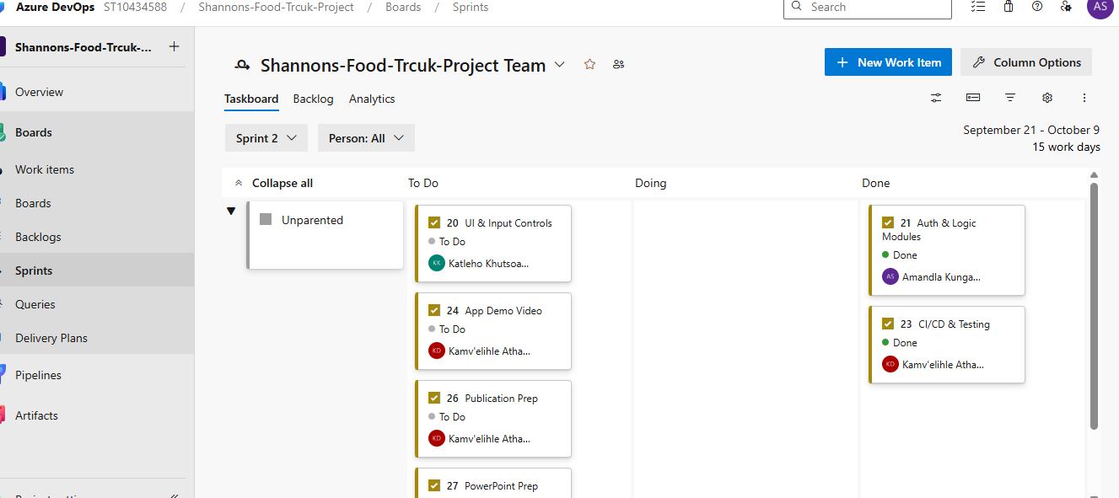
Version control and branching: The main branch is protected by our team rule: nobody commits directly to it. Each member works on their own feature branch, pushes it to GitHub and opens a pull request. The Team Lead reviews the pull request before it is merged. The repository contains the branches main, feature/home, feature/home-xml, feature/cart, feature/menu, Feedback and v2-compose.

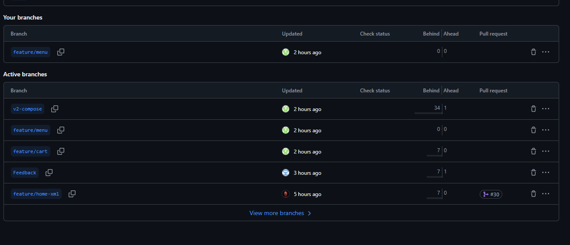

Continuous integration: A GitHub Actions workflow is planned to build the app and run the automated tests on every push, so we know the code works on a clean machine and not only on one team member’s computer.
standard for screens: The team agreed to build the screens using XML layouts with Kotlin fragments, following the pattern set by the home screen, so that all pages fit into one navigation structure.

Home page (Katleho)
Katleho built the home screen, the first screen a customer sees in the app. It was first written in Jetpack Compose and converted to XML on 18 October to follow the team standard. It was merged into main through pull requests #29 and #30, both titled “Add Home screen (XML)”. The screen consists of a HomeFragment (HomeFragment.kt), its layout (fragment_home.xml) and an item layout (item_featured.xml). It sits inside the main activity, which has its own layout (activity_main.xml). Katleho also fixed the build configuration and the theme in the commit “Fix build configuration, theme, and Home fragment navigation”.
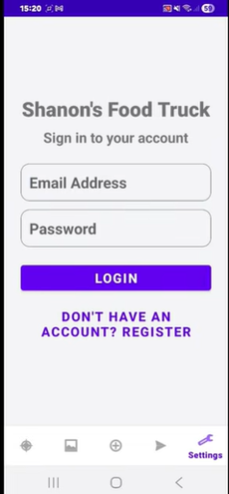
Code link: https://github.com/KamvelihleAthabileDyantyi17/Zentra/tree/main/app/src/main/java/com/example/shannosfoodtruck/features/home

Menu Page (Amandla)
Purpose: The menu page lets a customer browse everything Shannon sells, filter it by category and search by name. It is the first step of the ordering journey and feeds the Cart page.
Requirements covered:FR-01 (browse the menu with names, descriptions and prices), FR-02 (filter by category), the entry point for FR-03 (add to cart) and NFR-08 (menu available without a connection).
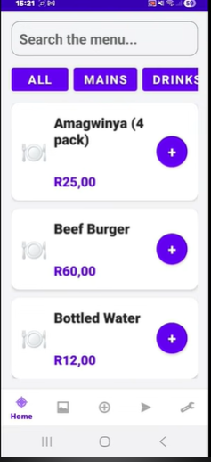
Code link: https://github.com/KamvelihleAthabileDyantyi17/Zentra/tree/main/app/src/main/java/com/example/shannosfoodtruck/features/menu

Cart page (Kamv’elihle)
Kamv’elihle built the cart page as an XML screen made of a CartFragment (CartFragment.kt), a CartViewModel (CartViewModel.kt) and a layout (fragment_cart.xml). It was added on 17 October in the commit “Implement XML exoskeleton, Cart ViewModel, and Tracker data passing”.The cart view model holds a list of cart items, each with a name, a quantity and a price. At the moment it uses sample data that stands in for the items that will be passed over from the menu page, so the link between the menu and the cart still has to be finished.
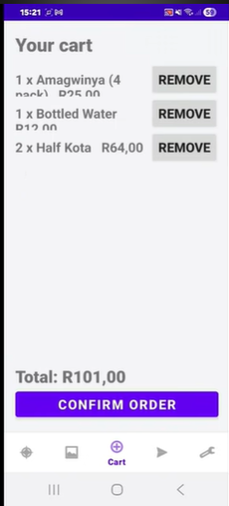

Code link: https://github.com/KamvelihleAthabileDyantyi17/Zentra/tree/main/app/src/main/java/com/example/shannosfoodtruck/features/cart

Feedback page (Neziswa)
The feedback page is an XML screen made of a FeedbackFragment (FeedbackFragment.kt), a FeedbackViewModel and a layout (fragment_feedback.xml). The customer gives a star rating with a rating bar and types of comments, then taps the submit button. The fragment passes the rating and comments to the view model, shows a “Thank you for your feedback!” message and clears the comments field.
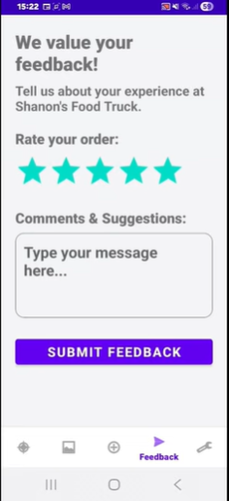
Code link: https://github.com/KamvelihleAthabileDyantyi17/Zentra/tree/main/app/src/main/java/com/example/shannosfoodtruck/features/feedback

Authentication, SSO and Settings
The brief requires that users can register and log in with an encrypted password, use single sign-on, and change their settings in the app.

Testing and github Actions
Manual testing: The menu screen was run in the Android Studio emulator and checked for normal use, category filtering and an empty search result. The brief requires testing on a physical Android phone, so each page also has to be run on a phone.
Automated testing: The repository contains only the default example tests from Android Studio so far. Planned unit tests cover the main logic, for example the menu filtering by category and search text.

Challenges and solutions
Problem |  | What happened | How we solved it
Android Gradle Plugin mismatch |  | The project used a newer Android Gradle Plugin version than one member’s Android Studio supported, so Gradle sync failed. | The member updated Android Studio to the latest stable version. We did not downgrade the plugin because that would have changed shared build files.
SDK location not found |  | The build could not find the Android SDK on one computer. | The SDK location was set in the SDK Manager, and the required Android platform was installed.
Missing icon library |  | The navigation code used Material icons that the project had not declared, so the build failed. | One dependency line was added to the module’s build.gradle.kts file and reported to the Team Lead.
Merge conflicts |  | A pull request conflicted with changes already merged into main. | We fetched the latest main, resolved the conflicts by keeping the correct version of each file, and reviewed the result before merging.
Compose and XML mismatch |  | The menu was first written in Jetpack Compose, but the team standard was XML. | The menu screen was converted to XML (MenuFragment and fragment_menu.xml), reusing the same data and filtering logic, and is now on main.
Emulator performance |  | The Android emulator froze on some computers. | Testing on physical phones, which the brief requires, replaces the emulator for the final demonstration.

Github links

- Repository: https://github.com/KamvelihleAthabileDyantyi17/Zentra
- Branches: https://github.com/KamvelihleAthabileDyantyi17/Zentra/branches
- Menu page: https://github.com/KamvelihleAthabileDyantyi17/Zentra/tree/main/app/src/main/java/com/example/shannosfoodtruck/features/menu
- Home page: https://github.com/KamvelihleAthabileDyantyi17/Zentra/tree/main/app/src/main/java/com/example/shannosfoodtruck/features/home
- Cart page: https://github.com/KamvelihleAthabileDyantyi17/Zentra/tree/main/app/src/main/java/com/example/shannosfoodtruck/features/cart
- Feedback page: https://github.com/KamvelihleAthabileDyantyi17/Zentra/tree/main/app/src/main/java/com/example/shannosfoodtruck/features/feedback
- GitHub Actions workflow: https://github.com/KamvelihleAthabileDyantyi17/Zentra/blob/main/.github/workflows/android.yml
- Video link: :https://youtu.be/KhhJptnaOf4

