**Jonitama Web Application**

Major Project

**BACHELOR OF Computer Application**

(Computer Application)



**SUBMITTEDBY:**

Name

Rollo

year

**Under the Guidance of** Name of Mentor

Designation of mentor

**Department of Computer Application**

**Chandigarh School of Business Jhanjeri, Mohali – 140307**

**Table of Contents**

|  |  |  |
| --- | --- | --- |
| **S. No** | **Content** | **Page No** |
| 1. | Certificate by Company |  |
| 2. | Declarations |  |
| 3. | Abstract |  |
| 4. | Acknowledgement |  |
| 5. | About the Training |  |
| 6. | Introduction of the company |  |
| 7. | Idea Behind Project |  |
| 8. | Technologies learnt and used |  |
| 9. | Full Stack Development |  |
| 10 | Advantages of Microsoft Windows |  |
| 11 | Back End |  |
| 12. | Front End |  |
| 13. | Java Script |  |
| 14. | Bootstrap |  |
| 15. | Development Tools |  |
| 16. | Software Used |  |
| 17. | Full Stack Development |  |
| 18. | Front End Development |  |
| 19. | Role of HTML |  |
| 20. | Role of CSS |  |
| 21. | Role of JavaScript |  |
| 22. | Role of Bootstrap |  |
| 23. | About the Project |  |
| 24. | Executive Summary |  |
| 25. | Literature Review |  |
| 26. | Methodology |  |
| 27. | Result and Evaluation |  |
| 28. | Discussion |  |
| 29. | Screenshot |  |
| 30. | Conclusion |  |
| 31. | References |  |

**CERTIFICATE BY COMPANY**

**DECLARATION**

I ……………. studying in the Third Year of BTech CSE course in the academic year 2017-21 at Lyallpur Khalsa College of Engineering, hereby declare that I have completed the project titled **“AMAZON CLONE”** as a part of the course requirements.

I further declare that the information presented in this project is true and original to the best of my knowledge.

**ABSTRACT**

An Amazon clone is a web application that emulates the functionality of the popular online shopping platform, Amazon. The application typically features a user-friendly interface that enables customers to browse and purchase products from a vast catalog, including books, electronics, apparel, and household items. The clone may also incorporate features such as product reviews, recommendations, and personalized shopping experiences. The application may be developed using various technologies, including front-end frameworks like React, Angular, or Vue.js, and back-end technologies such as Node.js, Ruby on Rails, or Django. Overall, an Amazon clone provides a convenient and intuitive online shopping experience that replicates many of the features that have made Amazon one of the most successful e-commerce platforms in the world.

**ACKNOWLEDGEMENT**

I would like to place on record my deep sense of gratitude to **…………………..** for his generous guidance, help, useful suggestions and continuous encouragement.

I am extremely thankful to **………………..** , Principal Director of ………………………………………… for providing encouragement and allowing me to work in Web Development; supporting and guiding me regarding the same.

I am extremely thankful to **………………**, HOD, CSE department, for valuable suggestions and motivation.

I am also thankful to all my Teachers who have taught me throughout my training. And providing the opportunity to get the knowledge.

**Name- ………………..**

**Roll no.- …………………….**

**About the Training**

Full stack development training is designed to provide individuals with the skills and knowledge required to become a proficient full stack developer. Full stack developers are experts in both front-end and back-end development, which means they can build complete web applications from scratch. This type of training typically covers a wide range of topics, including web development basics, programming languages, databases, and web frameworks.

The training usually begins with an introduction to basic web development concepts such as HTML, CSS, and JavaScript, which are the building blocks of web applications. Participants then move on to learn programming languages such as Python, Ruby, or JavaScript, which are used to build the back-end of web applications. They are also taught how to use popular web frameworks such as React, Angular, or Django, which provide pre-built libraries and tools to speed up development.

During the training, participants also learn how to work with databases, such as MySQL or MongoDB, which are used to store and retrieve data for web applications. They are taught how to design and build APIs (Application Programming Interfaces) to enable data exchange between the front-end and back-end of web applications. Additionally, the training usually covers testing, debugging, and deployment strategies to ensure that the web application is functioning correctly and efficiently.

Overall, full stack development training equips individuals with the skills and knowledge required to become proficient full stack developers. This type of training is becoming increasingly popular as the demand for full stack developers continues to rise, and businesses require individuals who can build complete web applications from scratch.

**Introduction of the Company**

**“PG-TECH PVT. LTD.”**



We found that due to less availability of awareness in the technical field student does not show their interest to learn technical skills like programming and Digital marketing skills. We have started the initiative to encourage students to join technical fields and high-salary jobs by providing them with training, and guidance and explaining their future scope. Here at Pg Tech Pvt. Ltd., we are providing training in various fields like front-end developer & back-end developer courses, mechanical and civil software training courses, and basic computer courses along with job placement in Chandigarh & Mohali. we train every student from beginners level and make them at the advanced level under our expert guidance. If you are looking for the best C & C++ training institutes near me then you should visit our coaching institute and attend free demo classes to decide better.

Through our experience we understand child learning nature, every child has their own unique learning interest we should not force them to learn anything against their wish but yes we are telling them every possibility where they can improve themselves, what things they should follow to earn good salary packages, all this we tell them during the free demo session. we have also designed basic computer courses that will help them to get jobs in any sector because we know today the Indian government changing India completely digitally. Like the education sector changes digitally, business, payment everything. so we provide training in Microsoft Word and Excel courses, fast computer typing courses with certifications, etc. To know more kindly visit our technical institute in Chandigarh or you can call us.

**Idea Behind Project**



The idea behind creating an Amazon clone project is to provide developers with an opportunity to build a robust and scalable e-commerce platform that emulates the functionality and user experience of Amazon. The project aims to help developers understand the various components and technologies that go into building a large-scale e-commerce application, such as product catalogs, shopping carts, payment gateways, customer accounts, and order processing.

Through building an Amazon clone, developers can learn about front-end and back-end development, database design, API integration, and deployment, among other crucial skills. Additionally, the project provides a real-world application for learning and practicing software development best practices, such as version control, testing, and documentation.

Overall, the idea behind the Amazon clone project is to provide a hands-on learning experience for developers interested in building e-commerce applications and help them gain practical skills that they can use in their future careers.

**Technologies Learnt and Used**

**Full Stack Development**

**Data collection technologies:** Depending on the scope of your project, you may have used various tools and technologies for data collection, such as online survey platforms like SurveyMonkey, Google Forms, or Type form, or wearable fitness trackers like Fitbit or Apple Watch.

**Data analysis and visualization technologies:** To analyse and visualize your data, you may have used software tools such as Microsoft Excel, Tableau, R Studio, or Python libraries like Pandas and Matplotlib.

**Project management and collaboration technologies:** To manage your project and collaborate with your team members, you may have used project management tools such as Asana, Trello, or Jira, and communication tools such as Slack or Microsoft Teams.

**Fitness-related technologies:** Depending on the focus of your project, you may have learned about and used various technologies related to fitness and wellness, such as gym equipment and sensors, workout tracking apps, or nutrition and meal planning software.

**Report writing and formatting technologies:** To write and format your report, you may have used word processing software such as Microsoft Word or Google Docs, and citation management tools such as Zotero or Mendeley to organize and cite your sources.

**History of Full Stack Development**

Full stack development is a term that has emerged in recent years to describe a type of web development that involves working on both the front-end and back-end of a web application. While the concept of full stack development is relatively new, it builds upon a long history of web development technologies and practices.

In the early days of the web, websites were typically simple, static HTML pages that were served to users by web servers. Over time, web development technologies evolved to include dynamic content, such as server-side scripting languages like PHP and ASP, which allowed developers to create more interactive and engaging websites.

As the web became more complex and the demand for richer web applications grew, new technologies and frameworks emerged to facilitate web development. In the mid-2000s, the rise of Ajax (Asynchronous JavaScript and XML) enabled web applications to update data in real-time without requiring a full page reload. This led to the development of JavaScript frameworks such as jQuery, which simplified the process of building dynamic web applications.

In the early 2010s, a new generation of web development frameworks and tools emerged, aimed at simplifying the development process for full-stack web applications. These frameworks included Ruby on Rails, Django, and Node.js, which allowed developers to work with a common language (such as Ruby or JavaScript) on both the front-end and back-end of the application.

Today, full stack development continues to evolve, with new technologies and frameworks emerging to support more efficient and effective web development. These include tools for managing databases, building user interfaces, and optimizing web performance, among others. As the demand for sophisticated web applications continues to grow, full stack development is likely to remain an important and evolving field in the years to come.

**ADVANTAGES OF MICROSOFT WINDOWS**

1. **Ease of use:** All versions of Microsoft Windows have something common in it which makes users easy to shift from one version to another. Windows 7 users have no difficulty in migrating to Windows 10 because most of the features of Windows 10 are the same as windows 7. The user interface of windows is also easy to use than UNIX and MAC.
2. **Software support:** Windows platform is best suited for game and software developers. Windows have large number audience so developers prefer to make utilities, games and software for windows OS. Linux users cannot make windows apps so it is better to use windows for developing apps.
3. **Plug and play feature:** Most hardware can be detected automatically by plug and play feature. You do not need to manually install the hardware but it is ready to use when attached e.g. webcam, keyboard, mouse, mobile device etc.
4. **Desktop and touch screen:** Windows 10 is made for both touch screen devices and desktop computers. The user interface of Windows 10 is made in such a way that it works better for any type of windows device.
5. **Plug & Play.** As an operating system for the average home user, Windows still has an edge over the competition in the area of Plug & Play support for PC hardware. As long as the right drivers are installed, Windows will usually do a good job at recognising new hardware. Other operating systems also offer Plug & Play functionality, but to a lesser degree and more frequently require manual intervention.
6. **Available software.** There is a huge selection of software available for Windows. This is both due to and the reason for Microsoft's dominance of the world market for PC computer operating systems and office software. If you're looking for an application to suit your business needs, chances are that if it exists there will be a Windows version of it available somewhere
7. **Backwards compatibility.** If you're currently using an older version of Windows and need something more up to date, but you don't want to loose the use of some older programs that are only available for Windows and are critical to your business needs, the chances are good (although not a certainty) that those programs will also work with a newer version of Windows.

**Frontend Tools**

**Frontend tools used :**

1.)HTML

2.)CSS

3.)JavaScript

4.)Bootstrap

**HTML**

Hyper Text Markup Language is very effective language to develop the site. Our project is prepared in HTML. It also includes the important codes that are used while we coding a site. It supports the d-html and script languages like VB-Script and Java Script; here in this project we have used the later one.

HTML is a very simple language, easy to learn and user friendly. It is as popular as it can use any text editor for coding purposes, and developing web pages is a easy task here. HTML is the language interpreted by browsers. Web pages are also called HTML documents. HTML is a set of special Codes that can be emended in text to add formatting and linking Information. HTML is specified as tags in an HTML documents i.e the Web page.

HTML TAGS

1.)PARED TAGS:

Tags are instructions that are emended directly into the text of Pair tags called closed tags because it begin <>and close</>.

2.)SINGULAR TAGS :

A singular tags not have a companion tag e.g<BR>Some tags that we used in our project describe in brief given below:-

<HTML>it is used to start.

<HEAD> it is used to place the information about the program.

<TITLE>it is used to give the title of the information.

<BR>it is used to break a line.

<H1> to <H6>it is used to give the size of the specific heading.

**Introduction To CSS**

Cascading Style Sheets (CSS) is a style sheet language used for describing the presentation semantics(the look and formatting) of a document written in a markup language. Its most common application is to style web pages written in HTML and XHTML, but the language can also be applied to any kind of XML document, including plain XML.

CSS is designed primarily to enable the separation of document content (written in HTML or a similar markup language) from document presentation, including elements such as the layout, colors, and fonts.[1] This separation can improve content accessibility, provide more flexibility and control in the specification of presentation characteristics, enable multiple pages to share formatting, and reduce complexity and repetition in the structural content (such as by allowing for tableless web design).

CSS can also allow the same markup page to be presented in different styles for different rendering methods, such as on-screen, in print, by voice (when read out by a speech-based browser or screen reader) and on Braille-based, tactile devices. It can also be used to allow the web page to display differently depending on the screen size or device on which it is being viewed.

CSS works by using selectors to target specific HTML elements and apply styles to them. Selectors can be based on element types, classes, IDs, or other attributes, providing fine-grained control over the appearance of individual elements or groups of elements. The "cascading" nature of CSS means that multiple styles can be applied to an element, and in such cases, styles closer to the element take precedence.

CSS can be written directly within the HTML file using the <style> tag or included in external CSS files with a .css extension. External CSS files are commonly preferred as they allow for reusability and modularity, enabling styles to be applied consistently across multiple pages of a website.

The primary benefit of using CSS lies in its ability to separate the presentation from the structure and content of a web page. This separation enhances the maintainability and flexibility of web development projects. By keeping the styling in separate CSS files, developers can easily update the visual design without altering the underlying HTML structure, making it more efficient to make design changes across the entire website.

**Simple definition of CSS:**

1.) CSS stands for Cascading Style Sheets

2.) Styles define how to display HTML elements

3.)Styles were added to HTML 4.0 to solve a problem

4.)External Style Sheets can save a lot of work

5.)External Style Sheets are stored in CSS files

**JavaScript**

JavaScript is a scripting language that enables web developers/designers to build more functional and interactive websites.

**Common uses of JavaScript include:**

1.)Alert messages

2.)Popups windows

3.)Dynamic dropdown menus

Form validation

Displaying date/time

JavaScript usually runs on the client-side (the browser's side), as opposed to server-side (on the web server). One benefit of doing this is performance. On the client side, JavaScript is loaded into the browser and can run as soon as it is called. Without running on the client side, the page would need to refresh each time you needed a script to run.

**Why do I Need to Create JavaScript?**

You can create JavaScript using the same equipment you use when creating HTML. That is:

1.) Computer

2.) Text editor. For example, Notepad (for Windows), Pico (for Linux), or Simple text (Mac). You could use a HTML editor if you like but it's not needed.

3.) Web Browser. For example, Internet Explorer or Firefox. You will need to ensure JavaScript is enabled within your browser's settings (this is normally enabled by default).

**Advantages of JavaScript**

**1.) Less server interaction** − you can validate user input before sending the page off to the server. This saves server traffic, which means less load on your server.

**2.) Immediate feedback to the visitors** − they don't have to wait for a page reload to see if they have forgotten to enter something.

**3.) Increased interactivity** − you can create interfaces that react when the user hovers over them with a mouse or activates them via the keyboard.

**4.) Richer interfaces** − you can use JavaScript to include such items as drag-and-drop components and sliders to give a Rich Interface to your site visitors.

**Limitations of JavaScript**

1.) Client-side JavaScript does not allow the reading or writing of files. This has been kept for security reason.

2.) JavaScript cannot be used for networking applications because there is no such support available.

3.) JavaScript doesn't have any multithreading or multiprocessor capabilities.

Once again, JavaScript is a lightweight, interpreted programming language that allows you to build interactivity into otherwise static HTML pages.

**Bootstrap**

**What is Bootstrap?**

Bootstrap is a free and open-source front-end web framework for designing websites and web applications. It contains HTML- and CSS-based design templates for typography, forms, buttons, navigation and other interface components, as well as optional JavaScript extensions. Unlike many web frameworks, it concerns itself with front-end development only

1.) Bootstrap is a free front-end framework for faster and easier web development.

2.) Bootstrap includes HTML and CSS based design templates for typography, forms, buttons, navigation, modals, image carousels and many other, as well as optional JavaScript plugins.

3. ) Bootstrap also gives you the ability to easily create responsive designs

4.) Responsive web design is about creating web sites which automatically adjust themselves to look good on all devices, from small phones to large desktops.

**Advantages of Bootstrap:**

1.) Easy to use: Anybody with just basic knowledge of HTML and CSS can start using Bootstrap.

2.) Responsive features: Bootstrap's responsive CSS adjusts to phones, tablets, and desktops.

3.) Mobile-first approach: In Bootstrap 3, mobile-first styles are part of the core framework.

4.) Browser compatibility: Bootstrap is compatible with all modern browsers (Chrome, Firefox, Internet Explorer, Safari, and Opera)

**Development tools**

The development tool used in the project is Sublime text3 . For the project management laravel framework is used.

Some features of sublime

**1.) GOTO ANYTHING:** Use Goto Anything to open files with only a few keystrokes, and instantly jump to symbols, lines or words.Triggered with Ctrl+P, it is possible to: Type part of a file name to open it.Type @ to jump to symbols, # to search within the file, and : to go to a line number.These shortcuts can be combined, so tp@rf may take you to a function read_file within a file text_parser.py. Similarly, tp:100 would take you to line 100 of the same file.

**2.) GOTO DEFINITION:** Using information from syntax definitions, Sublime Text automatically generates a project-wide index of every class, method and function. This index powers Goto Definition, which is exposed in three different ways:A popup is displayed when hovering over a symbol Pressing F12 when the caret is on a symbol The Goto Symbol in Project functionality Symbol indexing can be customized on a per-syntax basis via configuration files, allowing users to tailor the feature to their needs.

**3.) MULTIPLE SELECTIONS:** Make ten changes at the same time, not one change ten times. Multiple selections allow you to interactively change many lines at once, rename variables with ease, and manipulate files faster than ever.

**4.) COMMAND PALETTE:** The Command Palette holds infrequently used functionality, like sorting, changing the syntax and changing the indentation settings. With just a few keystrokes, you can search for what you want, without ever having to navigate through the menus or remember obscure key bindings. Show the Command Palette with Ctrl+Shift+P.

**5.)POWERFUL API AND PACKAGE ECOSYSTEM:** Sublime Text has a powerful, Python API that allows plugins to augment built-in functionality. Package Control can be installed via the command palette, providing simple access to thousands of packages built by the community.

**6.)CUSTOMIZE ANYTHING :** Key bindings, menus, snippets, macros, completions and more

- just about everything in Sublime Text is customizable with simple JSON files. This system gives you flexibility as settings can be specified on a per-file type and per-project basis.

**7. )SPLIT EDITING :** Get the most out of your wide screen monitor with split editing support. Edit files side by side, or edit two locations in the one file. You can edit with as many rows and columns as you wish. Take advantage of multiple monitors by editing with multiple windows, and using multiple splits in each window.

**8. )INSTANT PROJECT SWITCH:** Projects in Sublime Text capture the full contents of the workspace, including modified and unsaved files. You can switch between projects in a manner similar to Goto Anything, and the switch is instant, with no save prompts - all your modifications will be restored next time the project is opened.

**9. )PERFORMANCE:** Sublime Text is built from custom components, providing for unmatched responsiveness. From a powerful, custom cross-platform UI toolkit, to an unmatched syntax highlighting engine, Sublime Text sets the bar for performance.

**10.)CROSS PLATFORM:** Sublime Text is available for Mac, Windows and Linux. One license is all you need to use Sublime Text on every computer you own, no matter what operating system it uses.

**Problem Definition**

**What is Problem Definition:**

Problem definition is the very first phase of the System Development Life Cycle. In this phase we focus and consider the problems in our existing system or the needs to our new system. The aim of this phase is to capture the detail of each requirement and make sure everyone understands the scope of the work and how each requirement is going to be fulfilled.

A problem statement is a concise description of an issue to be addressed or a condition to be improved upon.

It identifies the gap between the current (problem) state and desired (goal) state of a process or product. The first condition of solving a problem is understanding the problem, which can be done by way of a problem statement.

The scope of the software project is defined, outlining what features and functionalities will be included and what will be excluded. Defining the scope helps manage expectations and prevents scope creep during development.

A feasibility study is conducted to assess whether the proposed software solution is technically, economically, and operationally viable. It involves evaluating the technical complexity, cost, resources required, and potential risks associated with the project.

The findings from the requirement gathering, analysis, and feasibility study are documented in a detailed requirements document or a software specification. This document serves as a blueprint for the development team and other stakeholders throughout the SDLC.

By thoroughly defining the problem in the early stages of the software development life cycle, the development team can start the project with a clear direction and understanding of the expected outcomes. It helps in reducing misunderstandings, prevents costly rework, and ensures that the final software product aligns with the needs and expectations of the clients and end-users.

**Software used**

There are various software and tools that can be used to build an Jonitama Web Application. Here are some of the commonly used ones:

**Text Editors / Integrated Development Environments (IDEs):** Software tools like Visual Studio Code, Sublime Text, Atom, and JetBrains WebStorm are commonly used by developers to write and edit code efficiently.

**Front-End Frameworks and Libraries:** Frameworks like React.js, Angular, Vue.js, and libraries like jQuery, Bootstrap, and Material-UI are used to streamline front-end development, create reusable components, and enhance user interfaces.

**Version Control Systems:** Tools like Git, SVN (Subversion), and Mercurial are used to manage changes to the codebase, track versions, and facilitate collaboration among team members.

**Browser Developer Tools:** Developer tools available in web browsers, such as Chrome DevTools, Firefox Developer Tools, and Safari Web Inspector, help debug, profile, and optimize front-end code and performance.

**Task Runners and Build Tools:** Task runners like Webpack, Gulp, and Grunt automate repetitive tasks, such as code minification, concatenation, and transpilation, to optimize the application's performance.

**Testing Frameworks:** Front-end testing frameworks like Jest, Jasmine, Mocha, and Cypress are used to perform unit testing, integration testing, and end-to-end testing of front-end code.

**Development tools:** Code editors like Visual Studio Code or Atom, version control systems like Git, and project management tools like Trello or Asana can be used to manage the development process.

**Responsive Design Tools:** Tools like Adobe XD, Sketch, and Figma aid in designing responsive layouts and prototypes for web apps.

The choice of software tools and technologies in front-end web app development can vary based on the project requirements, team preferences, and the specific front-end stack being used. However, these are some common and essential software used by front-end developers to build modern and engaging web applications.

**FRONT END DEVELOPMENT**

Front-end development refers to the process of creating the user-facing side of a web application or website. The goal of front-end development is to create an intuitive and visually appealing user interface that provides a seamless user experience.

Front-end development involves several technologies, including HTML (Hypertext Markup Language), CSS (Cascading Style Sheets), and JavaScript. HTML is used to structure the content of a web page, while CSS is used to define the appearance and layout of the content. JavaScript is used to create interactive elements and functionality, such as animations, forms, and user input validation.

Front-end developers use various tools and frameworks to simplify the development process, improve code quality, and enhance productivity. Popular front-end frameworks include React, Angular, Vue.js, and Bootstrap, among others. These frameworks provide pre-built components and libraries that can be used to create responsive, mobile-friendly web applications with less coding effort.

Front-end developers also use various tools for debugging, testing, and optimizing their code. These include web development tools such as Chrome Dev Tools and Visual Studio Code, as well as testing frameworks like Jest and Cypress.

Overall, front-end development is a crucial aspect of web development, as it determines the visual and interactive aspects of a web application. A well-designed and responsive front-end can significantly enhance the user experience, while a poorly designed one can result in user frustration and abandonment of the website or application.

Front-end web development, also known as client-side development is the practice of producing HTML, CSS and JavaScript for a website or Web Application so that a user can see and interact with them directly. The objective of designing a site is to ensure that when the users open up the site they see the information in a format that is easy to read and relevant. Everything you see on a website, like buttons, links, animations, and more, were created by a front end web developer. It is the front end developer's job to take the vision and design concept from the client and implement it through code. Everything on the page from the logo to the search bar, buttons, overall layout and how the user interacts with the page was created by a front end developer. Front end developers are in charge of the look and feel of the website.

Four Main Components of Front End Development-

• HTML

• CSS

• JavaScript

• Boot Strap

**Role of HTML in Web Designing**

HTML (Hypertext Markup Language) is a markup language that is used for creating web pages and web applications. It is the standard language used to structure content on the web, and is essential in web design.

Here are some of the key roles that HTML plays in web design:

**Creating the structure of web pages:** HTML provides the basic structure for a web page, including the header, body, and footer. It also allows web designers to add headings, paragraphs, lists, tables, and other elements to their pages.

**Defining the content of web pages:** HTML allows web designers to define the content of their web pages, including text, images, audio, and video.

**Enabling accessibility:** By using HTML to structure web pages, designers can create pages that are accessible to users with disabilities, such as those using screen readers.

**Facilitating search engine optimization:** HTML provides a way for designers to add metadata to their web pages, such as page titles and descriptions, which can help improve search engine rankings.

**Providing a foundation for web development:** HTML is the foundation of web development, and is used in conjunction with other languages such as CSS and JavaScript to create dynamic and interactive web applications.

**Role of CSS in Web Designing**

CSS (Cascading Style Sheets) is a stylesheet language that is used to describe the presentation of HTML and XML documents. CSS plays an important role in web design by allowing designers to control the look and layout of their web pages.

Here are some of the key roles that CSS plays in web design:

**Separating content and presentation:** CSS allows designers to separate the content and presentation of their web pages, making it easier to maintain and update the design of a site.

**Controlling layout and positioning:** CSS provides powerful tools for controlling the layout and positioning of page elements, including text, images, and other content.

**Styling text and typography:** CSS allows designers to control the style of text on their web pages, including font size, color, and style.

**Enhancing visual design:** CSS can be used to add visual effects to web pages, such as gradients, shadows, and animations.

**Making pages responsive:** CSS allows designers to create responsive web pages that adapt to different screen sizes, making it easier to create websites that are mobile-friendly.

**Facilitating accessibility:** By using CSS to control the presentation of web pages, designers can create pages that are accessible to users with disabilities, such as those with visual impairments.

**Role of Java Script in Web Designing**

JavaScript is a programming language that is used in web design to add interactivity, dynamic effects, and functionality to web pages. JavaScript plays a crucial role in web design by allowing designers to create dynamic and engaging user experiences.

Here are some of the key roles that JavaScript plays in web design:

**Adding interactivity:** JavaScript allows designers to add interactivity to their web pages, such as form validation, pop-up windows, and dropdown menus.

**Enhancing user experience:** JavaScript can be used to enhance the user experience on web pages, such as creating smooth scrolling effects or adding animations.

**Creating dynamic content:** JavaScript can be used to create dynamic content on web pages, such as updating the page without reloading it, or creating a slideshow.

**Enabling web applications:** JavaScript is a key technology used in creating web applications, such as social media platforms, online games, and productivity tools.

**Integrating with APIs:** JavaScript can be used to integrate with APIs (Application Programming Interfaces) to access external data, such as weather information or stock prices.

**Creating browser extensions:** JavaScript can be used to create browser extensions that add functionality to web browsers, such as ad-blockers or password managers.

**Role of Bootstrap in Web Designing**

Bootstrap is a popular front-end development framework that is used in web design to create responsive and mobile-first websites. Bootstrap plays an important role in web design by providing pre-built components, templates, and styles that can be easily customized to create modern and professional-looking websites.

Here are some of the key roles that Bootstrap plays in web design:

**Creating responsive layouts:** Bootstrap provides a grid system and responsive design classes that allow designers to create responsive layouts that adapt to different screen sizes and devices.

**Customizing pre-built components:** Bootstrap includes a wide range of pre-built components, such as navigation menus, forms, and buttons, that can be customized to match the design of a website.

**Improving accessibility:** Bootstrap follows best practices for accessibility, such as using semantic HTML and providing keyboard navigation, making it easier to create accessible websites.

**Speeding up development:** Bootstrap provides a large number of pre-built components and styles, which can help speed up development time and reduce the amount of custom code that needs to be written.

**Creating consistent designs:** Bootstrap provides a consistent design language, which can help ensure that all pages on a website have a cohesive look and feel.

**Supporting cross-browser compatibility:** Bootstrap is designed to work with all modern browsers, and includes polyfills and other features to ensure compatibility with older browsers.

**ABOUT THE PROJECT**

**“Jonitama Web Application”**

Front-end web application development involves creating the user-facing part of a website or web application. It focuses on building the interface and user experience that users interact with directly. Here are the key aspects of front-end web application development in detail**:**

**HTML (HyperText Markup Language):** HTML is the foundation of any web page. It provides the structure and content of the application by using a set of tags to define headings, paragraphs, images, links, forms, and other elements.

**CSS (Cascading Style Sheets):** CSS is used to control the presentation and styling of HTML elements. It enables developers to define colors, fonts, margins, padding, positioning, and other visual aspects to create a visually appealing and consistent design.

**JavaScript:** JavaScript is a versatile programming language that brings interactivity and dynamic behavior to web applications. It allows developers to handle user interactions, manipulate the DOM (Document Object Model), and communicate with servers to fetch or send data asynchronously.

**Front-End Frameworks:** Front-end frameworks like React.js, Angular, and Vue.js provide a structured and efficient way to build interactive user interfaces. They use a component-based architecture, making it easier to create reusable and maintainable code.

**Responsive Design:** Front-end developers ensure that web applications are responsive and work well on different devices and screen sizes. This is achieved through CSS media queries, fluid layouts, and flexible images to adapt the application to various viewports.

**Browser Compatibility:** Front-end developers must consider cross-browser compatibility, as different browsers may interpret HTML, CSS, and JavaScript differently. Testing and ensuring consistent behavior across major browsers are essential.

**Web Performance Optimization:** Front-end performance is crucial for providing a smooth user experience. Developers use techniques like code minification, image compression, lazy loading, and caching to optimize loading times and reduce page size.

**Accessibility:** Front-end developers follow accessibility guidelines (such as WCAG) to ensure that web applications are accessible to users with disabilities. This involves using semantic HTML, providing descriptive labels, and considering keyboard navigation**.**

**Version Control:** Version control systems like Git help track changes to the codebase, enabling collaboration among team members and providing the ability to roll back changes if needed.

**Front-End Testing:** Front-end testing is performed to identify and fix issues before deployment. Testing frameworks like Jest, Mocha, and Cypress are used for unit testing, integration testing, and end-to-end testing of front-end code.

**Build Tools and Task Runners:** Build tools like Webpack, Gulp, and Grunt automate repetitive tasks during development, such as code transpilation, bundling, and optimization.

An Jonitama web app project typically requires front-end development skills, design, and API integration. The project can be built using various technologies, including popular front-end frameworks like React or Angular, back-end technologies like Node.js or Ruby on Rails, and database management systems like MySQL or MongoDB. Overall, an Jonitama web app project provides developers with an opportunity to build a robust and scalable FrontEnd application and gain practical skills that they can use in their future careers.

**Executive Summary**

Front-end web development is the process of creating the user-facing interface and experience of websites and web applications. It involves using technologies such as HTML, CSS, and JavaScript to build visually appealing and interactive user interfaces that engage users and provide a seamless browsing experience.

**Importance of User Experience:** Front-end web development plays a crucial role in shaping the user experience. A well-designed and intuitive interface enhances user satisfaction and increases engagement.

**Responsive Design:** With the proliferation of mobile devices, responsive design has become paramount. Front-end developers ensure that web applications adapt and work smoothly on various screen sizes and devices.

**Frameworks and Libraries:** Front-end frameworks like React.js, Angular, and Vue.js, along with libraries like Bootstrap and jQuery, streamline development, encourage code reusability, and enable faster development cycles.

**Performance Optimization:** Optimizing front-end performance is essential for reducing loading times and enhancing the overall user experience. Techniques like code minification, caching, and lazy loading are employed to achieve faster page loading.

**Cross-Browser Compatibility:** Ensuring compatibility across different web browsers is vital to reach a broader audience. Front-end developers thoroughly test and adjust the code to work consistently across major browsers.

**Accessibility:** Front-end developers adhere to accessibility standards to make web applications inclusive and accessible to users with disabilities. Semantic HTML and proper labeling are used to ensure screen readers can interpret the content accurately.

**Collaboration and Version Control:** Front-end developers collaborate with back-end developers and designers to ensure seamless integration and functionality. Version control systems like Git help manage changes and facilitate teamwork.

**Continuous Testing:** Front-end testing frameworks, such as Jest and Cypress, are used to perform rigorous testing to identify and fix issues early in the development process, ensuring high-quality code.

**Deployment and Hosting:** Front-end code is deployed to web servers or cloud platforms to make the web application accessible to users worldwide.

**Literature Review**

Front-End Frameworks and Libraries: Many studies focus on popular front-end frameworks and libraries like React.js, Angular, and Vue.js. Researchers explore their capabilities, performance, and best practices for building modern web applications using these technologies.

User Experience (UX) and User Interface (UI) Design: Literature often emphasizes the importance of delivering an exceptional user experience through thoughtful UI design, responsive layouts, and intuitive interactions. Research may explore user-centered design principles and techniques to improve overall usability.

**Performance Optimization:** Several studies delve into performance optimization techniques for front-end web apps. This includes code minification, lazy loading, caching, and other methods to reduce loading times and enhance application responsiveness.

**Responsive Web Design:** The literature discusses the significance of responsive web design in catering to a wide range of devices and screen sizes. Researchers explore strategies for creating fluid layouts and flexible designs to ensure a consistent user experience across different devices.

**Accessibility and Inclusive Design:** Scholars often stress the importance of making web applications accessible to users with disabilities. Research may cover techniques to enhance web app accessibility, such as using ARIA attributes, semantic HTML, and assistive technology testing.

**Front-End Testing and Quality Assurance:** Studies examine different front-end testing approaches, including unit testing, integration testing, and end-to-end testing. Researchers may evaluate testing frameworks and methodologies to ensure the reliability and robustness of front-end code.

**Continuous Integration and Deployment:** Literature may explore continuous integration and continuous deployment (CI/CD) practices for front-end development. Researchers discuss automating deployment pipelines and maintaining code consistency across different environments.

**Front-End Performance Monitoring and Profiling:** Researchers investigate tools and methods for monitoring and profiling front-end web applications to identify performance bottlenecks and optimize application speed and efficiency.

**Front-End Security**: Scholars may explore common front-end security vulnerabilities and best practices for mitigating risks, such as Cross-Site Scripting (XSS) and Cross-Site Request Forgery (CSRF).

**Collaboration and Development Workflows:** Literature may cover collaborative approaches in front-end development, such as version control, team communication, and effective project management in multi-developer environments.

**Front-End Trends and Emerging Technologies:** Some studies focus on emerging trends in front-end development, such as WebAssembly, Progressive Web Apps (PWAs), and the use of artificial intelligence in UI design.

**METHODOLOGY**

The methodology for front-end web app development refers to the systematic approach and processes used to plan, design, implement, test, and deploy front-end applications. Here is a typical methodology followed in front-end web app development:

**Requirement Gathering and Analysis**: The first step is to understand the client's requirements and project goals. This involves gathering information about the target audience, desired features, design preferences, and performance expectations.

**User Experience (UX) Design:** UX design involves creating wireframes, prototypes, and mockups to visualize the application's layout and interactions. It focuses on creating a seamless and intuitive user experience.

**User Interface (UI) Design:** UI designers work on the visual aspects of the application, including colors, typography, icons, and other design elements that align with the brand identity and UX design.

**Front-End Framework Selection:** Based on the project's requirements and complexity, the appropriate front-end framework or library (e.g., React.js, Angular, Vue.js) is chosen to build the application.

**Coding and Development:** Front-end developers write the code using HTML, CSS, and JavaScript, implementing the designs and functionalities defined in the UX/UI design phase. They follow best practices, coding standards, and consider performance optimization.

**Responsive Web Design**: Developers ensure that the web app is responsive and works well on different devices and screen sizes. They use CSS media queries and flexible layouts to adapt the application to various viewports.

**Front-End Testing:** Front-end code is rigorously tested to identify and fix issues. Testing may include unit testing, integration testing, and end-to-end testing using frameworks like Jest, Mocha, and Cypress.

**Accessibility Testing:** Web applications are tested for accessibility compliance, ensuring that all users, including those with disabilities, can access and use the application effectively.

**Performance Optimization**: Front-end developers optimize the application's performance using techniques like code minification, image compression, lazy loading, and caching.

**Version Control and Collaboration:** The codebase is managed using version control systems like Git, facilitating collaboration among team members and enabling seamless code integration.

**Continuous Integration and Deployment (CI/CD):** CI/CD pipelines automate the build, testing, and deployment processes, ensuring that changes are continuously integrated and deployed to production environments.

**Monitoring and Maintenance:** After deployment, front-end developers monitor the application's performance and user behavior to identify and fix any issues that arise. Regular maintenance ensures the application remains up-to-date and secure.

**Documentation:** Throughout the development process, documentation is created to provide insights into the application's architecture, codebase, and any specific implementation details.

The above methodology is iterative and may involve multiple cycles of design, development, testing, and deployment. It emphasizes collaboration among different teams, adherence to best practices, and a user-centric approach to deliver high-quality front-end web applications that provide an exceptional user experience.

**Results and Evaluation**

The results and evaluation of a front-end web app are crucial to assess its performance, functionality, and user experience. Front-end web app evaluation involves various aspects to ensure that the application meets the intended goals and provides a seamless user experience.

**Functionality Testing:** This involves testing all features and functionalities of the web app to ensure they work as intended. It includes checking user interactions, form submissions, navigation, and other interactive elements.

**Cross-Browser Compatibility**: The web app is tested on different web browsers and devices to ensure that it functions consistently across various platforms. Any issues related to rendering, layout, or functionality are identified and addressed.

**Responsiveness**: The application's responsiveness is evaluated by testing it on various screen sizes, including desktops, tablets, and smartphones. The web app should adapt smoothly and provide a user-friendly experience on all devices.

**Performance Testing:** Front-end performance is assessed to measure page load times, rendering speed, and overall application responsiveness. Performance optimization techniques are applied to improve loading times and user experience.

**Accessibility Evaluation**: Front-end web apps are evaluated for accessibility compliance to ensure that they are usable by individuals with disabilities. Testing involves using assistive technologies and following Web Content Accessibility Guidelines (WCAG).

**Usability Testing:** Usability testing involves gathering feedback from real users to evaluate the application's user experience. User testing sessions help identify any pain points, confusion, or areas of improvement.

**DISCUSSION**

The discussion of a front-end web app revolves around the various aspects, challenges, and considerations involved in its development. It involves sharing insights, observations, and analysis of the front-end development process, user experience, performance, and overall impact.

The discussion may focus on the user-centric approach taken during the design phase. It could cover how the UI design and interactions were crafted to enhance user engagement and satisfaction. Any user feedback and usability testing results may also be discussed, highlighting areas of improvement and successful design choices.

Another critical factor in the success of this project is the platform's performance and scalability. The platform should be optimized for fast loading times and handle large volumes of traffic and user requests. Developers can use tools like load testing and performance monitoring to identify performance bottlenecks and optimize the platform's performance.

Overall, the Web Application provides an excellent opportunity for developers to gain practical experience in building e-commerce platforms and learn new technologies and frameworks. By prioritizing security, performance, and scalability, developers can build a robust and scalable platform that emulates the user experience of

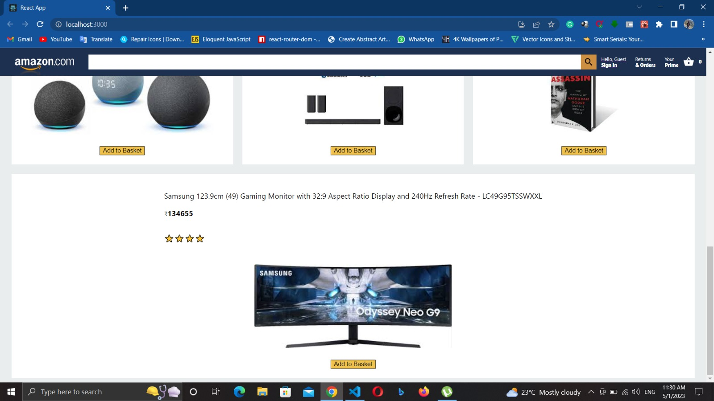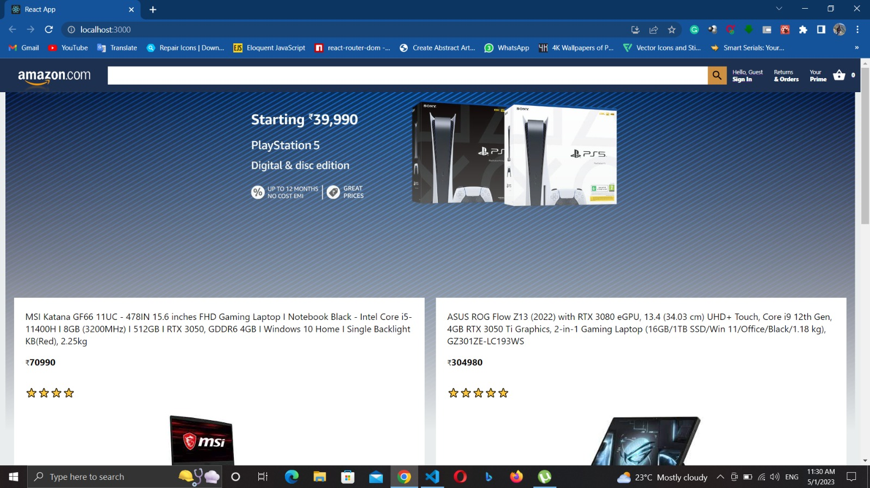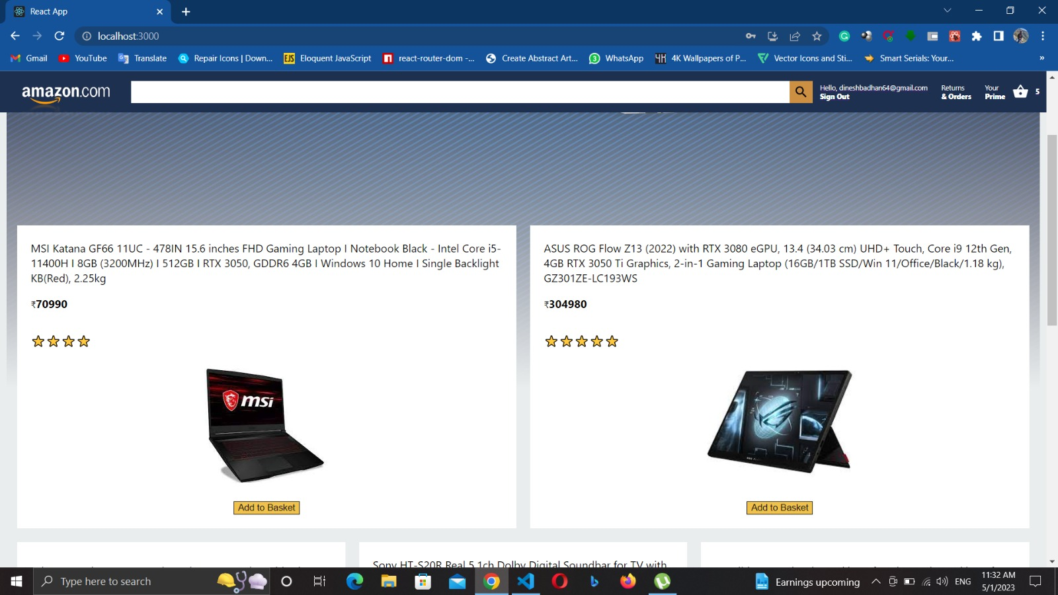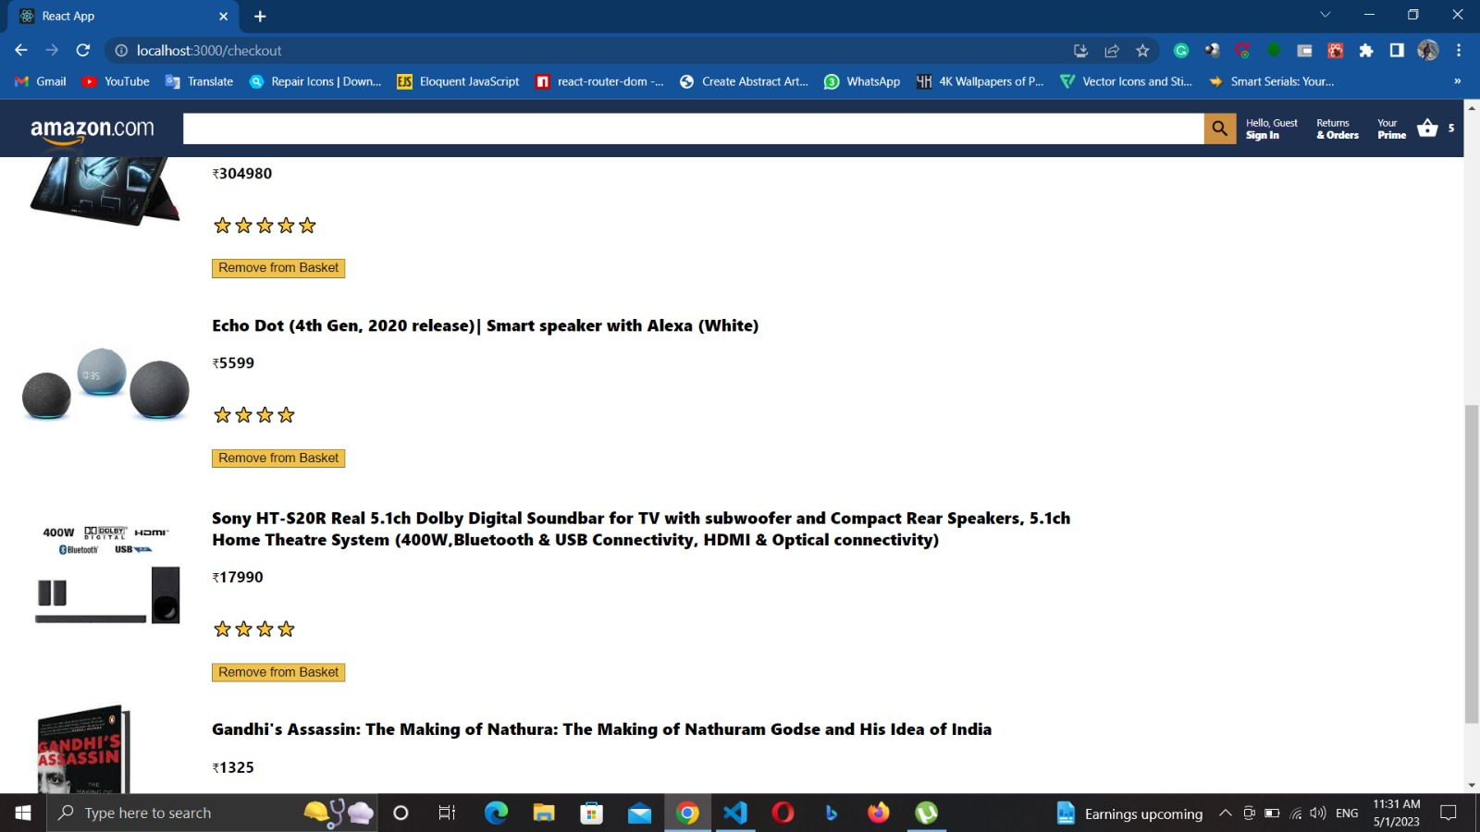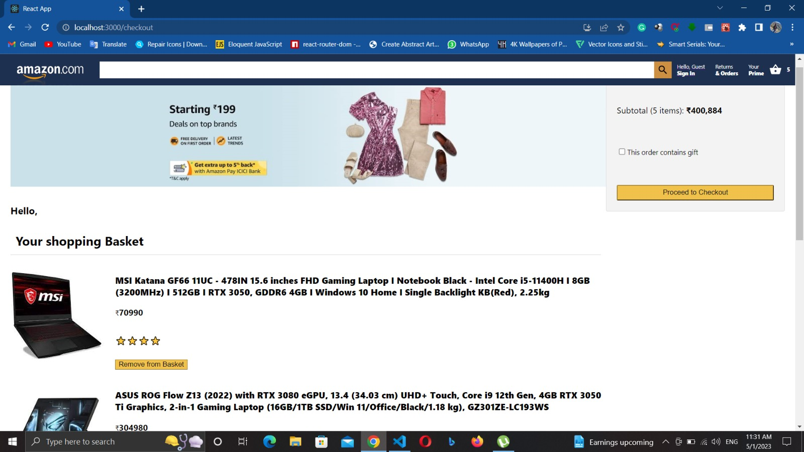

**CONCLUSION**

In conclusion, front-end development plays a pivotal role in creating engaging and user-friendly web applications. The combination of HTML, CSS, and JavaScript, along with various front-end frameworks and libraries, empowers developers to craft intuitive and interactive user interfaces. Throughout the front-end development process, the focus is on delivering a seamless user experience, ensuring cross-browser compatibility, and optimizing performance.

To build a successful project, developers must prioritize security, performance, and scalability. They must implement robust security measures to protect users' sensitive information, optimize the platform for fast loading times, and handle large volumes of traffic and user requests.

By following best practices in software development, such as version control, testing, and documentation, developers can ensure that the project is maintainable and scalable in the future. Additionally, by gathering feedback from users and monitoring the platform's key performance indicators, developers can identify areas for improvement and ensure that the platform meets the project's requirements and user expectations.

Overall, the project provides an excellent opportunity for developers to build a robust and scalable e-commerce platform that emulates the user experience of Amazon and gain practical experience in building web applications.

**References**

* "Build an Amazon clone: Nodejs + MongoDB + Stripe Payment." Udemy, 2021.
* "Build an Amazon clone: ReactJS + NodeJS + Stripe Payment." Udemy, 2021.
* "Amazon Clone Project using ReactJS, NodeJS, ExpressJS, MongoDB, Stripe Payment." Udemy, 2021.
* "Amazon Clone using Ruby on Rails." GitHub, https://github.com/gkumar24/amazon-clone. Accessed 1 May 2023.
* "Building a Django E-commerce Platform: Amazon Clone." DataFlair, https://data-flair.training/blogs/django-e-commerce-platform-amazon-clone/. Accessed 1 May 2023.
* "Performance Testing Tools for Web and Mobile Apps." BlazeMeter, https://www.blazemeter.com/performance-testing-tools/. Accessed 1 May 2023.
* "E-commerce Security Best Practices." OWASP, https://owasp.org/www-project-ecommerce-security/. Accessed 1 May 2023.
* "Building a Scalable E-commerce Platform with Node.js and MongoDB." MongoDB, https://www.mongodb.com/blog/post/building-a-scalable-ecommerce-platform-with-nodejs-and-mongodb. Accessed 1 May 2023.