Introduction:

*Brain tumor is an uncontrolled growth of solid mass formed*

*by undesired cells found in different parts of the brain.*

***GLIOMAS*** *are the most common brain tumors in adults, which*

*start from glial cells and infiltrate the surrounding tissues.*

*The most important thing that determine whether there is a tumor or not is* ***MRI****.*

***There are five types of MRI images:***

*contrast enhancement (T1wc),*

*T2-weightedMRI (T2w), Proton*

*Density-Weighted MRI (PDW),*

*Fluid-Attenuated Inversion*

*Recovery (FLAIR) , and so forth*

*Traditional feature produced through image gradients, Gabor filters, Histogram*

*of Oriented Gradients (HOG), or Wavelets shows bad performance especially when boundaries between tumors and healthy tissues are fuzzy*

*By combining multi-scale CNNs, both local and global feature are extracted.*

**Our Multi-scale Convolutional Neural Networks**

*In order to cut computation time caused by 3D CNNs, we utilize 2D CNNs from axial view, respectively*

For each 2D axial image, each pixel combines information from different image modalities, including T1, T2, T1c, and FLAIR

**CNNs** are composed of two parts: the feature extraction part

and the full connection of classification part.

The feature extraction part consists of pairs of convolution layer and down sample layer, through which hierarchy of features is extracted

Multi-Scale CNNs framework which could detect both local and global features at the same time

***The Architecture of Our Multi-scale CNNs Model***

Here we make a prior procedure before the training part

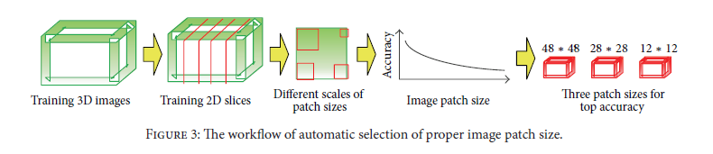

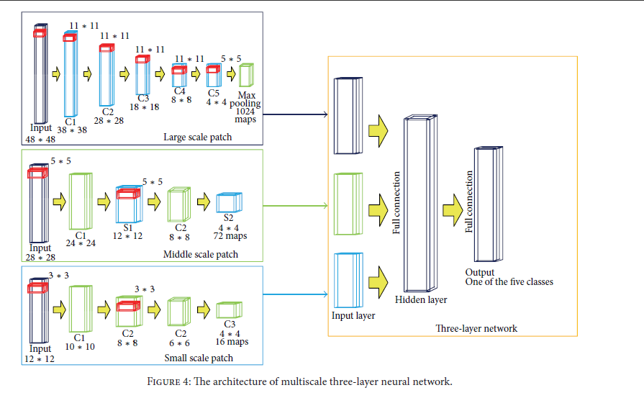

In this research starting with a 3D image and then convert it into 2D image

-select patches in different size .

-then take the most accurate 3 patches

-extracting feature maps from each of 3 patches.

-apply convolution process five times and then apply the max-pooling process minimize the size of image.

-insert the three feature maps as input to the hidden layer.

-the output of the hidden layer is called fully connected network.

**Experiment Results**:

Dice ratio is commonly utilized to validate algorithm segmentation result. As defined in (2), dice ratio is to show similarity between manual standard and our automatic algorithm segmentation result:

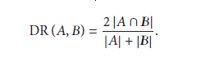

The experiments are performed over datasets provided by benchmark BRATS 2013

The datasets include T1, T1c, T2, and FLAIR images. The training data includes 30 patient datasets and 50 synthetic datasets. All these datasets have been manually annotated with tumor labels (necrosis, edema, non-enhancing tumor, and enhancing tumor denoted as 1, 2, 3, and 4, while 0 stands for normal issue)

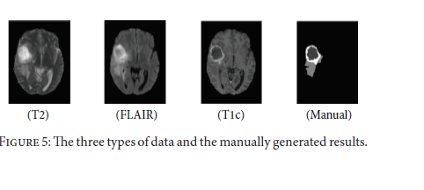

T1 shows brighter borders of the tumors, while T2 shows brighter tumor regions. FLAIR

is effective for separating edema region from CSF

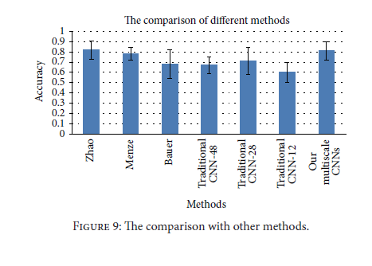

CNNs is lower than the best method (0.81 versus 0.82), our method is almost as stable as the best method (variance 0.099 versus 0.095). Compared with second best method Menze,

our method is more accurate (0.81 versus 0.78) but not as stable as it (0.099 versus 0.06). This is probably because of the lack of specific preprocessing step before CNNs training.

**Conclusion**

brain tumor can be of any size and shape and locate in any part of the brain. As a result, traditional CNNs are not adaptive to accurate segmentation and classification of brain tumor. To solve all the above problems, we present a multi-scale CNNs model, through which not only local and global features are learnt, but also complementary information from various MRI image modality (including T1, T1c, T2, and FLAIR) is combined