**INFT1004**

**Assessment 1**

**Kan zheng 1030280**

**Journal**

**Cover sheet**

Day 1: Thursday 14 December 2020 7:00pm-8:00pm 1

Day2: Monday 15 December 2020 8:00am-9:00am 1

Day3: Tuesday 15 December 2020 9:00am-11:30am 2

Day4: Thursday 17 December 2020 1:00pm-2:30pm 2

Day5: Saturday 19 December 2020 1:00pm-3:30pm 4

Day6: Sunday 20 December 2020 2:00pm-4:30pm 7

Day7: Monday 21 December 2020 1:00pm-3:00pm 9

## Day 1: Thursday 14 December 2020 7:00pm-7:30pm

* **I read the exam requirements throughout the article and started to make plans and ideas. By the way, this workload is a bit heavy, and I regret not choosing group cooperation:(**

## Day2: Monday 15 December 2020 8:00am-9:00am

* **Today I will make my project plan, I first read my project requirements in detail. My main task is to write two main functions on JES. ShowVolumeChart and drawCandlestickChart, they draw Volume charts and Candlestick charts respectively based on stock data. I will start thinking about how to draw Volume charts. My primary purpose is to enable my program to successfully read the data in the Excel file. This requires the use of the knowledge points I have learned to read files, and I will add the read data to the list by looping through the list**

## Day3: Tuesday 15 December 2020 9:00am-10:00am

* **According to the assignment requirement, I must store each column of data read in the corresponding list. First, I use the method of opening files mentioned in the courseware to open and close the Excel file of my choice.**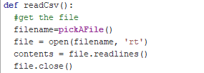
* **After that, I need to use a loop method to store all the data read in the new list created. The Len method can directly return the length of the list. By combining it with loops, I can traverse the entire list of data. Through the replace method, I can remove the extra \n in the list, and through the split method, I separate each data in the list with a comma. The finally returned list contains all the data read.**
* 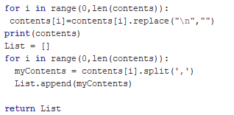



## Day4: Thursday 17 December 2020 1:00pm-2:30pm

* **According to the assignment requirements, each column of data in Excel needs to be stored in a list, so there are a total of six columns of data that need to be stored in six lists. They are Date, Open Price, High Price, Low Price, Close Price, Volume. Therefore, I will create six functions to get the data of each column in the List. They are getDate(List), getVolume(List), get_openPrice(List),get_highPrice(List), get_lowPrice(List), get_closePrice(List). According to the knowledge mentioned in the courseware, the list can also be stored in the list. If I want to read the list data in the list, as long as it is in the form of List[][] That's it. Therefore, I only need to loop through the List, and then use the append method to store the data of each column in its own new list. Among them, the getDate function is the most special. I need to remove the year by traversing, so that only the month and day will be displayed when drawing.**

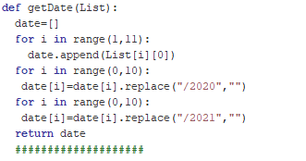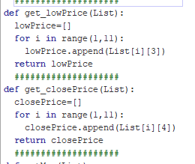

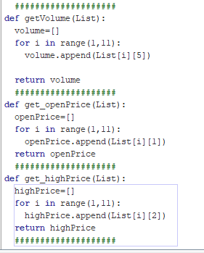

## Day5: Saturday 19 December 2020 1:00pm-5:30pm

* **Now I will start to make the showVolumeCharts function, this function has only one parameter sizeOption, by entering 1, 2, 3 to determine different sizes of charts. Therefore, I will use if to determine the parameter values I entered and draw charts of different sizes.**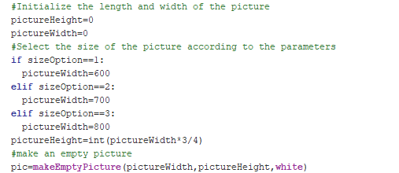
* **After that, I will start to draw the coordinate system, by observing that the abscissa is the date and the ordinate is the volume value. For these two values, I only need to draw the abscissa and ordinate values on the chart through the addText method and by looping through the dateList and volumeList. I will use the addLine method to draw horizontal lines in the chart. Through my observations and calculations, I found out the y-axis changes of each horizontal line.**
* **The date on the abscissa is very easy to draw, but the change rule of the scale value on the ordinate comes from the maximum value of Volume divided by 10, so I will make another getMax and getMin functions.**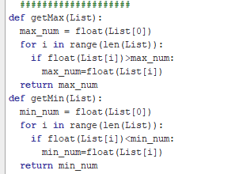 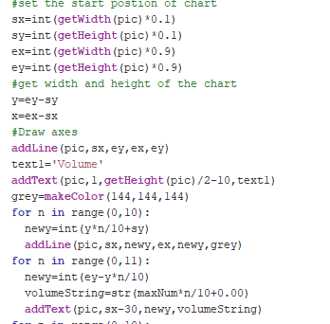

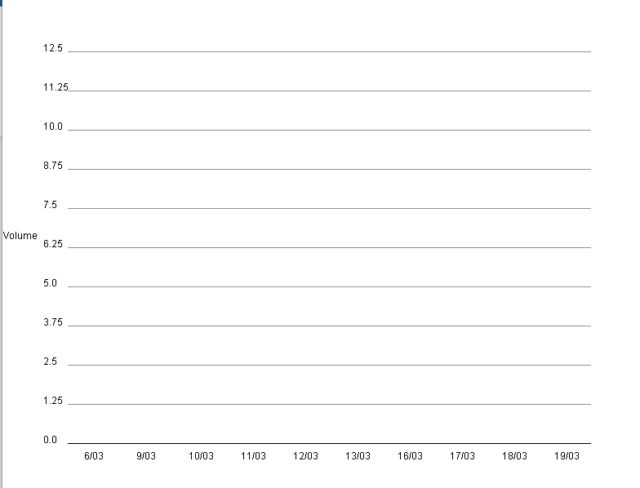

* **Now I only need to draw the column to complete the first function. According to the requirements, I need to draw the maximum value in red, the minimum value in green, and the other values in blue. Therefore, an if judgment is needed here. I need to use the addRectFilled method to draw the column. Now, the most difficult thing is how do I draw a column of corresponding height based on the scale of the ordinate. I thought of calculating a ratio value and multiplying it with the volume value of the column to draw the height.**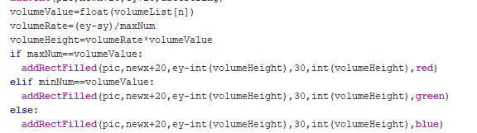 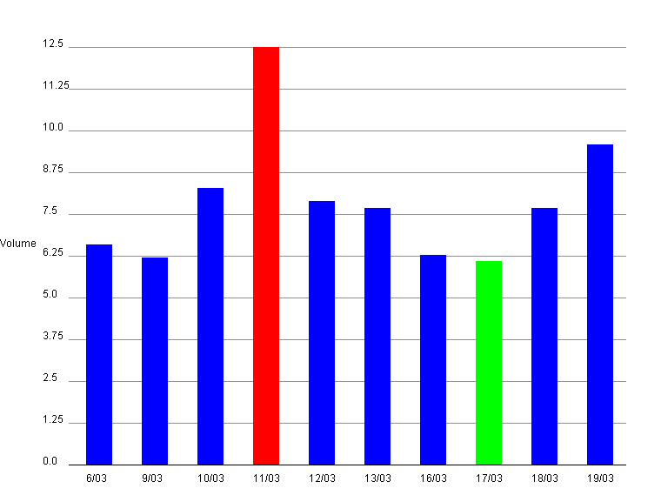 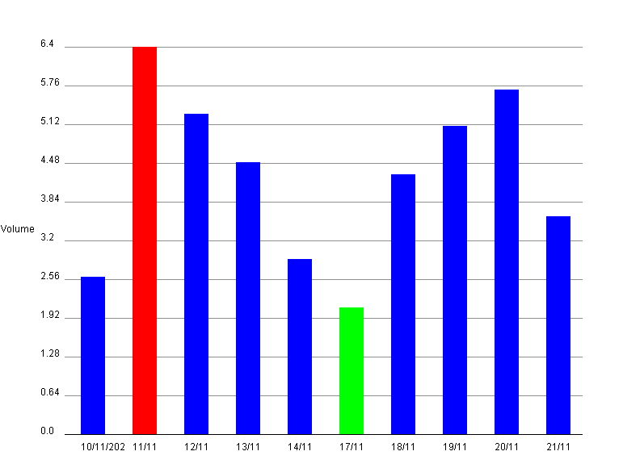

## Day6: Sunday 20 December 2020 2:00pm-3:30pm

**Now I’m going to start the second part of assignment. The drawCandlestickChart function has three parameters. The first argument inputDataFile will provide the name and extension of the text file that contains the data that the program will read in and analyze. This time, the file will be located in the media path, so before using this function, you need to set the media path correctly in the command area of JES. The second argument outputImageName will provide the name and extension of the image file used to save the chart from this question. It will be saved in the folder specified in the media path, which is the same location as the data. This function will display the result on the screen and save the chart as an image file, whose name and extension are specified by the string in outputImageName. The third argument sizeOption works in the same way as the first function. In other words, it can only take values 1, 2, or 3, which will guide it to generate charts with a width of 600 pixels, 700 pixels, or 800 pixels. The height of the chart is always three-quarters of the width.**

* **Therefore, my method of opening files will change from manual selection to opening by file name, so I have to create a new readCsv function and enter the setMediaPath method in the JES command line before the function runs.**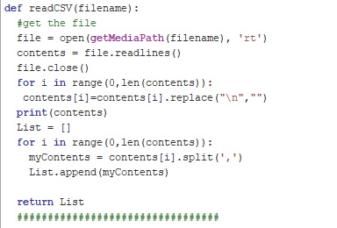
* **This time the abscissa is still the date, but the maximum and minimum on the ordinate scale are only highPrice and lowPrice. Through my observation, the law of their scale changes is the difference between highPrice-lowPrice and all the scale intervals of the coordinate are removed 10. Therefore, I need to make two more functions to find the highest price and the lowest price respectively.**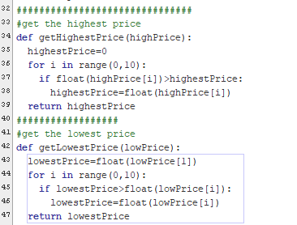
* **I will also create a function to add the y coordinate value, and draw the ordinate value by calling other functions. Among them, ‘%.2f’ allows the ordinate to indicate two decimal places.**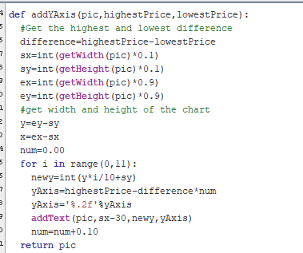

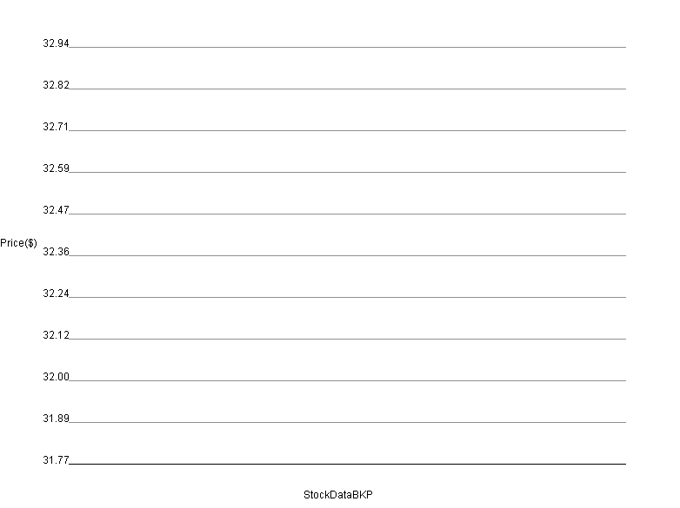

## Day7: Monday 21 December 2020 1:00pm-4:00pm

* **Now I only need to draw CandlestickChart. According to the prompt of assignment,**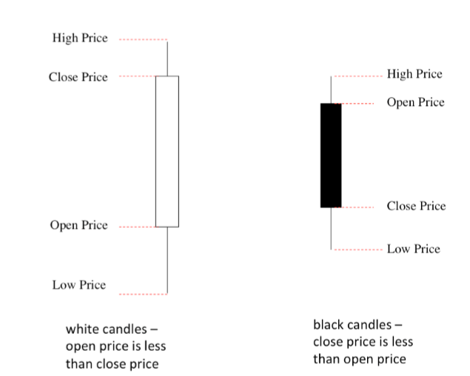
* **A candlestick chart is a chart specially used for stock market trading. The numbers (or candles) in this chart have a white or black bar chart showing the difference between the opening and closing prices of the stock. If the opening price of the day is lower than the closing price, the candle is white; if the opening price of the day is higher than the closing price, the candle is black. The "wick" of a candle is a vertical line drawn in the middle of the bar. The top wick extends up to the high price of the day, and the bottom wick extends down to the low price of the day.**

**Through the prompt of assignment, I will make two functions, which are to draw a black candlestick chart and a white candlestick chart.**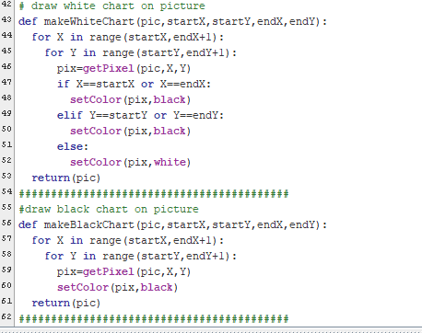

**By calling functions and multiple debugging experiments**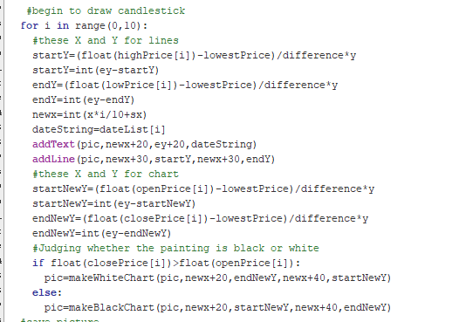 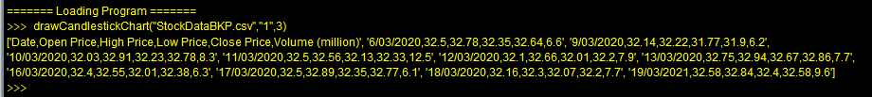

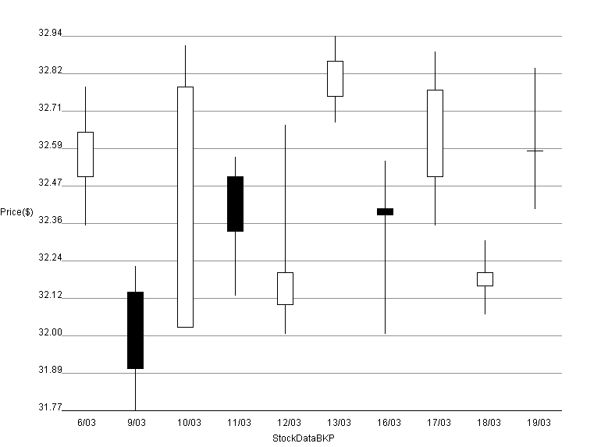

## Day8: Thursday 31 December 2020 4:30pm-5:30pm

* **The teacher give me advices：**

**1.make sure the two main function are up the top**

**2.Add more white space**

**3.The drawing should be done by another function**

**4.The main functions are too long and hard to maintain**

**So, I encapsulated my code to avoid program redundancy,** **I moved the two main functions to the top and try my best to fix the above problem.**

## In conclusion

* **In this assignment, through my self-study, I learned a lot of knowledge and ideas about programming. During this time, I put a lot of effort and time into this work. I also learned the importance of project planning, it can plan my tasks before I start the project, and let me have clear goals at each stage. Among them, the most important thing is that I learned the idea of ​​programming. I experienced a lot of frustration and pain in the process of programming, and the constant reporting of errors made me upset. However, through careful observation and continuous debugging, I continuously solved the problems encountered, and I found the law and method of drawing the coordinate system. When my code runs successfully and shows the correct results, I am very happy and proud. I realized that this is the fun of programming. I also understand a truth, even if it is a powerful programmer, it is impossible to write perfect and program code at once. All projects are completed in solving problems, solving errors, continuous debugging, and continuous iteration. No one can do it all at once. We need to learn to achieve our goals in continuous problem solving. Finally, although there are still many shortcomings in my program, I have tried my best. This is the result of my time and energy. I am very proud. This also allows me to truly experience the joy of programming.**