Software Engineering Project: Review-1 Report
NutriTwin - Consolidated Implementation Review
Scope boundary: this report documents the currently implemented platform foundation, manual nutrition workflow, deterministic decision support, and nutrition-chemistry evidence layer. Unimplemented features are identified without being presented as working.
1. Project & Team Information
Project Title: NutriTwin - An Explainable Personalized Nutrition Digital Twin with Multi-Objective RDA Optimization and Dietary Simulation
Team Information:
Student Name: K. Sarthak RegNo: 24BDS1121
Team/Role: Solo project; architecture, nutrition informatics, data engineering, optimization, backend development, testing, security review, and documentation.
Current Scope: Verified foundation and core backend workflow.
Repository Link: https://github.com/Kan-sar/NutriTwin (private; reviewer access must be granted)
2. Project Overview
Problem Statement:
Conventional calorie trackers often summarize logged food without preserving scientific source versions, separating consumed intake from estimated effective intake, or explaining how persistent nutrient gaps lead to recommendations. Indian users additionally need targets governed by ICMR-NIN references rather than silently substituted international defaults. The engineering problem is to maintain a reproducible longitudinal nutrition state while avoiding diagnostic, clinical, or biologically overstated claims.
Core Objective: Build a non-clinical, research-grade prototype that converts manual ingredient-level meal logs into versioned targets, consumed/effective nutrient traces, daily and rolling coverage, transparent intake-gap indications, and constraint-aware meal recommendations.
Proposed Solution:
NutriTwin is a modular FastAPI application with pure deterministic nutrition and optimization logic. PostgreSQL is the intended authoritative history store, while Redis/Celery and Neo4j are supporting services. The implemented workflow lets a Student or Adult authenticate, consent, create a profile, obtain a provisional synthetic target snapshot, search curated foods, log ingredient-level meals, view daily/7-day/30-day twin states, inspect a deterministic risk trace, and receive ranked explanations. Admin users can inspect scientific sources, ChEBI substances, FoodOn mappings, qualitative evidence, and audit records. The complete workflow operates without an LLM.
Safety Boundary: The prototype does not diagnose deficiency or disease, measure biological absorption, prescribe supplements, or recommend medication changes. Real Indian reference values are not yet bundled because lawful redistribution and expert verification remain unresolved.
3. Review of Related Works
Existing Solutions and Research: five representative works were reviewed against the project objective.
Related work | Relevant contribution | Gap addressed by NutriTwin
Cronometer | Food, recipe, barcode, device, and detailed nutrient tracking; its public feature page advertises tracking up to 84 nutrients. | NutriTwin makes versioned scientific provenance, deterministic calculation traces, Indian-reference governance, and consumed/effective separation explicit research requirements.
HealthifyMe | Public features include meal logging, macro checks, meal-photo input, personalized plans, coaching, body metrics, and timeline/history. | NutriTwin narrows the current core to reproducible manual logging and explainable non-clinical computations; optional photo recognition and coaching are deliberately deferred.
Food4Me RCT | A six-month, 1,607-participant European randomized trial evaluated Internet-delivered personalized nutrition and found modest improvements in dietary behavior. | The evidence supports personalization, but the study is European and intervention-focused rather than an Indian RDA/EAR-governed, ingredient-level longitudinal software twin.
eNutri | A web system uses a validated graphical food-frequency questionnaire to provide automated personalized food-based advice; its design/source were reported as openly available. | NutriTwin focuses on daily manual ingredient events, immutable snapshots, rolling memory, explicit hard constraints, and reproducible optimizer traces rather than FFQ-only feedback.
Virtual Digital Twins in Precision Nutrition | The 2020 concept combines longitudinal genetic, metabolic, microbial, clinical, and behavioral data for individualized simulation. | NutriTwin adopts the longitudinal twin idea but intentionally begins with a bounded, deterministic, low-data, non-clinical model suitable for a single-student prototype.
Gap Analysis: Existing products prioritize logging, coaching, broad health metrics, or convenience features, while research systems often assume European cohorts, FFQs, high-dimensional biomarkers, or clinical objectives. NutriTwin's distinct contribution is the combination of Indian reference-data governance, immutable calculation history, separate consumed and estimated-effective states, daily/7-day/30-day nutritional memory, transparent risk wording, hard-constraint-aware scoring, deterministic OR-Tools optimization, and explanations assembled from stored decision traces. The current implementation is limited to the deterministic backend and evidence-inspection subset; scientific reference imports and the client remain future work.
4. Novelty & Value Proposition
NutriTwin is designed as an explainable nutrition-computation system rather than a black-box diet chatbot. Its novelty is architectural and methodological: (1) logged consumption and estimated effective intake are separate traceable values; (2) target and rule versions are effective-dated and historical snapshots are immutable; (3) missing composition values remain missing, never silently zero; (4) persistent intake-gap indications use a transparent versioned formula and explicitly avoid deficiency diagnosis; (5) allergies and dietary restrictions are hard constraints that cannot be traded for a higher soft score; (6) OR-Tools construction is bounded and deterministic; and (7) an LLM, if ever added, can only rephrase already computed facts. This creates a reproducible academic base for later expert validation without making the system depend on opaque generative output.
5. Technical Specifications
Tech Stack:
Python 3.12-3.14; FastAPI 0.141.1; Pydantic 2.13.5; SQLAlchemy 2.0.52; Alembic 1.19.1; PostgreSQL 16.15; Redis 7.4.10; Celery 5.6.3; Neo4j 5.26.30; Google OR-Tools 9.15.6755; RDKit 2026.3.5; ChEBI and FoodOn reference identifiers; Argon2 password hashing; JWT access tokens and hashed rotating refresh sessions; Pytest 9.1.1; Hypothesis; Ruff; strict mypy; pip-audit; detect-secrets; Playwright 1.62.0; Docker Compose; GitHub Actions. Flutter is the primary planned client but is not implemented in the reported scope.
System Architecture: A reliable modular monolith keeps pure domain calculations independent from HTTP, ORM, workers, clients, and optional integrations. PostgreSQL owns transactional/history data. On-demand summaries provide current consistency; an idempotent Celery job is available for later scheduled materialization. Neo4j and an LLM are non-critical adapters and cannot change core results.
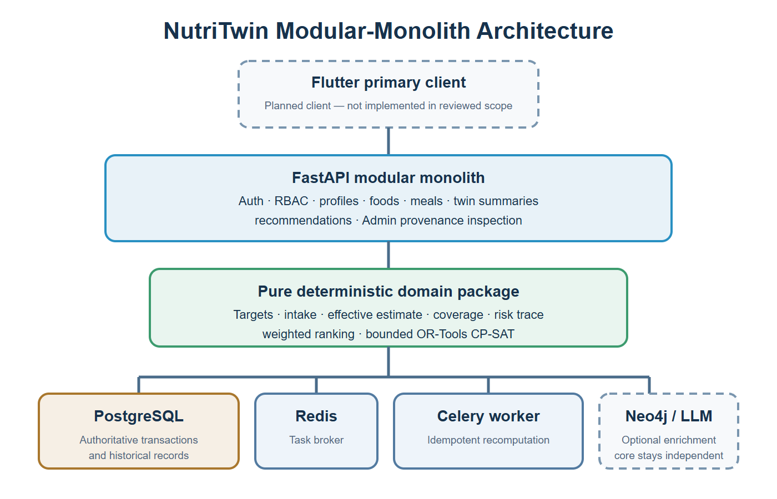
Figure 1. High-level architecture of the current implementation.
6. Current Progress & Implementation
Implementation Boundary: The verified repository contains a tested platform foundation, one complete manual backend workflow, deterministic domain calculations, and a bounded nutrition-chemistry reference layer. It does not claim scientific production readiness, a mobile client, or advanced pantry, simulation, graph-authoring, and research workflows.
- Access foundation: Student, Adult, and Admin roles; Argon2 password hashing; short-lived JWT access tokens; rotating/revocable hashed refresh sessions; backend RBAC; consent and audit records.
- Reference/profile foundation: data-source and nutrient registries; versioned target rules; immutable target snapshots; provisional/synthetic flags; complete calculation traces.
- Manual nutrition workflow: food search; ingredient-level meal create/list/edit/soft-delete; revision-aware recomputation requests.
- Twin computation: consumed and estimated-effective totals kept distinct; identity estimate when no approved quantitative absorption rule exists; daily, rolling 7-day, and rolling 30-day coverage with completeness metadata.
- Decision support: deterministic persistent intake-gap risk trace; hard-constraint-aware weighted meal ranking; deterministic explanations; tested bounded OR-Tools CP-SAT constructor in the pure domain package.
- Reproducibility: three Alembic revisions, idempotent synthetic seeding, seven synthetic foods/four nutrients, two reviewed demonstration substances, three FoodOn mappings, one calculation-inactive qualitative evidence record, Docker Compose, pinned dependencies, CI workflow, Makefile/direct Windows commands, and an automated no-LLM demo.
- Documentation/governance: architecture, algorithms, data dictionary, source register, traceability matrix, threat model, ADRs, validation report, demo walkthrough, third-party notices, and a checksum-bound screenshot evidence manifest.
Implemented API Surface: 19 OpenAPI paths covering health/readiness, auth, current user, consent, profile, target, foods, meal CRUD, twin summary, recommendations, and Admin reference, chemistry, qualitative-evidence, and audit inspection.
Explicitly Not Claimed: Flutter UI; licensed ICMR-NIN/IFCT rows; scientific golden cases; active quantitative absorption rules; Admin authoring/approval; persisted summary tables; CP-SAT API construction; pantry/grocery; what-if simulation; graph authoring; research export; OCR/vision/barcode; external prices; LLM adapter; Next.js; Kubernetes; or public deployment.
6.1 API and Database Design
HTTP routers are thin boundaries over pure domain services. SQLAlchemy models preserve users, consent, refresh-session families, profiles, source versions, target rules and snapshots, foods, nutrient rows, meal revisions, recomputation jobs, audit events, chemical substances, FoodOn mappings, and qualitative evidence. Alembic owns schema evolution. Historical target snapshots are append-only; meal deletion is soft; active qualitative evidence is prohibited by a database check constraint.
6.2 Deterministic Algorithm Summary
Canonical decimal units feed meal-level consumed totals. The current effective-intake baseline returns the same numeric amount with an explicit uncertainty trace because no quantitative rule is approved. Coverage is calculated independently for daily, rolling 7-day, and rolling 30-day windows. The versioned intake-gap model combines documented coverage and persistence factors and emits only non-diagnostic wording. Recommendations apply hard constraints before normalized weighted objectives; deterministic tie-breaking and stored rejection reasons make explanations reproducible. CP-SAT invariants are tested in the bounded domain subset.
6.3 Open-Source and Data-Resource Governance
External projects are pinned dependencies or versioned reference sources. They do not replace scientific authority, and their exact use and limitations are recorded in THIRD_PARTY_NOTICES.md and the data-source register.
Resource | Use | Pinned version/ref | License and boundary
RDKit | Optional structure consistency checks | 2026.3.5 / de8add1e | BSD-3-Clause; no clinical prediction
ChEBI | Two chemical identifiers and structures | Accessed 2026-08-30 | CC BY 4.0; demonstration subset
FoodOn | Three demo-food ontology mappings | 2025-12-30 / c5035015 | CC BY 4.0; reviewed mappings
NIH ODS | Qualitative iron interaction context | Accessed 2026-08-30 | Informational; calculation inactive
Playwright | Live browser evidence capture | 1.62.0 / 3b7c24c3 | Apache-2.0; test tooling only
Verified Execution Evidence: The following figures were captured from the running local application at commit 5f05f39. The manifest records timestamp, source endpoint or command, alternative text, and SHA-256 checksum for each image.
7. Working-State Evidence
All figures use local demo data. Tokens, passwords, connection strings, email addresses, user identifiers, and personal information are excluded. Synthetic nutrient values are software fixtures and are not dietary guidance.
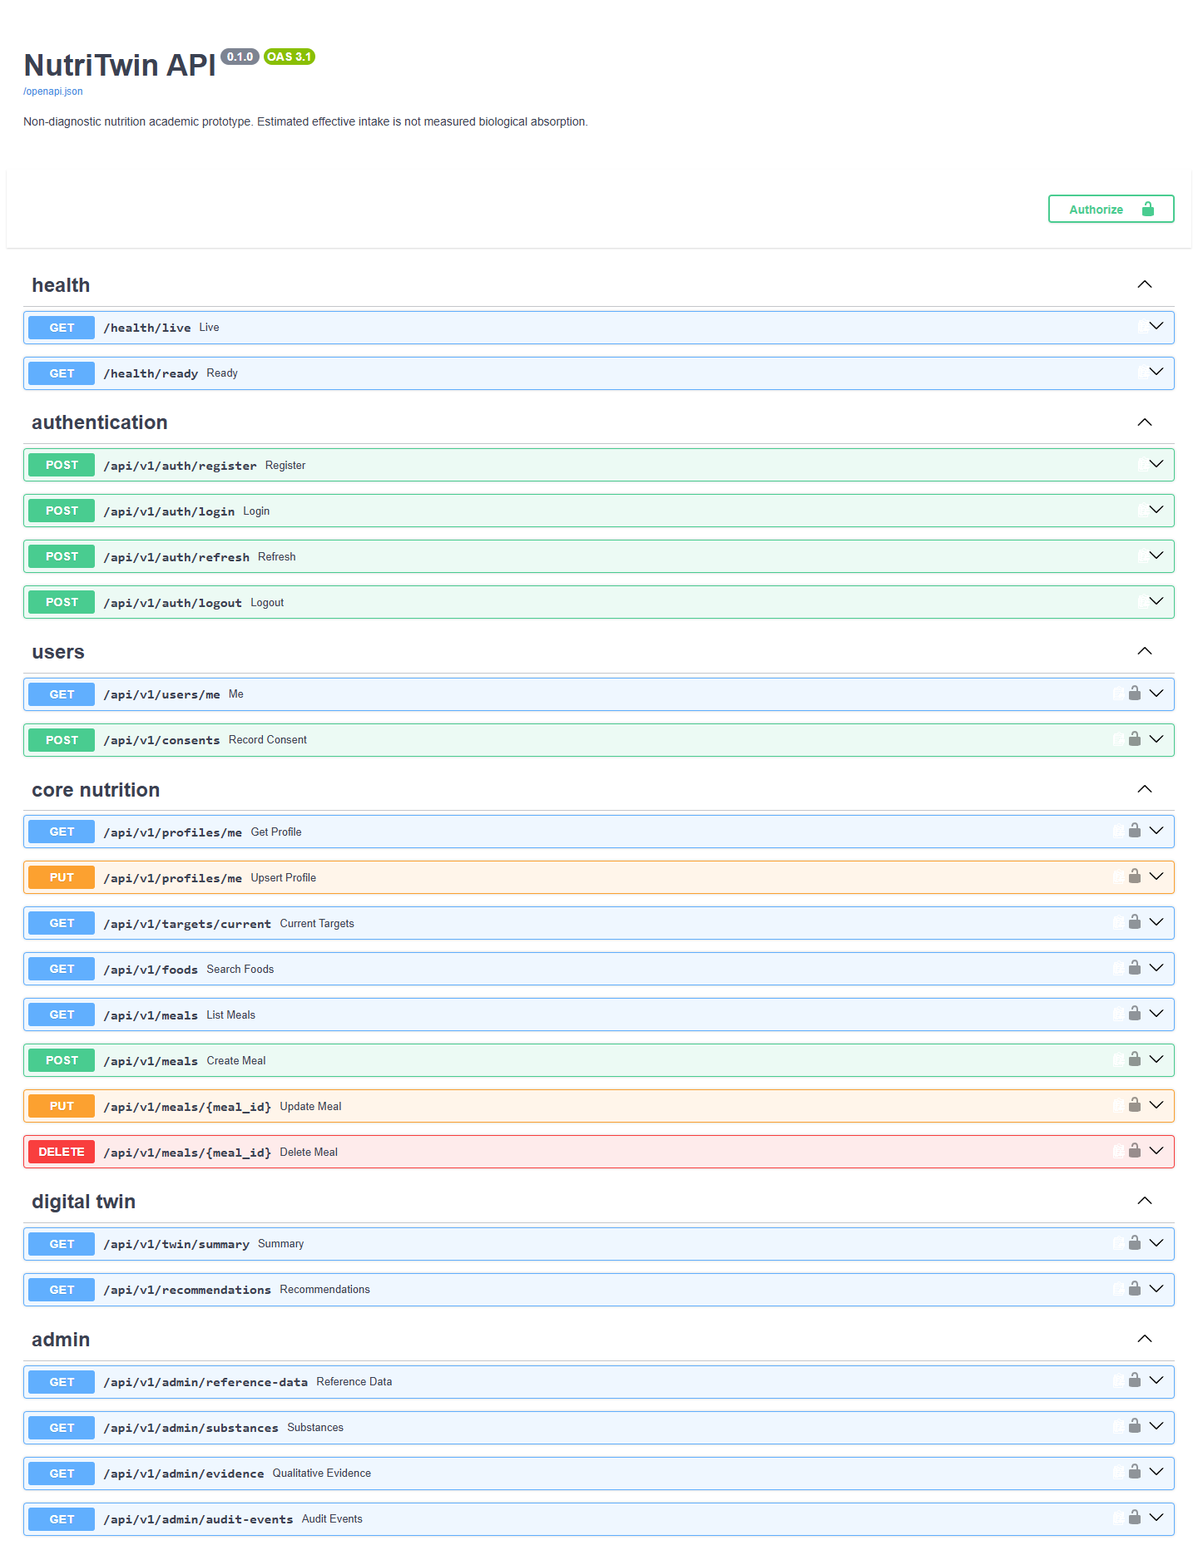
Figure 2. Live OpenAPI interface and implemented endpoint groups.

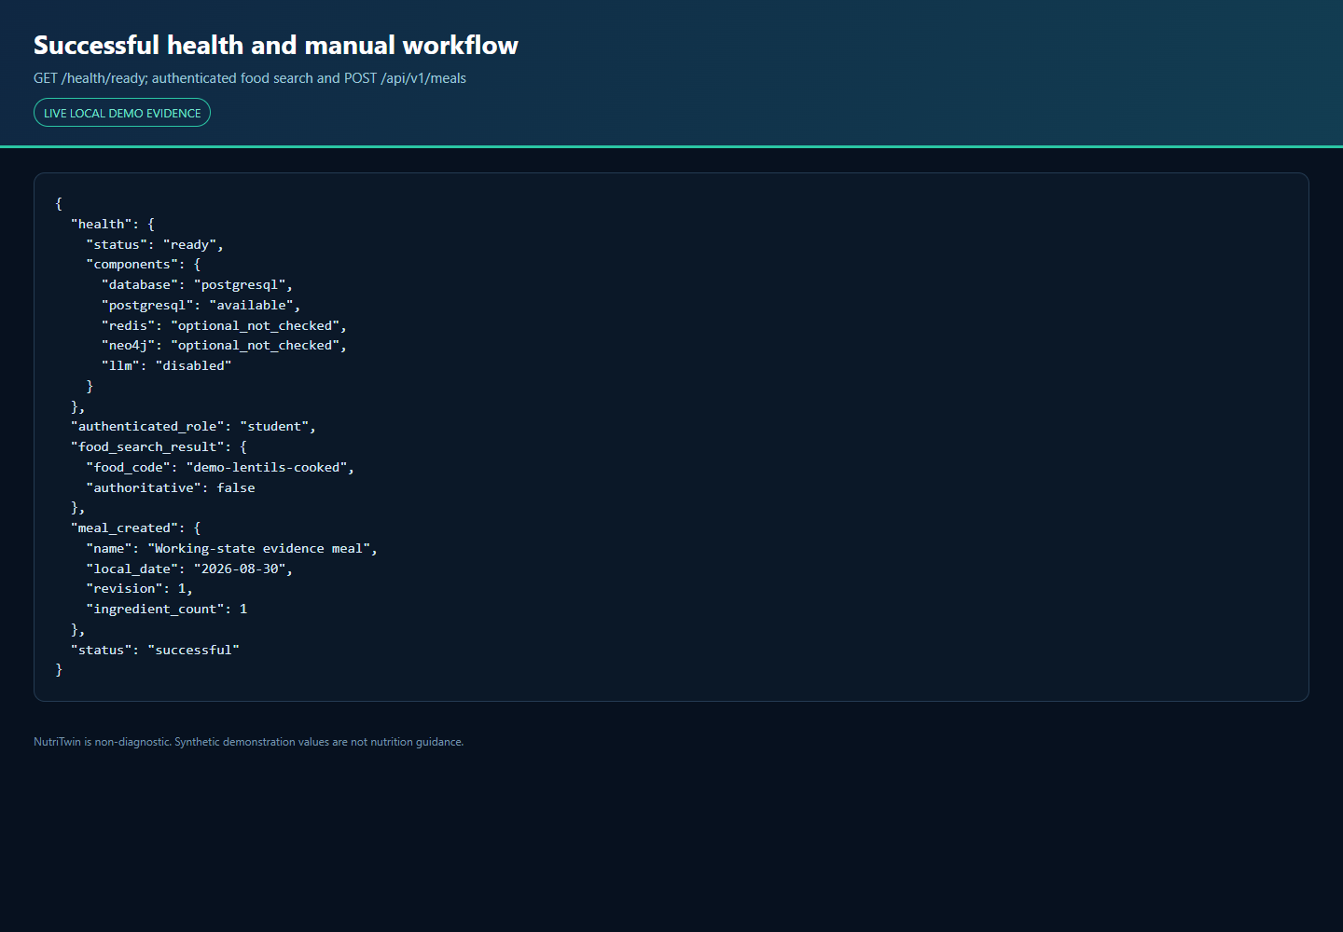
Figure 3. Successful readiness and authenticated Student workflow.

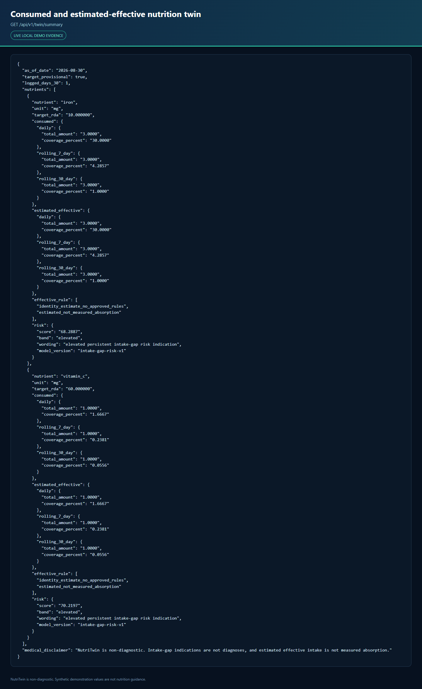
Figure 4a. Nutrition twin trace: target, daily, and rolling consumed values.


Figure 4b. Nutrition twin trace: estimated-effective values, risk wording, and disclaimer.

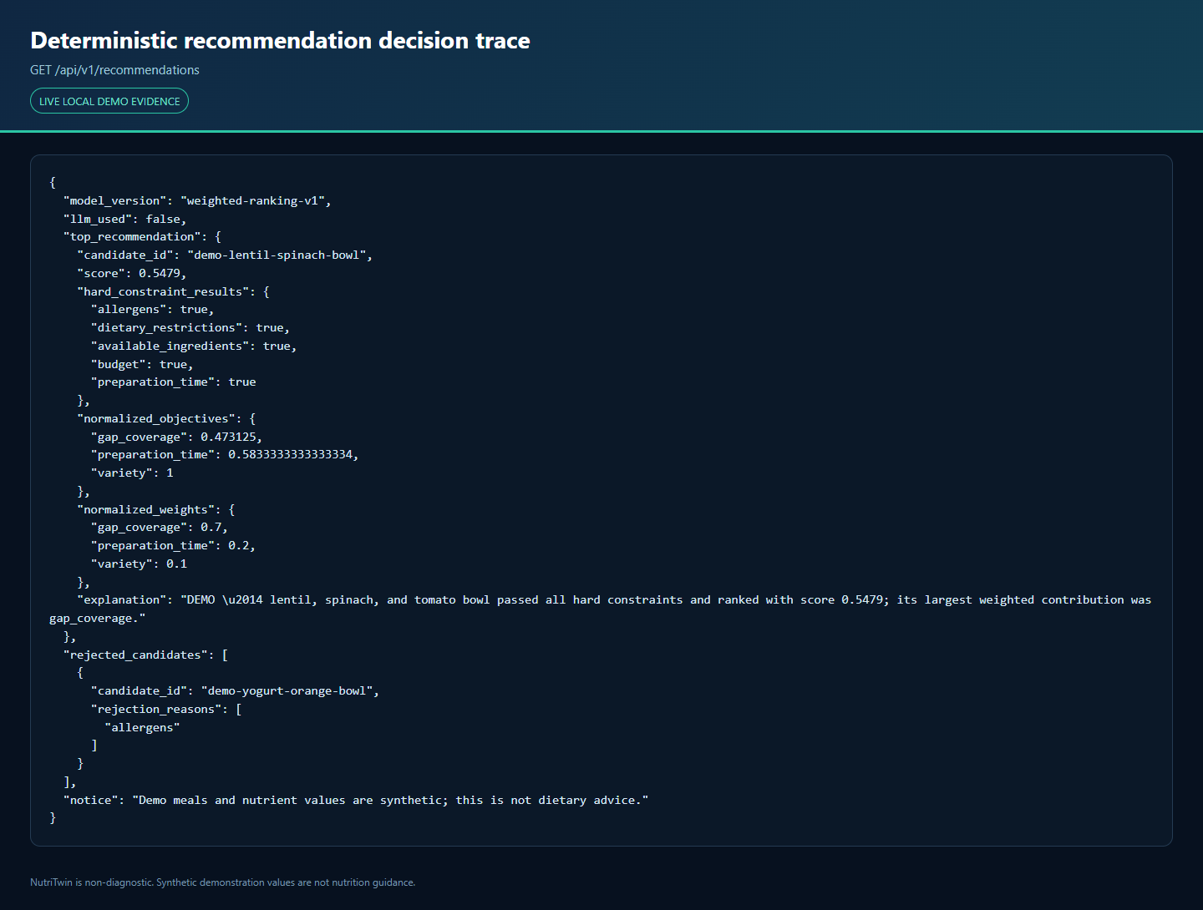
Figure 5. Deterministic recommendation constraints, scores, rejection, and explanation.

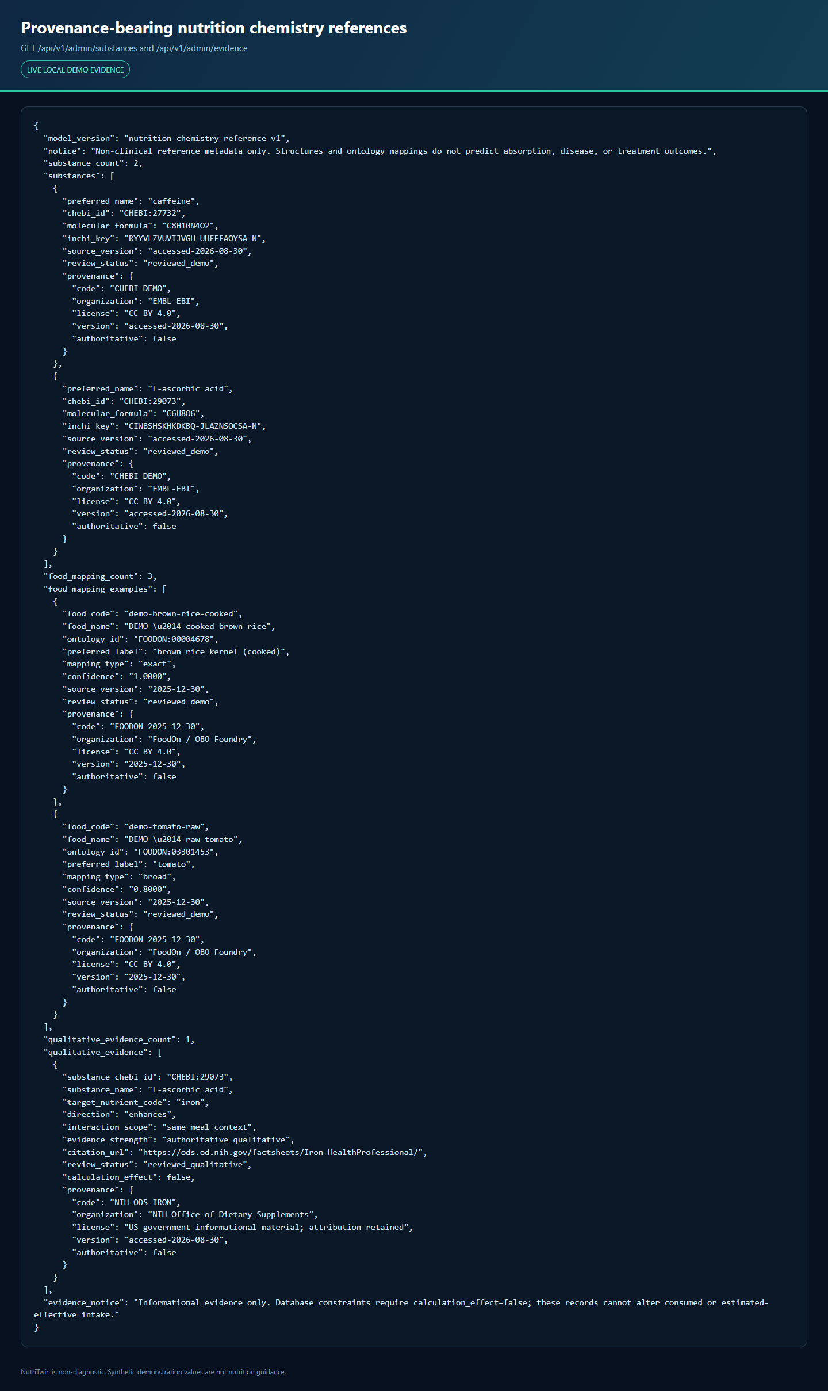
Figure 6a. ChEBI substances and FoodOn mapping provenance.


Figure 6b. Qualitative evidence with calculation effect disabled.

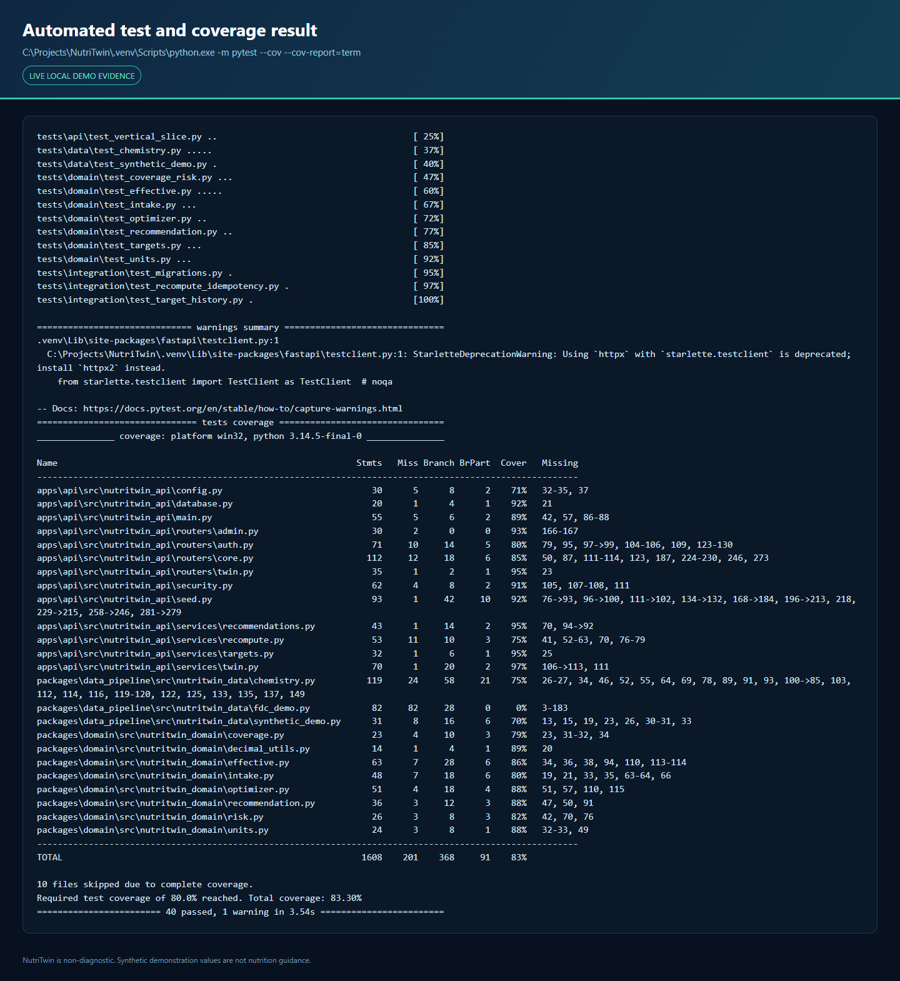
Figure 7. Passing automated tests and branch-aware coverage.

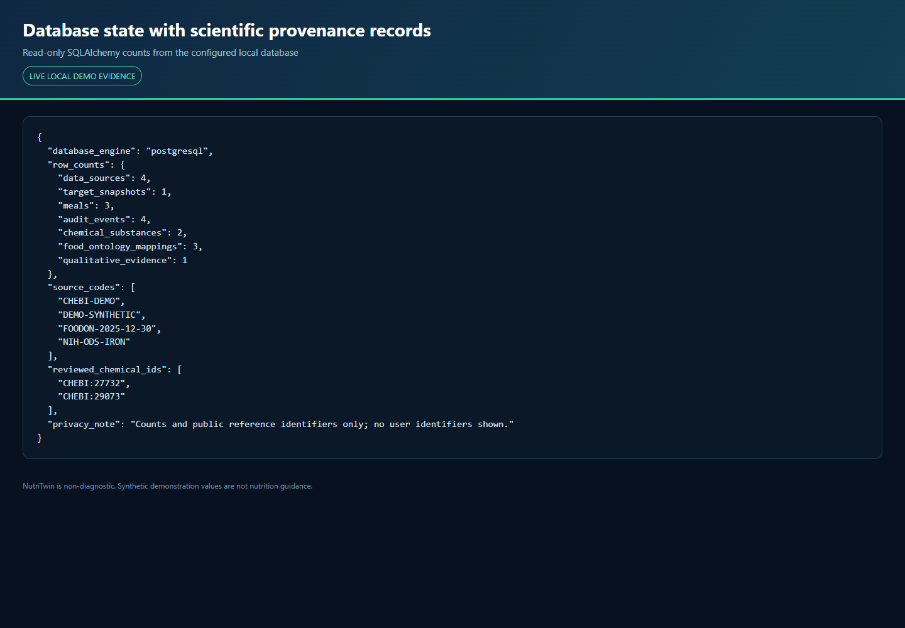
Figure 8. Secret-safe database state and provenance row counts.
8. Challenges & Next Steps
Challenges Faced:
- Scientific licensing: ICMR-NIN RDA/EAR 2020 and IFCT 2017 are authoritative, but lawful electronic redistribution/import permissions and verified machine-readable tables remain unresolved; synthetic data is therefore used only for software validation.
- Scientific uncertainty: qualitative enhancer/inhibitor evidence does not justify a universal quantitative absorption multiplier, so the active model uses an explicit identity estimate.
- Infrastructure recovery: Docker Desktop initially failed on stale Windows AF_UNIX runtime sockets. The exact runtime directories were preserved under recovery names, Docker recreated them, and engine 29.5.2 became healthy without a factory reset or data deletion. Container validation results are recorded in docs/VALIDATION_REPORT.md.
- Client tooling: Flutter is not installed on the development host; no mock client is presented as implemented.
- External source reliability: the optional USDA FoodData Central DEMO_KEY acquisition attempt returned HTTP 429, and no fetched FDC records are bundled.
- Academic validation: the risk formula and recommendation objectives are transparent prototypes that still require nutrition-expert review and future empirical evaluation.
Pending Deliverables:
- Lawful ICMR-NIN/IFCT import manifests, normalized reference rows, and independently verified golden examples.
- Reviewed evidence authoring and bounded quantitative absorption rules; materialized nutrition memory and scheduled Celery recomputation.
- Persisted/API-exposed CP-SAT meal construction, pantry, grocery optimization, substitutions, prices, shopping lists, and deterministic what-if simulation.
- Neo4j evidence graph with cited relationships, full Admin review/approval workflows, feature flags, audit inspection, and anonymized aggregate export.
- Flutter onboarding, authentication, profile, meal logging, dashboard, trends, recommendations, explanations, pantry, grocery, simulation, error/offline, accessibility, widget, and end-to-end states.
- Pending validation and implementation: production scientific-data review, scheduled materialization, full multi-service failure testing, Flutter, and later optional features remain outside the implemented scope.
Next-step sequence: resolve lawful Indian reference-data access and expert review, then materialize nutrition memory, expose bounded optimization workflows, and implement the Flutter client with accessibility and end-to-end tests.

Next step | Dependency | Planned validation
Authoritative Indian reference data | Lawful source access and nutrition-expert review | Checksums, transformation validation, and verified golden cases
Quantitative absorption rules | Reviewed evidence and bounded formulas | Golden traces, conflict tests, and calculation review
Materialized nutrition memory | PostgreSQL and Redis/Celery scheduling | Idempotency, retry, edit/delete, and migration tests
Flutter core client | Stable API contract and Flutter SDK | Unit, widget, accessibility, offline, and end-to-end tests
9. References
- Cronometer. Advanced Features for Accurate Nutrition & Calorie Tracking. https://cronometer.com/features/ (accessed 30 August 2026).
- HealthifyMe. Track Nutrition, Plan Your Diet, Get Fitter. https://www.healthifyme.com/ (accessed 30 August 2026).
- Livingstone KM et al. Effect of an Internet-based, personalized nutrition randomized trial on dietary changes associated with the Mediterranean diet: the Food4Me Study. American Journal of Clinical Nutrition. 2016;104(2):288-297. doi:10.3945/ajcn.115.129049.
- Franco RZ, Fallaize R, Hwang F, Lovegrove JA. Strategies for online personalised nutrition advice employed in the development of the eNutri web app. Proceedings of the Nutrition Society. 2019;78(3):407-417. doi:10.1017/S0029665118002707.
- Gkouskou K et al. The 'Virtual Digital Twins' Concept in Precision Nutrition. Advances in Nutrition. 2020;11(6):1405-1413. doi:10.1093/advances/nmaa089.
- ICMR-NIN Expert Group. Nutrient Requirements for Indians: Recommended Dietary Allowances and Estimated Average Requirements. 2020. Authoritative target source; tables not bundled pending lawful access.
- ICMR-NIN. Dietary Guidelines for Indians 2024. Educational and governance reference; electronic-product reuse restrictions observed.
- Longvah T et al. Indian Food Composition Tables 2017. ICMR-NIN. Preferred Indian food-composition source; redistribution permission unresolved.
- NutriTwin repository evidence: README.md, docs/ARCHITECTURE.md, docs/ALGORITHM_SPECIFICATION.md, docs/DATA_SOURCE_REGISTER.md, THIRD_PARTY_NOTICES.md, docs/VALIDATION_REPORT.md, and the evidence manifest at commit 5f05f39.
RDKit contributors. RDKit: Open-Source Cheminformatics Software. Release 2026.3.5; BSD-3-Clause. https://www.rdkit.org/.
EMBL-EBI. Chemical Entities of Biological Interest (ChEBI). CC BY 4.0. https://www.ebi.ac.uk/chebi/.
FoodOn Consortium. FoodOn food ontology, release 2025-12-30. CC BY 4.0. https://foodon.org/.
NIH Office of Dietary Supplements. Iron Fact Sheet for Health Professionals. https://ods.od.nih.gov/factsheets/Iron-HealthProfessional/.
Microsoft. Playwright for Python 1.62.0. Apache-2.0. https://github.com/microsoft/playwright-python.

