Software Engineering Project: Review-1 Report
NutriTwin - Consolidated Verified 30% Implementation
Scope boundary: this report documents only the verified foundation and backend vertical slice assessed as the first 30% of the planned project. It does not claim completion of the full platform.
1. Project & Team Information
Project Title: NutriTwin - An Explainable Personalized Nutrition Digital Twin with Multi-Objective RDA Optimization and Dietary Simulation
Team Information:
Student Name: [ENTER STUDENT NAME] Roll Number: [ENTER ROLL NUMBER]
Team/Role: Individual student project (confirm if different); architecture, nutrition informatics, data engineering, optimization, backend development, testing, security review, and documentation.
Review Milestone: Review-1 - verified 30% implementation boundary.
Repository Link: https://github.com/Kan-sar/NutriTwin (private; reviewer access must be granted)
2. Project Overview
Problem Statement:
Conventional calorie trackers often summarize logged food without preserving scientific source versions, separating consumed intake from estimated effective intake, or explaining how persistent nutrient gaps lead to recommendations. Indian users additionally need targets governed by ICMR-NIN references rather than silently substituted international defaults. The engineering problem is to maintain a reproducible longitudinal nutrition state while avoiding diagnostic, clinical, or biologically overstated claims.
Core Objective: Build a non-clinical, research-grade prototype that converts manual ingredient-level meal logs into versioned targets, consumed/effective nutrient traces, daily and rolling coverage, transparent intake-gap indications, and constraint-aware meal recommendations.
Proposed Solution:
NutriTwin is a modular FastAPI application with pure deterministic nutrition and optimization logic. PostgreSQL is the intended authoritative history store, while Redis/Celery and Neo4j are optional supporting services. The implemented Review-1 slice lets a Student or Adult authenticate, consent, create a profile, obtain a provisional synthetic target snapshot, search curated foods, log ingredient-level meals, view daily/7-day/30-day twin states, inspect a deterministic risk trace, and receive ranked explanations. The complete workflow operates without an LLM.
Safety Boundary: The prototype does not diagnose deficiency or disease, measure biological absorption, prescribe supplements, or recommend medication changes. Real Indian reference values are not yet bundled because lawful redistribution and expert verification remain unresolved.
3. Review of Related Works
Existing Solutions and Research: five representative works were reviewed against the project objective.
Related work | Relevant contribution | Gap addressed by NutriTwin
Cronometer | Food, recipe, barcode, device, and detailed nutrient tracking; its public feature page advertises tracking up to 84 nutrients. | NutriTwin makes versioned scientific provenance, deterministic calculation traces, Indian-reference governance, and consumed/effective separation explicit research requirements.
HealthifyMe | Public features include meal logging, macro checks, meal-photo input, personalized plans, coaching, body metrics, and timeline/history. | NutriTwin narrows the Review-1 core to reproducible manual logging and explainable non-clinical computations; optional photo recognition and coaching are deliberately deferred.
Food4Me RCT | A six-month, 1,607-participant European randomized trial evaluated Internet-delivered personalized nutrition and found modest improvements in dietary behavior. | The evidence supports personalization, but the study is European and intervention-focused rather than an Indian RDA/EAR-governed, ingredient-level longitudinal software twin.
eNutri | A web system uses a validated graphical food-frequency questionnaire to provide automated personalized food-based advice; its design/source were reported as openly available. | NutriTwin focuses on daily manual ingredient events, immutable snapshots, rolling memory, explicit hard constraints, and reproducible optimizer traces rather than FFQ-only feedback.
Virtual Digital Twins in Precision Nutrition | The 2020 concept combines longitudinal genetic, metabolic, microbial, clinical, and behavioral data for individualized simulation. | NutriTwin adopts the longitudinal twin idea but intentionally begins with a bounded, deterministic, low-data, non-clinical model suitable for a single-student prototype.
Gap Analysis: Existing products prioritize logging, coaching, broad health metrics, or convenience features, while research systems often assume European cohorts, FFQs, high-dimensional biomarkers, or clinical objectives. NutriTwin's distinct contribution is the combination of Indian reference-data governance, immutable calculation history, separate consumed and estimated-effective states, daily/7-day/30-day nutritional memory, transparent risk wording, hard-constraint-aware scoring, deterministic OR-Tools optimization, and explanations assembled from stored decision traces. At 30%, only the deterministic backend subset is claimed; scientific and client completeness remain future work.
4. Novelty & Value Proposition
NutriTwin is designed as an explainable nutrition-computation system rather than a black-box diet chatbot. Its novelty is architectural and methodological: (1) logged consumption and estimated effective intake are separate traceable values; (2) target and rule versions are effective-dated and historical snapshots are immutable; (3) missing composition values remain missing, never silently zero; (4) persistent intake-gap indications use a transparent versioned formula and explicitly avoid deficiency diagnosis; (5) allergies and dietary restrictions are hard constraints that cannot be traded for a higher soft score; (6) OR-Tools construction is bounded and deterministic; and (7) an LLM, if ever added, can only rephrase already computed facts. This creates a reproducible academic base for later expert validation without making the system depend on opaque generative output.
5. Technical Specifications
Tech Stack:
Python 3.12-3.14; FastAPI 0.141.1; Pydantic 2.13.5; SQLAlchemy 2.0.52; Alembic 1.19.1; PostgreSQL 16.15; Redis 7.4.10; Celery 5.6.3; Neo4j 5.26.30; Google OR-Tools 9.15.6755; Argon2 password hashing; JWT access tokens and hashed rotating refresh sessions; Pytest 9.1.1; Hypothesis; Ruff; strict mypy; pip-audit; detect-secrets; Docker Compose; GitHub Actions. Flutter is the primary planned client but is not implemented at this milestone.
System Architecture: A reliable modular monolith keeps pure domain calculations independent from HTTP, ORM, workers, clients, and optional integrations. PostgreSQL owns transactional/history data. On-demand summaries provide current consistency; an idempotent Celery job is available for later scheduled materialization. Neo4j and an LLM are non-critical adapters and cannot change core results.
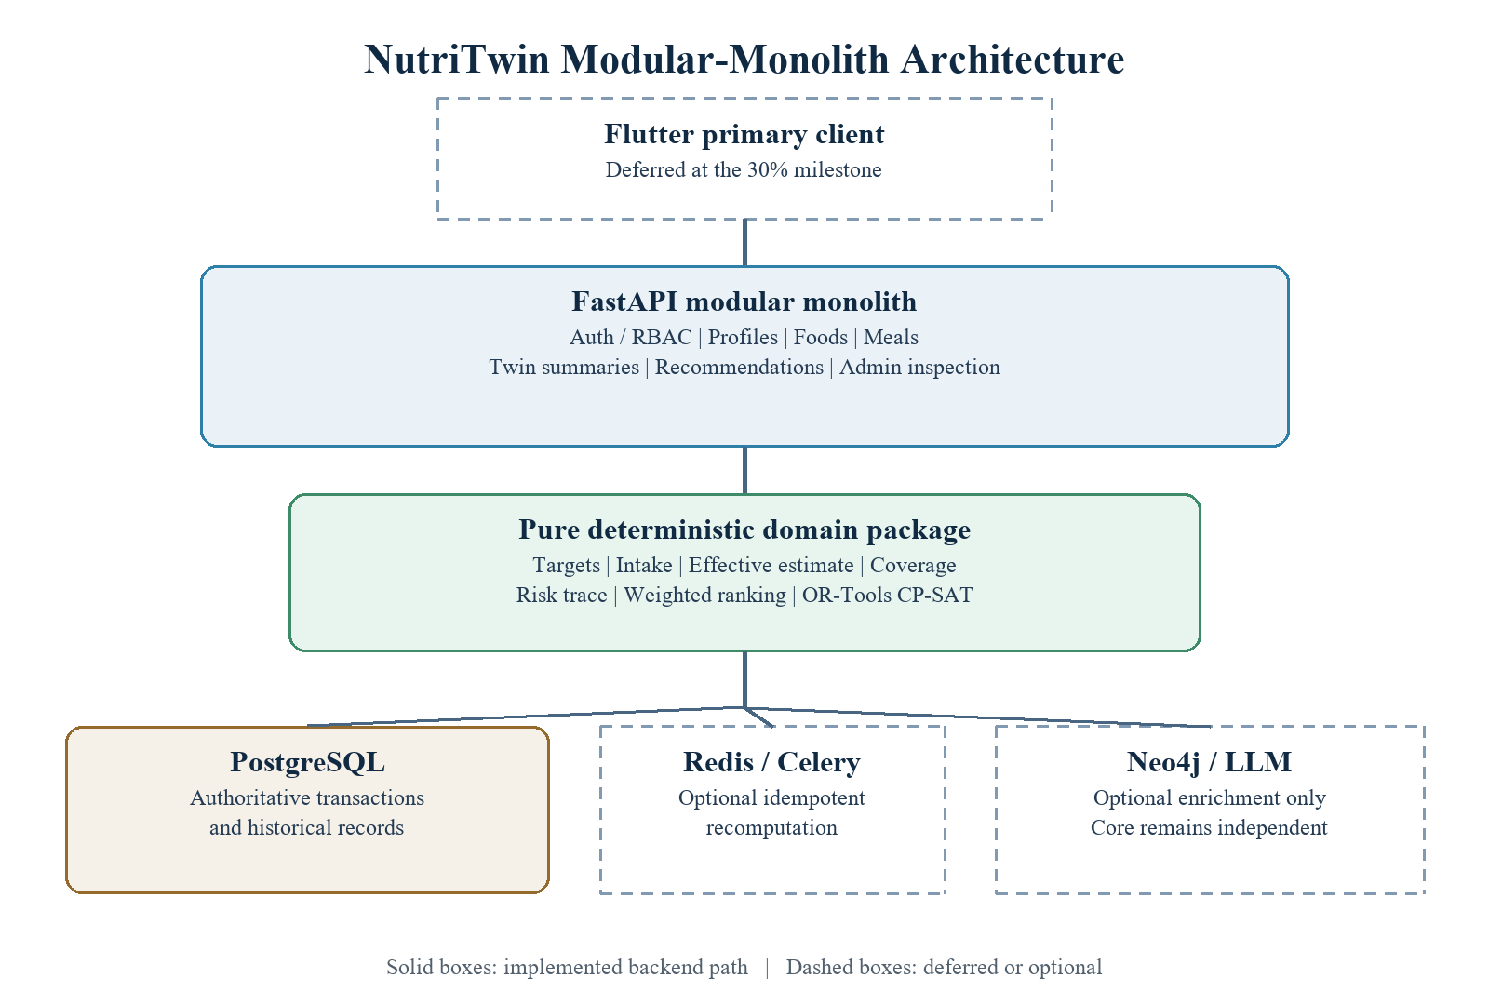
Figure 1. High-level architecture at the verified 30% implementation milestone.
6. Current Progress & Implementation
Implementation Boundary: The project is reported as 30% complete for Review-1. This percentage is a project-plan milestone, not code coverage. It represents a tested backend foundation and one manual end-to-end slice; it excludes the majority of scientific data, client, optimization workflow, graph, pantry, grocery, simulation, and research-support scope.
- Access foundation: Student, Adult, and Admin roles; Argon2 password hashing; short-lived JWT access tokens; rotating/revocable hashed refresh sessions; backend RBAC; consent and audit records.
- Reference/profile foundation: data-source and nutrient registries; versioned target rules; immutable target snapshots; provisional/synthetic flags; complete calculation traces.
- Manual nutrition workflow: food search; ingredient-level meal create/list/edit/soft-delete; revision-aware recomputation requests.
- Twin computation: consumed and estimated-effective totals kept distinct; identity estimate when no approved quantitative absorption rule exists; daily, rolling 7-day, and rolling 30-day coverage with completeness metadata.
- Decision support: deterministic persistent intake-gap risk trace; hard-constraint-aware weighted meal ranking; deterministic explanations; tested bounded OR-Tools CP-SAT constructor in the pure domain package.
- Reproducibility: two Alembic revisions, idempotent synthetic seeding, seven synthetic foods/four nutrients, Docker Compose, pinned dependencies, CI workflow, Makefile/direct Windows commands, and an automated no-LLM demo.
- Documentation/governance: architecture, algorithms, data dictionary, source register, traceability matrix, threat model, ADRs, validation report, and demo walkthrough.
Implemented API Surface: 17 OpenAPI paths covering health/readiness, auth, current user, consent, profile, target, foods, meal CRUD, twin summary, recommendations, and Admin reference/audit inspection.
Explicitly Not Claimed: Flutter UI; licensed ICMR-NIN/IFCT rows; scientific golden cases; active quantitative absorption rules; live PostgreSQL/Redis/Neo4j validation; Admin authoring/approval; persisted summary tables; CP-SAT API construction; pantry/grocery; what-if simulation; graph authoring; research export; OCR/vision/barcode; external prices; LLM adapter; Next.js; Kubernetes; deployment.
Verified Execution Evidence: The figures below reproduce the final command results and local API run recorded in docs/VALIDATION_REPORT.md.
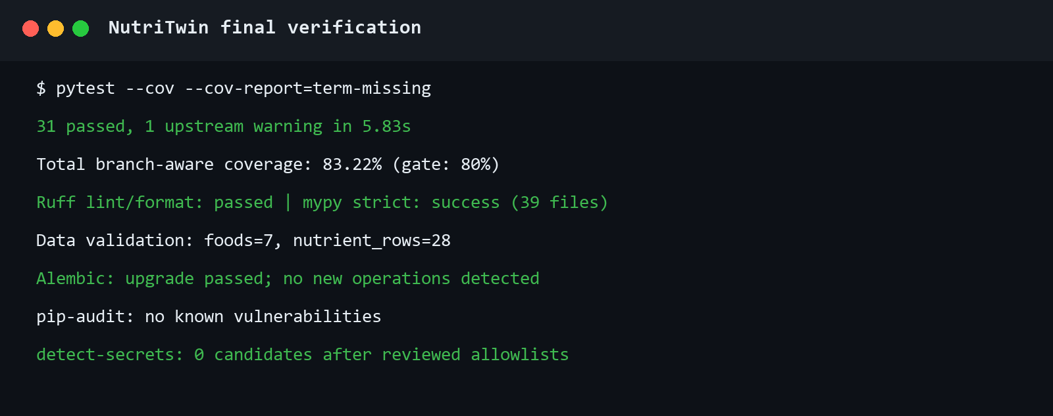
Figure 2. Final automated verification gate.
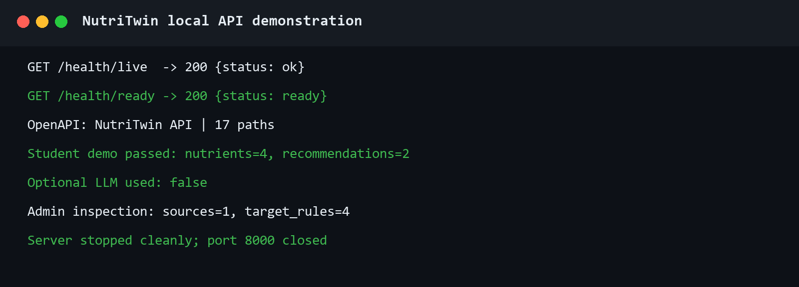
Figure 3. Live local API evaluation and complete Student/Admin demonstration.
7. Challenges & Next Steps
Challenges Faced:
- Scientific licensing: ICMR-NIN RDA/EAR 2020 and IFCT 2017 are authoritative, but lawful electronic redistribution/import permissions and verified machine-readable tables remain unresolved; synthetic data is therefore used only for software validation.
- Scientific uncertainty: qualitative enhancer/inhibitor evidence does not justify a universal quantitative absorption multiplier, so the active model uses an explicit identity estimate.
- Infrastructure validation: Docker Compose configuration passes, but Docker Desktop crashes on the host while initializing its dockerInference socket before NutriTwin containers start. Live PostgreSQL, Redis/Celery broker, and Neo4j validation remains open.
- Client tooling: Flutter is not installed on the development host; no mock client is presented as implemented.
- External source reliability: the optional USDA FoodData Central DEMO_KEY acquisition attempt returned HTTP 429, and no fetched FDC records are bundled.
- Academic validation: the risk formula and recommendation objectives are transparent prototypes that still require nutrition-expert review and future empirical evaluation.
Pending Deliverables:
- Lawful ICMR-NIN/IFCT import manifests, normalized reference rows, and independently verified golden examples.
- Reviewed evidence authoring and bounded quantitative absorption rules; materialized nutrition memory and scheduled Celery recomputation.
- Persisted/API-exposed CP-SAT meal construction, pantry, grocery optimization, substitutions, prices, shopping lists, and deterministic what-if simulation.
- Neo4j evidence graph with cited relationships, full Admin review/approval workflows, feature flags, audit inspection, and anonymized aggregate export.
- Flutter onboarding, authentication, profile, meal logging, dashboard, trends, recommendations, explanations, pantry, grocery, simulation, error/offline, accessibility, widget, and end-to-end states.
- Live multi-service integration, security hardening, final performance/accessibility checks, screenshots, and scientific validation report updates.
Timeline to Completion: proposed ten-week sequence after Review-1; dependent on lawful data access and a working container runtime.
Week | Focus | Expected deliverable
1 | Reference-data acquisition | Confirm permissions; build ICMR/IFCT manifests, checksums, normalization, and reviewed golden fixtures.
2 | Live persistence | Repair Docker Desktop or use an approved local engine; validate PostgreSQL migrations, Redis/Celery, and Neo4j degradation.
3 | Absorption evidence | Implement Admin evidence/review flow and activate only expert-approved bounded quantitative rules.
4 | Nutritional memory | Materialize daily/rolling/risk snapshots; schedule and retry idempotent recomputation.
5 | Optimization API | Persist and expose bounded CP-SAT construction, infeasibility fallback, and exact explanation traces.
6 | Pantry and grocery | Add pantry, expiry, price, budget, substitutions, shopping lists, and grocery linear optimization.
7 | Simulation and graph | Add bounded what-if projections and cited Neo4j evidence relationships with graceful degradation.
8 | Flutter core | Implement onboarding, auth, consent, profile, food search, meal logging, dashboard, and trends.
9 | Flutter decisions | Add recommendation/explanation, pantry, grocery, simulation, loading/error/offline, and accessibility states.
10 | Hardening | Run live integration, widget/end-to-end, security, migration, performance, accessibility, and reproducibility checks; finalize report.
References
- Cronometer. Advanced Features for Accurate Nutrition & Calorie Tracking. https://cronometer.com/features/ (accessed 30 August 2026).
- HealthifyMe. Track Nutrition, Plan Your Diet, Get Fitter. https://www.healthifyme.com/ (accessed 30 August 2026).
- Livingstone KM et al. Effect of an Internet-based, personalized nutrition randomized trial on dietary changes associated with the Mediterranean diet: the Food4Me Study. American Journal of Clinical Nutrition. 2016;104(2):288-297. doi:10.3945/ajcn.115.129049.
- Franco RZ, Fallaize R, Hwang F, Lovegrove JA. Strategies for online personalised nutrition advice employed in the development of the eNutri web app. Proceedings of the Nutrition Society. 2019;78(3):407-417. doi:10.1017/S0029665118002707.
- Gkouskou K et al. The 'Virtual Digital Twins' Concept in Precision Nutrition. Advances in Nutrition. 2020;11(6):1405-1413. doi:10.1093/advances/nmaa089.
- ICMR-NIN Expert Group. Nutrient Requirements for Indians: Recommended Dietary Allowances and Estimated Average Requirements. 2020. Authoritative target source; tables not bundled pending lawful access.
- ICMR-NIN. Dietary Guidelines for Indians 2024. Educational and governance reference; electronic-product reuse restrictions observed.
- Longvah T et al. Indian Food Composition Tables 2017. ICMR-NIN. Preferred Indian food-composition source; redistribution permission unresolved.
- NutriTwin repository evidence: README.md, docs/ARCHITECTURE.md, docs/ALGORITHM_SPECIFICATION.md, docs/DATA_SOURCE_REGISTER.md, and docs/VALIDATION_REPORT.md at commit 9f945b0 and the subsequent Review-1 report commit.
Academic-use note: Student identity fields must be completed and every claim should be independently reviewed against institutional policy before submission. The template's supplied evaluation rubric and AI-use warning are retained below without alteration.
Evaluation Rubric:
- Concept and Novelty – 5 marks
- Review of Related Works – 5 marks
- Tech Stack and Architecture – 5 marks
- Current Progress and Implementation – 5 marks
- Future Planning – 5 marks
Total Marks - 25
(Weightage for internal assessment will be decided and communicated later.)
Zero marks will be awarded for AI generated report as penalty.

