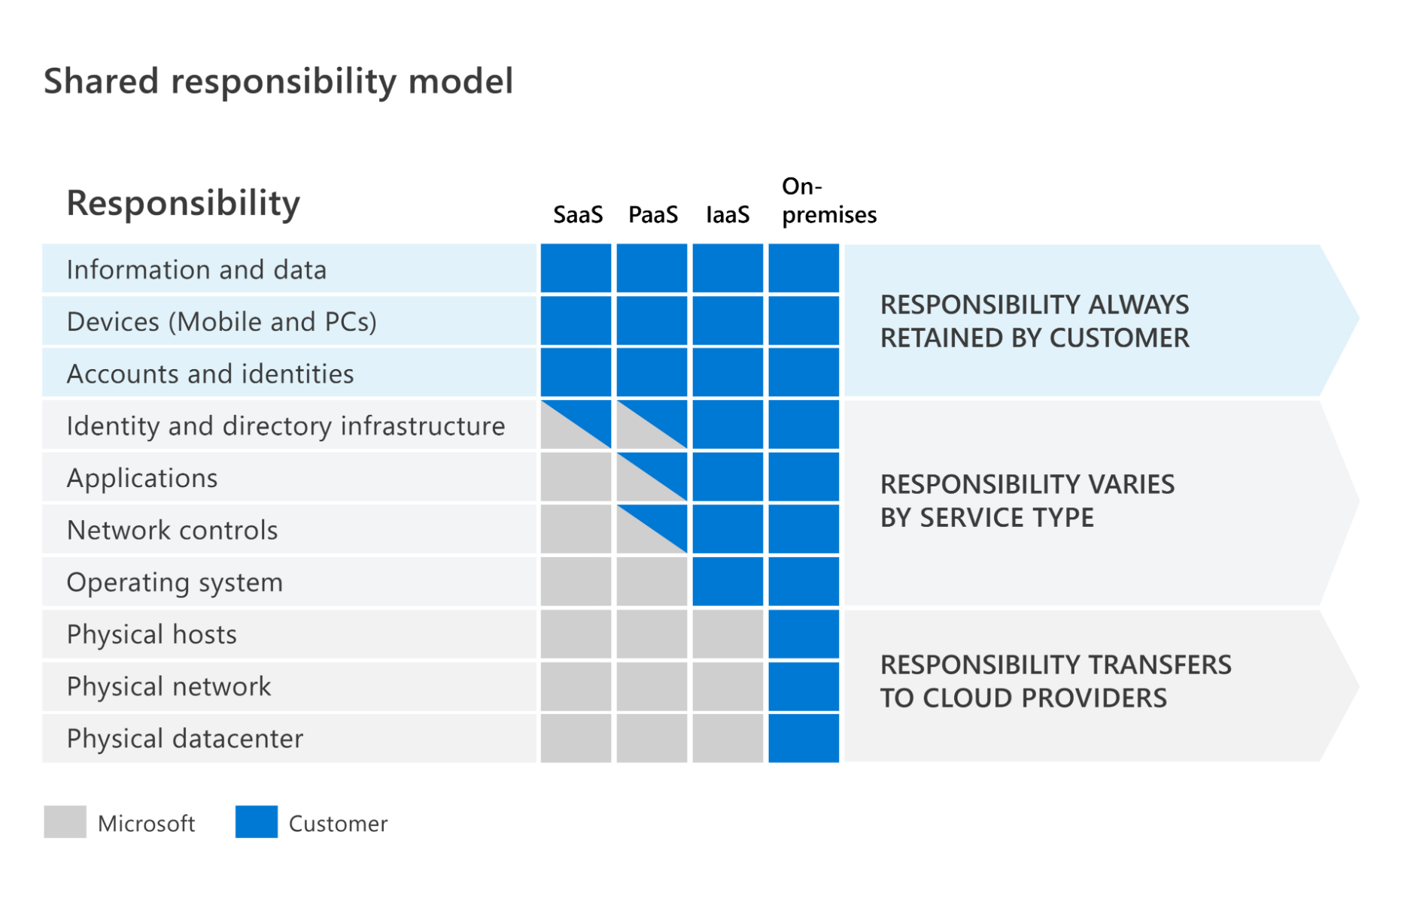
SaaS
Paas - no OS
IaaS - no physical XX
On-premises

Defense in depth
Physical (location) > Identity & Access (ID card)> Perimeter (DDoS) > Network(internal Network) > Compute(machine: OS, s/w patch) > Application (SSL/TLS) > Data (encryption )
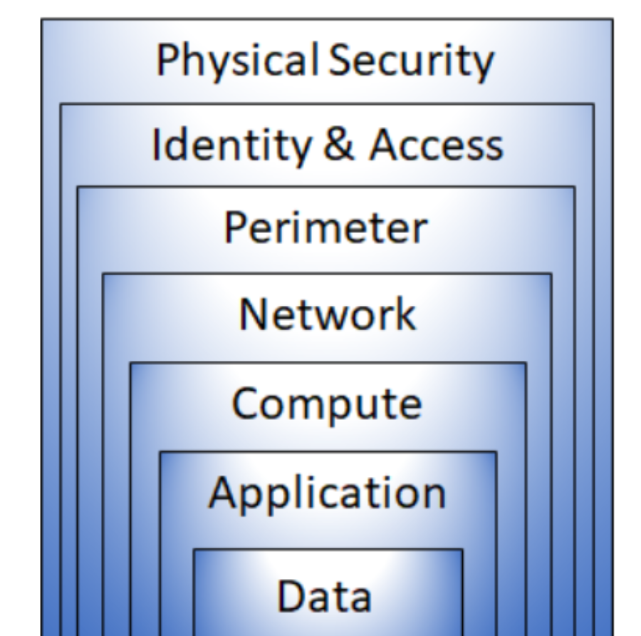

CIA : Confidentiality / Integrity / Availability
: confidential sensitive data (Cust.info, Pwd), encrypt data.
: keep data or msg correct, before encrypt and after decrypt
: available for who need it.

Zero Trust model
3 Principle : Verify explicitly : always Auth N + Auth Z
Least privileged access : JIT/JEA just-enough-access
Assume breach : Segment access by network, user, devices, and APP.

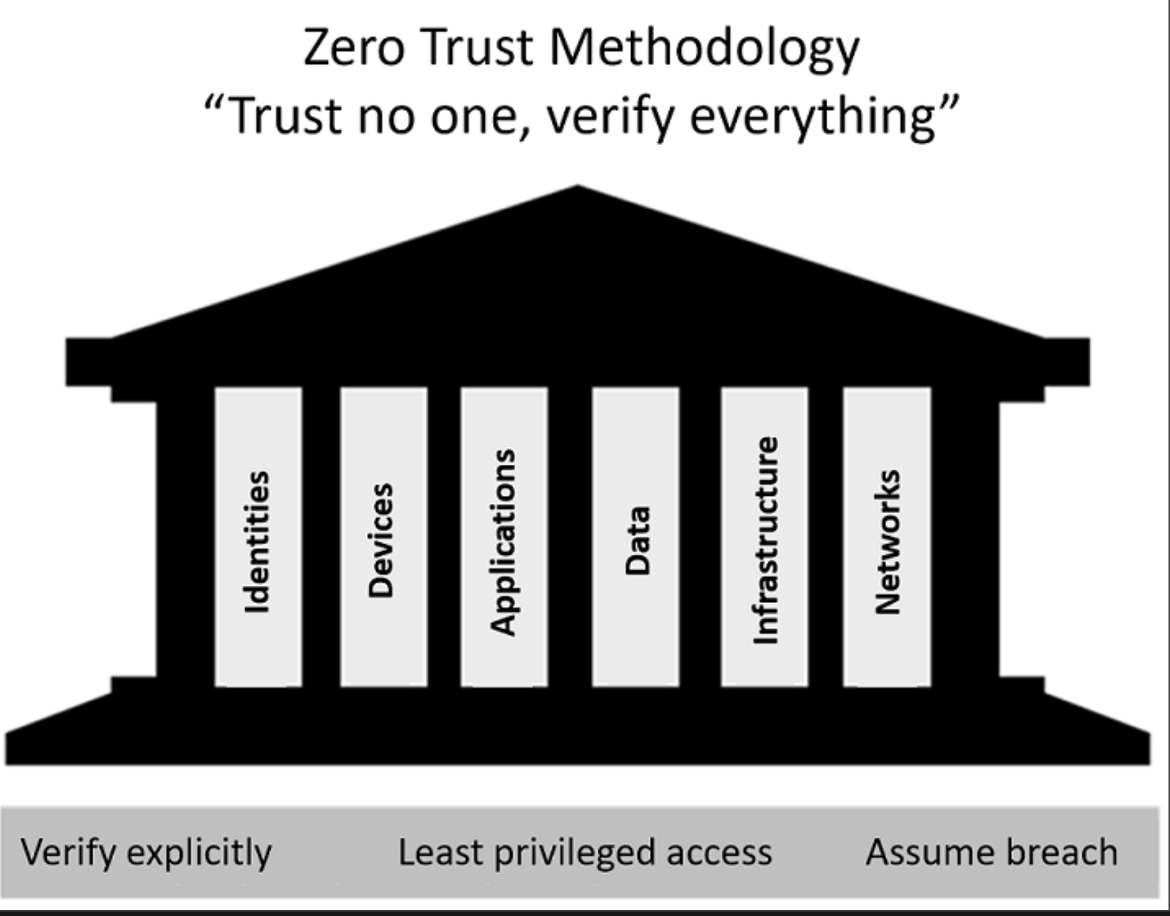
6 Pillars: Identities
Devices
Applications
Data
Infrastructure
Network

Encryption : at rest (DB,Storage) / in transit (HTTPS) / in use (RAM or Caches)
- Symmetric ( Shared Key ) A/B Shared Key , A/C Shared Key, B/C Shared Key
- Asymmetric ( Public Key / Private Key)

https://learn.microsoft.com/en-us/training/modules/describe-concepts-of-cryptography/
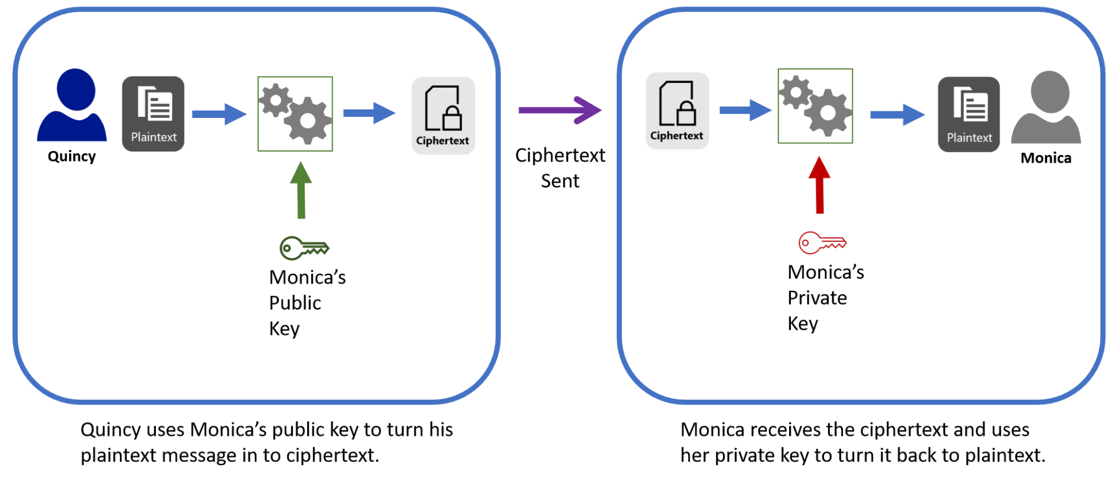
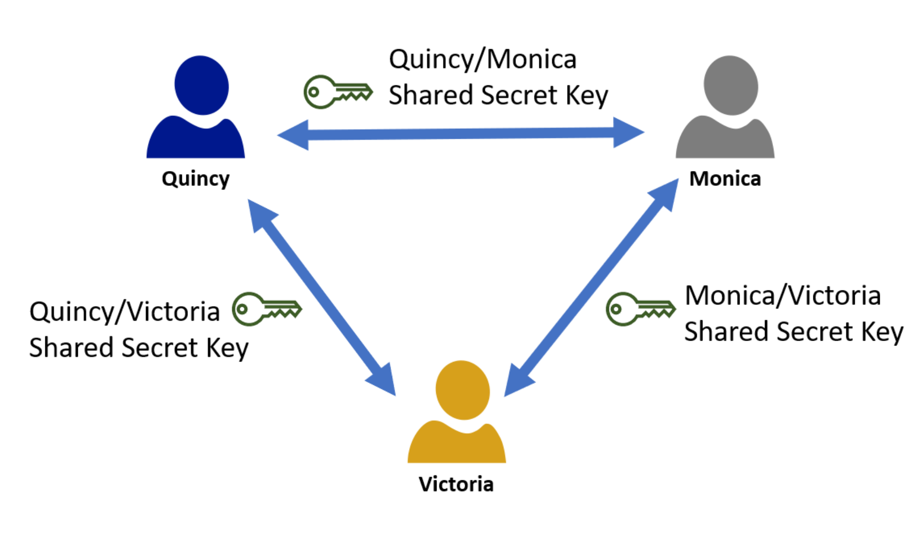

Different Type of Encryptions
- Data Encryption Standard (DES) and Triple-DES. This was one of the first symmetric encryption standards used.
- Advanced encryption standard (AES). AES replaced DES and Triple DES, and is still widely used today.
- RSA. This was one of the first asymmetric encryption standards, and variations are still being used today.

Hashing : Hashing uses an algorithm to convert the original text to a unique fixed-length hash value. With Salted fixed-length random value ( Secure Hash Algorithm – SHA )

Digital Signature :
- A hash a document into Hash Value, encrypt the hash with the private key then attached to the doc as a signature
- Send the Doc to B, B hash the document into Hash Value, decrypt the signature with public key, then compare the Hash and the Signature
Certificate authority (CA)
- M use her public key issue a digital certificate and shared with Q, then Q can use

Compliance Concepts : 遵守, the process to meeting the regulatiory
Data residency : where is the data, physical locations, how and when can transferred, processed or accessed
Data sovereignty 主權: who has control over the data, subject to the laws and regulations of the country/region
Data privacy : How is my data used? Safe / secure? Providing notice and being transparent about collection, processing, used and sharing of personal data by privacy laws and regulations.

Identity concept:
Authentication : grants access
Authorization : level of access or the permissions
Identity as the primary security perimeter 邊界
associated with User / Application / Device / Other
4 pillars of Identity infrastructure:
Administration : creation and mgmt / governance of identities of users.
Authentication : how much IT system need to know about an identify to have sufficient proof.
Authorization : level of access an authenticated person
Auditing : tracking who does what, when, where, how.

Modern authentication ( use identity provider(IdP) to get a token )
ie Idp: Microsoft Azure Active Directory (Identity as a Service : IDaas)
IdP offers auth Z, auth N, auditing
support Single Sign-On (SSO), when setup SSO btw multiple IdP, called federation.聯邦
https://www.microsoft.com/videoplayer/embed/RE4Kdt9

Concept of directory service and Active Directory
Active Directory Domain Services (AD DS) with on-premises IT infrastructure ( Domain Control )
- doesn’t native support mobile devices, SaaS application, line of business apps that require modern authentication

Concept of Federation:
IdP-A has trust relationship configured with IdP-B ( trust isn’t always bidirectional )

Capabilities of Microsoft Azure Active Directory, Part of Microsoft Entra
Explore the services and identity types in Azure AD
Entra that encompasses all of MS’s identity and access capabilities, including Azure AD : cloud-based service.
- Organizations can enable their employees, guests and others to sign in an daccess the resuource they need.
- Provide a single identity system for their cloud and on-premises applications. (Synchronized)
- Protect user identities and credentials and to meet an organization’s access governance requirments.
- Each Microsoft365, Office365, Azure, Dynamics365 online subscription use Azure AD tenant.
- enable mobiles and teablet, enable collaboration with business partners and customers
- developer can use SSO and use provided API using existing credentials and organizational data.

Azure AD identity types
- User : individual’s identity
- Device : hardware ( Azure AD registered – BYOD , Auzre AD joined – devcies owned by Organization )
- Service principal : identity for an application
- Managed identity : a type of service principal, a managed identity provides an identity for applications to use when connecting to resources that support Azure AD authentication. Developers don’t need to manage credentials.

External identities in Azure AD
B2B :
- allows you to share your organization’s applications and services with guest suser form other organizations, while maintaining control over your own data.
- use an invitation and redemption process, allowing external users to access your resources with their credentials.
- Azure AD B2B APIs
- external users are managed in the same directory as employees but as guest users.
- Guest managed as the same way as employees, with B2B, SSO to all Aure AD-connected apps is supported.

B2C :
- customer identity access management (CIAM) solution
- allows external users to sign in with their preferred social, enterprise or local account identities to get SSO to your applications. ( google, microsoft, facebook, etc... )
- supports millions of user and billions of authentications per day. Take care of the scaling and safety of the authentication platform, monitoring and automatically handing threats like denial-of-service, password spray, or brute force attacks.
- external user are managed in the Azure AD B2C directory, seperately from employee and partner directory. SSO to customer owned apps within Azure AD B2C tenant is supported.
- authentication solution can customized with your brand so taht it blends with your web and mbile applications.
- Azure AD external identities is a feature of Premium P1 and P2.

Concept of hybrid identities
- hybrid identity is a common user identity for authentication and authorization to all resources, and regardless of location ( on -prem & colud ).
- with Azure AD Connect, updates to your on-premises AD DS are synchronized to your Azure AD
- Three authentication methods
- Password hash synchronization :
- simplest way to enable auth-N of on-premises directory object in Azure AD
- can sign-in to Azure AD service by using the same n/pwd as their on-premises AD
- Azure AD handles users’ sign in process. ( validation in the cloud )
- Pass-through authentication (PTA) :
- key difference is authentication validates user’s passwords directly against on-premises AD. Password validation doesn’t happen in the cloud. This can be important factor for organizations to enforce their
on-premises AD security and password policies. ( validation in the on-premises )
- Federated authentication :
- Azure AD hands off the authentication process to a separate trusted authentication system, such as on- premises Active Directory Federation Services (AD FS), to validate user’s password.
- ensures that all user authentication occurs on-premises.
- recommended for organizations that have advanced features not currently supported in Azure AD, ( smart cards or certificates, sign-on using on-premises MFA server, or third party auth-N solution)

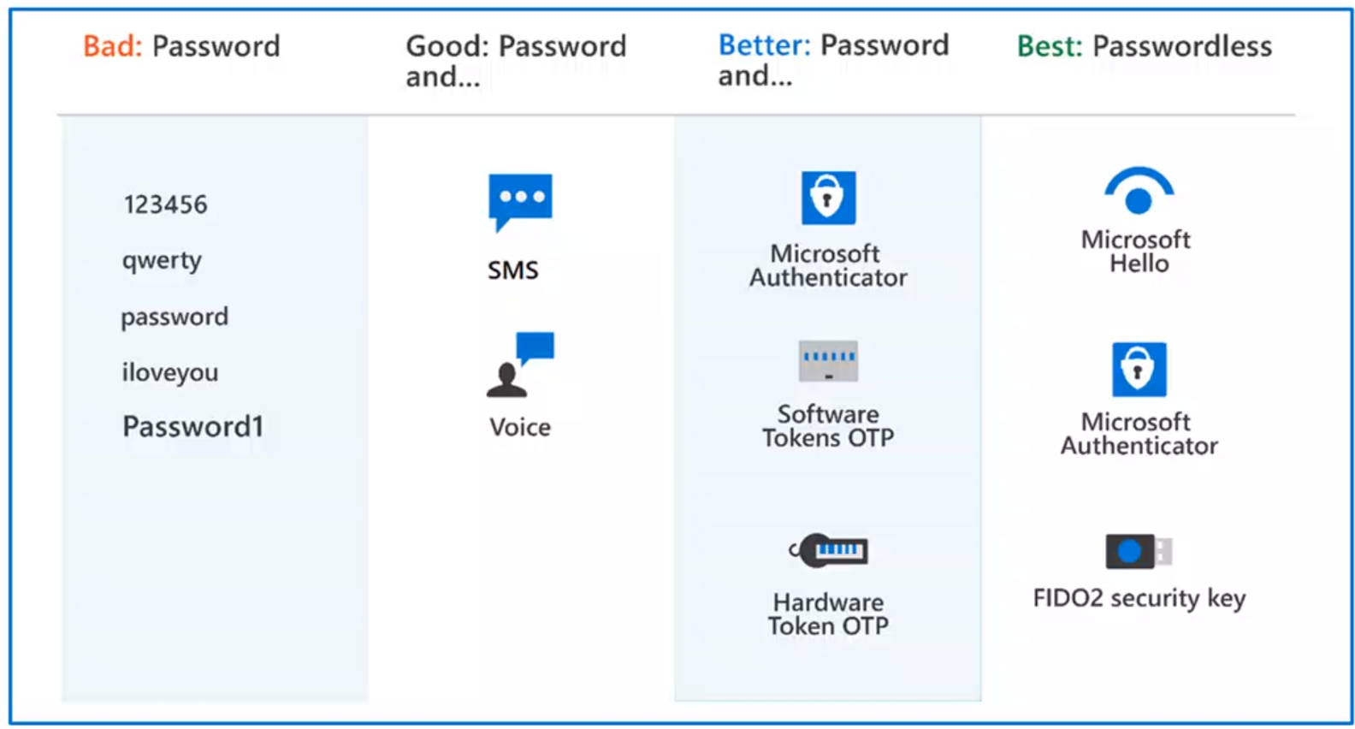
Moduel 2
Authentication methods of Azure AD
- Pasword
- Phone ( SMS, Voice )
- OATH:Open Auth-N (s/w, h/w generate OTP )
- Passwordless (Biometrics:Windows Hello, Microsoft Authenticator,
FIDO2:Fast Identity Online)

Multi-factor authentication (MFA) in Azure AD
- MFA requires more than one form of verification:
- Something you know : pwd / pin
- Something you have : trusted device, phone, hardware key
- Something you are : biometrics like fingerprint or face scan
- Security defaults:
- a set of basic identity security mechanisms recommended by Microsoft
- a great option for organizations that want to increase their security posture, free tier of Azure AD licensing

Self-service password reset (SSPR) in Azure AD
Benefits of Self-service password reset:
- Administrators can change setting to accommodate new security requirment
- save organization money by reducing # of calls and request to help desk staff
- increase productivity, allowing user to return to work faster

Self-service password reset in the following scenarios:
- password change / password reset / account unlock

To enable SSPR, users must : Assigned an Azure AD license / Enabled for SSPR / Registered

Authentication method of SSPR:
- Mobile app notification / Mobile phone
- Mobile app code / Office phone
- Email / Security questions

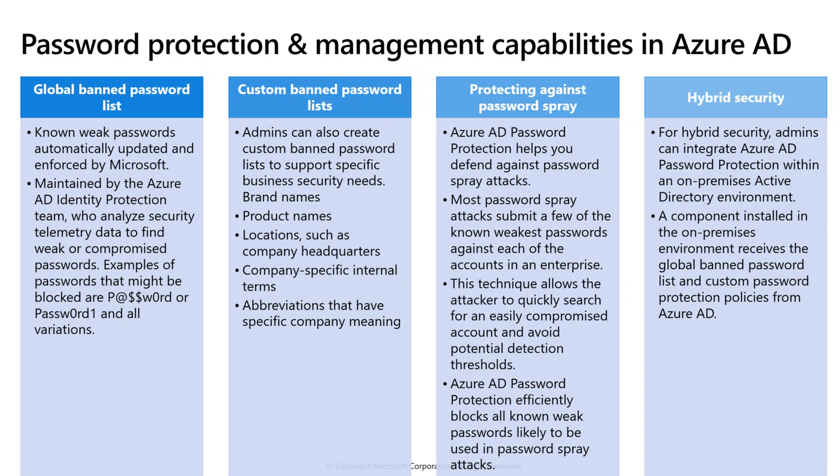
Password protection & management capabilities in Auze AD ( reduce the risk of user setting weak pwd)
- Global banned password list
- Custom banned password list
- Protecting against password spray
- Hybrid security

Module 3
Conditional Access ( who, what , where of the policy )
Conditional Access Signals :
- User or group membership : including admin role
- Named location information : using Ipaddr ranges, block/allow traffic country/region’s IP range
- Device : users with specific platforms or marked with specific state can be used.
- Application : users access specific application trigger different conditional access policies
- Real-time sign-in risk detection : Signals integration with Azure AD Identity Protection allows
conditional access policies to identify risk sign-in behavior ( the probability that a given sign-in or authentication request, isn’t authorized by the identity owner) real-time/offline
- Cloud apps or user actions : Conditional Access policies allow administrators to assign controls to all or specific applications or actions.
- User risk : for customers with access to Identity Protection, user risk can be evaluated as part of a Conditional Access policy. User risk represents the probability that a given identity or account is compromised. User risk can be configured for high, medium or low probability. (offline)

Access Controls:
- Block access
- Grant access
- Require one or more coditions to be met before granting access ( ie: MFA, change pwd )
- Control user access based on session controls to enable limited experiences within specific cloud applications.

Azure AD roles & role-based access control ( RBAC )
- Built-in roles :
Global administrator, have access to all administrative features in Azure AD.
The person who sign up for Azure AD tenant automatically becomes a global administrator.
User administrator, can create and manage all aspects of users and groups.
Also includes the ability to manage support tickets and monitor service health
Billing administrator, make purchases, manage subscriptions and support tickets and monitor service health
- Custom roles :
- Granting permission using custom Azure AD roles is a two-step process taht involves creating a custom role definition, consisting of a collection of permissions that you add from a preset list. This permission are the same one used in the built-in roles. When you created your role definition, you can assign it to a user by creating a role assignment.
- A role assignment grants the user the permisssions in a role definition, at a specified scope. A custom role can be assigned at organization-wide scope, meaning the role member has the role permissions over all resources.
- Customroles require an Azure AD Premium P1 or P2.
- Categories of Azure AD roles:
- Azure AD specific roles : manage resources within Azure AD only (ie: User Adm, App Adm,Groups Adm)
- Service-specific roles : major for Microsoft 365 services, Azure AD includes built-in, service-specific roles that grant ermissions to manage features within the service. ( ie: Exchange Adm, Intune Adm, SharePoint Adm, Teams Adm, can manage features with their respective services.
- Cross service roles : some roles within Azure AD that span services. ( ie: security-related roles, like Security Adm, grant access across multiple security services within Microsoft 365. similarly Compliance Adm role can manaage Complicance-related setting in Microsoft Purview compliance portal, exchange, etc...
- Only grant the access users need :
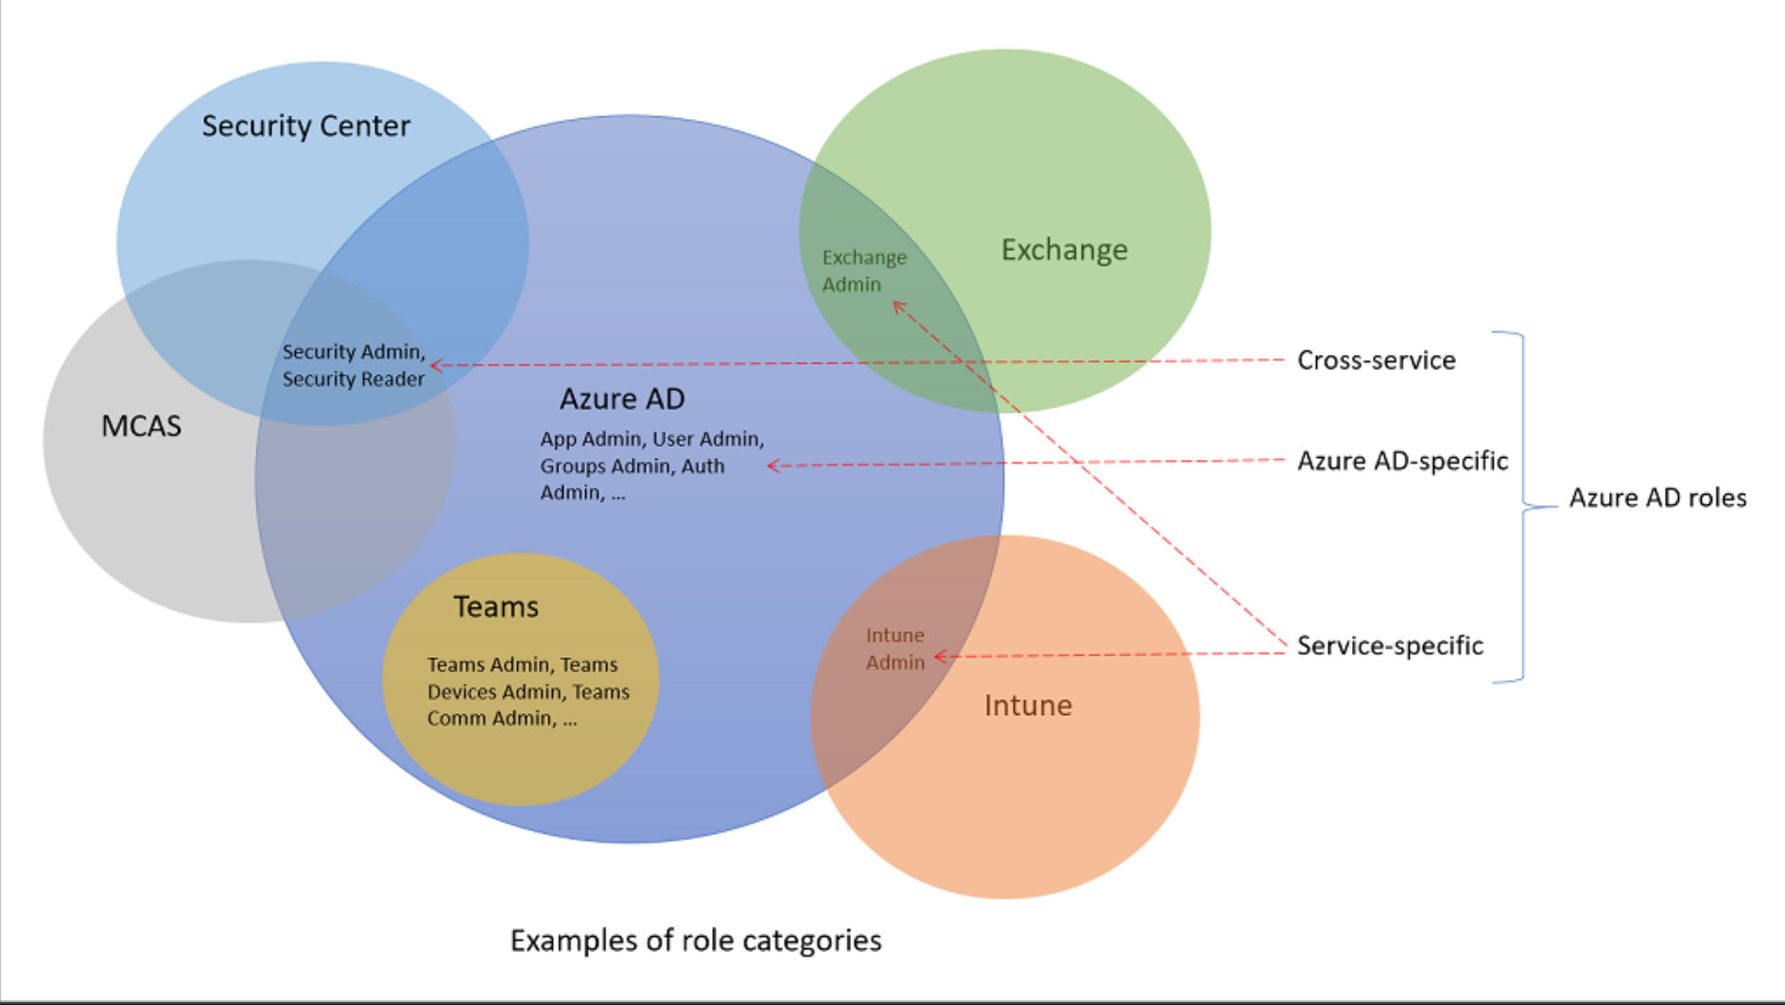

Different btw Azuer AD RBAC and Azure RBAC
- Azure AD roles control access to Azure AD resources (ie: users, groups, applications )
- Azure roles control access to Azure resources (ie: virtual machines or storage using Azure Resource Mgt )

Module 4:
Identity governance capabilities of Azure AD
intended to help organizations address these 4 key questions:
- which user should have access to which resources
- what are those users doing with that access
- are there effective organizational controls for managing access
- can auditors verify that the controls are working

- Govern identity lifecycle
Join: new digital identity is created
Move: update access authorizations
Leave: access may need to be removed
- Govern access lifecycle
- Secure privileged access for administration

Entitlement management
- it is an identity governance feature that enables organizations to manage identity and access lifecycle at scale
- it automates access request workflows, access assignments, reviews, and expiration

Access reviews ( can be created through Azure AD access reviews / PIM ), Azure AD P2 feature
- enable organiations to efficiently manage group memberships, access to enterprise applications, and role assignment.
- ensure that only the right people have access to resources
- used to review and manage access for both users and guests

Azure AD Terms of use
- allow information to be presented to users, before they access data or an application.
- ensure users read relevant disclaimers for legal or compliance requirements

Privileged Identity Management (PIM) (manage, control, monitor access to important resources)
- Just in time, provide privileged access only when needed, and not before
- Time-bound, by assigning start and end dates that indicate when a user can access resources.
- Approval-based, requiring specific approval to activate privileges.
- Visible, sending notifications when privileged roles are activated.
- Auditable, allowing a full access history to be downloaded.

Azure AD Identity Protection ( 6.5 trillion signal per day to identify potential threats. )
enable organizations to accomplish 3 key tasks:
- automate the detection and remediation of identity-based risks
- investigate risks using data in the portal
- Export risk detection data to thired-party utilities for further analysis

categorize and calculate risk:
- categorize risk into three tiers: low, medium, high
- calculate sign-in risk ( AnonymousIP, Atypical travel, Malware linked IP addr, unfamiliar sign-in properties, password spray, Azure AD threat intelligence) , and
user identity risk ( Leaked credential, Azure AD threat intelligence )

provides organizations with 3 reports:
- Risky users / Risky sign-ins / Risk detections

Basic security capabilities in Azure - Module 1
security management capabilities of Azure - Module 2
security capabilities of Microsoft Sentinel
treat protection with Microsoft 365 Defender

Module 1
Azure DDoS protection ( Distributed Denial of Service )
- analyzes network traffic and discards anything that looks like a DDoS attack
- 3 tiers:
- Default DDoS infrastructure protection ( previous : Basic ) : is automatically enabled for every property in Azure, at no extra cost, as part of the Azure platform. Always-on traffic monitoring and real-time mitigation of common network-level attack traffic across regions.
- DDoS Network Protection: ( available as a SKU, previous: Standard), combined with application design best practices, provides enhanced DDoS mitigation features to defend against DDoS attacks. It’s automatically tuned to help protect your specific Azure resources in a virtual network. Protection is simple to enable on any new or existing virtual network, and it require no app/resource changes. Advantanges over default : logging, alerting, telemetry
- DDoS IP Protection: pay-per-protected IP model. Same core engineering features as DDoS Network Protection, with differ in the follwing value-added services: DDoS rapid response support, cost protection, discounts on WAF

Azure Firewall
- cloud-based network security service that protects Centralized - Azure Virtual Network (VNet) resources from attackers.
- scale up the usage to accommodate changing network traffic flows, so don’t need to budget for peak traffic.

Features:
- Built-in high availability and availability zones: config to span multiple availability zones for increased availability.
- Network and application level filtering : use IP address, port and protocol to support fully qualified domain name filtering for outbound HTTP(s) traffic and network filtering controls.
- Outbound SNAT and inbound DNAT to communicate with internet resources: translate the private IP address of network resources to an Azure public IP address ( source network address translation) to identify and allow traffic originating from the virtual network to internet destinations. Similarly, inbound internet traffic to the firewall public IP address is translated (Destination Network Address Translation) and filtered to the private IP addresses of resources on the virtual network.
- Multiple public IP address: these addresses can be associated with Azure Firewall
- Threat intelligence: threat intelligence-based filtering can be enabled for your firewall to alert and deny traffic from /to known malicious IP addresses and domains.
- Integration with Azure Monitor: Integrated with Azure Monitor to enable collecting, analyzing, and acting on telemetry from Azure Firewall logs.

Web Application Firewall (WAF)
Web applications are increasingly targeted by malicious attacks that exploit commonly known vulnerabilities, like SQL injection and cross-site scripting. Preventing such attacks in application code is challenging. It can require rigorous maintenance, patching, and monitoring.

WAF provides centralized protection of your web applications from common exploits and vulnerabilities
- Simpler security management
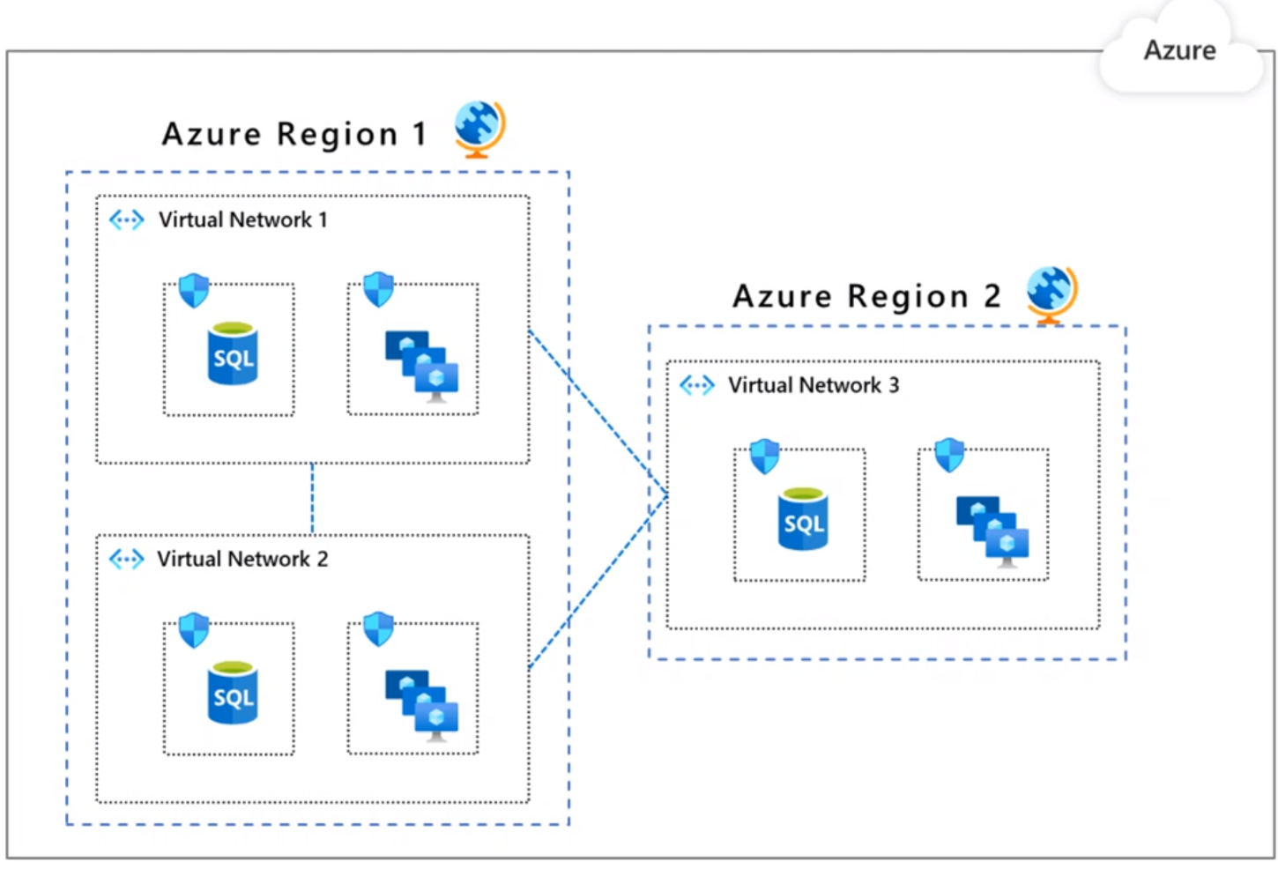
- Improves the response time to a security threat
- Patching a known vulnerability in one place
- Protection against threats and intrusions

Network segmentation and Azure VNet
Reasons for network segmentation
( supports Zero Trust mdoel )
- The ability to group related assets
- Isolation of resources
- Governance policies set by the organization

Azure Virtual Netowrk (VNet)
- Network level containment of resources with no traffic allowed across VNets or inbound to VNet
- Communication needs to be explicityly provisioned
- Control how resources in a VNet Communicate with other resources, the internet, and on-premises networks

Azure Network Security groups
Network security groups (NSG) let you allow or deny network traffic to and from Azure resources that exist in your Azure Virtual Network.
- NSG can be associated with multiple subnets or network interfaces in a VNet
- NSG is made up of inbound and outbound security rules
- Each rule specifies one or more of the following properties:
Name / Priority / Source or Destination / Protocol / Direction / Port Range / Action
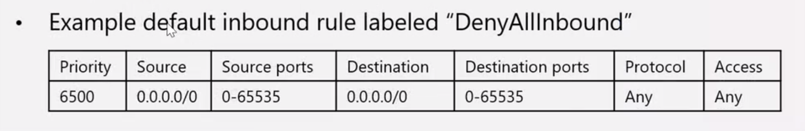

Different between NSG and Azure Firewall
- both protect VNet resource
- Azure Firewall service complements network security group functionality
- they provide better “defense-in-depth” network security
- NSG provide distributed network layer traffic filtering to limit traffic to resources Within VNet in each subscription
- Azure Firewall is a fully stateful, centralized network firewall as-a-service, which provides network and
application-level protection Across different subscriptions and VNet

Azure Bastion & Just-in-time access
Azure Bastion : secure connectivity to your VMs from the Azure Portal ( PasS, deployed per VNet )
- provides secure and seamless RDP and SSH connectivity to your VMs directly from the Azure portal
using Transport Layer Security (TLS)

Just-in-time access ( JIT ) : by Microsoft Defender for Cloud - tools
- allows lock down of the inbound traffic to your VMs, reducing exposure to attacks while providing easy access to connect to VMs when needed.

Way Azure encrypts data & use of Key Vault

Encryption on Azure :
- Azure Storage Service Encryption : helps to protect data at rest by automatically encrypting before persisting it to Azure-managed disks, Azure Blob Storage, Azure Files, or Azure Queue Storage, and decrypts the data before retrieval
- Azure Disk Encryption : helps you encrypt Windows and Linux IaaS virtual machine disks. Azure Disk Encryption uses the industry-standard BitLocker feature of WIndows and the dm-crypt feature of Linux to provide volume encryption for the OS and data disks
- Transparent data encryption ( TDE ) : helps protect Azure SQL Database and Azure Data Warehouse against the threat of malicious activity. It performs real-time encryption and decryption of the database, associated backups, and transaction log files at rest without requiring changes to the application.

Azure Key Vault : centralized cloud service for storing your application secrets. control applications' secrets by keeping them in a central location and by providing secure access, permissions control, access logging

- Secrets management : you can use key vault to store securely and tightly control access to tokens, passwords, certificates, Application Programming Interface (API) keys and other secrets
- Key management : you can use Key Vault as a key management solution. Key Vault makes it easier to create and control the encryption keys used to encrypt your data
- Certificate management : Key Vault lets you provision, manage, and deploy your public and private
Secure Sockets Layer (SSL) / Transport Layer Security (TLS) certificates for Azure, and internally connected, resources more easily
- Store secrets backed by HW or SW : The secrets and keys can be protected either by software or
by FIPS 140-2 Level 2 validated HSMs.

Module 2 ( portal.azure.com ) ( IaaS )
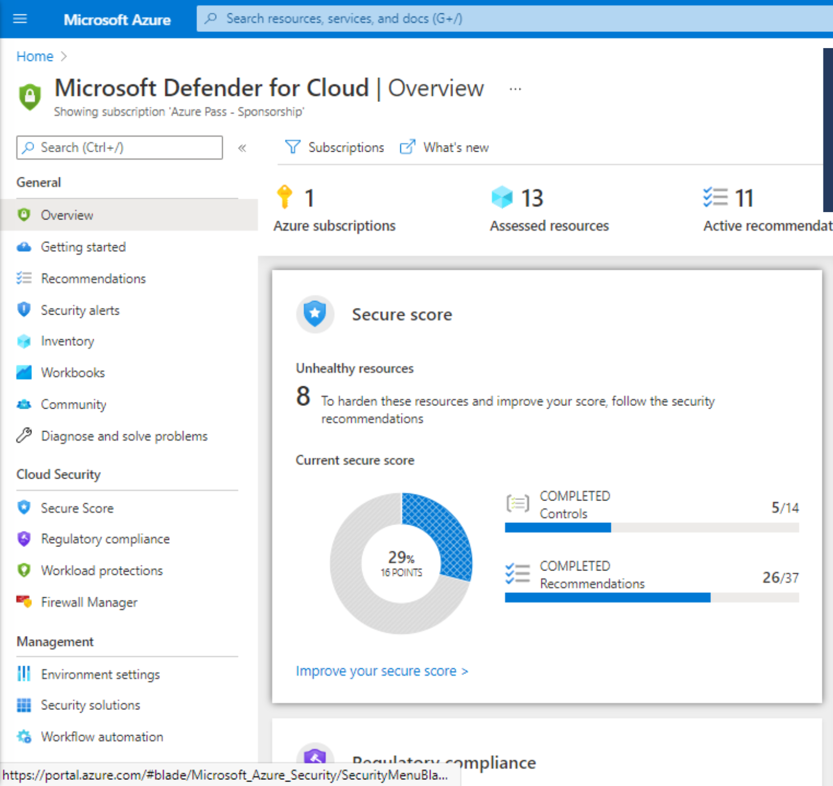
Microsoft Defender for Cloud : is a tool for security posture management and threat protection. It strengthens the security posture of your cloud resources, and with its integrated Microsoft Defender plans, protects workloads running in Azure, hybrid, and other cloud platforms. Microsoft Defender for Cloud features cover 2 broad pillars of cloud security:

Cloud security posture management ( CSPM ) :
- Tools & services designed to improve cloud security management
- Monitor and prioritize security enhancements and features in your cloud environment
- Secure score in Microsfot Defender for Cloud provides visibility to your current security situation & hardening guidance to help improve security.

Cloud workload protection ( CWP ) :
- Detect and resolve threats to resources, workloads, and services.
- CWP provided through Microsoft Defender plans specific to the types of resources in your subscriptions.
- Defender plans include Microsoft Defender for servers, App Service, Storage, SQL, Kubernetes,
container registries, Key Vault, Resource Manager, DNS, open-source relational protections, and more...

Secure score in Microsoft Defender for Cloud: your security posture at-a-glance
- Continually assesses your resources, subscriptions, and organization for security issue
- Aggregates all the findings into a single score
- Hardening recommmendations on any identified security misconfigurations & weaknesses

Microsoft Defender for Cloud plans offer Enhanced security features for your workloads:
- Endpoint detection and response ( EDR ) : MS Defender for Endpoint
- Vulnerability scanning : for VMs, container registries, SQL resources.
- Multi-cloud security : connect from AWS, GCP
- Hybrid security : view of security across all of on-premises and cloud workloads
- Threat protection alerts
- Track compliance with a range of standards : apply a range of other industry standards, regulatory, benchmarks
- Access and application controls : block malware by Machine learning recommend to create allowlists/blocklists.

Microsoft Cloud Security Benchmark ( MCSB )
- Provides prescriptive best practives & recommendations to improve the security of workloads, data,
and services on Azure
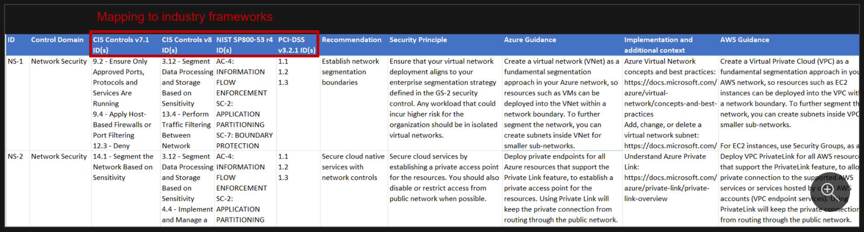
Security baselines for Azure
- Apply guidance from the MCSB to the spedific service for which it is defined.
- The image is an excerpt from the Azure Key Vault security baseline.
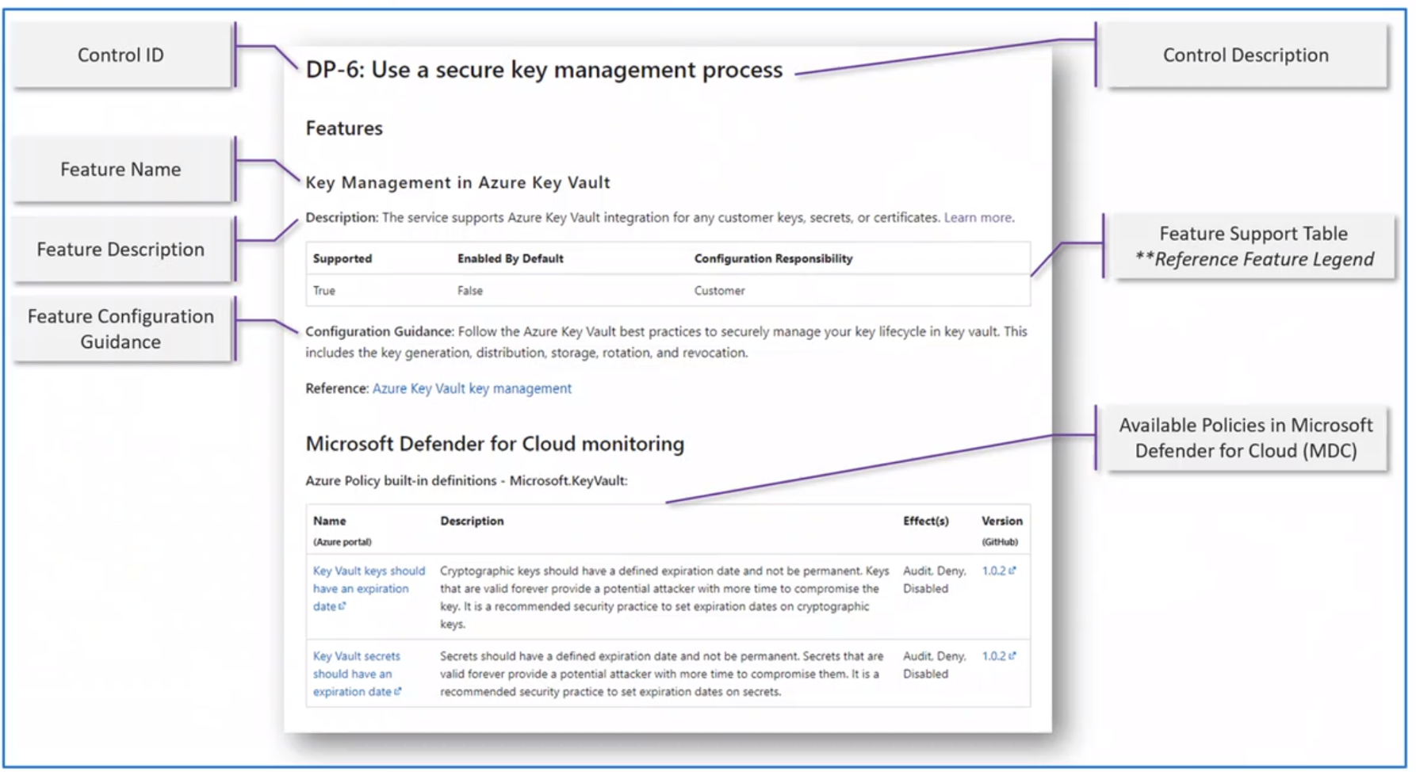

Module 3
two types of security systems make up Microsoft Sentinel
Security information event management : SIEM
- a tool that an organization uses to collect data from across the whole estate, including infrasturcture, software, resources. It does analysis, looks for correlations or anomalies, and generates alerts and incidents.

Security orchestration automated response : SOAR
- takes alerts from many sources, such as a SIEM system. Then triggers action-driven automated workflows and processes to run security tasks that mitigate the issue.

Microsoft Sentinel provides integrated threat management :
- Collect : data at cloud scale across all users, devices, applications, and infrastructure, both on-premises and in multiple clouds.
- Detect : previously uncovered threats and minimize false positives using analytics and unparalleled threat intelligence.
- Investigate : threats with AI and hunt suspicious activities at scale, tapping into decades of cybersecurity work at Microsoft.
- Respond : to incidents rapidly with built-in orchestration and automation of common security

Key features:
- Connect Microsoft Sentinel to your data: user connectors for Microsoft solutions providing real-time integration
- Workbooks: monitor the data useing the Microsoft Sentinel integration with Azure Monitor Workbooks.
- Analytics: using built-in anlytics alerts, you'll get notified when anything suspicious occurs
- Manage incidents: an incident is created when an alert that you've enabled is triggered.
- Security automation and orchestration: integrate with Logic Apps, to create workflows & playbooks, resp alert
- Notebooks: use jupyter notebooks (open-src) to extend the scope of what you can do with Microsoft Sentinel data
- Investigation: understand the scope of a potential security threat and find the root cause
- Hunting: use search-and-query tools, to hunt proactively for threats, before an alert is triggered
- Community: Download content from the private community GitHub repository to create custom workbooks, hunting queries, and more.
Cost:
- Capacity Reservations : fixed fee
- Pay-as-you-go : billed per GB for volume of data ingested for analysis

Module 4
Microsoft 365 Defender Service ( security.microsoft.com )
- Natively coordinate the detection, prevention, investigation, and response to threats
- Protects identities, endpoints, apps, and email & collaboration
- eXtender defection and response ( XDR )

https://learn.microsoft.com/en-us/microsoft-365/security/defender/microsoft-365-defender?view=0365-worldwide#microsoft-365-defender-interactive-quide
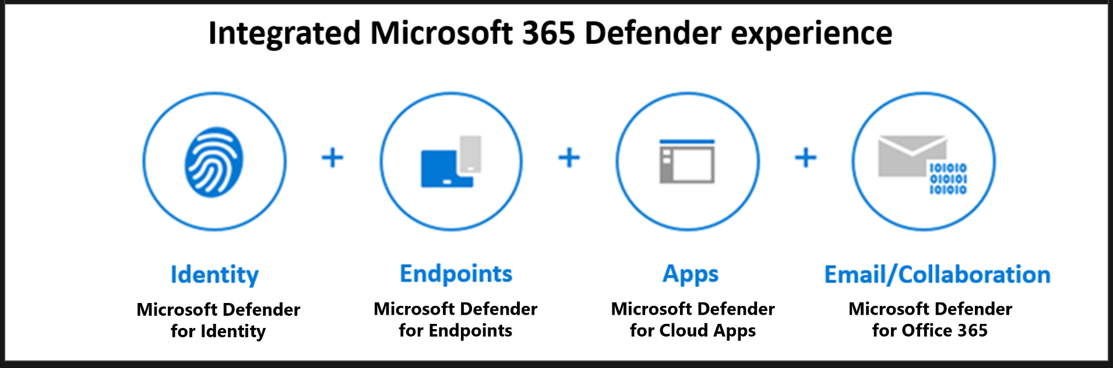

1) Microsoft Defender for Office 365 :
- Threat protection policies :
- Reports :
- Threat investigation and response capabilities :
- Automated investigation and response capabilities :

- Microsoft Defender for Office 365 Plan 1 :
- Safe Attachments
- Safe Links
- Safe Attachments for SharePoint, OneDrive, Microsoft Teams
- Anti-phishing protection
- Real-time detections

- Microsoft Defender for Office 365 Plan 2 : ( include Plan 1)
- Threat Trackers & Threat Explorer
- Automated investigation and response (AIR) : security playbook start automated investigation
- Attack Simulator
- Proactively hunt for threats with advanced hunting : query-based, explore upto 30 days of raw data
- Investigate incidents and alerts

- Microsoft Defender for Office 365 availability :
- Microsoft 365 E5 / Office 365 E5 / Office 365 A5 / Microsfot 365 Business Premium

2) Microsoft Defender for Endpoint : is a platform designed to help enterprise networks protect endpoint
- built into Windows 10 and MS cloud services

- Threat and Vulnerability Management
- Attack surface reduction
- Next generation protection
- Endpoint detection and response ( EDR )
- Automated investigation and remediation
- Microsoft Threat Expert
- APIs
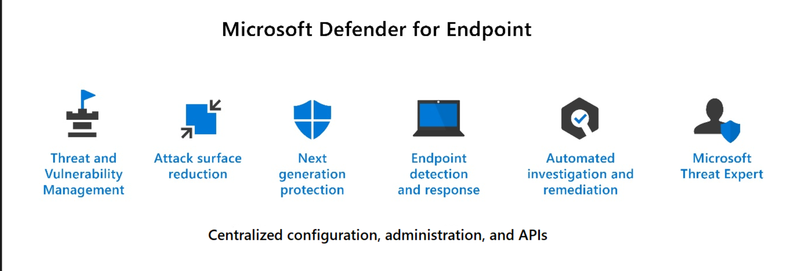

3) Microsoft Defender for Cloud Apps : ( Cloud Access Security Broker : CASB , cross-SaaS )
- provides rich visibility to your cloud services, control over data travel, and sophisticated analytics to identify and combat cyberthreats across all your Microsoft and third-party cloud services
- 4 pillars : Visibility, Threat protection, Data security, Compliance

The Defender for Cloud Apps framework:
- Descover and control the use of Shadow IT
- Protect your sensitive information anywhere in the cloud
- Protect against cyberthreats and anomalies
- Assess your cloud apps' compliance

: Office 365 Cloud App Security
- a subset of Microsoft Defender for Cloud Apps that provides enhanced visibility and control for Office 365
- threat detection based on user activity logs, discovery of Shadow IT for apps

: Enhaned Cloud App Discovery in Azure Active Directory ( P1 include )
- a reduced subset of the Microsfot Defender for Cloud Apps descovery capabilities
- deeper visibility into cloud app usage in your organization
- intelligently and proactively identify and respond to threats across MS and non-MS cloud services.

4) Microsoft Defender for Identity :
- Monitor and profile user behavior and activities
- Protect user identities and reduce the attack surface
- Identify suspicious activities and advanced attaks across the cyberattack kill-chain
- Investigate alerts and user activities
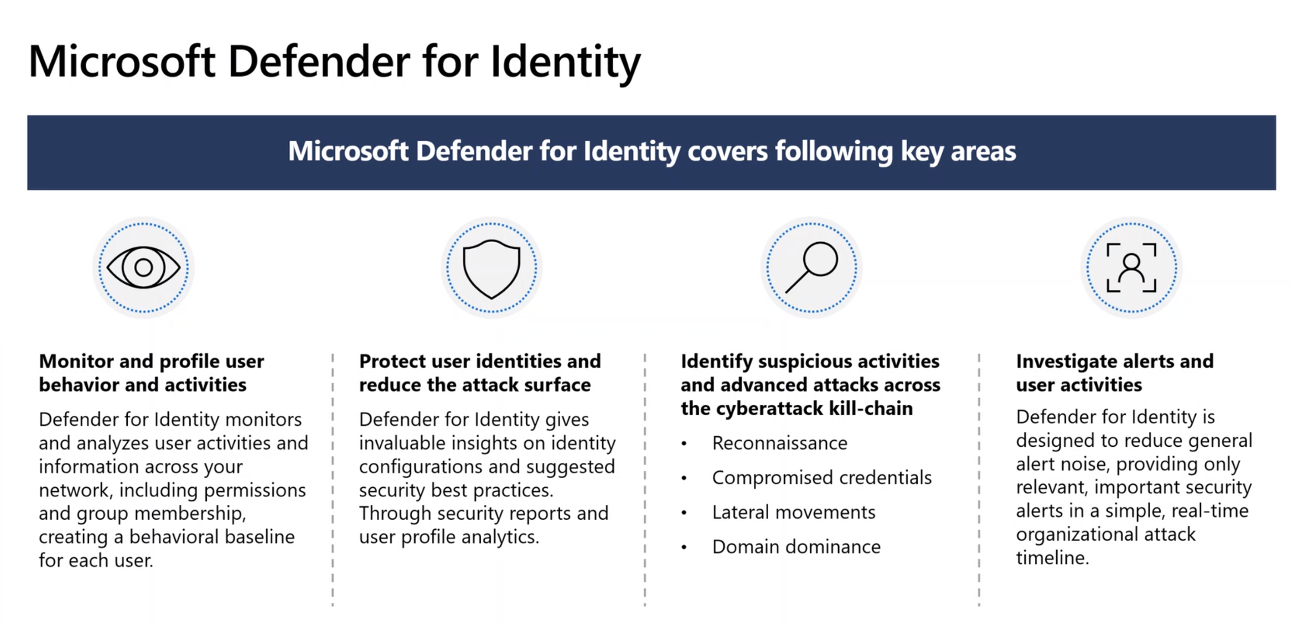

Microsoft 365 Defender portal :
combines protection, detection, investigation, and response to email, collaboration, identity, and device threats,
in a central portal. ( Dashboard : cards , Secure Score )
- Identities : Monitor the identities in your organization and keep track of suspicious or risky behaviors
- Data : help track user activity that could leasd to unauthorized data disclosure
- Devices : Get up-to-date info on alerts, breach activity, and other threasts on your devices
- Apps : Gain insight into how cloud apps are begin used in your organization

- View the security health of your organization
- Act to configure devices, users, and apps
- Get alerts for suspicious activity

- Incidents & alerts :
- Hunting : query-based threat-hunting tool, explore up to 30 days of raw data
- Action Center
- Threat analytics : threat intelligence solution, assist security team and respond to emerging threats.
- Secure Score : a representation of a company's security posture, help organizations:
- Report on the current state of their security posture
- Improve their security posture by providing descoverability, visibility, guidance, and control
- Compare benchmarks and establish key performance indicators (KPIs)
- Show all possible improvements for the product, whatever the license edition, subscription, or plan.
- Support recommendations for: Microsoft 365, Azure AD, Microsoft Defender for Endpoint,
Microsoft Defender for Identity, Microsoft Defender Cloud Apps, Microsoft Teams
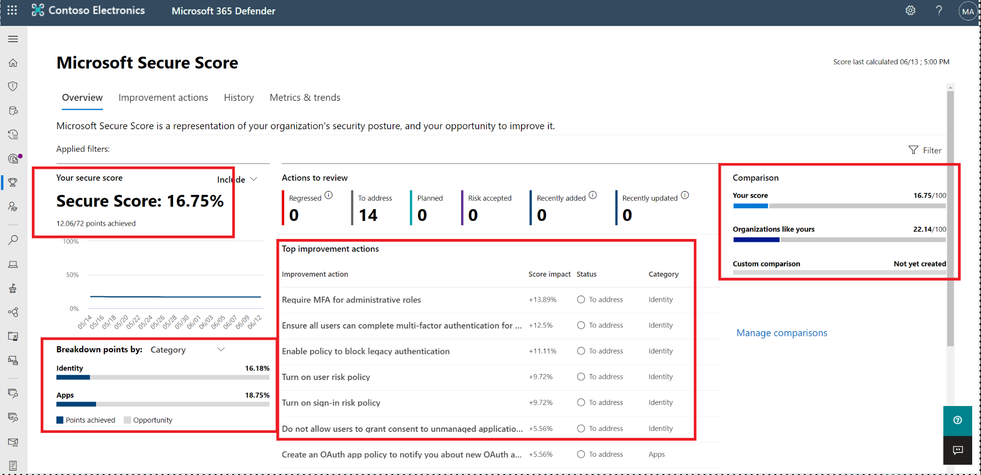

Different (Secure score ) between Microsoft Defender for Cloud (Azure) and Microsoft 365 Defender :

- Microsoft Defender for Cloud is a measure of the security posture of your Azure subscriptions (Plan)
- Microsoft 365 Defender portal is a measure of the security posture of the organization across
your apps, devices, and identities.

- Learning hub
- Report ( Endpoint , Email & collaboration )
- Permissions & roles

Module 1 c
Service Trust Portal ( STP ) : ( servicetrust.microsoft.com )
Microsoft's public site for publishing audit reports and other complicance-related informantion associated
with Microsoft's cloud services.

Content Categories:
- Certifications, Regulations and Standards : ISO/IEC, General Data Protection Regulation GDPR, etc...
- Reports, Whitepapers and Artifacts : Business Continuity & Disaster Recovery, Privacy and Data Protection
- Industry and Regional Resources : Financial Services, Healthcare and Life Sciences
- Resources for your Organization : Azure FebRAMP Doc, O365 Continuous Monitoring Report, etc..

Microsoft's privacy principles
- Control : Putting you, the customer, in control of your privacy with easy-to-use tools and clear choices.
- Transparency : Being transparent about data collection and use so that eveyrone can make informed decisions
- Security : Protecting the data that's entrusted to Microsoft by using strong security and encryption
- Strong legal protections : Respecting local privacy laws and fighting for legal protection fo privacy as a fundamental human right.
- No content-based targeting : Not using email, chat, files, or other personal content to target advertising
- Benefits to you : when microsoft does collect data, it's used to benefit you, then customer , and to make your experiences better

Microsoft Priva
Priva Privacy Risk Management
- Overview dashboard provides automatic updates about your data with important trends
- Data profile provides a snapshot view of the personal data your organization stores in M365 and where it lives
- Setup policies that identify privacy risks in your Microsoft 365 environment and enable easy remediation

Priva Subject Rights Requests
Workflow, automation, and collaboration capabilities to help search for subject data, review findings,
collect the appropriate files, and produce reports

Module 2
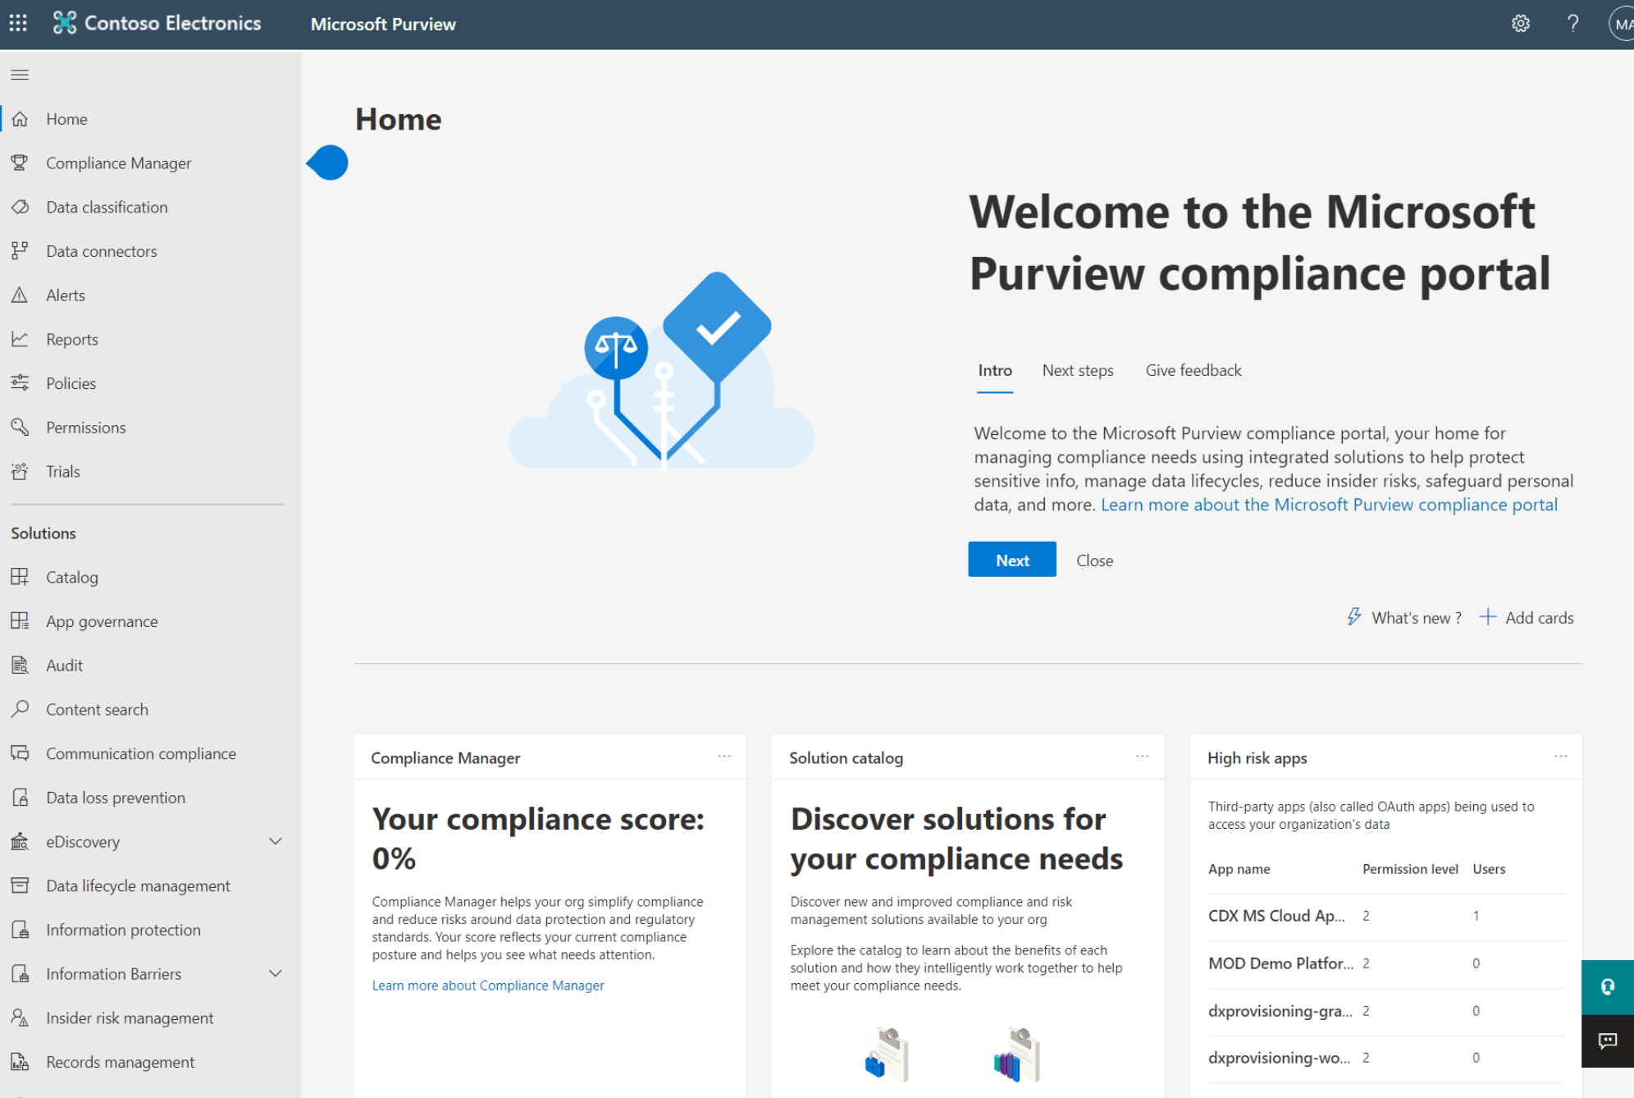
Microsoft Purview compliance portal (compliance.microsoft.com )
- A view of how the organization is meeting its compliance requirements
- Solutions that can be used to help with compliance
- Infromation about active alerts

Navigation
- Access to alerts, reports, policies, compliance solutions, and more
- Add ore remove options for a customized navigation pane.
- Customize navigation control.

Complicance Manager : simplifies compliance and redues risk by providing
- Prebuilt assessments based on common standards
- Workflow capabilities to complete risk assessments
- Step-by-step improvement actions
- Compliance score, shows overall compliance posture

Key elements of Compliance Manager
- Controls : a requirement of a regulation, standard, or policy : Microsoft-managed / Shared / Customer-Managed
- Assessments : a grouping of controls from a specific requlation, standard or policy
- Templates : help admins to quickly create assessments
- Improvement actions : help centralize compliance activities

Benefits of Compliance Score
- Help an organization understand its current compliance posture
- Help prioritize actions based on their potential to reduce risk

Understand your compliance score
- Actions:
- your imporoved actions
- Microsoft actions
- Action types ( & action subcategory)
- Mandatory (preventive, detective, or corrective)
- Discretionary 酌情 (preventive, detective, or corrective)

Module 3
Microsoft Purview Information Protection
Microsoft Purview Data Lifecycle Management

- Know your data: Understand your data landscape and identify important data across on-premises, cloud,
and hybrid environments.
- Protect your data: Apply flexible protection actions including encryption, access restrictions,
and visual markings
- Prevent data loss: Detect risky behaviour and prevent accidental oversharing of sensitive information
- Govern your data: Automatically keep, delete, and store data and records in a compliant manner.

Data classification capabilities of the compliance portal
- Sensitive information types (SIT) : pattern-based classifiers ( credit card#, Passport/id#, Bank Acc# )
- Trainable classifiers: Pre-trained classifiers and Custom trainable classifiers ( specific kinds contracts, invoices )
- Understsand and explore the data: # of items classified as sensitive, detail of locations, Summary of actions
- The content explorer: It enables administrators to gain visibility into the content that has been summarized in the overview pane.
- The activity explorer: It can monitor what's being done with labeled content across the organization.
( copy to removable media, copy to network share, Label changed )

Sensitivity labels and policies
- Sensitivity labels : ( Data classification )
- Customizable
- Clear text
- Persistent
Usage:
- Encrypt email and documents
- Mark the content
- Apply the label automatically
- Protect content in containers: sites and groups
- Extend sensitivity labels to third-party apps and services
- Classify content without using any protection settings.

- Sensitivity Label policies : (data protection) enable admins to
- Choose the users and groups that can see labels : can published to specific user, distribution groups
- Apply a default label to all new emails and doc: user can always change default label if mis-labeled
- Require justifications for label changes : if remove label, admin can require user to provide valid justifiation
- Require users to apply a label (mandatory labeling) : ensures label is applied before save, send
- Link users to custom help pages
Once a sensitivity label is applied to an email or document, any configured protection settings for
that label are enforced on the content

Data loss prevention (DLP)
DLP protects sensitive information and prevents its inadvertent disclosure
- DLP policies protect informatin by identifying and automatically protecting sensitive data
- Protect sensitive information across Microsoft 365 - OneDrive for Business, SharePoint Online,
Exchange Online and Microsfot Teams

Endpoint Data Loss Prevention
- DLP extended to Windows 10 , 11 and MacOS (Catalina 10.15 or up) devices
- Audit and manage activities including creating, copying, printing, & renaming items.

Data Loss Prevention in Microsoft Teams
- DLP capabilities extended to Microsoft Teams chat and channel message

Retention Labels and policies
Retention setting work with SharePoint, OneDrive, Teams, Yammer and Exchange and help organizations manage and govern information by ensureing content is kept only for a required time, and then permanently deleted.

Retention policies:
- Are applied at site or mailbox level
- Can be applied to multiple locations or specific locations or users.
- Items inherit the retention setting from their container
- If an item is moved, the retention setting does not travel to the new locaiton.

Retention labels:
- Are applied at an item level ( folder, doc, email )
- Emails and documents can have only a single retention label assgned to it at a time
- Retention settings from retention labels travel with the content in your Microsoft 365 tenant
- Can be applied manually or automatically
- Retention labels support disposition reveiw of the content before it's permanently deleted.

Records management: in Microsoft Pruview
helps an organization look after their legal obligations and helps to demonstrate compliance with regulations.

- When content is labeled as a record, the following happens:
- Restrictions are put in place to block certain activities.
- Activities are logged.
- Proof of disposition is kept at the end of the retention period.

- To enable items to be marked as records, and administrator sets up retention labels.
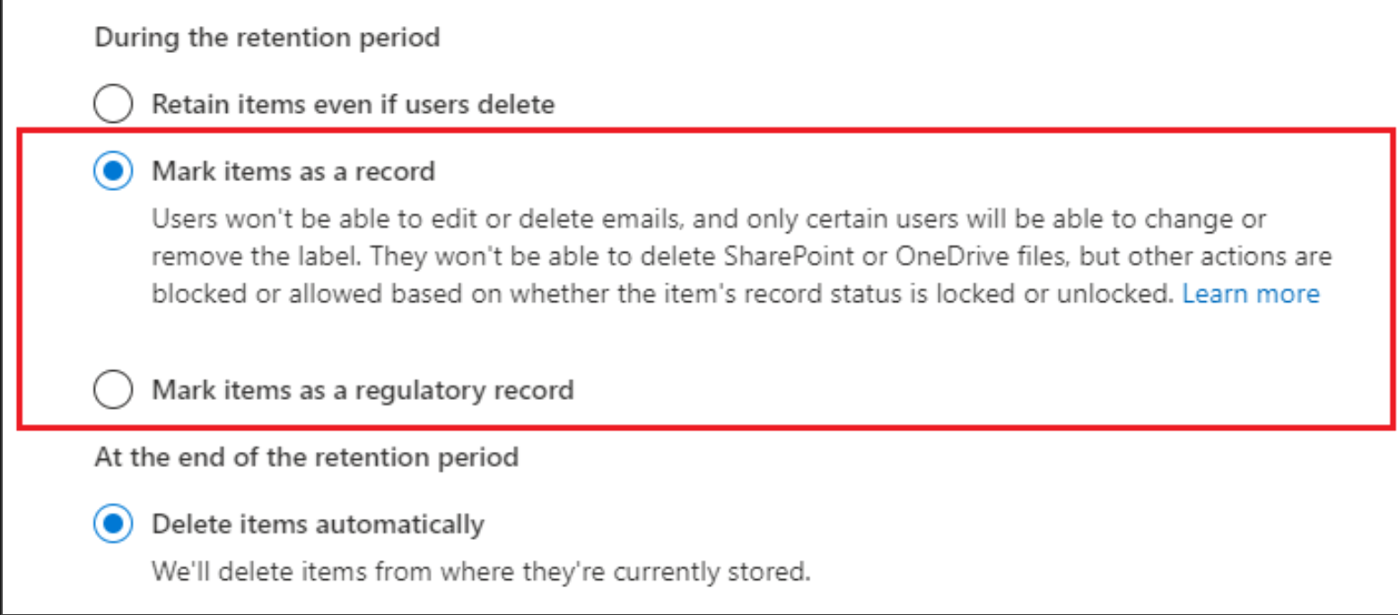

Module 4
Insider Risk solutions in Microsoft Purview:
- Insider Risk Management : helps minimize internal risks by enabling you to detect, investigate,
and act on malicious and inadvertent activities in your organization.

- Communication Compliance : helps minimize communication risks by helping you detect, capture,
and act on inappropriate messages in your organization. Supported services: Microsoft Teams,
Exchange Online, Yammer, & third party communications in an org.

- Information barriers : allow you to restrict communication and collaboration between two internal groups to avoid a conflict of interest from occurring in your organization. Supported in Microsoft Teams,
OneDrive for Business, SharePoint Online, and more.

Module 5
eDiscovery in Microsoft Purview
- Electronic discovery is the process of identifying and delivering electronic information that can be used
as evidence in legal cases.
- eDiscovery tools: Content search, eDiscovery (Standard), eDiscovery (Premium)
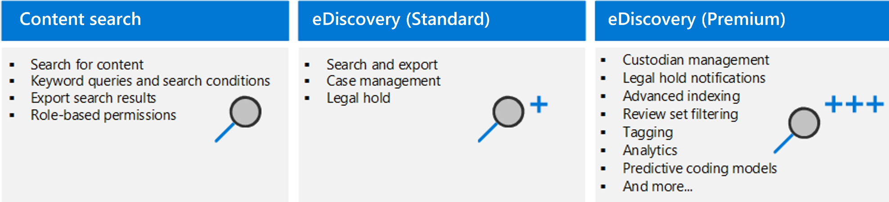
Auditing in Microsoft Purview
- Microsoft Purview auditing solutions help organization effectively respond to security events,
法庭forensic investigations, internal investigations, and compliance obligations.合規義務
- Microsoft Purview provides two auditing solutions: Audit(Standard) and Audit(Premium).
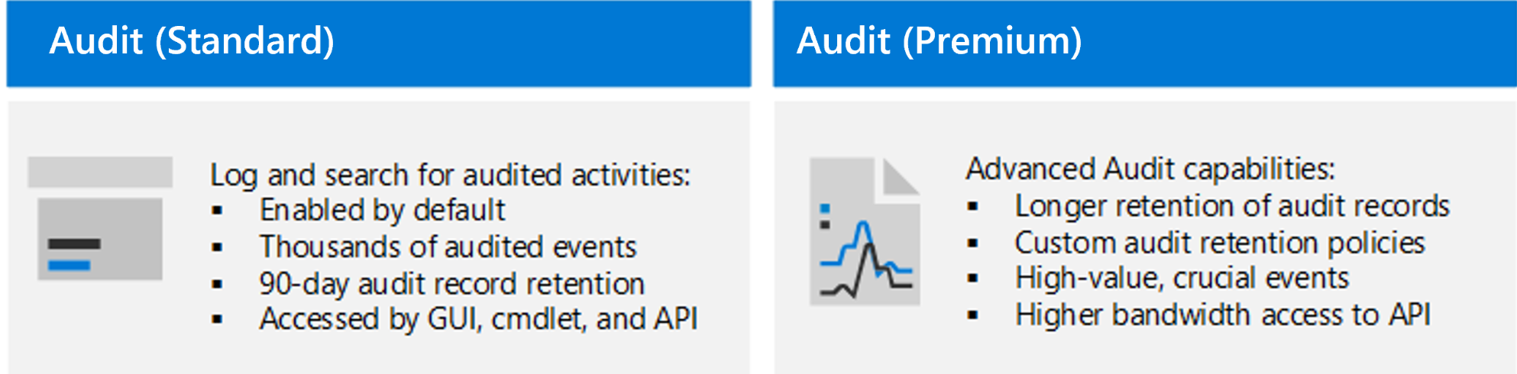

Azure Policy (2)
- Help enforce standards and assess compliance across your organization. ( business rules , state of resouce )
- A compliance dashboard, to evaluate the overall state of the environment.
- Evaluates resources in Azure and Arc enabled resources.

Trigger a Policy evaluation (1)
- In-scope resource is created, deleted, or updated with a policy assignment
- A policy or an initiative is newly assigned to a scope
- A policy or an initiative assigned to a scope is updated.
- The standard compliance evaluation cycle.

Responses to non-compliant resources: (3)
- Deny a change to a resource.
- Log changes to a resource.
- Alter a resource before or after a change
- Deploy related compliant resources.

Azure policy override role-based access control ?

Azure Blueprints
- Azure Blueprints provide a way to define a repeatable set of Azure resources.
- Rapidly provision environments, that are in line with the organization's compliance requirements.
- Provision Azure resources across several subscriptions simultaneously for quicker delivery.
- Declarative way to orchestrate the deployment of various resource templates and artifacts, including:
- Role Assgnments
- Policy Assignments
- Azure Resource Manager templates (ARM templates)
- Resource Groups
- Blueprint objects are replicated to multiple Azure regions.
- The relationship between the blueprint definition (what should be deployed) and the blueprint assignment (what was deployed) is preserved.

Microsoft Purview governance portal
provides a unified data governance service that helps organizations manage and govern their on-premises, multi-cloud, and SaaS data.
- Data Map : identify and classify sensitive data
- Data Catalog : quickly and easily find relevant data with filters
- Data Estate Insights : know where sensitive data is, and how it moves ( officers can get a bird's eye view )
- Data Sharing(preview) : share data within and between organizations.
- Data Policy(preview) : govern data access

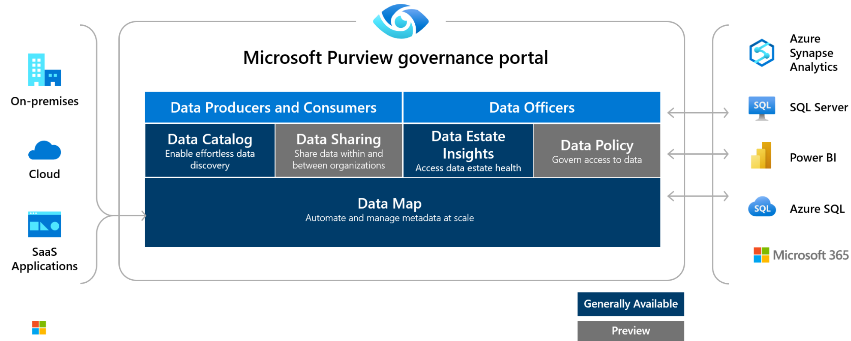

InTune (Microsoft Endpoint Mgr Admin Center) :
- mobile device management MDM / mobile application management : MAM / endpoint security

