My Ip Address: 127.0.0.1/8

The Moment When:

-Assignment asks to use packet sniffing tools

-WSL does not support nmap -_-

-Need linux based machine

-Friend has macOS laptop

-Nmap can't be installed via terminal on mac -_-

-Has to download nmap directly from website (extremely shady site)

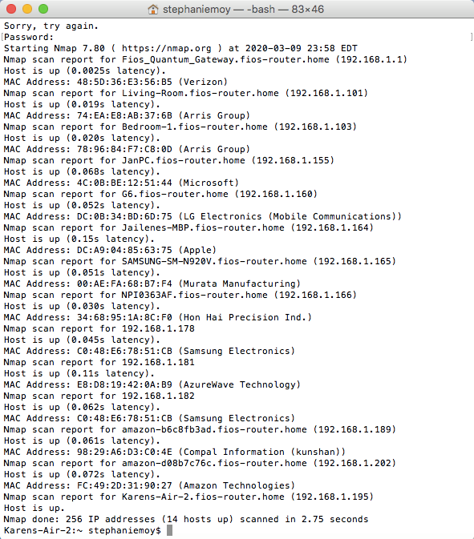

Conclusions:

1. Arris Group are routers
2. LG Electronics/Microsoft/Samsung Electronics are also routers
3. Verizon is internet provider
4. Samsung Electronics is personal device
5. AzureWave Technology is vendor used by Chromecast
6. Compal Information is also a router
7. Hon Hai Precision Ind.(Foxconn) is PS4