NetMAS Tutorial – make model

2010/07/05　AIST

This tutorial shows how to use the editor to make simple models.

* Using the object browser
* Basic usage of the editor frame
* Placing nodes and links
* Placing agents

## Prerequisite

The readers of this tutorial should have finished reading the basic tutorial.

# Run-through

First, we will start by a very brief run-through. Start NetMAS and show the **Browser** tab-panel. In the **Browser** tab-panel, (1) right click on the empty group and (2) select “Show Frame”.

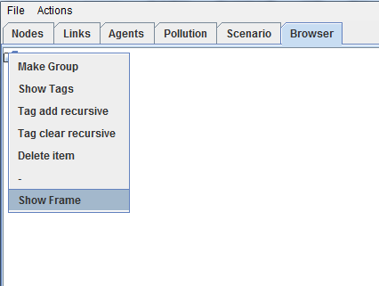

(2)

(1)

This will show the editor frame. Select “Place Nodes” from the “Mode” menu.

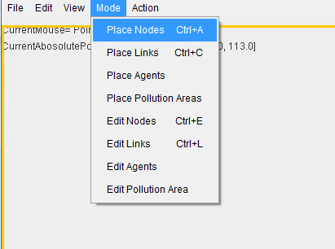

This will switch the editor to **node placing mode**. In this mode, press the left mouse button to place the nodes of the model.

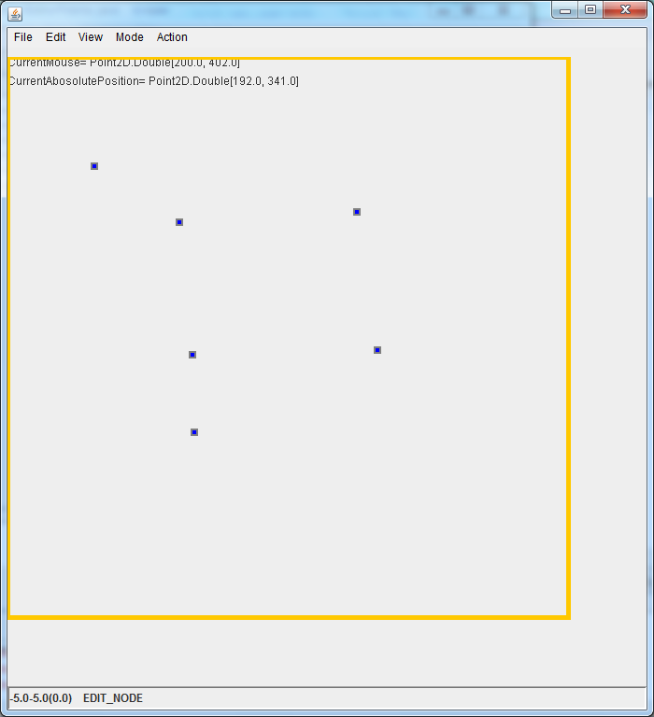

Next, to place links of the model, select “Place Links” from the “Mode” menu. To connect two nodes with a link, first select a node by clicking on the node (the *from node*). Then move the mouse and a candidate of link will be automatically shown in a blue line. To actually place a link, click the left mouse button again.

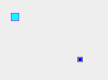→ 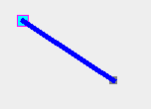 → 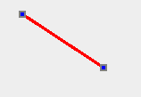

To place another link, just click on another node and do the same.

I have connected the nodes as following.

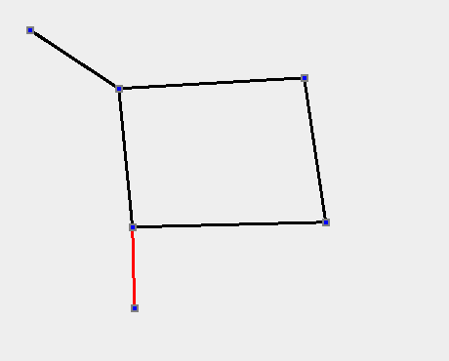

Next, set the goal for this model. Select “Edit Nodes” from the “Mode” menu. Left click on a node to select a node. Then right click to show the menu and select “Change to exit”.

|  |  |  |
| --- | --- | --- |
|  |  |  |

See that when you hover the mouse on the node, “EXIT” will be shown.

Now place the agents. First, go back to the main window and select the “Agents” tab-panel.

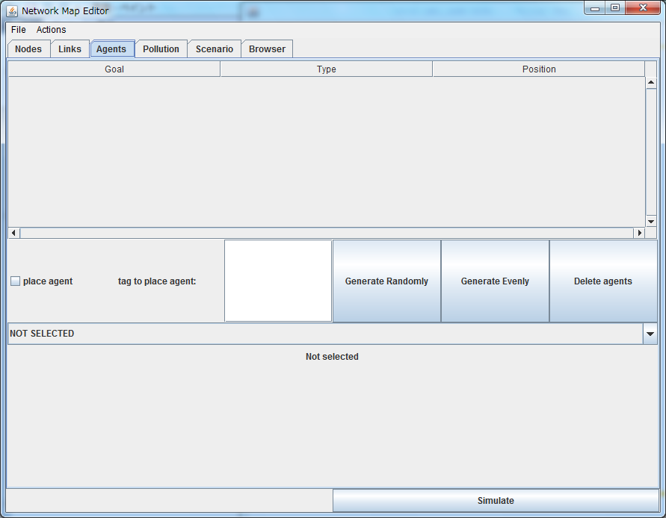

To select the type of agent to be generated, use the list where first shown “NOT SELECTED”. Here, select “RunningAroundPerson” for the type of agent.

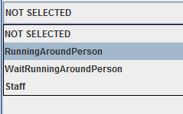

This will show the panel to control the parameters for the agents (Click the empty space below the list if nothing is shown).

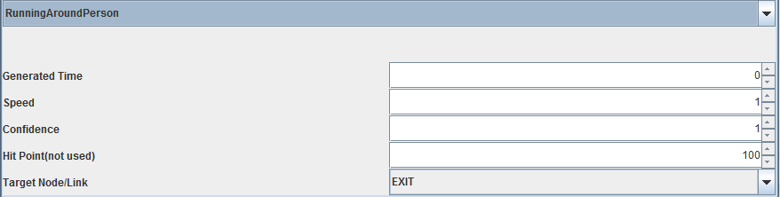

As we have selected the type of agent to be generated, we can go back to the editor frame. Select “Place Agents” from the “Mode” menu. By moving the mouse over the links, a blue dot representing the candidate to place the agent will be shown. Click the left mouse button to actually place the agent.

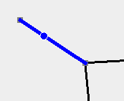→ 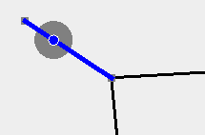

Now we are done, and ready to run the simulation!

# Object browser

The “Browser” tab-panel is an object browser to edit how to group together objects. Each group can be edited independently, so it is a good idea to keep each group to the size of your interest. If you are making a model of a building, for example, you can divide the building in floors.

## Making groups

To make a group, select “Make Group” from the context menu in the object browser. This will show a window to prompt for a *tag* for the group and the default height of the group.

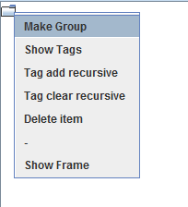→ 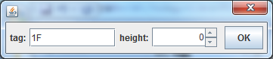

A group with the tag “1F” is added to the root of the object browser. The default height of the group effects all the nodes created in this group.

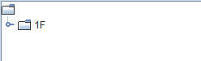

You can edit the contents of the group by right clicking the group and selecting “Show Frame”.

## Connecting between groups

To connect between two nodes in a different group, use the “symlink”. A symlink is a pointer that shows where a node in another group is placed. To make a symlink, select a node in the node editing mode, show the context menu and select in which group to place the symlink.

For example if you have two groups “1F” and “2F”, and you want a node in “1F” to be also seen in “2F”, you make a symlink of that node in “2F”.

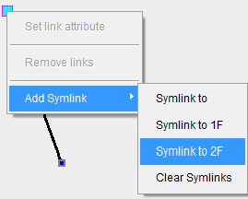

More on groups

Groups and symlinks are useful on making multistory buildings. There are some editor functions such as floor-copying and automatic generation of stairs to help making multistory buildings.

# Editor frame

Here are some more basic functions of the Editor frame.

## Scrolling and zooming

There are two ways each to scroll and zoom in the editor frame.

|  |  |  |
| --- | --- | --- |
| Scroll | Drag with central button | Drag with shift + left button |
| Zoom in/out | Mouse wheel | Drag with shift + right button |

Note that in many settings, the wheel click does not yield a click with the central mouse button. Check with your mouse settings if the drag with central button does not function.

## Placing background picture

By selecting “Set Background File” from the “File” menu, you can place a picture in the background. This is useful when tracing a draw plan.

## Setting scales

The original editor does not know the correspondence of the length shown in the editor and the actual length of the model (i.e. how many pixels means how many meters). You can set this value in several ways, but the easiest way is to use the “Set Scale” in the “Edit” menu.

Using this function, you draw a line on the editor frame, and then tell the editor the actual length of that line. The editor will automatically calculate the actual length of all the links in the group (or in all groups).