首页看板

## 主要涉及界面

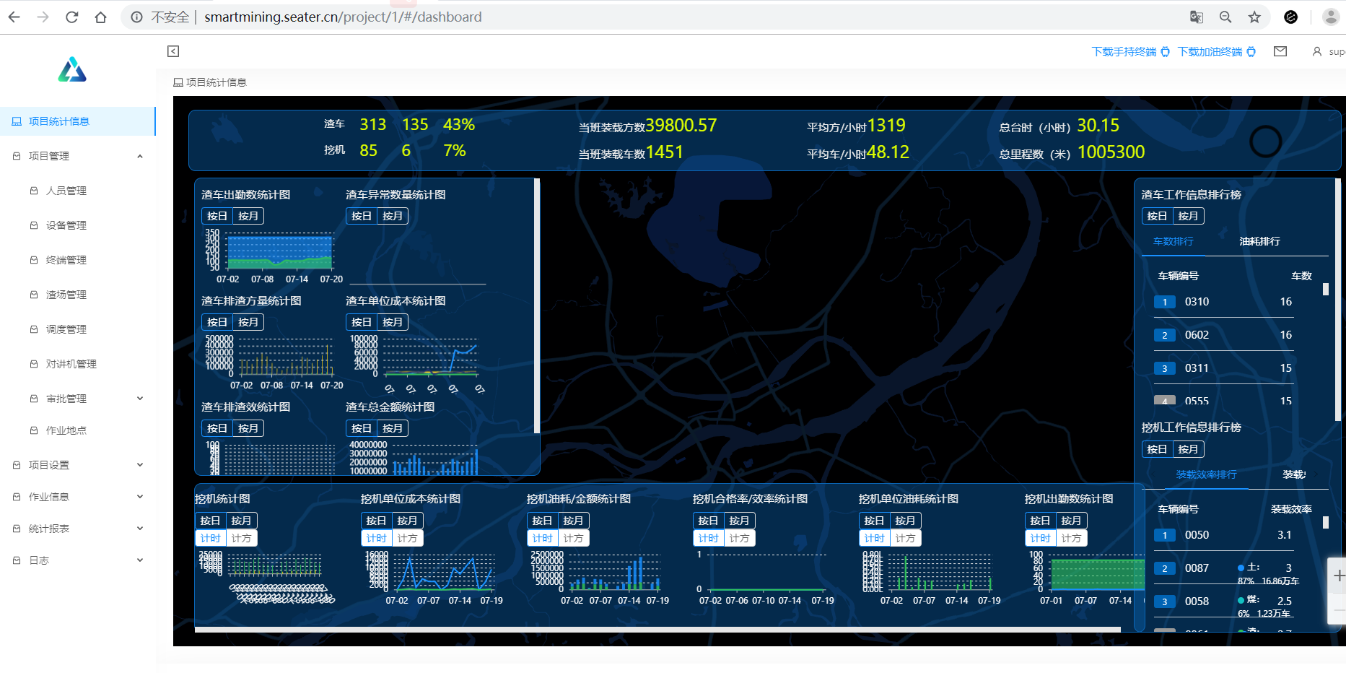

## 测试数据

|  |  |  |  |
| --- | --- | --- | --- |
| 账号 | 15914886839 |  |  |
| 密码 | 123456 |  |  |
| 项目 | 上元三区 | 项目id:1 |  |
| 角色 | 管理员 |  |  |
| 权限 | 所有权限 |  |  |

## 接口测试

相关页面



|  |  |  |  |  |  |  |
| --- | --- | --- | --- | --- | --- | --- |
| **接口(控件)\标准** | **正常** | **异常** | **备注** | **详细图片** | **意见** | **后期解决结果(填写更新完的version number ,最好带上截图)** |
| 当班实时数据 | ✔ |  |  |  |  |  |
| 渣车出勤统计 | ✔ |  |  |  |  |  |
| 渣车异常数量统计 | ✔ |  |  |  |  |  |
| 渣车排渣方量统计 | ✔ |  |  |  |  |  |
| 渣车单位成本统计 | ✔ |  |  |  |  |  |
| 渣车排渣效率统计 | ✔ |  |  |  |  |  |
| 渣车总金额统计统计 | ✔ |  |  |  |  |  |
| 挖机统计 |  | ✔ |  |  | 前端单位转换问题? | 2019年8月6日已修复 |
| 挖机单位成本统计 | ✔ |  |  |  |  |  |
| 挖机油耗/金额统计 | ✔ |  |  |  |  |  |
| 挖机合格率/效率统计 | ✔ |  |  |  |  |  |
| 挖机单位油耗统计 | ✔ |  |  |  |  |  |
| 挖机出勤数统计 | ✔ |  |  |  |  |  |
| 渣车装载车数排行榜 | ✔ |  |  |  |  |  |
| 渣车油耗比排行榜 | ✔ |  |  |  |  |  |
| 挖机装载效率排行榜 | ✔ |  |  |  |  |  |
| 挖机装载总车数排行榜 | ✔ |  |  |  |  |  |
| 挖机油耗比排行榜 | ✔ |  |  |  |  |  |
| 物料总车数 | ✔ |  |  |  |  |  |
| 物料总方量 | ✔ |  |  |  |  |  |
| 用油金额统计 | ✔ |  |  |  |  |  |
| 费用总占比 | ✔ |  |  |  |  |  |

## 数据和数据完整性测试

|  |  |  |  |  |  |  |
| --- | --- | --- | --- | --- | --- | --- |
| **数据** | **期望值** | **结果值** | **详细图片** | **是否符合期望** | **备注** | **后期解决结果** |
| **所有接口** | **数据正常** | **数据正常** |  | **是** | 挖机统计前端已调整 |  |

## 功能测试(业务)

### 业务流程:

|  |  |  |  |  |  |  |
| --- | --- | --- | --- | --- | --- | --- |
| **业务流程** | **是否完全通过** | **异常环节** | **备注** | **详细图片** | **意见** | **后期解决结果** |
|  |  |  |  |  |  |  |