Industrial Internship Report on
” Grocery delivery application”
Prepared by
Kanaga Durga M
Executive Summary
This report provides details of the Industrial Internship provided by upskill Campus and The IoT Academy in collaboration with Industrial Partner UniConverge Technologies Pvt Ltd (UCT).
This internship was focused on a project/problem statement provided by UCT. We had to finish the project including the report in 6 weeks’ time.
My project was ShopNGo is a full-stack online grocery and e-commerce web application developed using Firebase and modern web technologies. The platform allows users to browse products across multiple categories, add items to cart with interactive animations, place orders with secure online payments, and track order history. It also includes an admin panel for product and inventory management, making it a scalable and real-world ready solution suitable for internship and portfolio showcase.
This internship gave me a very good opportunity to get exposure to Industrial problems and design/implement solution for that. It was an overall great experience to have this internship.

TABLE OF CONTENTS
1 Preface 3
2 Introduction 4
2.1 About UniConverge Technologies Pvt Ltd 4
2.2 About upskill Campus 8
2.3 Objective 9
2.4 Reference 9
2.5 Glossary 10
3 Problem Statement 11
4 Existing and Proposed solution 12
5 Proposed Design/ Model 13
5.1 High Level Diagram (if applicable) 13
5.2 Low Level Diagram (if applicable) 13
5.3 Interfaces (if applicable) 13
6 Performance Test 14
6.1 Test Plan/ Test Cases 14
6.2 Test Procedure 14
6.3 Performance Outcome 14
7 My learnings 15
8 Future work scope 16

Preface
This report summarizes the work carried out during the six weeks internship program. The internship provided hands-on exposure to real-world software development practices and helped bridge the gap between academic learning and industry requirements.
A relevant internship plays a crucial role in career development by providing practical skills, professional discipline, and exposure to modern tools and technologies used in the industry.
The project undertaken during this internship is “ShopNGo – Online Grocery, Food Delivery & E-Commerce Application”, which addresses the growing demand for digital shopping platforms that combine multiple services into a single application.
This internship opportunity was provided by UniConverge Technologies Pvt Ltd (UCT) in association with Upskill Campus (USC) and The IoT Academy. The program was well planned with structured learning, guidance, and project milestones.
Throughout the internship, I gained valuable technical knowledge, problem-solving skills, and practical experience in full-stack development.
I would like to sincerely thank UniConverge Technologies Pvt Ltd, Upskill Campus, mentors, trainers, and all individuals who directly or indirectly supported me during this internship.
To my juniors and peers: stay curious, practice consistently, and use internships as a platform to explore real-world problems and build strong foundations for your career.

Introduction

About UniConverge Technologies Pvt Ltd
A company established in 2013 and working in Digital Transformation domain and providing Industrial solutions with prime focus on sustainability and RoI.
For developing its products and solutions it is leveraging various Cutting Edge Technologies e.g. Internet of Things (IoT), Cyber Security, Cloud computing (AWS, Azure), Machine Learning, Communication Technologies (4G/5G/LoRaWAN), Java Full Stack, Python, Front end etc.
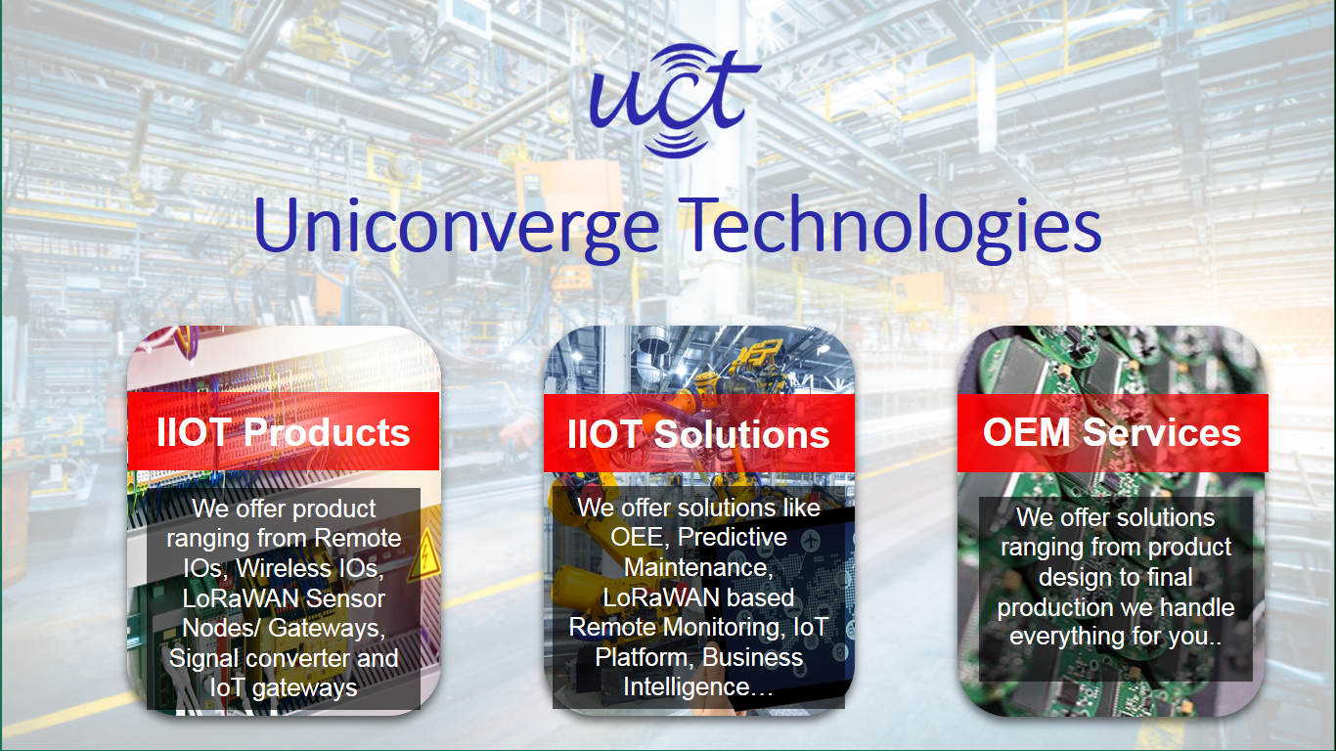
- UCT IoT Platform ()
UCT Insight is an IOT platform designed for quick deployment of IOT applications on the same time providing valuable “insight” for your process/business. It has been built in Java for backend and ReactJS for Front end. It has support for MySQL and various NoSql Databases.
- It enables device connectivity via industry standard IoT protocols - MQTT, CoAP, HTTP, Modbus TCP, OPC UA
- It supports both cloud and on-premises deployments.
It has features to
• Build Your own dashboard
• Analytics and Reporting
• Alert and Notification
• Integration with third party application(Power BI, SAP, ERP)
• Rule Engine

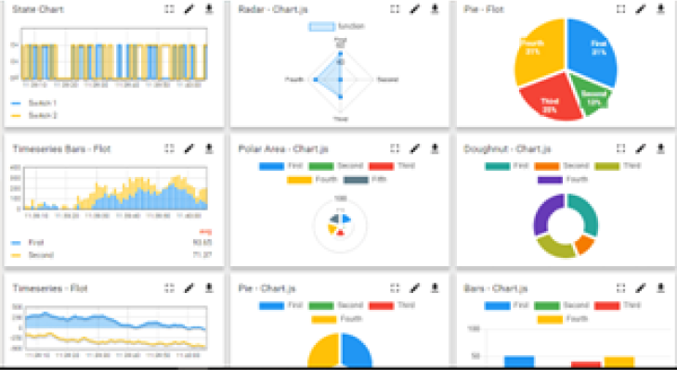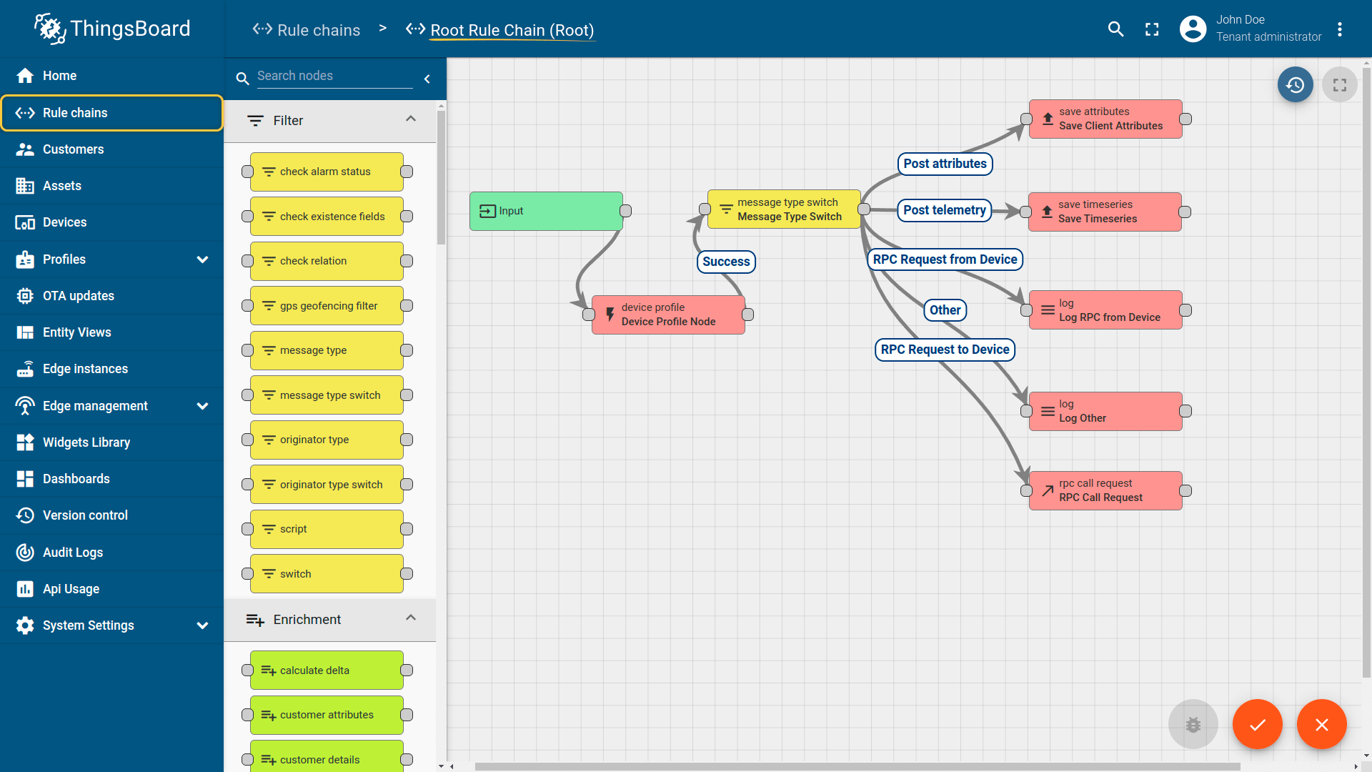

- Smart Factory Platform ()
Factory watch is a platform for smart factory needs.
It provides Users/ Factory
- with a scalable solution for their Production and asset monitoring
- OEE and predictive maintenance solution scaling up to digital twin for your assets.
- to unleased the true potential of the data that their machines are generating and helps to identify the KPIs and also improve them.
- A modular architecture that allows users to choose the service that they what to start and then can scale to more complex solutions as per their demands.
Its unique SaaS model helps users to save time, cost and money.
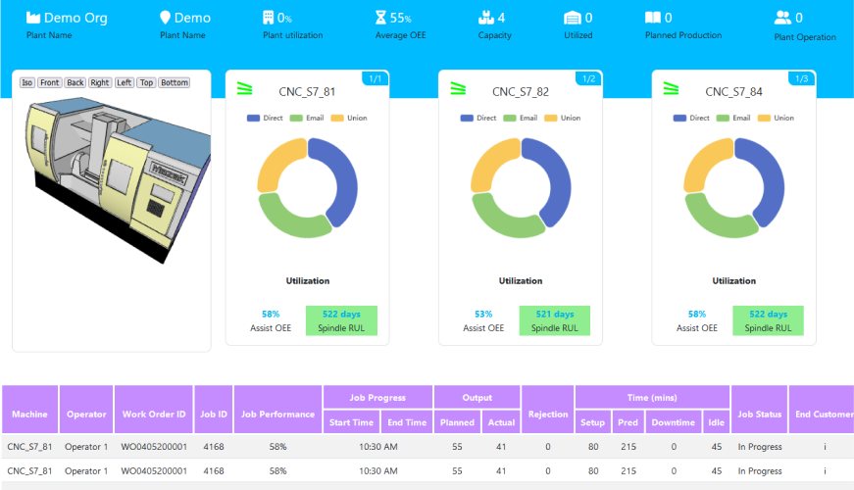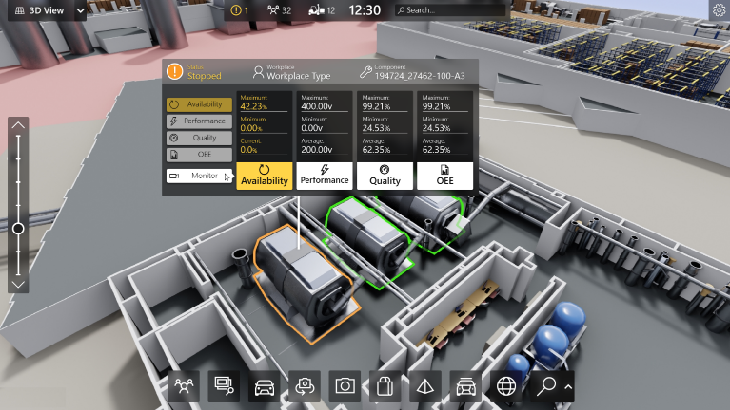

- 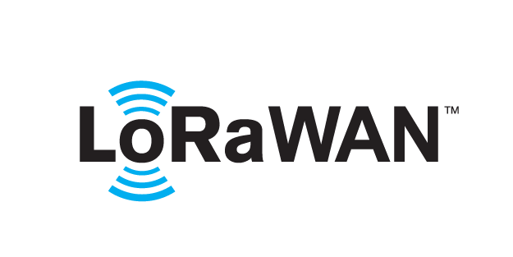 based Solution
UCT is one of the early adopters of LoRAWAN teschnology and providing solution in Agritech, Smart cities, Industrial Monitoring, Smart Street Light, Smart Water/ Gas/ Electricity metering solutions etc.
- Predictive Maintenance
UCT is providing Industrial Machine health monitoring and Predictive maintenance solution leveraging Embedded system, Industrial IoT and Machine Learning Technologies by finding Remaining useful life time of various Machines used in production process.
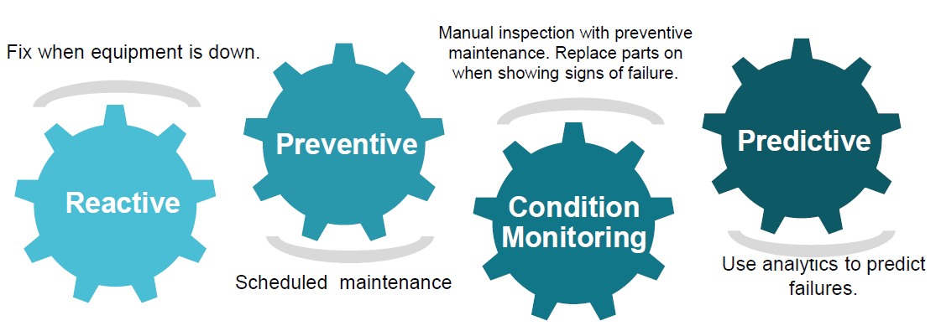

About upskill Campus (USC)
upskill Campus along with The IoT Academy and in association with Uniconverge technologies has facilitated the smooth execution of the complete internship process.
USC is a career development platform that delivers personalized executive coaching in a more affordable, scalable and measurable way.




Seeing need of upskilling in self paced manner along-with additional support services e.g. Internship, projects, interaction with Industry experts, Career growth Services
https://www.upskillcampus.com/
upSkill Campus aiming to upskill 1 million learners in next 5 year

The IoT Academy
The IoT academy is EdTech Division of UCT that is running long executive certification programs in collaboration with EICT Academy, IITK, IITR and IITG in multiple domains.

Objectives of this Internship program
The objective for this internship program was to
☛ get practical experience of working in the industry.
☛ to solve real world problems.
☛ to have improved job prospects.
☛ to have Improved understanding of our field and its applications.
☛ to have Personal growth like better communication and problem solving.

Reference
[1]
[2]
[3]

Glossary
Terms | Acronym

Problem Statement

Traditional grocery shopping requires physical visits to stores, which can be time-consuming and inconvenient. Existing online platforms often suffer from:
- Complex user interfaces
- Limited product organization
- Poor order tracking
- Lack of transparency in purchase history
The challenge is to build a scalable and efficient grocery e-commerce website that ensures smooth product browsing, secure payments, and reliable order management.

3. Proposed Solution
The proposed solution is a web-based grocery and e-commerce platform that enables users to:
- View grocery and household products
- Add or remove items from the cart
- Place orders using online payment methods
- Store and view order history
The application uses a modern frontend and a cloud-based backend to ensure scalability and data security.

4.Objectives of the Project
- To develop a user-friendly grocery e-commerce website
- To implement add-to-cart and checkout functionality
- To integrate secure online payment options
- To maintain records of all orders placed
- To provide an efficient shopping experience

5. Scope of the Project
The scope of this project includes:
- User registration and login
- Product listing with categories
- Cart management (add, update, delete)
- Online payment integration
- Order history and order records
- Admin-side product management (optional)

6. System Architecture
The system follows a client–server architecture:
- Frontend: User interface for browsing and purchasing products
- Backend: Handles authentication, orders, and payments
- Database: Stores user details, product data, and order history
- Payment Gateway: Processes secure online transactions

7. Technology Stack
Frontend
- HTML5
- CSS3
- Bootstrap
- JavaScript
Backend
- Firebase Authentication
- Firebase Firestore / Realtime Database
Hosting & Version Control
- Firebase Hosting
- GitHub
Payments
- Online Payment Gateway (UPI / Cards / Wallets)

8. Functional Modules
8.1 User Module
- User registration and login
- Product browsing
- Cart management
- Order placement
- View order history
- 8.2 Product Module
- Product listing
- Categories (Grocery, Household, Kids, etc.)
- Price and availability
- 8.3 Cart Module
- Add to cart
- Remove from cart
- Quantity update
- Confirmation pop-ups
- 8.4 Payment Module
- Secure online payments
- Payment confirmation
- Order success notification
- 8.5 Order Management Module
- Stores all placed orders
- Displays order history
- Order status tracking

9. Advantages of the System
- Saves time and effort
- Easy and convenient shopping
- Secure online transactions
- Organized order records
- Scalable and cloud-based

10. Limitations
- Requires internet connectivity
- No offline access
- Delivery management not included

11. Future Enhancements
- Mobile application version
- AI-based product recommendations
- Real-time order tracking
- Loyalty points and offers
- Multi-vendor support

12. Conclusion
The Smart Grocery & E-Commerce Web Application successfully provides a digital solution for grocery shopping. By integrating modern web technologies and cloud services, the system delivers a secure, scalable, and user-friendly platform. This project demonstrates practical implementation of e-commerce concepts and enhances real-world development skills.

Code submission (Github link)
https://github.com/Kanaga-Durga316/grocery

Report submission (Github link) : first make placeholder, copy the link.

Proposed Design/ Model

Given more details about design flow of your solution. This is applicable for all domains. DS/ML Students can cover it after they have their algorithm implementation. There is always a start, intermediate stages and then final outcome.

High Level Diagram (if applicable)

Figure 1: HIGH LEVEL DIAGRAM OF THE SYSTEM

Low Level Diagram (if applicable)

Interfaces (if applicable)
Update with Block Diagrams, Data flow, protocols, FLOW Charts, State Machines, Memory Buffer Management.

Performance Test

This is very important part and defines why this work is meant of Real industries, instead of being just academic project.
Here we need to first find the constraints.
How those constraints were taken care in your design?
What were test results around those constraints?
Constraints can be e.g. memory, MIPS (speed, operations per second), accuracy, durability, power consumption etc.
In case you could not test them, but still you should mention how identified constraints can impact your design, and what are recommendations to handle them.

Test Plan/ Test Cases

Test Procedure

Performance Outcome

My learnings

You should provide summary of your overall learning and how it would help you in your career growth.

Future work scope

You can put some ideas that you could not work due to time limitation but can be taken in future.

