**FLOOD MONITORING AND EARLY WARNING**

**PHASE 4 : Development Part 2**

The purpose of this project is to sense the water level in river beds and check if they are in normal condition. If they reach beyond the limit, then it alerts people through LED signals and buzzer sound. Also it alerts people through Sms and Emails alerts when the water level reaches beyond the limit.

### **Demonstration**

Lets First have a look at the workflow of this project.

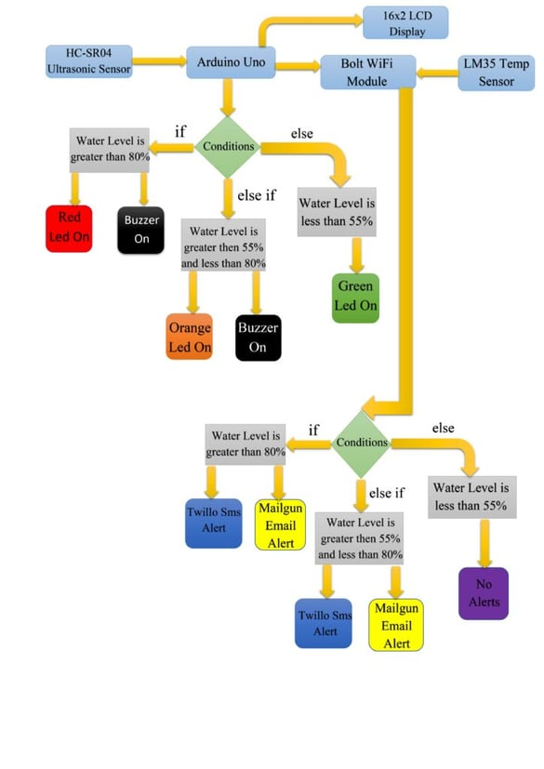

For doing the practical demonstration. First connect the USB cable type-B to the Laptop’s USB slot for power supply. Also simultaneously run the python program(i.e Main.py). Firstly the ultrasonic sensor will sense the water level in distance and then the arduino program will help to convert it into percentage. Also the sensed water level will be displayed on Lcd display(In Percentage) along with zone/area the water level is present. The full water tank/container is divided into 3 zones i.e Green, Orange and Red. Now lets look into each zone.

* When water level is at Min/Normal level. That resembles ‘Green Alert’. This means that water is at normal position and no sign about flood condition. Also green led will glow and it will also show green alert in Lcd display with water level.  
  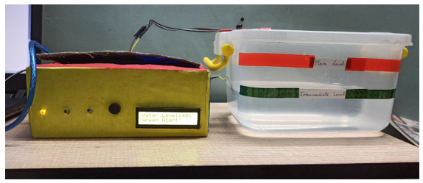
* When water level crosses the Intermediate level. That resembles ‘Orange Alert’. This means that water has crossed the 55% mark and there can be chances of flood condition at that place. With increase in water level the system sends Sms and Email alerts to the authority or registered user from Twillo and Mailgun Services respectively. Also orange led will glow and buzzer will buzz. It will also show orange alert in Lcd display.

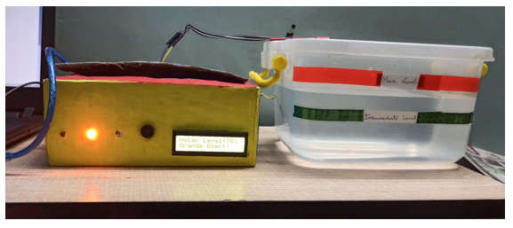

Also Sms and Email is send to registered user with proper message and current temperature of that place.

### **Twillo Sms Alert:**

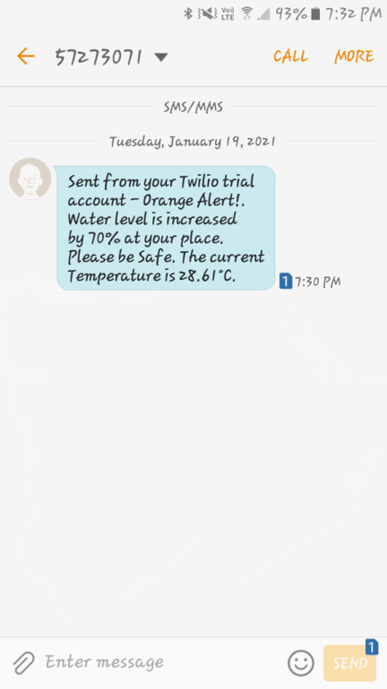

**Mailgun Email Alert:**

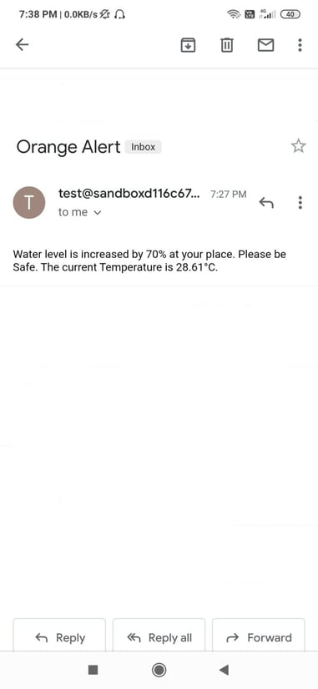

* When water level crosses the Max Level. That resembles ‘Red Alert’. This means that water level has crossed the 80% and flood situation has occured at that place. With increase in water level the system sends Sms and Email alerts to the authority or registered user from Twillo and Mailgun Services respectively. Also red led will glow and buzzer will buzz for two times. It will also show red alert in Lcd display.

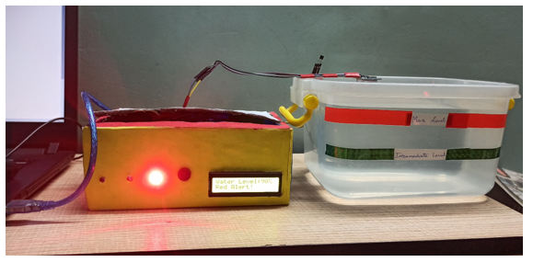

* 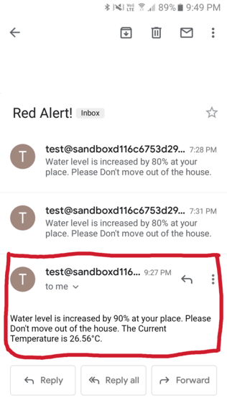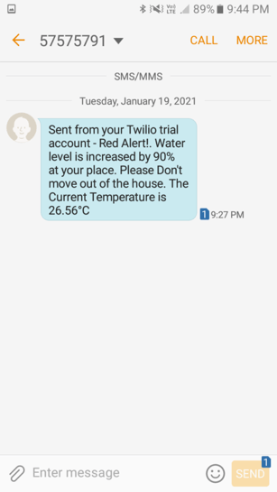Also Sms and Email is send to registered user with proper message and current temperature of that place.