UNITED COLLEGE OF ARTS AND SCIENCE
(Affiliated to Bharathiar University)

Website Corrections as on 02.12.2024

- In header below the college name, remove “An Autonomous College” and keep it as
“(Affiliated to Bharathiar University)” only.
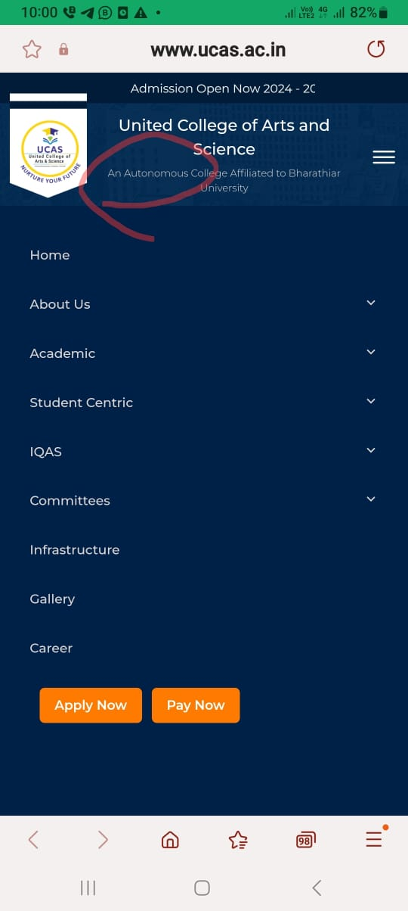

- About UsManagement
- Change “Mr. S. Shanmugam.S” to “Er. S. Shanmugam”
- Change “Mrs.Mythili.S” to “Dr. S. Mythili”
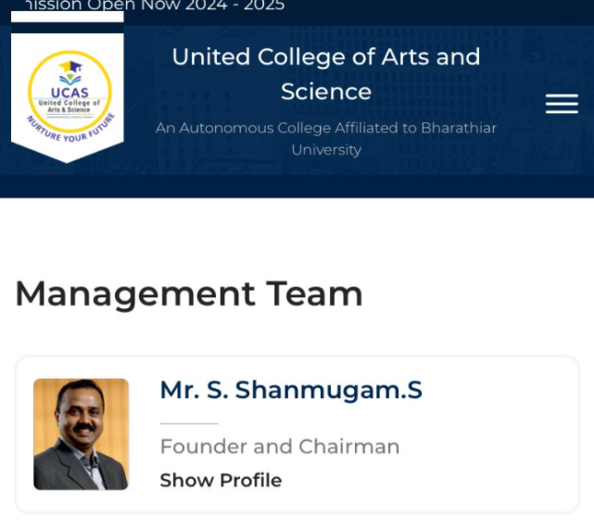
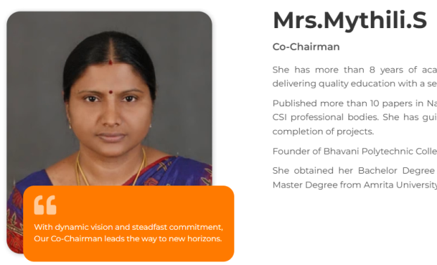

- Student Centric Government Scholarship Add
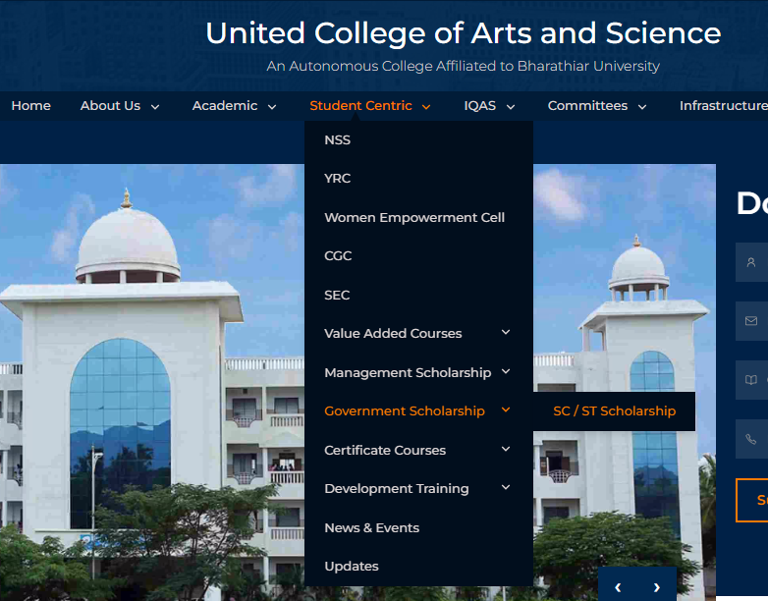
- Pudhumai Penn
- Tamil Pudhalvan

- In Home Page Apply Now Button Popup screen, remove “An Autonomous College” and keep it as “(Affiliated to Bharathiar University)” only.
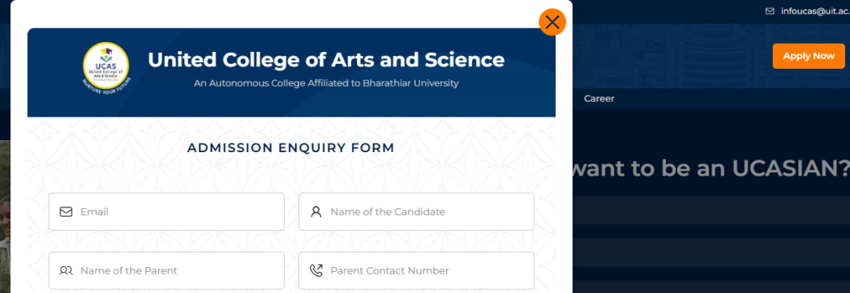

- Add extra menu in “Student Centric Management Scholarship” After “Reference Scholarship”
- Single Parent Scholarship
- Sibling Scholarship
- Sports Scholarship
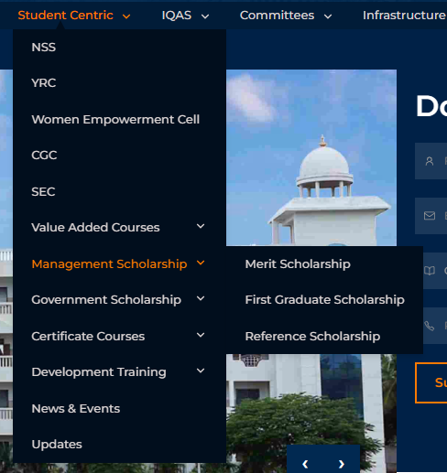

- Add one more menu in “Student Centric Muthamizh Mandram” after SEC


- In Menu “Academic Courses Undergraduate Programs”.
Change the following courses into a single line.
- B.Com - Professional Accounting
- B.Com - Information Technology

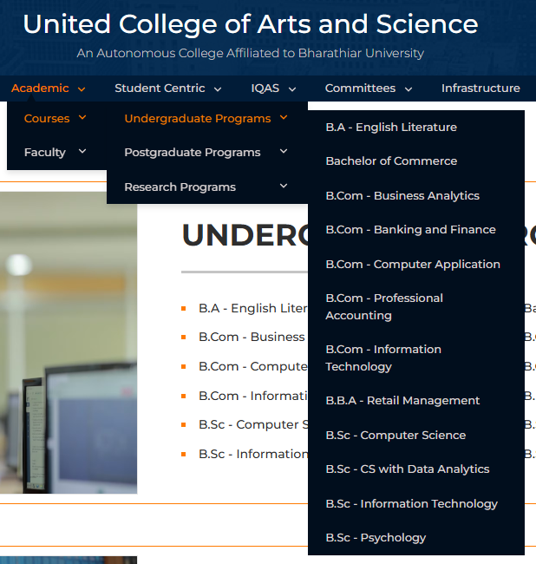

- Add “Alumni Spotlight / Testimonials” in between Management Team and United Educational Institutions
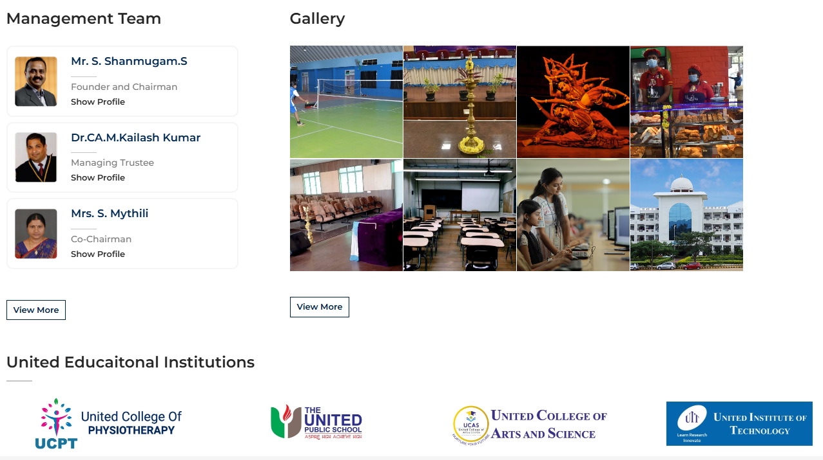

Reference
https://www.drngpasc.ac.in/ Home Page

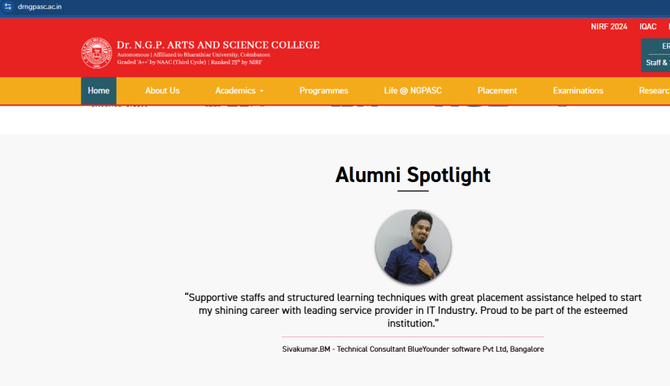

- Add Two more Menus in “Academic” such as
- Examination Cell
- Placement Cell


