**Researchers Discover New State of Matter: Liquid Glass**

**U**

**sing a technique called confocal microscopy, a team of scientists from Germany and the Netherlands has found that suspensions of ellipsoidal colloids form an unexpected state of matter, a liquid glass, in which individual particles are able to move yet unable to rotate.**

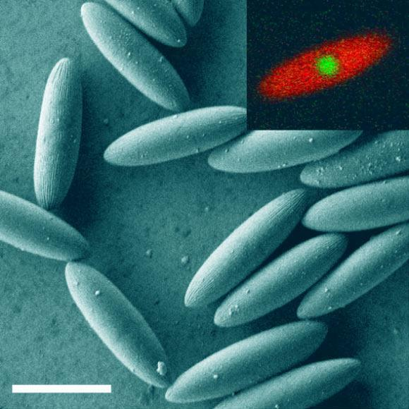  
“Figure 1.Description:Scanning electron microscope image of the ellipsoidal colloids. Inset shows a confocal microscopy image, highlighting the core-shell structure. Scale bar – 5 μm. Image credit:   
Roller et al., doi: 10.1073/pnas.2018072118.”

“Suspensions of colloidal particles are widely spread in nature and technology and have been studied intensely over more than a century,” said co-senior author Professor Andreas Zumbusch from the Department of Chemistry at the University of Konstanz and his colleagues.

“When the density of such suspensions is increased to high volume fractions, often their structural dynamics are arrested in a disordered, glassy state before they can form an ordered structure.”

“To date, most experiments have been done using spherical colloids. The recent interest in synthetic colloids as material building blocks, however, has led to the development of a multitude of novel techniques for the synthesis of colloidal particles with specific geometries and interactions.”

In their experiments, Professor Zumbusch and co-authors focused on ellipsoidal polymethylmethacrylate colloids.

“Due to their distinct shapes our particles have orientation, as opposed to spherical particles, which gives rise to entirely new and previously unstudied kinds of complex behaviors,” Professor Zumbusch explained.

Using confocal laser scanning microscopy, the researchers recorded the temporal development of the 3D positions and orientations for more than 6,000 ellipsoidal particles.

“At certain particle densities orientational motion froze whereas translational motion persisted, resulting in glassy states where the particles clustered to form local structures with similar orientation,” Professor Zumbusch said.

“What we’ve termed liquid glass is a result of these clusters mutually obstructing each other and mediating characteristic long-range spatial correlations.”

“These prevent the formation of a liquid crystal which would be the globally ordered state of matter expected from thermodynamics.”

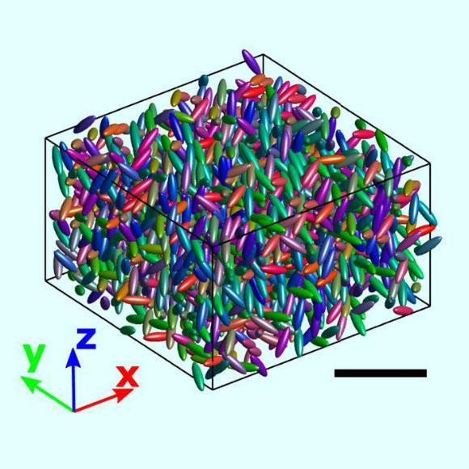  
“Figure 2. Description:Computer rendered 3D reconstruction of a subset of a sample volume with the red-green-blue value of the color indicating the particle orientations. Scale bar – 20 μm. Image credit: Roller et al., doi: 10.1073/pnas.2018072118.”  
 мәтін элементтерін қамтитын сурет

Сипаттама автоматты түрде жасалды[1]

The team observed two glass transitions — a regular phase transformation and a nonequilibrium phase transformation — interacting with each other.

“This is incredibly interesting from a theoretical vantage point,” said co-senior author Professor Matthias Fuchs, a researcher in the Department of Physics at the University of Konstanz.

“Our experiments provide the kind of evidence for the interplay between critical fluctuations and glassy arrest that the scientific community has been after for quite some time.”

“A prediction of liquid glass had remained a theoretical conjecture for twenty years.”

“The results further suggest that similar dynamics may be at work in other glass-forming systems and may thus help to shed light on the behavior of complex systems and molecules ranging from the very small (biological) to the very big (cosmological).”

“It also potentially impacts the development of liquid crystalline devices.”

The discovery is reported in a [paper](http://www.google.com) published in the Proceedings of the National Academy of Sciences[2].

[PAPER](https://nothing.com)

1. Formula
2. Science