Return date and time from web application built on T2 Micro EC2 instance on ASG. It’s to be invoked by Application Load Balancer which is to be accessed by Route 53

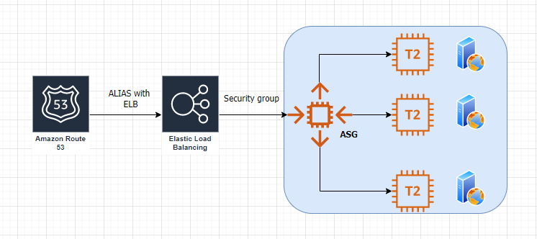

1. Create an Auto Scaling Group with minimum 3 instances and maximum 4 EC2 (T2 Micro) instances.
2. Built HTML based web application which will return system date and current day

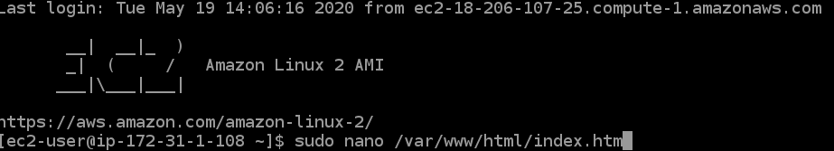

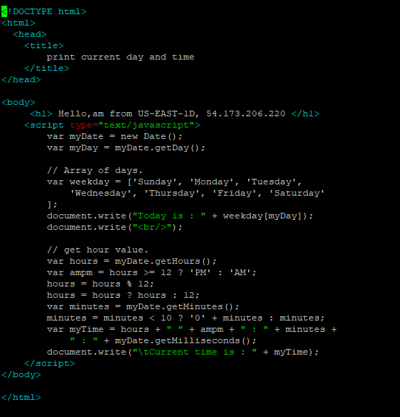

1. Create Application load balancer with target group registered with 3 EC2 instances
2. Set up security group of EC2 instances to accept traffic from ALB only
3. Once ALB is created, mapped with route53 ALIAS record.

