1. **Upload an image to S3 and get notification to your mobile and email ID**

Step 1 : Create a s3 bucket(s3lambdasms) with default settings

Step 2: Create a SNS(Simple Notification service) with topic name (Lambda_alert_SNS) and two subscriptions (1, email and 2, mobile number)

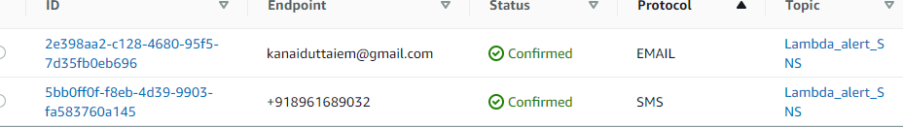

Step3: create a lambda function (S3_ImageTrigger) with Python 3.8 and created following dependencies,

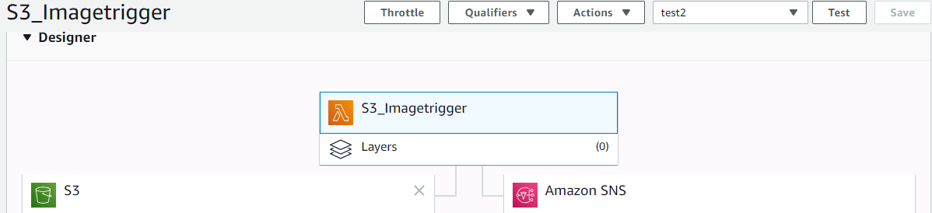

Lambda Coding is as follows,

import json

import boto3

def lambda_handler(event, context):

message={"Name":"Bublai"}

client=boto3.client('sns')

response = client.publish(

TargetArn='arn:aws:sns:ap-south-1:641747486325:Lambda_alert_SNS',

Message=json.dumps({'default': json.dumps(message),

'sms': 'SMS confirmation for impage upload to S3',

'email': 'SUCCESSFULLY uploaded to S3'}),

Subject='Image uploaded to S3 bucket ',

MessageStructure='json'

)

In order for Lambda to trigger SNS, need to set execution role and assign that to Lambda through Permission option.

