VPC based Lambda using EFS file system

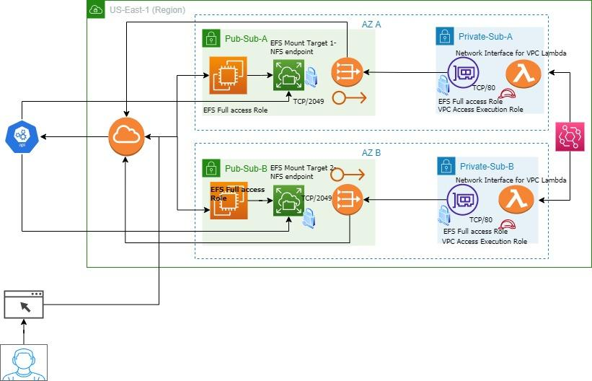

1. Created base infrastructure comprising 2 public subnets, 2 private subnets across two availability zones with NAT gateway in public subnet across two AZs to bring high availability factor and Internet Gateway
2. Configured route table for private subnet to take internet bound traffic through NAT gateway and internet gateway for public subnet
3. Created EFS mount targets, NFS endpoint across two AZ in public subnet with security group configured to accept NFS type traffic from EC2 instance at port 2049
4. Created two EC2 instances in a public subnet across two Azs, installed apache web server . This web server will fetch images from the EFS file system and display them in the web browser.

#!/bin/bash -xe

# STEP 1 - Updates

yum -y update

# STEP 2 - Begin Configuration

yum -y install httpd wget cowsay curl python3 pip3 amazon-efs-utils

amazon-linux-extras install -y php7.2

amazon-linux-extras install epel -y

yum install stress -y

systemctl enable httpd

systemctl start httpd

# STEP 3 - Custom Random Web Page

bgcolor=$(printf "%02x%02x%02x\n" $((RANDOM%256)) $((RANDOM%256)) $((RANDOM%256)))

instanceId=$(curl http://169.254.169.254/latest/meta-data/instance-id)

wget -O /var/www/html/cat.gif "http://thecatapi.com/api/images/get?format=src&type=gif&api_key=8f7dc437-0b9b-47b8-a2c0-65925d593acf"

cat <<'EOF' > /var/www/html/index.php

<html>

<head>

</head><body style="background-color:#1395c0;">

<center><h1>The Cat Gallery</h1></center><br>

<center><table>

<?php

$dirname = "images/";

$images = glob($dirname."*.png");

$i = 0;

echo '<tr>';

foreach($images as $image) {

if ($i < 3) {

echo '<td><center><img src="'.$image.'" width="300" /></td>';

$i++;

} elseif ($i ==3) {

echo '</tr><tr>';

$i = 0;

}

}

echo '</tr>';

?>

</table></center>

</body></html>

EOF

# STEP 4 - Mount EFS

mkdir -p /var/www/html/images

chown -R ec2-user:apache /var/www/

echo -e "${ElasticFileSystem}:/ /var/www/html/images efs _netdev,tls,iam 0 0" >> /etc/fstab

mount -a -t efs defaults

# Step 5 - permissions

usermod -a -G apache ec2-user

chown -R ec2-user:apache /var/www

chmod 2775 /var/www

find /var/www -type d -exec chmod 2775 {} \;

find /var/www -type f -exec chmod 0664 {} \;

1. Created EFS access point with following details

1000 for User ID

1000 for Group ID

1000 for Owner user ID

1000 for Owner group ID

0777 for Permissions

1. Lambda function is created with python runtime environment to get cat images from web api and load them to **EFS file system (EFS access point)** in Lambda environment.

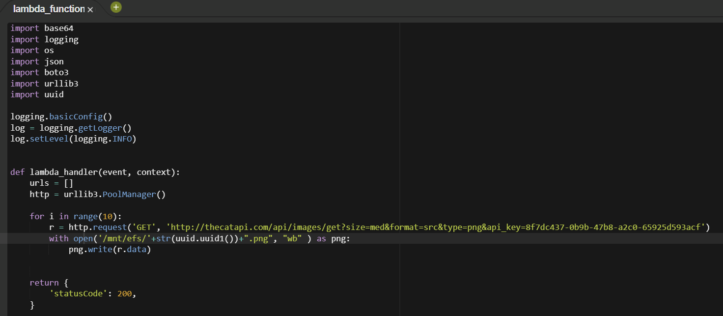

1. Configured VPC Network for Lambda function

* Added Lambda to VPC where rest of infrastructures are provisioned
* Added it into private subnet across AZ-A and AZ-B

Lambda execution role is created with managed policies

**AWSLambdaVPCAccessExecutionRole and AmazonElasticFileSystemClientFullAccess**

It will inject ENI into those private subnets which is configured to accept traffic at tcp/80

Port.

* 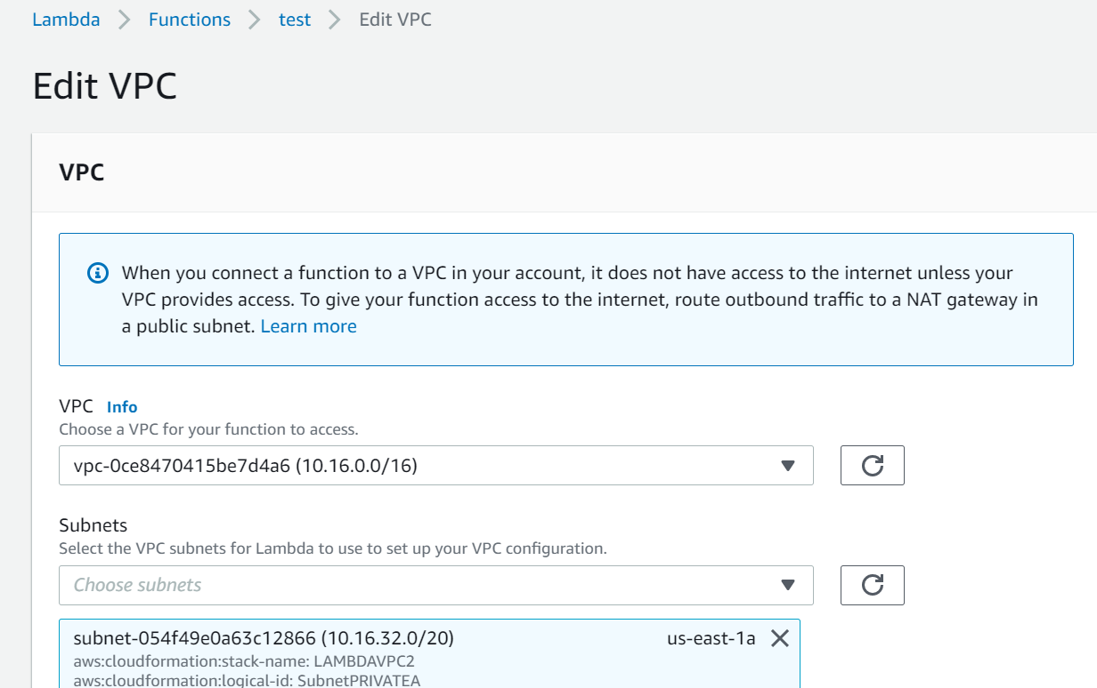

1. Add File System section , select **EFS access point** that was created in step 5 and point mount path which will be mentioned in Lambda function

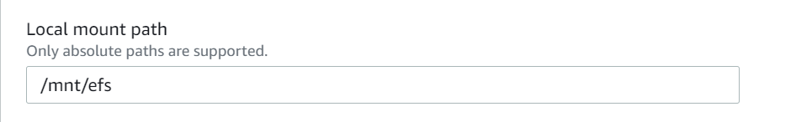

1. Add **event bridge schedule** with target as Lambda function which is to be invoked in every 5 mins . Once invoked, it will download cat images into EFS file share . Web applications can display those images.