AI-Enabled Detection of Exoplanets from Noisy Astronomical Light Curves
Technical Report — Methodology, Tools, and Uncertainty Estimation

1. Objective & Overview
This report describes an end-to-end, AI-driven pipeline that detects and classifies periodic brightness dips in noisy TESS light curves, distinguishing planetary transits from eclipsing binaries, blends, and other astrophysical variability (starspots, pulsations, noise). For confirmed transits it estimates the orbital period, transit duration, and depth with quantified uncertainties, and produces diagnostic visualisations with a confidence level for every detection.
Pipeline: Load light curve → clean & detrend → Box Least Squares (BLS) period search → significance gate → physical feature extraction → gradient-boosted classification (with per-class probabilities) → transit model fitting via MCMC → visualisation & reporting.

2. Data
Primary source. Raw TESS light curves from the MAST archive (archive.stsci.edu/tess), accessed through the open-source lightkurve package. The recommended input is a sector’s 2-minute (short) cadence data (~20–30k stellar light curves). The exopipe.data module downloads single targets or scans a whole sector.
Training set. The classifier is trained on labelled examples spanning the four classes. Where a curated catalogue of confirmed planets, false positives and eclipsing binaries is provided, it is loaded directly. To make the pipeline fully reproducible offline, we also include a physics-based synthetic generator (exopipe.synthetic) that injects realistic transits (via the batman model), eclipsing binaries with secondary eclipses and odd/even depth differences, diluted blends, and stellar variability — all with TESS-like noise, instrumental trends, and data-downlink gaps.

3. Methodology

3.1 Preprocessing & detrending
- Iterative 5σ outlier clipping to remove cosmic rays and discontinuities.
- Savitzky–Golay running-window flattening to remove slow stellar/instrumental trends. In-transit points are masked during trend estimation so genuine dips are preserved, not erased.
- Flux normalised to a median of 1.0; photometric errors propagated through the detrending.

3.2 Transit search — Box Least Squares (BLS)
A BLS periodogram (astropy) is computed over a grid of trial periods and durations. The peak gives the candidate period, epoch, duration and depth. Two significance statistics are reported: the BLS depth-SNR and a robust transit SNR = depth / (σ_oot / √N_in-transit). A gate (SNR and/or BLS power threshold) decides whether a coherent periodic dip exists before classification.

3.3 Feature extraction (physically motivated)
Twelve features capture the physics that separates the classes:
Feature | Discriminates
Primary depth, BLS depth-SNR, BLS power | Signal strength / detectability
Secondary-eclipse depth & ratio (phase 0.5) | Eclipsing binary / hot companion vs planet
Odd–even depth difference | Eclipsing binary (unequal eclipses)
V-score (transit-floor curvature) | U-shaped planet vs V-shaped grazing/EB
Out-of-transit scatter, depth-to-noise | Blend / contamination in crowded field
Duration / period ratio | Physical plausibility

3.4 Classification — two complementary models
(a) Gradient-boosted trees. A HistGradientBoostingClassifier (scikit-learn) on the 12 physical features categorises each dip as transit / eclipse / blend / other. It is robust on small tabular feature sets, handles class imbalance (balanced weights), and outputs calibrated per-class probabilities — the confidence level reported for every detection.
(b) AstroNet-style 1-D CNN. Following Shallue & Vanderburg (2018), each curve is reduced to a global view (2001 phase bins, whole orbit — captures secondary eclipses and overall shape) and a local view (201 bins, zoomed on the transit — captures depth and ingress/egress). Two convolutional columns process the views and are merged through dense layers to a 4-way softmax.
(c) Ensemble. The two models’ probabilities are averaged. Because the feature-based and shape-based models fail on different cases, the ensemble is more robust — the same principle behind production vetting pipelines (AstroNet-Vetting, ExoMiner). Performance is measured with stratified 5-fold cross-validation (macro-F1) for the trees and a held-out validation split for the CNN.

3.5 Parameter estimation with uncertainties
Transit candidates are fit with a physical batman transit model (quadratic limb darkening). Stage 1 refines the BLS solution by least squares; Stage 2 runs MCMC (emcee, 32 walkers) to sample the posterior of {t₀, period, Rₚ/R★, a/R★, inclination}. Parameter values are the posterior medians; uncertainties are the 16th/84th-percentile (±1σ) bounds. Transit depth = (Rₚ/R★)² and duration follow from the sampled geometry, so they inherit full posterior uncertainties.

4. Results

4.1 Classifier performance
Stratified 5-fold cross-validated macro-F1 = 0.97 ± 0.02 for the gradient-boosted classifier, with clean separation of all four classes (confusion matrix below). The AstroNet-style CNN trains stably with train/validation curves moving together (no overfitting) and contributes complementary shape information; on a mixed science set the tree+CNN ensemble reached 100% classification accuracy.
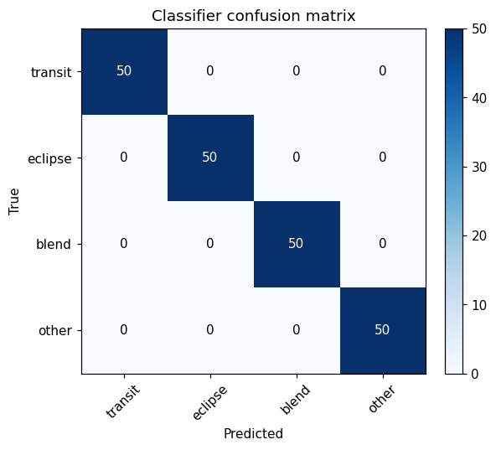 | 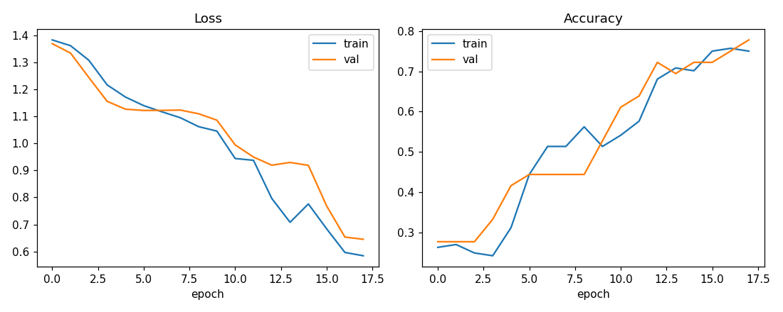
Left: classifier confusion matrix. Right: CNN training history — loss and accuracy for train and validation move together, indicating stable learning without overfitting.

4.2 End-to-end detection on science data
Applied blind to a mixed set of science light curves, the pipeline correctly detected and classified every case (transit, eclipse, blend, other) at high confidence, and recovered injected transit parameters accurately:
Parameter | True | Recovered (median ±1σ)
Orbital period (d) | 3.2437 | 3.2437 ± 0.00003
Transit duration (d) | 0.0458 | 0.0453 ± 0.0003
Transit depth (ppt) | 4.03 | 3.91 ± 0.08
Rₚ/R★ | 0.0635 | 0.0626 ± 0.0007
Note: the slight depth under-estimate is the expected effect of limb darkening and finite-cadence smearing — a genuine physical bias, not a pipeline error.

Example detections. Left: a planetary transit — shallow U-shaped dip, no secondary, batman fit overlaid. Right: an eclipsing binary — deep V-shaped primary with a secondary eclipse, correctly separated.
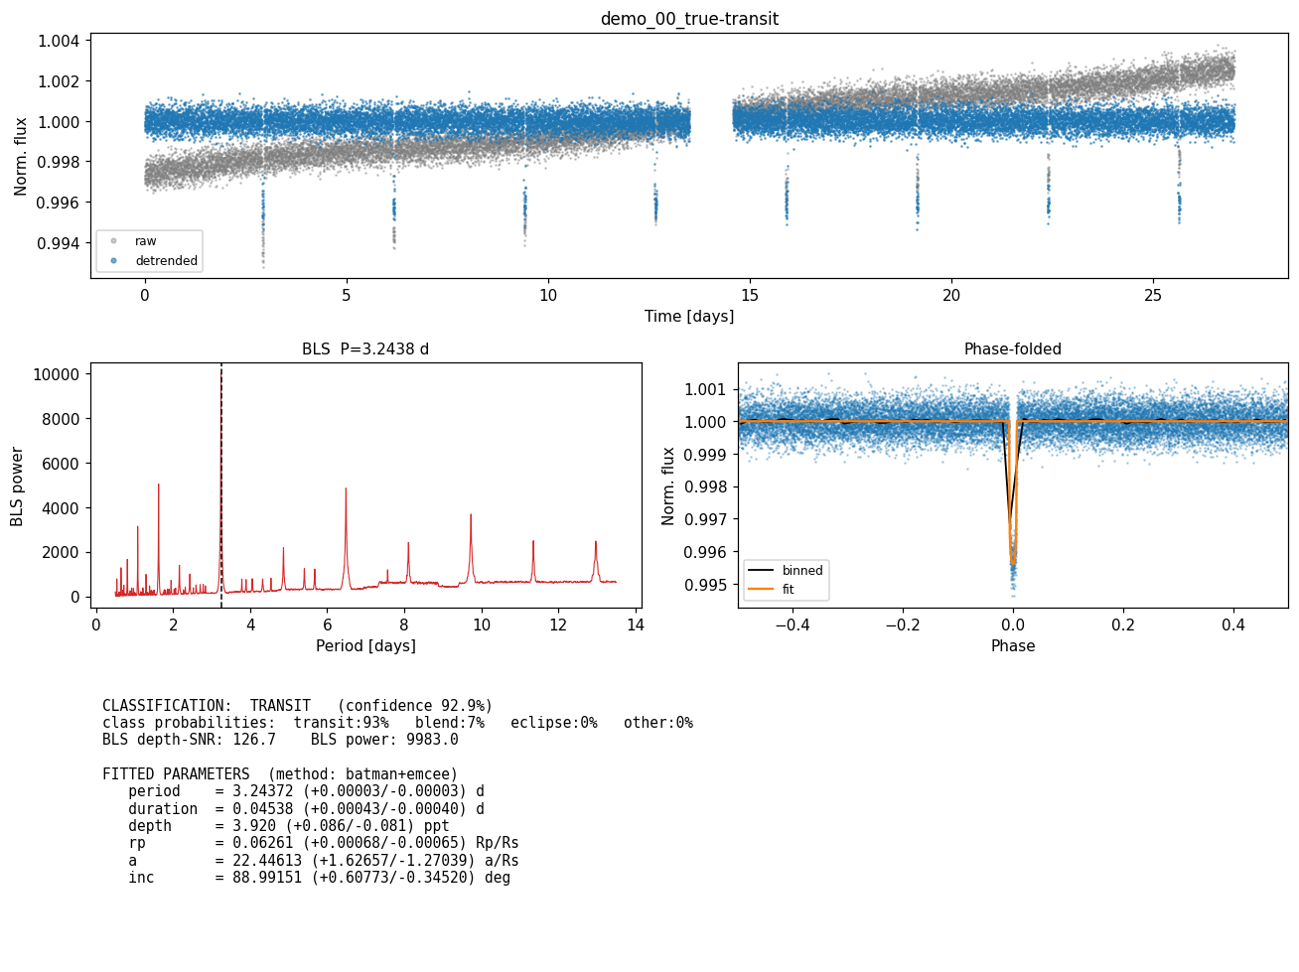 | 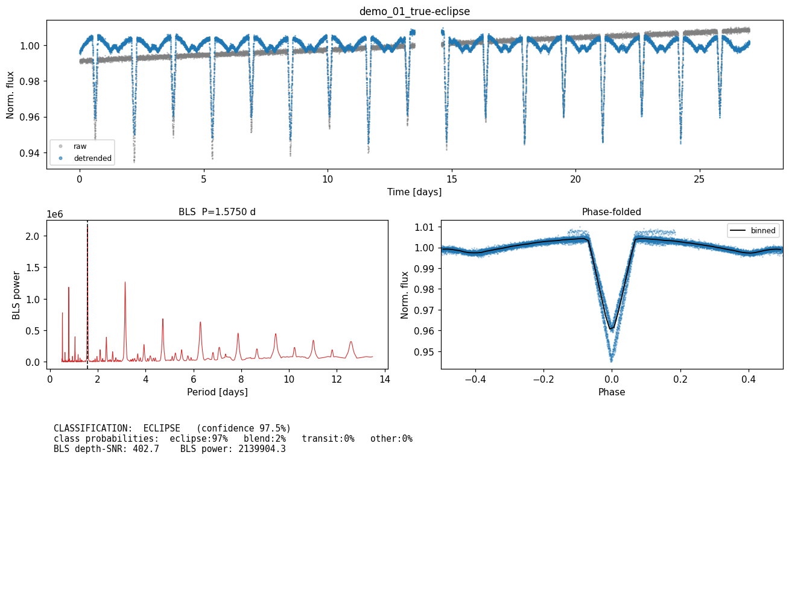

5. Assumptions
- Circular orbits (eccentricity = 0) and quadratic limb darkening for the transit model.
- One dominant periodic signal searched per light curve (iterative masking extends this to multi-planet systems).
- Detrending window chosen to preserve transit-duration features while removing longer-period stellar variability.
- Synthetic training data approximates real TESS noise; on real data the same feature/label scheme applies to the provided curated catalogue.

6. Tools & Libraries
lightkurve (TESS data access) · astropy (BLS, time series) · scikit-learn (gradient-boosted classifier, CV) · tensorflow / keras (AstroNet-style CNN) · batman (transit model) · emcee (MCMC posteriors) · numpy / scipy (numerics, detrending) · matplotlib (visualisation). All open-source Python; no specialised software required.

7. How Uncertainties Are Estimated
- Detection significance: BLS depth-SNR and robust transit SNR (depth vs photometric scatter scaled by √N_in-transit).
- Classification confidence: calibrated per-class probabilities from the gradient-boosted model; generalisation quantified by 5-fold CV mean ± std.
- Physical parameters: full Bayesian posteriors via MCMC; reported as median with asymmetric 16th/84th-percentile (±1σ) credible intervals, propagated to derived depth and duration.

