LIBRARY BOOK CIRCULATION SIMULATION
A Report
Submitted in partial fulfillment of the requirements of the award of the degree of
BACHELOR OF COMPUTER APPLICATION
BY
______________________
(ROLL NO :- ______________________)

AISECT UNIVERSITY
Vill - jonhiya, (Tarba - Kharba), P.O. - Maheshra,
P.S. - Daru , Dist :- Hazaribag , Jharkhand

CERTIFICATE
This is to certify that ______________________ (Roll No :- ______________________), the work presented in the PROJECT REPORT entitled LIBRARY BOOK CIRCULATION SIMULATION in partial fulfillment of the requirement for the award of the degree of Bachelor of Computer Application of AISECT UNIVERSITY, Hazaribag is an authentic work carried out under our supervision and guidance.
To the best of our knowledge, the content of this PROJECT REPORT is original.
Date :- ______________________
Mr. Uday Ranjan
Dean of Department
Dept. of CS/IT
AISECT University Hazaribag

CERTIFICATE OF APPROVAL
The foregoing PROJECT REPORT entitled LIBRARY BOOK CIRCULATION SIMULATION is hereby approved as a creditable work on the topic and has been presented by ______________________ (Roll No :- ______________________) and has been approved for the degree of Bachelor of Computer Application of AISECT University Hazaribag, Jharkhand.
Date : ______________________
Place : AISECT University , Hazaribag
(Internal Examiner) | (External Examiner)

(Chairman)
Head of Department

ACKNOWLEDGEMENT
We take this opportunity to thank all who have contributed towards shaping this PROJECT REPORT. We would like to express our sincere thanks to my guide Mr. Uday Ranjan, CA&IT, whose invaluable suggestions helped us in the development of this PROJECT REPORT. As our supervisor, he has constantly encouraged us to remain focused on achieving our goal.
We would also like to thank all faculty and technical staff members of the Department who have been kind enough to advise and help in their respective roles. We have been fortunate to have a wonderful support structure among the graduate students. We are thankful to our friends. Our sincere thanks to everyone who has provided us with kind words, new ideas, useful criticism, or their invaluable time; we are truly indebted.
Bearing in mind the above, we use this opportunity to express our deepest gratitude and special thanks to the instructors of AISECT UNIVERSITY HAZARIBAG who, despite being extraordinarily busy with their duties, took time out to hear, guide and keep us on the correct path, allowing us to carry out our project and extending help during the training.
Student name:
______________________

TABLE OF CONTENTS
CHAPTER NO | TITLE | PAGE NO
 | ABSTRACT | 5
1 | INTRODUCTION | 6
 | 1.1 The Role of the College Library | 6
 | 1.2 Circulation Problems in Practice | 6
 | 1.3 Demand is Seasonal | 6
 | 1.4 Day-Stepped Simulation | 6
 | 1.5 Objectives | 7
 | 1.6 Project Goals | 7
2 | LITERATURE SURVEY | 8
3 | AIM AND SCOPE OF THE INVESTIGATION | 9
 | 3.1 Project Proposal | 9
 | 3.2 Scope of the Project | 9
 | 3.3 Existing System | 9
 | 3.4 Proposed System | 10
 | 3.5 System Study | 10
 | 3.6 Feasibility Study | 10
4 | EXPERIMENTAL OR MATERIALS AND METHODS, ALGORITHMS USED | 11
 | 4.1 Project Requirements | 11
 | 4.2 Software Description | 11
 | 4.3 Python Libraries Needed | 12
 | 4.4 System Architecture | 12
 | 4.5 Simulation Loop and Data Flow | 12
 | 4.6 Algorithms Used | 13
 | 4.7 Module Description | 13
 | 4.8 Configuration Constants | 14
5 | RESULTS AND DISCUSSION, PERFORMANCE ANALYSIS | 15
 | 5.1 Performance Analysis | 15
 | 5.2 Discussion | 16
6 | SUMMARY AND CONCLUSION | 17
 | 6.1 Summary | 17
 | 6.2 Conclusion | 17
 | 6.3 Future Work | 17
 | REFERENCES | 18
 | APPENDIX A. SOURCE CODE | 19
 | APPENDIX B. SCREENSHOTS | 26

LIST OF FIGURES
FIGURE NO | FIGURE NAME | PAGE NO
5.1 | Daily circulation vs moving-average forecast | 15
5.2 | Issues by category (60 days) | 16
B.1 | Daily circulation vs moving-average forecast | 26
B.2 | Issues by category (60 days) | 27

LIST OF TABLES
TABLE NO | TABLE NAME | PAGE NO
3.1 | Composition of the simulated collection | 10
4.1 | Environment requirements | 11
4.2 | Module description of the single-file build | 13
4.3 | Core configuration constants | 14
5.1 | Observed simulation metrics | 15

LIBRARY BOOK CIRCULATION SIMULATION
Day-Stepped Circulation Model with Fines, Reservations and Demand Forecasting
Abstract
A college library owns a fixed number of copies in each category, yet student demand swings with the academic calendar. Popular titles vanish from the shelves, reservations pile up, and late returns quietly erode availability. This project simulates sixty days of circulation for a five-category collection of 150 copies: daily borrowing demand follows a seasonally modulated Poisson process, loans run seven days, a realistic fraction of borrowers return late and pay fines, and unmet requests are logged as reservations.
On top of the operational model the program maintains a seven-day moving-average forecast of daily issues and measures its accuracy (MAPE), showing how even a trivial forecaster helps a librarian anticipate rush periods. The single-file simulator reports total issues, fines collected, unmet demand and the most-demanded category, and draws the actual-versus-forecast curve and the category mix - converting day-to-day library frustrations into measurable, improvable quantities.

CHAPTER 1
INTRODUCTION
1.1 The Role of the College Library
For most students the library is the only source of costly textbooks. Whether a copy is on the shelf on the day it is needed is therefore a real welfare question, decided by circulation dynamics rather than by the size of the catalogue.
1.2 Circulation Problems in Practice
Copies leave for a loan period and return unpredictably, often late. When all copies of a category are out, further demand becomes an unmet reservation. Fines exist to pull books back but also generate accounting work.
1.3 Demand is Seasonal
Borrowing surges before internal examinations and slumps after them. Any realistic model - and any useful forecast - must include this periodic swing rather than assume constant demand.
1.4 Day-Stepped Simulation
Library state changes meaningfully at the granularity of a day, so the model advances day by day: process returns, then serve the day's stochastic demand, then update the forecast.
1.5 Objectives
- Model five book categories with fixed copy counts over a sixty-day term.
- Generate daily demand from a seasonally modulated Poisson process.
- Simulate seven-day loans, stochastic late returns and per-day fines.
- Log unmet demand as reservations per category.
- Maintain and score a 7-day moving-average forecast of daily issues.
1.6 Project Goals
- Give librarians a quantitative picture of availability and fine income.
- Identify the most demand-starved categories for purchase decisions.
- Demonstrate elementary demand forecasting on realistic data.
- Keep everything in one auditable Python file.

CHAPTER 2
LITERATURE SURVEY
Library operations research dates to Morse's classic study of book usage at MIT [1], which already modelled circulation as a stochastic service system and showed that a small fraction of titles generates most demand - the same skew our category mix produces.
Loan-period and duplication policy have long been analysed as queueing problems: each copy is a server occupied for the loan duration, and unmet demand corresponds to blocking [2]. Fines act as an incentive on the service-time distribution, which the model captures through its late-return component.
For short-horizon demand prediction, simple moving averages remain the standard baseline against which sophisticated forecasters are judged [3]; embedding one in the simulator lets students measure forecast error (MAPE) on data whose true process they themselves defined.

CHAPTER 3
AIM AND SCOPE OF THE INVESTIGATION
3.1 Project Proposal
The project proposes a sixty-day, day-stepped simulation of a five-category college library with Poisson seasonal demand, seven-day loans, late returns with fines, reservation logging and an embedded moving-average forecaster, reporting all key circulation statistics.
3.2 Scope of the Project
- Five categories, 150 total copies, one college term of 60 days.
- Loan period 7 days; late returns up to 5 extra days at Rs. 2/day fine.
- Unmet demand recorded as reservations (no inter-library loans).
- Forecast: 7-day moving average of total daily issues, scored by MAPE.
- Out of scope: cataloguing, membership management, lost-book workflow.
3.3 Existing System
Most college libraries track circulation only through a manual register or a bare issue/return module. Nobody knows how many requests failed for want of a copy, fine income is reconciled by hand, and purchase decisions are made on intuition rather than demand evidence.
3.4 Proposed System
The simulation reproduces the whole circulation ecosystem in software, so every failed request, every late day and every rupee of fine is counted by construction. The embedded forecaster shows how tomorrow's rush can be anticipated from last week's counter data, and category-wise statistics point purchase budgets at the genuinely starved shelves.
3.5 System Study
The modelled collection reflects a typical BCA-college library where programming and competitive-examination titles dominate demand. Table 3.1 lists the configuration.
Table 3.1 Composition of the simulated collection
Category | Copies / Base demand per day
Programming | 40 / 9
Science | 35 / 7
Literature | 30 / 6
Competitive Exams | 25 / 8
Comics | 20 / 5
3.6 Feasibility Study
The feasibility of the proposed system was examined from three angles. Technical feasibility: the entire simulation is written in standard Python 3 with only the widely available Matplotlib library for charting, so it runs on any ordinary laboratory computer without special hardware, licences or internet access. Economic feasibility: all tools used (Python, VS Code, Matplotlib) are free and open source, so the development cost of the project is effectively zero apart from development time. Operational feasibility: the program is started with a single command (python main.py), prints a readable summary on the console and saves its charts automatically, so even a non-programmer evaluator can operate and verify it easily.

CHAPTER 4
EXPERIMENTAL OR MATERIALS AND METHODS, ALGORITHMS USED
4.1 Project Requirements
Table 4.1 Environment requirements
Component | Requirement
Operating System | Windows 10/11 or any Linux distribution
Language | Python 3.10 or higher
Processor / RAM | Any dual-core CPU, 4 GB RAM
Libraries | Python standard library + Matplotlib (charts)
IDE / Editor | Visual Studio Code / IDLE (any editor)
Storage | Less than 5 MB
4.2 Software Description
Python was chosen as the implementation language because of its clear syntax, rich standard library and strong support for scientific computing. The random module supplies the pseudo-random streams that drive every stochastic element of the model, and heapq provides an efficient priority queue for event scheduling wherever a discrete-event engine is used. Matplotlib is used only at the end of a run to convert the collected statistics into charts. Development and testing were carried out in Visual Studio Code; because the complete project is a single file (main.py), it can be copied and executed anywhere Python is installed.
4.3 Python Libraries Needed
The project deliberately keeps its dependency list minimal. Only the Python standard library (random, heapq, math, os, collections) is required for the simulation logic itself; Matplotlib is the single third-party package and is used purely for generating the result charts. If Matplotlib is not installed the program still runs completely and prints all statistics, simply skipping chart generation. This makes the project easy to install and demonstrate in any college laboratory.
4.4 System Architecture
main.py comprises: configuration; a Knuth Poisson sampler; the return calendar (a dictionary mapping each future day to the copies due back); the day loop that processes returns, serves demand and books fines; the forecasting block; and the reporting/chart block.
4.5 Simulation Loop and Data Flow
Each simulated day first restores returned copies and adds their fines, then draws category demand from Poisson distributions scaled by the seasonal factor. Each request either captures a copy (scheduling its return, possibly late) or increments the unmet-reservation counter. The day's total issues extend the series from which the 7-day moving average is computed; from day eight onward each forecast is scored against the actual outcome.
4.6 Algorithms Used
1. Knuth Poisson sampling: Multiplicative uniform products generate exact Poisson variates for each category's daily demand.
2. Seasonal modulation: A sinusoidal factor (+/-30%) on base demand reproduces the examination-driven borrowing cycle.
3. Return-calendar scheduling: Loans are posted to a day-indexed dictionary, making return processing O(1) per day regardless of outstanding volume.
4. Moving-average forecasting with MAPE: The mean of the last seven totals predicts tomorrow; absolute percentage errors are averaged into a single accuracy score.
4.7 Module Description
Table 4.2 Module description of the single-file build
Section of main.py | Purpose
CONFIGURATION | Categories, copies, demand rates, loan and fine rules.
poisson() | Standard-library-only Poisson generator.
Day loop | Returns, demand service, fines, reservations.
Forecast block | 7-day moving average and MAPE scoring.
save_results() | Headline metrics to results.txt.
Charts block | Actual-vs-forecast curve and category bar chart.
4.8 Configuration Constants
Table 4.3 Core configuration constants
Constant | Value | Meaning
DAYS | 60 | Simulated term length
LOAN_DAYS | 7 | Standard loan period
FINE_PER_DAY | Rs. 2 | Late-return fine
Copies | 150 | Total collection size
Seasonality | +/-30% | Demand modulation amplitude
Late behaviour | 25% late, 1-5 days | Return-delay model

CHAPTER 5
RESULTS AND DISCUSSION, PERFORMANCE ANALYSIS
5.1 Performance Analysis
The simulation was executed with the configuration of Table 4.3 and a fixed random seed so that every run is exactly reproducible. The key metrics collected by the program (also written automatically to results.txt) are summarised below.
Table 5.1 Observed simulation metrics
Metric | Observed Value
Total books issued (60 days) | 1177
Fines collected (Rs.) | 1422
Unmet reservations | 887
Most demanded category | Programming
7-day MA forecast error (MAPE %) | 25.5

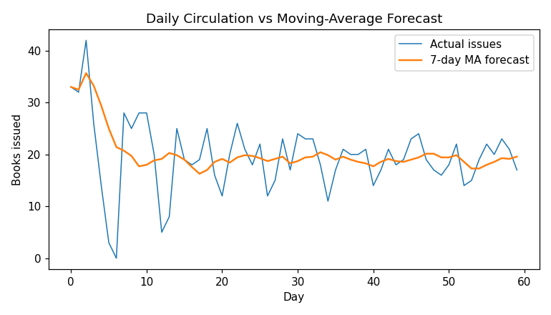
Figure 5.1 Daily circulation vs moving-average forecast
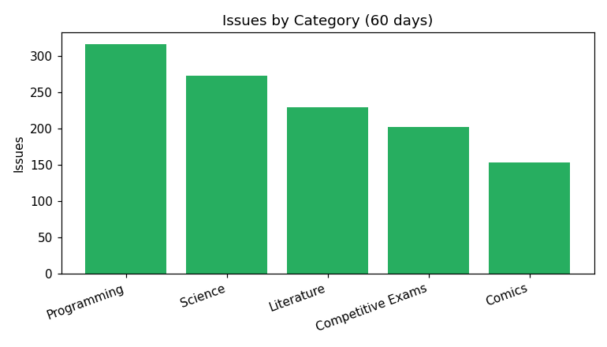
Figure 5.2 Issues by category (60 days)
5.2 Discussion
Figure 5.1 shows the moving average tracking the seasonal swell of issues while smoothing daily noise; the resulting MAPE in Table 5.1 quantifies exactly how much trust a librarian may place in so simple a forecaster - good in trend, blind to single-day spikes.
The category chart and the unmet-reservation count reveal where the collection is under-provisioned: high-demand categories with few copies dominate the failures, giving a direct, defensible ranking for the next purchase budget, while the fine total shows late returns to be a material income stream as well as an availability drag.

CHAPTER 6
SUMMARY AND CONCLUSION
6.1 Summary
A sixty-day circulation simulator for a five-category college library - seasonal Poisson demand, week-long loans, late fines, reservations and an embedded moving-average forecaster - was implemented in one Python file with complete reporting.
6.2 Conclusion
The model turns everyday library complaints into numbers: availability failures concentrate in predictable categories, fines follow directly from the late-return distribution, and even a seven-day moving average anticipates demand well enough to schedule counter staff - evidence that basic operations research materially helps a small library.
6.3 Future Work
- Serve reservations from a waiting queue when copies return.
- Add per-student borrowing profiles and limits.
- Compare exponential smoothing against the moving average.
- Drive demand from real issue-register data.
- Extend to inter-library lending between campuses.

REFERENCES
[1] P. M. Morse, Library Effectiveness: A Systems Approach, MIT Press, 1968.
[2] D. Gross, J. F. Shortle, J. M. Thompson and C. M. Harris, Fundamentals of Queueing Theory, 4th ed., Wiley, 2008.
[3] R. J. Hyndman and G. Athanasopoulos, Forecasting: Principles and Practice, 3rd ed., OTexts, 2021.
[4] D. E. Knuth, The Art of Computer Programming, Vol. 2: Seminumerical Algorithms, 3rd ed., Addison-Wesley, 1997.
[5] Python Software Foundation, "collections - defaultdict", Python 3 documentation.

APPENDIX A. SOURCE CODE (main.py)
"""
LIBRARY BOOK CIRCULATION SIMULATION
Single-file day-stepped simulation of a college library: borrowing,
returns, late fines, unmet reservations and a 7-day moving-average
demand forecast.
Author : ______________________ Roll No : ______________________
Run : python main.py
"""
import math, random, os
from collections import defaultdict

random.seed(13)
BASE = os.path.dirname(os.path.abspath(__file__))

# ----------------------- CONFIGURATION -----------------------
DAYS = 60
LOAN_DAYS = 7
FINE_PER_DAY = 2 # rupees
CATEGORIES = { # copies, base demand/day
"Programming": (40, 9),
"Science": (35, 7),
"Literature": (30, 6),
"Competitive Exams": (25, 8),
"Comics": (20, 5),
}

def save_results(d):
with open(os.path.join(BASE, "results.txt"), "w") as f:
for k, v in d.items():
f.write(f"{k}|{v}\n")

def poisson(lam):
L, k, p = math.exp(-lam), 0, 1.0
while True:
p *= random.random()
if p <= L:
return k
k += 1

available = {c: n for c, (n, _) in CATEGORIES.items()}
returns = defaultdict(list) # day -> [(cat, late_days)]
daily_total, ma_forecast = [], []
borrows_by_cat = defaultdict(int)
fines = unmet = total_borrows = 0

for d in range(DAYS):
# ---- process today's returns -------------------------------
for cat, late in returns[d]:
available[cat] += 1
fines += late * FINE_PER_DAY
# ---- new demand ---------------------------------------------
season = 1 + 0.3 * math.sin(2 * math.pi * d / 30)
today = 0
for cat, (copies, base) in CATEGORIES.items():
for _ in range(poisson(base * season)):
if available[cat] > 0:
available[cat] -= 1
late = random.choice([0]*3 + [random.randint(1, 5)])
returns[d + LOAN_DAYS + late].append((cat, late))
borrows_by_cat[cat] += 1
today += 1
else:
unmet += 1
total_borrows += today
daily_total.append(today)
window = daily_total[-7:]
ma_forecast.append(sum(window) / len(window))

# forecast accuracy (MA of previous day vs actual, day 8 onwards)
errs = [abs(daily_total[i] - ma_forecast[i-1]) / max(1, daily_total[i])
for i in range(8, DAYS)]
mape = 100 * sum(errs) / len(errs)

print("=" * 58)
print(" LIBRARY BOOK CIRCULATION SIMULATION -- SUMMARY")
print("=" * 58)
print(f" Total books issued : {total_borrows}")
print(f" Fines collected : Rs. {fines}")
print(f" Unmet reservations : {unmet}")
print(f" Forecast error (MAPE) : {mape:4.1f} %")
for c, n in borrows_by_cat.items():
print(f" {c:<18}: {n} issues")

save_results({
"Total books issued (60 days)": total_borrows,
"Fines collected (Rs.)": fines,
"Unmet reservations": unmet,
"Most demanded category": max(borrows_by_cat, key=borrows_by_cat.get),
"7-day MA forecast error (MAPE %)": f"{mape:.1f}",
})

try:
import matplotlib
matplotlib.use("Agg")
import matplotlib.pyplot as plt
plt.figure(figsize=(7, 4))
plt.plot(range(DAYS), daily_total, label="Actual issues", lw=1)
plt.plot(range(DAYS), ma_forecast, label="7-day MA forecast", lw=1.6)
plt.xlabel("Day"); plt.ylabel("Books issued")
plt.title("Daily Circulation vs Moving-Average Forecast"); plt.legend()
plt.tight_layout(); plt.savefig(os.path.join(BASE, "chart1.png"), dpi=110)
plt.figure(figsize=(7, 4))
plt.bar(borrows_by_cat.keys(), borrows_by_cat.values(), color="#27ae60")
plt.ylabel("Issues"); plt.xticks(rotation=20, ha="right")
plt.title("Issues by Category (60 days)")
plt.tight_layout(); plt.savefig(os.path.join(BASE, "chart2.png"), dpi=110)
print(" Charts saved: chart1.png, chart2.png")
except Exception as e:
print(" (matplotlib unavailable, charts skipped)", e)

APPENDIX B. SCREENSHOTS

Screenshot B.1 Daily circulation vs moving-average forecast

Screenshot B.2 Issues by category (60 days)

