UNIVERSITY INSTITUTE OF COMPUTING

PROJECT REPORT
ON
Online Book Store Layout

Program Name: BCA
Subject Name/Code: web designing(25CAH-153)

Submitted by: Submitted to:
Name: Ahshan Name: Ms. Preeti
UID: 25BCD10094 Designation:Professor
Section: 25BCD2(B)

Project Report: Online book store
- Title
Technical Bookcover - Online Book Store

- Aim of the Project
The primary aim of this project is to design and develop a highly responsive, interactive front-end layout for an online technical bookstore. This involves simulating a real-world e-commerce environment where users can browse an inventory of educational books, view pricing, and interact with a shopping cart interface. Furthermore, the project aims to bridge theoretical web design concepts with practical implementation, serving as a comprehensive milestone in understanding core client-side web technologies.
3. Objective
- To construct a well-organized, semantic web page structure using modern HTML5 elements (such as <header>, <nav>, <section>, and <footer>).
- To implement advanced layout techniques, specifically CSS Flexbox and CSS Grid, ensuring the application is fully responsive and visually consistent across mobile, tablet, and desktop viewports.
- To integrate JavaScript for dynamic, client-side interactions, enabling a functional shopping cart array, interactive modal pop-ups, and real-time interface updates without requiring page reloads.
- To apply fundamental principles of User Interface (UI) and User Experience (UX) design by creating intuitive navigation and clear, accessible call-to-action buttons.
4. Tools and Technologies Used
- Frontend Markup: HTML5 (HyperText Markup Language) for structuring the document logically.
- Styling and Layout: CSS3 (Cascading Style Sheets) for visual aesthetics, color grading, and responsive grid structures.
- Client-Side Scripting: Vanilla JavaScript (ES6) for handling DOM (Document Object Model) manipulation and user events.
- Integrated Development Environment (IDE): Visual Studio Code (or standard text editors like Notepad++ or Sublime Text) for code authorship and formatting.
- Testing & Debugging: Google Chrome Developer Tools for inspecting elements and debugging scripts.
5. System Requirements
- Hardware Requirements: * Processor: Intel Core i3 / AMD Ryzen 3 or higher.
  - Memory (RAM): Minimum 4 GB.
  - Storage: Minimum 50 MB of free hard disk space for project files.
- Software Requirements:
  - Operating System: Windows 10/11, macOS, or Linux.
  - Web Browser: Any modern web browser supporting HTML5 and ES6 JavaScript (e.g., Google Chrome v90+, Mozilla Firefox, Microsoft Edge).
  - Note: No specialized local server (like XAMPP or Node.js) or backend database is required as this is strictly a front-end layout project.
6. Algorithm / Logic
The interactive elements of the project rely on the following logical flows:
- Modal Triggering Logic:
  - User clicks the "Contact Us" or "Cart" button.
  - An event listener intercepts the click and prevents the default link behavior.
  - The JavaScript function (toggleContact() or toggleCart()) identifies the corresponding modal <div> by its ID.
  - The function toggles a specific CSS class (show-modal) that changes the display property of the modal from none to flex, making it visible as an overlay.
- Shopping Cart Logic:
  - Initialize an empty JavaScript array (cartItems) and a numeric variable (totalAmount = 0).
  - When a user clicks "Add to Cart" on a specific book, the addToCart(bookName, price) function is called, passing the respective parameters.
  - The item object is pushed into the cartItems array, and the price is added to totalAmount.
  - The updateCartUI() function is triggered, which clears the current HTML inside the cart list, loops through the cartItems array using .forEach(), and dynamically injects new <li> elements containing the updated items and the new total price into the DOM.
7. Code Overview
HTML
<!DOCTYPE html>
<html lang="en">
<head>
<meta charset="UTF-8">
<meta name="viewport" content="width=device-width, initial-scale=1.0">
<title>Technical Bookcover</title>
<link rel="stylesheet" href="style.css">
</head>
<body>

<header class="header">
<div class="logo">
<h1>📚 Technical Bookcover</h1>
</div>
<nav class="navbar">
<

<div class="book-card">
<div class="book-cover mock-cover-4">Comm</div>
<div class="book-info">
<h3>Barriers of Communication</h3>
<p class="author">By Management Experts</p>
<p class="price">₹250.00</p>
<button class="add-to-cart" onclick="addToCart('Barriers of Communication', 250)">Add to Cart</button>
</div>
</div>

</div>
</section>

<footer class="footer">
<div class="footer-info">
<p><strong>Email:</strong> support@technicalbookcover.in | <strong>Address:</strong> Mohali, Punjab</p>
<p><strong>Working Hours:</strong> Mon-Sat, 9 AM - 6 PM</p>
</div>
<div class="footer-bottom">
<p>&copy; 2026 Technical Bookcover. All Rights Reserved.</p>
</div>
</footer>

<li class="empty-cart">Your cart is currently empty.</li>
</ul>
<div class="cart-summary">
<h3 id="cart-total">Total: ₹0.00</h3>
<button class="submit-btn checkout-btn" onclick="alert('Proceeding to Checkout!')">Checkout</button>
</div>
</div>
</div>

<script>
// Modal Logic
function toggleContact(e) {
if(e) e.preventDefault(); // Prevent page jump if clicked from nav
document.getElementById('contact-modal').classList.toggle('show-modal');
}

function toggleCart() {
document.getElementById('cart-modal').classList.toggle('show-modal');
}

// Cart Logic
let cartItems = [];
let totalAmount = 0;

function addToCart(bookName, price) {
cartItems.push({ name: bookName, price: price });
totalAmount += price;
updateCartUI();

// Update Total
document.getElementById('cart-total').innerText = `Total: ₹${totalAmount}.00`;
}
</script>
</body>
</html>

CSS
/* Universal Reset & Base Styling */
* {
margin: 0;
padding: 0;
box-sizing: border-box;
font-family: 'Segoe UI', Tahoma, Geneva, Verdana, sans-serif;
scroll-behavior: smooth;
}

body {
background-color: #f8f9fa;
color: #333;
}

.cart-btn:hover {
background-color: #2ecc71;
}

/* Hero Banner */
.hero {
background: linear-gradient(rgba(44, 62, 80, 0.8), rgba(44, 62, 80, 0.8)), url('https://images.unsplash.com/photo-1507842217343-583bb7270b66?ixlib=rb-1.2.1&auto=format&fit=crop&w=1350&q=80') center/cover;
height: 50vh;
display: flex;
justify-content: center;
align-items: center;
text-align: center;
color: white;
padding: 0 20px;
}

.hero-content h2 {
font-size: 3rem;
margin-bottom: 15px;
}

.hero-content p {
font-size: 1.2rem;
margin-bottom: 25px;
max-width: 600px;
margin-left: auto;
margin-right: auto;
}

.shop-now-btn {
text-decoration: none;
background-color: #27ae60;
color: white;
padding: 12px 30px;
border-radius: 5px;
font-size: 1.1rem;
font-weight: bold;
transition: background 0.3s;
}

.modal-content {
background-color: #ffffff;
padding: 30px;
border-radius: 8px;
width: 90%;
max-width: 500px;
position: relative;
box-shadow: 0 10px 30px rgba(0,0,0,0.2);
}
.close-btn {
position: absolute;
top: 15px;
right: 20px;
font-size: 1.8rem;
cursor: pointer;
}

.close-btn:hover {
color: #e74c3c;
}
.
.cart-summary {
text-align: right;
border-top: 2px solid #2c3e50;
padding-top: 15px;
}
.checkout-btn:hover {
background-color: #2980b9;
}
Screenshots/ Output

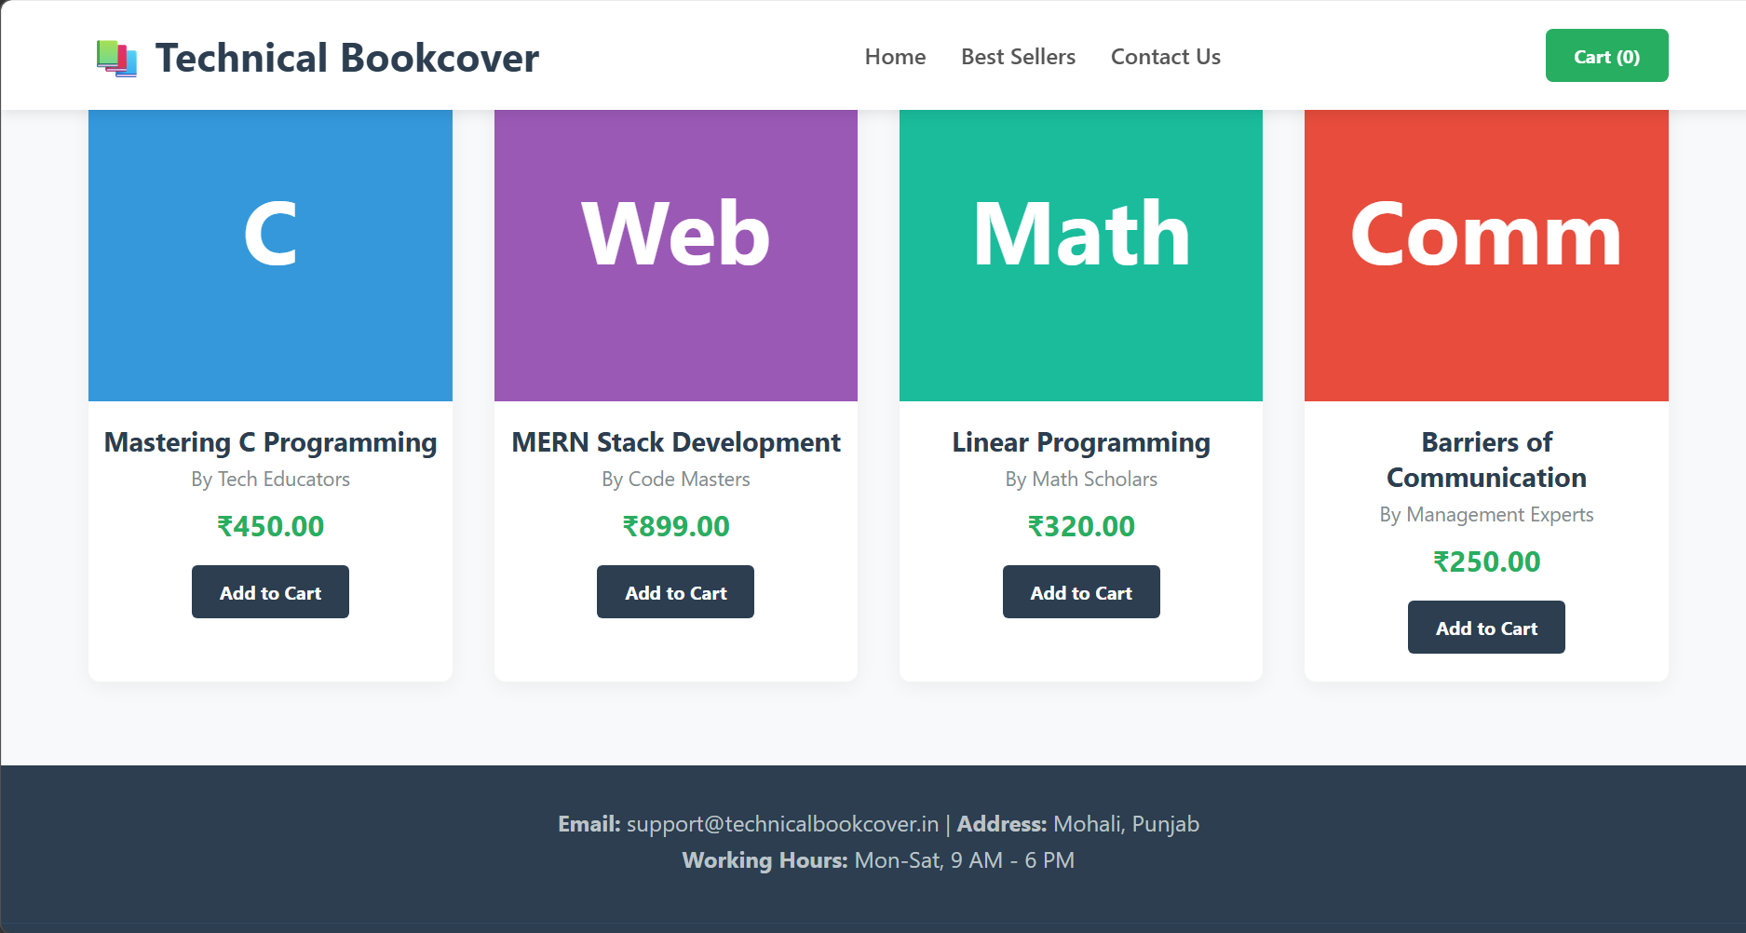
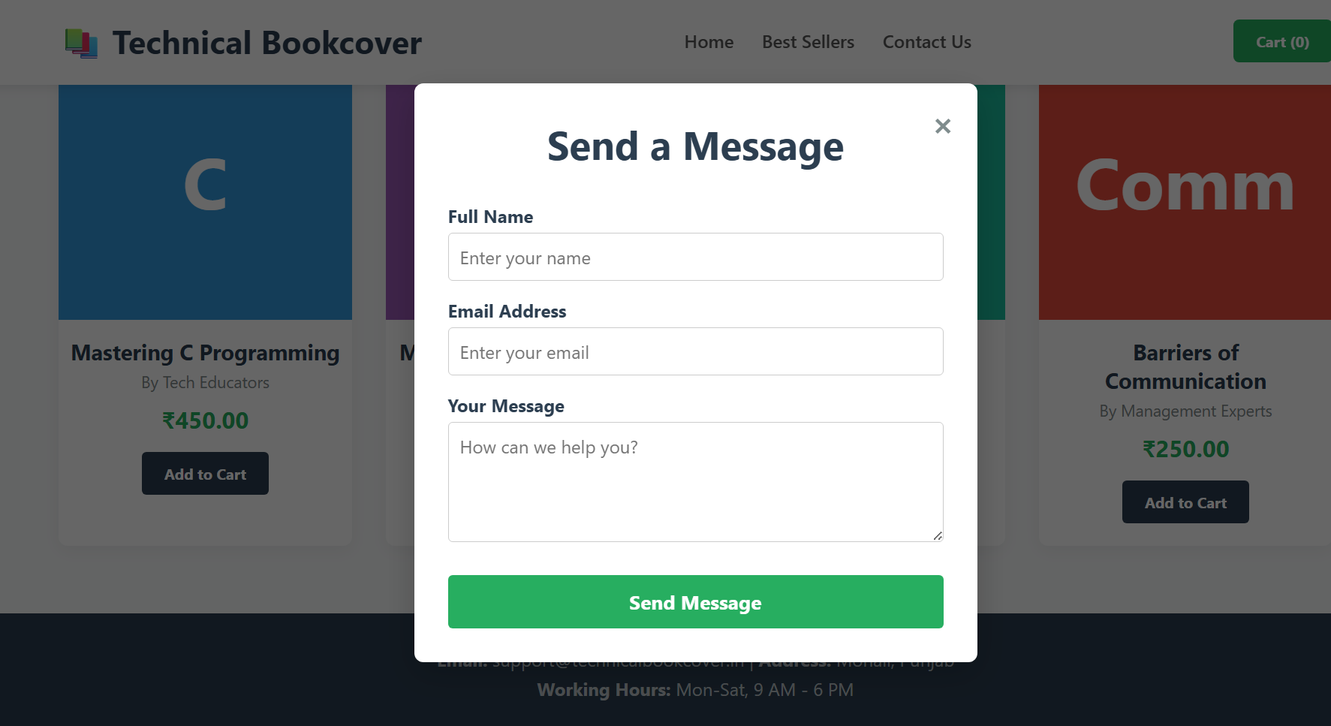

Conclusion
This project successfully demonstrates the creation of a functional, aesthetically pleasing, and highly interactive e-commerce layout. By strictly utilizing core web technologies, the project bridges the gap between a static design and an engaging user experience. It proves the capability of modern HTML, CSS, and lightweight JavaScript to build responsive interfaces that adapt smoothly to user inputs and screen dimensions.
10. Learning Outcomes
- Attained practical, hands-on experience in building modular and responsive layouts using modern CSS Grid and Flexbox architectures.
- Developed a strong understanding of Document Object Model (DOM) manipulation using JavaScript to dynamically update interface elements and text content based on user interactions.
- Learned the mechanics of event handling, specifically managing button clicks and form submissions while preventing default browser behaviors.
- Grasped the concept of state management on the client side using JavaScript arrays and variables to store shopping cart data temporarily.
11. References
- MDN Web Docs - Mozilla Developer Network (Comprehensive HTML, CSS, and JavaScript documentation).
- W3Schools Online Web Tutorials.
- CSS-Tricks (For advanced Flexbox and Grid layout techniques).
- "JavaScript HTML DOM" documentation for dynamic UI updates.

