PROJECT REPORT
on
NYC 311 SERVICE COMPLAINT PREDICTION
Predicting Daily City Service Complaints Using Poisson and Negative Binomial Regression
Submitted to Manipal University Jaipur
Towards the partial fulfilment for the Award of the Degree of
BACHELOR OF TECHNOLOGY
In Computer Science and Engineering
2026-2027
By
Kanakpreet Kaur 2427030168
Bhoomi Saraf 2427010306

Department of Computer Science and Engineering
School of Computer Science and Engineering
Manipal University Jaipur
Jaipur, Rajasthan

Abstract
City governments receive hundreds of non-emergency service requests every day through the NYC 311 system, covering noise, illegal parking, housing conditions, sanitation, damaged trees and more. Knowing in advance how many requests of each type will arrive on a given day helps departments plan crews, call-centre staff and budgets. This project builds a predictive model that estimates the number of 311 complaints per day for each of eight complaint categories in the borough of Staten Island, New York, using four years (2021–2024) of real data from the NYC Open Data portal.
Because the target is a count (a non-negative whole number), the project uses Generalized Linear Models for count data: Poisson regression and Negative Binomial regression. The methodology follows the steps of the course: exporting a manageable subset of a very large public dataset, auditing data types, duplicates and missing values, standardising inconsistent text categories, correcting logical errors such as requests closed before they were opened, imputing missing ZIP codes from coordinates, detecting outliers with the IQR method, exploratory visual analysis, feature engineering and likelihood-ratio-based feature selection, testing for overdispersion, time-based cross-validation, grid and random search for the dispersion parameter, a model-complexity check for over- and under-fitting, and final evaluation on an unseen year with RMSE and MAE.
The final Negative Binomial model reduced AIC from 81,920 (Poisson) to 68,039, achieved a test-year RMSE of 18.0 and MAE of 11.2 complaints per category-day (10–17% better than a seasonal-average baseline), and its 90% prediction level covered 89.4% of days in 2024.
Keywords: Predictive Analytics, Poisson Regression, Negative Binomial Regression, Generalized Linear Models, Overdispersion, NYC 311, Data Preprocessing, Count Data

1. Introduction

1.1 Background
Predictive analytics is the practice of studying historical data with statistical and machine-learning methods in order to estimate outcomes that are not yet known. Many real-world prediction targets are counts: the number of hospital admissions in a week, insurance claims in a month, website errors in an hour, or service requests in a day. Ordinary linear regression is not well suited to counts because it can predict negative values and assumes constant variance. Count data are instead modelled with Poisson regression and its extension, Negative Binomial regression, both members of the family of Generalized Linear Models (GLMs).
NYC 311 is New York City's non-emergency service line. Residents report problems by phone, website or mobile app, and each report is routed to the responsible agency, such as the Department of Sanitation (DSNY), Police (NYPD), Transportation (DOT) or Housing Preservation and Development (HPD). The city publishes every request as open data, which makes it a realistic and freely available source for a count-prediction project.

1.2 Problem Statement
Given the calendar characteristics of a day and the type of complaint, predict how many 311 service requests of that type Staten Island will receive on that day, and identify which factors are associated with higher complaint volumes. The model output is an expected count (for example, 42 noise complaints on a Saturday in July), together with a probability distribution that can be used for capacity planning.

1.3 Objectives
- To export and work with a subset of a very large real-world dataset that contains inconsistent text, missing values, logical errors and outliers.
- To clean and prepare the data through type correction, text standardisation, imputation, logical-error correction and IQR-based outlier treatment.
- To explore weekly, seasonal and long-term patterns in complaint volumes through visualisation.
- To convert individual requests into a daily count table and engineer calendar features.
- To fit a Poisson regression model, test its equal-mean-and-variance assumption, and fit a Negative Binomial regression model to correct for overdispersion.
- To validate and tune the models with a chronological train-test split, time-based cross-validation, grid and random search, and to check for over- and under-fitting.
- To evaluate the final model on an unseen year using RMSE and MAE, and to turn its forecast into a capacity-planning level.

2. Dataset Description
The project uses the 311 Service Requests from 2020 to Present dataset published by the City of New York on the NYC Open Data portal. The full dataset contains tens of millions of rows and more than 40 columns, which is far too large for a mini-project. A focused subset was therefore exported through the portal's API: all requests in the borough of Staten Island created between 1 January 2021 and 31 December 2024, keeping 12 relevant columns.
Property | Details
Dataset name | 311 Service Requests from 2020 to Present (dataset ID erm2-nwe9)
Source | NYC Open Data, City of New York
Link | https://data.cityofnewyork.us/Social-Services/311-Service-Requests-from-2020-to-Present/erm2-nwe9
Subset used | Borough = Staten Island; created 01-01-2021 to 31-12-2024
Total records | 546,250 service requests (file nyc311_staten_island_2021_2024.csv, about 106 MB)
Columns | 12 of the 41 available columns
Target variable | Number of requests per day per complaint category (derived by aggregation)

2.1 Features Used
Feature | Type | Description
unique_key | Identifier | Unique ID of each service request
created_date | Date-time | When the request was opened (used to build daily counts)
closed_date | Date-time | When the request was closed (used for response time and error checks)
agency | Categorical | Responsible agency (NYPD, DSNY, DOT, DEP, HPD, DPR, …)
complaint_type | Categorical | Type of complaint (224 distinct spellings in the raw file)
descriptor | Categorical | More detailed description of the complaint
status | Categorical | Closed, Open, In Progress, Pending, Assigned, …
incident_zip | Categorical | ZIP code of the incident (Staten Island ZIPs 10301–10314)
borough | Categorical | Borough of the incident (Staten Island only in this subset)
open_data_channel_type | Categorical | Reporting channel: Phone, Online, Mobile, Unknown, Other
latitude / longitude | Numerical | Location of the incident (used only for ZIP imputation)

2.2 Modelling Table
Individual requests are aggregated into one row per day per complaint category, giving 1,461 days × 8 categories = 11,688 rows. The derived variables are:
Variable | Type | Description
count (target) | Count | Number of requests of that category on that day
category | Categorical (8) | Noise, Housing, Trees, Parking & Vehicles, Sanitation, Water & Sewer, Streets & Traffic, Other
dow | Categorical (7) | Day of the week
month | Categorical (12) | Month of the year (seasonality)
holiday | Binary | 1 if the day is a US federal holiday
trend | Numerical | Years elapsed since 1 January 2021

2.3 Dataset Shape
Item | Value
Raw data | 546,250 rows × 12 columns
After removing non-complaint appointment rows | 491,159 complaints
Modelling table | 11,688 rows (1,461 days × 8 categories)
Training data (2021–2023) | 8,760 rows; 8,669 after removing 91 extreme one-off category-days
Testing data (2024) | 2,928 rows
Parameters in final model | 153 regression coefficients + dispersion parameter α

2.4 Data Cleaning Summary
The data-quality issues found in the raw file and how each was treated (details in Section 4):
Issue found | Records | Treatment
Duplicate requests | 0 | Checked; none found
Case-variant complaint types | 12 types | Standardised (224 → 212 types)
Renamed complaint types | 2 types | Merged into current name
Appointment bookings (not complaints) | 55,091 | Removed
Missing closing date | 7,028 | Kept: mostly open cases
Missing descriptor | 8,225 | Labelled "Unspecified"
Missing ZIP | 2,146 | 68 imputed from coordinates; rest kept
Closed before created | 536 | Invalid closing date set to missing
Closed status without closing date | 430 | Flagged
Midnight placeholder timestamps | 311 | Kept (date valid)
Long-running cases (> 1 year) | 11,781 | Excluded from response-time statistics
Extreme one-off category-days | 91 | Excluded from training only

3. Tools and Technologies
Tool / Library | Purpose
Python | Programming language
Jupyter Notebook / VS Code | Development environment for the step-by-step analysis
Pandas | Loading, cleaning, reshaping and aggregating the request data
NumPy | Numerical and mathematical operations
Statsmodels | Poisson and Negative Binomial GLMs, likelihood-ratio tests, coefficient inference
SciPy | Statistical distributions (chi-square, Negative Binomial) and tests
Scikit-Learn | Evaluation metrics (RMSE, MAE)
Matplotlib | Line charts, histograms, box plots and saving figures
Seaborn | Heatmaps of weekday and monthly patterns

4. Methodology

4.1 Step 1: Load the Data
The file nyc311_staten_island_2021_2024.csv (546,250 rows × 12 columns) is read into a Pandas DataFrame. All columns are first read as text so that every type conversion is done deliberately and any value that cannot be converted is detected rather than silently changed.

4.2 Step 2: Audit the Data
Dates are converted with pd.to_datetime and coordinates with pd.to_numeric, with errors='coerce' so that invalid values become missing. All 546,250 creation dates parsed correctly and covered 1 January 2021 to 31 December 2024. No duplicate unique_key values and no fully duplicated rows were found. Missing values were present in closed_date (7,028), descriptor (8,225), incident_zip (2,146) and latitude/longitude (10,767).

4.3 Step 3: Clean and Standardise Text Categories
Complaint types were recorded inconsistently by different agencies. Three corrections were applied:
- Case standardisation: 12 types existed in two spellings that differed only in capital letters (for example HEAT/HOT WATER and Heat/Hot Water). Converting all types to the same case reduced 224 types to 212.
- Consistency over time: every frequent type was checked for years in which it suddenly disappeared. Two types had been renamed after 2021 (Missed Collection (All Materials) → Missed Collection; Dirty Conditions → Dirty Condition) and were merged.
- Non-complaints removed: Request Large Bulky Item Collection and Electronics Waste Appointment are appointment bookings, not complaints, and their recording in 311 stopped part-way through the period. Keeping them would have created a false drop in later years, so their 55,091 rows were removed, leaving 491,159 complaints.
The remaining 208 types were grouped into 8 categories by meaning, using the responsible agency where unambiguous: Noise (type contains "noise"), Housing (HPD), Trees (type contains the word "tree"), Parking & Vehicles, Sanitation (DSNY), Water & Sewer (DEP), Streets & Traffic (DOT) and Other. A whole-word match was used for trees so that "street" (which contains the letters "tree") was not misclassified.

4.4 Step 4: Handle Missing Values
Each missing value was treated according to the reason it was missing:
- closed_date: cross-tabulating with status showed that most missing closing dates belong to requests that are still Open, In Progress, Pending or Assigned. These are legitimately missing and were kept as missing.
- descriptor: free text that is not a model input; missing values were labelled "Unspecified".
- incident_zip: for rows with coordinates but no ZIP, the ZIP was imputed as the most frequent ZIP of complete records in the same ~100 m grid cell (coordinates rounded to three decimals). This recovered 68 ZIPs; the remaining 2,078 rows (0.42%) have neither ZIP nor coordinates and were kept because ZIP is not a model input.

4.5 Step 5: Correct Logical Errors
- Closed before created: 536 requests had a closing date earlier than their creation date, which is impossible. The request itself is real, so only the invalid closing date was set to missing.
- Placeholder timestamps: 311 requests were created at exactly 00:00:00, typical of a date entered without a time. The date is still valid, so these rows were kept for daily counts.
- Inconsistent records: 430 requests had status Closed but no closing date; they were flagged.

4.6 Step 6: Detect Outliers (IQR Method)
For response time (hours from opening to closing), which is extremely right-skewed, the IQR rule was applied on the log scale, and a business rule flagged cases open for more than one year (11,781 requests, 2.4%). Flagged requests were excluded from response-time statistics but kept for counting. For daily volume, the upper fence Q3 + 1.5 × IQR was 502 requests per day and 41 days exceeded it. These spikes were concentrated in single categories, mainly a sanitation collection backlog in late October 2021 and storm-related requests on 2 September 2021 (remnants of Hurricane Ida). They are real events, not recording errors, so the raw records were kept.

4.7 Step 7: Build the Daily Count Table and Engineer Features
The cleaned complaints were grouped by date and category, and the table was completed so that every one of the 1,461 days appears for all 8 categories; a category with no requests on a day is recorded explicitly as 0. Calendar features were then added: day of week, month, a federal-holiday indicator (44 holidays from the US federal holiday calendar) and a trend variable measured in years since 1 January 2021. Because the exploratory analysis showed that each category has its own weekly, seasonal and long-term pattern, interaction terms category × trend, category × day-of-week and category × month were also created.

4.8 Step 8: Chronological Train-Test Split
The data were split by time, not randomly, so that the model is never trained on days that come after the days it is tested on. Training data: 2021–2023 (8,760 rows). Test data: the whole of 2024 (2,928 rows), used only once for the final evaluation. One-off extreme events inside the training years, such as the October 2021 sanitation backlog, would otherwise be learned as regular seasonality through the category × month feature. Category-days beyond the far-out fence Q3 + 3 × IQR (computed per category on training data only) were therefore removed from training: 91 rows (1.04%). The test year was left untouched.

4.9 Step 9: Feature Selection
Feature selection used likelihood-ratio (drop-in-deviance) tests. Each candidate term was removed from the full model in turn; a term was kept if its removal significantly worsened the fit (p < 0.05) and increased AIC. All four tested terms were retained: holiday (χ² = 76.1, 1 df), category-specific trend (χ² = 244.6, 7 df), category × day-of-week (χ² = 1,725.3, 42 df) and category × month (χ² = 1,731.4, 77 df), all with p < 0.001.

4.10 Step 10: Poisson Regression and Overdispersion Tests
Poisson regression models the logarithm of the expected count as a linear function of the features: log(μ) = β₀ + β₁x₁ + … + βₖxₖ. It assumes that the variance of the count equals its mean. Coefficients are estimated by maximum likelihood, and e^β is an Incidence Rate Ratio (IRR), the factor by which the expected count is multiplied. The equal-variance assumption was checked with the Pearson dispersion statistic (χ²_Pearson divided by residual degrees of freedom, which should be close to 1) and the Cameron–Trivedi regression test.

4.11 Step 11: Negative Binomial Regression
Negative Binomial (NB2) regression keeps the same log-linear mean but allows extra variance: Var(y) = μ + αμ². The dispersion parameter α was estimated by maximum likelihood and confirmed by profile likelihood (refitting over a grid of α values and choosing the one with the highest log-likelihood). Poisson and Negative Binomial models were compared with a likelihood-ratio test, AIC and their standard errors.

4.12 Step 12: Cross-Validation, Hyperparameter Tuning and Complexity Check
Expanding-window cross-validation was carried out within the training years with three folds, each validating on a following half-year (Jul–Dec 2022, Jan–Jun 2023, Jul–Dec 2023) after training on at least 18 months. Using these folds, the dispersion parameter α was tuned by grid search (15 evenly spaced values) and random search (15 log-uniform random values), scoring the mean Negative Binomial log-likelihood on the validation data. The same folds were used to compare five models of increasing complexity to detect under- and over-fitting.

4.13 Step 13: Evaluate the Model
The final model was refitted on all training data and evaluated once on the 2024 test year using RMSE and MAE, alongside a baseline (the training average for each category and weekday), linear regression and Poisson models. Its predictive distribution was then turned into a capacity-planning level (the 90th percentile of the predicted Negative Binomial distribution), and the share of 2024 days on which that level covered actual demand was measured. The results are in Section 6.

5. Data Visualization

5.1 Yearly and Category Totals
Figure 1 shows complaints per year after cleaning and the total per category. Sanitation and Parking & Vehicles are the largest categories and Trees the smallest. The yearly totals hide opposite movements between categories (Section 6.4), which is why category-specific trends are included in the model.
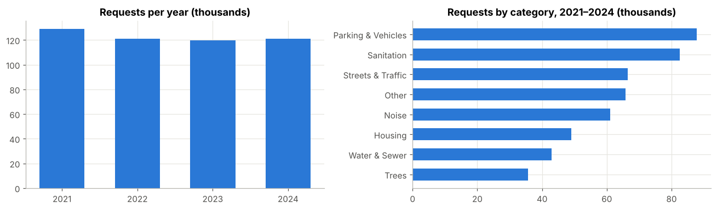
Figure 1: Complaints per year and by category, 2021–2024 (after cleaning)

5.2 Outliers in Response Time and Daily Volume
Response time (left) is extremely right-skewed even on the log scale. In the daily-volume box plot (right), the points beyond the whisker are the 41 high-volume days found with the IQR rule, mainly the October 2021 sanitation backlog and the September 2021 storm.
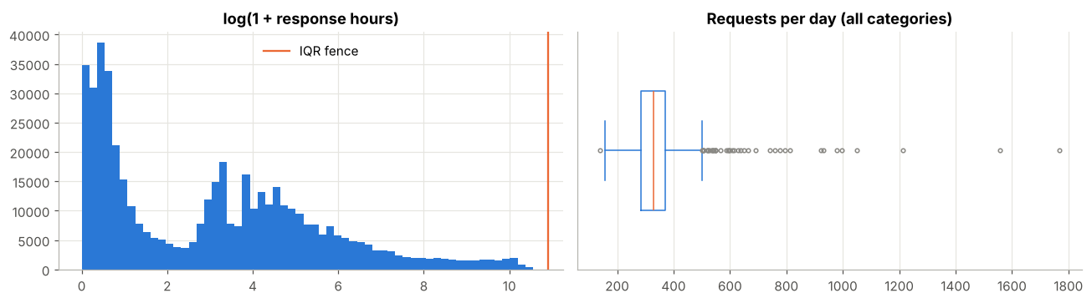
Figure 2: Response-time distribution (log scale) and daily-volume box plot

5.3 Weekday and Monthly Patterns by Category
Figure 3 shows each category's weekday and monthly index (1.0 = that category's average; red above, blue below). Most categories fall sharply at weekends (Streets & Traffic to about 0.5), but Noise rises to 1.6 on Saturdays. Housing (heating) peaks in winter, while Trees and Noise peak in summer. The 1.9 index for Sanitation in October comes from the one-off 2021 backlog, which is why such extreme days were excluded from training.
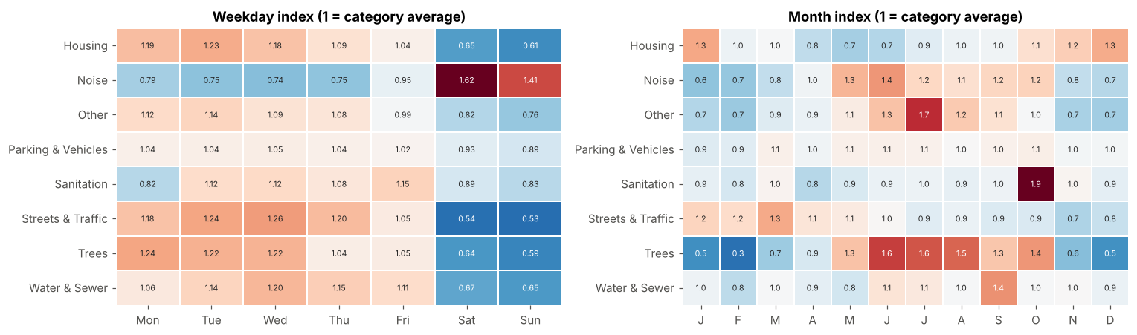
Figure 3: Weekday index and month index by complaint category

5.4 Overdispersion: Variance vs Mean
In the right panel of Figure 4 each point is a category, and the orange line marks variance equal to mean. Every category lies far above the line: the variance of daily counts is 3 to 79 times the mean. This visual evidence of overdispersion motivates the Negative Binomial model.
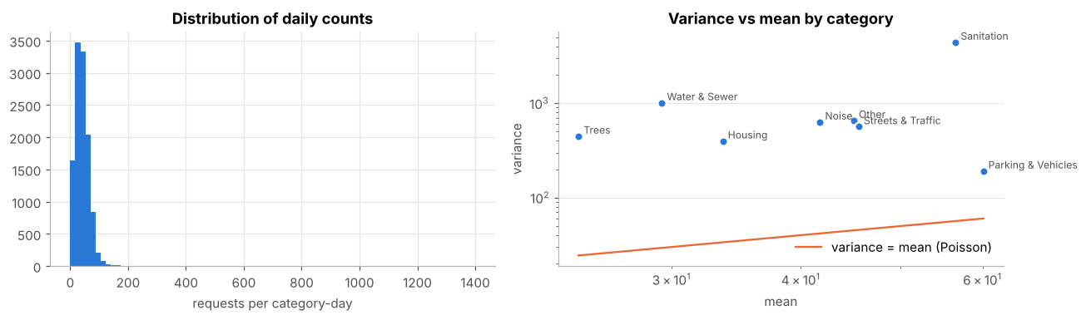
Figure 4: Distribution of daily counts and variance vs mean by category

5.5 What the Final Model Learned
Figure 5 shows the expected complaints per day predicted by the final model, by weekday (left, July) and by month (right, Wednesdays). It reproduces the patterns in the raw data: Noise peaks at weekends and in summer, Housing in winter, Trees from May to October.
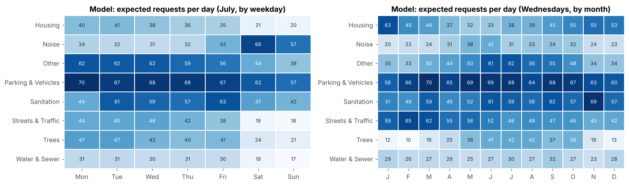
Figure 5: Final model — expected complaints per day by weekday and by month

5.6 Hyperparameter Tuning and Model Complexity
In Figure 6 (left), grid search (line) and random search (points) reach a similar optimum for α. In Figure 6 (right), models 1–3 are low on both training and validation log-likelihood (under-fitting). The gap widens for model 5 (over-fitting), so model 4 is chosen.
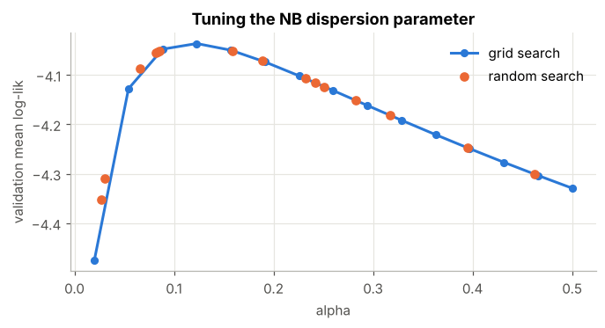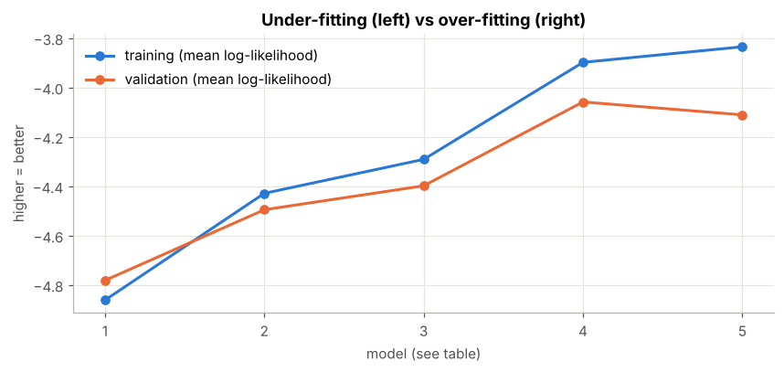
Figure 6: Grid/random search for α (left) and training vs validation log-likelihood by model complexity (right)

5.7 Forecast vs Actual for 2024
Figure 7 compares weekly forecasts with actual complaints in the unseen year 2024. The model follows the seasonal shape of Sanitation, Trees and Noise closely. Housing is over-forecast in the second half because the model extrapolated the 2021–2023 growth, which did not continue. Storm spikes, such as July in Trees, cannot be predicted from calendar features.
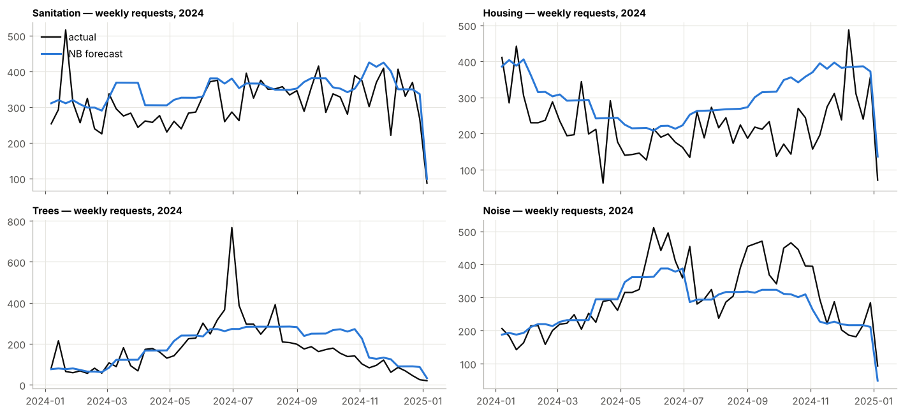
Figure 7: Weekly actual vs Negative Binomial forecast, 2024 (test year)

6. Results and Evaluation

6.1 Poisson vs Negative Binomial: Model Fit
Check | Poisson | Negative Binomial
Pearson dispersion (≈ 1 if adequate), main effects | 7.72 | 1.12
Cameron–Trivedi overdispersion test | α̂ = 0.138, t = 30.6, p < 0.001 | —
Likelihood-ratio test, Poisson vs NB | χ² = 35,455, p < 0.001 | —
AIC, main-effects model | 108,274 | 72,819
AIC, final model (with interactions) | 81,920 | 68,039
Standard errors | Too small | 2.6–2.8 × larger (honest)
Dispersion parameter α | 0 (assumed) | 0.171 (main), 0.080 (final)

6.2 Test-Year Accuracy (2024)
Model | Test RMSE | Test MAE
Baseline (category × weekday average) | 19.91 | 13.42
Linear regression (Gaussian GLM), full features | 18.02 | 11.36 (4 negative predictions)
Poisson regression — main effects | 20.76 | 13.94
Negative Binomial — main effects | 20.75 | 13.93
Poisson regression — with interactions | 17.89 | 11.07
Negative Binomial — final model | 18.00 | 11.19

6.3 Cross-Validation and Hyperparameter Tuning
Model complexity | Parameters | Train log-lik | Validation log-lik | Validation MAE
1. Intercept only | 1 | −4.861 | −4.781 | 16.82
2. Category only | 8 | −4.429 | −4.495 | 13.86
3. Main effects | 27 | −4.291 | −4.398 | 13.74
4. Final model | 153 | −3.898 | −4.058 | 11.18
5. + 3-way interaction | 681 | −3.835 | −4.111 | 11.60

Tuning method | Best α | CV mean log-likelihood | Evaluations
Grid search | 0.123 | −4.036 | 15
Random search | 0.159 | −4.051 | 15
Maximum-likelihood estimate | 0.080 | −4.058 | —

6.4 Inference: Effects on Complaint Volume
Federal holidays: IRR = 0.763 (95% CI 0.730–0.797), i.e. about 24% fewer complaints on a federal holiday.
Category | Change per year | 95% confidence interval
Housing | +14.1% | +11.3% to +16.9%
Parking & Vehicles | +11.1% | +8.6% to +13.7%
Trees | +7.5% | +4.7% to +10.4%
Noise | +0.3% | −2.1% to +2.7% (not significant)
Sanitation | −2.0% | −4.2% to +0.3% (not significant)
Other | −7.2% | −9.3% to −5.0%
Water & Sewer | −8.2% | −10.5% to −5.8%
Streets & Traffic | −13.5% | −15.5% to −11.5%

6.5 Per-Category Accuracy and Capacity Planning
Category | Actual mean / day | MAE | MAE % of mean | Days covered by 90% level
Parking & Vehicles | 71.3 | 9.2 | 12.9% | 98.1%
Other | 45.2 | 10.3 | 22.8% | 86.6%
Sanitation | 45.0 | 10.7 | 23.7% | 97.0%
Noise | 43.9 | 11.8 | 26.9% | 84.2%
Streets & Traffic | 40.9 | 9.8 | 24.0% | 80.6%
Housing | 32.8 | 16.3 | 49.7% | 96.2%
Water & Sewer | 26.9 | 10.7 | 39.6% | 82.5%
Trees | 25.0 | 10.8 | 42.9% | 90.4%
Overall | 41.4 | 11.2 | 27% | 89.4%

6.6 Metric Definitions
- RMSE (Root Mean Squared Error): the square root of the average squared difference between predicted and actual counts. It penalises large misses heavily.
- MAE (Mean Absolute Error): the average absolute difference between predicted and actual counts, in complaints per category-day.
- AIC (Akaike Information Criterion): a measure of model fit that penalises the number of parameters; lower is better.
- Log-likelihood: how probable the observed counts are under the model's predicted distribution; higher is better. It judges the whole distribution, not just the mean.
- Incidence Rate Ratio (IRR): e^β, the factor by which the expected count is multiplied for a one-unit change in a feature.
- Pearson dispersion: the Pearson χ² statistic divided by residual degrees of freedom; values well above 1 indicate overdispersion.

6.7 Interpretation
The Poisson model's dispersion statistic of 7.72 shows that daily complaint counts vary almost eight times more than Poisson regression allows. The Cameron–Trivedi and likelihood-ratio tests reject the Poisson assumption with p < 0.001. Under Poisson the standard errors are about 2.7 times too small, so the model would report effects as far more certain than they really are. The Negative Binomial model corrects this (dispersion 1.12) and lowers AIC from 81,920 to 68,039, making it the statistically valid model.
On the unseen year 2024, the final Negative Binomial model achieved an RMSE of 18.0 and an MAE of 11.2 complaints per category-day. With an average of about 41 complaints per category per day, the typical error is about 27%. This is 9.6% lower RMSE and 16.6% lower MAE than the seasonal-average baseline. Both main-effects models performed worse than the baseline, which shows that the accuracy comes from the category-specific weekday, seasonal and trend terms. Poisson and Negative Binomial models with the same features give practically the same point forecasts (RMSE 17.89 vs 18.00), because they share the same mean structure. Negative Binomial is preferred because of its far lower AIC, honest standard errors and calibrated prediction intervals. Linear regression came close on error but produced 4 negative predictions, which are impossible for counts.
Cross-validation confirms the chosen complexity: models 1–3 under-fit, and the 3-way interaction model over-fits (better training fit, worse validation). Grid search (α = 0.123) and random search (α = 0.159) agree closely. Finally, the 90th percentile of the Negative Binomial forecast covered actual demand on 89.4% of category-days in 2024, very close to the 90% target, so the model's uncertainty can be trusted for planning. Parking & Vehicles is the most predictable category. Trees and Water & Sewer are the least predictable because they are storm-driven. Housing is over-forecast because its 2021–2023 growth stopped in 2024.

7. Conclusion
This project demonstrated the complete predictive-analytics process on a large, real public dataset. A manageable subset of the NYC 311 data was exported, and real data-quality problems were found and corrected: inconsistent and renamed complaint types, appointment bookings mixed with complaints, missing values with different causes, impossible closing dates, and one-off extreme events. The individual requests were turned into a daily count table with calendar features, and count models were built, tested and validated.
The analysis showed that daily complaint counts are strongly overdispersed, so Poisson regression is not adequate and Negative Binomial regression is the appropriate model. The final model, with category-specific weekly, seasonal and trend effects, predicted the unseen year 2024 with an MAE of 11.2 complaints per category-day, outperformed a seasonal baseline, and produced well-calibrated prediction intervals that can support staffing and crew planning.
Complaint volume in Staten Island is associated with the complaint category, the day of the week (most categories fall at weekends while noise rises), the season (heating complaints in winter; tree and noise complaints in summer), federal holidays (about 24% fewer complaints) and long-term trends that differ between categories, from +14% per year for Housing to −14% per year for Streets & Traffic.
Limitations and future work: weather is not included, although it drives the largest spikes. Category trends are extrapolated linearly on the log scale, so a category whose growth stops will be over-predicted. Complaint counts measure reporting behaviour rather than the true incidence of problems. Only one borough is analysed. Adding weather data and extending the analysis to all five boroughs are natural next steps.

References
- City of New York, NYC Open Data, "311 Service Requests from 2020 to Present" (dataset erm2-nwe9). https://data.cityofnewyork.us/Social-Services/311-Service-Requests-from-2020-to-Present/erm2-nwe9
- Cameron, A. C., & Trivedi, P. K. (2013). Regression Analysis of Count Data (2nd ed.). Cambridge University Press.
- Hilbe, J. M. (2011). Negative Binomial Regression (2nd ed.). Cambridge University Press.
- McCullagh, P., & Nelder, J. A. (1989). Generalized Linear Models (2nd ed.). Chapman and Hall.
- Seabold, S., & Perktold, J. (2010). Statsmodels: Econometric and Statistical Modeling with Python. Proceedings of the 9th Python in Science Conference.
- Statsmodels documentation. https://www.statsmodels.org
- Pandas documentation. https://pandas.pydata.org
- Seaborn documentation. https://seaborn.pydata.org

