Q1. Create the following types of a files using (i) shell command
a. soft link (symlink system call)
→
Command: ln -s “filename” “linkname”
Output:
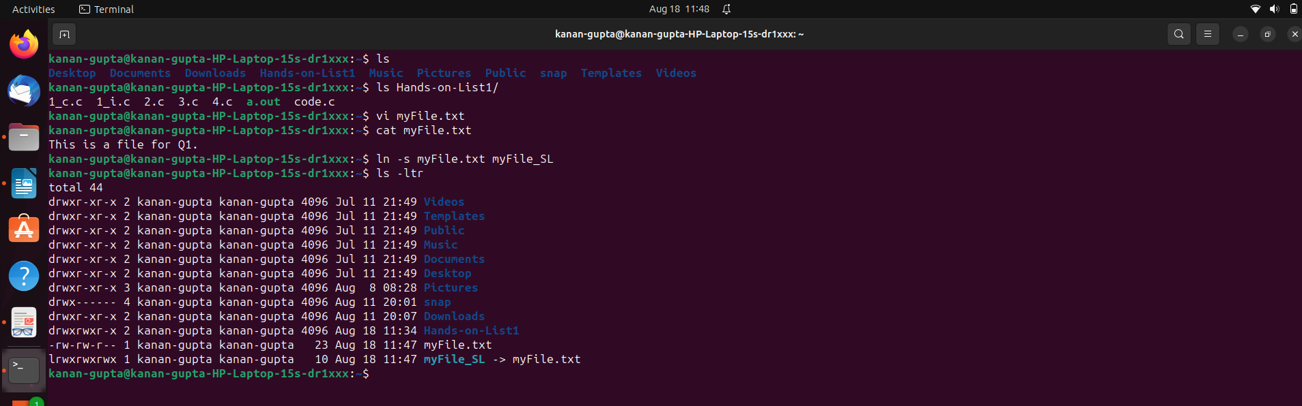
b. hard link (link system call)
→
Command: ln “filename” “linkname”
Output:
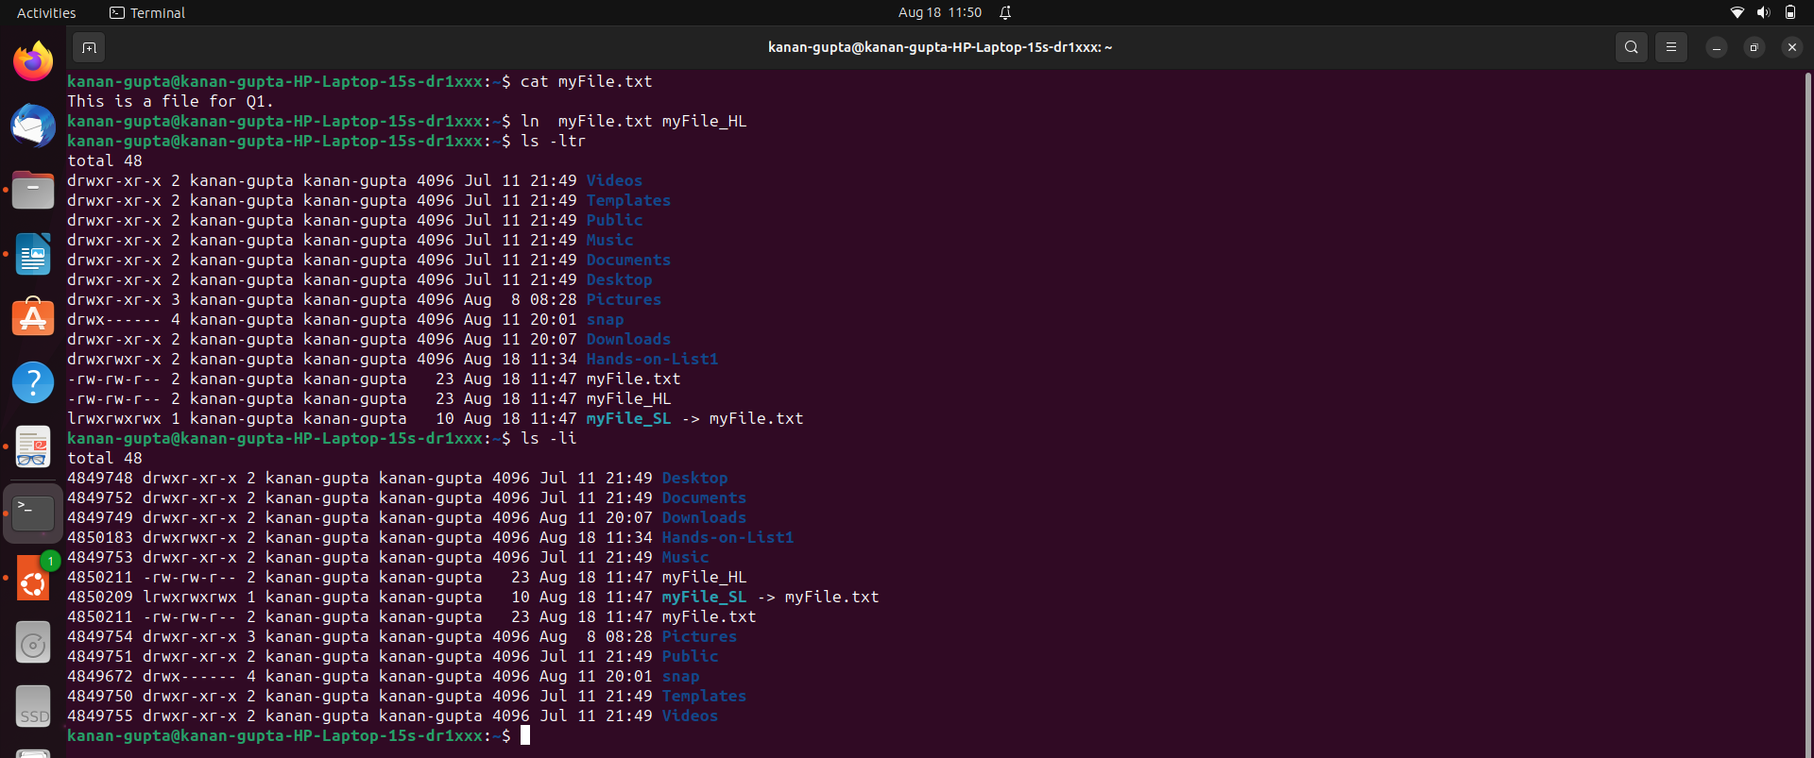
c. FIFO (mkfifo Library Function or mknod system call)
→
Command:
Terminal 1: create fifo file by mkfifo “name”
read by cat < “fifoname”
Terminal 2: write into fifo file

Output:

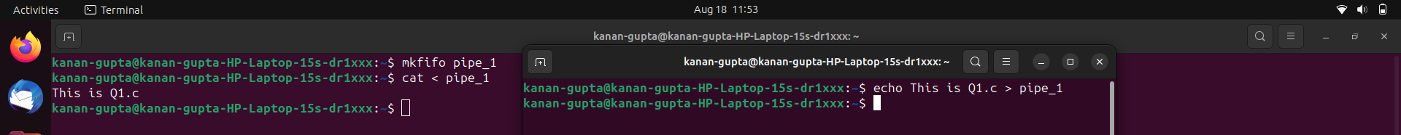
Q1. Create the following types of a files using (ii) system call

a. soft link (symlink system call)
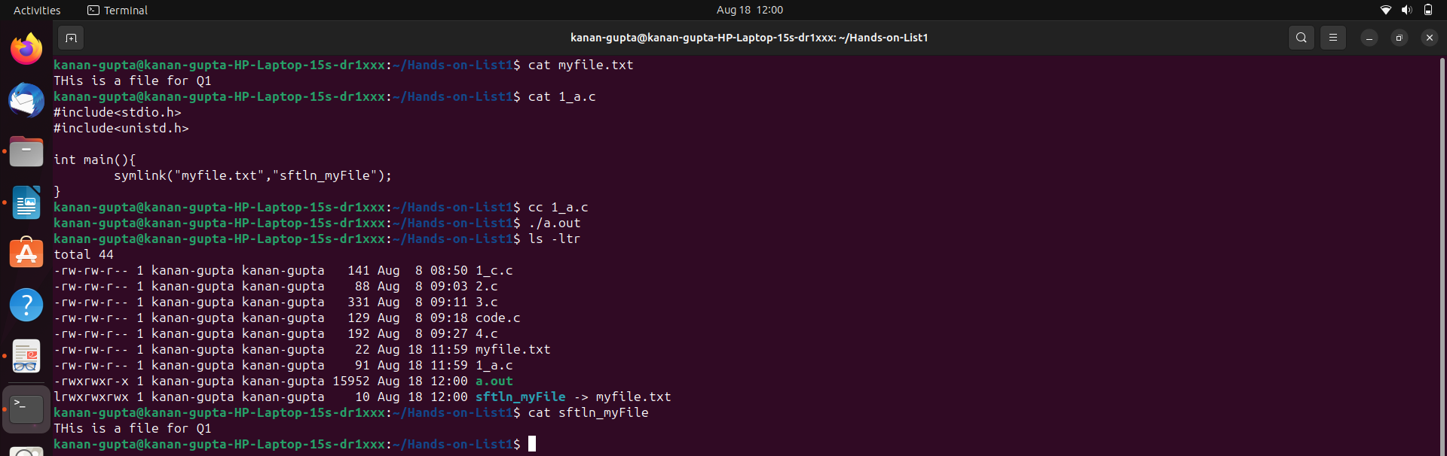

b. hard link (link system call)

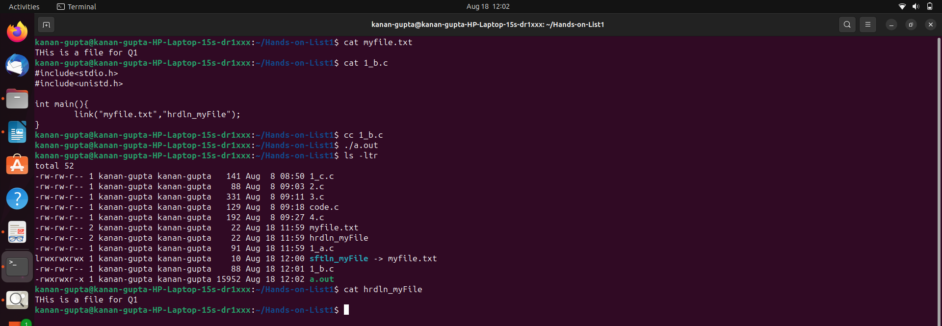

c. FIFO (mkfifo Library Function or mknod system call)

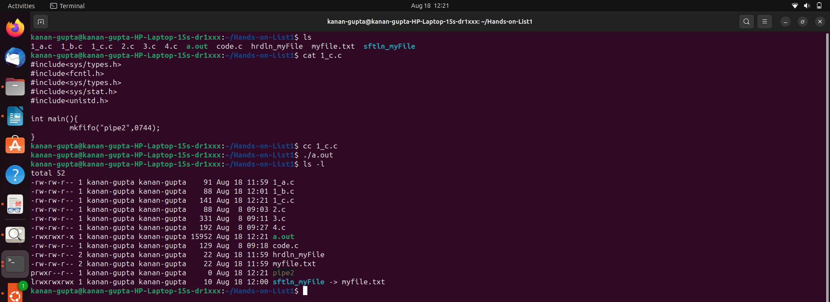
Q2. Write a simple program to execute in an infinite loop at the background. Go to /proc directory and
identify all the process related information in the corresponding proc directory.
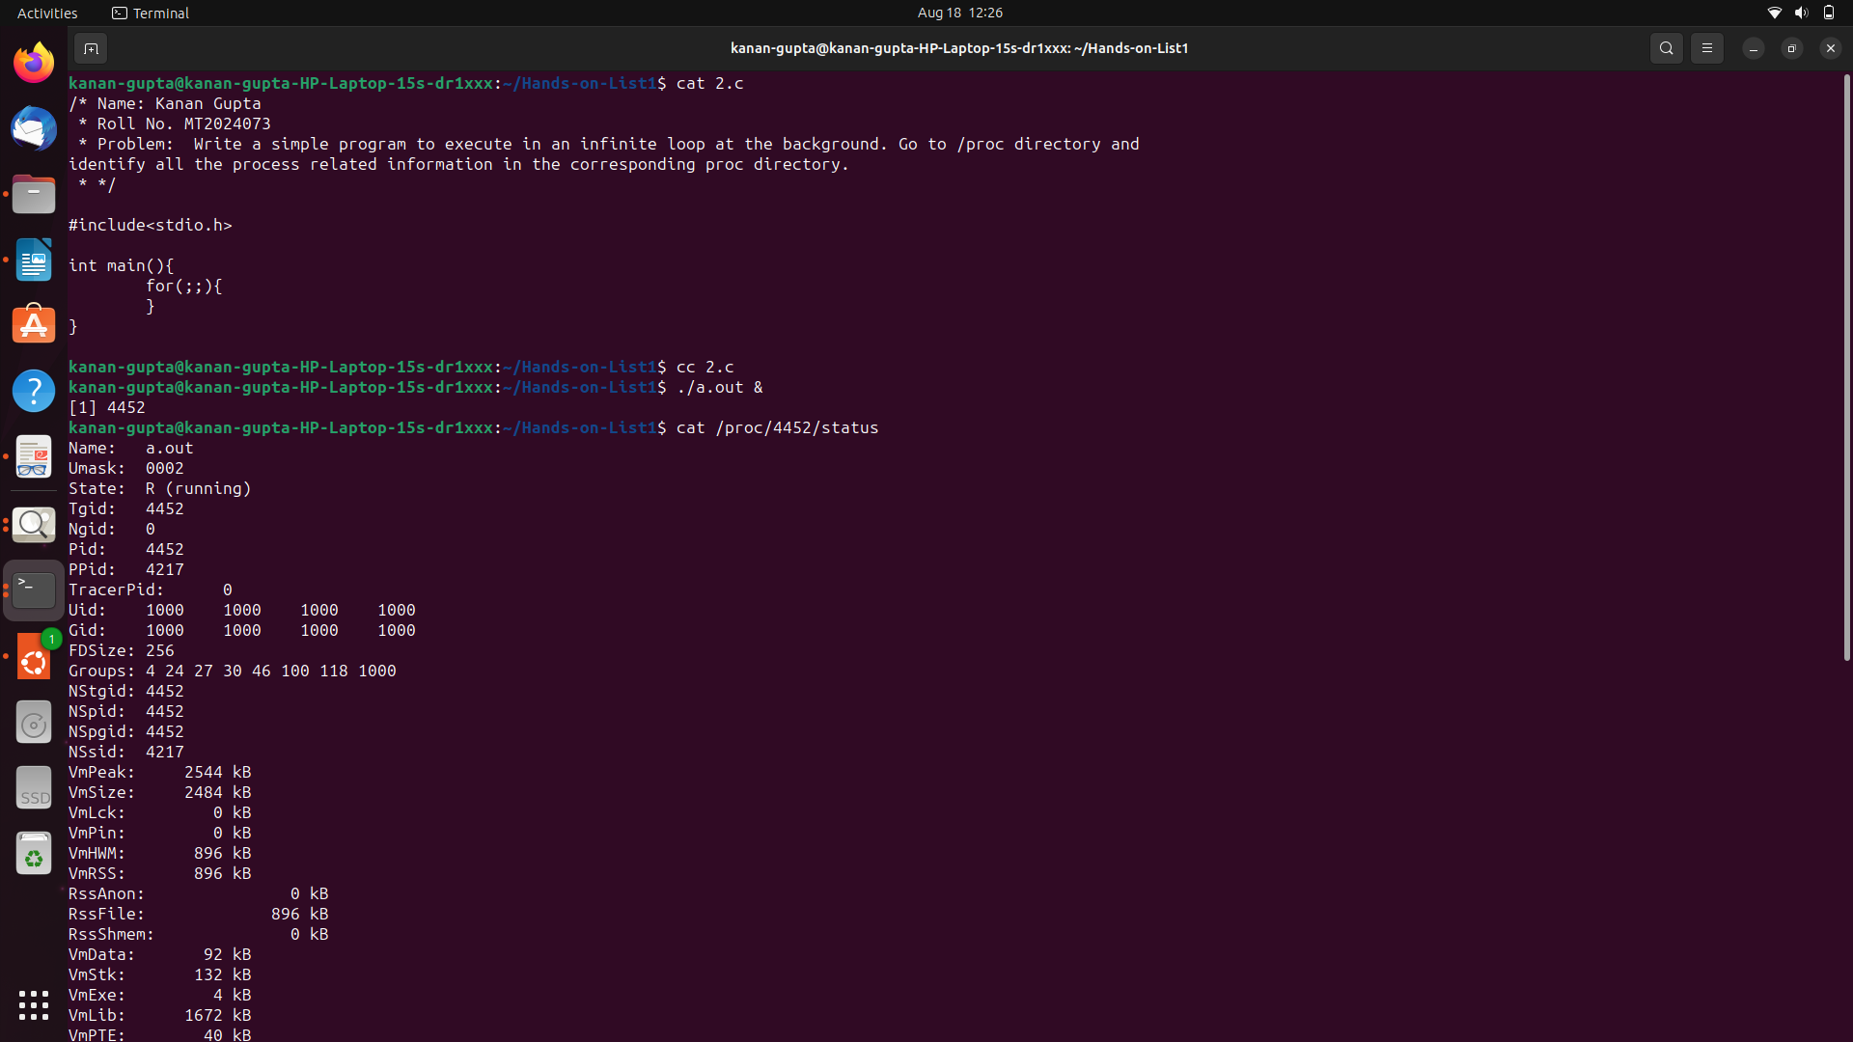
Q3. Write a program to create a file and print the file descriptor value. Use creat ( ) system call

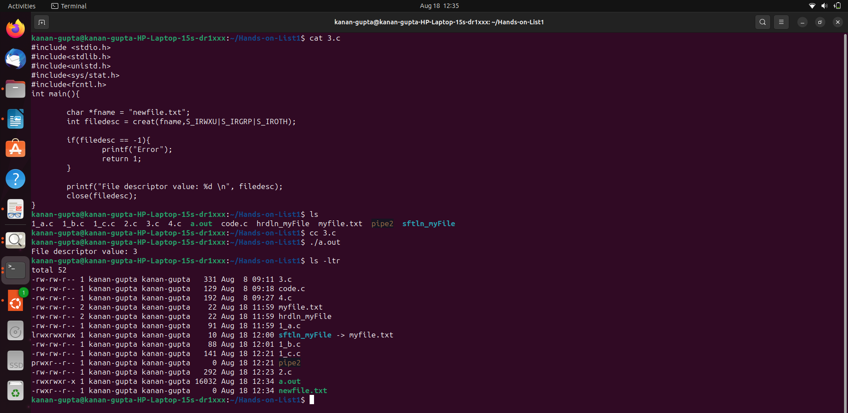
Q4. Write a program to open an existing file with read write mode. Try O_EXCL flag also.
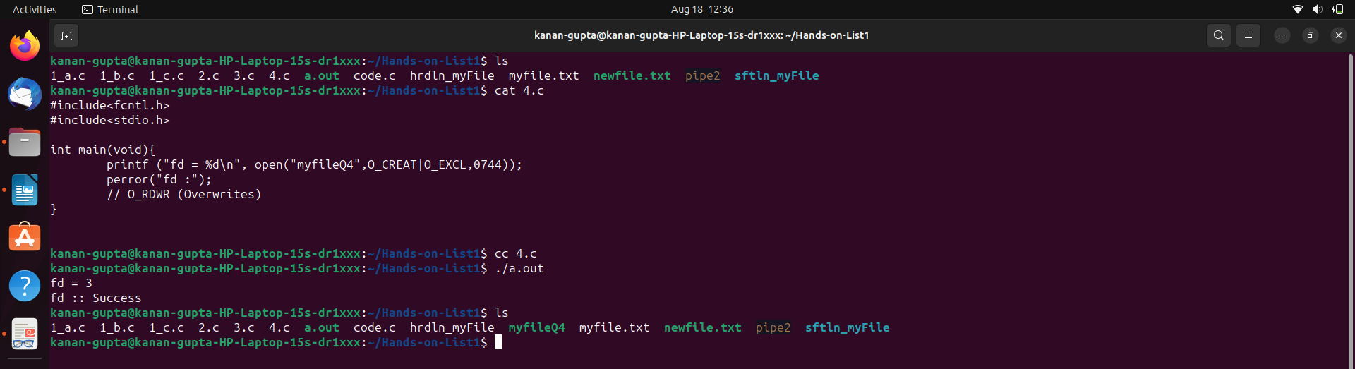
Q5. Write a program to create five new files with infinite loop. Execute the program in the background
and check the file descriptor table at /proc/pid/fd.

