Q1. Write a separate program (for each time domain) to set a interval timer in 10sec and
10micro second

a. ITIMER_REAL

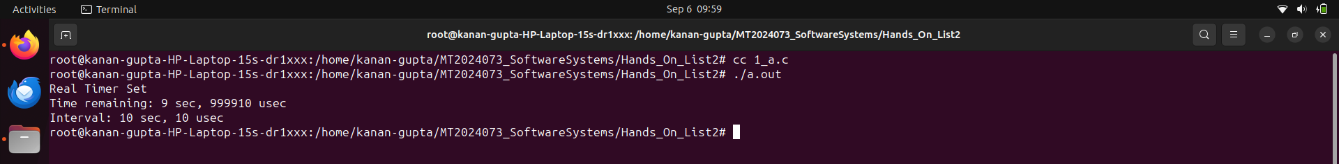
b. ITIMER_VIRTUAL
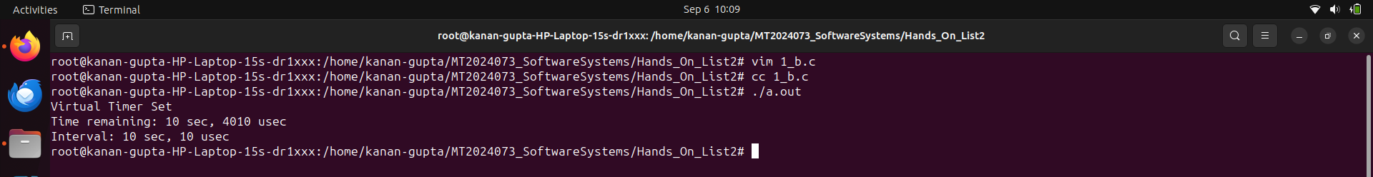
c. ITIMER_PROF
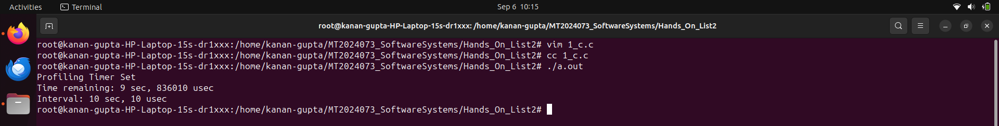
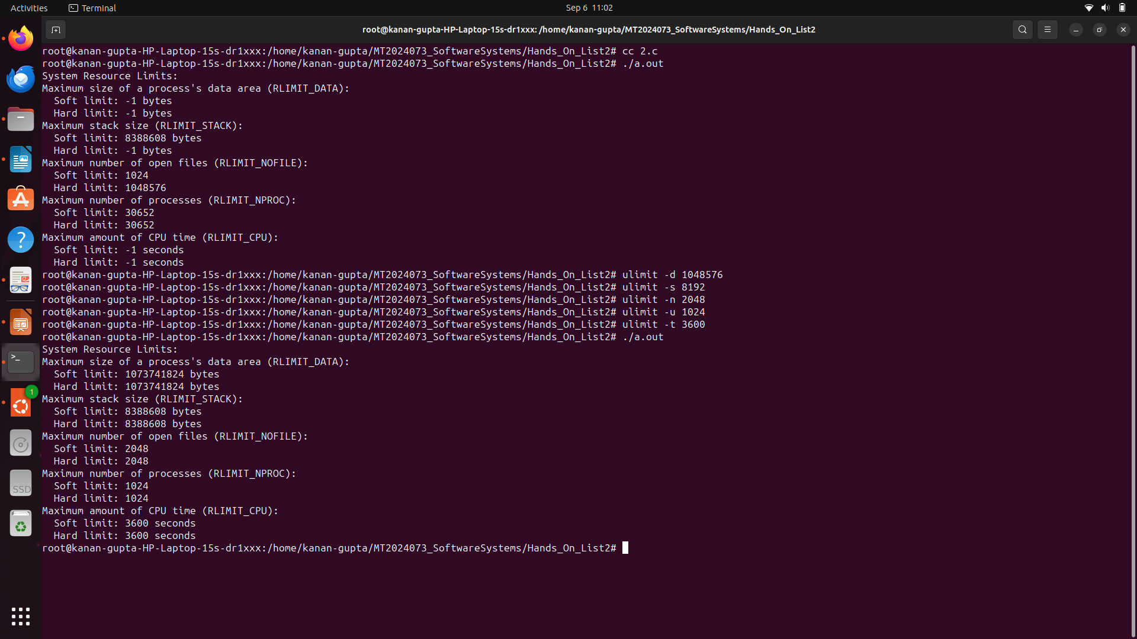
Q2. Write a program to print the system resource limits. Use getrlimit system call.
Q3. Write a program to set (any one) system resource limit. Use setrlimit system call.
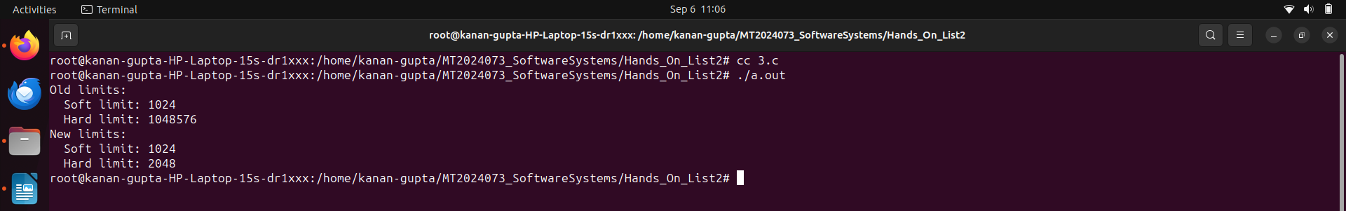
Q4. Write a program to measure how much time is taken to execute 100 getppid ( )
system call. Use time stamp counter.

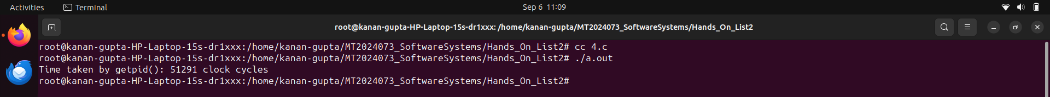
Q5. Write a program to print the system limitation of
a. maximum length of the arguments to the exec family of functions.
b. maximum number of simultaneous process per user id.
c. number of clock ticks (jiffy) per second.
d. maximum number of open files
e. size of a page
f. total number of pages in the physical memory
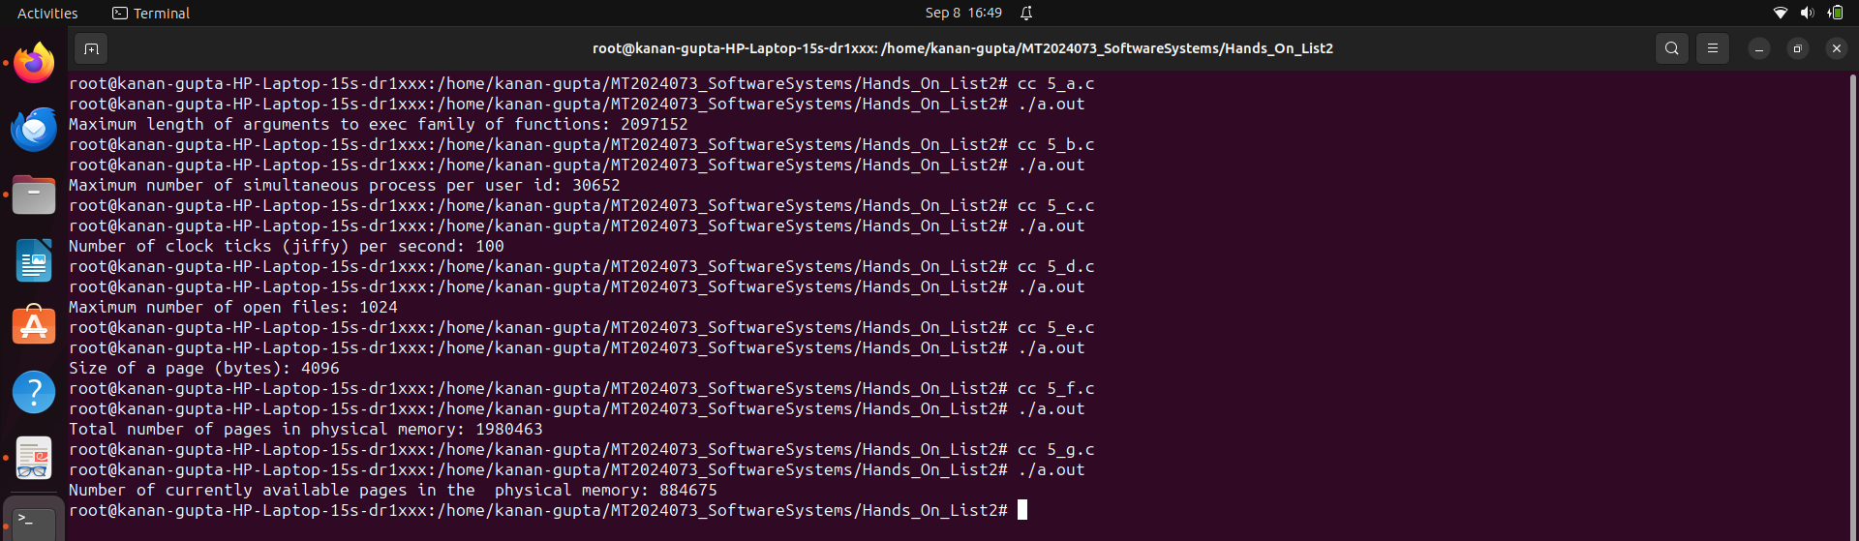
g. number of currently available pages in the physical memory.
Q6. Write a simple program to create three threads.
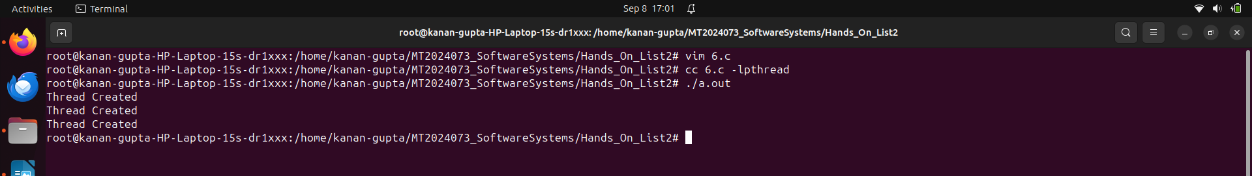
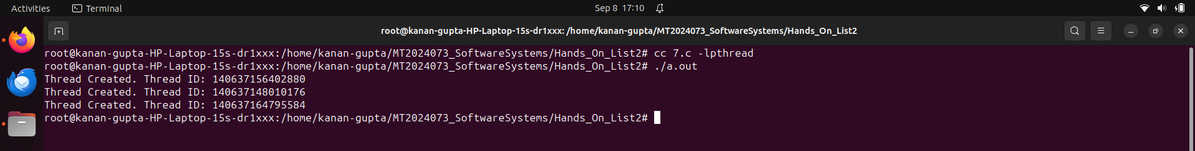
Q7. Write a simple program to print the created thread ids.
Q8. Write a separate program using signal system call to catch the following signals.
a. SIGSEGV
b. SIGINT
c. SIGFPE
d. SIGALRM (use alarm system call)
e. SIGALRM (use setitimer system call)
f. SIGVTALRM (use setitimer system call)
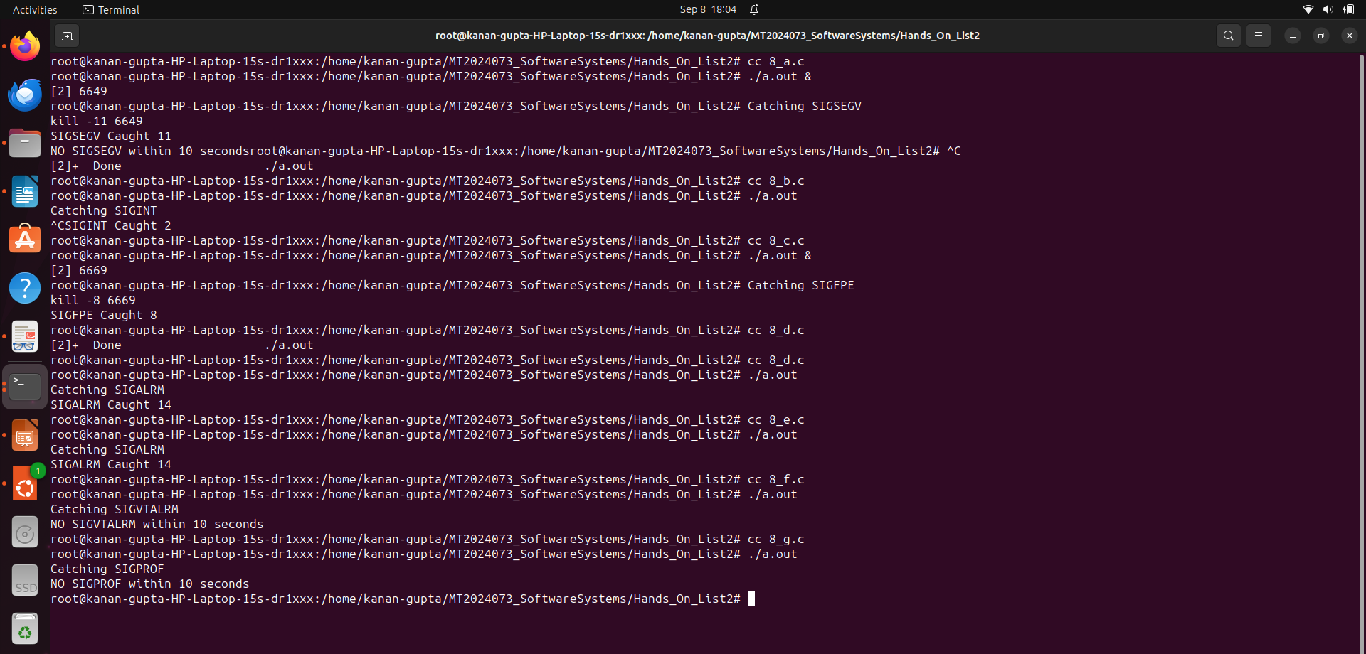
g. SIGPROF (use setitimer system call)
Q9. Write a program to ignore a SIGINT signal then reset the default action of the SIGINT
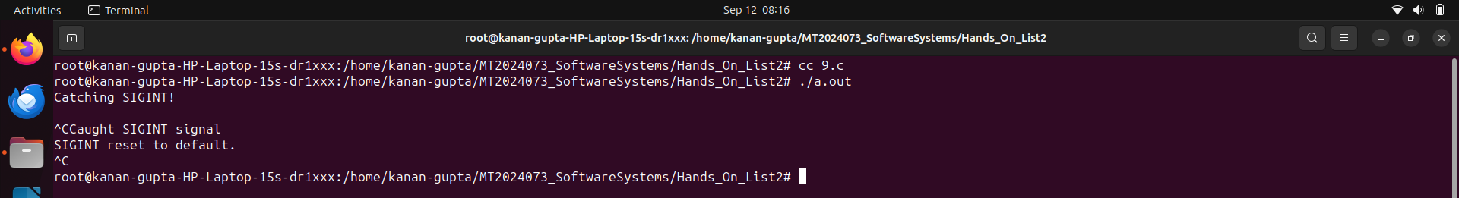
signal - Use signal system call.
Q10. Write a separate program using sigaction system call to catch the following signals.
a. SIGSEGV
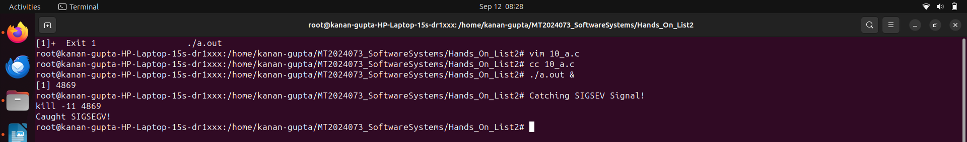
b. SIGINT

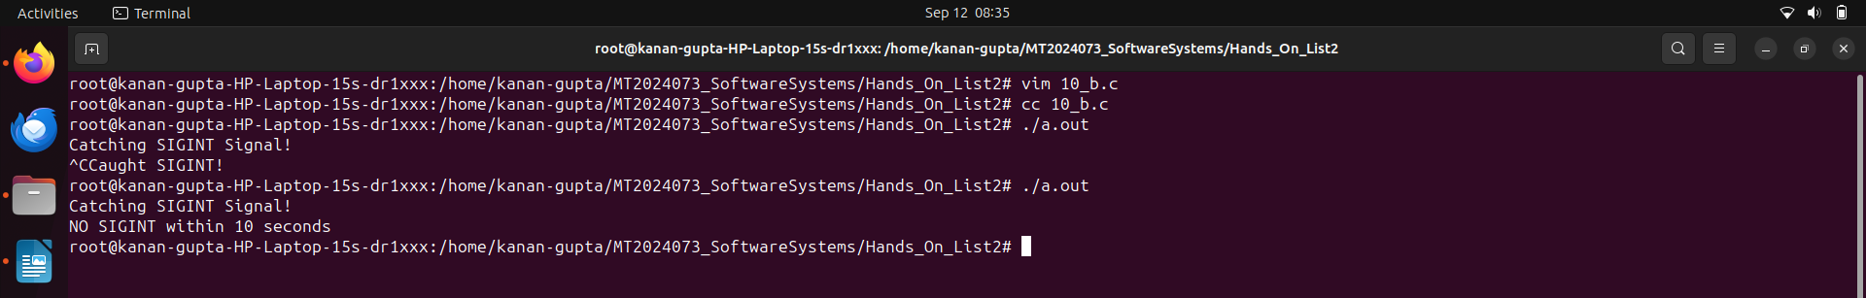
c. SIGFPE
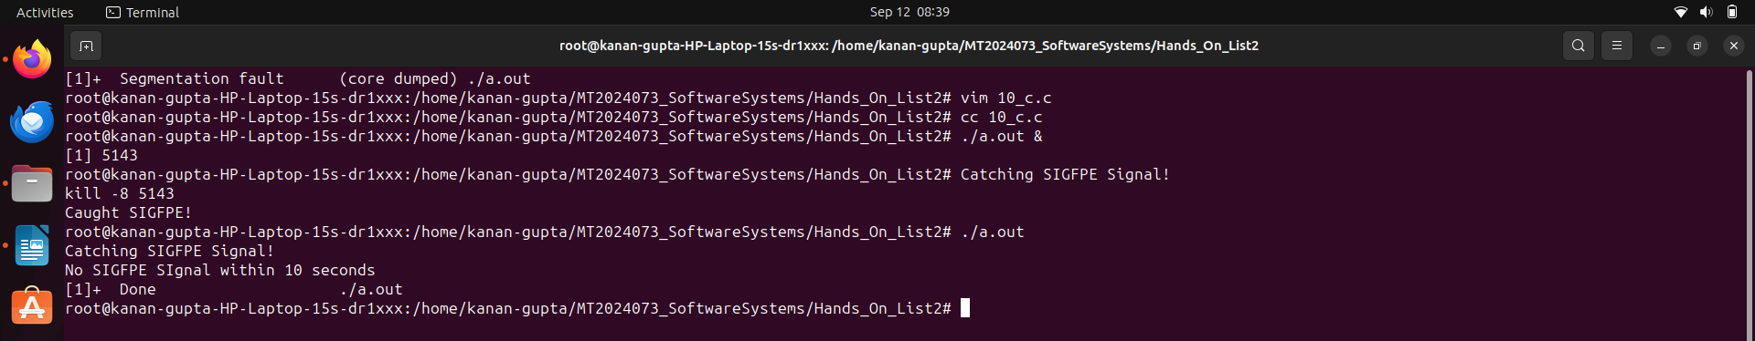
Q11. Write a program to ignore a SIGINT signal then reset the default action of the SIGINT signal -
use sigaction system call

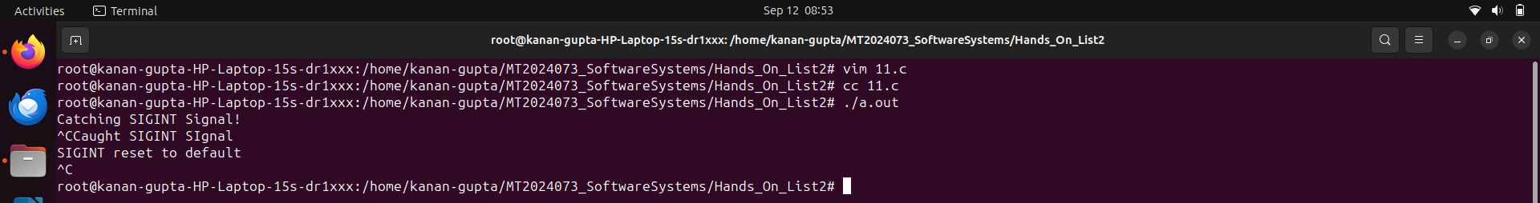
Q12. Write a program to create an orphan process. Use kill system call to send SIGKILL signal to
the parent process from the child process.

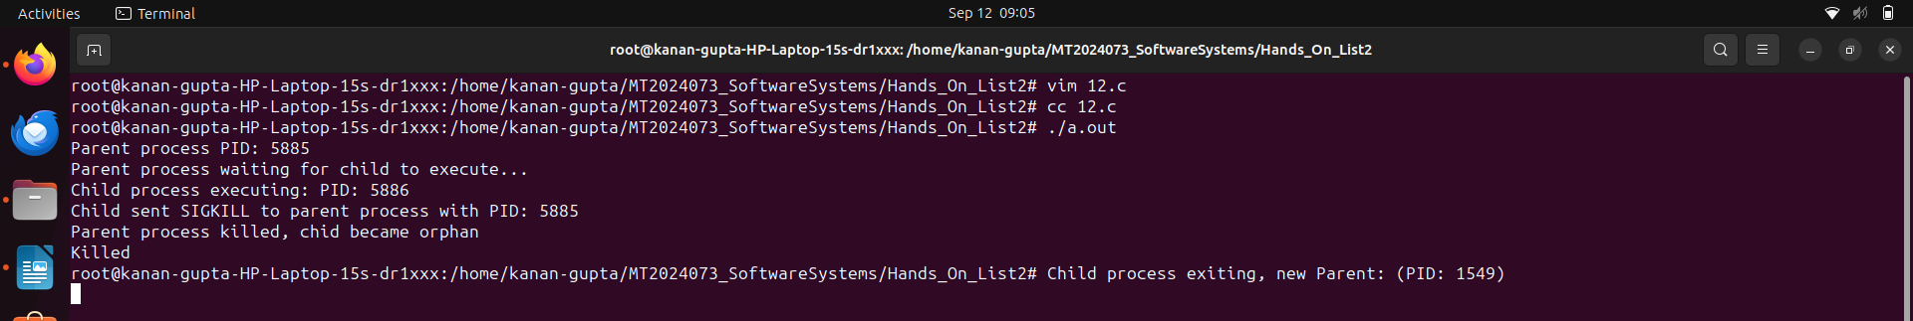
Q13. Write two programs: first program is waiting to catch SIGSTOP signal, the second program
will send the signal (using kill system call). Find out whether the first program is able to catch
the signal or not.
SIGINT:
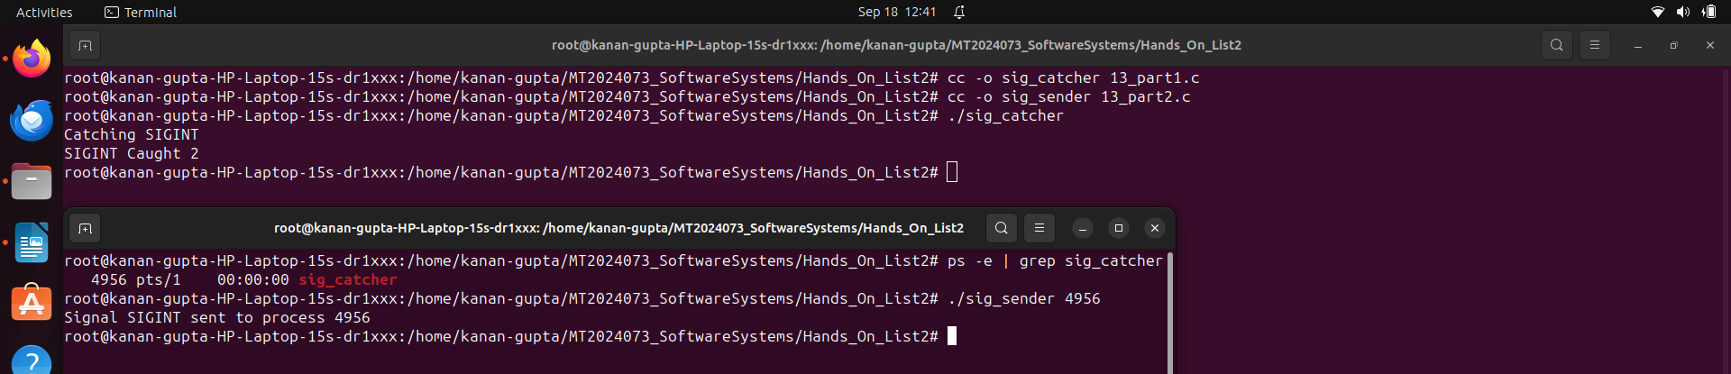
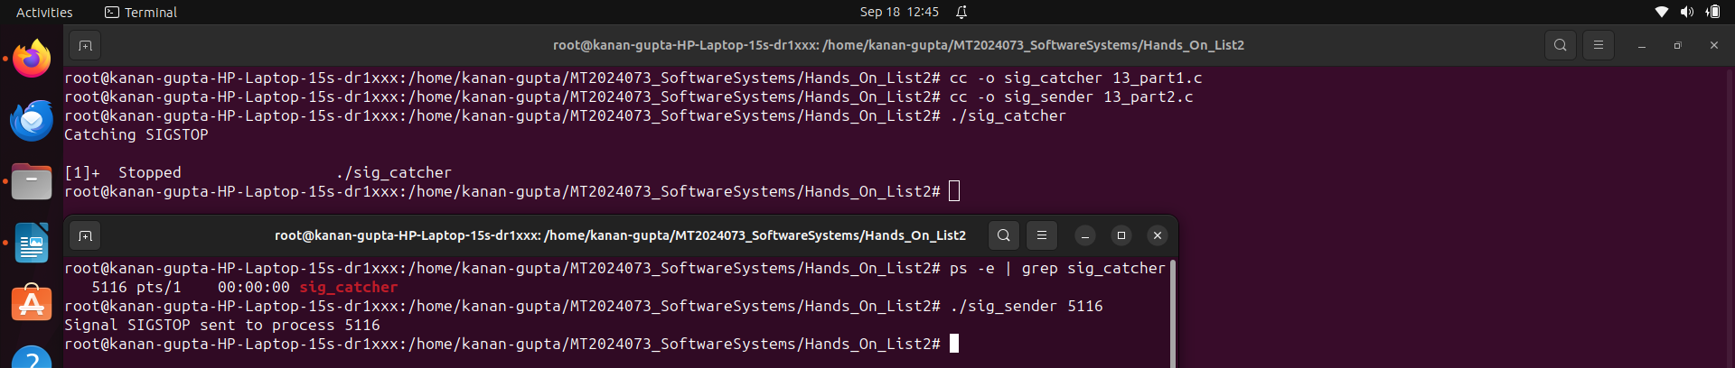
SIGSTOP:
As SIGSTOP cannot be caught
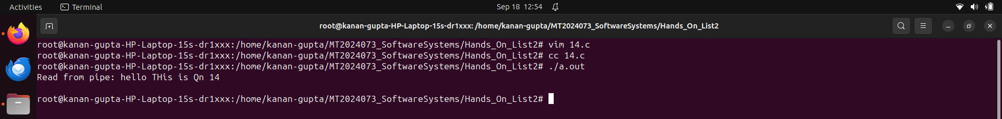
Q14. Write a simple program to create a pipe, write to the pipe, read from pipe and display onthe monitor.
Q15. Write a simple program to send some data from parent to the child process.

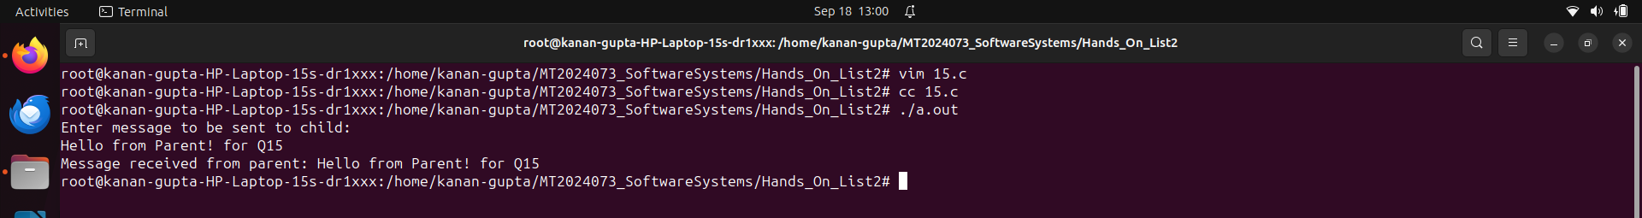
Q16. Write a program to send and receive data from parent to child vice versa. Use two way
communication.

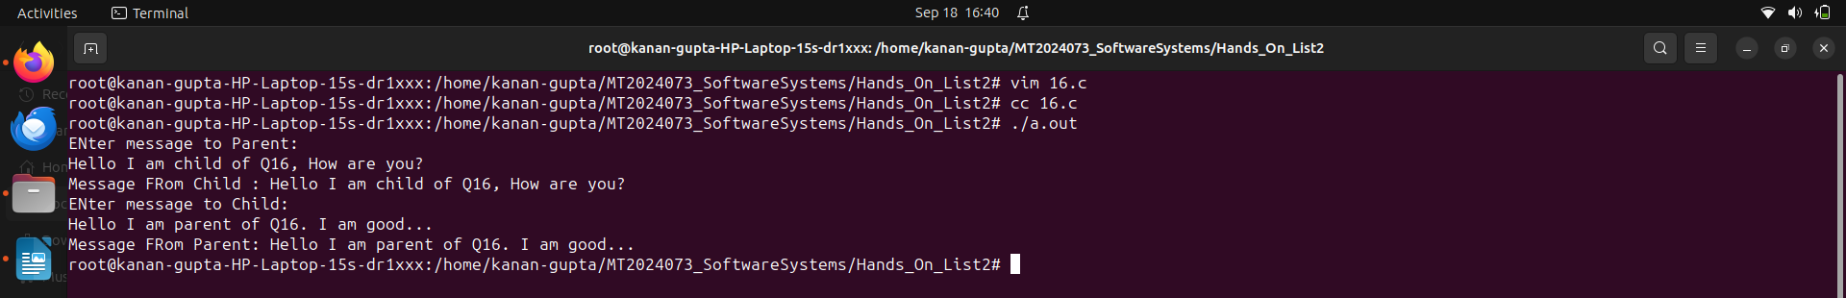
Q17. Write a program to execute ls -l | wc.
a. use dup
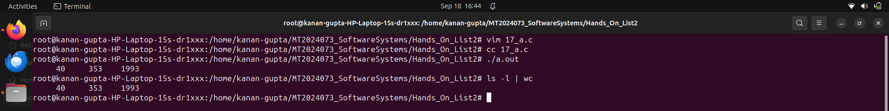
b. use dup2
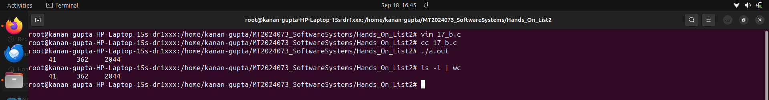
c. use fcntl

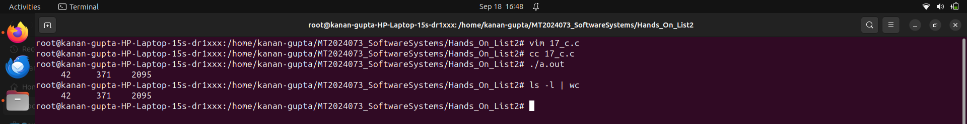
Q18. Write a program to find out total number of directories on the pwd.
execute ls -l | grep ^d | wc ? Use only dup2.

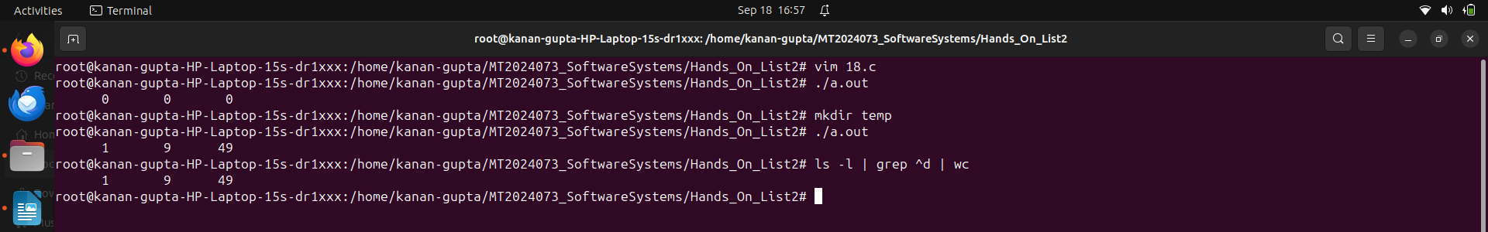
Q19.

