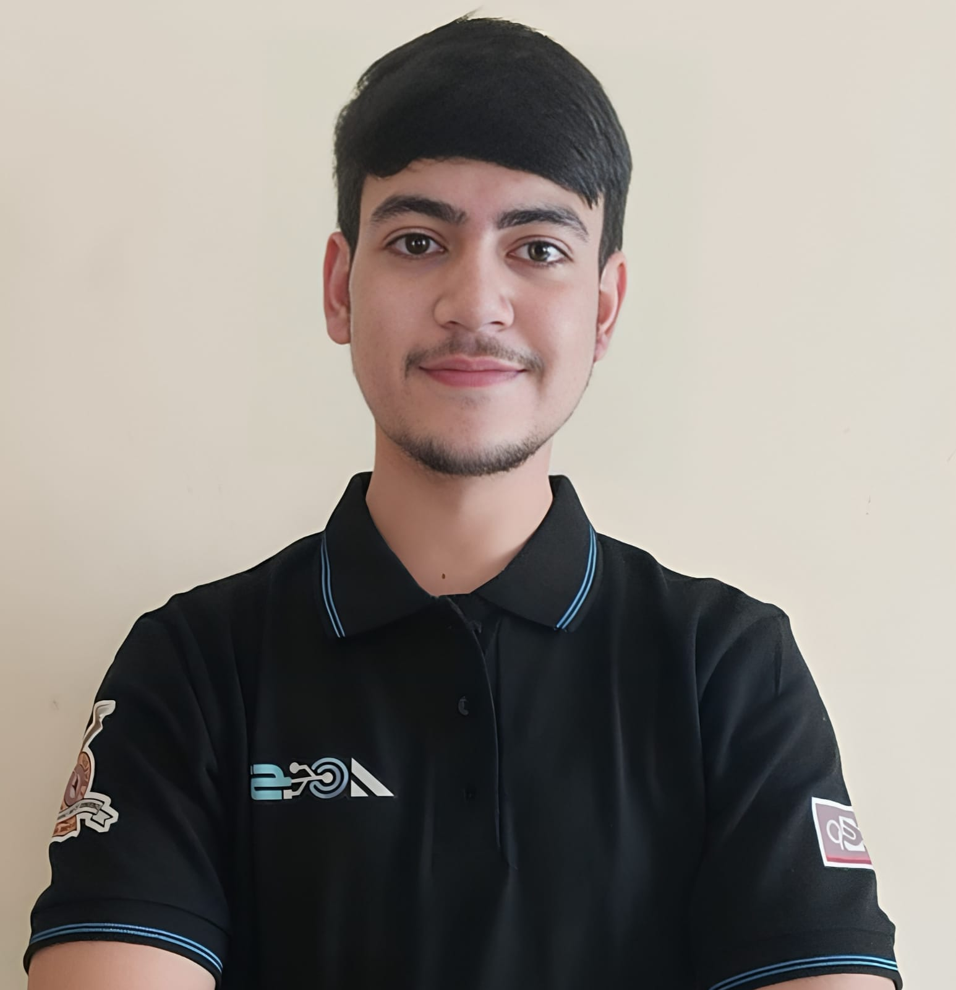

**Kanav Dogra**  
📍 Pune ,Maharashtra, India - 411046  
📞 +91 7889933488  
✉️ [kanavdogra97@gmail.com](mailto:kanavdogra97@gmail.com)

 https://www.linkedin.com/in/kanav-dogra-527293276/

* **SUMMARY**  
  Front-end Developer with a strong background in HTML, CSS, JavaScript, and Tailwind CSS. Proficient in building responsive and user-friendly web applications with clean, efficient code. Possesses foundational knowledge in PHP, Node.js, MySQL, and MongoDB. Driven to leverage technical skills and creativity to develop innovative web solutions.
* **SKILLS**
* **Front-End Technologies:** HTML5, CSS3, JavaScript, Tailwind CSS,Responsive Web Design
* **Scripting Languages:** PHP, JavaScript
* **Version Control:** Git, GitHub
* **Database Management:** MySQL, MongoDB
* **Problem-Solving & Critical Thinking**
* **Programming Languages:** Basic knowledge of C, C++, Java, Python
* **EDUCATION**
* **Bharati Vidyapeeth (DU) College of Engineering, Pune, India**  
  *Bachelor of Technology* | Expected Graduation: July 2026

Second Year CGPA: 10.00

First Year CGPA: 09.92

* **Govt. Hr. Sec. School, Vijaypur, J&K, India**  
  *Class 12th* | June 2022

Marks: 488/500 (97.6%)

* **National Academy High School, Vijaypur, J&K, India**  
  *Class 10th* | June 2020

Marks: 473/500 (94.6%)

* Experience and Leadership Roles
* Designed a targeted curriculum for teaching HTML and CSS that included real-world examples, resulting in 4 friends being able to create fully functional websites within one month of training sessions.
* EPST (Engagement of People with Science and Technology ) Head @ ACES ,BVUCOEP

(2024-2025)

* EPST Team Member @ ACES,BVUCOEP (2023 -2024)
* **PROJECTS**
* CPU Scheduling Algorithms Simulator
* Train Ticket Booking System | HTML, CSS, PHP, MySQL
* BMI Calculator
* Online Food Ordering Website (UI Design)
* **COURSES & CERTIFICATIONS**
* *Software Engineering* | NPTEL - 75%
* *Database Management System* | NPTEL - 88%
* *Introduction to Front-end Development* | Meta
* *Building Web Applications in PHP* | University of Michigan
* *Backend Development* | PW Skills