**Lending and Returning Library**

1. **books.dat = เก็บข้อมูลหนังสือ**

|  |  |  |  |
| --- | --- | --- | --- |
| ฟิลด์ | ชนิดข้อมูล | ขนาด | ตัวอย่าง |
| book_id | int | 4 | 2001 |
| title | str | 100 | ComPro |
| author | str | 100 | Kanawath |
| publisher | str | 100 | Siam Book Co. |
| year_pub | int | 4 | 2021 |
| category | str | 50 | Computer |
| language | str | 50 | Thai |
| shelf_no | str | 20 | A3-15 |
| total_copies | int | 4 | 10 |

1. **members.dat = เก็บข้อมูลสมาชิก**

|  |  |  |  |
| --- | --- | --- | --- |
| ฟิลด์ | ชนิดข้อมูล | ขนาด | ตัวอย่าง |
| member_id | int | 4 | 1001 |
| name_surname | str | 100 | Kana Dech |
| birth_date | int | 10 | 2002-05-12 |
| gender | str | 1 | M |
| home_address | str | 200 | 1/1 Bangkok |
| mobile | int | 15 | 0888888888 |
| Email_address | str | 100 | Test@email.com |
| reg_date | int | 4 | 2023-01-01 |

1. **borrows.dat = ตารางยืมคืน**

|  |  |  |  |
| --- | --- | --- | --- |
| ฟิลด์ | ชนิดข้อมูล | ขนาด | ตัวอย่าง |
| member_id | Int | 4 | 1001 |
| book_id | Int | 4 | 2001 |
| date_out | Int | 10 | 2025-09-05 |
| date_due | Int | 10 | 2025-09-05 |
| date_return | Int | 10 | 2025-09-07 |
| status | str | 20 | Return |
| fine_amount | float | 4,2 | 0.00 |
| notes | str | 200 | - |

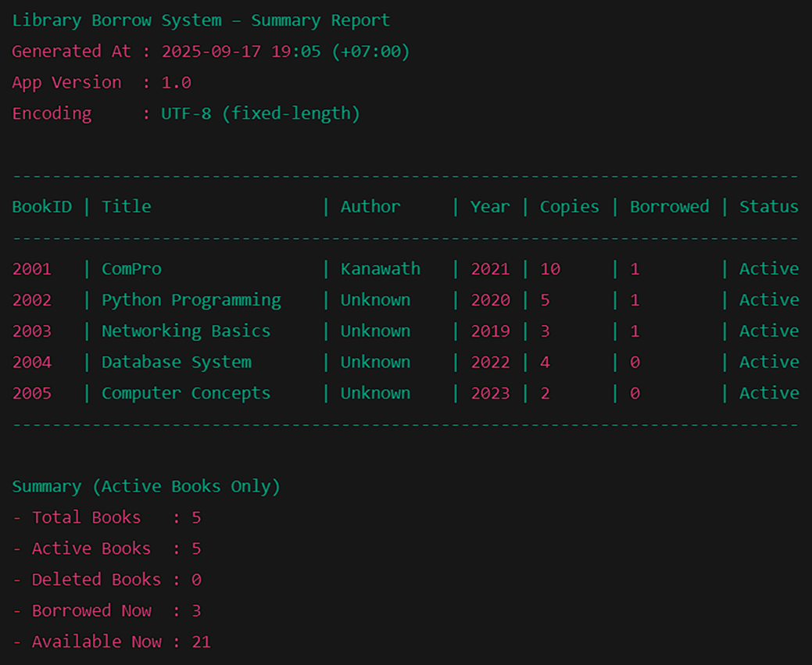

**Library Borrow System – Borrowed Report**

**Generated At : 2025-09-27 21:30 (+07:00)**

**App Version : 1.0**

**Encoding : UTF-8 (fixed-length)**

|  |  |  |  |  |  |  |  |  |
| --- | --- | --- | --- | --- | --- | --- | --- | --- |
| **MemberID** | **Member Name** | **Email** | **Title** | **Author** | **Date Out** | **Due Date** | **Fine Amount** | **Status** |
| **1002** | **Narin Boon** | **[Test1@email.com](mailto:Test1@email.com)** | **- Python Programming**  **- Match Learning** | **Alex** | **2025-09-06** | **2025-09-13** | **20.00** | **Borrow** |
| **1003** | **Suda Lert** | **Test2@email.com** | **- Networking**  **Basics**  **- Happy life** | **Harry** | **2025-09-07** | **2025-09-14** | **22.00** | **Borrow** |
| **1004** | **Somchai Rakdee** | **Test3@email.com** | **- Database System**  **- Hardware** | **Parry** | **2025-09-08** | **2025-09-15** | **165.50** | **Borrow** |
| **1005** | **Araya Wong** | **Test4@email.com** | **- Computer Concepts**  **- Smart Home** | **John** | **2025-09-09** | **2025-09-16** | **40.00** | **Borrow** |

**Summary (Borrowed Only)**

**- Borrowed Now : 4**

**- Members : 4**