Contents

Introduction 2

Justification of Project 2

Problem Definition 3

Description of Problem 3

Project Scope 4

Development Methodology 5

Design Pattern 6

System Architecture 7

Time Estimation 9

Milestones 9

Scheduling and Gantt chart 10

Risk Management 11

Configuration Management 14

Conclusion of Project 15

References 16

# Introduction

In the present situation people has become very modern and technology-dependent. They want fast and easy method for communication as well as in working platforms. They don’t want to waste their valuable time in unnecessary things like standing on queue for a simple work. It is like wasting time for them. They want something which they can access from their home by using their mobiles phones, computers or by using internet services. They are using technology in their day to day activities like purchasing products, ordering goods, foods, air ticket booking, booking movie ticket etc. Taking people demand on consideration, the proposed project is to build "Online Air Ticketing" where people can purchase air ticket by sitting in their home without any stress.

# Justification of Project

Online Air Ticketing is a web application where people can book ticket for specific date as well as they can cancel ticket if emergency occurs. It also includes price of the ticket with ticket class like normal, business, economy etc. You can also see the time of flights of many airways companies.As you travel by air ticket, you can also search for the hotel around local areas using this web portal. You can easily book ticket a month before travelling. You can get cheapest flight for several places of country using this application. All you need to do is register first in application and you can book air ticket simply by browsing. Tickets are available for all the airports inside Nepal and it has 24 hours services.

Online Air Ticketing is very friendly application where users can easily interact with application without any knowledge and training. It is simply designed application with the motto of better performance. You don’t need to go to office for air ticket. You can see all the details of flight on web application. For building this project, I have used PHP for programming and My SQL for storing all the data inside databases.

# Problem Definition

I encountered some of the problems during the project completion. One of the major problems was standing in the queue for tickets. It is completely time wasting for people. There are so many air ticketing application but very complicated to use for customers. The services are also slow inside the office which will demotivate customer. To see any kinds of information regarding flight like flight cost, time duration you should contact office or visit office.

The proposed system will overcome all the problems related to Online Air Ticketing. It will help customers to know about everything regarding the flight details by sitting in their home. It will change the way of working inside the organization. They can see flight date, time, cost, duration simply by browsing or by registering into application. It will surely attract customer towards company.

# Description of Problem

The proposed system will contain the following features which are mentioned below:

**Users Registration and Log In**

Inside the system the user should first register their details. They should provide all the necessary details about themselves like their name, address, phone number etc. After registering into the application the user can directly log in into the system for ticket booking.

**Users can Book Flight**

Users can book flight on the particular date by following the booking process. They need provide their details for booking.

**Users can see all flight details**

Users can see all flight details of all the places inside the system they can search for all details of the flights like time, date, price etc.

**User can ask questions**

Inside the system user can ask question regarding the flight issue. If anything thing unusual happen then they can ask for the problems.

**Admin can update information**

Admin can update information of flight details. They have responsibility to update all the information if any problems occurs about particular flight. The updated information should be informed to the customers who have booked ticket.

# Project Scope

**Scope Aims Objectives and Limitations**

**Scope**

Inside the Online Air Ticketing system user can see all the information regarding the flight like flight date, time, duration, cost etc. Also user can book flight for a particular places and they can keep up their questions regarding any problems related to flight.

**Aims**

The aims and objectives of Project is given below:

* Booking ticket of flight of different places
* Providing all the details of flight like flight date, price, time etc.
* Providing quality service to customer anytime anywhere
* Maintaining customer satisfaction as they don’t have to be on queue
* To manage the way of working of air ticketing
* To decrease the pressure of staffs by providing online services

**Objectives**

* To keep all the record of the products and customer details.
* To provide anytime anywhere services to the customers.
* To keep the customer data systematically.
* To create the secured database.
* Members login to view their details.
* Registering new members through the system.
* Testing of project

**Limitations**

Following are the limitations of the system

There is no online payment system inside the application. They can book flight but they have to visit office for the payment which is a big issue inside the system.

# Development Methodology

I have used waterfall approach for this project. Waterfall model is first approach used in the software development. This model is sequential approach where one step must finish before start another step. In waterfall model each step is divided. Outcomes of one step is input for next step in waterfall model. Here steps are divided into six different phases i.e. Requirement analysis, Design, Implementation, testing, Deployment (TutorialPoint, 2018)

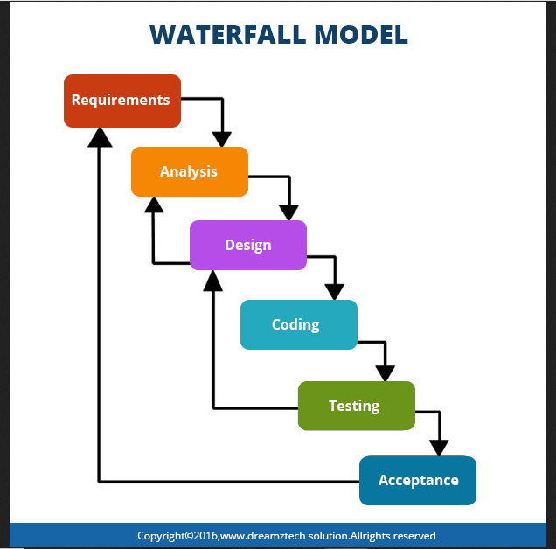

Figure 1: waterfall model

Firstly, all possible requirements are collected and document in requirement gathering phrase. From references of requirement phrase, System design is prepared. From design phrase, system is developed in small program called as unit in implementation. Each unit is tested in testing phrase which is called as unit testing. After completion of all functional and non-functional testing, system is deployed in client environment in deployment phase. After installing to client environment, system maintenance is done.

# Design Pattern

Design Pattern is reusable solution for commonly occurring problem in software development. I am using MVC (Model View Controller) design pattern in this project. MVC is Model View Controller which is most used framework in software development in today's markets. It used on both desktop and web-based application.

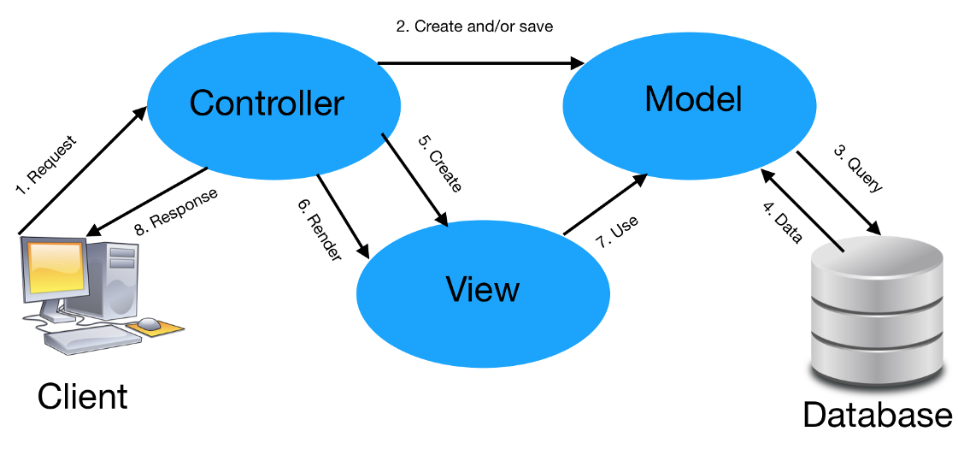

Figure 2: model view controller

**Model**

The model handles all the data related logic that user work with. This represent data that is transfer between view and controller.

**View**

The view handles all UI logic of application.

**Controller**

Controller acts as intermediary between model and view to process incoming requests and logic

# System Architecture

System architecture is theoretical model that characterizes the structure, conduct and perspective on framework. It portrays the portrayal of entire framework. For this venture, I have use 3-level structure. System engineering is applied model that characterizes the structure, conduct and perspective on framework. It depicts the portrayal of entire framework. For this task, I have use 3-level structure.

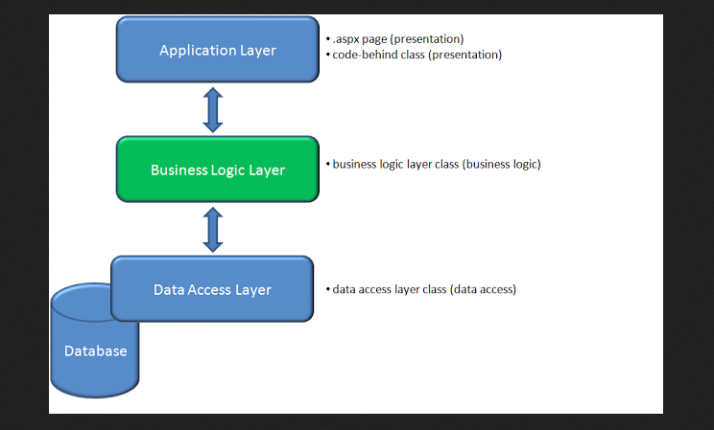

Figure: 3-Tier structure

**Work Breakdown Structure/ Scheduling**

Work Breakdown Structure is process of dividing complex project into small and manageable tasks. Usually, project Manager uses WBS for a project execution. It is overall working model of a system.

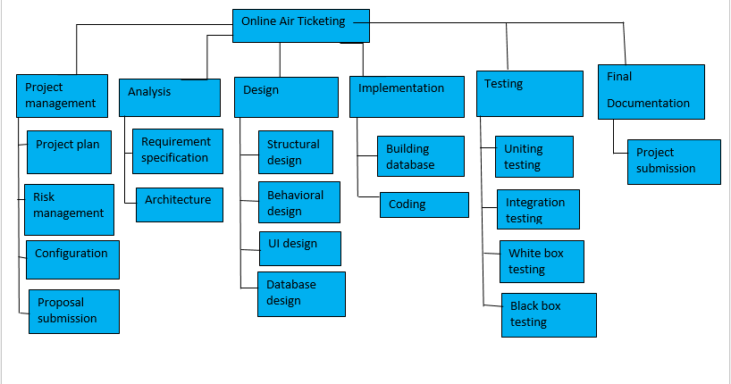

Figure 4: Work Breakdown Structure

The above figure demonstrate the work breakdown of the project which I have chosen. The above figure illustrates the project being divided into several parts. In the initial phase of my project, I have done the project management through which the planning can be done. After the project management I will be doing the analysis part which will help me in the identification of requirement as well as to build the architecture of the system. After that I will be doing the design part which will include structural design, behavioral design, UI design and database design. After completing design part, I will do the implementation part where I will build database and do coding part. After implementing all the requirement I will start the testing part which will include unit testing, integration testing, white box testing and black box testing. It will help me in fixing minor bugs. And in the end of the work breakdown, I will be doing the documentation part. This part will help other people to understand about the application. They will have a little bit of glimpse of the application through the documentation.

# Time Estimation

Time estimation is a key factor for a completion of any kind of project. We should estimate time for all the sector for a better project management. It will give us time limitation for the completion of project and it will be very easy for us if we allocate time. Time estimates drive the setting of deadlines for delivery and planning of projects, and hence will impact on other people’s assessment of our reliability and competence as a project manager.

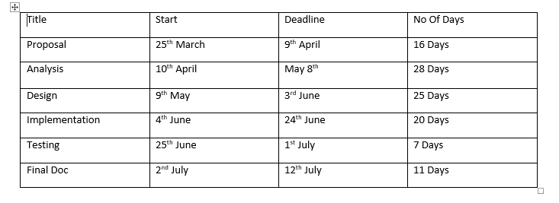

Figure 5: Time estimation

# Milestones

A Milestone is a reference point that marks a major event in a project management system and is used to monitor the project management process. I have some dates in which the different steps of my project will be done and they are the milestones of my project.

|  |  |  |
| --- | --- | --- |
| S.N | Milestone | Date |
| 1 | Proposal | 9th April, 2019 |
| 2 | Analysis | 8th May, 2019 |
| 3 | Design | 3rd June, 2019 |
| 4 | Implementation | 24th June, 2019 |
| 5 | Testing | 1st July, 2019 |
| 6 | Final Doc | 12th July, 2019 |

Figure 6: Mile stones

**Description of Milestones**

**Project Management:**

I allocate total 16 days for this task i.e. is 4 days for Risk Management, 3days for WBS, 6 days for configuration management and 3 days for proposal.

**Analysis**

I allocate total 28 days for this task i.e. 10 days for requirement analysis, 5 days for Use case diagram, 8 days for Class Diagram, 5 days for Analysis Specification.

**Design**

I allocate total 25 days for this task i.e. 5 days for Structural model, 5 days for Behavioral model, 8 days for UI design, and 7 days for database design.

**Implementation**

I allocate total 20 days for this task i.e. 7 days for database build and 13 days for coding.

**Testing**

I allocate total 7 days for this task i.e. 3 days for unit testing 2 days for integration testing, 1 days for black box testing and 1 days for white box testing.

**Final document**

I allocate total 11 days for this task i.e. 6 days for user training and 5 days for Final Report.

# Scheduling and Gantt chart

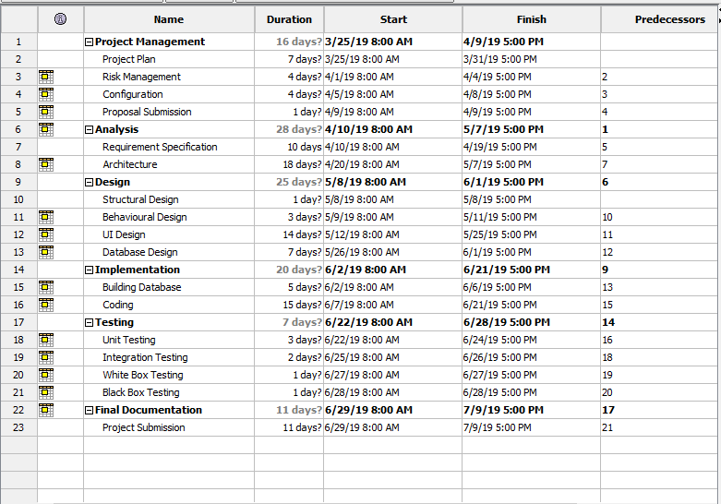

Figure 7: Gantt chart

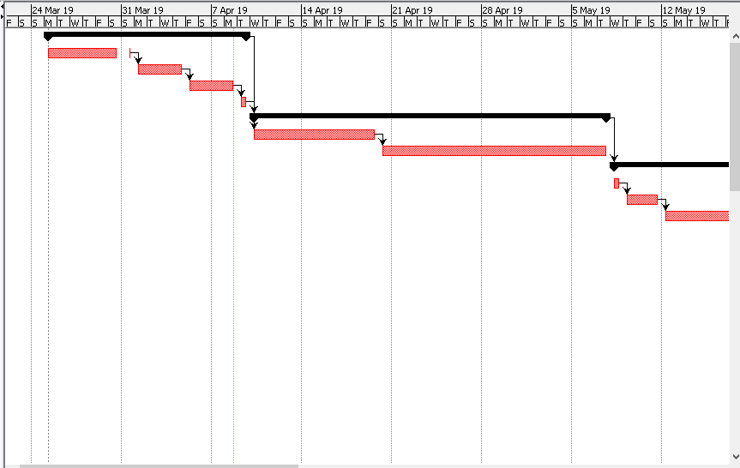

Figure 8: Gantt chart

# Risk Management

Risk Management is the process of identify, analyzing of risk factor in project. It should be part of planning process to figure out risk in the project and control risk for future events. It will help to prevent the risks of organization by detecting it and making us known that which problems are of great threats to organization. It is one of the important methodology to see organization future success.

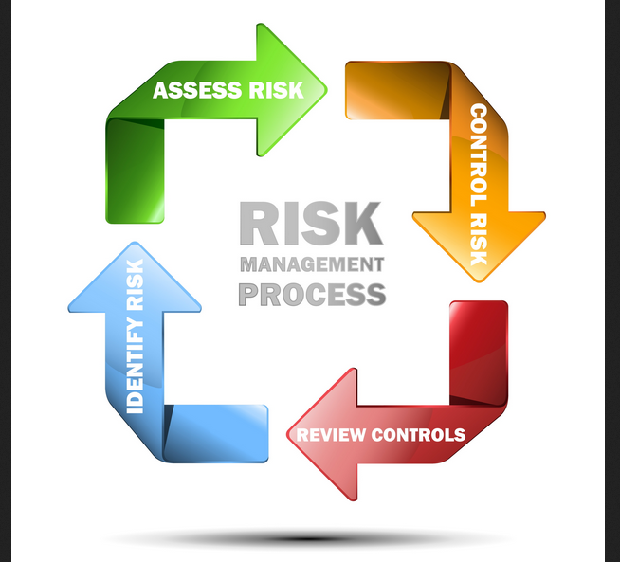

Figure 9: Risk Assessment

Following are the method to control risk inside the Project Management:

1. Avoidance
2. Reduction
3. Sharing
4. Retention

**Risk Identification**

The risk of the project are identified and mentioned below:

Insufficient resources

Hard disk crash

Requirement not matching

Server Failure

Lack of experience

Low budget

Errors in implementation

Natural Disaster

Risk Likelihood values are shown in below table:

|  |  |
| --- | --- |
| Likelihood | Values |
| Low | 1 |
| Medium | 2 |
| High | 3 |

Figure 9: Table showing likelihood

Risk Consequence values are shown in table:

|  |  |
| --- | --- |
| Consequences | Values |
| Very Low | 1 |
| Low | 2 |
| Medium | 3 |
| High | 4 |
| very High | 5 |

Figure 10: Table showing consequences

**Impact= Likelihood*Consequences**

Risk Consequence values are shown in the below table:

|  |  |  |  |  |  |
| --- | --- | --- | --- | --- | --- |
| S.N | Risks | Likelihood | Consequences | Impact | Action |
| 1 | Insufficient Resources | 2 | 3 | 6 | All required resources for the project should be gathered |
| 2 | Hard Disk Crash | 1 | 5 | 5 | Backup Plan should be implemented before starting project. |
| 3 | Requirement not matching | 2 | 4 | 8 | Proper planning should be implemented |
| 4 | Server Failure | 1 | 4 | 4 | Online backup should be done |
| 5 | Lack of experience | 1 | 3 | 3 | Training should be provided |
| 6 | Low budget | 2 | 4 | 8 | Proper budgeting should be done |
| 7 | Errors in implementation | 2 | 4 | 8 | Proper coding should be done |
| 8 | Natural Disaster | 1 | 5 | 5 | Data backup plan should be implemented |

Figure 11: Table showing risk and impact

# Configuration Management

The term configuration management refers to the system which track hardware, software and related information of the system. Configuration management is involving practices of processing system changes systematically with updating system while maintain the system integrity. To achieve of goal of the system, configuration management should be implemented with details policies, procedures to manage to version. Version controls are the category of software tools that helps to manage source code for the software team. It will help the developer to analyze the work being done by them and to go in a systematic flow. It will help in smooth development of any project. (Atlassion, 2018)

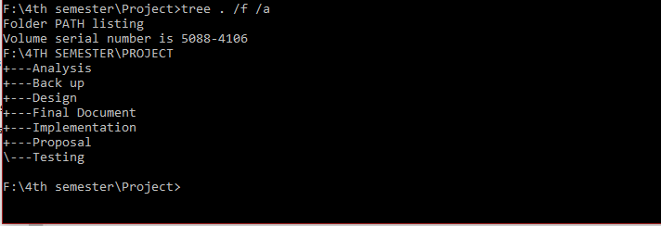

Figure 12: Configuration Management

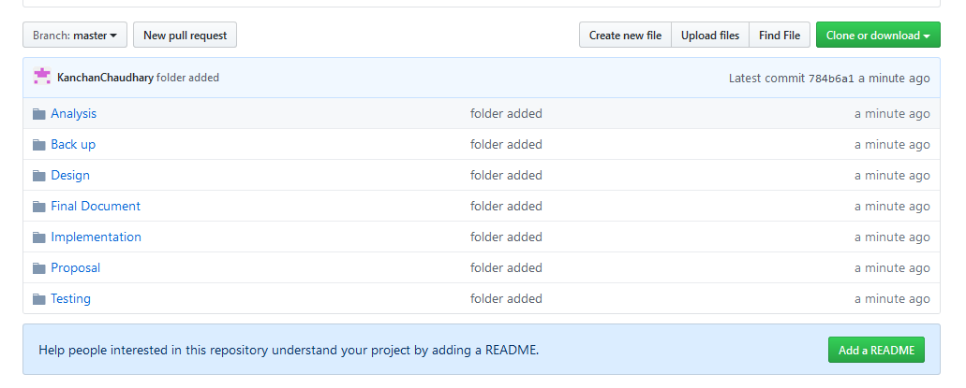

Figure 13: git screenshot

Github Link: https://github.com/KanchanChaudhary/Computing_Proj

# Conclusion of Project

Online Air Ticketing system is a customized and user friendly web application where user can book air tickets from their home at any time. The application is developed by considering the demand of people and for their satisfaction. The application has facilities of booking tickets and also user can see flight details like flight price, date, time etc. It has facility of asking question by users. Suitable breakdown and scheduling are done properly. Design pattern MVC and Waterfall methodology is used for the project. The only limitation of the system is it has not online payment system otherwise it has all the features which users seek inside the online air ticketing application.

# References

[Bright Hub PM. (2019). *Agile vs. Waterfall Methods: Which Should You Choose?*. [online] Available at: https://www.brighthubpm.com/agile/50473-agile-vs-waterfall-is-there-a-real-winner/ [Accessed 8 Apr. 2019].](Bright%20Hub%20PM.%20(2019).%20Agile%20vs.%20Waterfall%20Methods:%20Which%20Should%20You%20Choose?.%20%5bonline%5d%20Available%20at:%20https://www.brighthubpm.com/agile/50473-agile-vs-waterfall-is-there-a-real-winner/%20%5bAccessed%208%20Apr.%202019%5d.)

[Bright Hub PM. (2019). *Agile vs. Waterfall Methods: Which Should You Choose?*. [online] Available at: https://www.brighthubpm.com/agile/50473-agile-vs-waterfall-is-there-a-real-winner/ [Accessed 8 Apr. 2019].](Bright%20Hub%20PM.%20(2019).%20Agile%20vs.%20Waterfall%20Methods:%20Which%20Should%20You%20Choose?.%20%5bonline%5d%20Available%20at:%20https://www.brighthubpm.com/agile/50473-agile-vs-waterfall-is-there-a-real-winner/%20%5bAccessed%208%20Apr.%202019%5d.)