# Chapter 5 Testing



Fig: Testing of program

Testing can simply be defined as the process executed in any program with the objective of finding errors or bugs. For the good software or website, a proper application with errors free should be provided. Testing should be performed in a way so that it can find all the bugs inside the program in order to fix it.

There are a lot of testing methods for a program or any other application. Some of them are listed below:

* Unit Testing
* Black Box Testing
* Integration Testing
* Functional Testing
* Acceptance Testing
* Beta Testing

Among of above testing methods, I have chosen Unit Testing and Black Box Testing.

**Black Box Testing:** It is a type of test where test case is obtained through analysis and design view if the system. It checks whether correct value is assigned or not for valid and invalid inputs. Coding part can also be neglected as it is performed on UI design.

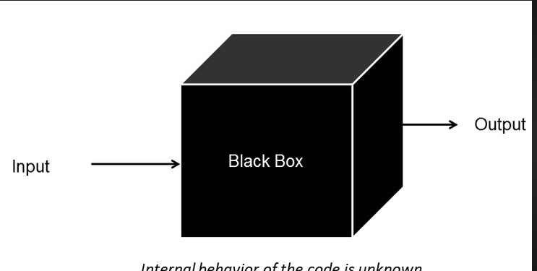

Fig: Black Box Testing

**Test Name: Registration Test**

Pre-Condition: Customer or should get access to register inside the system.

|  |  |  |  |  |  |
| --- | --- | --- | --- | --- | --- |
| **Test No:** | **Test Scenario** | **Test Input Data** | **Expected Result** | **Actual Result** | **Result Pass/Fail** |
| Test No: 1 | It checks the validity of the inputs | Username, Password, Gmail and Phone Number are inserted | All the inputs should be inserted and new user should be created | New user was successfully created and inputs were saved (database) | Pass |

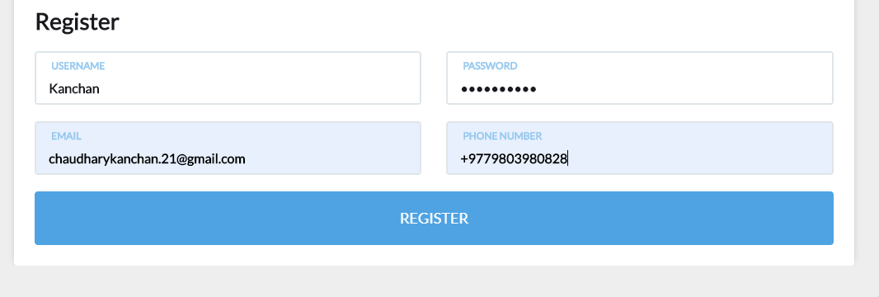

Fig: Inputs for user registration

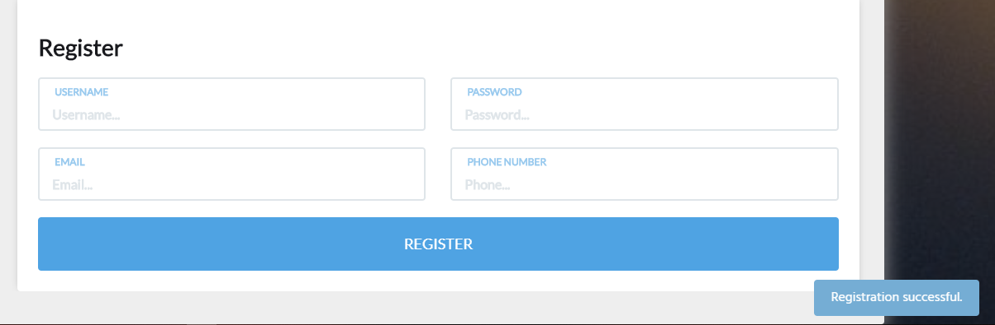

Fig: Successful message for user registration

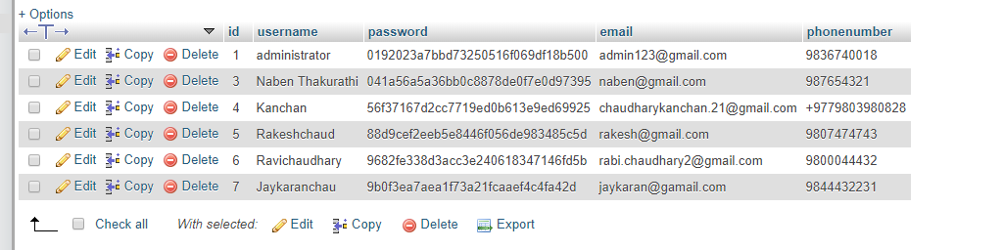

Fig: Registered data in database

**Test Name: Log in Test**

Pre-Condition: The user should enter dashboard of the system

|  |  |  |  |  |  |
| --- | --- | --- | --- | --- | --- |
| **Test No:** | **Test Scenario** | **Test Input Data** | **Expected Result** | **Actual Result** | **Result Pass/Fail** |
| Test No: 2 | It checks whether user gets access to dashboard or not | Username and password | User should successfully enters to dashboard | Opens dashboard of the system | Pass |

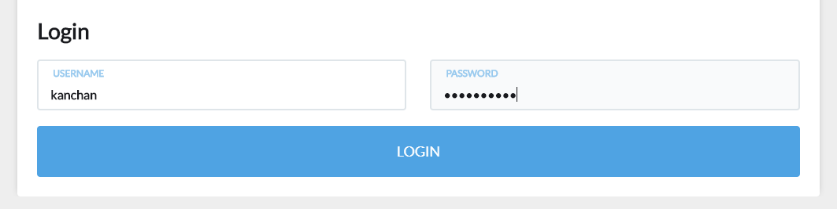

Fig: Entering username and password for log in

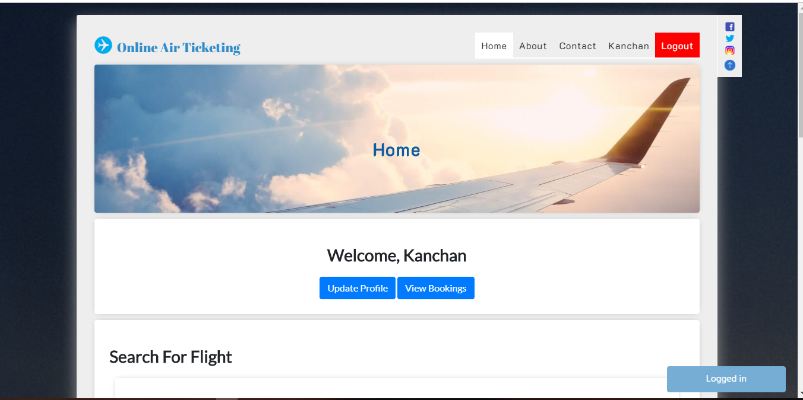

Fig: Login successfully and opens dashboard

**Test name: Valid and Invalid Test**

Pre-Condition: Message should be displayed

|  |  |  |  |  |  |
| --- | --- | --- | --- | --- | --- |
| **Test No:** | **Test Scenario** | **Test Input Data** | **Expected Result** | **Actual Result** | **Result Pass/Fail** |
| Test No: 3 | It checks whether inputs are according to requirements or not | Invalid data type to the column | Should give message for invalid data type | A pop off message for insertion of wrong data type | Pass |

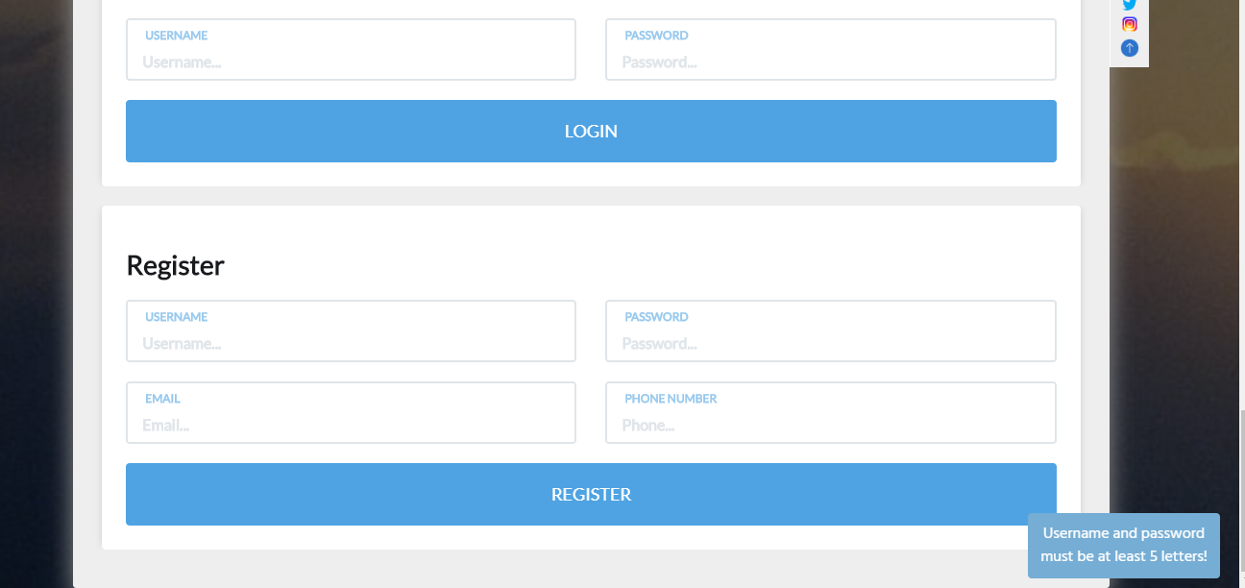

Fig; Message for invalid data type insertion



Fig: Message for insertion of invalid data

**Test Name: Data Insert Test**

Pre-Condition: The inserted data should be saved inside the database

|  |  |  |  |  |  |
| --- | --- | --- | --- | --- | --- |
| **Test No:** | **Test Scenario** | **Test Input Data** | **Expected Result** | **Actual Result** | **Result Pass/Fail** |
| Test No: 4 | It ensures whether the inserted data gets saved or not | Data inserted into different components | Inserted data should get saved in database | Inserted data are saved in database | Pass |



Fig: Data inserted inside database

**Test Name: Update Test**

Pre-Condition: Data should get updated

|  |  |  |  |  |  |
| --- | --- | --- | --- | --- | --- |
| **Test No:** | **Test Scenario** | **Test Input Data** | **Expected Result** | **Actual Result** | **Result Pass/Fail** |
| Test No: 5 | It should allow for update of data | Inserted data | Should allow for update function | Data were successfully updated | Pass |

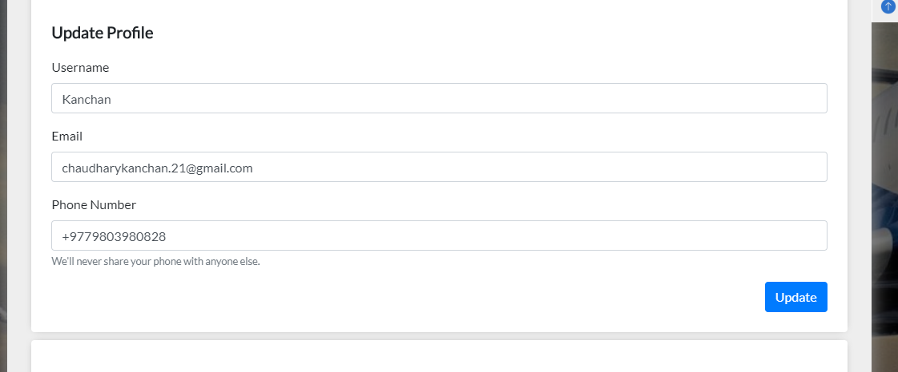

Fig: Update of inserted data

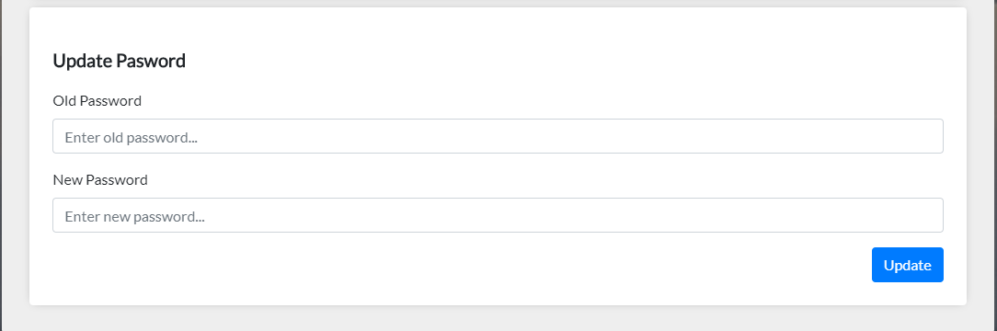

Fig: Update of inserted data

**Test Name: Delete Test**

Pre-Condition: Should allow for data deletion

|  |  |  |  |  |  |
| --- | --- | --- | --- | --- | --- |
| **Test No:** | **Test Scenario** | **Test Input Data** | **Expected Result** | **Actual Result** | **Result Pass/Fail** |
| Test No: 6 | It should allow for delete of data | Inserted data | Allow for the delete of inserted data | Inserted data can be deleted successfully | Pass |

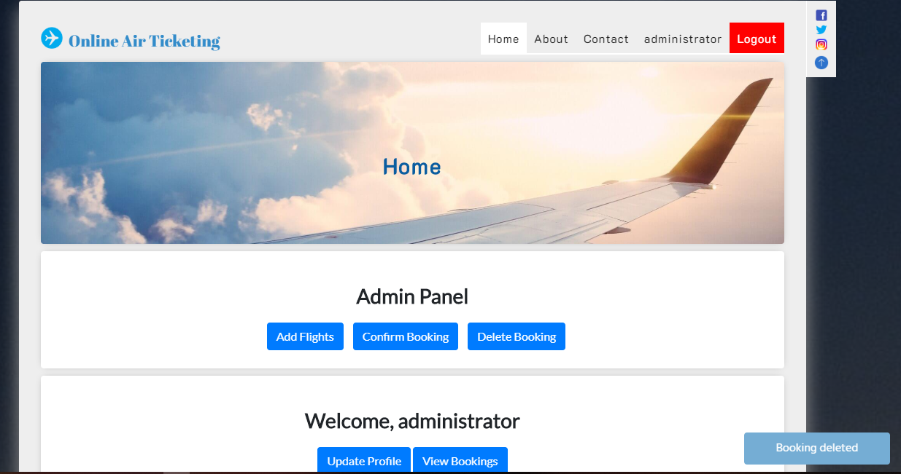

Fig: Delete process execution of inserted data

**Test Name: Contact Us Test**

Pre-Condition: Should allow user to contact to admin

|  |  |  |  |  |  |
| --- | --- | --- | --- | --- | --- |
| **Test No:** | **Test Scenario** | **Test Input Data** | **Expected Result** | **Actual Result** | **Result Pass/Fail** |
| Test No: 7 | It should allow user to contact to admin | Comments and feedbacks | Allow to contact to admin | Successfully contacted to admin | Pass |

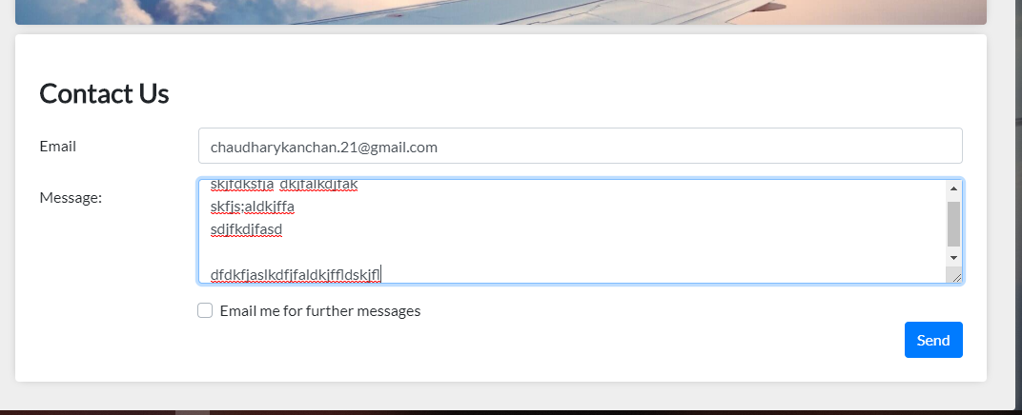

Fig: Contact Us page in program

**Test Name: Registering without any kinds of inputs**

Pre-Condition: Registration Unsuccessful

|  |  |  |  |  |  |
| --- | --- | --- | --- | --- | --- |
| **Test No:** | **Test Scenario** | **Test Input Data** | **Expected Result** | **Actual Result** | **Result Pass/Fail** |
| Test No: 8 | It shouldn’t allow for registration | Registration form | Should not register user | User was not registered | Pass |

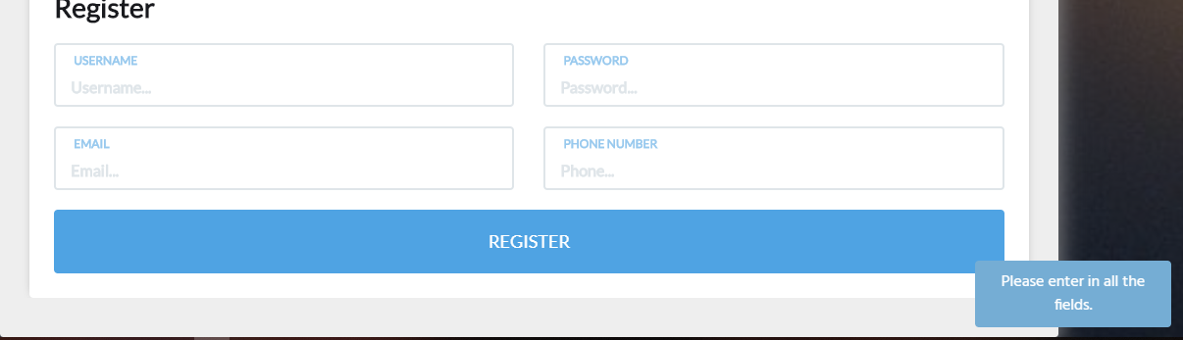

Fig: Registering without inputs

**Test Name: Login test with wrong username and password**

Pre-Condition: Login should be unsuccessful

|  |  |  |  |  |  |
| --- | --- | --- | --- | --- | --- |
| **Test No:** | **Test Scenario** | **Test Input Data** | **Expected Result** | **Actual Result** | **Result Pass/Fail** |
| Test No: 9 | It shouldn’t allow for login | Username and password | Should not get access to dashboard | Log in was unsuccessful | Pass |

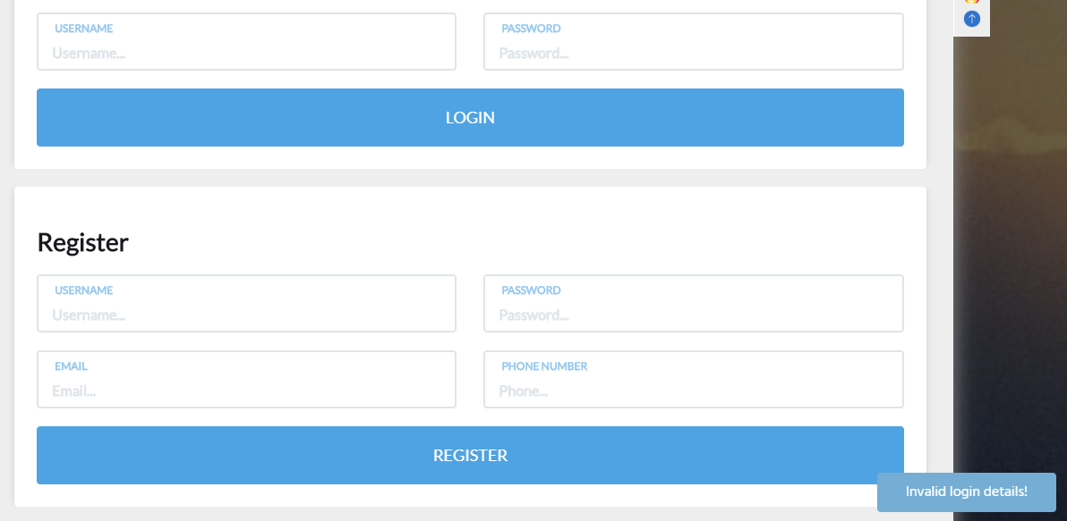

Fig: Invalid username and password

**Test Name: Registration with invalid email**

Pre-Condition: Should show notification for incorrect email

|  |  |  |  |  |  |
| --- | --- | --- | --- | --- | --- |
| **Test No:** | **Test Scenario** | **Test Input Data** | **Expected Result** | **Actual Result** | **Result Pass/Fail** |
| Test No: 10 | It should show message for incorrect email | Email address | Should show message for incorrect email | Message was showed for incorrect email | Pass |

**Test Name: Registration with valid email**

Pre-Condition: Should allow for registration

|  |  |  |  |  |  |
| --- | --- | --- | --- | --- | --- |
| **Test No:** | **Test Scenario** | **Test Input Data** | **Expected Result** | **Actual Result** | **Result Pass/Fail** |
| Test No: 11 | It should allow for registration | Email address | Should allow for user registration | User registered successfully | Pass |



Fig: Registration with correct email

**Test Name: login with wrong password**

Pre-Condition: Should allow to log in inside the system

|  |  |  |  |  |  |
| --- | --- | --- | --- | --- | --- |
| **Test No:** | **Test Scenario** | **Test Input Data** | **Expected Result** | **Actual Result** | **Result Pass/Fail** |
| Test No: 12 | It should not give access inside the dashboard | Invalid password | Should not give access inside the system | Login was unsuccessful | Pass |

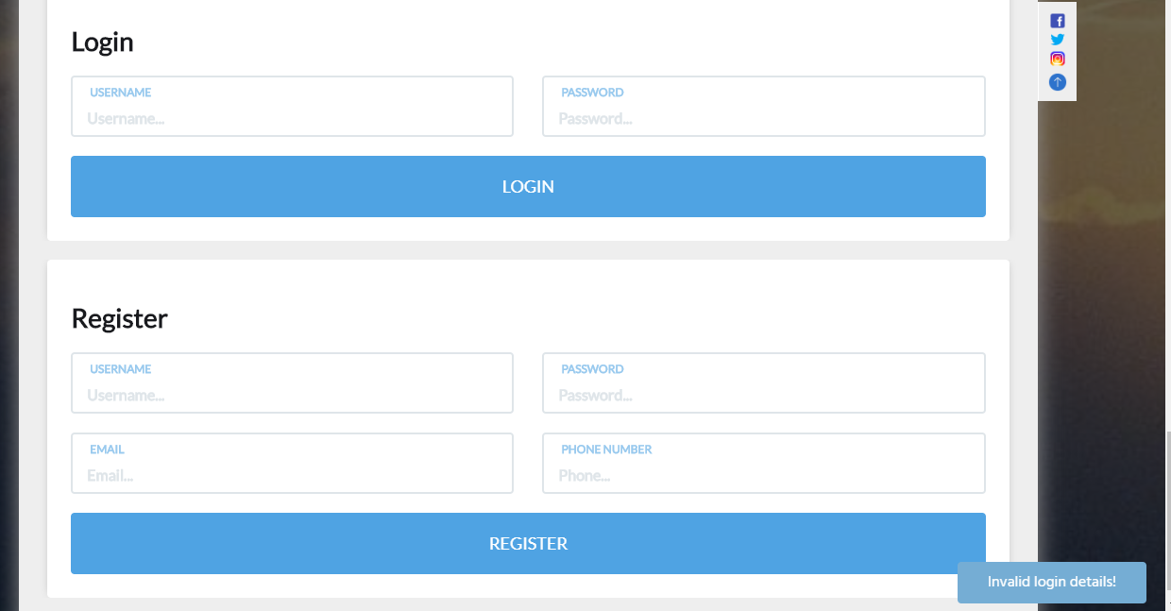

Fig: Login with invalid password

**Test Name: Contact us without data test**

Pre-Condition: No comments should be registered

|  |  |  |  |  |  |
| --- | --- | --- | --- | --- | --- |
| **Test No:** | **Test Scenario** | **Test Input Data** | **Expected Result** | **Actual Result** | **Result Pass/Fail** |
| Test No: 13 | It should not save any comments inside database | No inputs | No save of data inside database | Data was not saved | Pass |

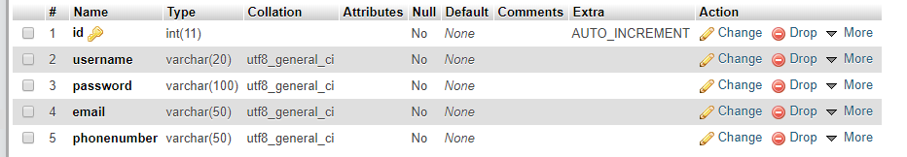

Fig: No comments were saved

**Test Name: Searching flight without inputs**

Pre-Condition: Should ask to fill data

|  |  |  |  |  |  |
| --- | --- | --- | --- | --- | --- |
| **Test No:** | **Test Scenario** | **Test Input Data** | **Expected Result** | **Actual Result** | **Result Pass/Fail** |
| Test No: 14 | No flights should be shown | No inputs | Ask to fill the corresponding data | Message to fulfill data | Pass |

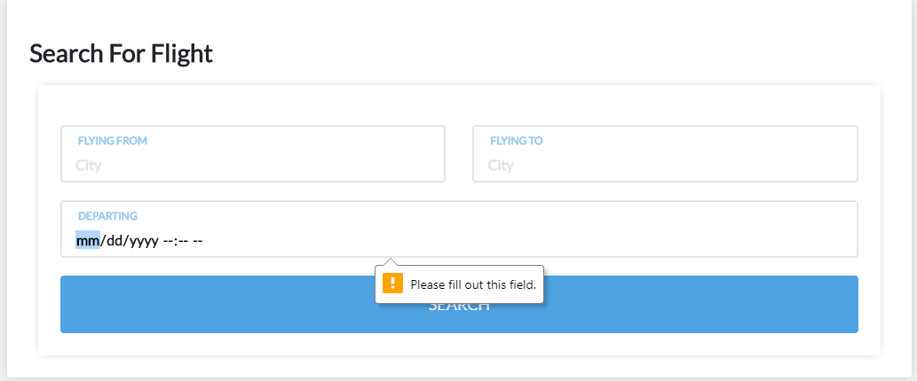

Fig: Searching flights with no inputs

**Test Name: Profile update**

Pre-Condition: Should allow for profile update

|  |  |  |  |  |  |
| --- | --- | --- | --- | --- | --- |
| **Test No:** | **Test Scenario** | **Test Input Data** | **Expected Result** | **Actual Result** | **Result Pass/Fail** |
| Test No: 15 | Should allow for profile update | Profile data | Should allow for profile update | Profile was updated successfully | Pass |

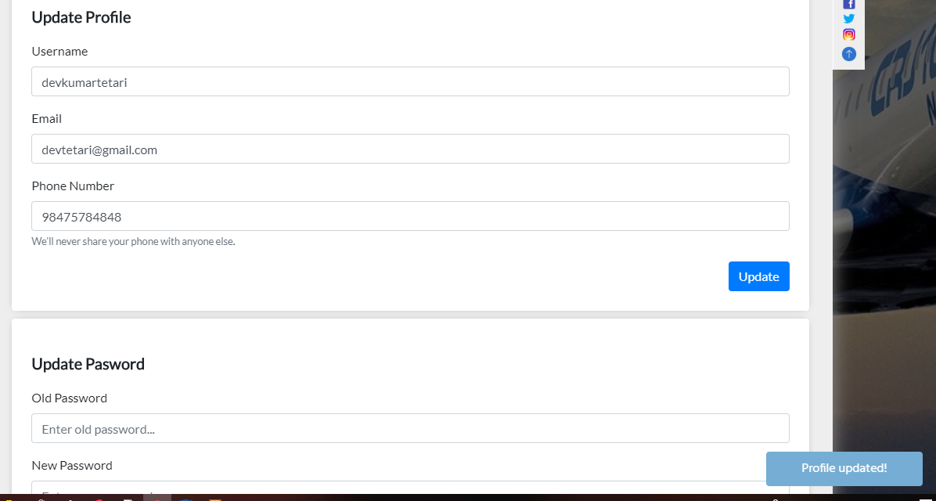

Fig: Profile updated successfully

**Test Name: Update password test**

Pre-Condition: Should allow for password update

|  |  |  |  |  |  |
| --- | --- | --- | --- | --- | --- |
| **Test No:** | **Test Scenario** | **Test Input Data** | **Expected Result** | **Actual Result** | **Result Pass/Fail** |
| Test No: 16 | Should allow for password update | Password | Should allow for password update | Password was updated successfully | Pass |

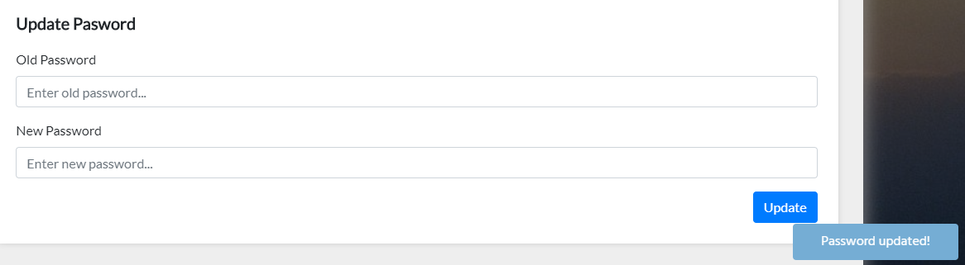

Fig: Password updated successfully

**Test Name: Add flights test**

Pre-Condition: Should allow for flights adding

|  |  |  |  |  |  |
| --- | --- | --- | --- | --- | --- |
| **Test No:** | **Test Scenario** | **Test Input Data** | **Expected Result** | **Actual Result** | **Result Pass/Fail** |
| Test No: 17 | Should allow to add flights | Flight details | Flight should be added | Flight added successfully | Pass |

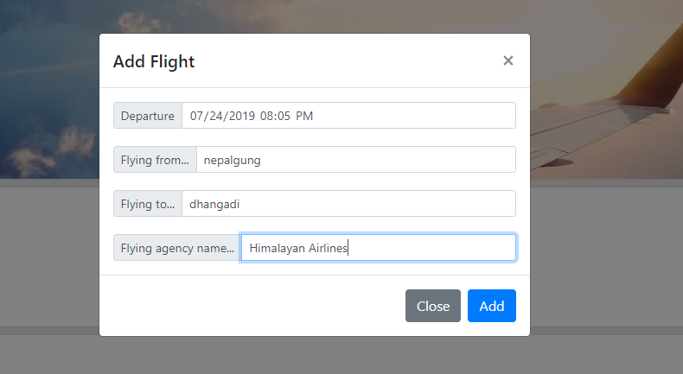

Fig: Details of the flight for adding

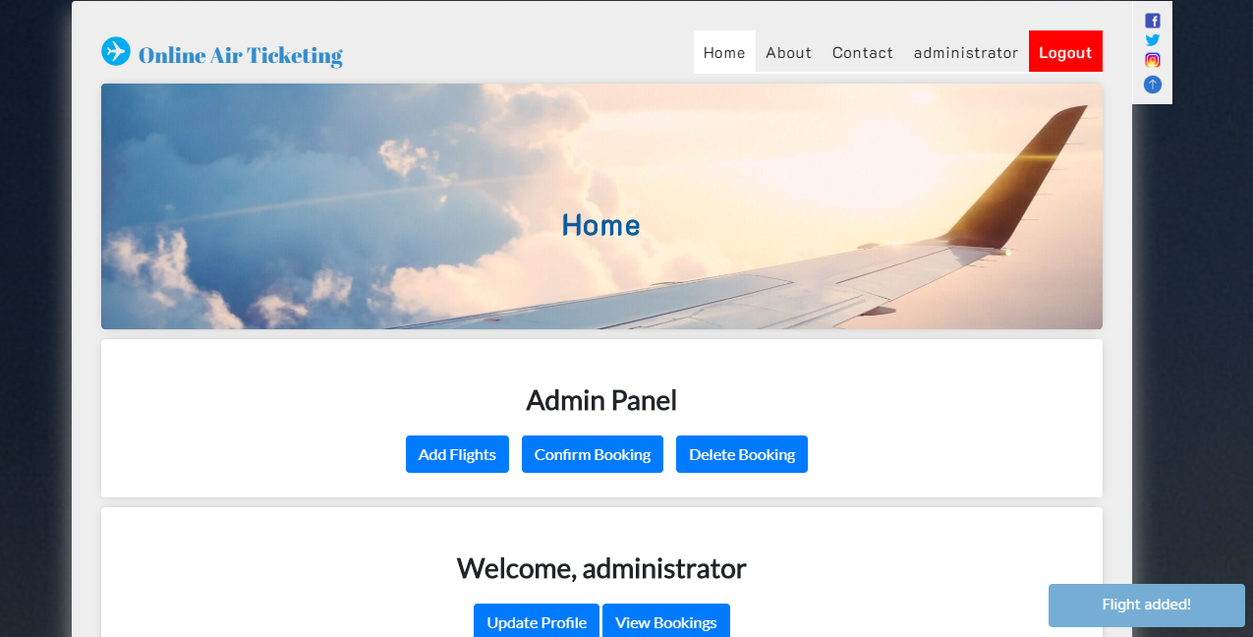

Fig: Flight added successfully

**Test Name: Delete Booking test**

Pre-Condition: The booking should be deleted

|  |  |  |  |  |  |
| --- | --- | --- | --- | --- | --- |
| **Test No:** | **Test Scenario** | **Test Input Data** | **Expected Result** | **Actual Result** | **Result Pass/Fail** |
| Test No: 18 | Should allow to delete booking | Booking id | Booking should be deleted | Booking deleted successfully | Pass |

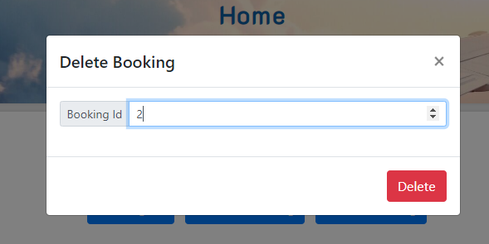

Fig: Booking id for deleting



Fig: Booking deleted successfully

**Test Name: Booking Confirmation test**

Pre-Condition: Should show message for confirmation

|  |  |  |  |  |  |
| --- | --- | --- | --- | --- | --- |
| **Test No:** | **Test Scenario** | **Test Input Data** | **Expected Result** | **Actual Result** | **Result Pass/Fail** |
| Test No: 19 | Should show message for confirmation | Booking id | Should show message for confirmation | Booking was confirmed | Pass |

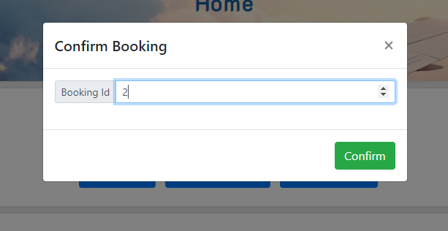Fig: Id for confirmation

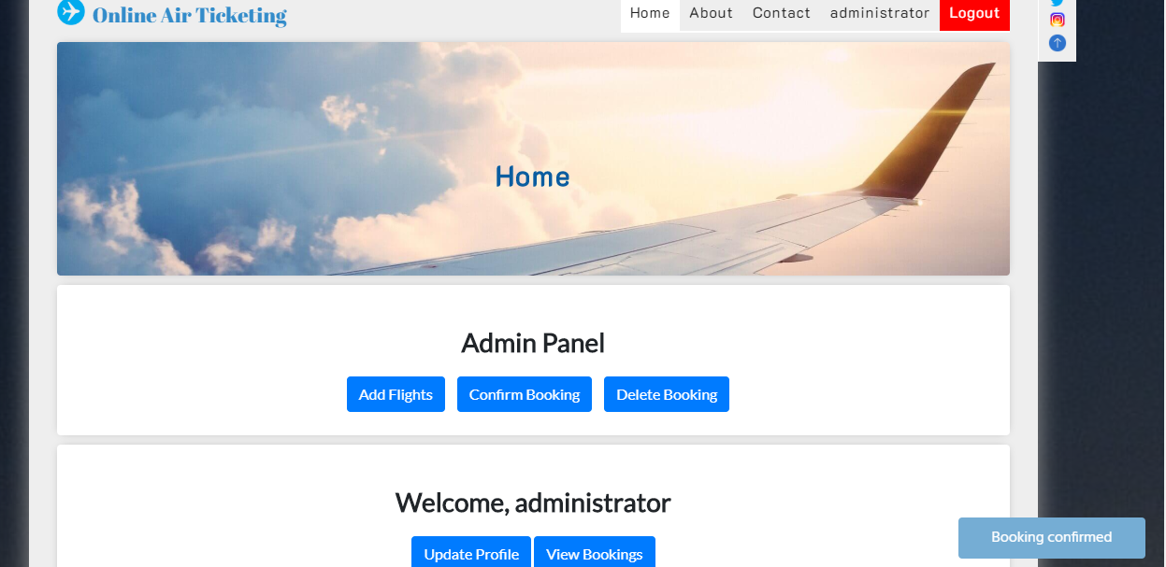

Fig: Message for confirmation

**Unit Testing:** It is kind of testing where particular units/components are tested thoroughly. This is performed in order to confirm that all the components of the particular things perform effectively. It is often performed by the software engineer by the use of test input and comparing yields.

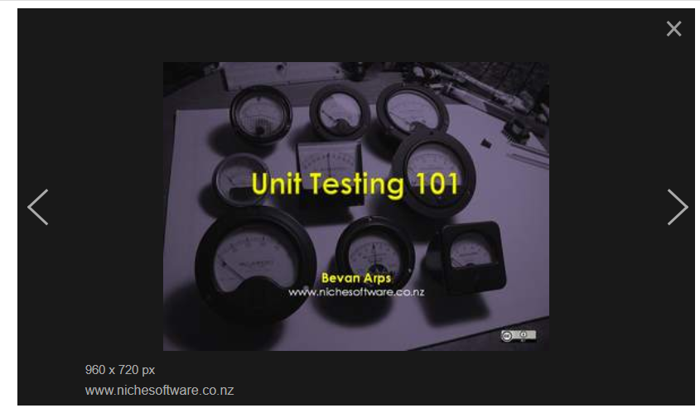

Fig: Unit testing