Schematic:

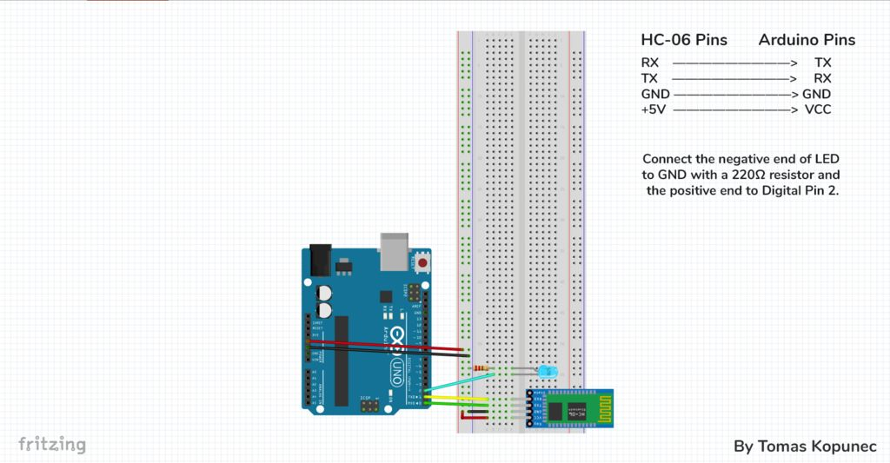

Code:

const int led = 2;

void setup() {

Serial.begin(9600);

pinMode(led, OUTPUT);

}

void loop() {

char c = Serial.read();

if(c == 'a'){

digitalWrite(led, HIGH);

}

else if(c == 'b'){

digitalWrite(led, LOW);

}

else{

}

delay(25);

}

Note: Remove Rx and Tx Connection before uploading the program.

Application:

<https://play.google.com/store/apps/details?id=com.kopunectomas.smartbluetooth>