**Graphical Programming Language Applications**

In this modern era of science and technology, people are attracted to the most easy and reliable technique. Programming language was able to do that. This mainly includes Graphical Programming Language (GPL). It is also known as Visual Programming Language (VPL) which can be easily understood with the help of visualization. A VPL employs techniques to design a software program in two or more dimensions, and includes graphical elements, text, symbols and icons within its programming context. This allows users to select or design a different skin at will, and eases the designer's work to change the interface as user needs evolve.

The software is based on **Agile Methodology**.

**Agile development** refers to a group of software development methodologies based on iterative development, where requirements and solutions evolve through collaboration between self-organizing cross-functional teams.

 Characteristics of agile process:

* It releases and fixed-length iterations.
* It delivers working and tested software.
* Value driven development
* Continuous planning
* Multi-level planning in agile development
* Relative estimation
* Emergent feature discovery
* Continuous testing
* Continuous improvement

**Methodology:**

* Planning:
* Service level agreements and its conditions.
* Information gathering.
* Requirement analysis:
* Gather all the requirements required to implement in project.
* Design:
* Breakdown of tasks
* Test Scenario preparation for each task
* Regression Automation Framework
* Execution:
* Coding
* Unit Testing
* Execution of Manual test scenarios
* Defect Report generation
* Conversion of Manual to Automation regression test cases
* Mid Iteration review
* End of Iteration review

**Main form:**

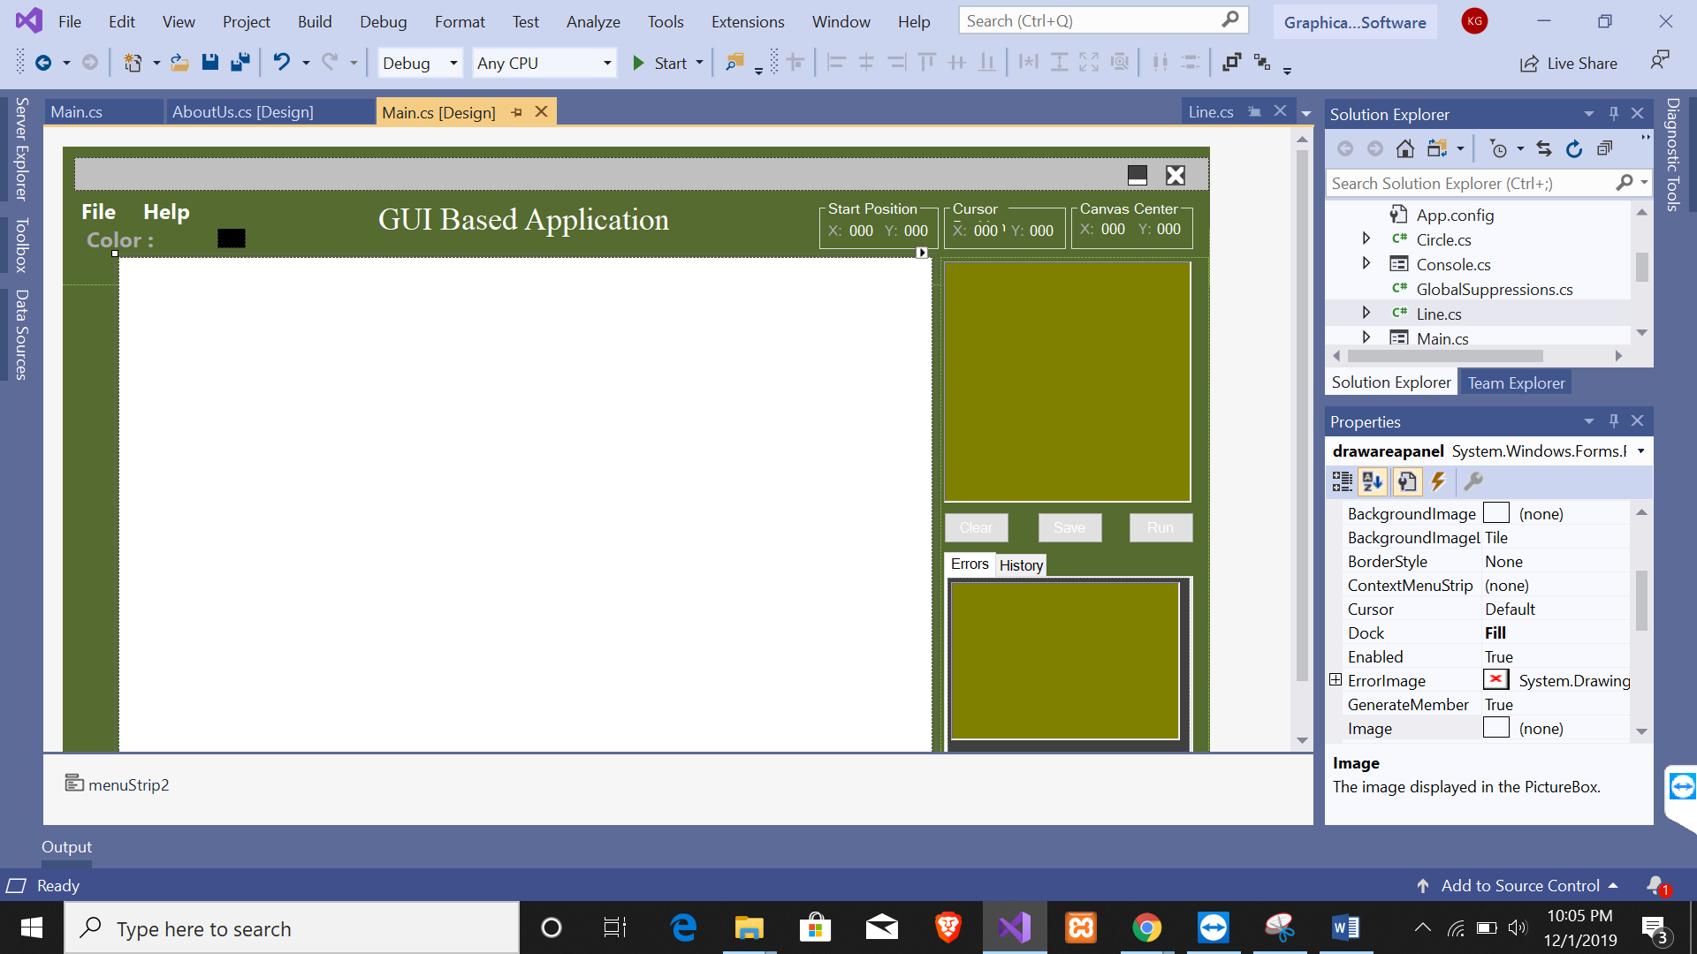

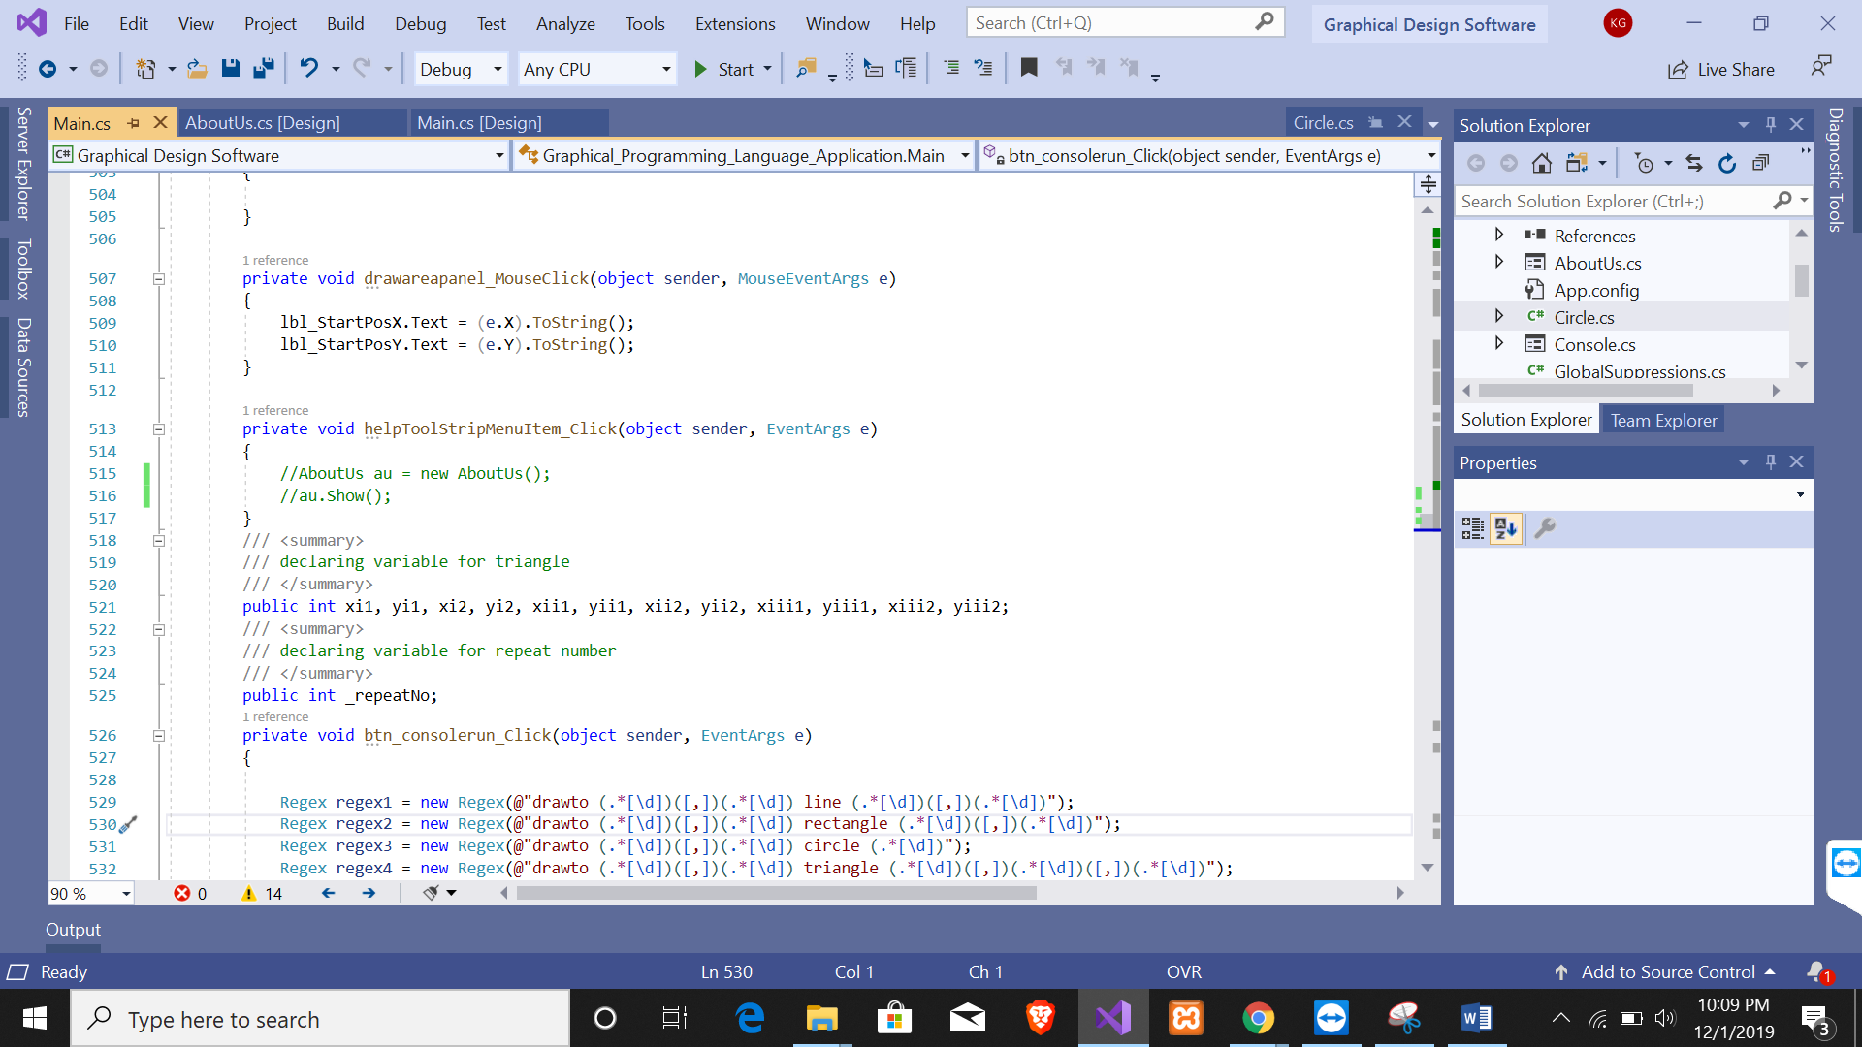

**Circle**

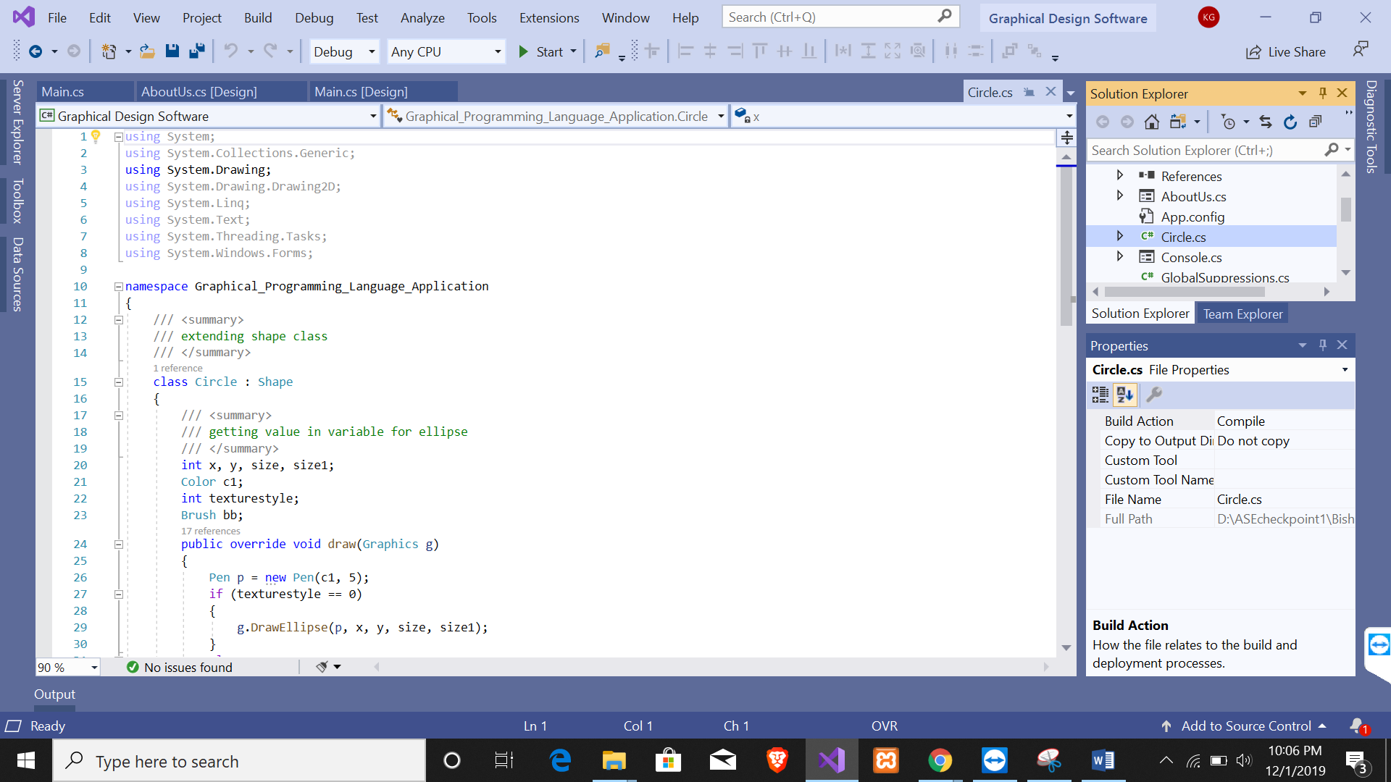

**Line**

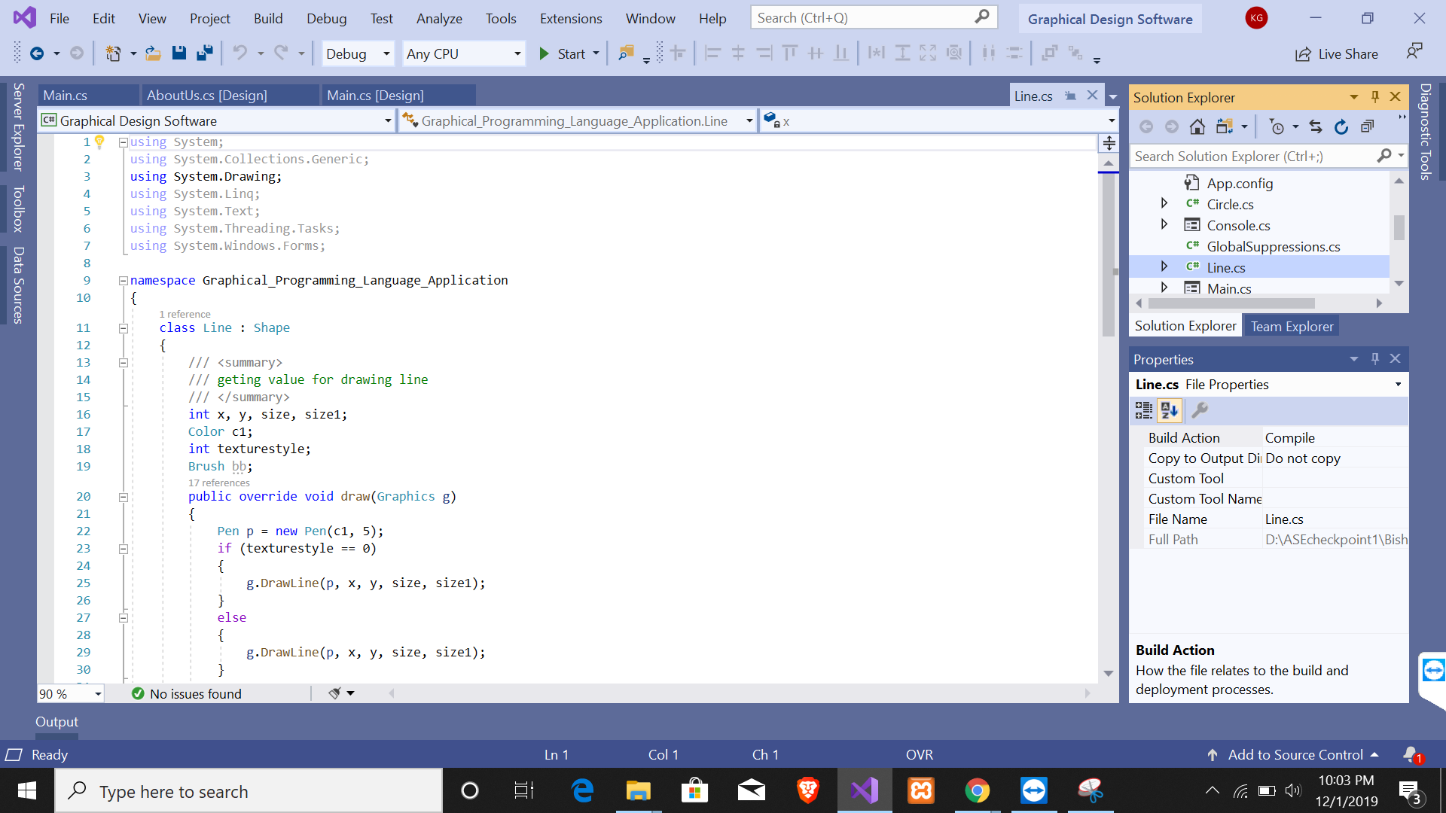

Rectangle

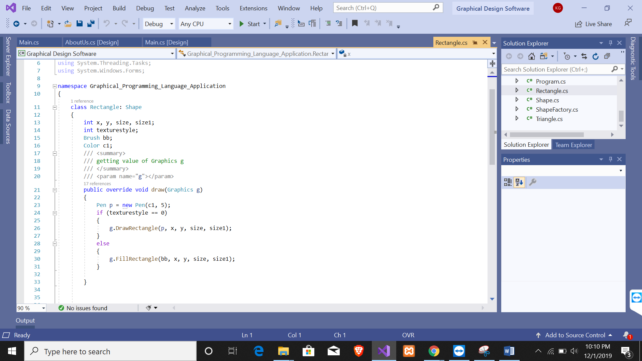

Triangle

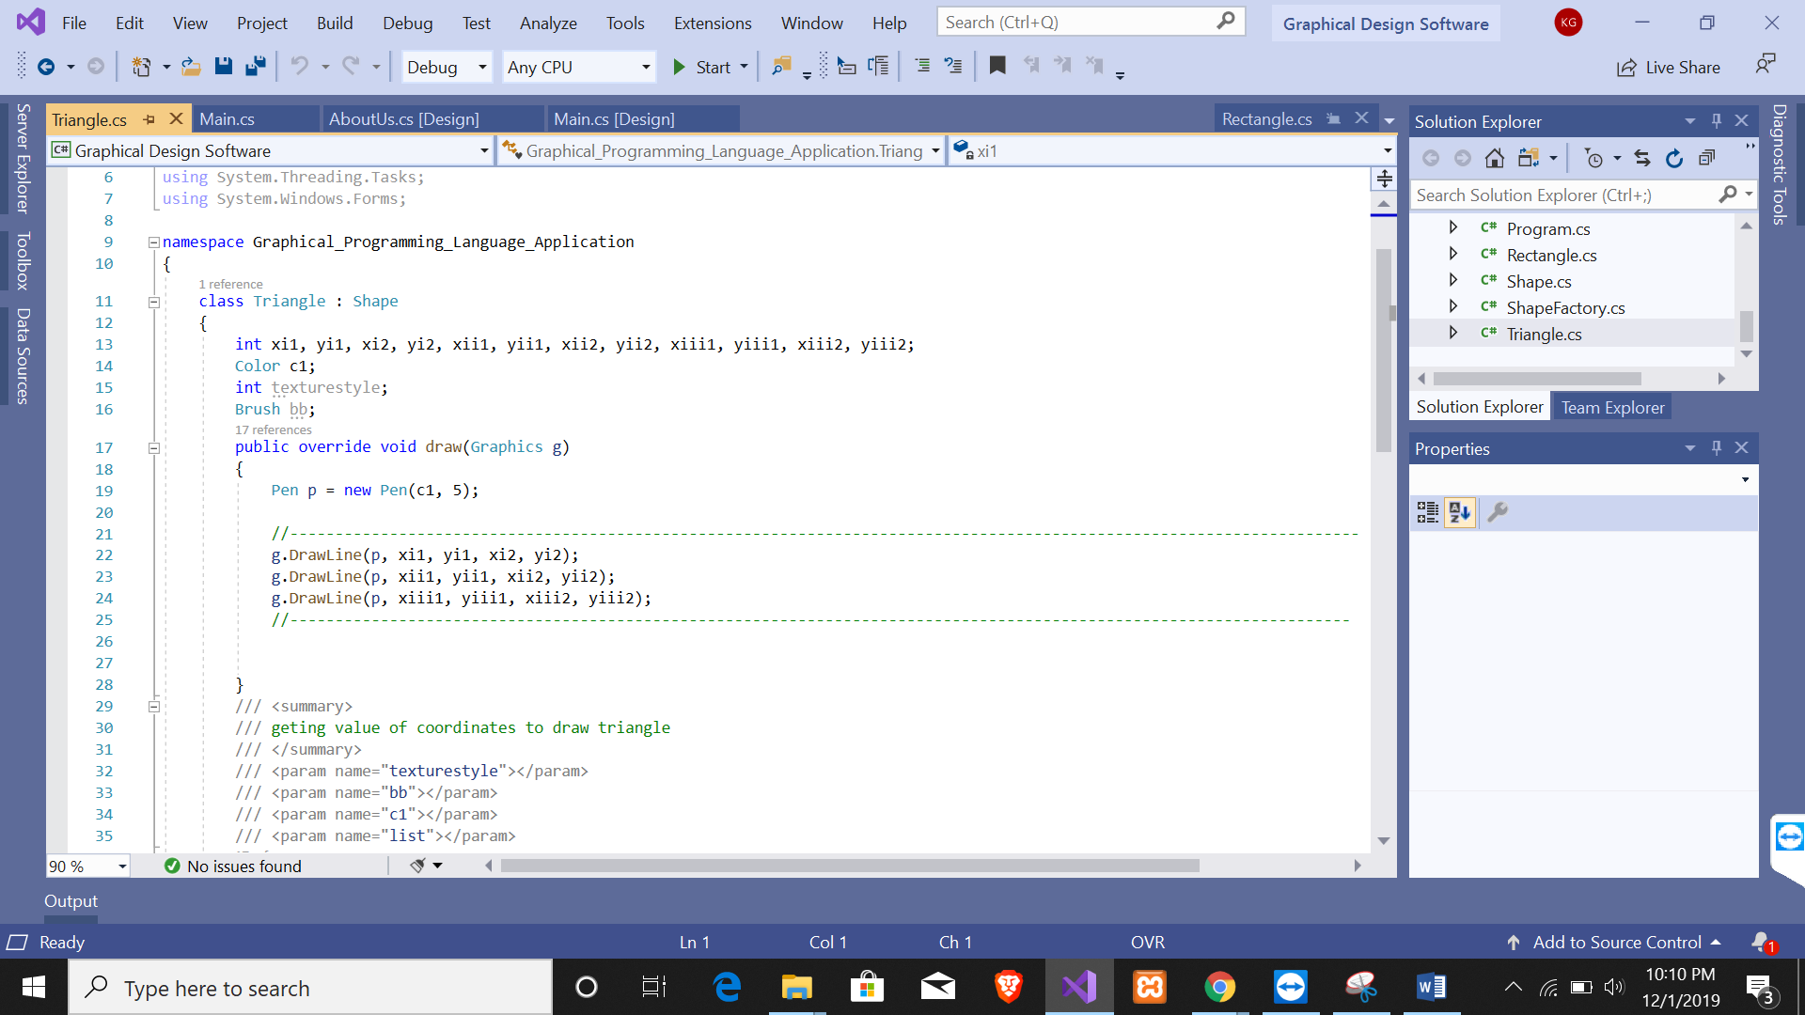

Unit Testing

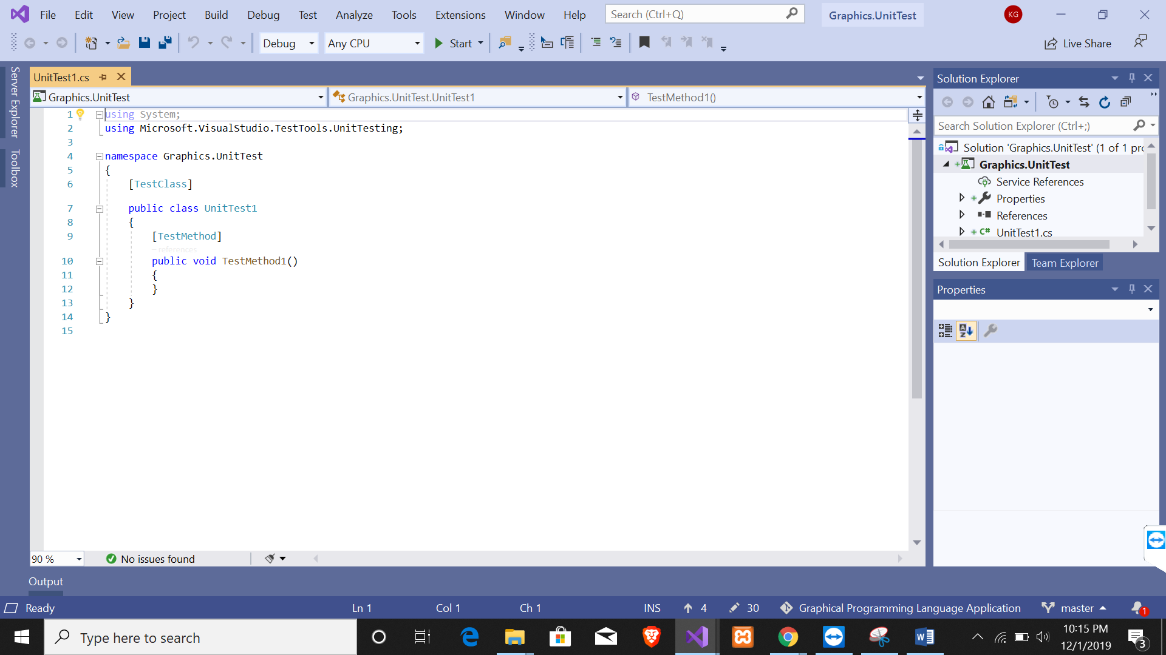

|  |  |  |  |
| --- | --- | --- | --- |
| What was tested | Expected output | Actual Output | Remark |
| Circle Set Parameter tested | The value of x, y and radius of circle class should be same as the value passed in circle test class | As expected the value x, y and radius of circle class was same as the parameter provide in circle test class | Successful |
| Rectangle Set Parameter tested | The value of x, y, width, height rectangle class should be same as the value passed in rectangle test class | As expected the value x, y, width and height of rectangle was same as the parameter provided in rectangle test class | Successful |
| Triangle Set Parameter tested | The value of x, y, tox and toy triangle class should be same as the value in triangle test class | As expected the value x, y, tox and toy triangle was same as the parameter provided in triangle test class | Successful |
| 3DRectangle Set Parameter tested | The value of x, y, width and height of 3drectangle class should be same as the value passed in 3drectangle test class | As expected the value x, y, width and height of the 3drectangle was same as the value provided in 3drectangle test class | Successful |

**Git Hub**

Version control is independent of the kind of project / technology / framework we are working with the different projects. The version control system writes changes made by the user to a file in the project. This is about version control. It's really simple. It is the management of changes to documents, programs and other information stored as computer files.

Here I have used the GitHub to commit my project i.e. Graphical Programming Language Application