Basic Concept of Git and GitHub

What is Version Control System (VCS)?

Version Control Systems are the software tools for tracking/managing all the changes made to the source code during the project development.

It keeps a record of every single change made to the code. It also allows us to turn back to the previous version of the code if any mistake is made in the current version.

Without a VCS in place, it would not be possible to monitor the development of the project.

Types of VCS

1.Centralized Version Control System

2.Distributed Version Control System

1.Centralized Version Control System:

In the Centralized Version Control Systems, there will be a single central server that contains all the files related to the project, and team members can download the files from this single server that he wants to change and after doing the work simply upload them to the server.

The problem with the Centralized Version Control Systems is if the central server crashes, almost everything related to the project will be lost.

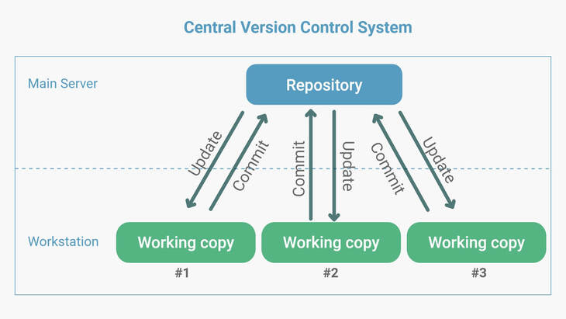

2.Distributed Version Control System

In a distributed version control system, there will be one or more servers and many team members similar to the centralized system. But the difference is, not only do they will download the latest version, but each member will have an exact copy (mirroring) of the main repository (including its entire history) on their local machines.

Each user has their own repository and a working copy. This is very useful because even if the server crashes, we would not lose everything as several copies are residing in several other computers.

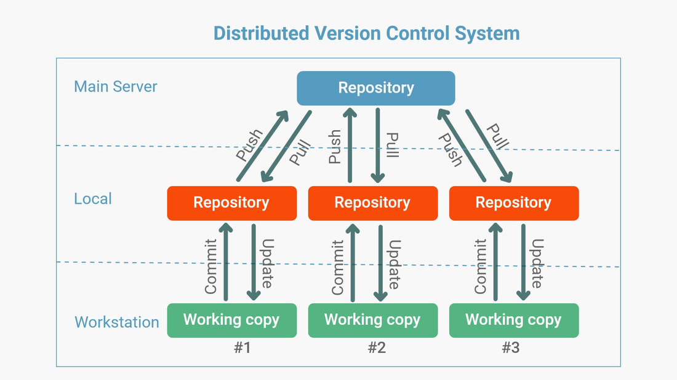

|  |  |
| --- | --- |
| CVCS | DVCS |
| Benefits of CVCS | Benefits of DVCS |
| Easy to learn and manage | Except for pushing and pulling the code, the user can work offline in DVCS |
| Works well with binary files | DVCS is fast compared to CVCS because you don't have to contact the central server for every command |
| More control over users and their access. | Performance of DVCS is better |
| Example: CVS and SVN are some conventional Central Version Control systems. | Even if the main server crashes, code will be stored in the local systems |
| Drawbacks of CVCS | Drawbacks of DVCS |
| It is not locally available, which means we must connect to the network to perform operations. | None |
| During the operations, if the central server gets crashed, there is a high chance of losing the data. |  |
| For every command, CVCS connects the central server which impacts speed of operation |  |

So, Why do we need Version Control System?

When multiple team members work on the same project, it is essential to have version control for the program. Version control system helps the team to share changes and merge changes made to artifacts seamless and efficient.

VCS improves the following factors:

1. Collaboration
2. Storing Versions
3. Backup
4. Improves visibility
5. Accelerate product delivery

Before diving deep, let’s explain a scenario before Git:

1. Developers used to submit their codes to the central server without having copies of their own.
2. Any changes made to the source code were unknown to the other developers
3. There was no communication between any of the developers

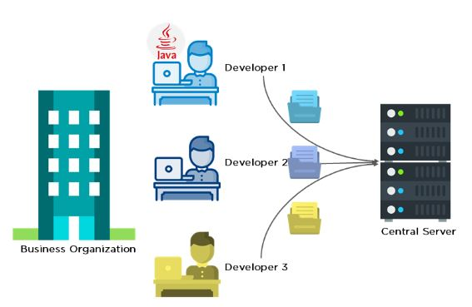

Now let’s look at the scenario after Git:

1. Every developer has an entire copy of the code on their local systems
2. Any changes made to the source code can be tracked by others
3. There is regular communication between the developers

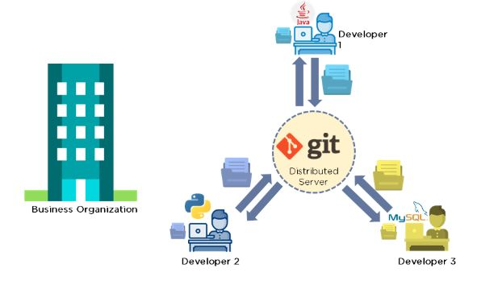

What is Git?

Git is a most commonly used distributed version control system. It was created by Linus Torvalds in 2005, and has been maintained by Junio Hamano since then.

It is used for:

Tracking code changes

Tracking who made changes

Coding collaboration

What is GitHub?

GitHub is a cloud based open-source repository hosting service, it is a web-based interface that uses Git, an open-source version control system.

It maintains track of the modifications made to each iteration of your source code projects in a variety of programming languages.

