**Lab 1: Getting Familiar with Microsoft Project**

* 1. **Creating a Project File**

Firstly, we install the Microsoft Project and open it. Then, the landing page is:

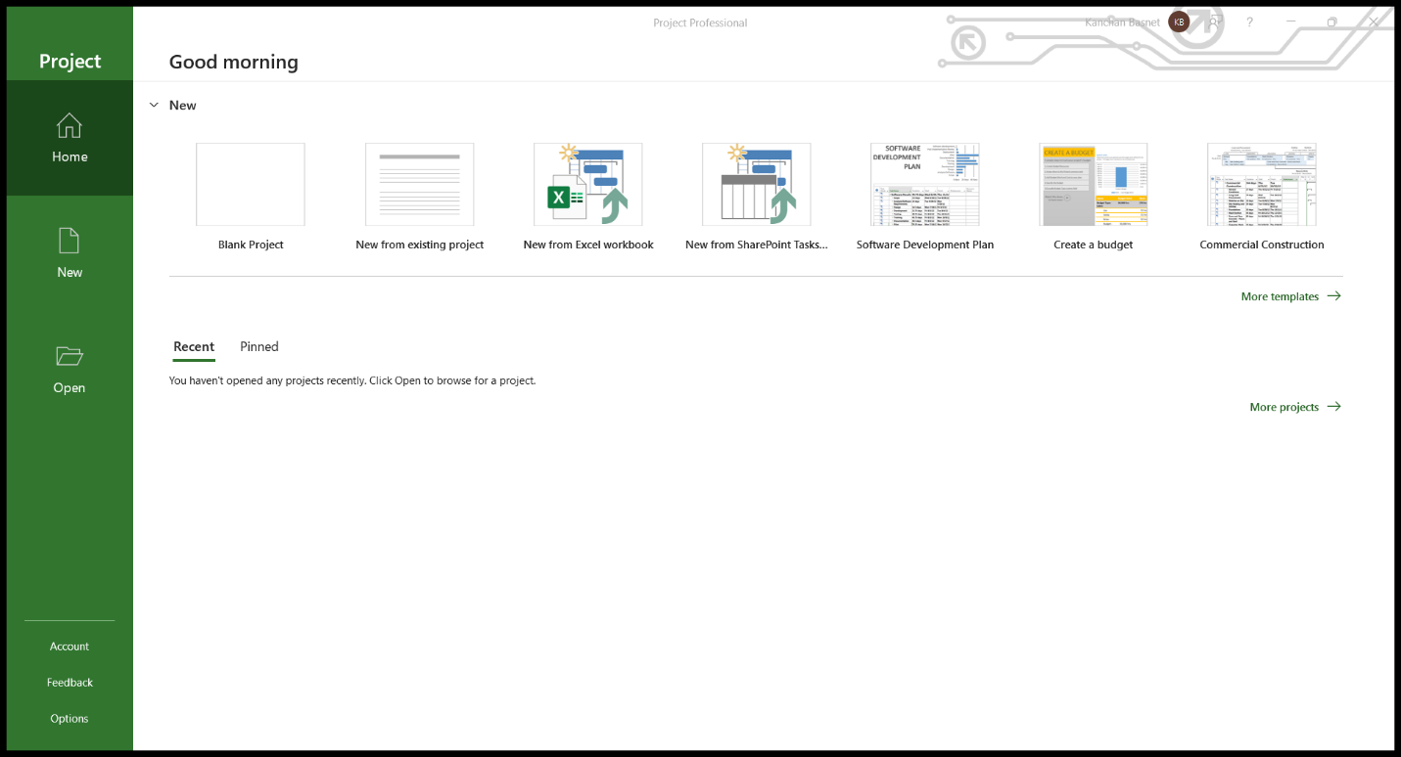

Then, we can view the options available on the page to start a project.

- Start a new blank project.

- Start a new project from existing project.

- Start a new project from Excel workbook.

- Start a new project from SharePoint tasks.

Let’s start by selecting a Blank Project.

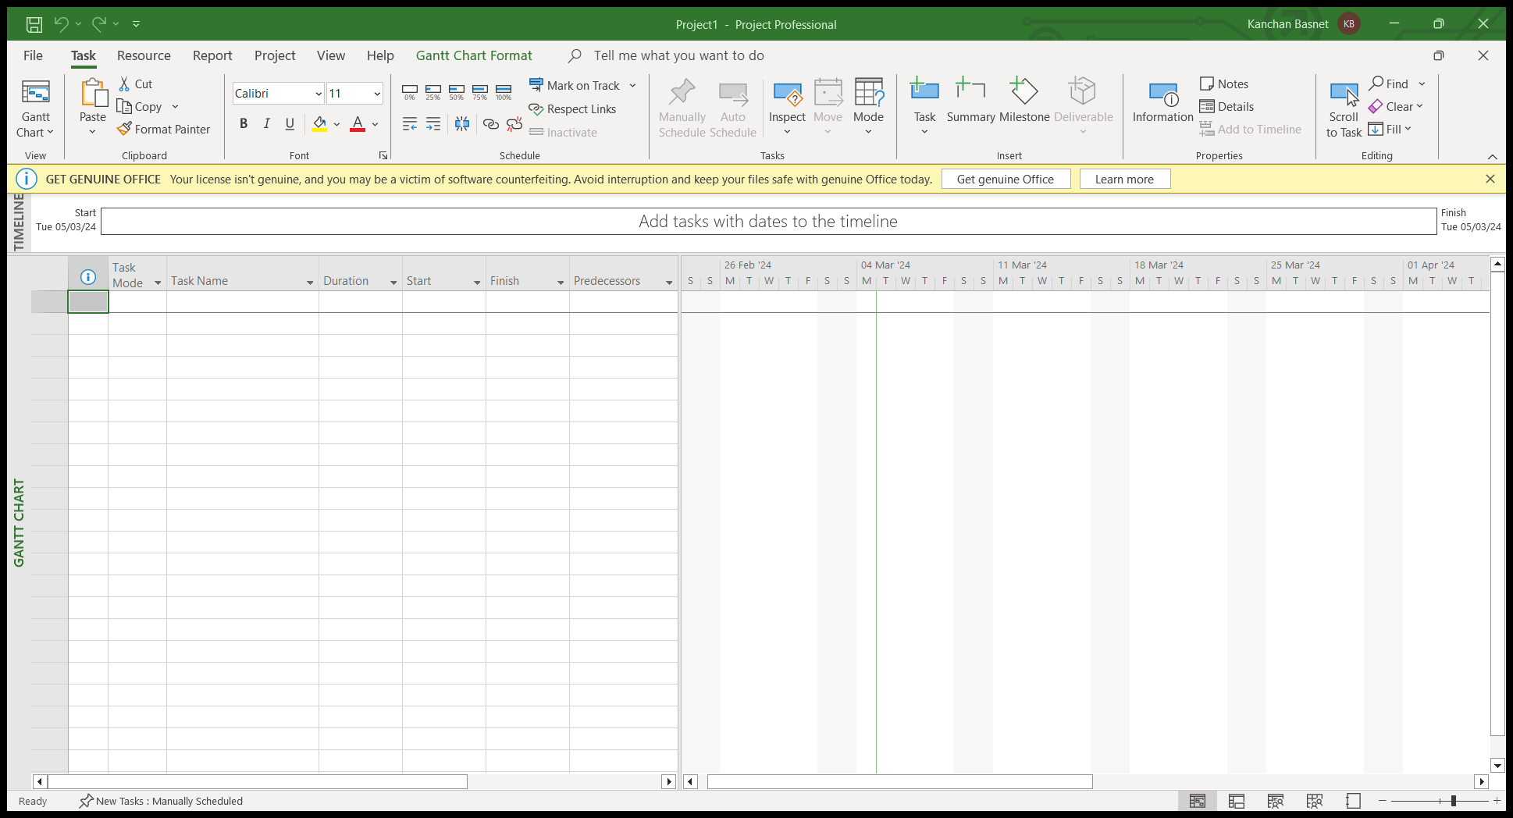

In the menu bar, we can see various interfaces.

The menu bar in Microsoft Project typically includes the following standard menus:

**I. File:**

• Options to create, open, save, and print project files.

• Import and export options.

• Recent Files and account information

On clicking the file, we see this page:

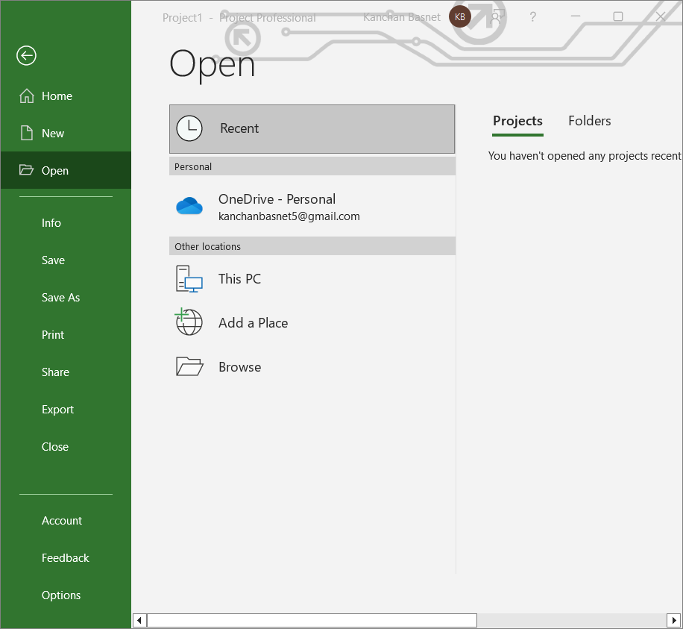

**II. Task:**

• Commands related to task management, such as creating, editing, and formatting tasks.

• Options for outlining and organizing tasks.

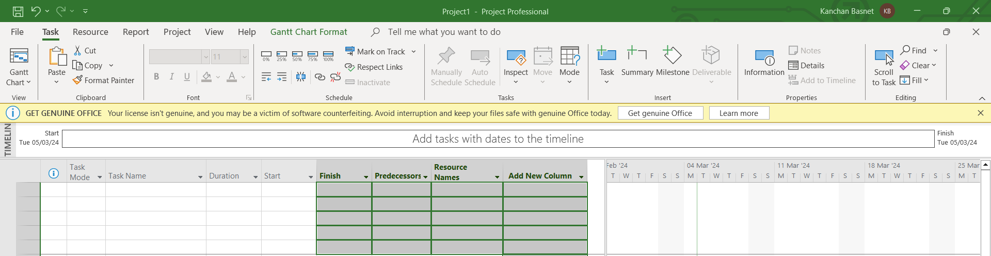

**III. Resource:**

• Commands related to resource management, including adding and editing resources.

• Assigning resources to tasks.

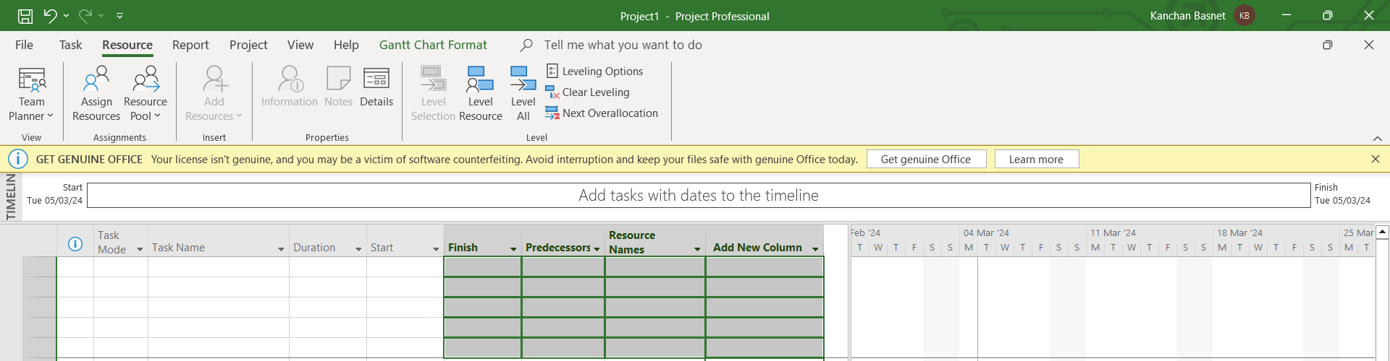

**IV. Project:**

• Project-related commands, such as changing project settings and views.

• Options for managing project information.

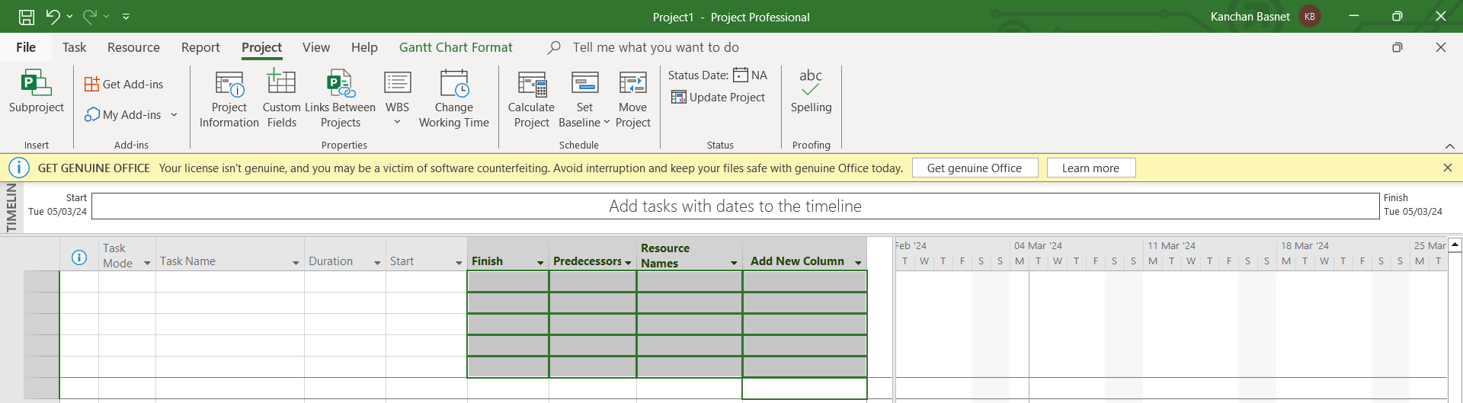

**V. View:**

• Commands for changing the current view, such as Gantt Chart, Resource Sheet, and

Network Diagram.

• Options for customizing the appearance of the project.

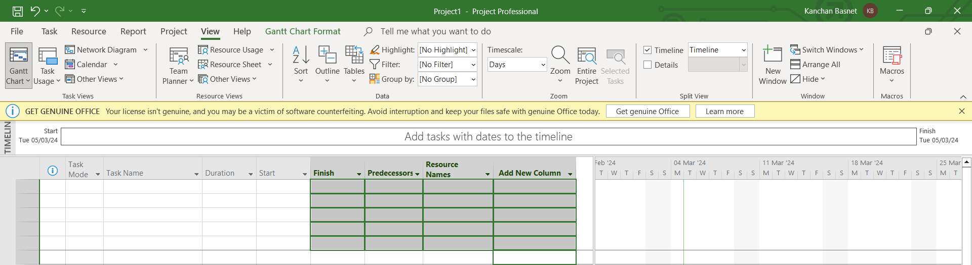

**VI. Help:**

• Access to the software's help resources, including documentation and online support

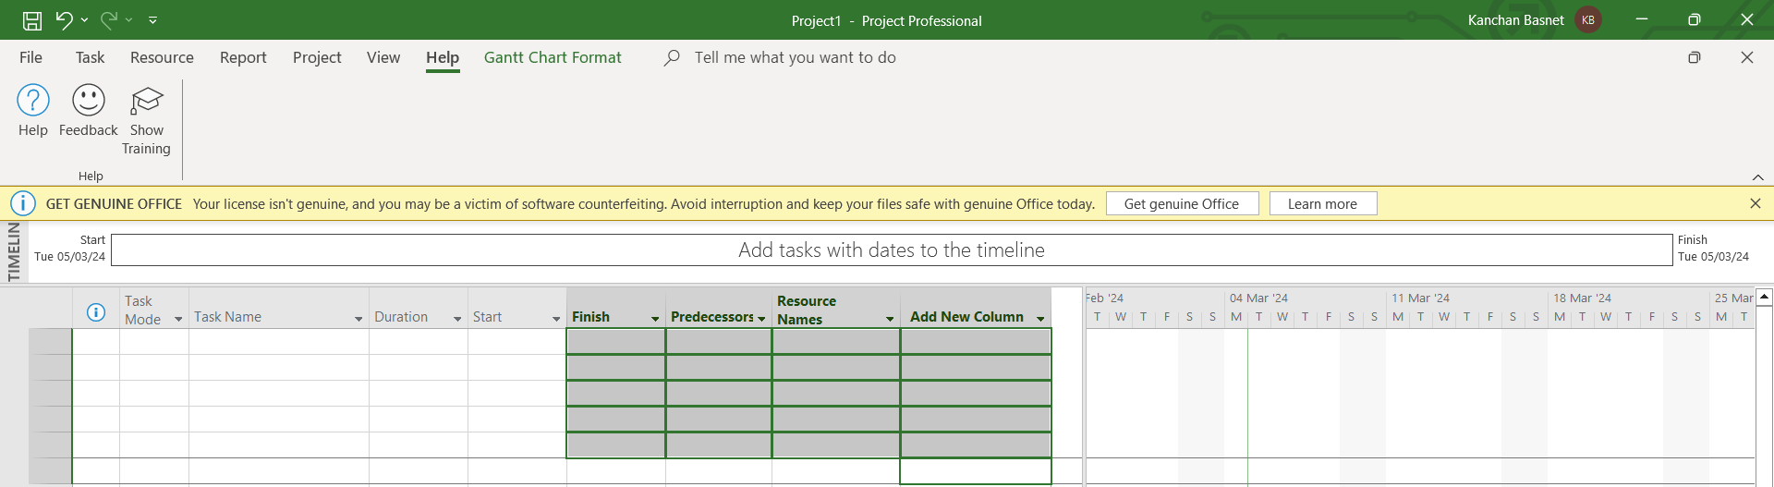

**VII. Gantt Chart Format**

• The Gantt Chart is a key feature used for visualizing project tasks and timelines

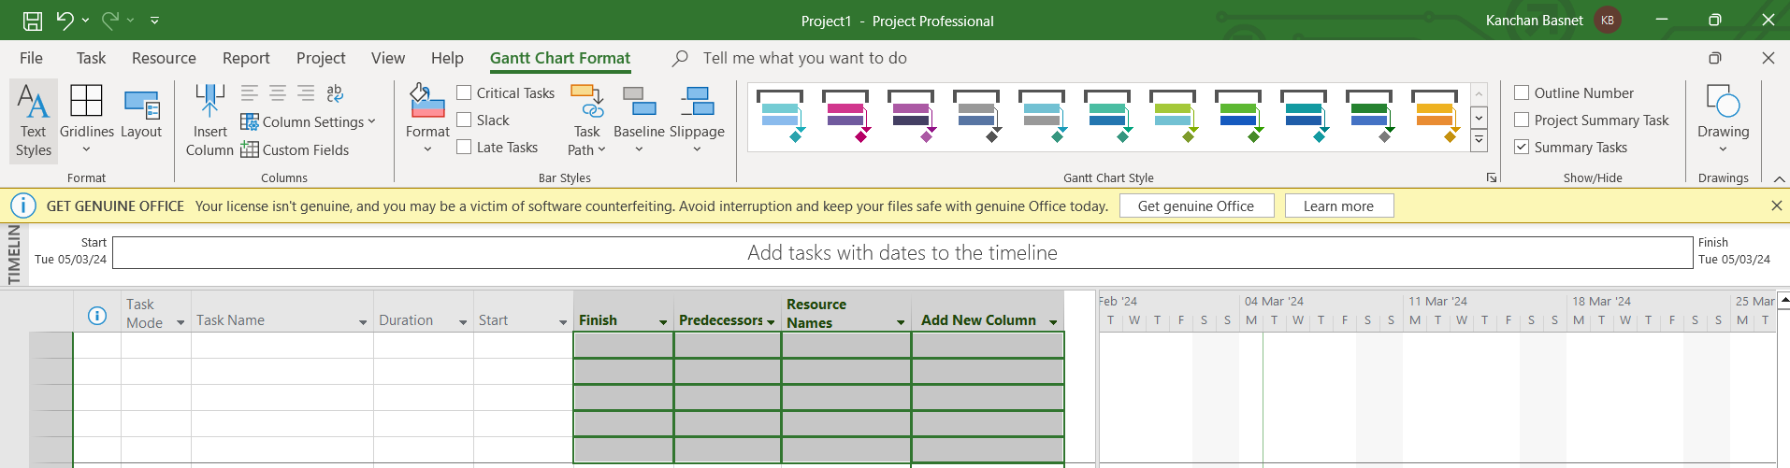

**Lab 2: Creating a Gantt chart using Microsoft Project**

**Theory**

A Gantt chart is a visual representation of a project schedule that shows tasks, their start and end dates, dependencies between tasks, and the overall timeline of the project. It provides a comprehensive view of the project, allowing project managers and team members to understand the sequence of activities and their duration.

Steps to create Gantt chart using Microsoft Project:

1. Start a new Blank Project

2. Click on Task and select the Gantt chart.

3. Add all task in the Task Name.

4. Indentation can also be done to create a task hierarchy.

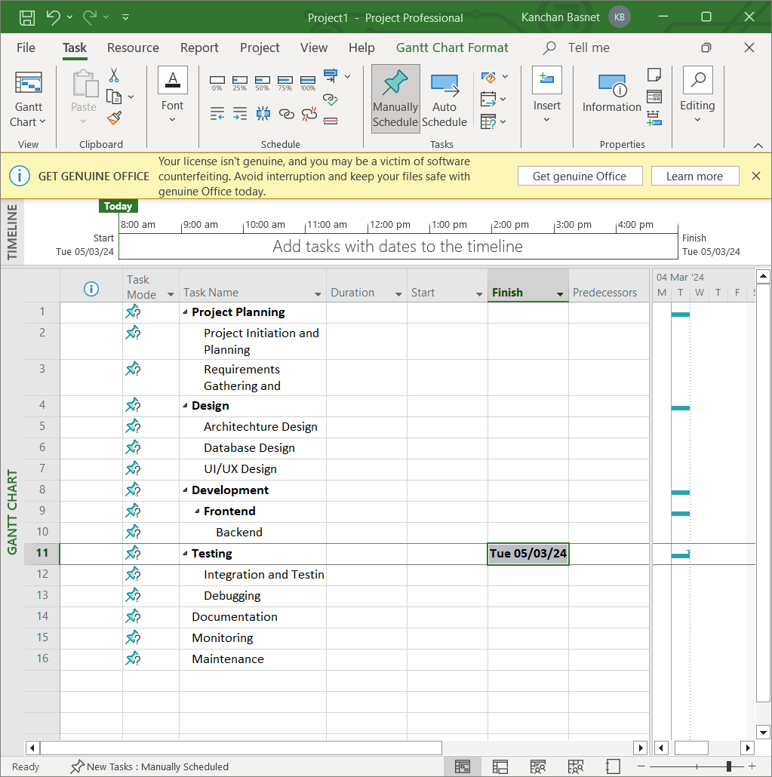

5. Then, we define the duration, start and end dates. We can set dates manually as well as do auto schedule.

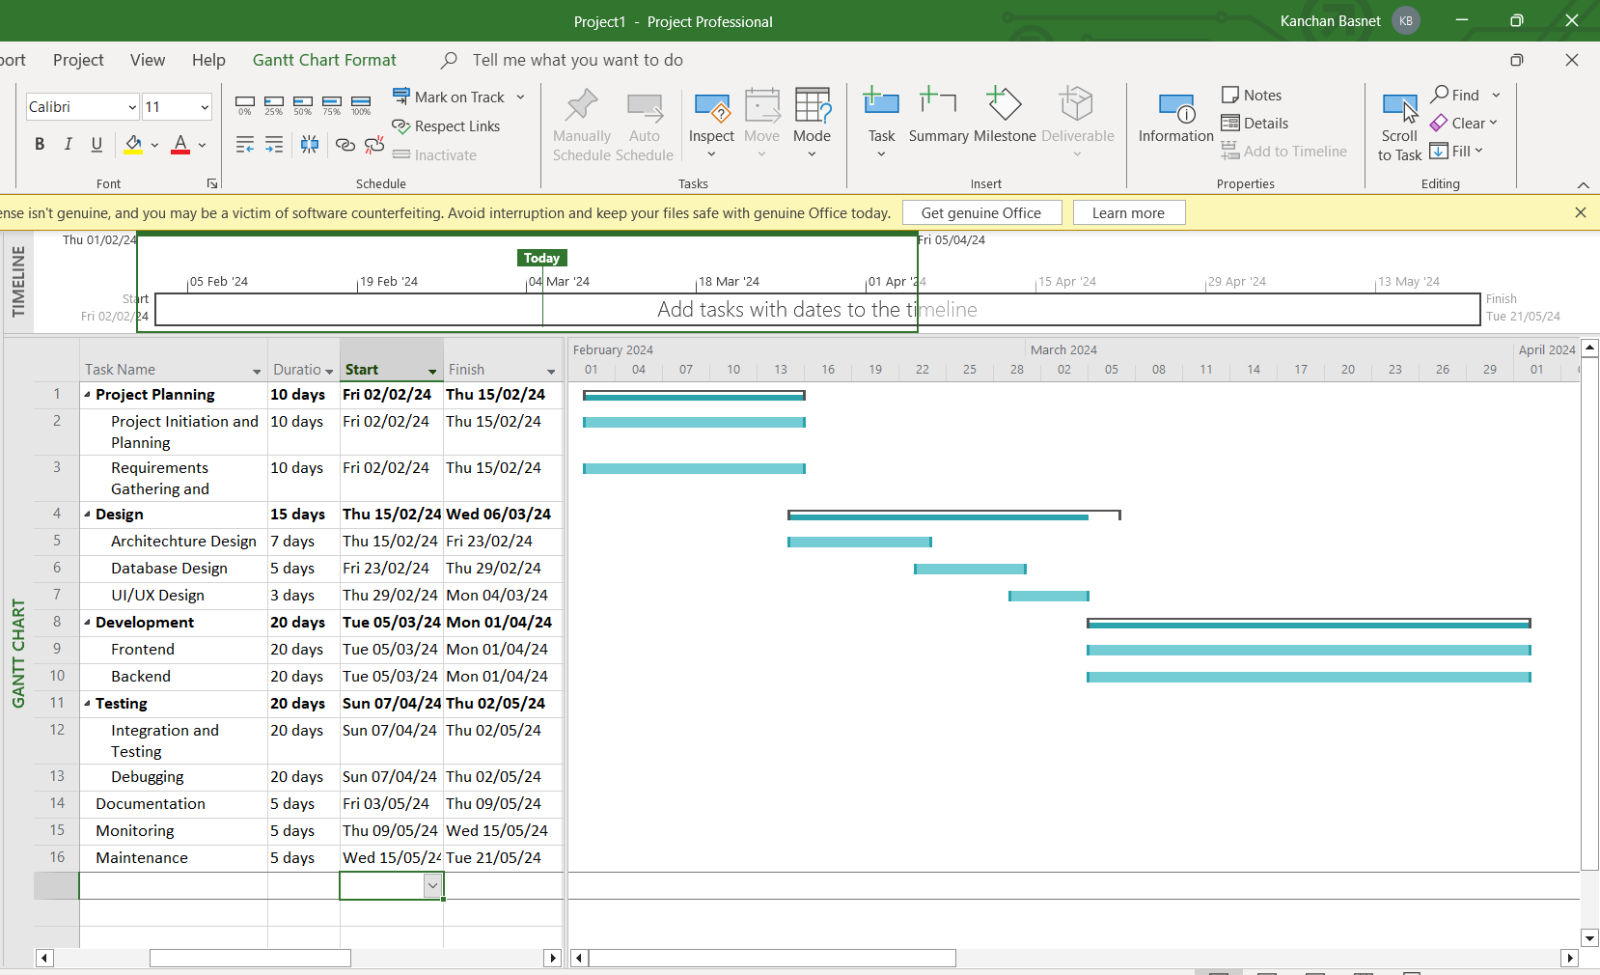

6. We can see Gantt chart on the right hand side of the Microsoft Project.

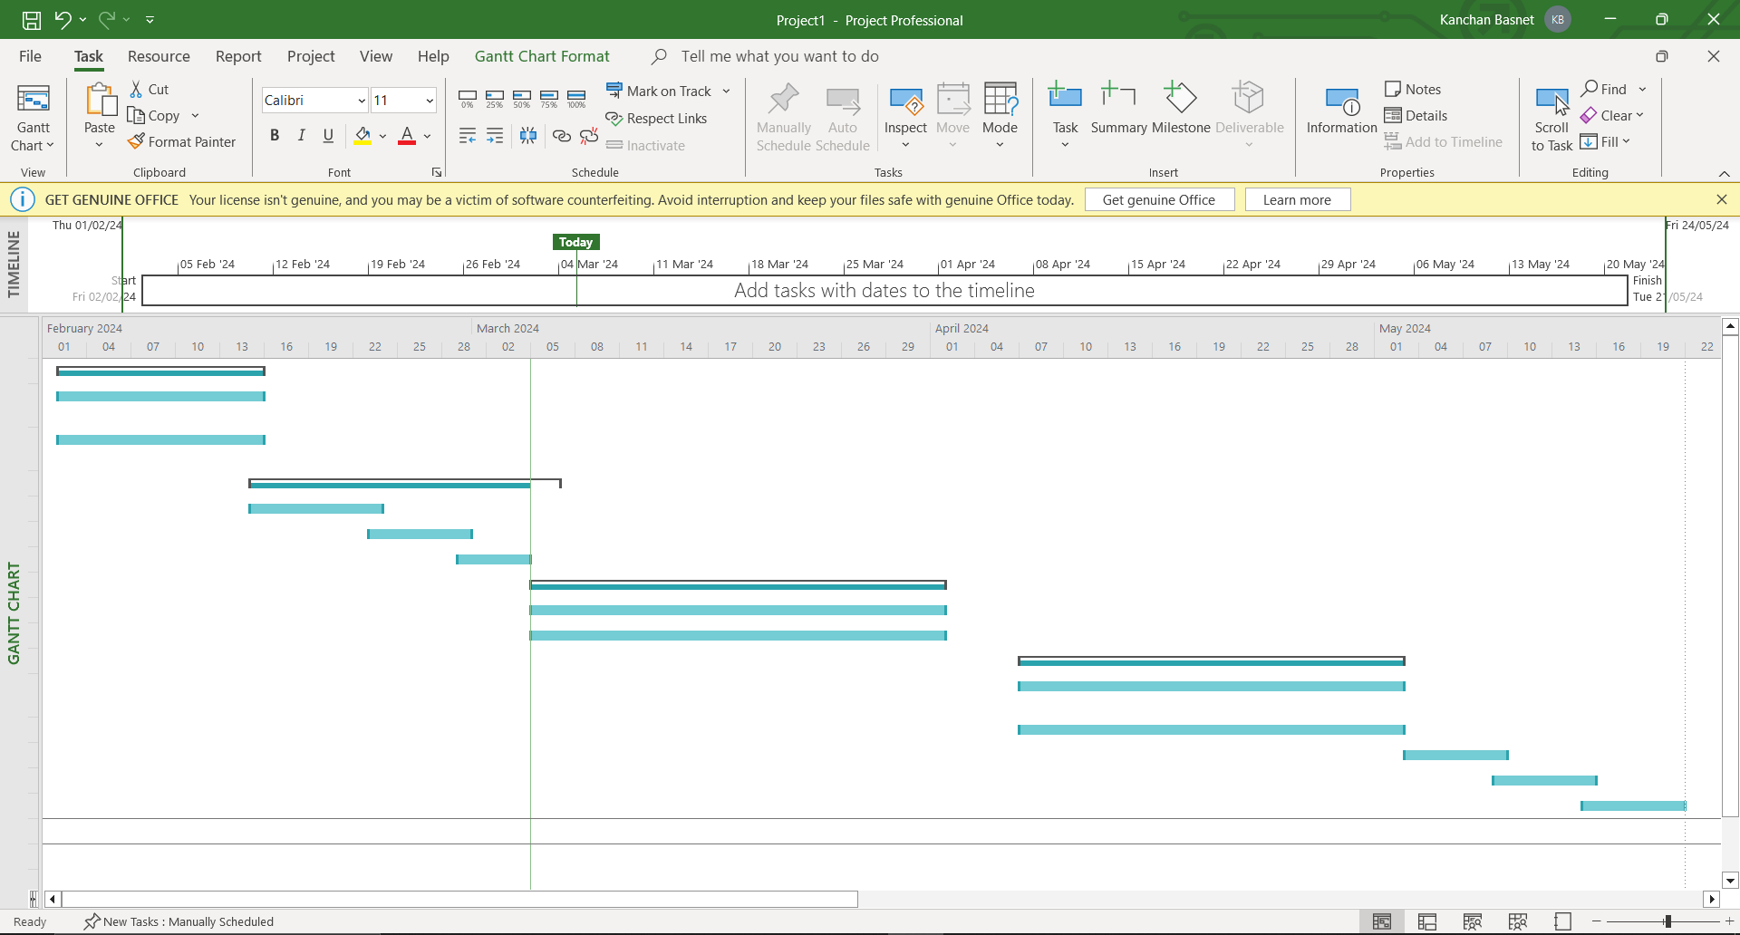

**Lab 3: Adding Predecessors, Priority, Lag and Managing Dependencies.**

**3.1 Adding Predecessors**

We have the option to include predecessors for tasks by entering the task number in the predecessor's column. The task number of the preceding task or tasks is entered in the corresponding predecessor column for the dependent task. This establishes a straightforward finish-to-start dependency between the tasks, and this connection is visible on the Gantt chart as well.

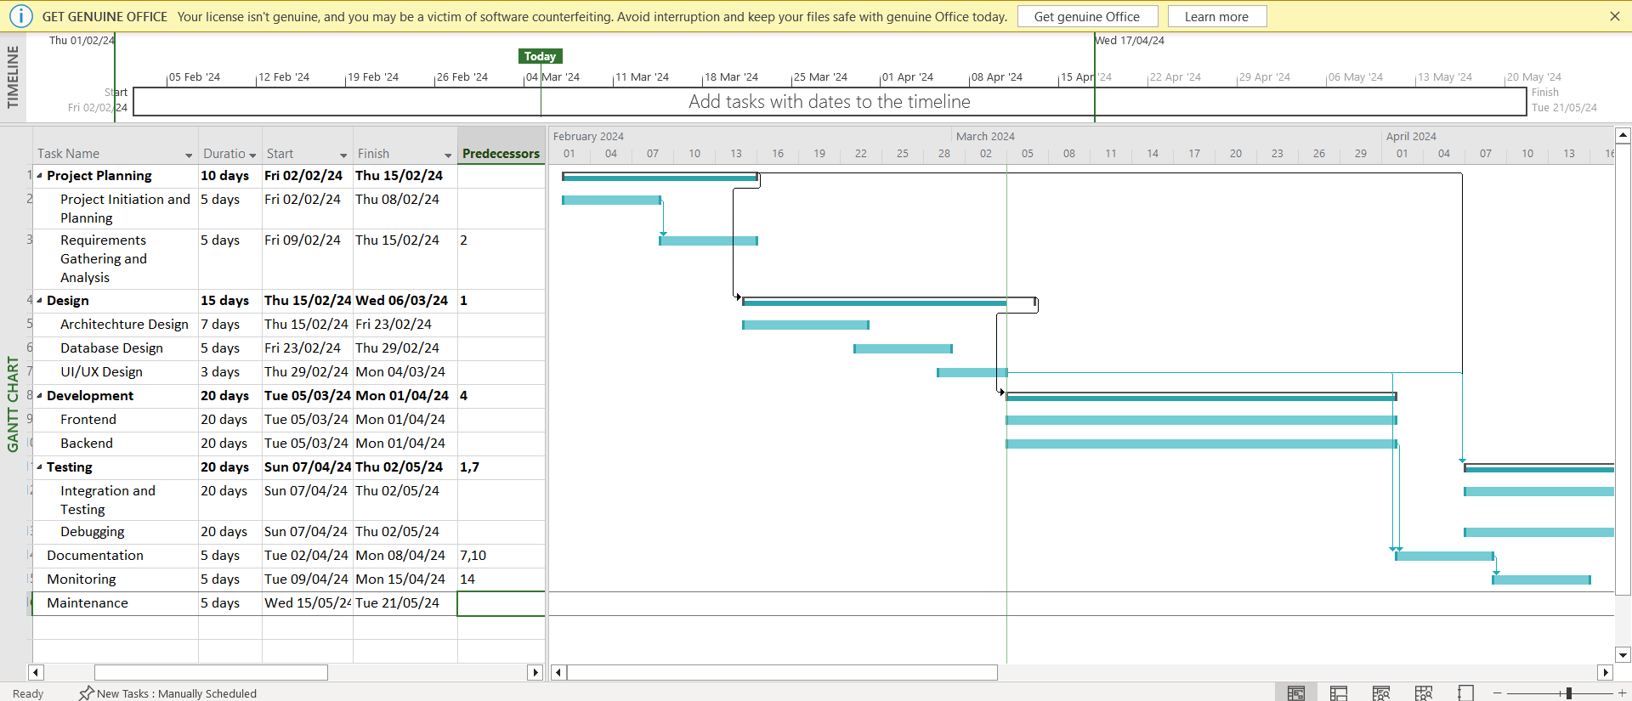

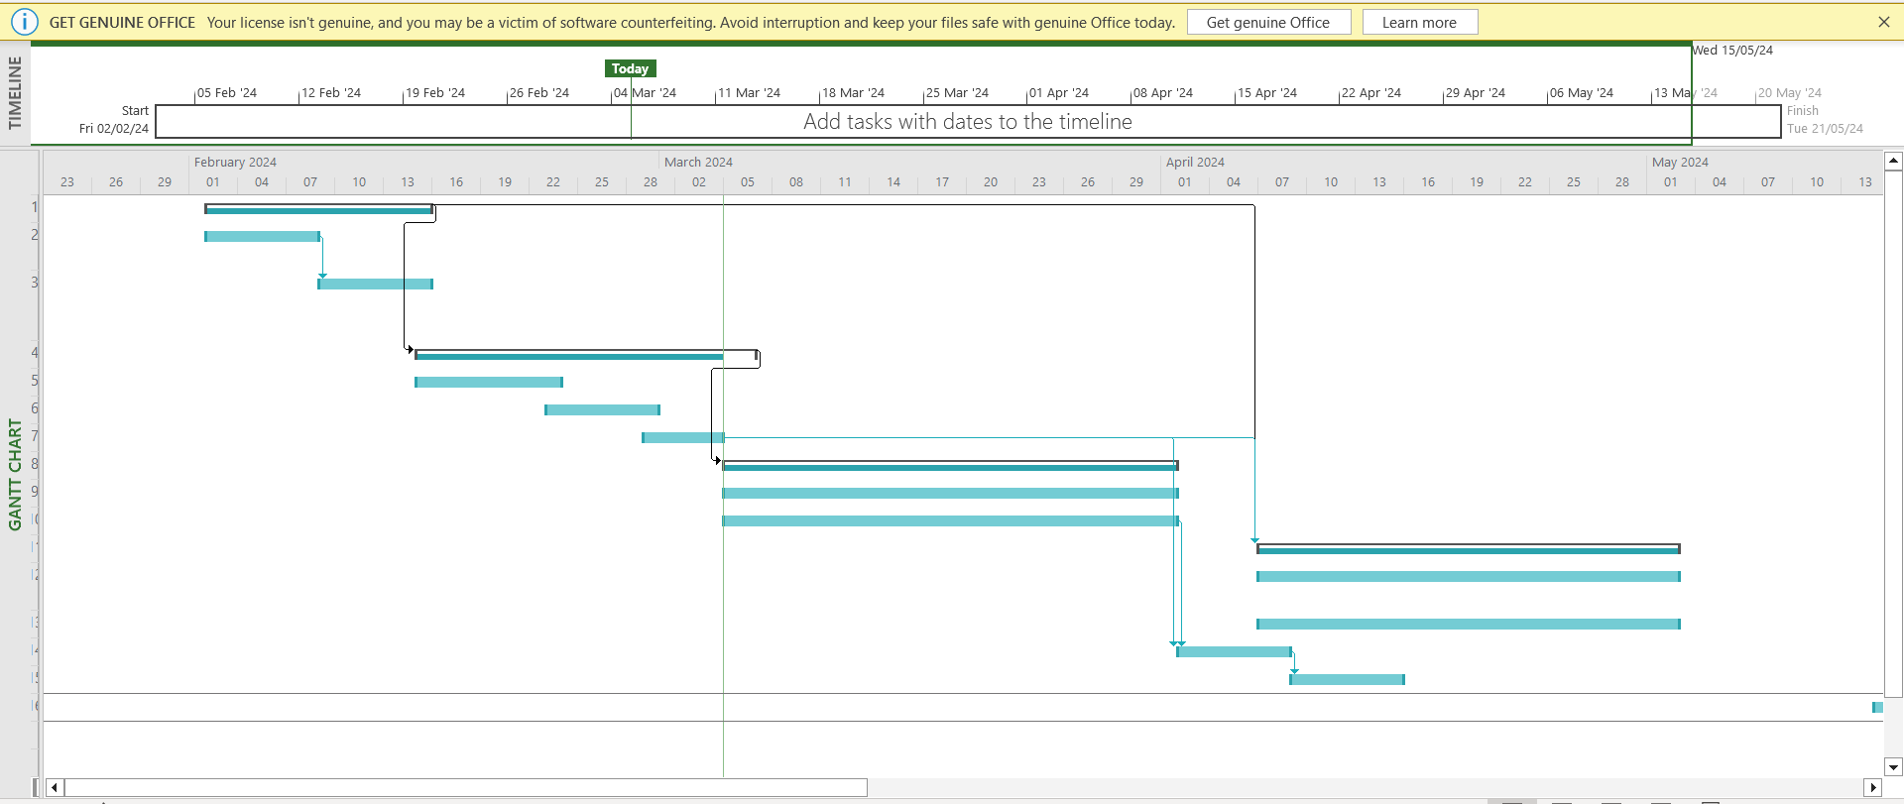

**3.2 Adding Priorities**

In order to incorporate priority, a new column needs to be inserted in the sheet. The "Add New Column" function is located at the sheet's end. Upon selecting "Add New Column," a list of options will be presented. From this list, we opt for the Priority option to generate a new column specifically for priorities. Once the priority column is established, we can assign the desired priority points to each task as needed.

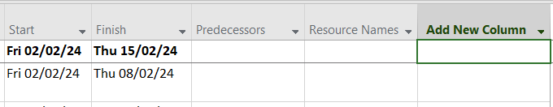

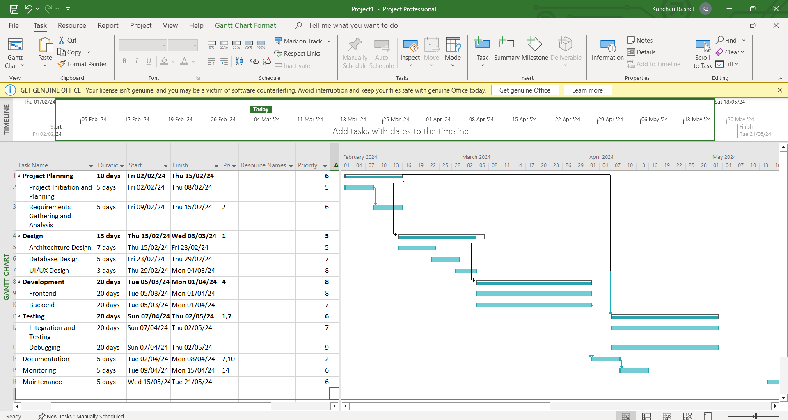

**3.3 Managing Dependencies and defining Lag**

We included priority and predecessors by utilizing the sheet's columns. Nevertheless, for more intricate control over dependencies and other aspects of a task, it is possible to double-click on the task. This action opens up a Task menu, which encompasses tabs such as General, Predecessors, Resources, and more.

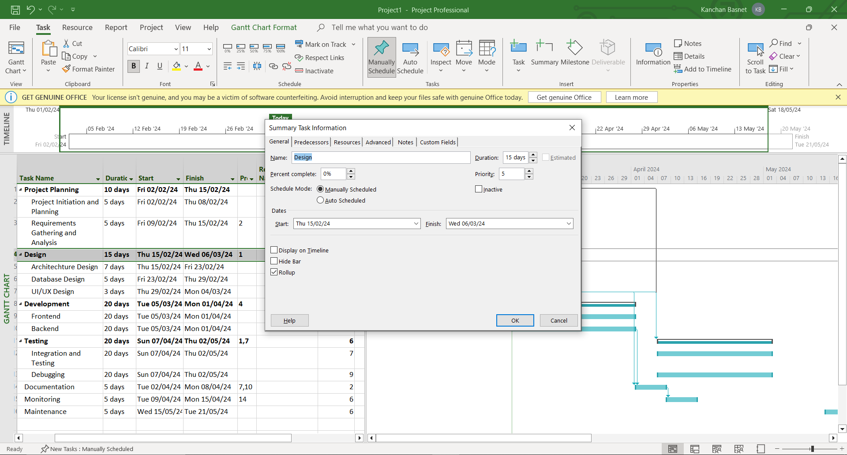

To specify dependencies and set lag in project management, navigate to the Predecessors tab, where a sheet displays a list of predecessors, their types, and associated lag, allowing for the customization of dependency types and the inclusion of desired lag intervals.

**Lab 4: Allocating Resources to Task**

**4.1 Creating Resource Pool**

To establish a resource pool, begin by accessing the resource sheet, which can be done by selecting the view options or Gantt chart at the upper-left corner of the menu ribbon; subsequently, a dropdown menu will appear, and from there, opt for the Resource Sheet.

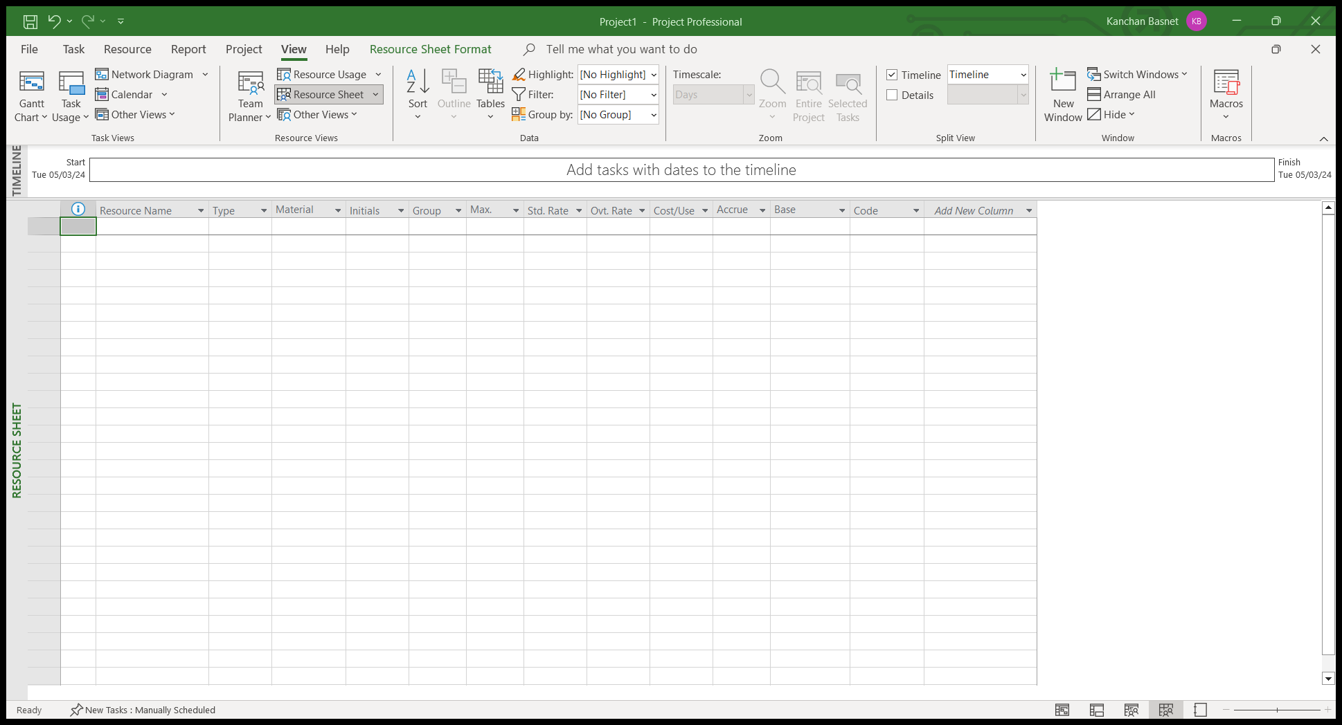

Now, let’s take employees as resources:

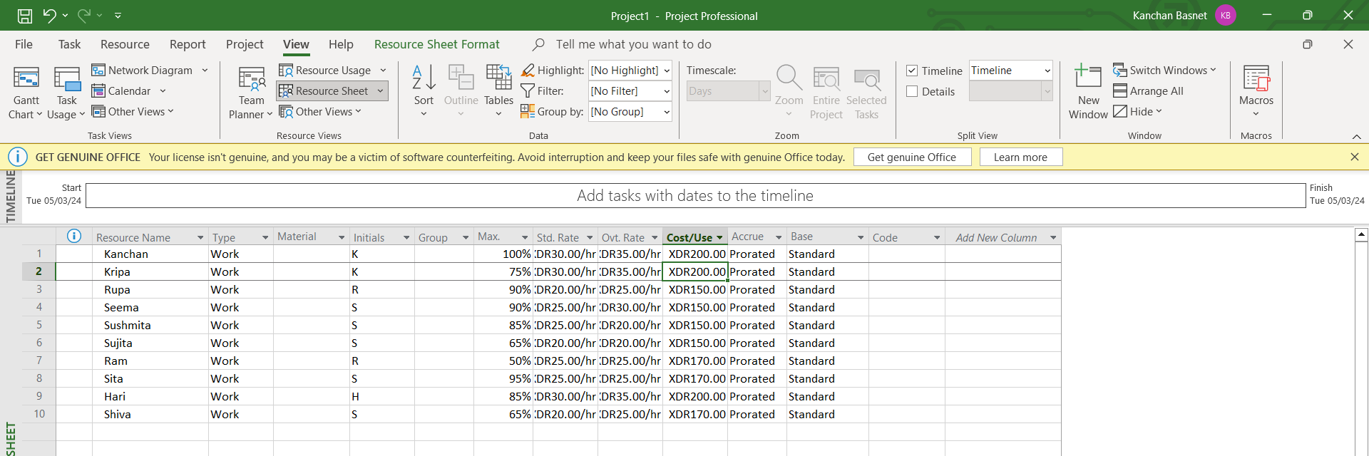

Later, open the gantt chart and assign the resources to each task and the resulting gantt Chart is:

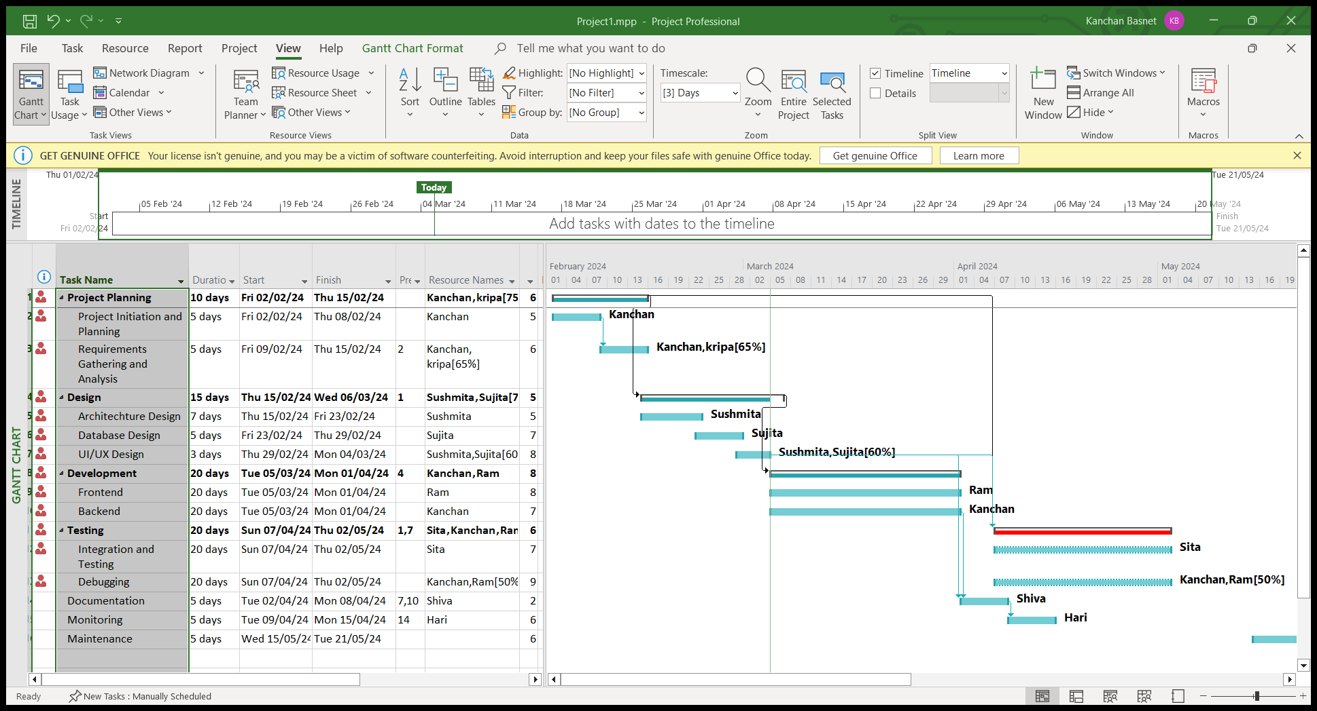

**Lab 5: Defining and Adjusting Work Time**

For modifications pertaining to work time, navigate to the Project tab in the menu bar, proceed to select Change Working Time. This action initiates the 'Change Working Time' dialog box, providing a platform for managing, editing, or adjusting any elements associated with the project's work time.

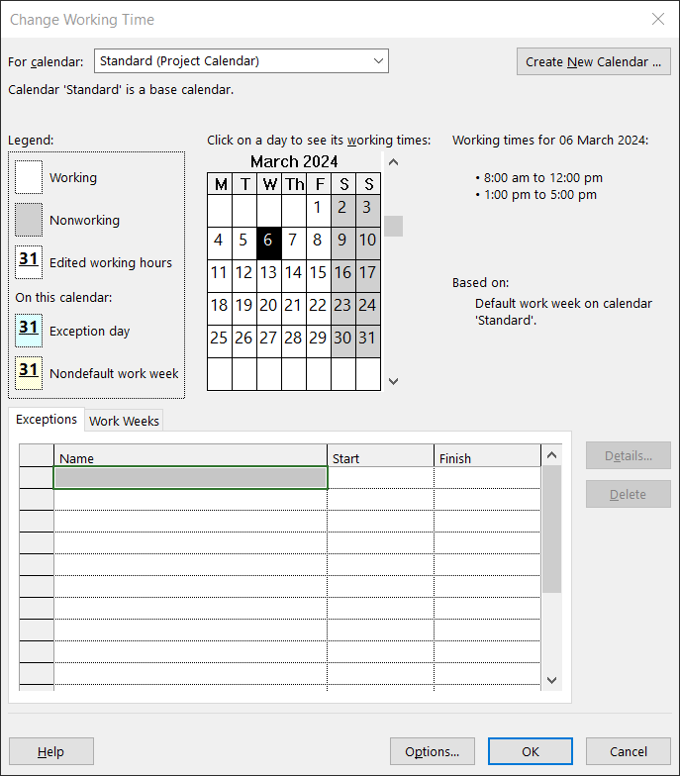

**5.1 Creating a new calendar**

Within the Change Working Time dialog box, time adjustments can be made on the standard calendar, or alternatively, a new calendar can be generated. To create a new calendar, select Create New Calendar located at the top right corner, initiating a dialog box inquiring about the preferred method for new calendar creation. Subsequently, a further dialog box will appear, enabling modifications to calendar defaults.

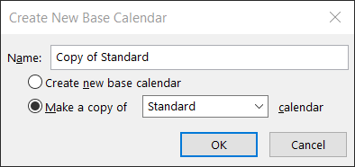

**5.2 Changing Work Time defaults**

Default values for schedule elements like the start of the day, work start time, work end time, and hours per day can be modified based on personal preferences; to adjust these defaults, select the Options button located at the bottom right within the Change Working Time dialog box.

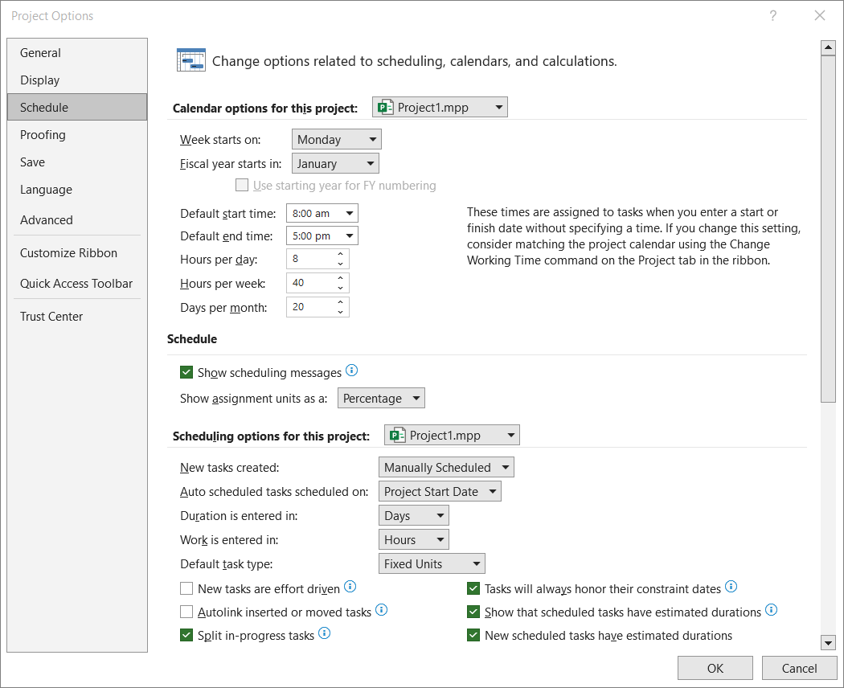

**5.3 Adding exceptions and holidays to the calendar**

To incorporate exceptions or holidays into the calendar, one can easily document them within the exception sheet of the Change Working Time dialog box. Inputting the exception's name, start date, and finish date is required for accurate representation.

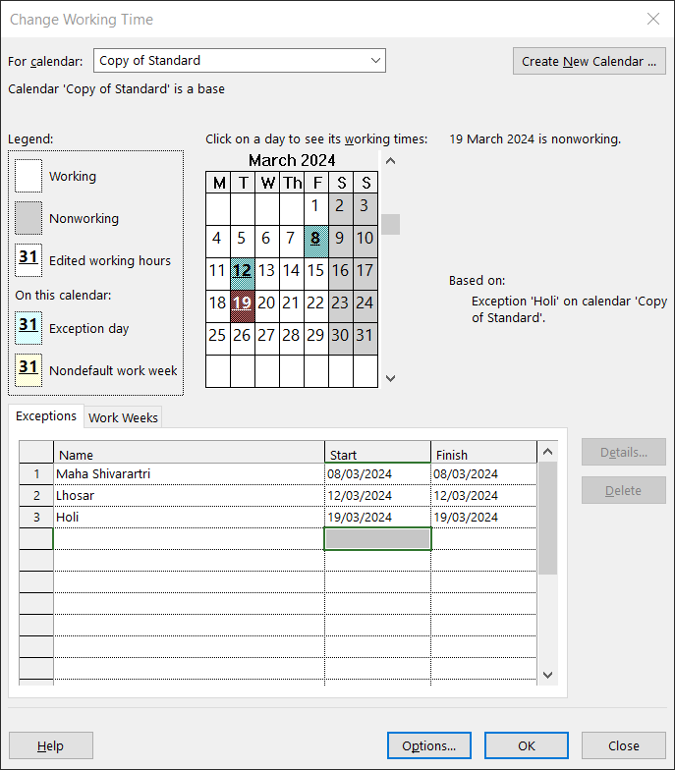

Additional details for exceptions, including options such as half-day work, recurrence patterns, or recurrence ranges, can be incorporated by either double-clicking on the exception's name or clicking the Details button located on the right side.

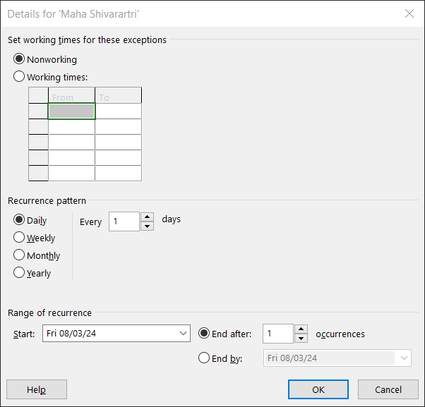

**Lab 6: Critical Tasks, Slack and Late Tasks**

Identifying critical tasks, slack, and late tasks in Microsoft Project is effortlessly accomplished. Simply navigate to the Format menu within the Gantt chart view, proceed to the bar styles section, and select the desired option among critical tasks, slack, or late tasks.

**6.1 Critical Tasks**

Here, light-orange color shows the critical tasks.

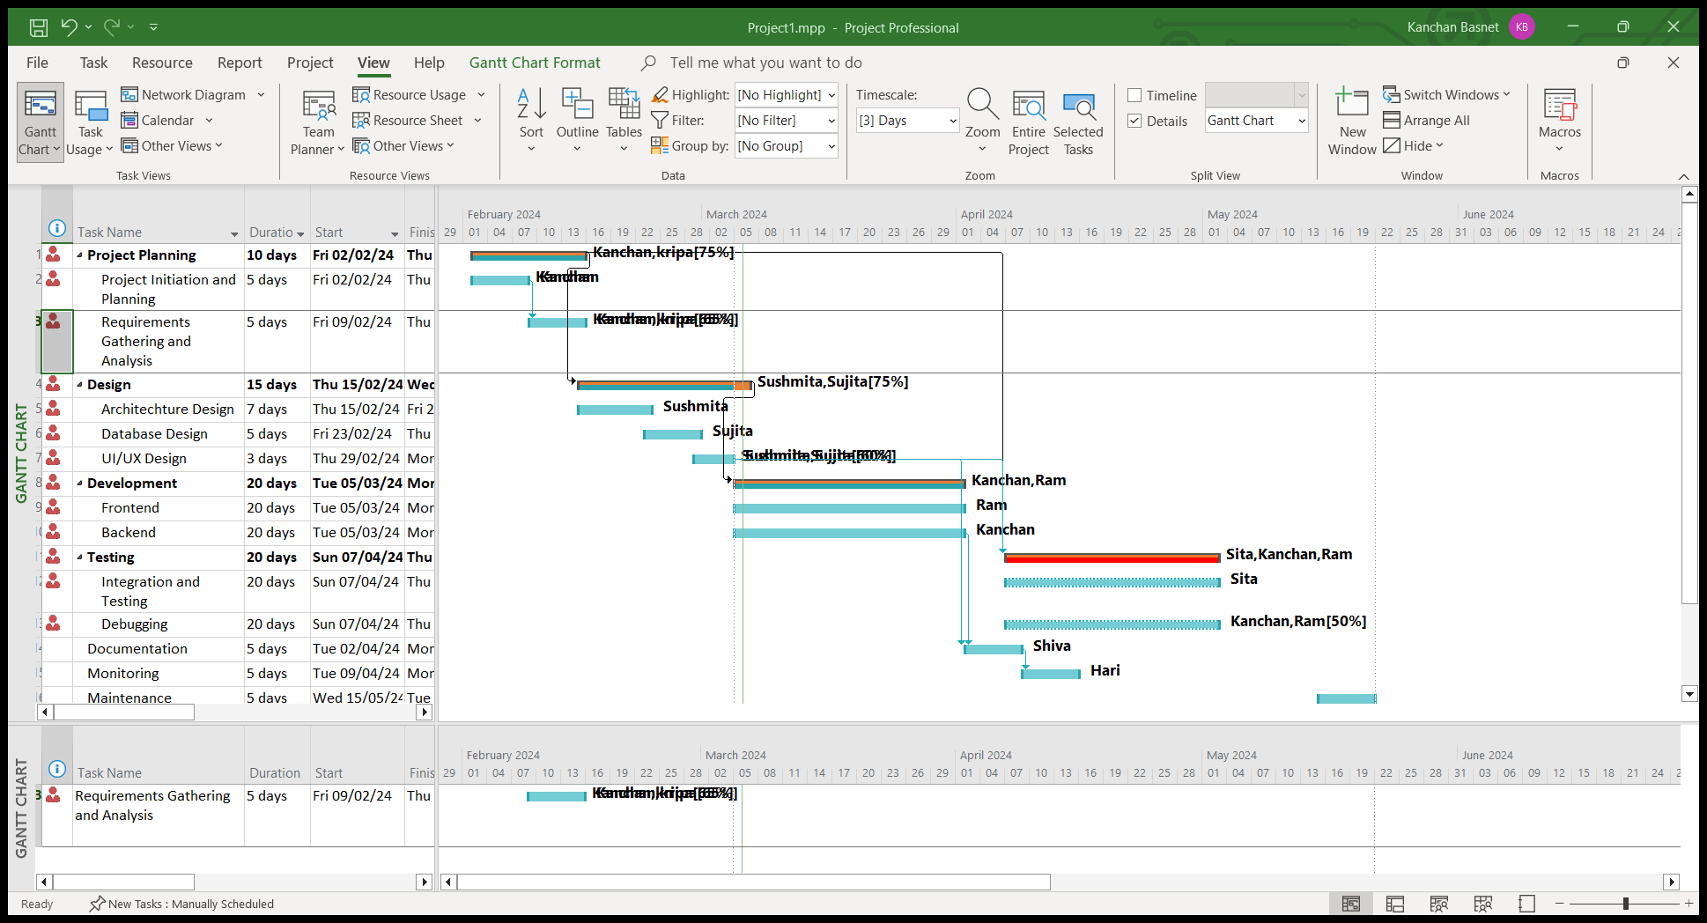

**6.2 Slack**

Dark link by the end of task shows slack.

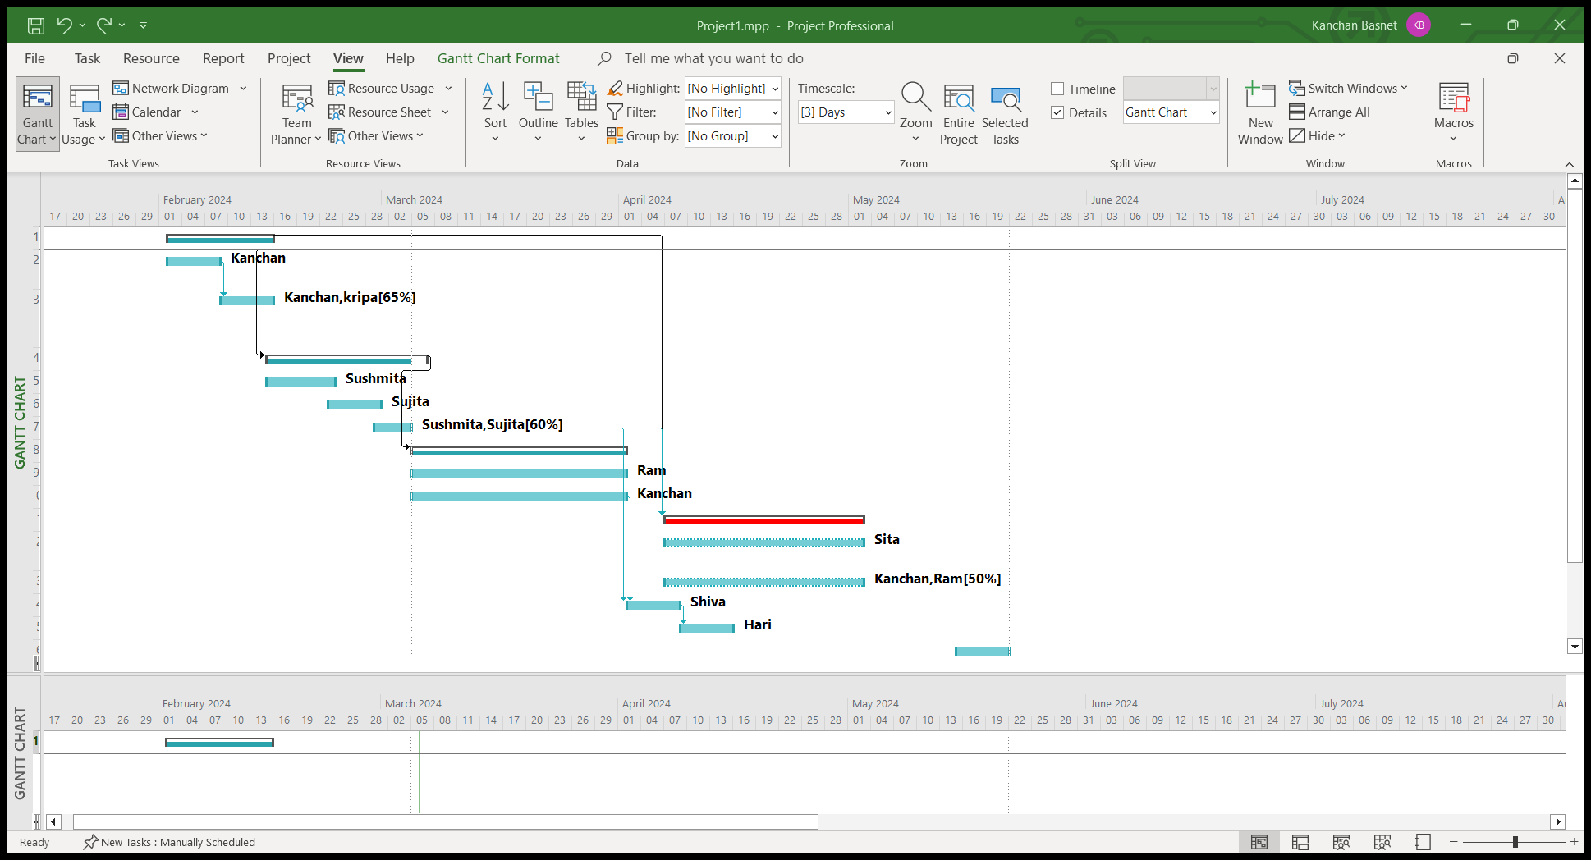

**6.3 Late task**

Here, Dark black task is late task.

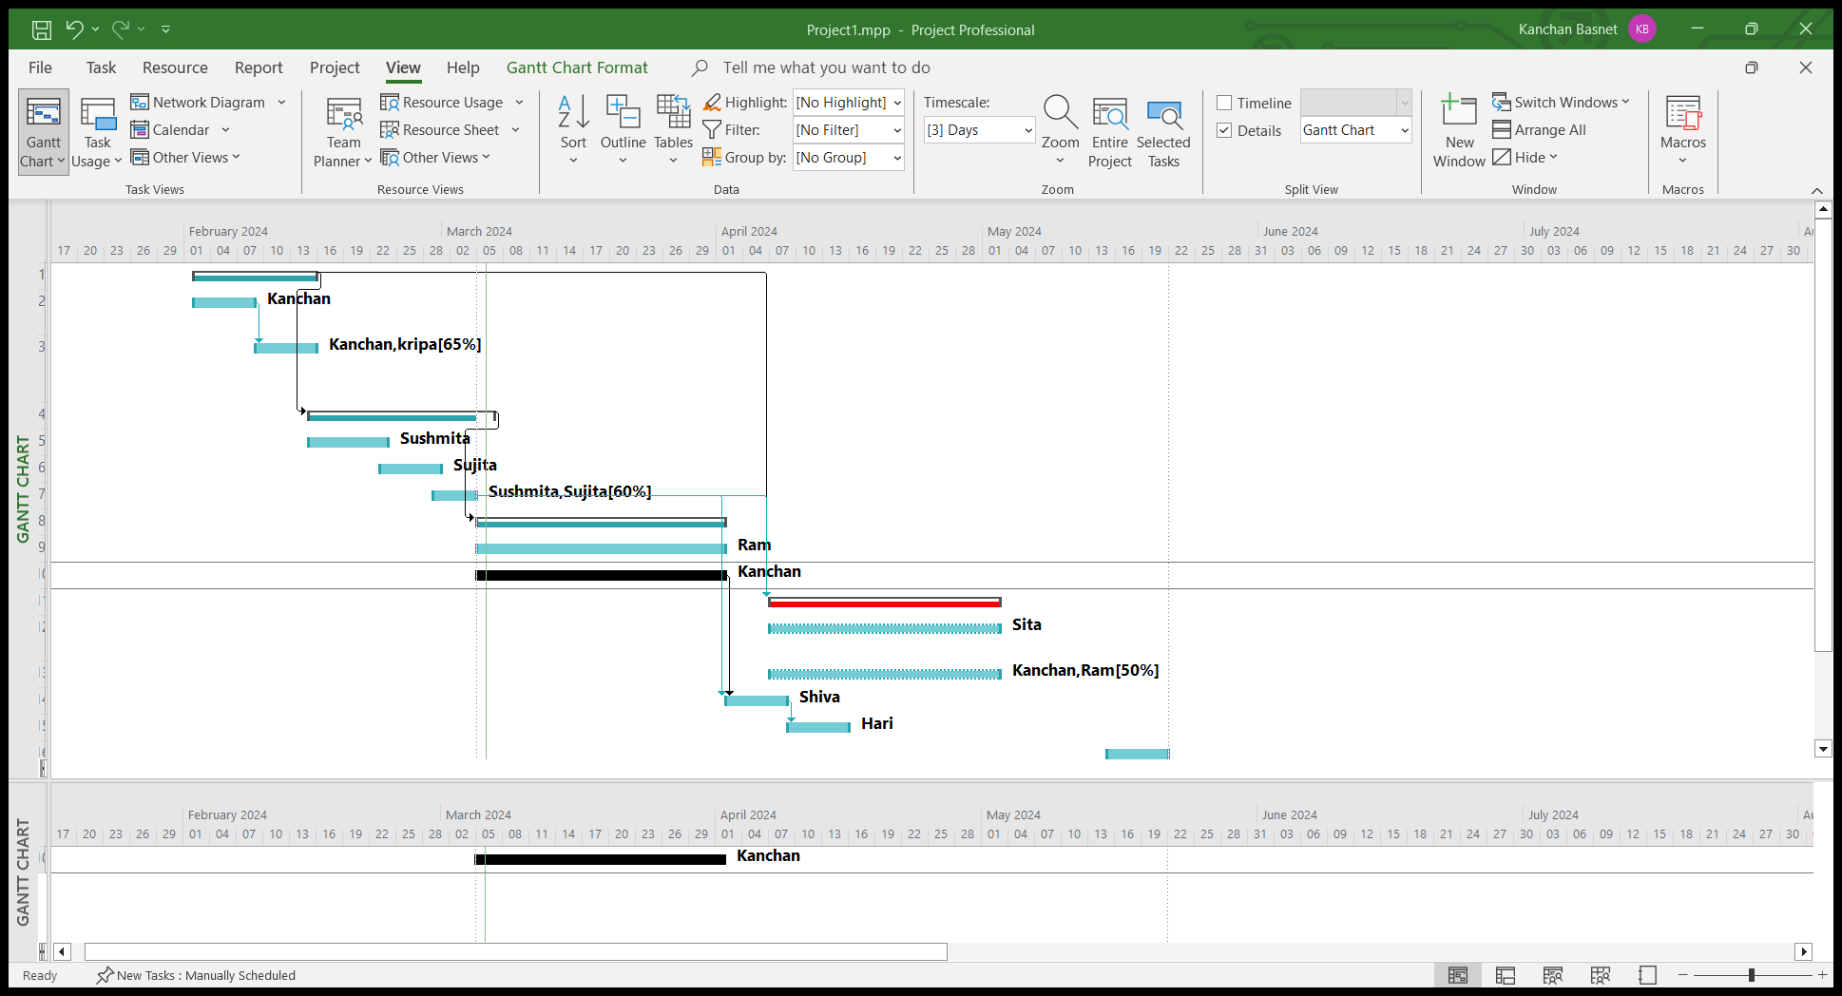

**Lab 7: Critical Path Numerical**

**Theory**

The critical path in project management represents the sequential order of tasks that must be completed to ensure the project's timely completion. It is the longest path through the project network, determining the minimum time required for project execution. Tasks on the critical path have zero slack or float, meaning any delay in these tasks directly impacts the overall project duration. Identifying and managing the critical path is crucial for project managers to prioritize activities and ensure project deadlines are met. Utilizing critical path analysis helps teams focus on key tasks that influence the project's overall timeline.

**Numerical Question:**

|  |  |  |
| --- | --- | --- |
| **Activity** | **Predecessor Activity** | **Duration(weeks)** |
| **A** | **-** | **3** |
| **B** | **A** | **5** |
| **C** | **A** | **7** |
| **D** | **B** | **10** |
| **E** | **C** | **5** |
| **F** | **D, E** | **4** |
|  |  |  |

**Solution:**

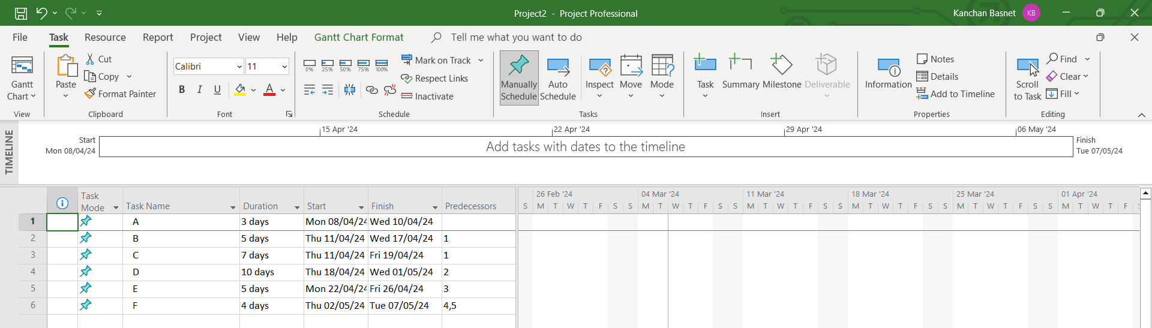

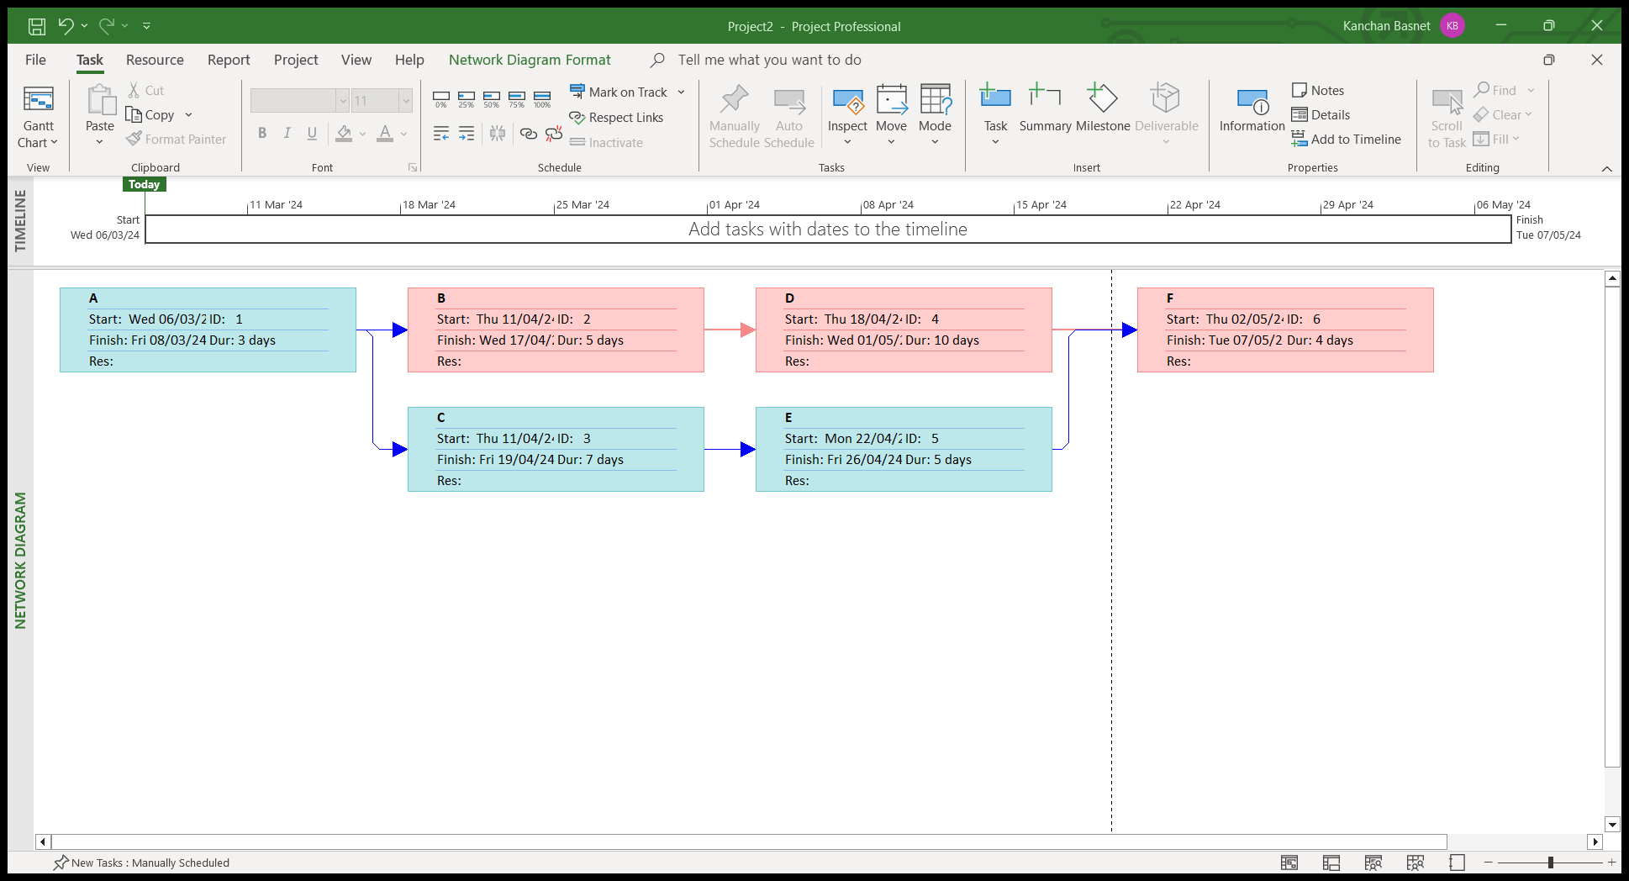

**Lab 8: An organization purchases software license A, which is valued at $600,000. Two years later, the organization sells the license for $800,000. Calculate ROI using Excel.**

**Theory:**

Return on Investment (ROI) is a financial metric used to evaluate the profitability of an investment relative to its cost. It is expressed as a percentage and is calculated by dividing the net gain from the investment by the initial cost, then multiplying the result by 100. The formula is:

A positive ROI indicates a profit, while a negative ROI suggests a loss. ROI is a versatile tool applicable to various investments, including financial assets, real estate, business initiatives, and even software licenses. It provides a straightforward way to assess the efficiency and success of an investment over a specified period. Higher ROI values generally indicate more favorable returns, making it a crucial metric for decision-makers in both business and personal finance. However, it's important to consider other factors and use ROI in conjunction with other metrics for a comprehensive analysis. Formula to calculate ROI :

ROI=(Net Gain/Cost of Investment)*100%

Steps to calculate ROI In Excel

1. Open the Excel and start with a Blank Workbook

2. In cell A1(or any cell you want) type “Initial Cost”, in cell B1 type “Selling Price”

3. Add initial cost and selling price in cell A2 and B2 respectively.

4. Now, in cell C1, type “Net Gain”

5. In cell C2, enter the formula for Net gain, which is B2-A2.

6. In cell D1, type ROI

7. In cell D2, enter the formula for ROI, which is ROI=(Net Gain/Cost of Investment)*100%

Now, cell D2 should display the ROI percentage. The result will be the percentage increase in value from the initial cost to the selling price.

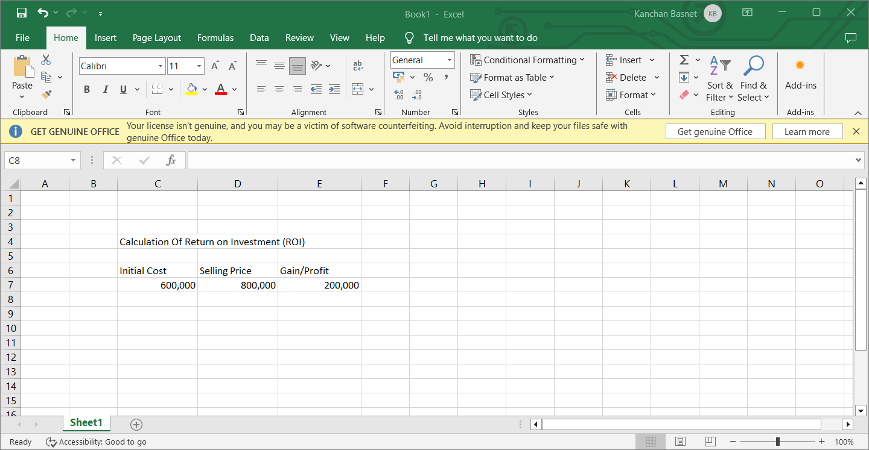

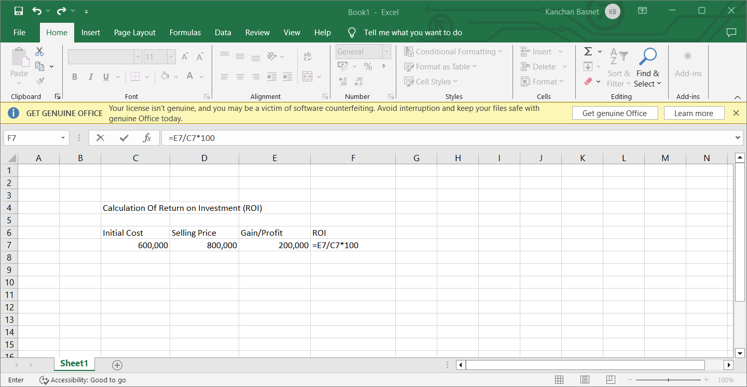

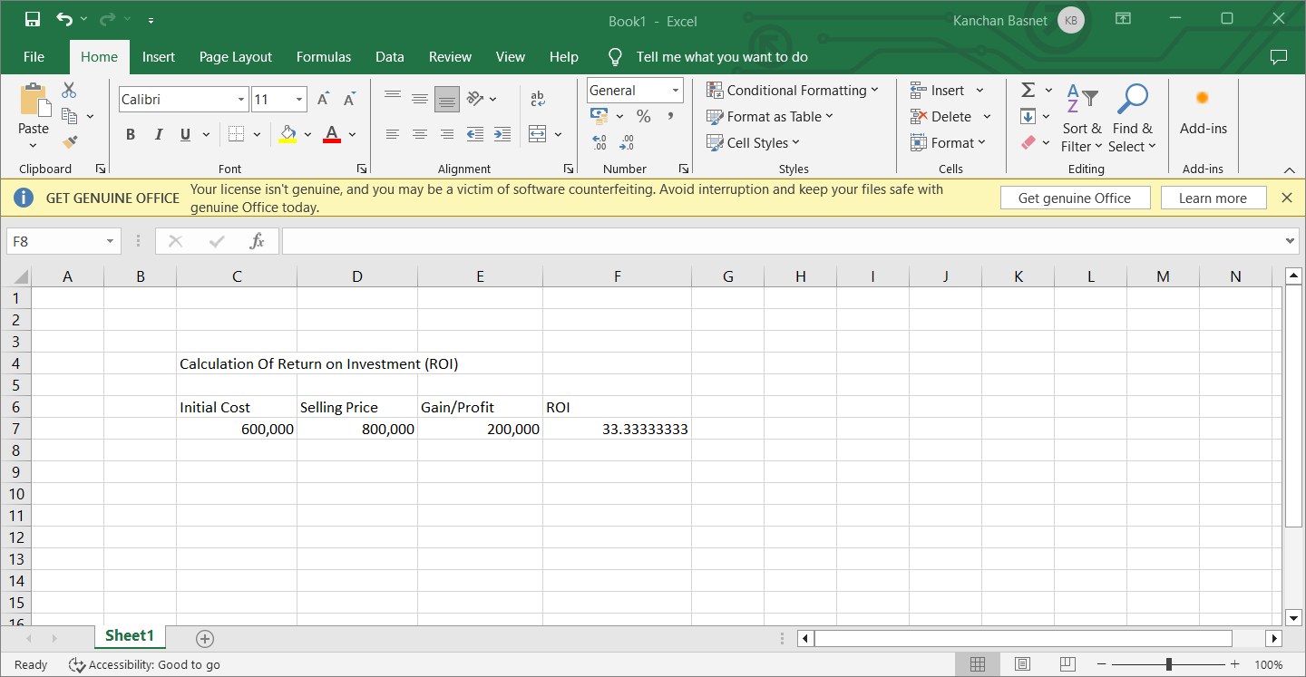

**Lab 9: Prepare a probability impact matrix, incorporate risks on it, and define the tolerance line on it.**

**Theory:**

A Probability-Impact Matrix is a visual tool used in risk management to assess and prioritize risks based on their probability and impact. It involves categorizing risks into a matrix, where the probability of occurrence is on one axis, and the impact on the other. Each intersection in the matrix represents a different level of risk severity. The matrix helps prioritize risks, focusing attention on those with higher probability and impact. The identification of a tolerance line in the matrix establishes a threshold, beyond which risks are considered unacceptable and require special attention or mitigation efforts.

1. Creating Risk table

**Lab 10:Git and GitHub**

**Theory**

Git is a distributed version control system designed to track changes in source code during software development. Developed by Linus Torvalds, it allows multiple developers to collaborate on a project, maintaining a complete history of code changes.

GitHub is a web-based platform that provides hosting for Git repositories and adds collaborative features such as bug tracking, task management, and team collaboration. It enhances Git by providing a user-friendly interface, social coding features, and a platform for sharing open-source projects.

**1.Create Repository**

A Git repository is a storage location where a collection of files and directories, along with the version history of those files, is stored and managed using Git, a distributed version control system. The repository is the core element of Git and serves as a centralized location for developers to collaborate on a project.

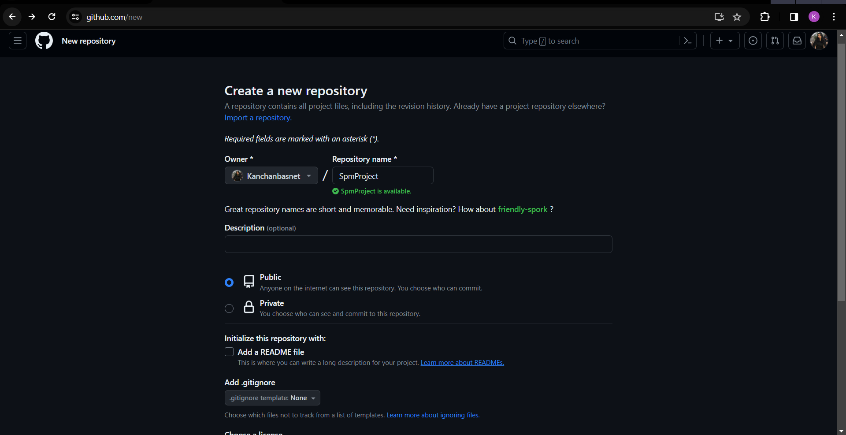

**2.Initialize the repository**

Command is: git init

3.Adding files

Command is: git add

We can also add all files at once

4. Git Commit

Command is: git commit -m “first commit”

5. Git branch

Command is: git branch -M main

6. Git remote add

7. Git push

Command is: git push -u origin main

8. Git status

It gives information regarding current state of files, folders and repositories.

Repository after all these commands:

There are various other git commands, we can use according to our need.