Business Insight Report
Period: September 2026 | Generated: 09 Oct 2026 19:14 | Source: rule-based engine
Note: AI service unavailable (LLM_API_KEY is not set. Add it to your .env file.). Showing the rule-based report instead.

Executive Summary
September 2026: Moderate revenue growth of 6.7% to ₹1,03,95,191. Profit was ₹19,82,338 (+6.7% vs the previous month), with a profit margin of 19.1% and 449 orders. Projected revenue for 2026-10 is about ₹1,20,89,174 (range ₹1,13,84,904 to ₹1,27,93,445), an estimate rather than a guarantee.

KPI Summary
Metric | Current | Previous | Change
Revenue | ₹1,03,95,191 | ₹97,38,780 | +6.7%
Profit | ₹19,82,338 | ₹18,57,731 | +6.7%
Orders | 449 | 426 | +5.4%
Customers | 364 | 358 | +1.7%
Average Order Value | ₹23,152 | ₹22,861 | +1.3%
Profit Margin | 19.1% | 19.1% | +0.0 pp

Trend Analysis
Revenue trend over the last months is increasing (+4.1% per month on average); year-over-year change for the latest month is +37.8%.
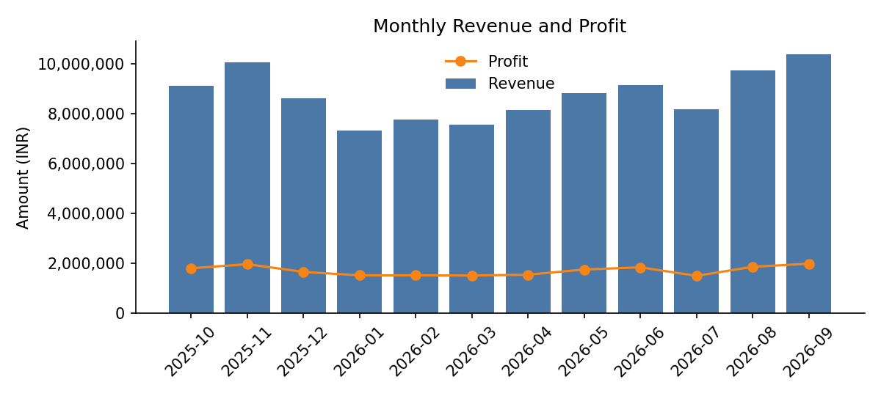

Forecast
Month | Projected revenue | 95% range
2026-10 | ₹1,20,89,174 | ₹1,13,84,904 - ₹1,27,93,445
2026-11 | ₹1,26,73,937 | ₹1,19,69,667 - ₹1,33,78,208
2026-12 | ₹1,16,26,319 | ₹1,09,22,049 - ₹1,23,30,590

Method: seasonal trend. Statistical projection with a 95% range, not a guarantee. Backtest error on the last 3 known months: 4.8% (MAPE).

Unusual Movements (anomalies)
- Corporate (Customer Segment): MoM +73.9% vs typical +4.4% (z=2.9, spike)
- 2026-09-17: revenue ₹10,26,023 vs typical ₹3,15,526 (spike, robust z=4.5)

Growth Drivers
- North (Region) is a growth driver: revenue +11.2% (+₹4,81,108).
- South (Region) is a growth driver: revenue +6.8% (+₹1,80,098).
- Electronics (Product Category) is a growth driver: revenue +5.3% (+₹4,49,814).
- Home Appliances (Product Category) is a growth driver: revenue +21.7% (+₹2,12,932).
- Mobile (Product) is a growth driver: revenue +11.6% (+₹2,46,811).
By Region
Type | Name | Growth | Revenue change
Driver | North | +11.2% | ₹4,81,108
Driver | South | +6.8% | ₹1,80,098
Driver | East | +9.0% | ₹1,28,594
Decliner | West | -9.8% | -₹1,33,391

By Product Category
Type | Name | Growth | Revenue change
Driver | Electronics | +5.3% | ₹4,49,814
Driver | Home Appliances | +21.7% | ₹2,12,932
Decliner | Accessories | -2.6% | -₹6,336

By Sales Channel
Type | Name | Growth | Revenue change
Driver | Retail Store | +22.6% | ₹4,27,496
Driver | Online | +2.9% | ₹1,94,055
Driver | Distributor | +2.9% | ₹34,859

By Payment Method
Type | Name | Growth | Revenue change
Driver | UPI | +11.9% | ₹6,37,287
Driver | Debit Card | +42.6% | ₹1,84,486
Decliner | Credit Card | -3.4% | -₹74,883
Decliner | Cash | -6.7% | -₹53,254
Decliner | Net Banking | -3.8% | -₹37,225

By Customer Segment
Type | Name | Growth | Revenue change
Driver | Corporate | +74.0% | ₹11,79,658
Driver | Consumer | +0.5% | ₹31,079
Decliner | Small Business | -23.2% | -₹5,13,188

By Product
Type | Name | Growth | Revenue change
Driver | Mobile | +11.6% | ₹2,46,811
Driver | Laptop | +4.3% | ₹2,29,137
Driver | Microwave | +28.6% | ₹1,06,862
Decliner | Tablet | -4.7% | -₹34,839

Negative Contributors
- West (Region) declined 9.8% (-₹1,33,391 change) and is flagged for investigation.
- Tablet (Product) declined 4.7% (-₹34,839 change) and is flagged for investigation.
- Small Business (Customer Segment) declined 23.2% (-₹5,13,188 change) and is flagged for investigation.
- Credit Card (Payment Method) declined 3.4% (-₹74,883 change) and is flagged for investigation.
- Cash (Payment Method) declined 6.7% (-₹53,254 change) and is flagged for investigation.
- Net Banking (Payment Method) declined 3.8% (-₹37,225 change) and is flagged for investigation.

Risks / Areas to Investigate
- Growth is concentrated: North accounts for 73% of the net revenue change across Region.
- Growth is concentrated: Electronics accounts for 69% of the net revenue change across Product Category.
- Corporate (Customer Segment) moved +73.9% this month versus a typical monthly change of +4.4%: statistically unusual (z-score 2.9).

Recommended Actions
These are suggestions for the business to consider, not observed facts.
- Investigate the decline in West (Region): review pricing, stock availability and promotions.
- Investigate the decline in Tablet (Product): review pricing, stock availability and promotions.
- Investigate the decline in Small Business (Customer Segment): review pricing, stock availability and promotions.
- Investigate the decline in Credit Card (Payment Method): review pricing, stock availability and promotions.
- Investigate the decline in Cash (Payment Method): review pricing, stock availability and promotions.
- Investigate the decline in Net Banking (Payment Method): review pricing, stock availability and promotions.

Appendix: Data Quality
Rows received: 12,149. Rows used after cleaning: 11,785.
- invalid dates removed: 47
- text values standardized: 975
- rows missing critical fields: 105
- exact duplicates removed: 179
- region repaired from state: 117
- category repaired from product: 95
- discount missing filled: 119
- discount percent converted: 35
- invalid quantity removed: 35
- invalid sales removed: 22
- cost imputed: 118
- profit recalculated: 252
- outliers flagged: 28
- extreme outliers removed: 23
Method: all figures are computed in Python from the cleaned dataset; the AI only phrases verified results.

