🔧 Node.js fs Module Summary (Aligned with Code Examples)

✅ Three API Styles
- Promises API (node:fs/promises)
  - Modern async style using await
  - Clean and preferred for most use cases
  - Example:
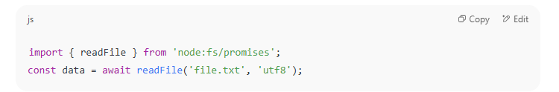

- Callback API (node:fs)
- Traditional Node.js async approach using callbacks
- Example:
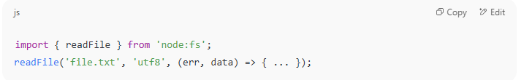

- Synchronous API (node:fs)
- Blocks the event loop; suitable for small scripts or startup code
- Example:
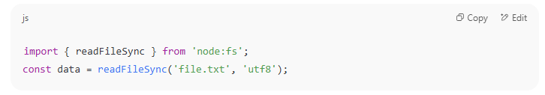

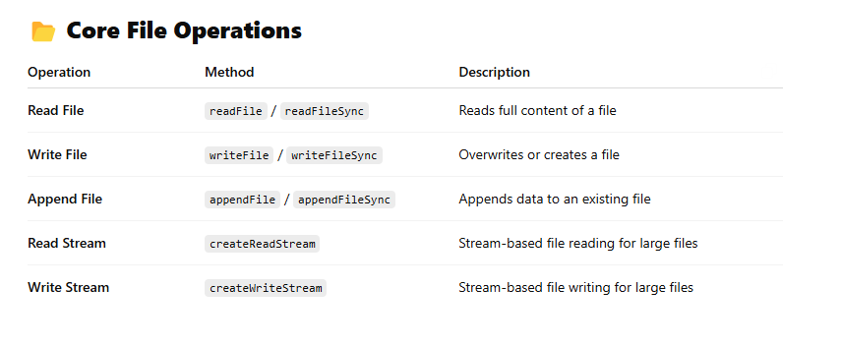
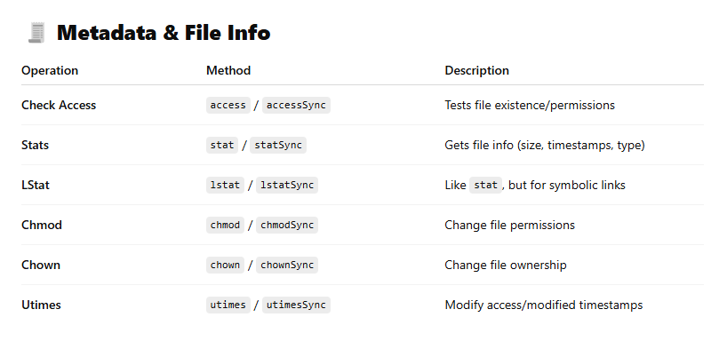
We use symlinks (symbolic links) to create shortcuts or references to files or directories, without duplicating them. Think of it like a pointer.
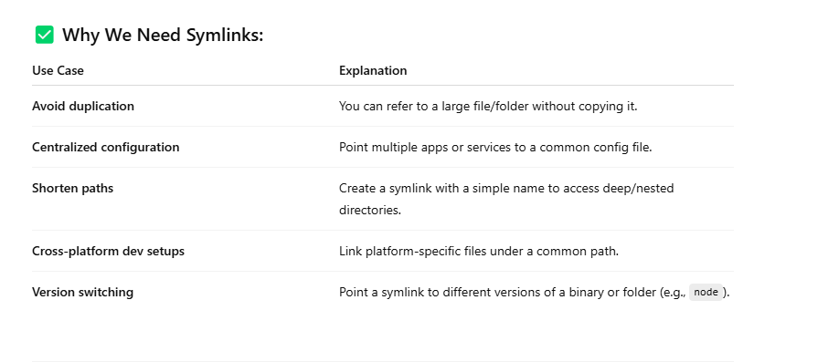
It's like a shortcut icon on your desktop — clicking it opens the actual file elsewhere.
Chmod:
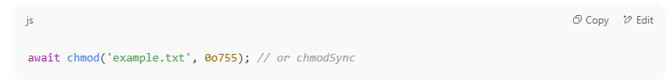

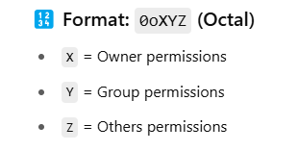

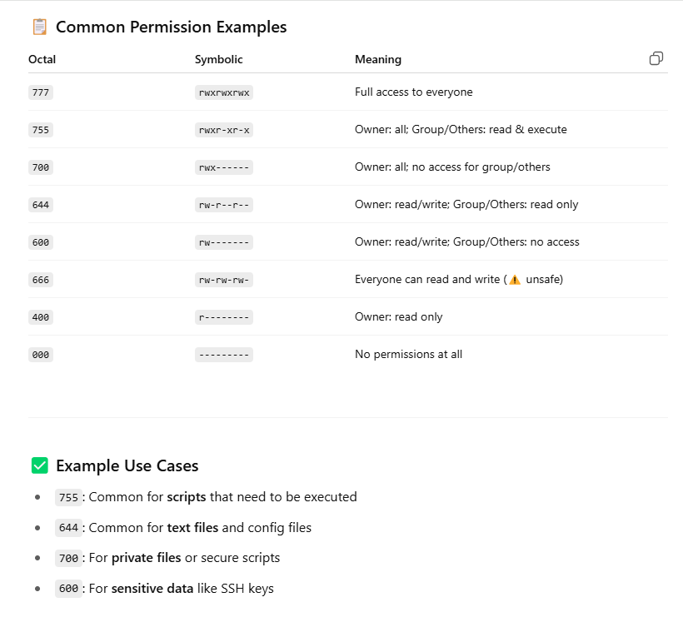

Chown:
To change the owner (UID) and group (GID) of a file in Node.js using chown() or chownSync(), you need to pass:
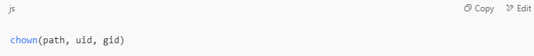
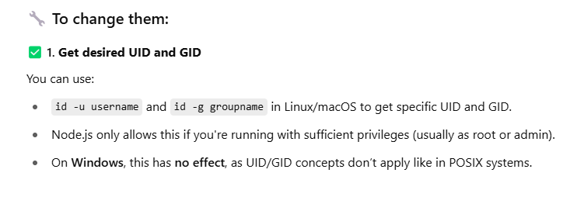
Utimes/utimesSync:
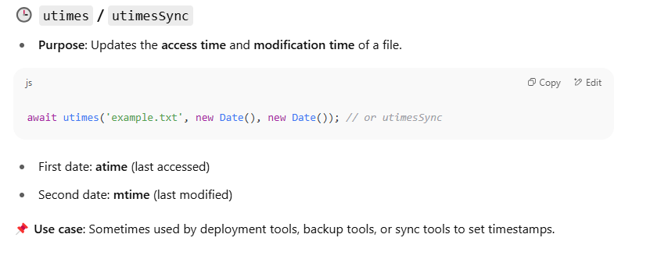

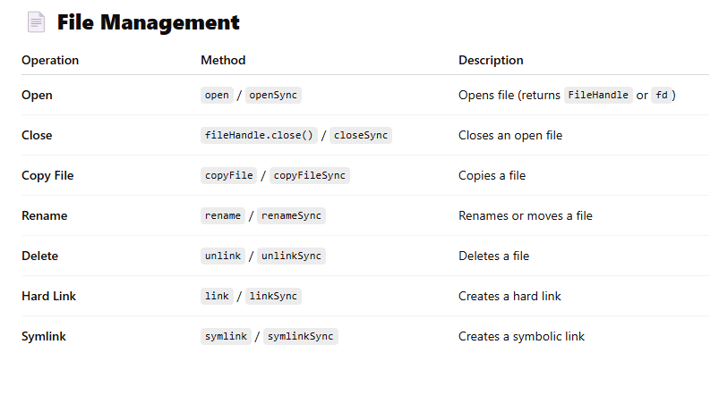
Hard Link vs Symlink:
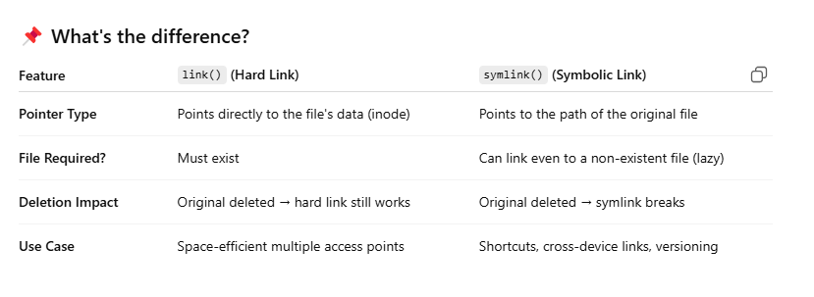
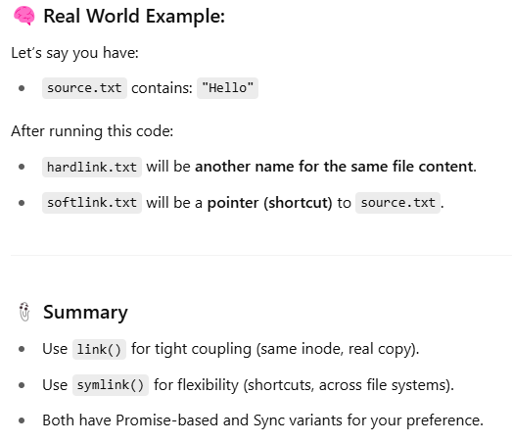
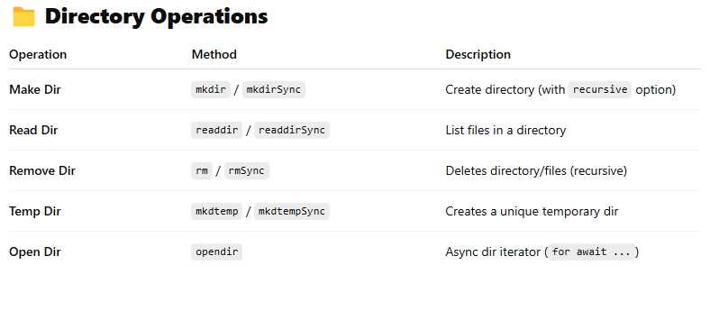
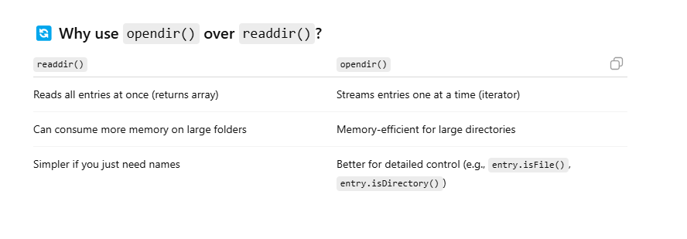
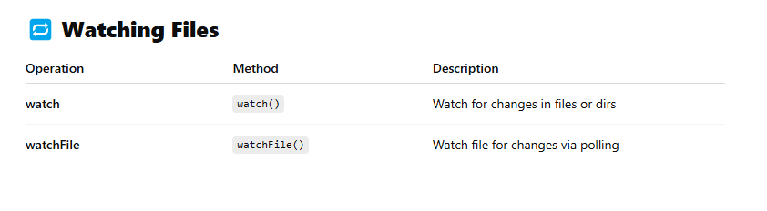

✅ fs.watch(filename, callback)
📌 Purpose:
Watches a file or directory for changes (using the OS’s native file watching APIs).
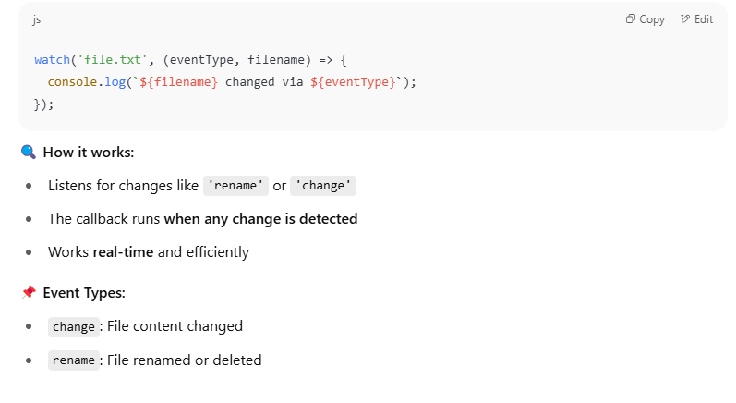
✅ fs.watchFile(filename, callback)
📌 Purpose:
Also watches for changes but uses polling (checks file stats at intervals).
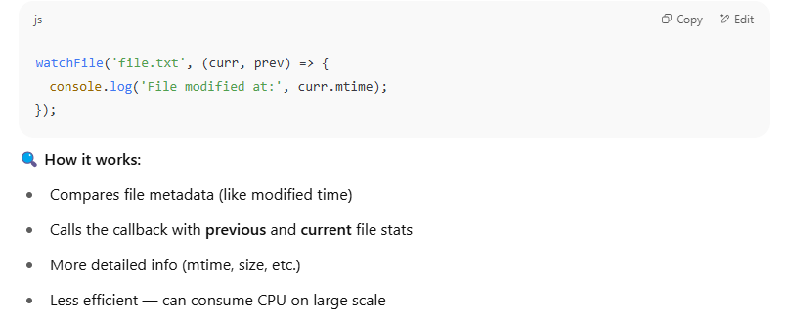

Bonus: What is the difference between Files and Streams
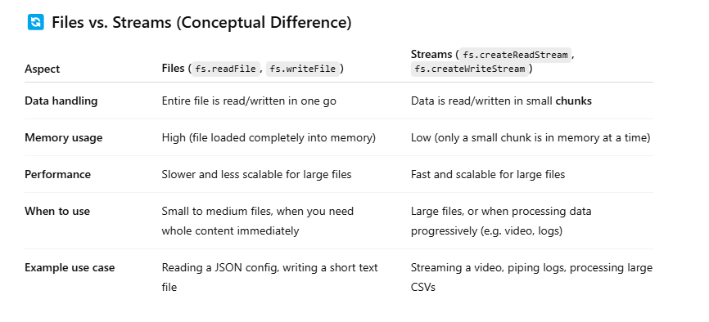
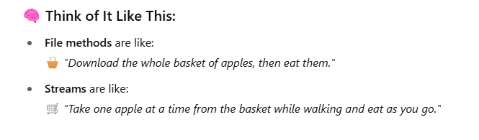
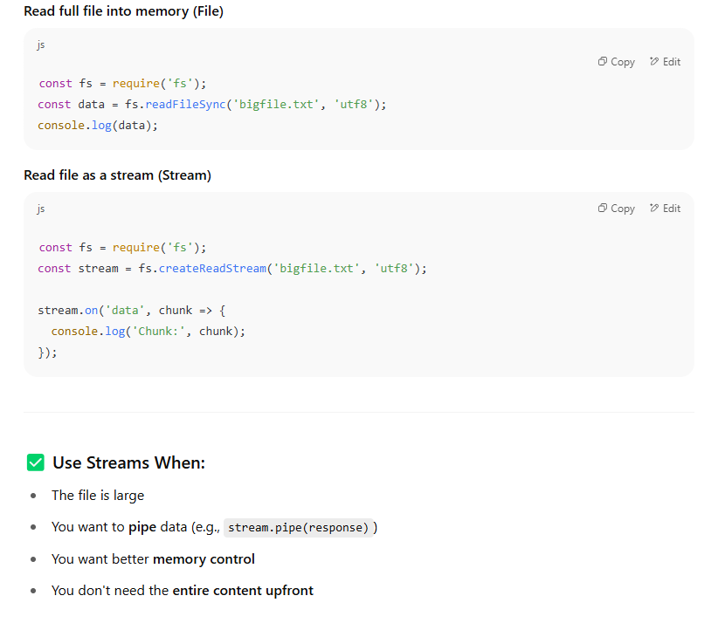

🧪 stream.pipe(response) — What Does It Mean?
In Node.js, pipe() is a method used to connect two streams, so that data flows automatically from one stream to another.

🔁 Real Meaning of stream.pipe(response)
You’re telling Node.js:
“Take the data from stream (a Readable Stream) and send it directly into response (a Writable Stream) — without me manually handling each chunk.”
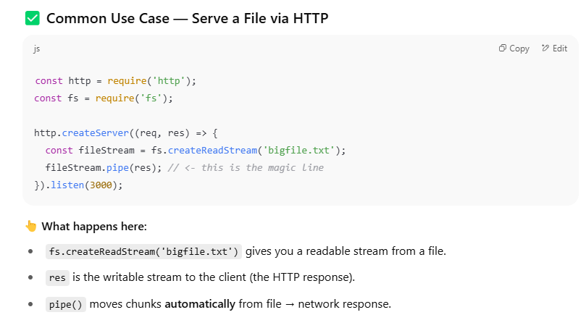

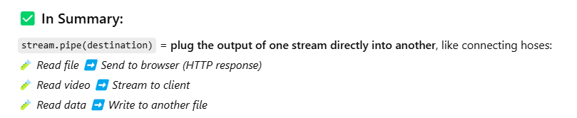

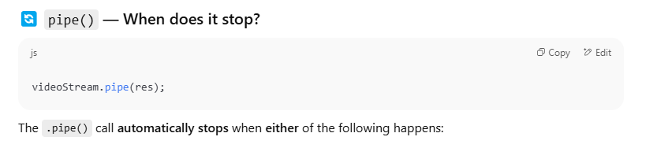
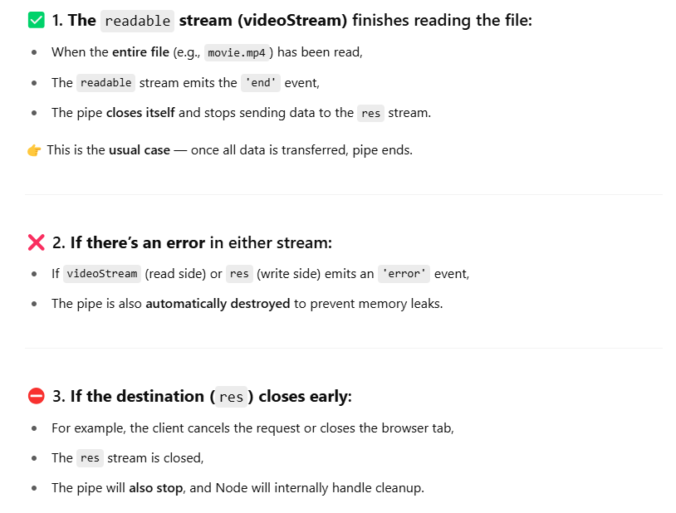

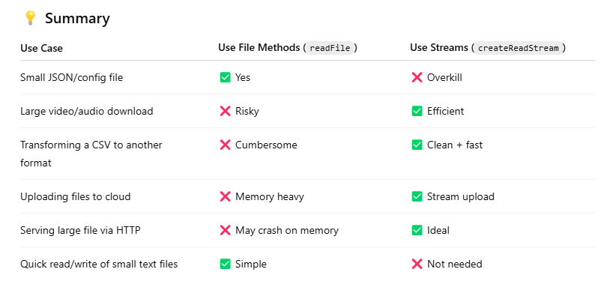

Node.js fs Module – Quick Study Guide
This guide summarizes key concepts, APIs, and use cases for the node:fs module.

I. API Types
- Promises API (fs/promises): Modern async/await-friendly. Best for clean async code.
  - Example: await fs.readFile('file.txt')
- Callback API (fs): Traditional async with callbacks.
  - Example: fs.readFile('file.txt', (err, data) => {})
- Synchronous API (fs): Blocking operations (e.g., fs.readFileSync). Avoid in non-scripting environments.

II. Important Objects
- FileHandle: Returned from fs.promises.open. Represents an open file. Use .close() after use.
- fs.Dir / fs.Dirent: Used to read directories and directory entries (opendir, readdir).
- fs.Stats: Provides metadata about files/directories (stat, lstat). Includes size, timestamps, type.
- fs.ReadStream / fs.WriteStream: Stream-based reading/writing for large files.
- fs.StatFs: Info about the filesystem itself (statfs).

III. Common Operations
- Read/Write:
  - Read entire file: fs.readFile, fs.readFileSync
  - Read in chunks: fs.createReadStream
  - Write data: fs.writeFile, fs.createWriteStream
- Directories:
  - Create: fs.mkdir({ recursive: true })
  - Read: fs.readdir({ withFileTypes: true })
  - Temp: fs.mkdtemp()
  - Remove: fs.rm({ recursive: true, force: true })
- Metadata & Access:
  - fs.stat(), fs.lstat(): Get stats
  - fs.access(): Check permissions
  - fs.chmod(), fs.chown(): Change perms/ownership
- Monitoring:
  - fs.watch(): Watch changes
  - fs.watchFile(): Poll-based watcher (less efficient)

IV. Key Concepts
- File Descriptor: Numeric ID for an open file, used internally.
- Race Conditions: Don’t use fs.access() before open() or readFile(). Just try the operation and handle errors.
- Thread Pool: fs async methods use libuv's thread pool for non-blocking behavior.

Takeaway
Use Promises for modern Node apps. Prefer streams for large file operations. Understand Stats, FileHandle, and avoid race conditions for safe, performant file system interaction.

