🔄 What Are Streams in Node.js?
Streams are built-in Node.js interfaces used to handle reading or writing data piece by piece instead of all at once. They're ideal for processing large data efficiently, like files, network responses, or long logs.

🚦 Types of Streams
There are four main types:
- Readable – you can read data from (e.g., file, HTTP request body)
- Writable – you can write data to (e.g., file, HTTP response)
- Duplex – both readable and writable (e.g., TCP socket)
- Transform – duplex with the ability to modify data (e.g., zlib compression)

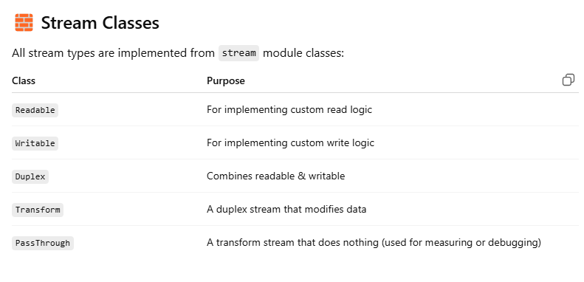

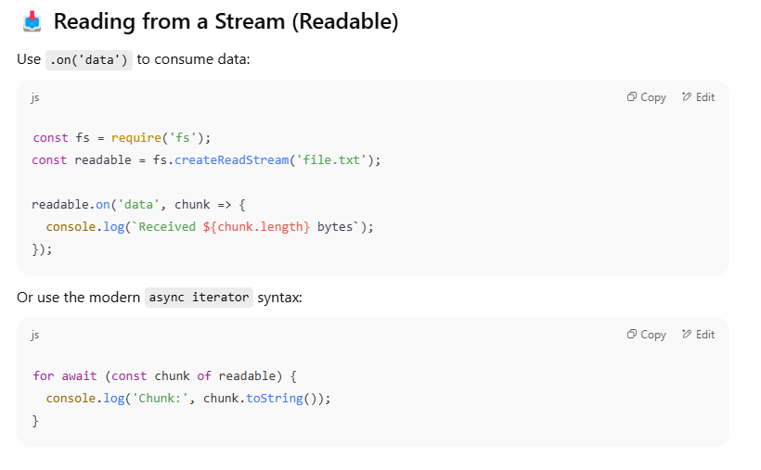

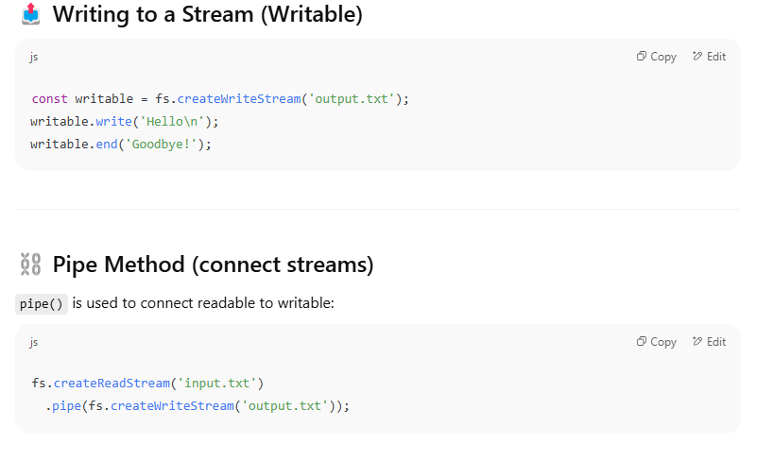

🧠 Backpressure
Backpressure is when the writable stream can’t keep up with the readable stream. Node handles this automatically in most cases (especially with .pipe()), but you can manage it using .pause() / .resume() manually if needed.

🔄 1. Duplex Stream – (Read + Write)
💡 Analogy:
Imagine a walkie-talkie. You can talk (write) and listen (read) using the same device.
A Duplex stream can do both: read and write, independently.
✅ Use Case:
- TCP sockets (you send and receive data)
- WebSocket
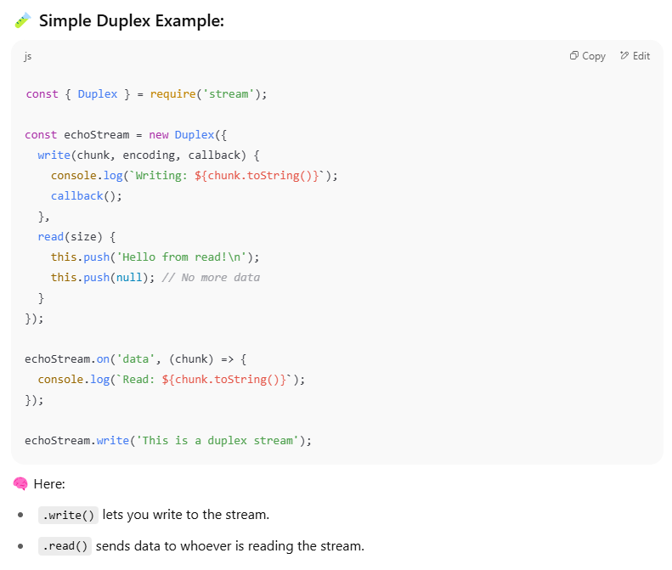

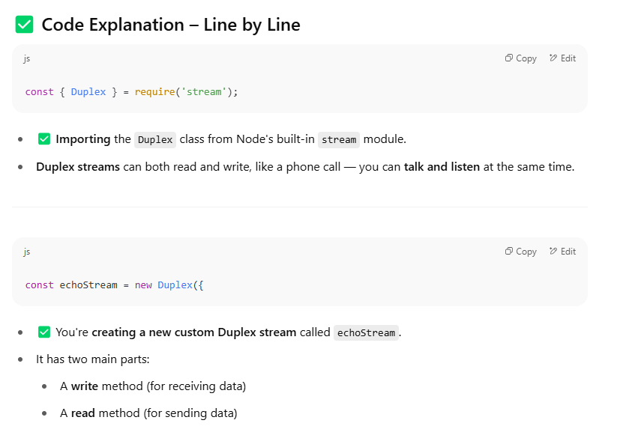

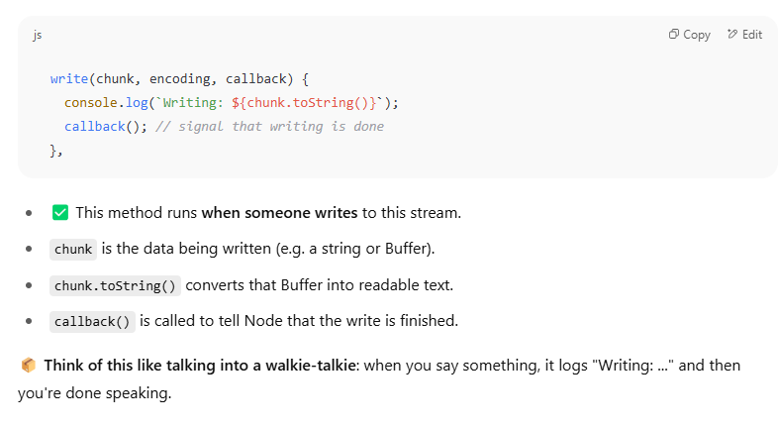

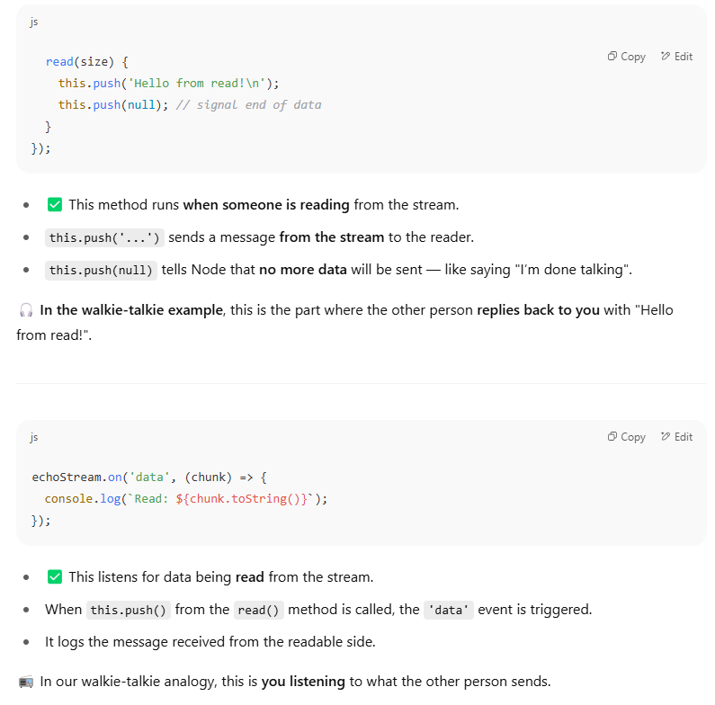

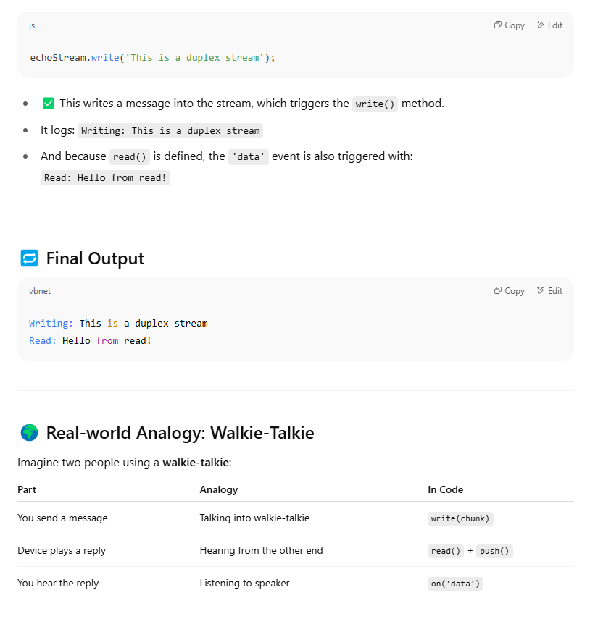
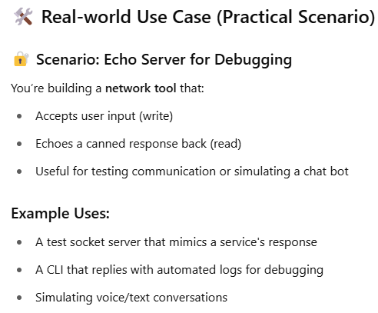

🔄 2. Transform Stream – (Duplex + Modify Data)
💡 Analogy:
Imagine a translator between two people. He reads a message, transforms it (e.g., changes language), and speaks it out.
A Transform stream reads data, modifies it, and writes the result — all in one flow.
✅ Use Case:
- Compressing/decompressing (gzip, Brotli)
- Encrypting/decrypting
- Converting lowercase to uppercase
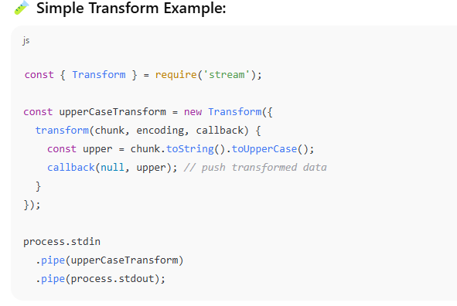
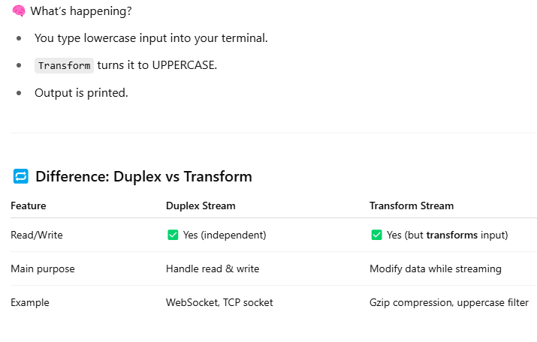
WHY CAN’T WE USE THE DUPLEX STREAM FOR TRANSFORM STREAM TASK AS WELL????
✅ What Duplex Is Designed For
- Duplex streams are two independent channels:
  - A Writable stream (write ())
  - A Readable stream (read ())
🔁 These two channels are not automatically connected. If you write () some data, it won’t appear in read () unless you explicitly push it there.
So yes, you can write custom logic to transform data inside Duplex, but you must handle the connection manually.
✅ What Transform Is Designed For
- Transform is a special type of Duplex that:
  - Takes input from the writable side
  - Automatically transforms it
  - Pushes it to the readable side
It’s built for "input → transform → output" use cases — like compressing, encrypting, modifying text, etc.

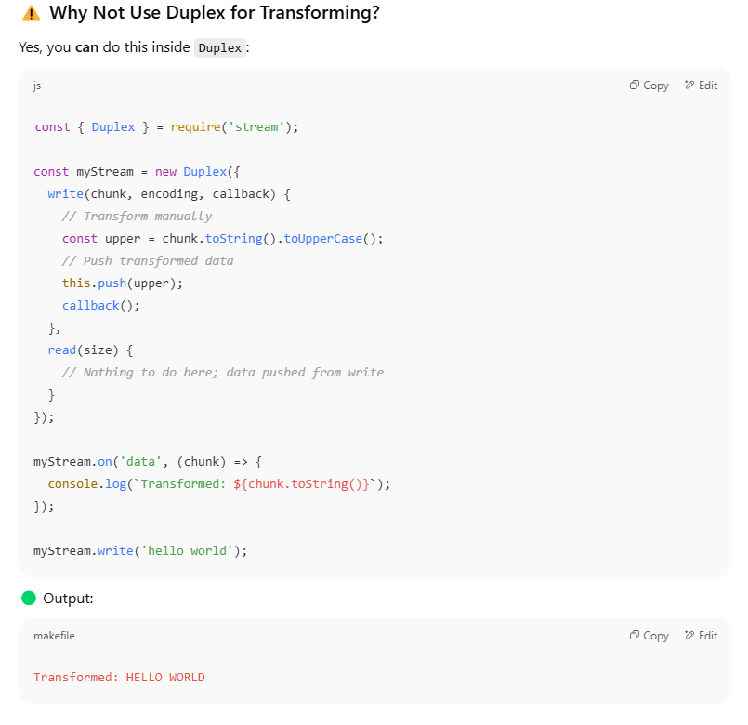
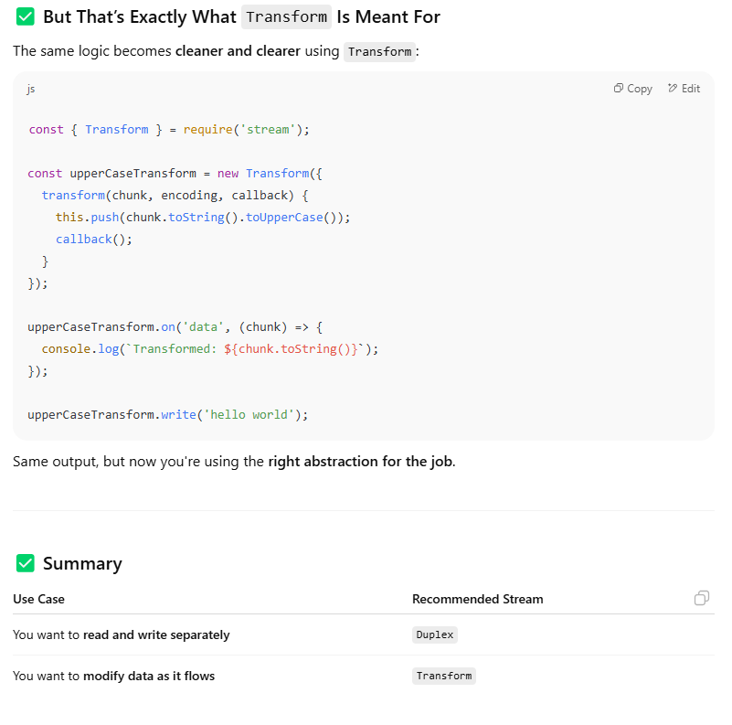
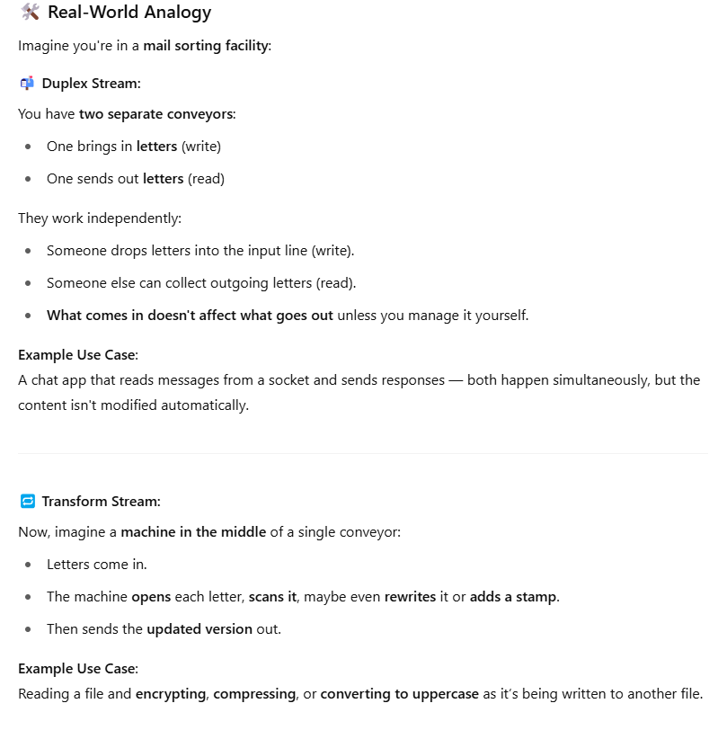

BONUS:
- We have Readable ( ), Writable ( ), fs.createReadStream ( ), fs.createWriteStream ( ) among these when to use what?????
🧊 THE ANALOGY: Water Flow System
Imagine:
- A water tank (source of water) = Readable
- A pipe (carries water) = pipe()
- A water filter or transformer (changes water) = Transform or custom stream
- A bucket (collects water) = Writable

