**Assignment Report**

Prepared For:



By:

Kanchi Sharma

Table of Contents

|  |  |
| --- | --- |
| **Contents** | **Page No.** |
| Final approach for projects |  |
| Challenges Faced |  |
| Results |  |
| References |  |
| Appendix |  |

**Final Approach Used For Projects**

Project 1:

* I started with loading libraries and images path on colab. I tried all the adjustments on a single image first to understand the working and to eliminate errors while running my final code.
* I have use python function for every process in my code as it is convenient to apply those on a bunch of images altogether.
* I started by reading the images and masks using read_images_and_masks(). The image masks had several white dots in the background so I applied preprocessing to fill them by using preprocess_masks().
* After that my next step was to create the background of car using wall and floor and replace it from the actual one. create_background() and replace_background() does this process smoothly by assigning 65% of background to wall and the rest to floor. And then by using car masks the background is replaced keeping the car intact.
* I am still figuring out a way to map shadow masks to the correct position in the image. Also, I am trying to resize the cars and adjust their locations on floor. The approach I am trying: I am trying to set a threshold for resizing the cars, so that all the cars can be of same size. I am also trying to set a threshold for car’s location on floor so that they all appear on floor and not in air.
* Lastly process_images() runs all the functions and output is saved.

**Challenges Faced**

Project 1:

* 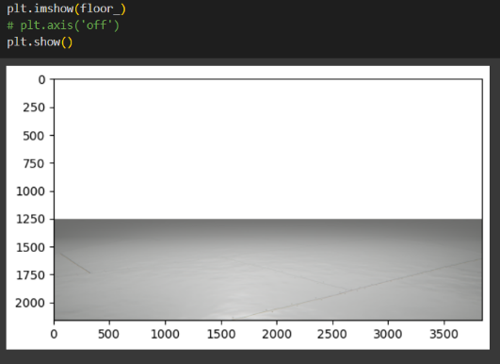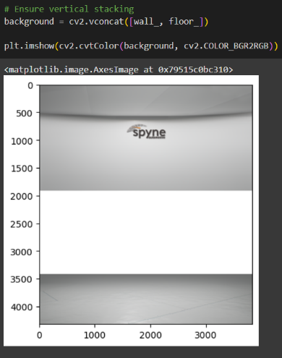The main challenge I faced was to stack wall and floor. I suppose there was some padding in both the images which was not visible before I loaded it using imread(). I spent hours figuring out the mistake while stacking them. I tried different methods to load and stack images until I realized the images has some discrepancies. I ended up cropping the space to perfectly stack wall and floor. Some visuals of my hardships:

* Another challenging task for me is to align shadow and adjust car size and location.

**Results**

Project 1:

Output for car1:

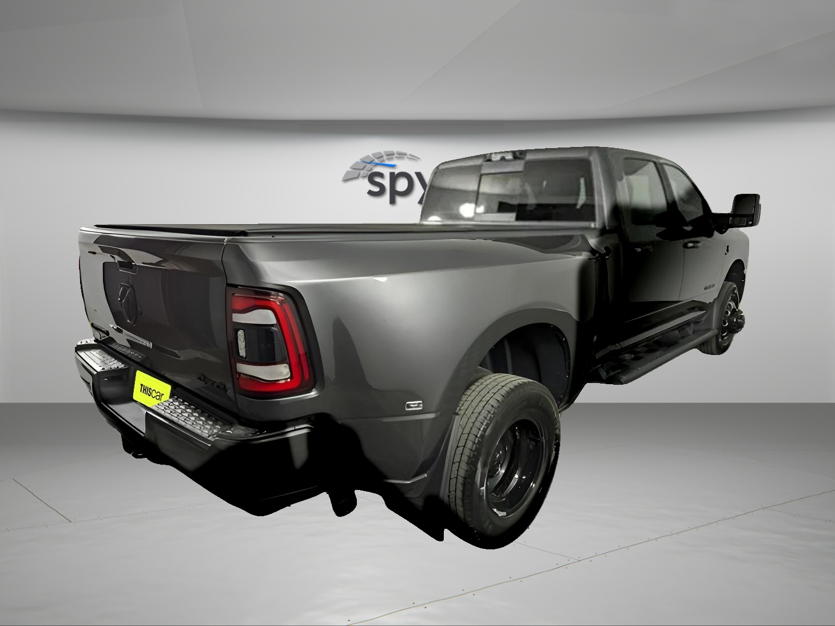

**References**

* docs.opencv.org

**Appendix**



Code for project 1: [Link](https://colab.research.google.com/drive/1ASvH-SzpMMe54kYroTJAAabb75w3TtbO?usp=sharing)

Code for Project 2: