**1. I want to change admin email id to get notification when user delete molecule**

- go to 'config.php', change email id for notification

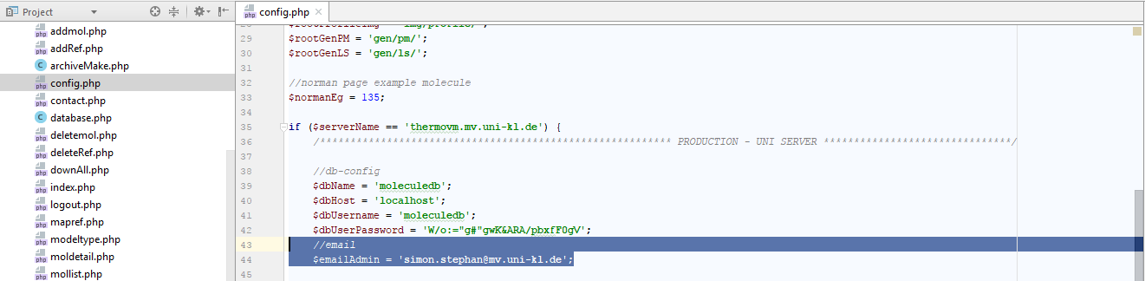

**2. I want to link new database / I want to change database user and password**

- originally admin can change database user id and password using sql  
- after that admin needs to link that database to project  
- go to 'config.php' change and change database configuration accordingly for production environment

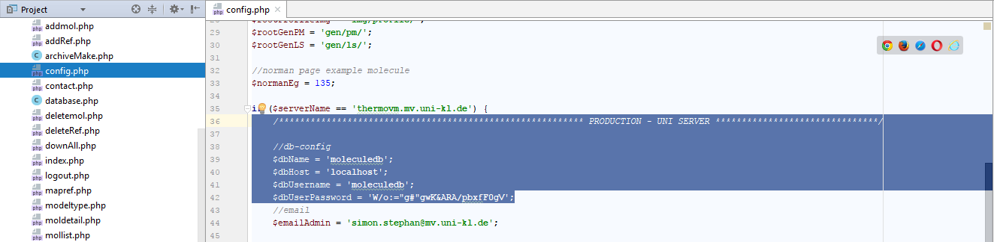

**3. I want to change text**

- as admin I am going through website and found this needs to be change.

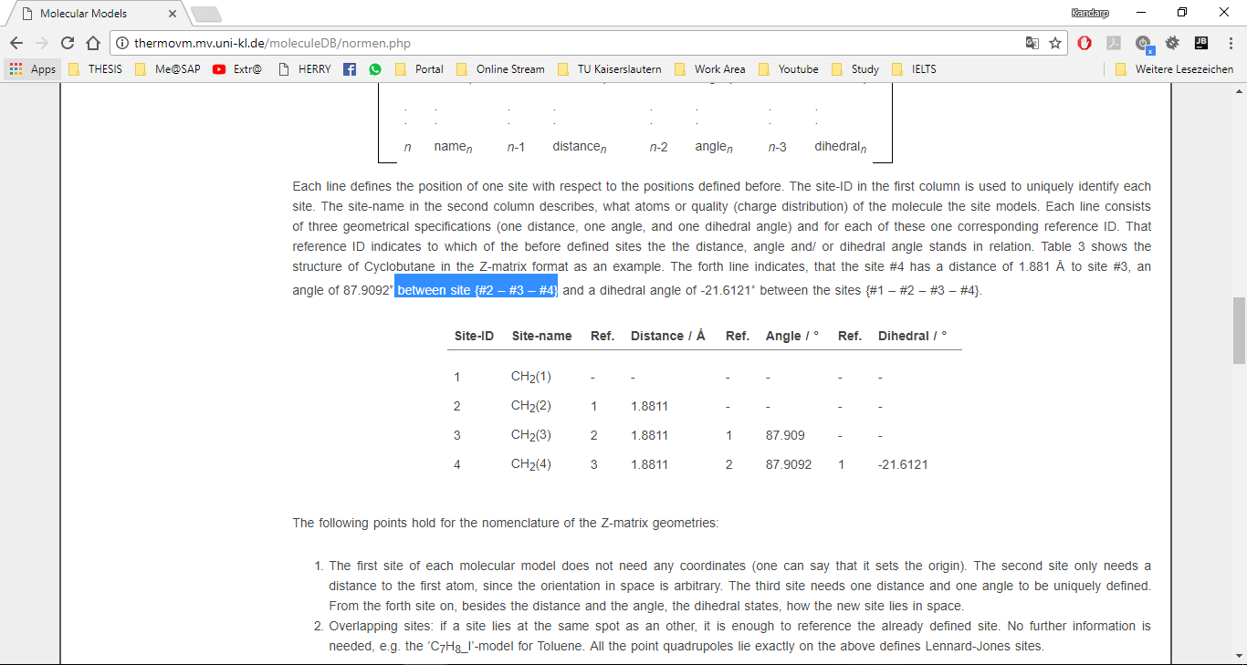

- read URL of browser  
- check which page is opened in browser



- go to that page (ex. Normen.php) from backend, find content that want to change

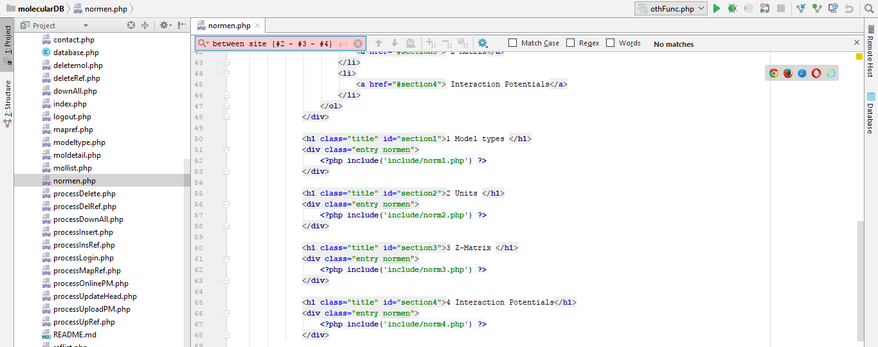

- content not found.

- check for the 'include' tag. **(ex. <?php include('include/norm2.php') ?>).**

- open that included files **(ex. norm1.php, norm2.php, etc.)** and find content

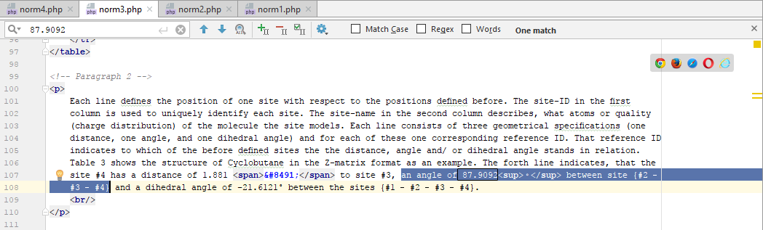

- found in norm3.php  
- change content

**4. I want to change image**

- as admin I am going through website and found this image needs to be change.

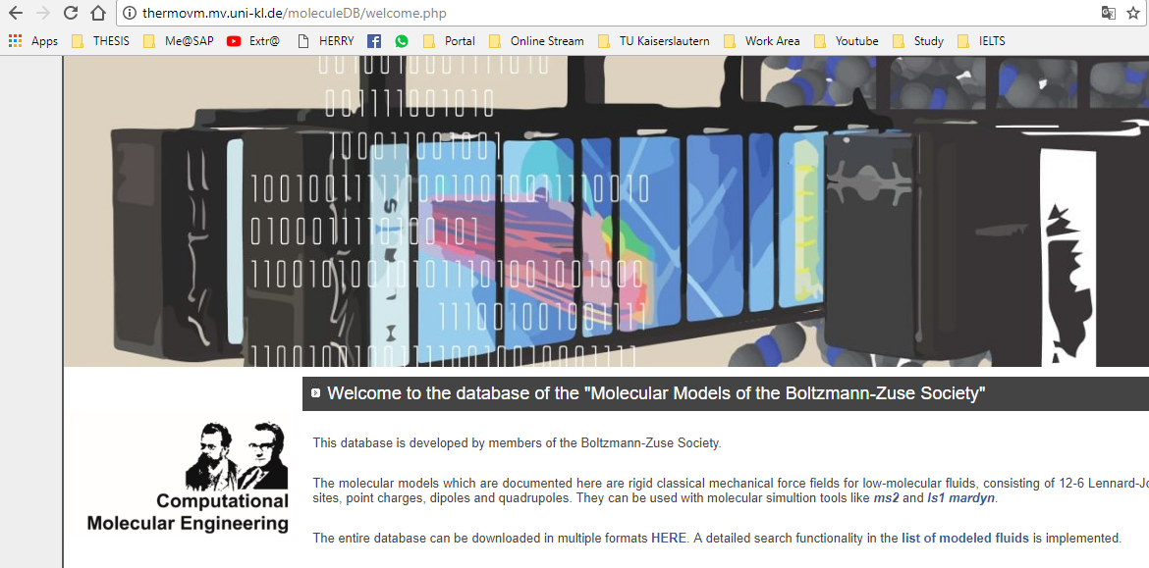

- check which image is used here by going **‘moleculeDB/img/’** directory.

- place new image in this folder as well.

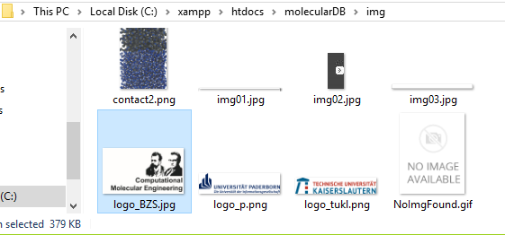

- read URL of browser.



- check which page is opened in browser  
- go to that page **(ex. welcome.php)** from backend, find image that want to change

- change image reference to new image.

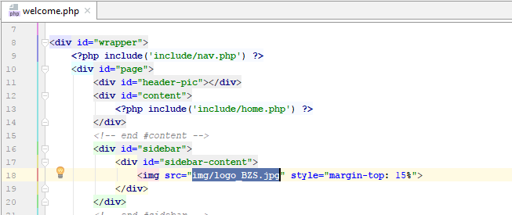

**5. I want to change admin login password**

- go to database  
- open table 'usr_access'  
- select record of user and update record

**6. I want to add new user.**

- go to database  
- open table 'usr_access'  
- add new user with user_id and password and role

