Course code: ECA3101
Course: Nano electronics
Experiment 5: Band Structure Simulation for Graphene and CNTs using NanoHub Aim: To simulate the band structure of nanowire for various materials

Output: The NanoHub band structure simulation successfully visualizes the electronic energy bands of graphene/CNT nanowires. The obtained E–k diagram shows how electron energy varies with momentum and provides insight into the material's conductivity. By analyzing the band dispersion and band gap, the simulation enables the classification of the nanowire as metallic or semiconducting. This study demonstrates the importance of band structure analysis in the design of nanoscale electronic devices such as carbon nanotube field-effect transistors (CNTFETs), graphene transistors, nanosensors, and other nanoelectronic applications.
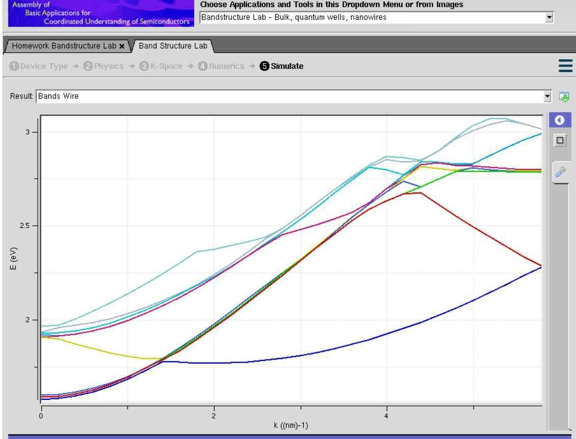
Case study1: Simulate the band-structure of InAs circular nanowire
Aim: To simulate the electronic band structure of an Indium Arsenide (InAs) circular nanowire using a nanotechnology simulation tool (e.g., NanoHub) and analyze its energy band dispersion and quantum confinement effects.
- Outcome: Successful simulation of the E–k band structure of the InAs circular nanowire.
- Identification of the conduction and valence bands and estimation of the band gap.
- Observation of quantum confinement effects due to the nanowire's small diameter.
- Understanding of the electronic properties of InAs nanowires for applications such as nanowire field-effect transistors (NWFETs), infrared photodetectors, high-electron-mobility devices, and quantum electronic devices.

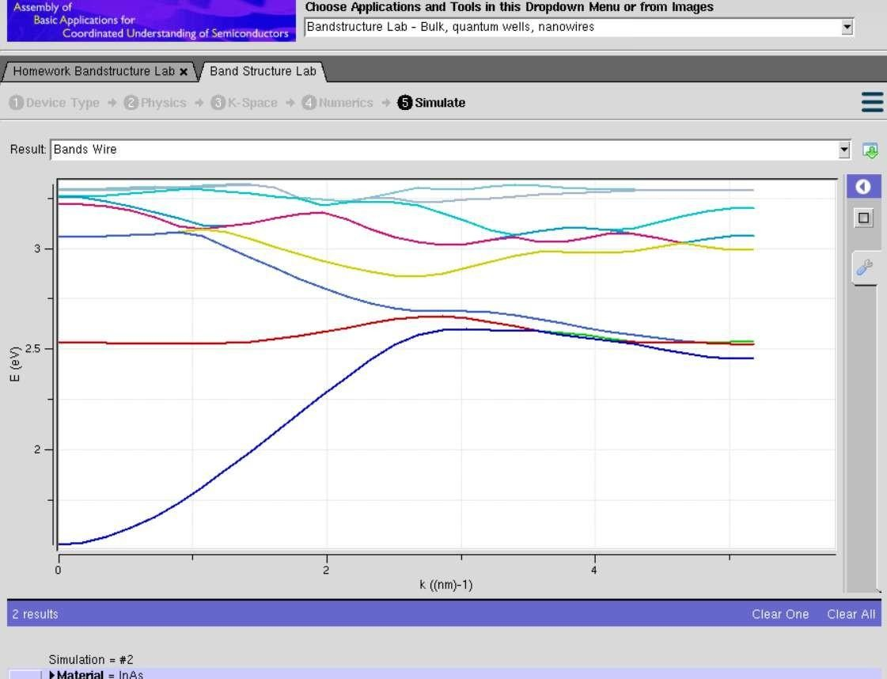
Case study2: Simulate the band-structure of AlGaAs circular nanowire
Aim: To simulate the electronic band structure of an Aluminum Gallium Arsenide (AlGaAs) circular nanowire using a nanotechnology simulation tool (e.g., NanoHub) and analyze its energy band dispersion and quantum confinement effects.
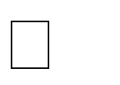
Outcome: • Successful simulation of the E–k band structure of the AlGaAs circular nanowire.

- Identification of the conduction and valence energy bands and estimation of the band gap.


- Observation of quantum confinement effects due to the nanowire's nanoscale dimensions. • Understanding of the electronic properties of AlGaAs nanowires for applications such as highelectron-mobility transistors (HEMTs), laser diodes, light-emitting diodes (LEDs), photodetectors, and high-speed optoelectronic devices.
