Course: ECA3101
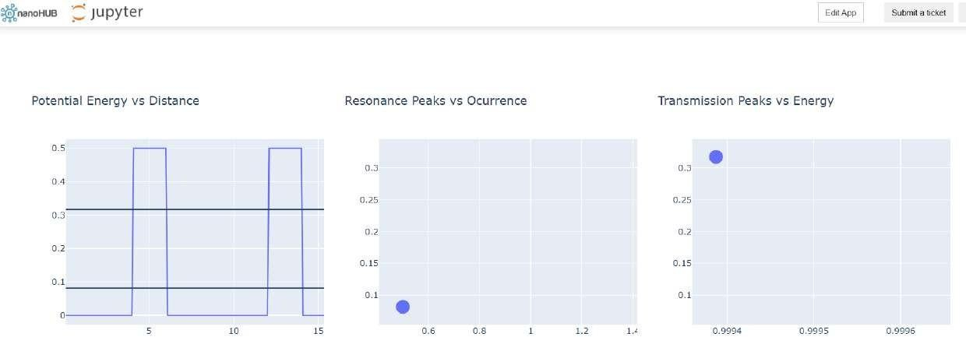
Nano electronics
Experiment 6: Demonstration of Quantum Tunneling
Aim: To demonstrate the concept of quantum tunneling, where electrons or other quantum particles pass through a potential energy barrier that cannot be crossed according to classical physics, and to study its applications in modern electronic devices.
Case study 1: Analysis of Transmission Co-efficient vs Energy Characteristics on a Refined Grid Aim: To analyze the variation of the transmission coefficient (T) with respect to the incident particle energy (E) using a refined computational grid, and to study the quantum tunneling behavior through a potential barrier with improved numerical accuracy.
Observation:
- At low energies, the transmission coefficient is very small.
- As the particle energy increases, the transmission coefficient gradually increases.
- Near and above the barrier energy, the transmission coefficient approaches 1 (100% transmission).
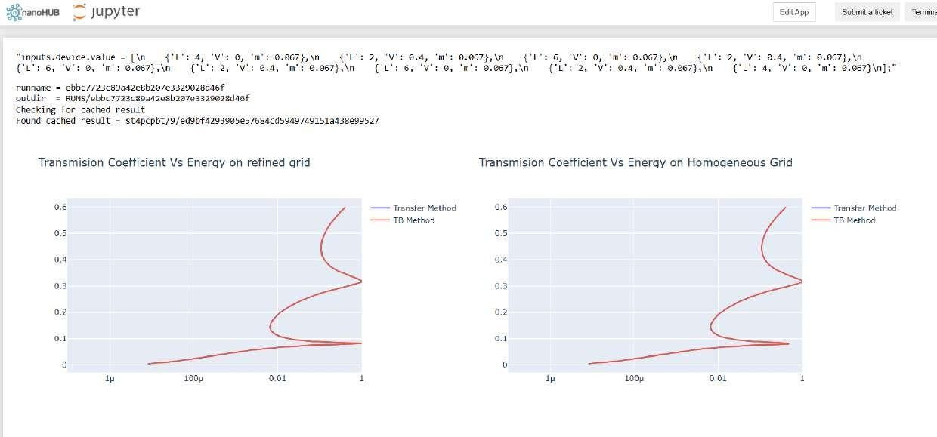
Case study 2: Analysis of Reflection Co-efficient vs Energy on a Homogeneous Grid
Aim: To analyze the variation of the reflection coefficient (R) with respect to the incident particle energy (E) using a homogeneous (uniform) computational grid, and to study the reflection characteristics of quantum particles interacting with a potential barrier.
Observation:
- At low energies, the reflection coefficient is close to 1 (complete reflection).
- As the particle energy increases, the reflection coefficient decreases.
- At energies higher than the barrier height, the reflection coefficient approaches 0 (negligible reflection).
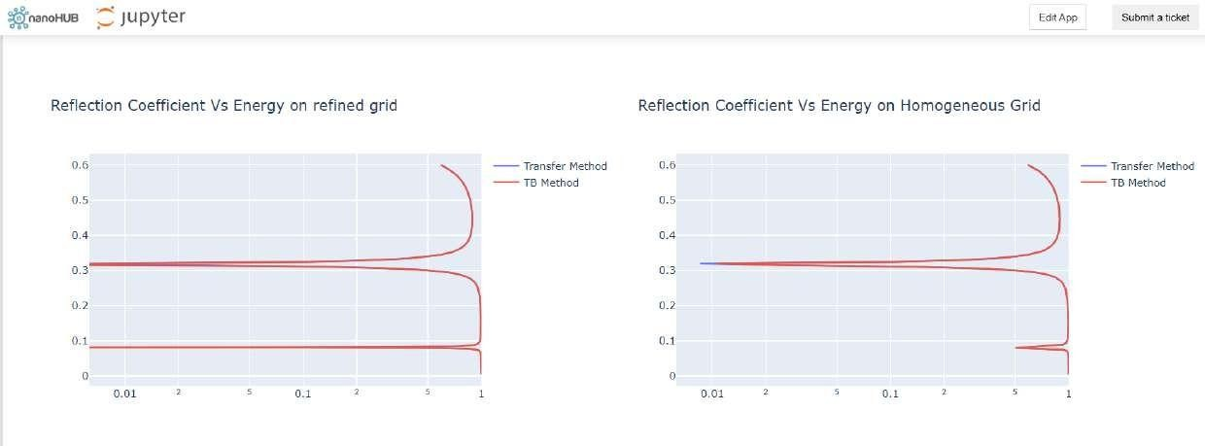
Conclusion: The two case studies demonstrate the fundamental principle of quantum tunneling by analyzing the transmission and reflection behavior of particles encountering a potential barrier.
- Case Study 1 shows that the transmission coefficient increases with increasing particle energy, indicating a higher probability of tunneling through the barrier.
- Case Study 2 shows that the reflection coefficient decreases as particle energy increases, meaning fewer particles are reflected when they possess higher energy.
- Since Transmission Co-efficient (T) + Reflection Co-efficient (R) = 1, the results satisfy the law of probability conservation in quantum mechanics.
- Overall, these analyses validate the quantum mechanical prediction that particles can tunnel through a barrier even when their energy is lower than the barrier height, a phenomenon that has important applications in tunnel diodes, scanning tunneling microscopes (STM), flash memory, quantum devices, and semiconductor technology.

