ECA3101
Nanoelectornics
Exp3: Simulation of Energy States of Quantum Dot using NanoHub
Aim: To simulate the energy states of a semiconductor quantum dot using the NanoHUB simulation platform and analyze the effect of three-dimensional quantum confinement on the discrete energy levels. Case Study 1: Simulate the energy states of cylindrical quantum dots of X=15 nm, Y = 10.5nm and Z = 8 nm.
Aim: To simulate the energy states of a cylindrical quantum dot with dimensions X = 15 nm, Y = 10.5 nm, and Z = 8 nm using NanoHUB. The study aims to analyze the effect of three-dimensional quantum confinement on the discrete electron energy levels and understand the electronic behavior of nanoscale semiconductor structures.
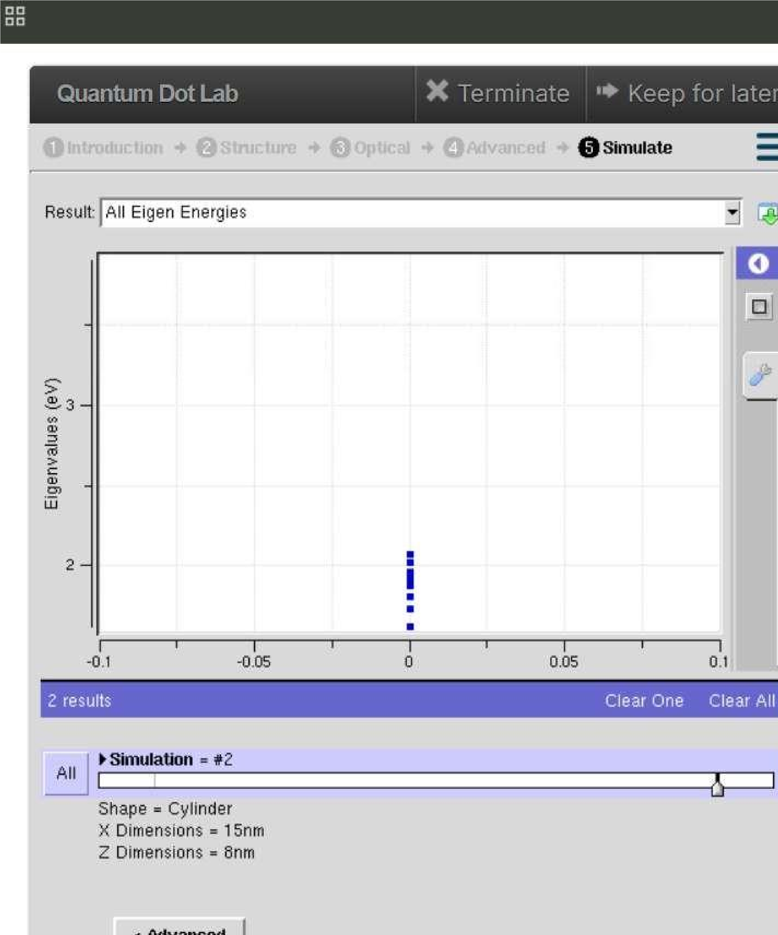
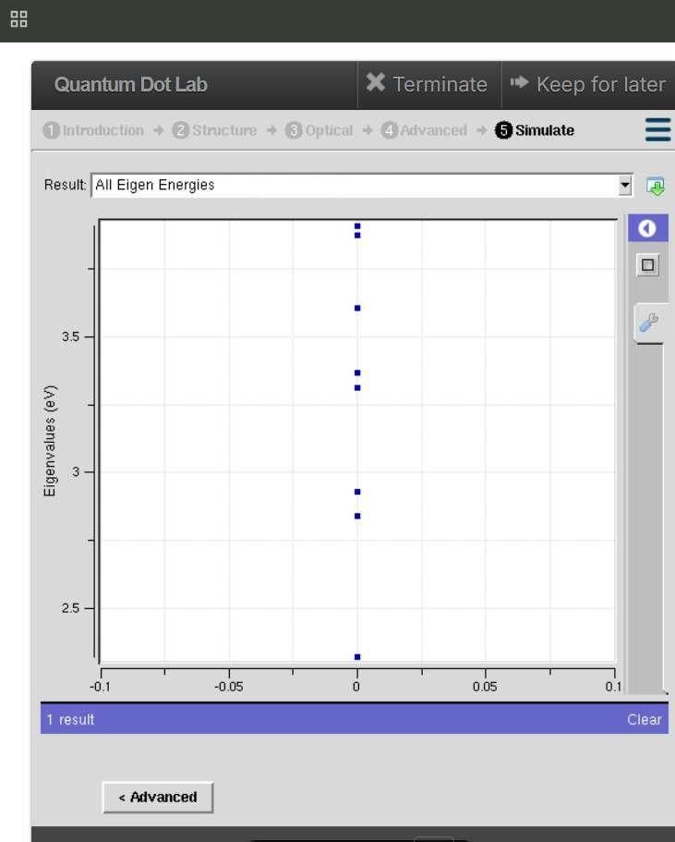

Case Study 2:
Simulate the energy states of two layer cuboid quantum dots

Aim:
To simulate the
energy states of a two
-
layer cuboid quantum dot

using NanoHUB and analyze the effect of
multilayer quan
tum confinement on the discrete electron energy levels.

Why:
The study aims to investigate how the layered structure influences the electronic properties for potential
nanoelectronic and optoelectronic device applications.

