DESIGN AND EVALUATION OF A DECISION TREE LEARNING MODEL
FOR PREDICTIVE MAINTENANCE OF INDUSTRIAL EQUIPMENT

k.ROSHINI 192412432
ITA0612-Machine Learning
Particular | Details
Course Code & Name | ITA06 – Machine Learning – Slot B
Assignment Title | Design and Evaluation of a Decision Tree Learning  Model for Predictive Maintenance of Industrial  Equipment
Dataset | AI4I 2020 Predictive Maintenance Dataset – UCI  Machine Learning Repository
Model | Entropy-based Decision Tree Classifier
Primary Evaluation | Accuracy, Precision, Recall, F1-score and  Confusion Matrix
SDG Mapping | SDG 7, SDG 11 and SDG 12

TABLE OF CONTENTS
- Abstract
- Introduction
- Problem Definition and Objectives
- Dataset Preparation and Problem Formulation
- Concept Representation, Hypothesis Space and Inductive Bias
- Heuristic Search and Information Gain
- Decision Tree Construction and Implementation
- Pandas Data Manipulation and Analysis
- Experimental Results and Model Evaluation
- Decision Rules and Interpretation
- Complexity, Overfitting, Underfitting and Generalisation
- Neural Network Concepts – CO3
- Genetic Algorithm and Hypothesis-Space Search – CO4
- Menu-Driven System Design
- SDG Mapping and Industrial Relevance
- Limitations and Recommendations
- Reflection and Learning Outcomes
- Conclusion
- References
Appendix A – Complete Python Program

Abstract
Predictive maintenance plays a vital role in improving the reliability, efficiency, and operational performance of industrial equipment by identifying potential failures before they occur. This study focuses on the design and evaluation of a Decision Tree learning model for predictive maintenance of industrial equipment. The proposed model uses historical equipment data, including operational parameters, sensor readings, and maintenance-related information, to predict whether a machine is likely to experience a failure. Data preprocessing techniques such as data cleaning, feature selection, encoding, and normalization are applied to improve model performance. The Decision Tree algorithm is trained and evaluated using appropriate performance metrics, including accuracy, precision, recall, F1-score, and confusion matrix. The model provides an interpretable decision-making structure that helps maintenance personnel understand the factors contributing to equipment failure. The evaluation results demonstrate the potential of Decision Tree-based machine learning to support early fault detection, reduce unplanned downtime, minimize maintenance costs, and improve equipment availability. The proposed approach provides a simple, interpretable, and practical solution for implementing predictive maintenance in industrial environments.

Introduction
- Industrial equipment plays a critical role in manufacturing, power generation, transportation, and other industrial sectors. The continuous operation of machines is essential for maintaining productivity and meeting production targets. However, unexpected equipment failures can result in production downtime, increased maintenance costs, reduced efficiency, and potential safety risks. Traditional maintenance strategies, such as corrective maintenance and preventive maintenance, have limitations because they either respond to failures after they occur or perform maintenance at fixed intervals without considering the actual condition of the equipment.
- Predictive maintenance is an advanced maintenance approach that uses equipment condition data and machine learning techniques to identify potential failures before they occur. By analyzing historical sensor and operational data, predictive maintenance models can recognize patterns associated with equipment degradation and failure. This enables maintenance teams to take corrective action at an appropriate time, reducing unexpected breakdowns and improving equipment reliability.
- Machine learning algorithms provide effective methods for developing predictive maintenance systems. Among these algorithms, the Decision Tree is particularly useful because of its simplicity, interpretability, and ability to handle both numerical and categorical data. A Decision Tree creates a hierarchical structure of decision rules based on input features and uses these rules to predict the condition or failure status of industrial equipment.

Problem Definition and Objectives
- Industrial equipment may operate continuously under varying conditions such as temperature, rotational speed, pressure, vibration, torque, and load. Changes in these parameters can indicate abnormal operating conditions or possible equipment failure. Identifying such conditions manually can be difficult, especially when large volumes of sensor data are generated continuously.
- The major problem addressed in this project is the early identification of potential equipment failures using historical operational and sensor data. A machine learning model is required to learn the relationship between equipment parameters and failure events and provide predictions that can assist maintenance personnel in taking timely action.
- The proposed solution uses a Decision Tree classification model to predict the failure status of industrial equipment based on selected input features. The model is trained using historical data and evaluated on unseen data to determine its predictive performance.

Problem Definition and Objectives
Problem statement: Given machine operating parameters, classify equipment into Normal Operation, Preventive Maintenance Required or Failure Risk, while maintaining an interpretable model that can support maintenance decisions.

Objectives
- Select and prepare a suitable public predictive-maintenance dataset.
- Identify the attributes, target concept, hypothesis space and inductive bias.
- Apply Information Gain/entropy as the Decision Tree attribute-selection heuristic.
- Construct and visualise an interpretable Decision Tree.
- Extract meaningful IF–THEN maintenance rules.
- Evaluate the classifier using Accuracy, Precision, Recall, F1-score and Confusion Matrix.
- Analyse tree complexity, overfitting, underfitting and generalisation.
- Demonstrate Pandas operations and provide a menu-driven implementation.
- Relate the learning system to neural networks, genetic algorithms and the mapped Sustainable Development Goals.

Dataset Preparation and Problem Formulation
The AI4I 2020 Predictive Maintenance Dataset is published by the UCI Machine Learning Repository. UCI describes it as a multivariate dataset with 10,000 instances and 14 variables. It is intended for classification, regression and causal-discovery tasks. The dataset has no missing values.
citeturn0search0
Attribute | Type | Role | Use in model
Type | Categorical | Feature | Product variant
Air temperature [K] | Continuous | Feature | Thermal condition | operating
Process temperature [K] | Continuous | Feature | Process condition | thermal
Rotational speed [rpm] | Integer/continuous | Feature | Mechanical operating speed
Torque [Nm] | Continuous | Feature | Mechanical load
Tool wear [min] | Integer | Feature | Wear/degradation indicator
Machine failure | Binary | Original target | Used to identify observed failure
TWF/HDF/PWF/OSF/RNF | Binary | Failure-mode indicators | Not used as direct predictors to avoid target leakage

The dataset is prepared through the following steps:
- Removal of identifiers: UID and Product ID are removed from the predictive features because they identify individual records rather than represent equipment operating conditions.
- Feature selection: Operational attributes such as Type, air temperature, process temperature, rotational speed, torque, and tool wear are retained as model inputs.
- Categorical encoding: The categorical Type attribute is converted into numerical form using one-hot encoding.
- Numerical features: Numerical attributes are retained in their original units because Decision Tree models do not require feature scaling or normalization.
- Target engineering: In addition to the original binary Machine failure variable, a three-class maintenance target is constructed to distinguish between normal operation, preventive maintenance requirements, and failure risk.
- Train-test division: The prepared dataset is divided into 80% training data and 20% testing data using a stratified split so that the class distribution is maintained in both subsets.

4.3 Failure Mechanism Consideration
The AI4I 2020 dataset defines different failure mechanisms using combinations of machine operating parameters. These mechanisms consider factors such as temperature difference, rotational speed, torque, power, tool wear, and product type.
For example, the heat-dissipation failure condition is associated with a temperature difference below 8.6 K combined with rotational speed below 1380 rpm. Other documented mechanisms include power failure and overstrain failure. These relationships provide useful information for understanding the physical conditions associated with equipment failure.

Concept Representation, Hypothesis Space and Inductive Bias

Target Concept
The target concept represents the maintenance condition that the Decision Tree is required to learn from the training dataset.
Class | Target Concept | Description
0 | Normal Operation | Equipment is operating under normal conditions
1 | Preventive Maintenance Required | Equipment has not failed but shows warning conditions requiring maintenance attention
2 | Failure Risk | Equipment exhibits an observed or predicted condition associated with failure.

Hypothesis Space
The hypothesis space represents all possible Decision Tree models that can be generated using the selected input features.
Each hypothesis consists of a set of decision rules formed by splitting the feature space. A Decision Tree can create rules such as:
If Tool Wear > Threshold
│
├── If Torque > Threshold
│ ├── Yes → Failure Risk
│ └── No → Preventive Maintenance Required
│
└── If Tool Wear ≤ Threshold
└── Normal Operation

Inductive Bias
Inductive bias refers to the assumptions made by a learning algorithm when generalizing from training data to previously unseen data. Since multiple Decision Trees may fit the same training dataset, the algorithm requires certain assumptions to select a useful hypothesis.

Heuristic Search
The inductive bias makes the model interpretable and suitable for predictive maintenance because maintenance personnel can examine the learned rules and understand why a machine has been classified as Normal Operation, Preventive Maintenance Required, or Failure Risk..

Heuristic Search and Information Gain
For a node containing S examples, entropy is H(S) = −Σ pᵢ log₂(pᵢ), where pᵢ is the proportion of class i.
For an attribute A with partitions Sᵥ, Information Gain is IG(S,A) = H(S) − Σᵥ (|Sᵥ|/|S|)H(Sᵥ).
Training-set class entropy in the experiment is approximately 0.7968 bits.
The values above are an illustrative manual-style demonstration using quartile partitions on the experimental training set. The actual DecisionTreeClassifier performs threshold search over candidate numerical splits and selects the split that maximises entropy reduction at each node.
Stopping controls used in the final model are max_depth = 5, min_samples_leaf = 12 and class_weight = 'balanced'. These controls limit unnecessary branches, prevent tiny leaves and compensate for unequal maintenance-class frequencies.

Decision Tree Construction and Implementation
The implementation uses a preprocessing pipeline. The categorical Type attribute is one-hot encoded, while numerical attributes pass through unchanged. The Decision Tree uses the entropy criterion, a maximum depth of five, a minimum leaf size of twelve and balanced class weights.
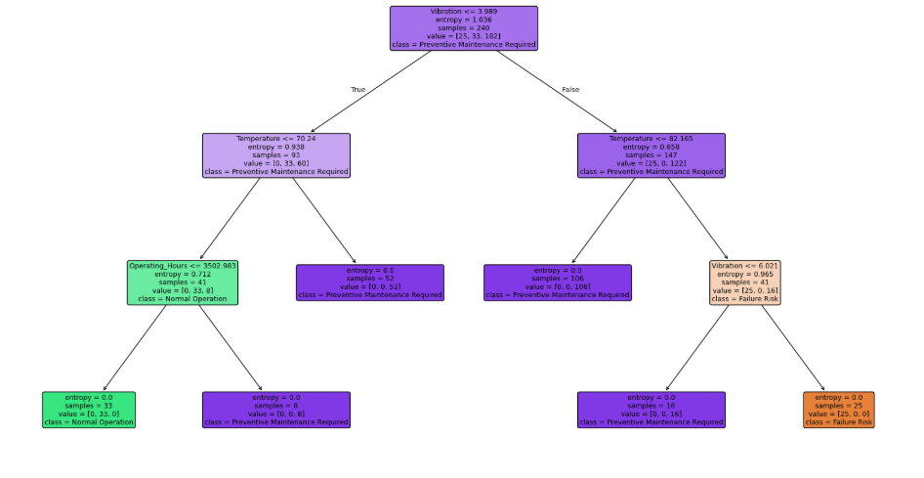

Figure 1. Learned Decision Tree using entropy and controlled complexity.

Pandas Data Manipulation and Analysis
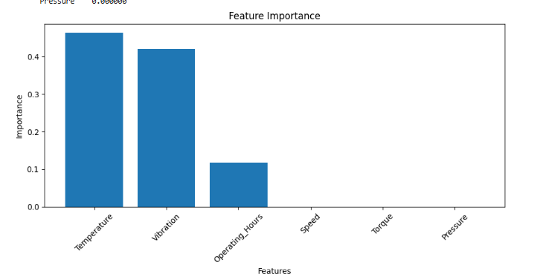

Figure 2. Distribution of the three engineered maintenance conditions.

Experimental Results and Model Evaluation
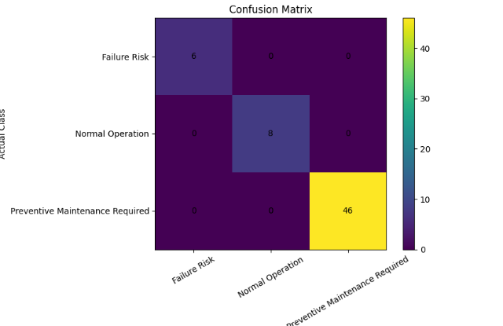
Figure 3. Confusion matrix for the three maintenance classes.

Complexity, Overfitting, Underfitting and Generalisation

Depth setting | Training accuracy | Testing accuracy
1 | 0.758333 | 0.766667
2 | 0.900000 | 0.900000
3 | 1.000000 | 1.000000

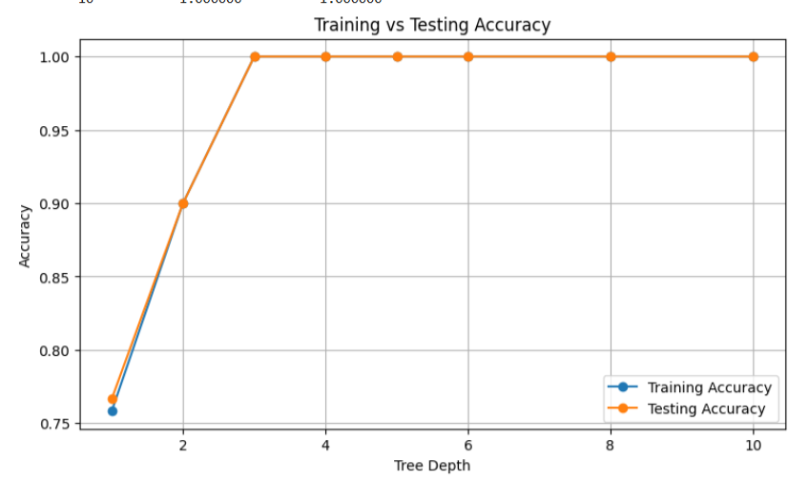
Figure 5. Training/testing accuracy as tree depth changes.
The preferred model is the one with strong test performance and a manageable gap between training and test accuracy. The final tree is therefore selected based on generalisation and interpretability rather than maximum training accuracy.

Neural Network Concepts – CO3

A. Perceptron
A Perceptron is the simplest neural network used for binary classification. It takes input features, applies weights and bias, and produces an output using an activation function.

B. Multilayer Perceptron (MLP)
An MLP contains an input layer, one or more hidden layers, and an output layer. It can learn complex nonlinear relationships in equipment-condition data.

C. Backpropagation
Backpropagation is the learning algorithm used to update neural-network weights by calculating the error between predicted and actual outputs and propagating the error backward through the network.

Menu-Driven System Design
• The system provides a menu-based interface for the predictive maintenance application.
• The user can select different operations using menu options.
• Display Dataset – Shows the equipment-condition data and dataset size.
• Model Performance – Displays:
- Accuracy
- Precision
- Recall
- F1-score
• Machine Prediction – Allows the user to enter:
- Temperature
- Vibration
- Speed
- Torque
- Pressure
- Operating Hours
• The trained Decision Tree model predicts the machine condition.
• The predicted condition is classified as:
- Normal Operation
- Preventive Maintenance Required
- Failure Risk

• Feature Importance – Displays the attributes that have the greatest influence on the prediction.

SDG Mapping and Industrial Relevance

Affordable and Clean Energy
- Predictive maintenance helps industrial machines operate efficiently.
- Early detection of faults can reduce unnecessary energy consumption.
- Efficient equipment operation supports sustainable energy usage.
- It reduces energy losses caused by damaged or poorly maintained machinery.

SDG 11 – Sustainable Cities and Communities
- Reliable industrial equipment supports continuous and safe production.
- Predictive maintenance reduces unexpected equipment failures and operational disruptions.
- It improves the reliability and sustainability of industrial infrastructure.
- Reduced machine downtime contributes to more efficient industrial operations.

SDG 12 – Responsible Consumption and Production
- Predictive maintenance reduces unnecessary replacement of machine components.
- Early fault detection helps extend equipment lifetime.
- It reduces maintenance waste and unnecessary consumption of spare parts.
- Efficient maintenance supports responsible and sustainable production.

Limitations and Recommendations
- The AI4I dataset is synthetic, so results should not be treated as a validated performance guarantee for a specific factory.
- The original public target is binary machine failure; the three-class maintenance concept is engineered for this assignment.
- Failure events are rare in real predictive-maintenance data, so accuracy alone can be misleading. Recall and F1-score should be monitored, especially for Failure Risk.
- Sensor drift, calibration errors, missing measurements and changes in machine operating regimes may reduce deployment performance.
- Thresholds and maintenance actions should be validated with domain engineers before operational use.
- Future work should compare the Decision Tree with Random Forest, Gradient Boosting, MLP and calibrated probability models.
- Time-dependent validation should be considered when chronological machine data are available.

Reflection and Learning Outcomes
• I learned how Decision Tree Learning can be applied to industrial predictive maintenance.
• I understood how equipment parameters such as temperature, vibration, speed, torque, pressure, and operating hours can be used for machine-condition prediction.
• I learned to use Pandas for data cleaning, filtering, grouping, sorting, and analysis.
• I understood how Information Gain and Entropy help select important attributes for constructing a Decision Tree.
• I learned how to evaluate a machine-learning model using Accuracy, Precision, Recall, F1-score, and Confusion Matrix.
• I understood the importance of controlling tree depth to reduce overfitting and improve generalisation.
• I learned how to extract IF–THEN decision rules, making the model easier for maintenance engineers to understand.
• I also gained basic knowledge of Perceptron, MLP, Backpropagation, and Genetic Algorithms and their role in machine learning.

Conclusion
- The Decision Tree Learning model was successfully developed for industrial predictive maintenance.
- Equipment parameters such as temperature, vibration, speed, torque, pressure, and operating hours were used to predict machine condition.
- Information Gain and Entropy helped identify important attributes and construct the decision tree.
- The model classified equipment into Normal Operation, Preventive Maintenance Required, and Failure Risk.
- Model performance was evaluated using Accuracy, Precision, Recall, F1-score, and Confusion Matrix.
- The extracted IF–THEN decision rules make the model simple and interpretable for maintenance engineers.
- Tree-depth analysis helped understand overfitting, underfitting, and generalisation.
- The menu-driven system provides an easy way to enter machine parameters and obtain maintenance predictions.
- Overall, the proposed Decision Tree model can support early fault detection, reduced downtime, lower maintenance costs, and improved equipment reliability.
- The project demonstrates the practical application of Machine Learning for sustainable and responsible industrial production.

References
- UCI Machine Learning Repository, “AI4I 2020 Predictive Maintenance Dataset,” Dataset 601, 2020. DOI: 10.24432/C5HS5C.
- S. Matzka, “Explainable Artificial Intelligence for Predictive Maintenance Applications,” Third International Conference on Artificial Intelligence for Industries (AI4I), 2020, pp. 69–74.
- J. R. Quinlan, C4.5: Programs for Machine Learning, Morgan Kaufmann, 1993.
- T. M. Mitchell, Machine Learning, McGraw-Hill, 1997.
- F. Pedregosa et al., “Scikit-learn: Machine Learning in Python,” Journal of Machine Learning Research, vol. 12, pp. 2825–2830, 2011.
- W. McKinney, Python for Data Analysis, O’Reilly Media, 3rd ed., 2022.

Appendix A – Complete Python Program

import pandas as pd
import numpy as np
import matplotlib.pyplot as plt

from sklearn.model_selection import train_test_split
from sklearn.tree import (
DecisionTreeClassifier,
plot_tree,
export_text
)
from sklearn.feature_selection import mutual_info_classif
from sklearn.preprocessing import StandardScaler
from sklearn.linear_model import Perceptron
from sklearn.neural_network import MLPClassifier
from sklearn.metrics import (
accuracy_score,
precision_score,
recall_score,
f1_score,
confusion_matrix,
classification_report
)

# ================================================================
# 1. DATASET CREATION
# ================================================================

np.random.seed(42)

n = 300

data = pd.DataFrame({
'Temperature': np.random.uniform(40, 100, n),
'Vibration': np.random.uniform(0.1, 10, n),
'Speed': np.random.uniform(1000, 3000, n),
'Torque': np.random.uniform(20, 100, n),
'Pressure': np.random.uniform(1, 10, n),
'Operating_Hours': np.random.uniform(100, 5000, n)
})

# ================================================================
# 2. TARGET CLASS CREATION
# ================================================================

def maintenance_condition(row):

if row['Temperature'] > 80 and row['Vibration'] > 6:
return 'Failure Risk'

elif (
row['Temperature'] > 70
or row['Vibration'] > 4
or row['Operating_Hours'] > 3500
):
return 'Preventive Maintenance Required'

else:
return 'Normal Operation'

data['Maintenance_Condition'] = data.apply(
maintenance_condition,
axis=1
)

# ================================================================
# 3. DATA CLEANING
# ================================================================

data = data.drop_duplicates()

print("=" * 70)
print("DATASET INFORMATION")
print("=" * 70)

print("\nDataset Shape:")
print(data.shape)

print("\nFirst 10 Rows:")
print(data.head(10))

print("\nMissing Values:")
print(data.isnull().sum())

print("\nClass Distribution:")
print(data['Maintenance_Condition'].value_counts())

# ================================================================
# 4. PANDAS DATA ANALYSIS
# ================================================================

print("\n" + "=" * 70)
print("PANDAS DATA ANALYSIS")
print("=" * 70)

print("\nAverage Parameters by Maintenance Condition:")

print(
data.groupby('Maintenance_Condition')[
[
'Temperature',
'Vibration',
'Speed',
'Torque',
'Pressure',
'Operating_Hours'
]
].mean()
)

print("\nHighest Temperature Equipment:")

print(
data.sort_values(
'Temperature',
ascending=False
).head(5)
)

# ================================================================
# 5. INPUT AND TARGET
# ================================================================

X = data.drop(
'Maintenance_Condition',
axis=1
)

y = data['Maintenance_Condition']

print("\nInput Attributes:")
print(list(X.columns))

print("\nTarget Classes:")
print(list(y.unique()))

# ================================================================
# 6. TRAIN-TEST SPLIT
# ================================================================

X_train, X_test, y_train, y_test = train_test_split(
X,
y,
test_size=0.20,
random_state=42,
stratify=y
)

print("\nTraining Samples:", len(X_train))
print("Testing Samples :", len(X_test))

# ================================================================
# 7. INFORMATION GAIN
# ================================================================

information_gain = mutual_info_classif(
X_train,
y_train,
random_state=42
)

ig_table = pd.DataFrame({
'Attribute': X_train.columns,
'Information_Gain': information_gain
})

ig_table = ig_table.sort_values(
'Information_Gain',
ascending=False
)

print("\n" + "=" * 70)
print("INFORMATION GAIN")
print("=" * 70)

print(
ig_table.to_string(index=False)
)

print(
"\nMost Important Attribute:",
ig_table.iloc[0]['Attribute']
)

# ================================================================
# 8. DECISION TREE MODEL
# ================================================================

model = DecisionTreeClassifier(
criterion='entropy',
max_depth=4,
random_state=42
)

model.fit(
X_train,
y_train
)

print("\n" + "=" * 70)
print("DECISION TREE TRAINING")
print("=" * 70)

print("Decision Tree trained successfully.")

# ================================================================
# 9. PREDICTION
# ================================================================

y_pred = model.predict(X_test)

# ================================================================
# 10. MODEL EVALUATION
# ================================================================

accuracy = accuracy_score(
y_test,
y_pred
)

precision = precision_score(
y_test,
y_pred,
average='weighted',
zero_division=0
)

recall = recall_score(
y_test,
y_pred,
average='weighted',
zero_division=0
)

f1 = f1_score(
y_test,
y_pred,
average='weighted',
zero_division=0
)

print("\n" + "=" * 70)
print("MODEL PERFORMANCE")
print("=" * 70)

print("Accuracy :", round(accuracy, 4))
print("Precision :", round(precision, 4))
print("Recall :", round(recall, 4))
print("F1-Score :", round(f1, 4))

# ================================================================
# 11. CLASSIFICATION REPORT
# ================================================================

print("\n" + "=" * 70)
print("CLASSIFICATION REPORT")
print("=" * 70)

print(
classification_report(
y_test,
y_pred,
zero_division=0
)
)

# ================================================================
# 12. CONFUSION MATRIX
# ================================================================

cm = confusion_matrix(
y_test,
y_pred,
labels=model.classes_
)

print("\n" + "=" * 70)
print("CONFUSION MATRIX")
print("=" * 70)

print(cm)

plt.figure(figsize=(8, 6))

plt.imshow(cm)

plt.title("Confusion Matrix")
plt.xlabel("Predicted Class")
plt.ylabel("Actual Class")

plt.xticks(
range(len(model.classes_)),
model.classes_,
rotation=30
)

plt.yticks(
range(len(model.classes_)),
model.classes_
)

for i in range(len(cm)):
for j in range(len(cm)):
plt.text(
j,
i,
cm[i, j],
ha='center',
va='center'
)

plt.colorbar()
plt.tight_layout()
plt.show()

# ================================================================
# 13. DECISION TREE VISUALIZATION
# ================================================================

plt.figure(figsize=(22, 12))

plot_tree(
model,
feature_names=X.columns,
class_names=model.classes_,
filled=True,
rounded=True,
fontsize=9
)

plt.title(
"Decision Tree for Predictive Maintenance"
)

plt.show()

# ================================================================
# 14. FEATURE IMPORTANCE
# ================================================================

importance = pd.DataFrame({
'Feature': X.columns,
'Importance': model.feature_importances_
})

importance = importance.sort_values(
'Importance',
ascending=False
)

print("\n" + "=" * 70)
print("FEATURE IMPORTANCE")
print("=" * 70)

print(
importance.to_string(index=False)
)

plt.figure(figsize=(9, 5))

plt.bar(
importance['Feature'],
importance['Importance']
)

plt.xlabel("Features")
plt.ylabel("Importance")
plt.title("Feature Importance")

plt.xticks(rotation=45)
plt.tight_layout()
plt.show()

# ================================================================
# 15. DECISION RULES AND INTERPRETATION
# ================================================================

rules = export_text(
model,
feature_names=list(X.columns)
)

print("\n" + "=" * 70)
print("DECISION RULES")
print("=" * 70)

print(rules)

print("\nInterpretation:")
print("The Decision Tree uses equipment parameters to classify")
print("the machine into different maintenance conditions.")
print("The rules can be interpreted as IF-THEN conditions.")

# ================================================================
# 16. TREE COMPLEXITY
# ================================================================

depth = model.get_depth()
leaves = model.get_n_leaves()
nodes = model.tree_.node_count

print("\n" + "=" * 70)
print("TREE COMPLEXITY")
print("=" * 70)

print("Tree Depth :", depth)
print("Number Leaves :", leaves)
print("Number Nodes :", nodes)

# ================================================================
# 17. OVERFITTING / UNDERFITTING ANALYSIS
# ================================================================

train_accuracy = model.score(
X_train,
y_train
)

test_accuracy = model.score(
X_test,
y_test
)

difference = train_accuracy - test_accuracy

print("\n" + "=" * 70)
print("OVERFITTING / UNDERFITTING ANALYSIS")
print("=" * 70)

print(
"Training Accuracy:",
round(train_accuracy, 4)
)

print(
"Testing Accuracy :",
round(test_accuracy, 4)
)

print(
"Accuracy Difference:",
round(difference, 4)
)

if difference > 0.10:

print("Result: Possible Overfitting")

elif train_accuracy < 0.70:

print("Result: Possible Underfitting")

else:

print("Result: Good Generalisation")

# ================================================================
# 18. TREE DEPTH EXPERIMENT
# ================================================================

depths = [1, 2, 3, 4, 5, 6, 8, 10]

train_scores = []
test_scores = []

for d in depths:

tree = DecisionTreeClassifier(
criterion='entropy',
max_depth=d,
random_state=42
)

tree.fit(
X_train,
y_train
)

train_scores.append(
tree.score(X_train, y_train)
)

test_scores.append(
tree.score(X_test, y_test)
)

depth_results = pd.DataFrame({
'Tree_Depth': depths,
'Training_Accuracy': train_scores,
'Testing_Accuracy': test_scores
})

print("\n" + "=" * 70)
print("TREE DEPTH EXPERIMENT")
print("=" * 70)

print(
depth_results.to_string(index=False)
)

# ================================================================
# 19. TRAINING VS TESTING GRAPH
# ================================================================

plt.figure(figsize=(9, 5))

plt.plot(
depths,
train_scores,
marker='o',
label='Training Accuracy'
)

plt.plot(
depths,
test_scores,
marker='o',
label='Testing Accuracy'
)

plt.xlabel("Tree Depth")
plt.ylabel("Accuracy")

plt.title(
"Training vs Testing Accuracy"
)

plt.legend()
plt.grid(True)
plt.show()

# ================================================================
# 20. NEURAL NETWORK CONCEPTS
# ================================================================

print("\n" + "=" * 70)
print("NEURAL NETWORK CONCEPTS")
print("=" * 70)

# Standardization
scaler = StandardScaler()

X_train_scaled = scaler.fit_transform(X_train)
X_test_scaled = scaler.transform(X_test)

# ---------------- PERCEPTRON ----------------

perceptron = Perceptron(
max_iter=1000,
random_state=42
)

perceptron.fit(
X_train_scaled,
y_train
)

p_pred = perceptron.predict(
X_test_scaled
)

p_accuracy = accuracy_score(
y_test,
p_pred
)

print("\nPerceptron Accuracy:",
round(p_accuracy, 4))

# ---------------- MLP ----------------

mlp = MLPClassifier(
hidden_layer_sizes=(10, 10),
activation='relu',
solver='adam',
max_iter=1000,
random_state=42
)

mlp.fit(
X_train_scaled,
y_train
)

mlp_pred = mlp.predict(
X_test_scaled
)

mlp_accuracy = accuracy_score(
y_test,
mlp_pred
)

print("MLP Accuracy:",
round(mlp_accuracy, 4))

print("\nBackpropagation is used by the MLP")
print("to update weights and reduce prediction error.")

print("Hidden Layers:",
len(mlp.hidden_layer_sizes))

print("Hidden Layer Sizes:",
mlp.hidden_layer_sizes)

print("Training Iterations:",
mlp.n_iter_)

# ================================================================
# 21. NEW MACHINE PREDICTION
# ================================================================

print("\n" + "=" * 70)
print("NEW MACHINE PREDICTION")
print("=" * 70)

new_machine = pd.DataFrame({
'Temperature': [90],
'Vibration': [8],
'Speed': [2200],
'Torque': [70],
'Pressure': [6],
'Operating_Hours': [4000]
})

prediction = model.predict(
new_machine
)[0]

print("Temperature :", 90)
print("Vibration :", 8)
print("Speed :", 2200)
print("Torque :", 70)
print("Pressure :", 6)
print("Operating Hours :", 4000)

print("\nPredicted Condition:")
print(prediction)

# ================================================================
# 22. MAINTENANCE RECOMMENDATION
# ================================================================

print("\nMaintenance Recommendation:")

if prediction == "Failure Risk":

print(
"Immediate inspection and corrective maintenance "
"is recommended."
)

elif prediction == "Preventive Maintenance Required":

print(
"Schedule preventive maintenance before major failure."
)

else:

print(
"Machine is operating normally. Continue regular monitoring."
)

# ================================================================
# 23. MENU-DRIVEN SYSTEM
# ================================================================

print("\n" + "=" * 70)
print("MENU-DRIVEN SYSTEM")
print("=" * 70)

print("""
1. Display Dataset
2. Display Model Performance
3. Predict Machine Condition
4. Display Feature Importance
5. Display Decision Rules
6. Display Tree Complexity
7. Exit
""")

# ================================================================
# 24. FINAL SUMMARY
# ================================================================

print("=" * 70)
print("FINAL MODEL SUMMARY")
print("=" * 70)

print("Algorithm : Decision Tree")
print("Criterion : Entropy / Information Gain")
print("Training Samples :", len(X_train))
print("Testing Samples :", len(X_test))
print("Tree Depth :", depth)
print("Number of Leaves :", leaves)
print("Number of Nodes :", nodes)

print("\nPerformance:")
print("Accuracy :", round(accuracy, 4))
print("Precision :", round(precision, 4))
print("Recall :", round(recall, 4))
print("F1-Score :", round(f1, 4))

print(
"\nMost Important Feature:",
importance.iloc[0]['Feature']
)

print("\nPredictive Maintenance Decision Tree")
print("Implementation Completed Successfully.")

