**1.Answer:**

Identify the Actors:

Satellite Information Systems

Satellite Communication

Weather Station

Thermometer and other device readings

Database Connection

**2.Answer:**

Creating a sequence diagram for a group diary system when a group of people are arranging a meeting involves multiple objects and interactions. Let's break down the key interactions step by step.

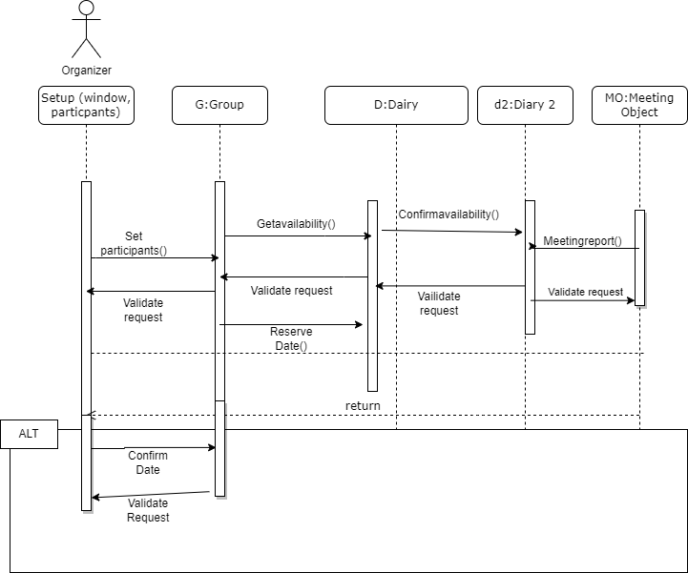

**3.ANSWER**

Configuration management (CM) is a set of processes and tools that helps teams track and manage changes to software and systems. CM is essential for handling problems that can arise when integrating code into a larger system.

Here are some specific ways that CM can be useful for handling integration problems:

* **Version control:** CM provides a way to track different versions of the code. This makes it easy to identify which version of the code was integrated, making it easier to isolate and fix problems.
* **Change tracking and traceability:** CM tools track changes made to the codebase. This traceability can be used to identify the root cause of problems that occur after integration.
* **Baseline management:** CM defines and maintains baselines, which are known good versions of a system or software. Baselines can be used to compare the integrated code against a known stable state, helping to identify discrepancies and troubleshoot issues.
* **Parallel development:** CM facilitates parallel development by allowing developers to work on different parts of a system simultaneously and then merge their changes systematically. This minimizes conflicts and issues during integration.
* **Isolation of changes:** CM provides a controlled environment for making and testing changes. Developers can create branches to isolate their changes from the main codebase until they are ready for integration. This minimizes the risk of introducing bugs or disruptions to the larger system.
* **Reproducibility**: CM enables the reproducibility of software builds. This is important for debugging and resolving problems efficiently, as it allows teams to recreate the environment and conditions under which the integration occurred.
* **Rollback and recovery:** When problems are encountered during integration, CM tools allow for easy rollback to a previous known working version. This helps to restore the system to a stable state while the root cause of the problem is investigated and resolved.
* **Collaboration and communication:** CM facilitates collaboration by providing a central repository for the codebase. This makes it easier for team members to communicate changes, updates, and issues related to integration. Proper documentation and communication can help teams to better handle and resolve problems.
* **Automated build and deployment:** CM tools often integrate with automated build and deployment systems. Automated processes can help to identify integration issues early in the development pipeline, reducing the likelihood of problems surfacing when code is integrated into the larger system.

**4.Answer:**

Testers may not always fully understand the intended use or specific requirements of a program for various reasons. Some of these reasons include:

* **Incomplete or outdated documentation:** Testers rely on documentation and specifications to understand the program's intended functionality. However, if these documents are incomplete, outdated, or missing altogether, testers may struggle to determine the program's purpose.
* **Miscommunication:** Poor communication between different stakeholders in the software development process can lead to misunderstandings about the program's intended functionality. For example, if developers, product managers, and testers do not communicate effectively or have different interpretations of requirements, testers may not fully grasp the intended use cases.
* **Changing requirements:** Software development is an iterative process, and requirements can change throughout the project. Testers may not be updated promptly or comprehensively about these changes, leading to a mismatch between their testing efforts and the current goals of the program.
* **Complexity of the system:** In complex systems, it can be challenging to understand the entire scope of functionality and all possible use cases. Testers may not be aware of every potential feature or edge case, leading to gaps in test coverage.
* **Domain-specific knowledge:** Some programs are designed for specialized domains or industries. Testers without domain-specific knowledge may struggle to understand the nuances of the program's intended functionality and the specific needs of its users.
* **Lack of access to developers: Testers** may not have direct access to developers or the development process. This can hinder their ability to ask clarifying questions or get additional information about the program's intended use.
* **Ambiguity in requirements:** Sometimes, requirements themselves can be ambiguous or open to interpretation. Testers may interpret requirements differently from developers or other stakeholders, leading to varying expectations about what the program should do.
* **Assumptions:** Testers may make assumptions about the program's functionality based on their own experiences or biases, which may not align with the actual intent of the software.
* **Time constraints:** In fast-paced development environments, testers may have limited time to thoroughly understand the program's intended use. They might prioritize testing based on the information available, which may not cover all aspects of the software's intended functionality.

**5th answer:**

This is a long-debated question in the software development community. Both approaches have their pros and cons.

**Arguments for developers testing their own code:**

* Faster feedback loop: Developers can identify and fix bugs quickly, leading to better code quality.
* In-depth understanding: Developers have a deep understanding of their code, which helps them design comprehensive tests.
* Reduced context switching: Developers can stay in the development mindset, which can boost productivity.
* Ownership and accountability: Developers are more likely to take ownership of their code and ensure its quality when they test it themselves.
* Early bug detection: Developer testing can catch bugs early in the development process, preventing downstream problems.

**Arguments against developers testing their own code:**

* Bias and blind spots: Developers may have biases or blind spots that prevent them from testing their code effectively. They may overlook certain test cases or assume the code behaves as intended, leading to missed issues.
* Limited perspective: Developers tend to test based on their understanding of the code's logic, which may not always align with real-world usage scenarios or user perspectives.
* Time constraints: Developers may prioritize writing new code over testing, especially when under tight deadlines. This can result in inadequate testing coverage.
* Conflict of interest: Developers may feel pressured to skip rigorous testing to meet deadlines or avoid finding critical issues that could reflect negatively on their work.

**Arguments for separate testing teams:**

* Impartial evaluation: Independent testers approach the code with fresh eyes and fewer preconceptions, making it more likely that they will identify issues that developers might overlook.
* Diverse skill sets: Testers often have specialized testing skills and tools to thoroughly evaluate code from different perspectives, including user experience, security, and performance.
* Reduced confirmation bias: Independent testers are less likely to validate their own assumptions about the code's behavior, reducing confirmation bias.
* Third-party perspective: Separate testing teams provide a third-party perspective that can better mimic how end-users will interact with the software.

**Arguments against separate testing teams:**

* Increased handoff complexity: Handing off code to a separate testing team can introduce communication challenges and delays in addressing issues.
* Contextual gap: Testers may not fully understand the developer's intent, which can lead to misaligned testing efforts.
* Feedback delay: Waiting for a separate testing team's feedback can slow down the development process and hinder the rapid iteration of code.
* Cost and resource allocation: Maintaining a separate testing team can be costlier and may require additional resources.

**Which approach is best?**

In practice, the optimal approach often depends on the size and nature of the project, the available resources, and the organization's culture. Many organizations adopt a balanced approach, where developers perform unit testing and integration testing, while an independent testing team focuses on system-level testing, usability, and other specialized testing areas. This combines the strengths of both approaches to deliver high-quality software.