[**Personal-Technical-Portfolio-Documentation**](https://github.com/KandhalaKiran/Personal-Technical-Portfolio-Documentation) **Project Report**

**INTRODUCTION**

* Overview: The portfolio project aims to showcase a comprehensive collection of my work as a student. This platform serves as a curated representation of my skills, expertise, and achievements, allowing potential employers, clients, or collaborators to assess my capabilities and potential contributions to their projects.
* Purpose: The purpose of this portfolio project is to create a centralized repository that exhibits my proficiency, experience, and creativity in my field. By showcasing a diverse range of projects, I intend to demonstrate my problem-solving abilities, adaptability, and the ability to deliver effective solutions.

**LITERATURE SURVEY**

* Existing problem: The primary challenge in natural language understanding lies in the ambiguity and complexity of human language. Previous research and projects have attempted to address this problem, but there is still room for improvement and innovative approaches.
* Proposed solution: My portfolio project proposes a unique and innovative solution to address the existing challenges in AI-ML. I have employed methodologies, technologies, or techniques to create effective solutions for various projects.

**THEORITICAL ANALYSIS**

* Block diagram: The portfolio project's structure consists of a user-friendly web-based platform that categorizes and showcases the different projects I have worked on. It includes an intuitive navigation system to allow easy exploration of each project.
* Hardware / Software designing: The portfolio project is primarily built using web technologies, including HTML, CSS, Bootstrap, JavaScript and vs code. No specific hardware requirements are necessary as it is a web-based platform.

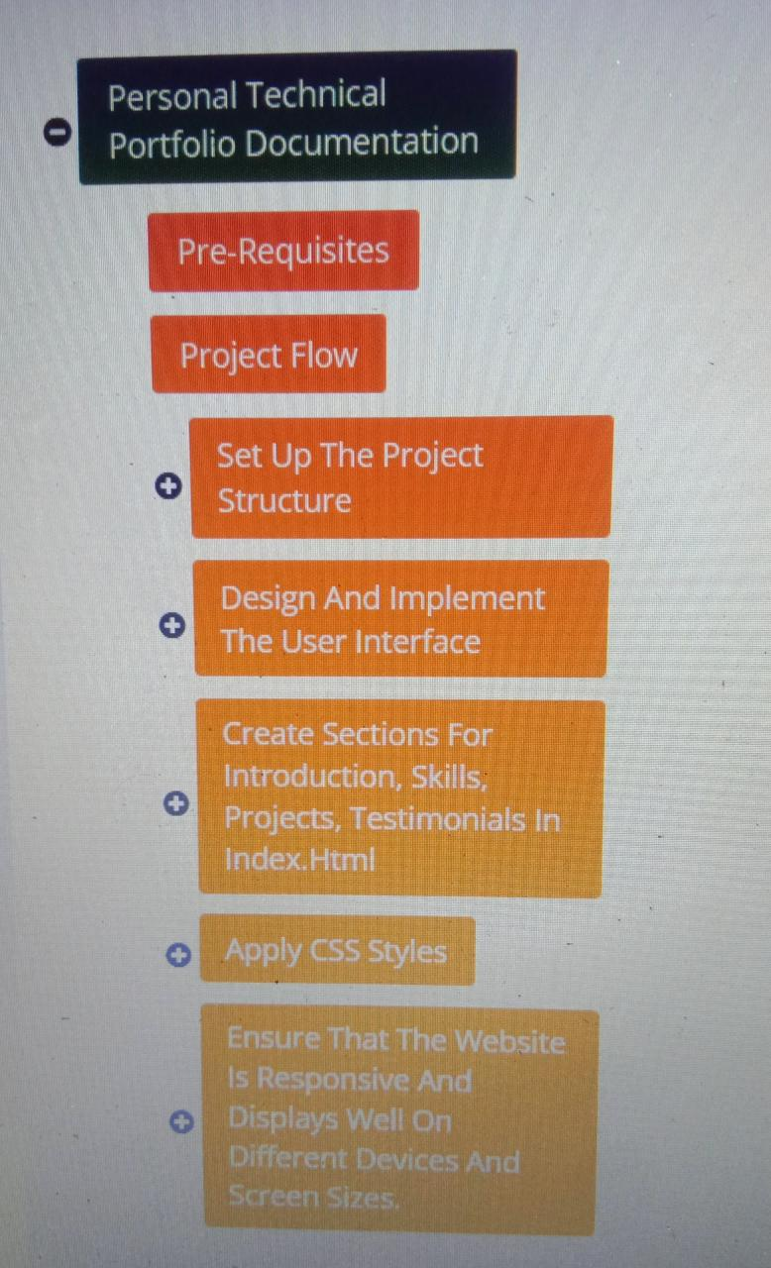

**RESULT**

The portfolio project showcases the final results of various projects I have undertaken. It includes detailed project descriptions, code snippets, and interactive components to demonstrate the outcomes effectively. Screenshots are provided to present the projects visually.

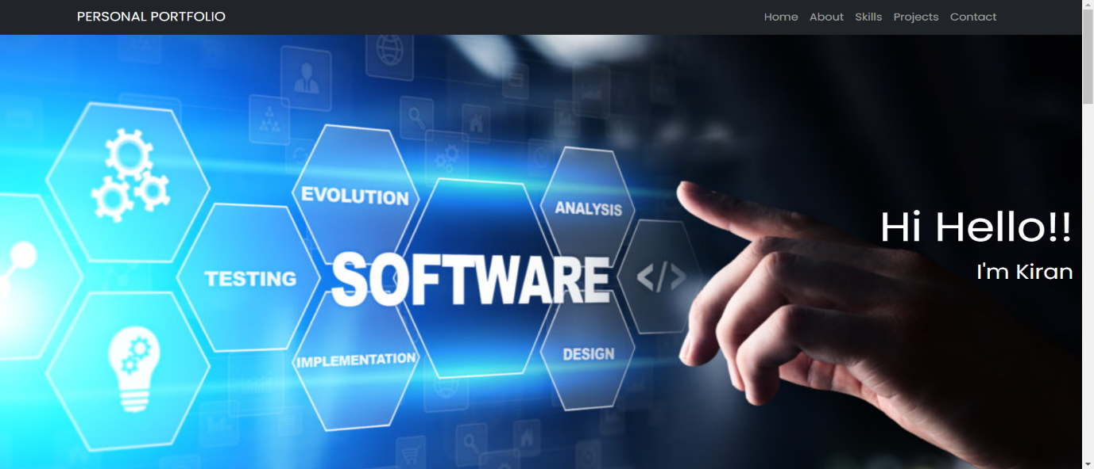

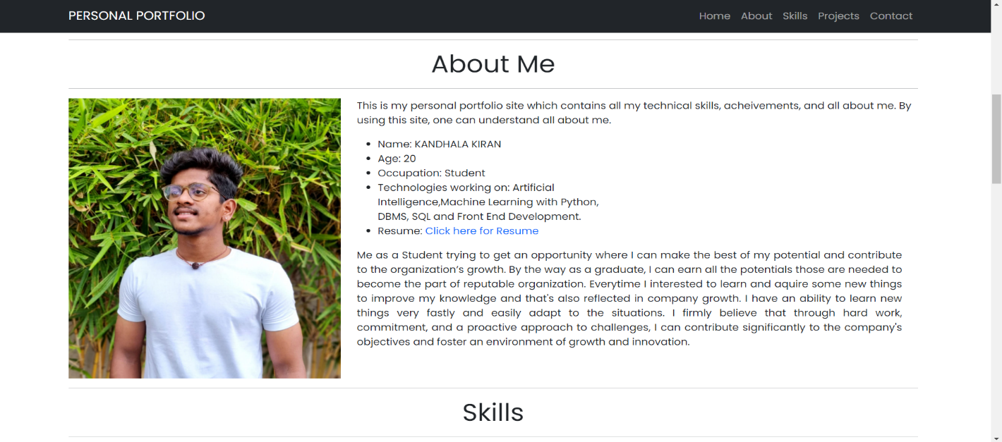

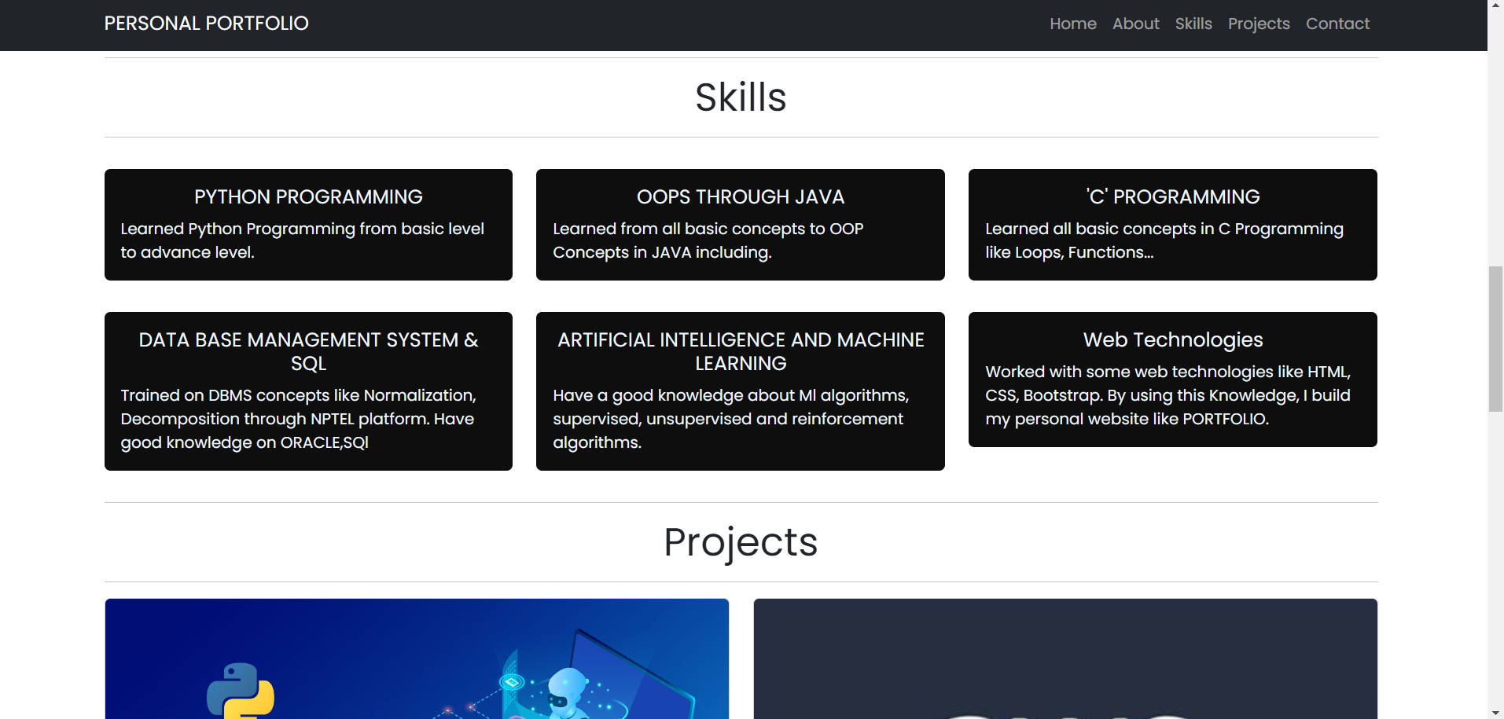

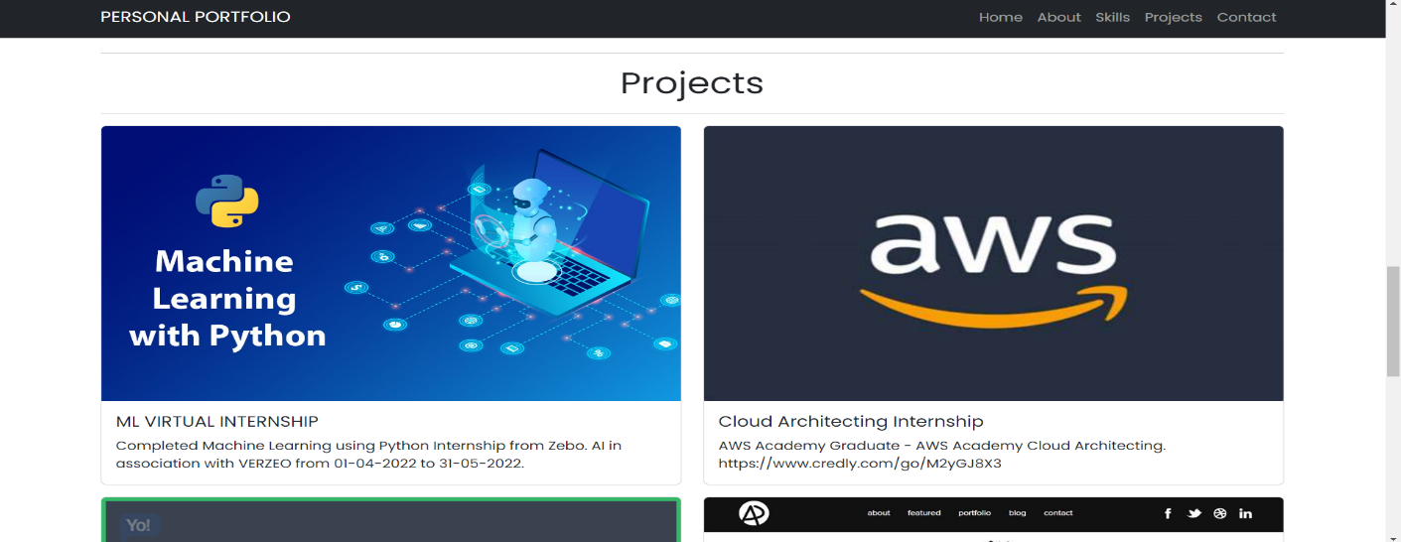

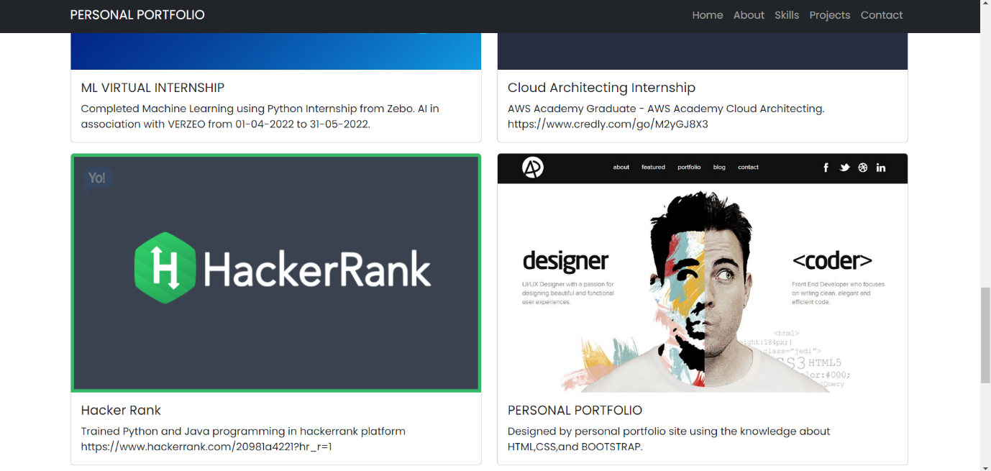

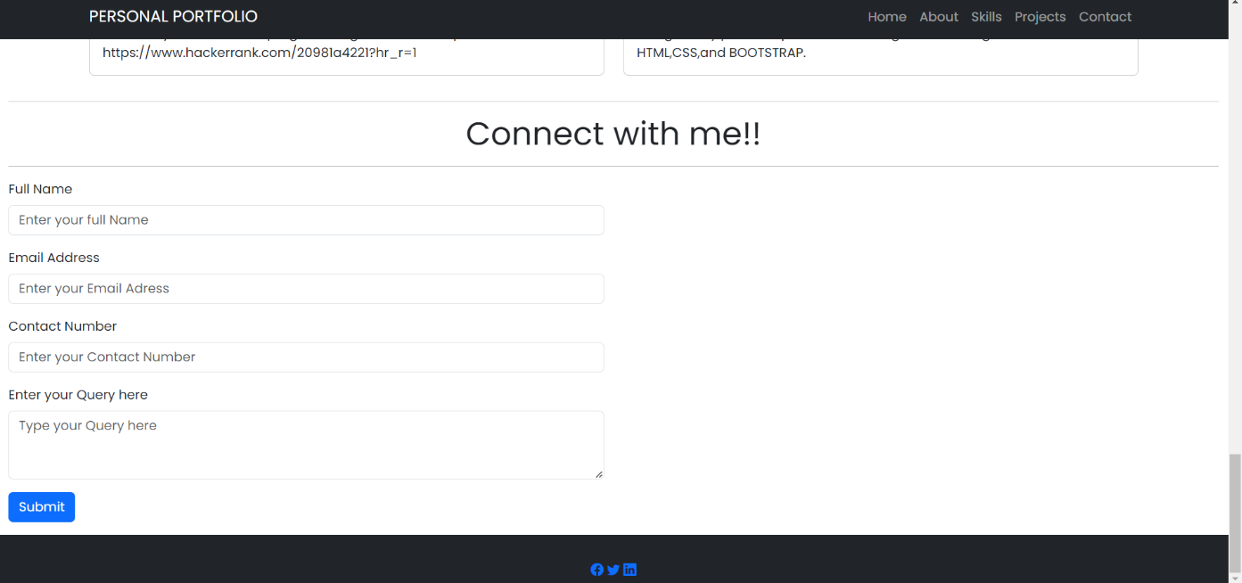

**ADVANTAGES & DISADVANTAGES**

Advantages:

* Provides a comprehensive display of my skills and expertise.
* Demonstrates my ability to tackle diverse projects and challenges.
* Highlights my problem-solving capabilities through real-world examples.

Disadvantages:

* May not include every project or aspect of my work due to space constraints.
* The portfolio's effectiveness may depend on the quality of project documentation and presentation.

**APPLICATIONS**

* The portfolio project demonstrates my proficiency and capabilities. It can be applied in various contexts, including but not limited to:
* Attracting potential clients or employers for freelance or job opportunities.
* Showcasing my abilities to collaborate with teams on challenging projects.
* Establishing my expertise in specific domains and technologies.

**CONCLUSION**

The portfolio project serves as a comprehensive representation of my journey as a student. It has provided me with a platform to present my work and abilities in a structured and visually appealing manner. The project demonstrates my dedication to continuous improvement and innovation.

**FUTURE SCOPE**

In the future, I plan to enhance the portfolio project by:

Adding new projects and updating existing ones to keep it up-to-date.

Improving the user experience and design of the platform.

Expanding the project's scope to include additional technologies and domains I explore in my career.